1.Task: Create an Image from a Running Docker Container
Objective
Create a new Docker image from an existing running container using the docker commit command.

Step 1: Check the running container
Command
docker ps
Explanation:
This command displays all running Docker containers and verifies that the nginx-container is running.

Step 2: Create a Docker image from the running container
Command
docker commit nginx-container amazon-nginx:v2
Explanation:
The docker commit command creates a new Docker image from the current state of the running container.
- nginx-container → Source container
- amazon-nginx → New image name
- v2 → Image tag (version)

Step 3: Verify the newly created image
Command
docker images
Explanation:
This command lists all Docker images available on the system and verifies that the new image amazon-nginx:v2 has been created successfully.

Step 4: Run a new container using the new image
Command
docker run -d -p 8081:80 --name amazon-nginx-v2 amazon-nginx:v2
Explanation:
- docker run → Creates and starts a new container.
- -d → Runs the container in detached mode.
- -p 8081:80 → Maps host port 8081 to container port 80.
- --name amazon-nginx-v2 → Assigns a name to the new container.
- amazon-nginx:v2 → Specifies the image to use.

Step 5: Verify the new container
Command
docker ps
Explanation:
This command verifies that the new container created from the committed image is running successfully.

Commands Summary
docker ps
docker commit nginx-container amazon-nginx:v2
docker images
docker run -d -p 8081:80 --name amazon-nginx-v2 amazon-nginx:v2
docker ps
Result
A new Docker image named amazon-nginx:v2 was successfully created from the running container nginx-container using the docker commit command. A new container was then launched from the newly created image, confirming that the image was created successfully.
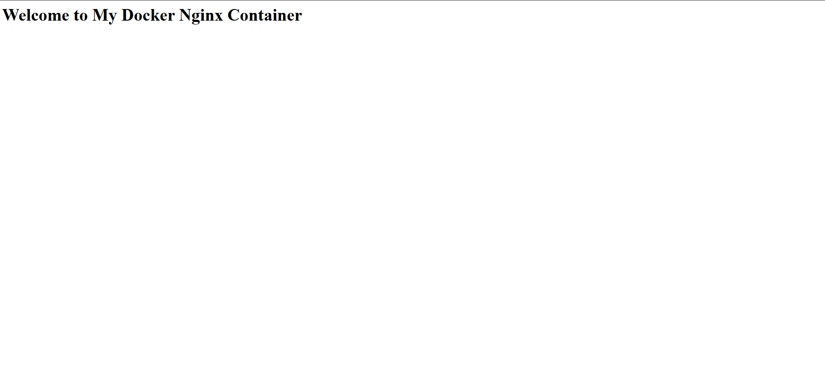
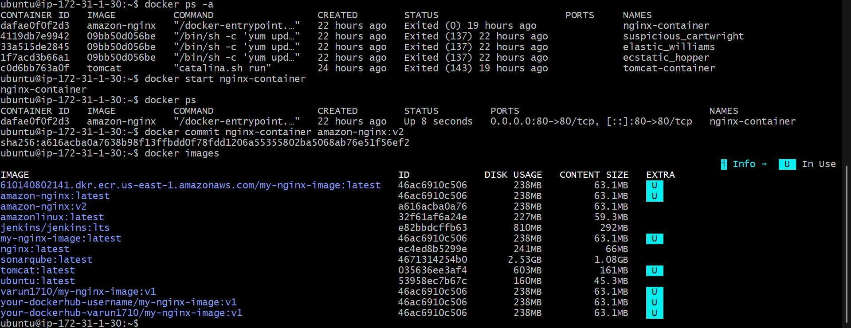

2.Task: Copy Docker Image from Local Machine to Docker Server and Load the Image
Objective
Copy a Docker image from the local machine to a Docker server and load the image into Docker.

Step 1: Verify the Docker image
Command
docker images
Explanation:
Verify that the Docker image (amazon-nginx:v2) is available on the source machine.

Step 2: Save the Docker image as a TAR file
Command
docker save -o amazon-nginx.tar amazon-nginx:v2
Explanation:
This command exports the Docker image into a TAR file named amazon-nginx.tar.

Step 3: Verify the TAR file
Command
ls -lh
Explanation:
Verify that the file amazon-nginx.tar has been created successfully.

Step 4: Copy the TAR file to the Docker server
Command
scp -i dockerkey.pem amazon-nginx.tar ubuntu@35.172.110.98:/home/ubuntu/
Explanation:
This command securely copies the TAR file from the source machine to the destination Docker server.

Step 5: Log in to the Docker server
Command
ssh -i dockerkey.pem ubuntu@35.172.110.98
Explanation:
Connect to the destination Docker server using the SSH private key.

Step 6: Verify the copied TAR file
Command
ls -lh
Explanation:
Verify that the amazon-nginx.tar file is present on the destination server.

Step 7: Load the Docker image
Command
docker load -i amazon-nginx.tar
Explanation:
This command imports the Docker image from the TAR file into the Docker server.

Step 8: Verify the loaded image
Command
docker images
Explanation:
Verify that the image amazon-nginx:v2 is available on the Docker server.

Commands Summary
docker images
docker save -o amazon-nginx.tar amazon-nginx:v2
ls -lh
scp -i dockerkey.pem amazon-nginx.tar ubuntu@35.172.110.98:/home/ubuntu/
ssh -i dockerkey.pem ubuntu@35.172.110.98
ls -lh
docker load -i amazon-nginx.tar
docker images
Result
The Docker image amazon-nginx:v2 was successfully exported as a TAR file, transferred to the Docker server, and loaded using the docker load command. The image is now available on the destination Docker server for creating containers.
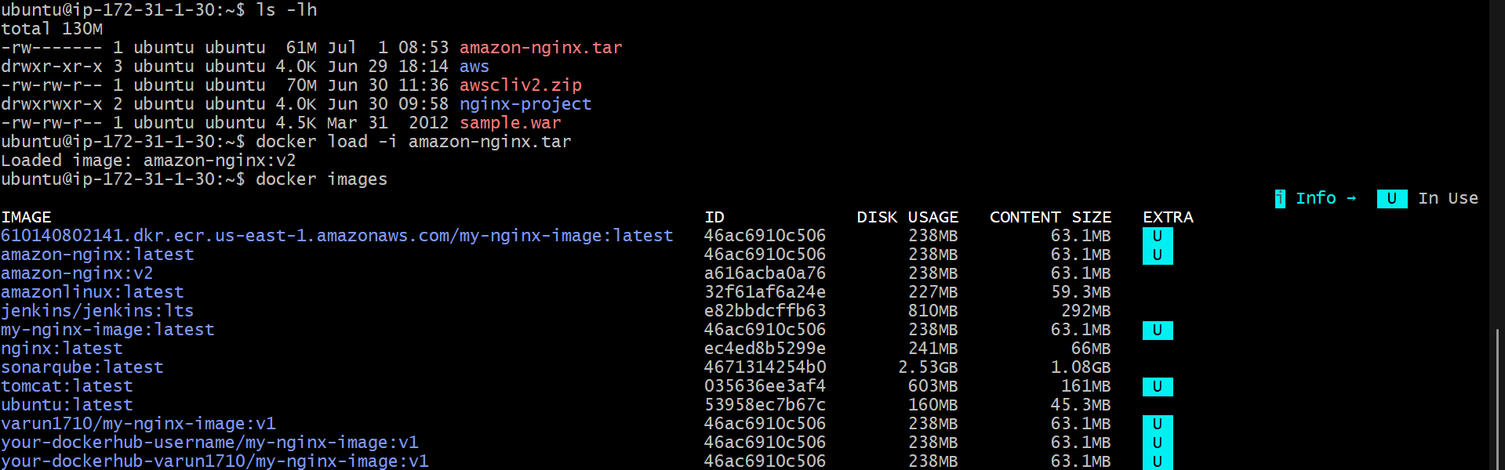

3.Task: Create a Docker Image Using Alpine and Customize It with Tomcat
Objective
Create a custom Docker image using the Alpine Linux base image, install Java and Tomcat, and build the image.

Step 1: Create a project directory
Command
mkdir alpine-tomcat
cd alpine-tomcat
Explanation:
Creates a new project directory and navigates into it.

Step 2: Create a Dockerfile
Command
vi Dockerfile
Explanation:
Creates a new Dockerfile.

Step 3: Add the following content to the Dockerfile
FROM alpine:latest

LABEL maintainer="Varun Dalal"

RUN apk update && \
apk add openjdk17-jdk wget tar

WORKDIR /opt

RUN wget https://archive.apache.org/dist/tomcat/tomcat-10/v10.1.42/bin/apache-tomcat-10.1.42.tar.gz && \
tar -xzf apache-tomcat-10.1.42.tar.gz && \
mv apache-tomcat-10.1.42 tomcat && \
rm apache-tomcat-10.1.42.tar.gz

EXPOSE 8080

CMD ["/opt/tomcat/bin/catalina.sh","run"]
Explanation:
- Uses Alpine Linux as the base image.
- Installs Java, wget, and tar.
- Downloads and extracts Apache Tomcat.
- Exposes port 8080.
- Starts Tomcat when the container runs.

Step 4: Save and exit
Press:
Esc
Type:
:wq
Press:
Enter

Step 5: Build the Docker image
Command
docker build -t alpine-tomcat:v1 .
Explanation:
Builds a Docker image named alpine-tomcat with the tag v1.

Step 6: Verify the image
Command
docker images
Explanation:
Verifies that the image alpine-tomcat:v1 has been created successfully.

Step 7: Run the container
Command
docker run -d -p 8080:8080 --name alpine-tomcat-container alpine-tomcat:v1
Explanation:
Starts a container from the newly created image and maps port 8080.

Step 8: Verify the running container
Command
docker ps
Explanation:
Confirms that the Tomcat container is running.

Step 9: Access Tomcat
Open a web browser and navigate to:
http://<EC2-Public-IP>:8080
Replace <EC2-Public-IP> with your EC2 instance's public IP address.

Commands Summary
mkdir alpine-tomcat
cd alpine-tomcat
vi Dockerfile
docker build -t alpine-tomcat:v1 .
docker images
docker run -d -p 8080:8080 --name alpine-tomcat-container alpine-tomcat:v1
docker ps
Result
A custom Docker image was successfully created using the Alpine Linux base image. Java and Apache Tomcat were installed, the image was built successfully, and a container was launched. Tomcat is accessible on port 8080.

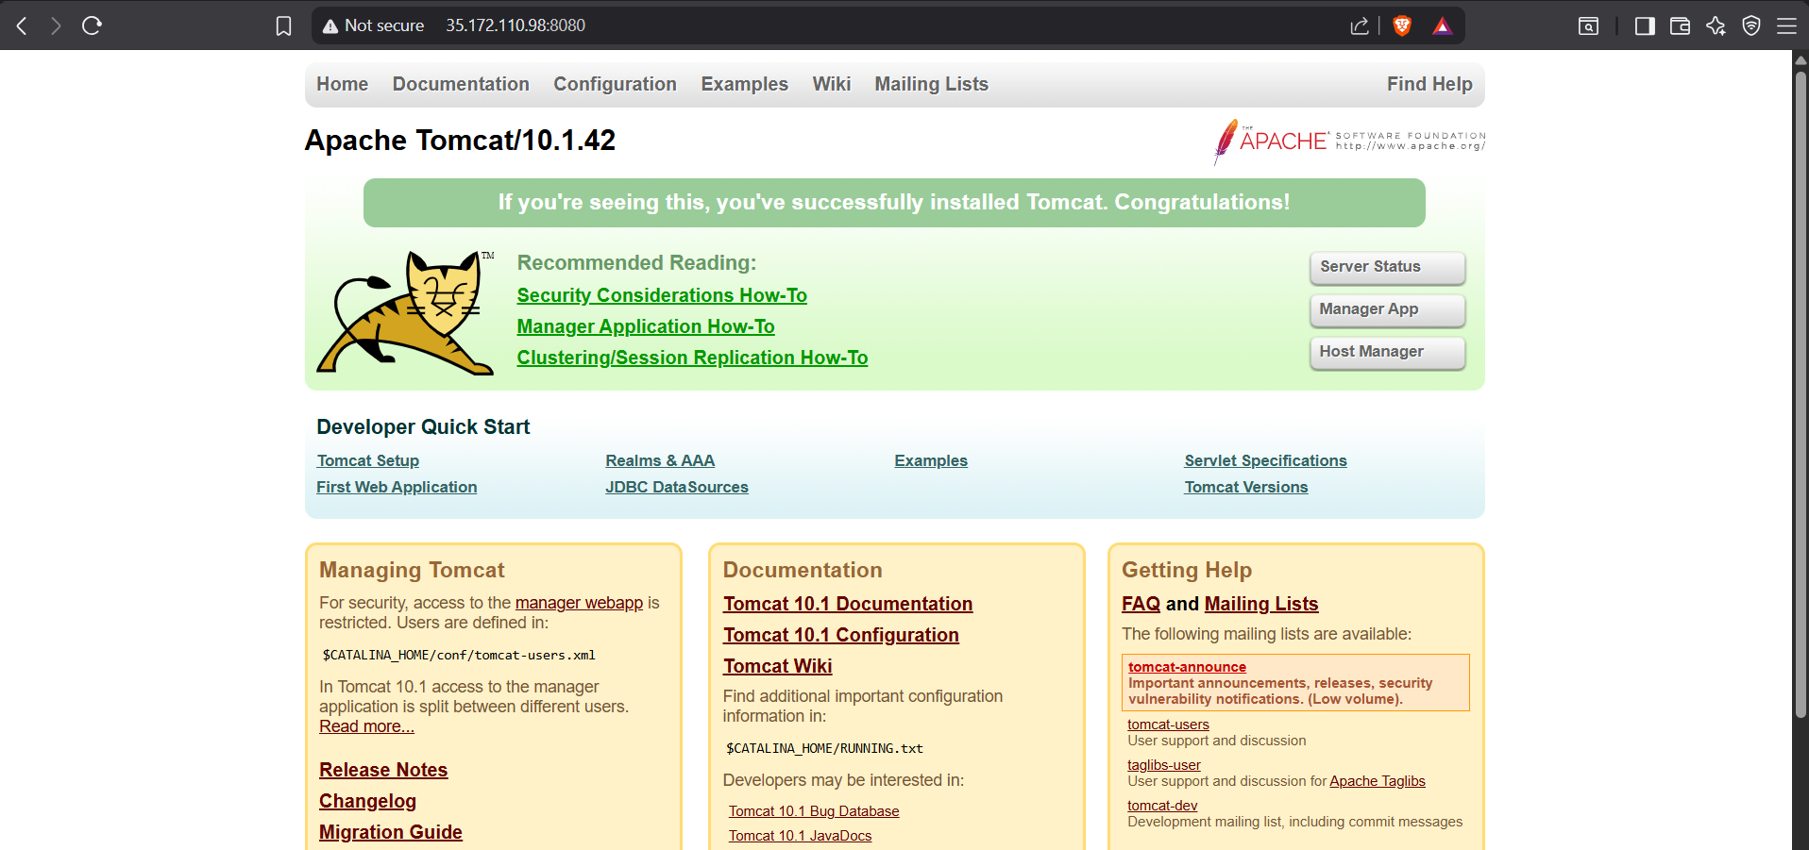
Experiment: Create Single-Stage and Multi-Stage Dockerfiles Using a Java Spring Boot Application
Aim
4. Create single stage and multi stage docker file using this source code:https://github.com/betawins/multi-stage-example.git
Source Code Repository: https://github.com/betawins/multi-stage-example.git

Prerequisites
- Ubuntu/Linux system
- Docker installed
- Git installed
- Internet connection

Step 1: Clone the Repository
Move to the home directory:
cd ~
Clone the repository:
git clone https://github.com/betawins/multi-stage-example.git
If the repository already exists:
cd ~/multi-stage-example
Verify the project files:
ls
Output:
Dockerfile
Dockerfile.multistage
README.md
pom.xml
mvnw
src

Step 2: View the Single-Stage Dockerfile
cat Dockerfile
Contents:
FROM maven:3.9.6-eclipse-temurin-8

WORKDIR /app

COPY . .

RUN mvn clean package

EXPOSE 8080

CMD ["java","-jar","target/multi-stage-example-0.0.1-SNAPSHOT.jar"]
Explanation
- FROM – Uses Maven with Java 8 as the base image.
- WORKDIR – Sets /app as the working directory.
- COPY – Copies the project files into the container.
- RUN – Builds the Spring Boot application using Maven.
- EXPOSE – Exposes port 8080.
- CMD – Starts the application.

Step 3: Build the Single-Stage Image
docker build -t java-single-stage -f Dockerfile .
Verify the image:
docker images

Step 4: Run the Single-Stage Container
docker run -d --name java-single-container -p 8080:8080 java-single-stage
Verify the running container:
docker ps

Step 5: View the Multi-Stage Dockerfile
cat Dockerfile.multistage

Step 6: Build the Multi-Stage Image
docker build -t java-multi-stage -f Dockerfile.multistage .
Verify the image:
docker images

Step 7: Run the Multi-Stage Container
Run the container on port 8081 because port 8080 is already used by the single-stage container.
docker run -d --name java-multi-container -p 8081:8080 java-multi-stage
Verify the running containers:
docker ps

Step 8: Compare Docker Images
docker images
Example:
REPOSITORY TAG SIZE
java-single-stage latest 736 MB
java-multi-stage latest 280 MB
The multi-stage image is smaller because it contains only the runtime environment and excludes Maven, source code, and build dependencies.

Step 9: Access the Application
Single-Stage Application:
http://<EC2-Public-IP>:8080
Multi-Stage Application:
http://<EC2-Public-IP>:8081
The application displays the Spring Boot Whitelabel Error Page (404) because the project does not contain any controller or endpoint. This indicates that the application is running successfully, but no URL is mapped.

Useful Docker Commands
Build Image:
docker build -t image-name .
List Images:
docker images
Run Container:
docker run -d -p HOST_PORT:8080 image-name
List Running Containers:
docker ps
Stop Container:
docker stop container-name
Remove Container:
docker rm container-name
Remove Image:
docker rmi image-name

Result
- Successfully cloned the Java Spring Boot project from GitHub.
- Successfully built the Single-Stage Docker image.
- Successfully built the Multi-Stage Docker image.
- Successfully ran both Docker containers.
- Verified the containers using docker ps.
- Compared the image sizes and observed that the multi-stage image is smaller than the single-stage image.
- Verified that the application starts successfully inside both containers.


5.Task: Install Docker Compose and Execute a Sample Application
Step 1: Update the Package List
sudo apt update

Step 2: Install Docker Compose
sudo apt install docker-compose -y

Step 3: Verify Docker Compose Installation
docker-compose --version
Sample Output:
docker-compose version 1.29.2

Step 4: Create a Project Directory
mkdir compose-demo

cd compose-demo

Step 5: Create docker-compose.yml
nano docker-compose.yml
Paste the following:
version: "3.8"

services:
nginx:
image: nginx:latest
container_name: nginx-compose
ports:
- "8083:80"
Save and exit.

Step 6: Start the Application
docker-compose up -d

Step 7: Verify the Running Container
docker ps
Sample Output:
CONTAINER ID IMAGE STATUS PORTS
xxxxxxxxxxxx nginx:latest Up 0.0.0.0:8083->80/tcp

Step 8: Access the Application
Open a browser and navigate to:
http://35.175.124.97:8083
The Welcome to nginx! page confirms the application is running successfully.

Step 9: Check Docker Compose Services
docker-compose ps

Step 10: View Logs
docker-compose logs

Step 11: Stop the Application
docker-compose stop

Step 12: Start the Application Again
docker-compose start

Step 13: Remove the Application
docker-compose down

Result
- Docker Compose was installed successfully.
- A sample Nginx application was deployed using Docker Compose.
- The application was verified by accessing http://35.175.124.97:8083.
- The default Nginx welcome page confirmed the deployment was successful.

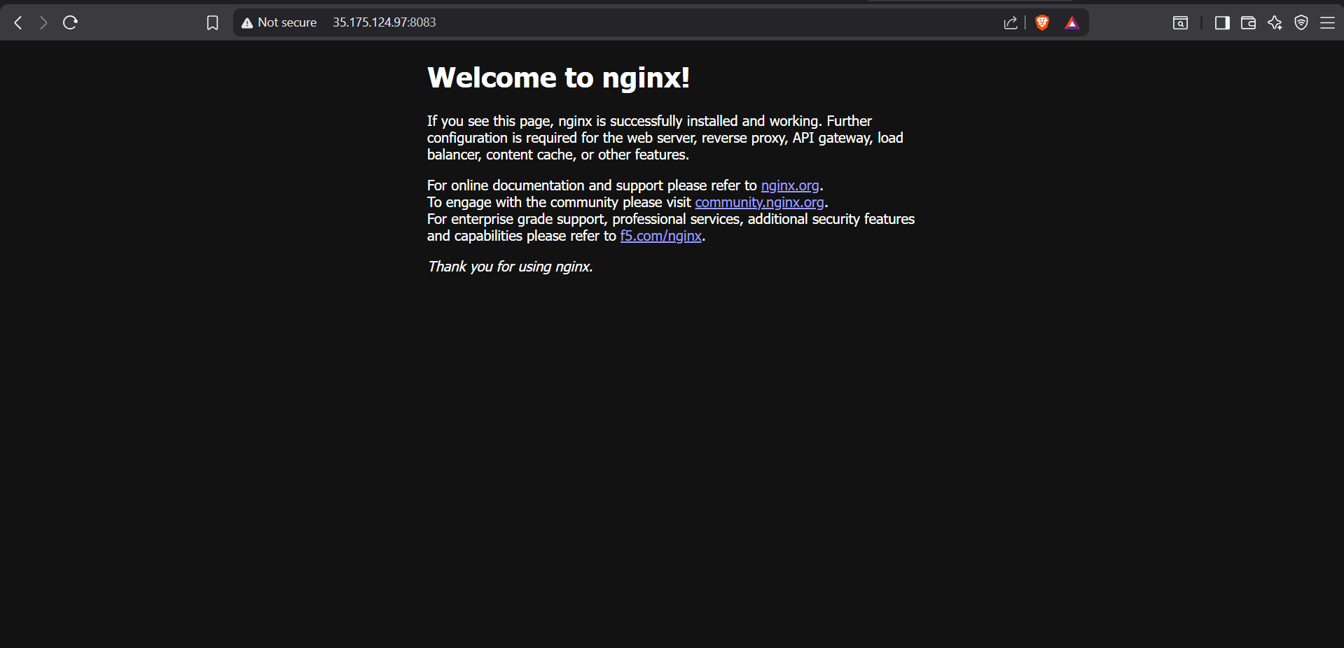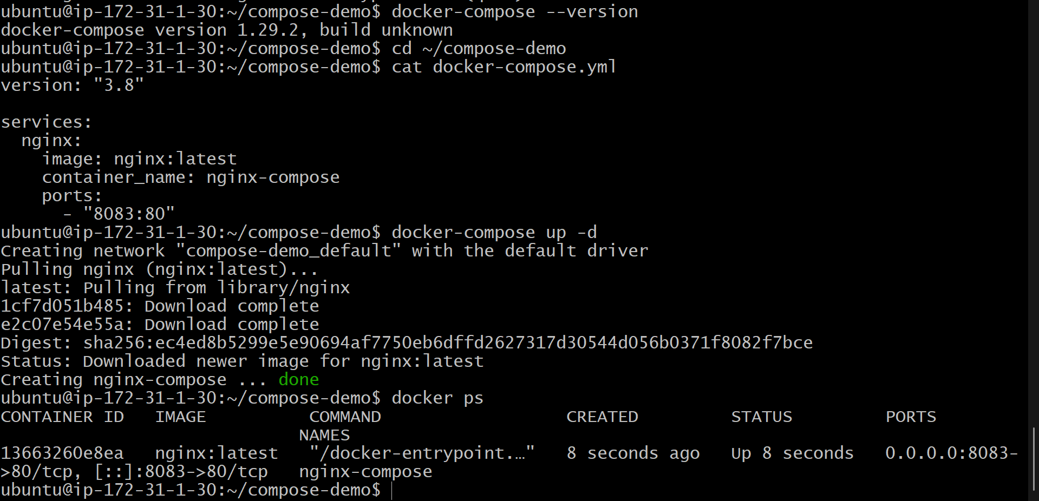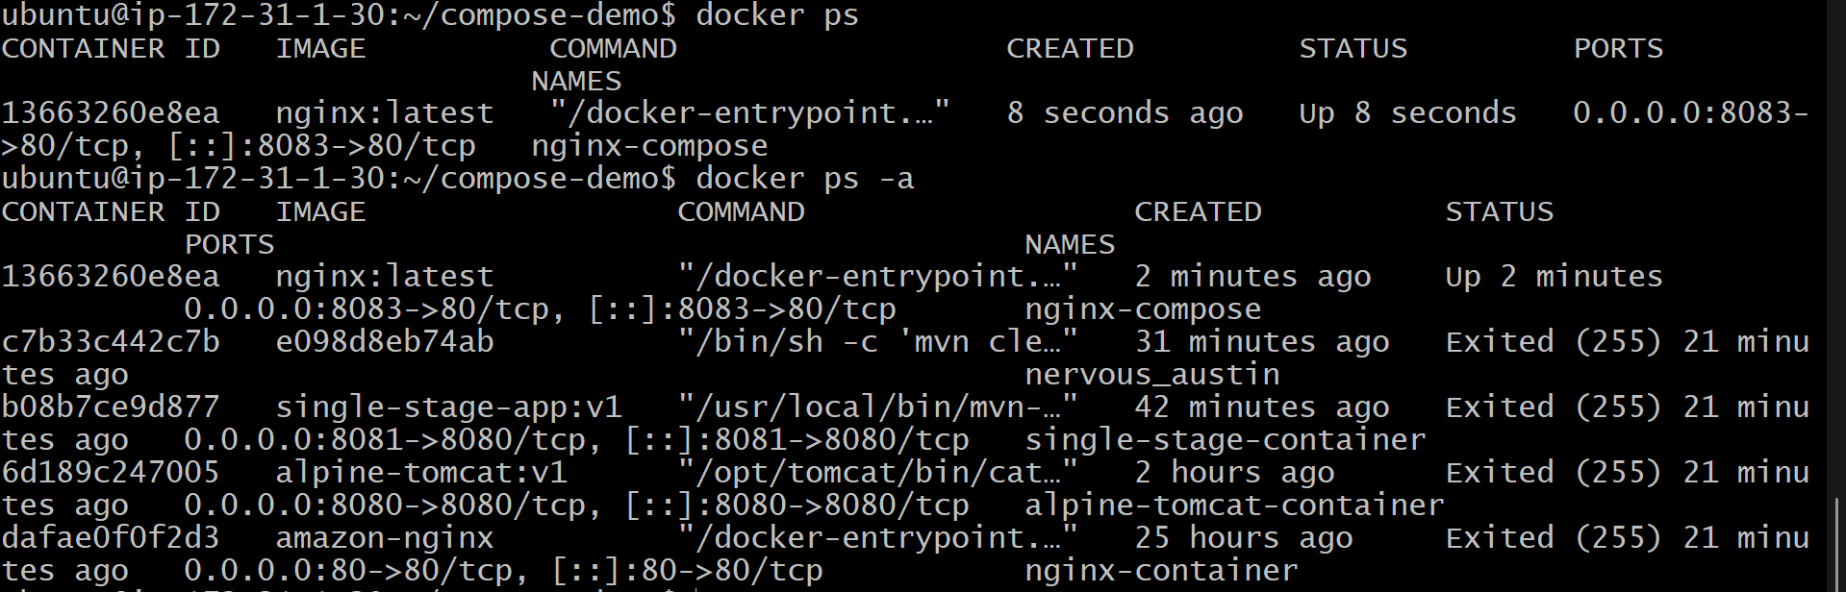

6.Implement solution to scan images when pushed to docker registry.
Objective:
Push the Docker image to Docker Hub with the tag v2.
Step 1: Login to Docker Hub
docker login
Enter your Docker Hub username and password.

Step 2: Verify the Local Image
Check whether the image exists locally.
docker images
Expected Output:
amazon-nginx:latest

Step 3: Tag the Image
Tag the local image with your Docker Hub repository name.
docker tag amazon-nginx:latest varun1710/my-nginx-image:v2

Step 4: Push the Image to Docker Hub
docker push varun1710/my-nginx-image:v2

Step 5: Expected Output
The push refers to repository [docker.io/varun1710/my-nginx-image]

Layer already exists
Layer already exists
Layer already exists
Layer already exists
Layer already exists
Layer already exists
Layer already exists
Layer already exists

v2: digest: sha256:46ac6910c5063a7f81616108c74134e643ef4d0559328acf6333742c3c132418
size: 2043
Note: The message "Layer already exists" is normal. Docker only uploads new layers and skips layers that are already present in the repository.

Step 6: Verify the Image
Run the following command:
docker images
Expected Output:
varun1710/my-nginx-image:v2
This confirms that the image is available locally with the correct tag.

Result
- Successfully tagged the Docker image as varun1710/my-nginx-image:v2.
- Successfully pushed the image to Docker Hub.
- Verified that the image is available locally.
- The Docker image is now available in the Docker Hub repository under the v2 tag.
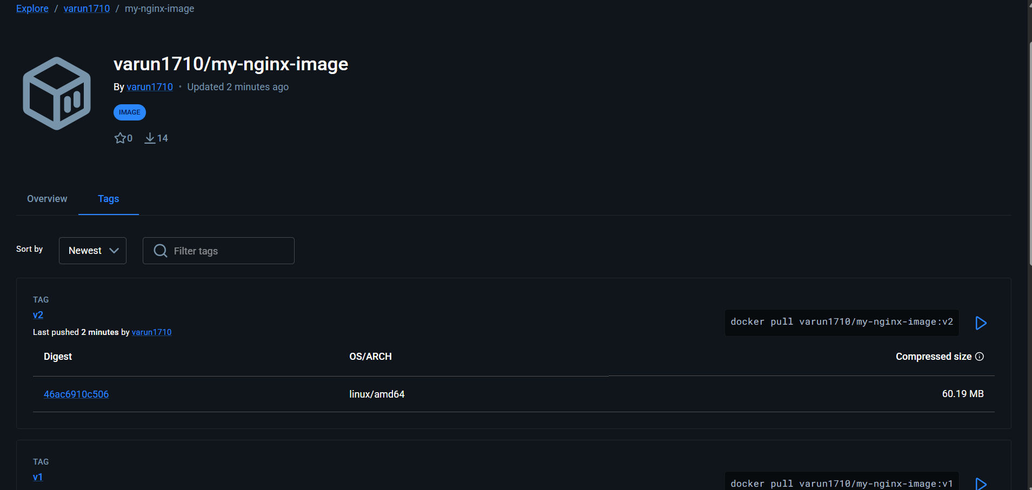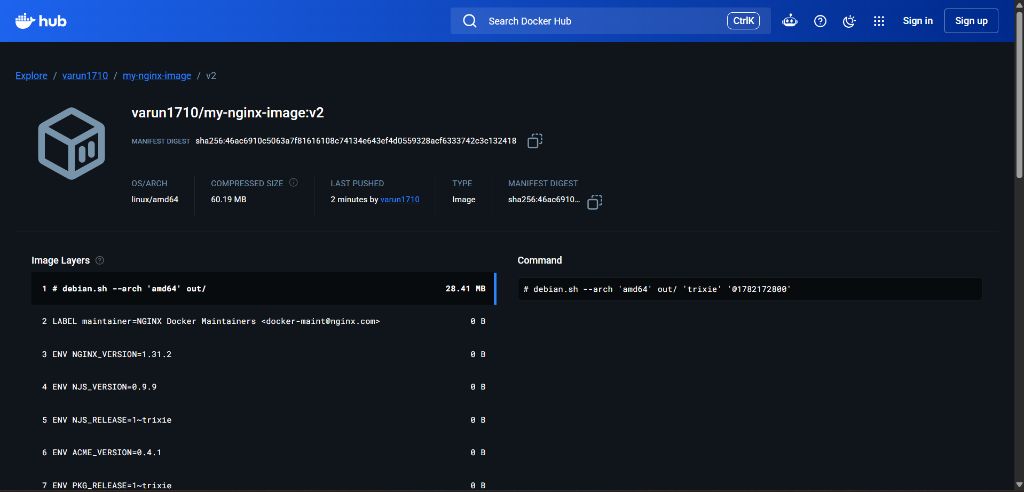

7.Implement Solution to Scan Images When Pushed to AWS ECR
Objective
Configure Amazon ECR to automatically scan Docker images for security vulnerabilities whenever a new image is pushed.

Step 1: Verify the Amazon ECR Repository
Run the following command to verify that the repository exists.
aws ecr describe-repositories --region us-east-1
Repository Name:
my-nginx-image

Step 2: Enable Scan on Push
Enable automatic image scanning for the repository.
aws ecr put-image-scanning-configuration \
--repository-name my-nginx-image \
--image-scanning-configuration scanOnPush=true \
--region us-east-1

Step 3: Verify Scan Configuration
aws ecr describe-repositories \
--repository-names my-nginx-image \
--region us-east-1
Verify that the output contains:
"scanOnPush": true

Step 4: Authenticate Docker to Amazon ECR
aws ecr get-login-password --region us-east-1 | docker login --username AWS --password-stdin 610140802141.dkr.ecr.us-east-1.amazonaws.com
Expected Output:
Login Succeeded

Step 5: Tag the Docker Image
docker tag amazon-nginx:latest 610140802141.dkr.ecr.us-east-1.amazonaws.com/my-nginx-image:v3

Step 6: Push the Image to Amazon ECR
docker push 610140802141.dkr.ecr.us-east-1.amazonaws.com/my-nginx-image:v3
Expected Output:
The push refers to repository [610140802141.dkr.ecr.us-east-1.amazonaws.com/my-nginx-image]

Layer already exists
...

v3: digest: sha256:46ac6910c5063a7f81616108c74134e643ef4d0559328acf6333742c3c132418
Note: The message "Layer already exists" is normal. Docker uploads only new layers and reuses existing ones.

Step 7: Verify Image Scan
Open the AWS Management Console.
Navigate to:
Amazon ECR → Repositories → my-nginx-image → Images → v3
The scan status should display:
- Status: Complete
- Scan completed successfully
Vulnerability Summary
Severity | Count
Critical | 2
High | 23
Medium | 31
Low | 0
Informational | 0

Result
- Successfully enabled Scan on Push for the Amazon ECR repository.
- Successfully pushed the Docker image (v3) to Amazon ECR.
- Amazon ECR automatically scanned the image after the push.
- The scan completed successfully and generated a vulnerability report.
- The vulnerability summary was available in the AWS Management Console.
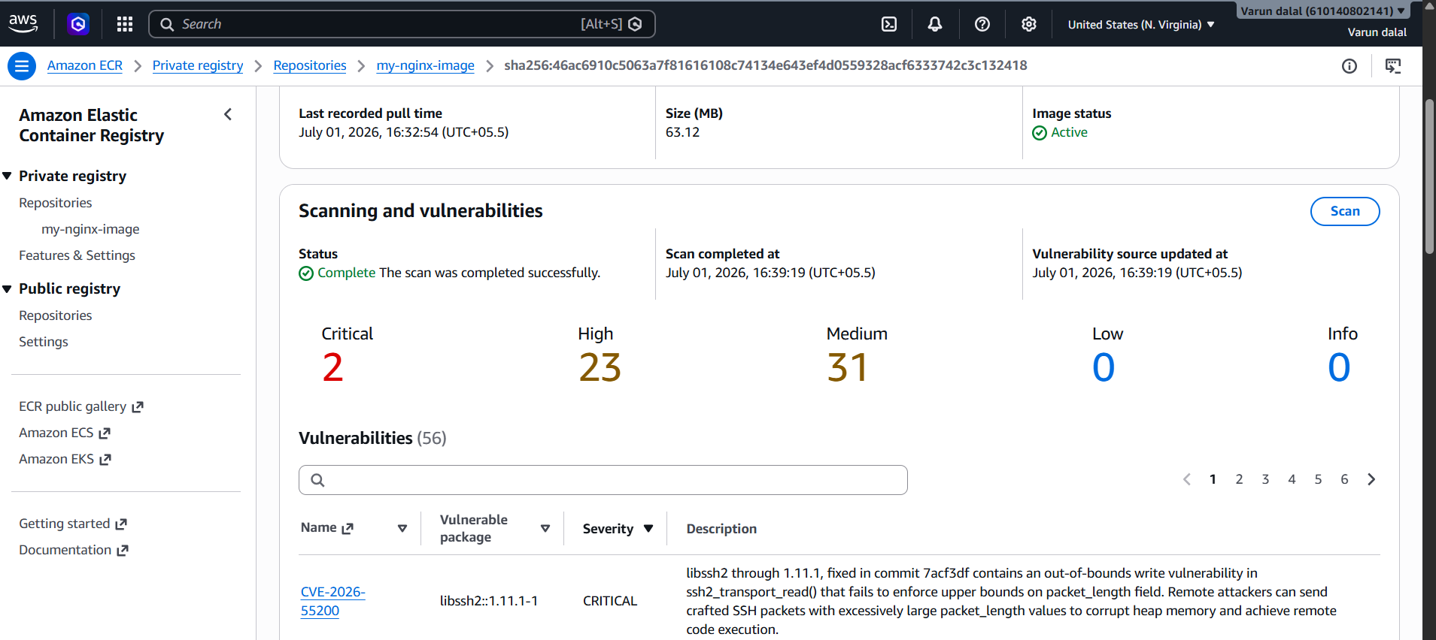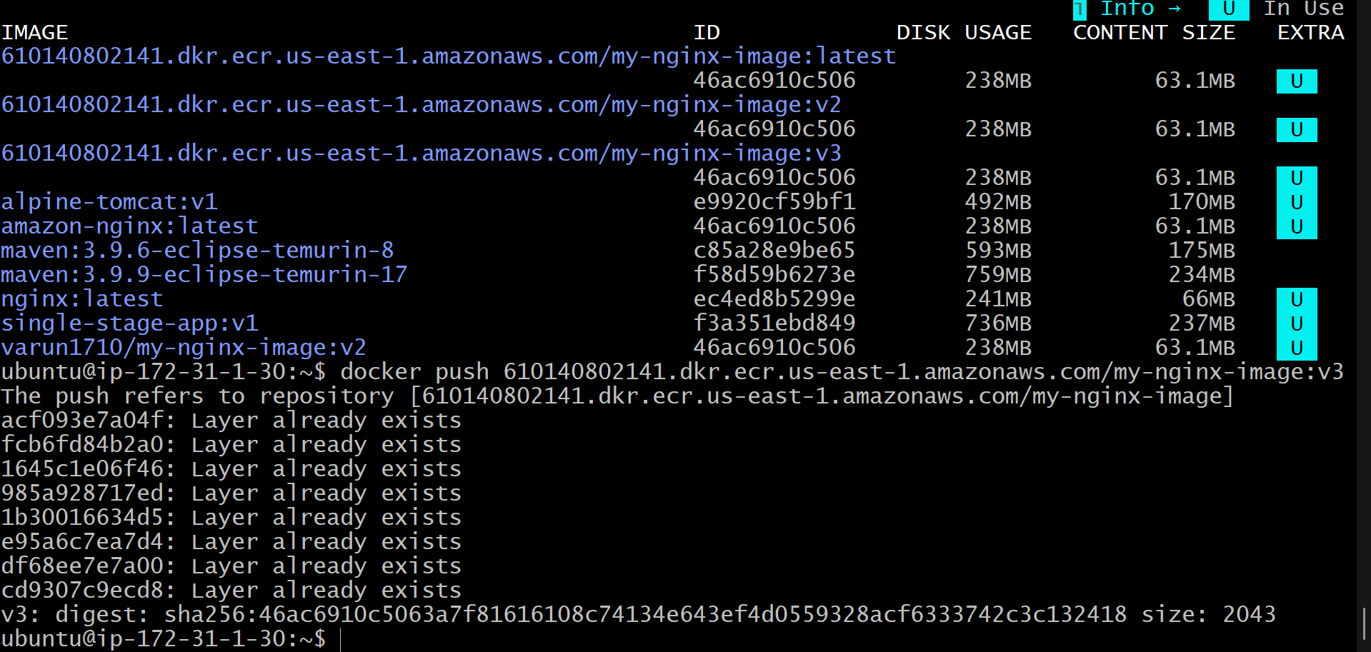

8. Experiment: Create a Jenkins Pipeline to Build a Docker Image and Push It to Docker Hub
Aim
To create a Jenkins Pipeline that builds a Docker image from the application source code and pushes the image to Docker Hub automatically.

Prerequisites
- Ubuntu/Linux Server
- Jenkins installed and running
- Docker installed
- Git installed
- Docker Hub account
- Jenkins configured with Docker permissions
- Docker Hub credentials added in Jenkins

Step 1: Create a Docker Hub Repository
- Log in to Docker Hub.
- Click Create Repository.
- Repository Name: my-nginx-image
- Set the repository visibility (Public or Private).
- Click Create.

Step 2: Add Docker Hub Credentials in Jenkins
- Open Jenkins Dashboard.
- Go to Manage Jenkins → Credentials.
- Select Global Credentials.
- Click Add Credentials.
- Choose Username with Password.
- Enter:
  - Username: Your Docker Hub username
  - Password: Your Docker Hub password or access token
  - ID: dockerhub-credentials
- Click Create.

Step 3: Create a New Pipeline Job
- Open Jenkins Dashboard.
- Click New Item.
- Enter the project name.
- Select Pipeline.
- Click OK.

Step 4: Configure Source Code Management
Under the Pipeline section:
- Definition: Pipeline script from SCM
- SCM: Git
- Repository URL:
https://github.com/betawins/multi-stage-example.git
- Branch:
*/main
- Script Path:
Jenkinsfile
Save the project.

Step 5: Create the Jenkinsfile
Create a file named Jenkinsfile in the project root directory.
pipeline {
agent any

environment {
IMAGE_NAME = "YOUR_DOCKERHUB_USERNAME/my-nginx-image"
}

stages {

stage('Clone Repository') {
steps {
checkout scm
}
}

stage('Build Docker Image') {
steps {
sh 'docker build -t $IMAGE_NAME:v1 .'
}
}

stage('Docker Login') {
steps {
withCredentials([usernamePassword(
credentialsId: 'dockerhub-credentials',
usernameVariable: 'DOCKER_USER',
passwordVariable: 'DOCKER_PASS'
)]) {
sh 'echo $DOCKER_PASS | docker login -u $DOCKER_USER --password-stdin'
}
}
}

stage('Push Docker Image') {
steps {
sh 'docker push $IMAGE_NAME:v1'
}
}
}

post {
always {
sh 'docker logout'
}

success {
echo 'Docker image built and pushed successfully.'
}

failure {
echo 'Pipeline execution failed.'
}
}
}
Replace YOUR_DOCKERHUB_USERNAME with your Docker Hub username.

Step 6: Build the Pipeline
- Open the Jenkins project.
- Click Build Now.
- Wait for the build to complete.

Step 7: Verify the Pipeline
Click the build number and open Console Output.
Successful stages include:
- Checkout SCM
- Build Docker Image
- Docker Login
- Push Docker Image

Step 8: Verify Docker Hub
Log in to Docker Hub and open your repository.
The image should appear as:
my-nginx-image:v1

Jenkins Pipeline Stages
Stage | Description
Clone Repository | Downloads the project source code from GitHub.
Build Docker Image | Creates a Docker image using the Dockerfile.
Docker Login | Authenticates Jenkins with Docker Hub.
Push Docker Image | Uploads the Docker image to Docker Hub.

Useful Docker Commands
Build Image
docker build -t my-nginx-image:v1 .
List Images
docker images
Login to Docker Hub
docker login
Push Image
docker push YOUR_DOCKERHUB_USERNAME/my-nginx-image:v1
List Running Containers
docker ps

Result
- Successfully created a Jenkins Pipeline.
- Successfully cloned the source code from GitHub.
- Successfully built the Docker image.
- Successfully authenticated with Docker Hub.
- Successfully pushed the Docker image to Docker Hub.
- Verified the image in the Docker Hub repository.
