1.Task: Setup a Virtual Machine Using Ubuntu Image on AWS EC2
Step 1: Log in to AWS Console
- Open your browser and go to:
  - AWS Management Console
- Sign in with your AWS account credentials.

Step 2: Open EC2 Dashboard
- In the AWS search bar, type EC2.
- Click EC2 to open the EC2 Dashboard.

Step 3: Launch a New Instance
- Click Launch Instance.
- Enter an instance name:
  - Name: Ubuntu-VM

Step 4: Select Ubuntu AMI
Under Application and OS Images (Amazon Machine Image):
- Select Ubuntu Server 24.04 LTS (or Ubuntu Server 22.04 LTS).
This Ubuntu AMI will be used to create the virtual machine.

Step 5: Choose Instance Type
Under Instance Type, select:
- t2.micro (Free Tier eligible)

Step 6: Create or Select a Key Pair
- Under Key Pair, click Create New Key Pair.
- Enter:
  - Key Pair Name: ubuntu-key
  - Key Pair Type: RSA
  - Private Key Format: .pem
- Click Create Key Pair.
- The .pem file will be downloaded automatically.

Step 7: Configure Network Settings
Under Network Settings:
- Allow SSH (Port 22) from your IP address.
(Optional)
- Allow HTTP (Port 80) if you plan to host a web application.

Step 8: Configure Storage
Under Configure Storage:
- Root Volume: 8 GB (default) or 20 GB.

Step 9: Launch the Instance
- Review all configurations.
- Click Launch Instance.
AWS will create the Ubuntu virtual machine.

Step 10: Verify Instance Status
- Click View All Instances.
- Wait until:
  - Instance State: Running
  - Status Checks: 2/2 checks passed

Step 11: Connect to the Ubuntu EC2 Instance
Open Terminal and run:
chmod 400 ubuntu-key.pem
ssh -i ubuntu-key.pem ubuntu@<Public-IP>
Example:
ssh -i ubuntu-key.pem ubuntu@54.xx.xx.xx

Step 12: Verify Ubuntu Installation
After connecting, run:
lsb_release -a
uname -a
hostname

Step 13: Update the System
sudo apt update
sudo apt upgrade -y

Verification
Check the operating system:
cat /etc/os-release
Expected output:
NAME="Ubuntu"
VERSION="24.04 LTS"

Result
✅ Successfully created and launched an Ubuntu virtual machine (EC2 instance) on AWS and connected to it using SSH.
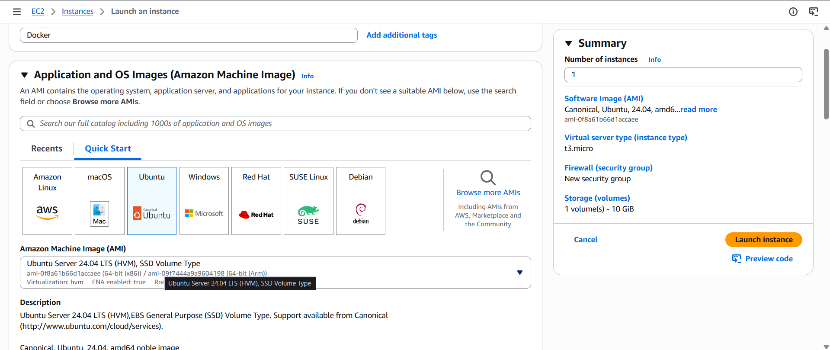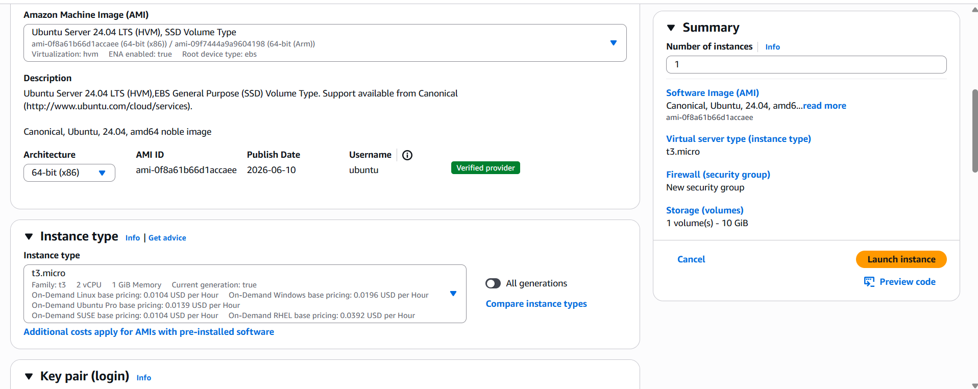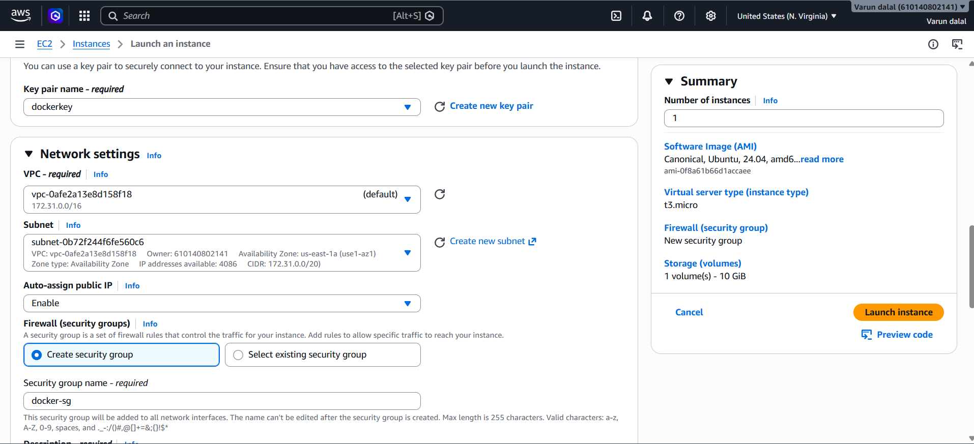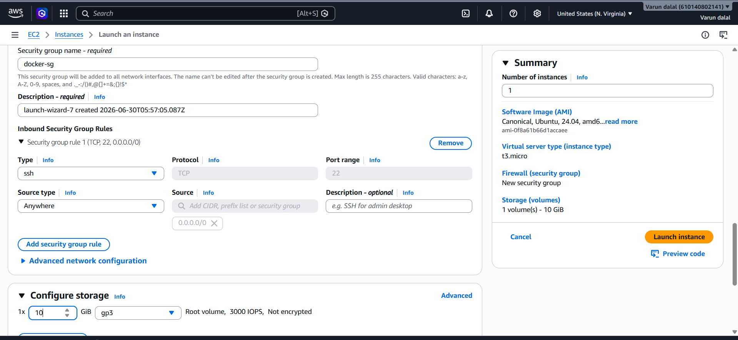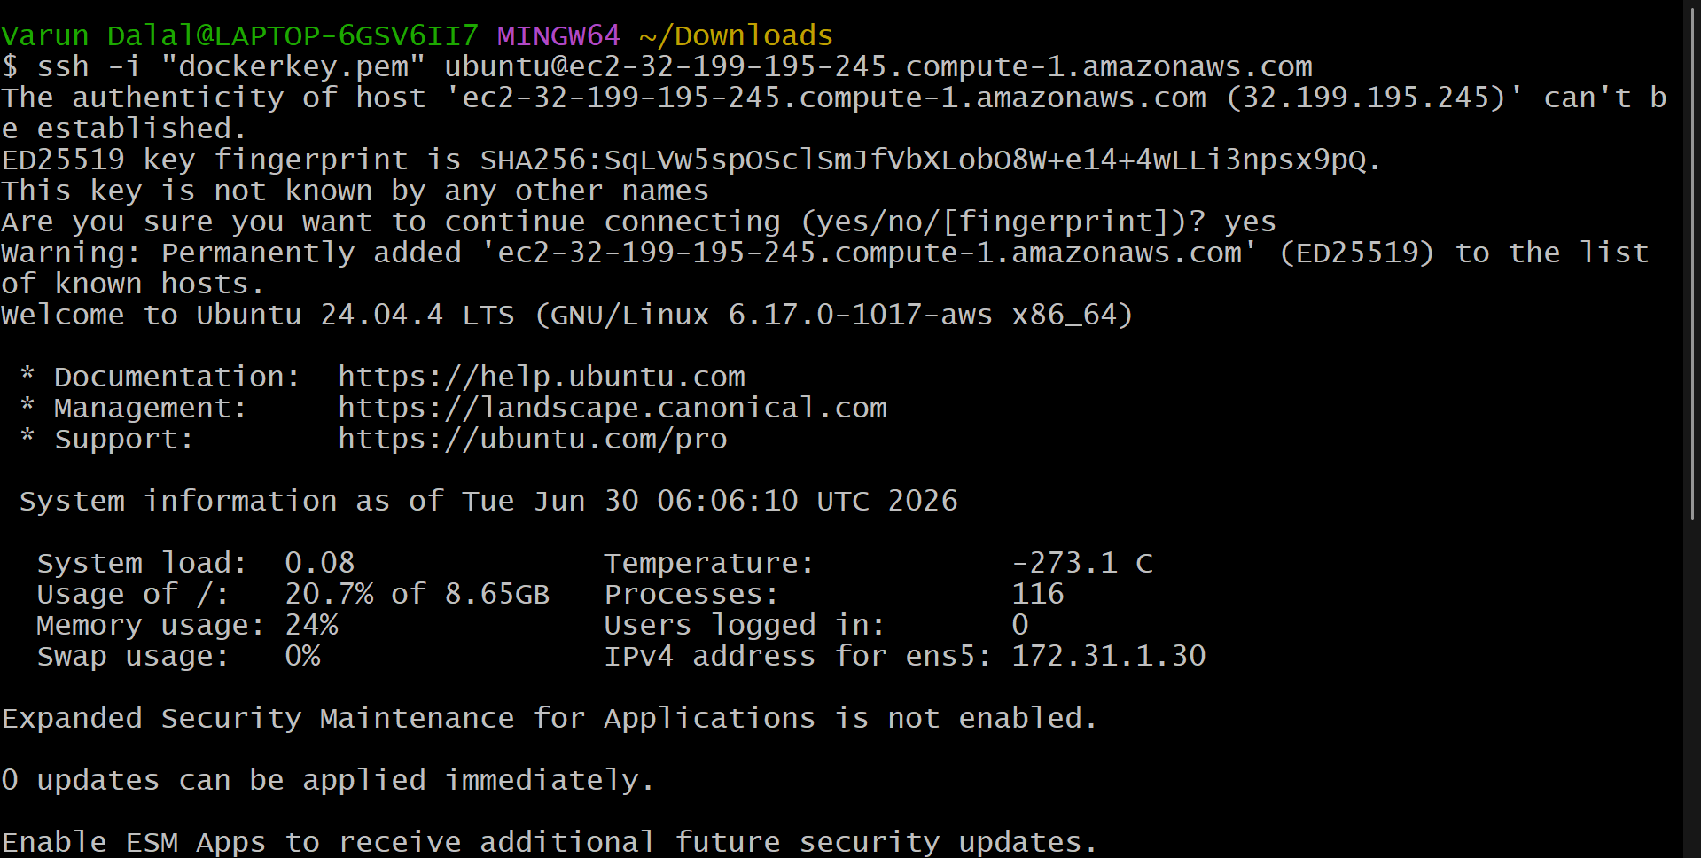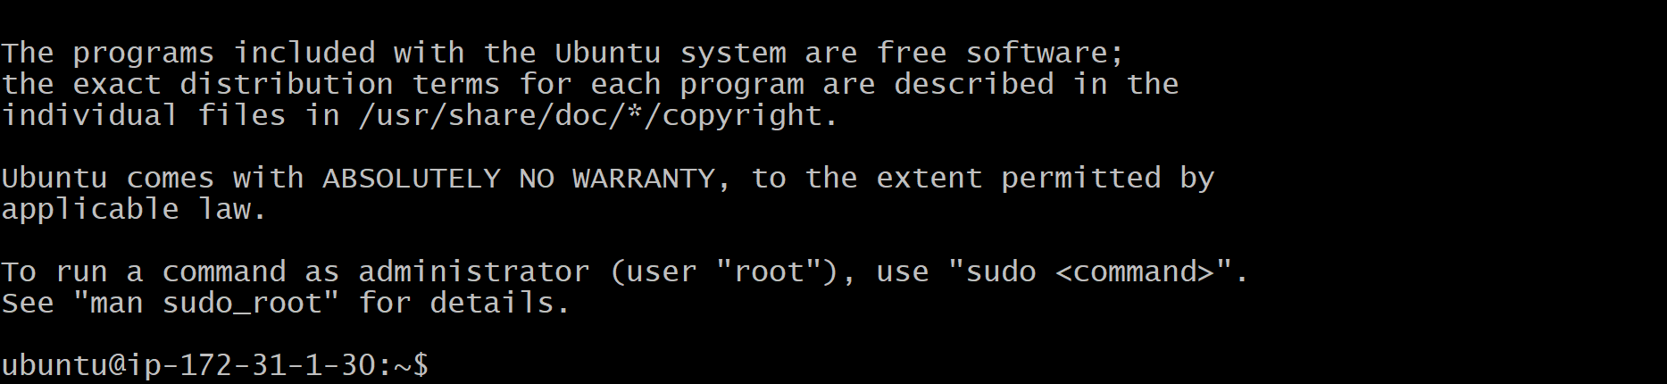

2.Install docker on ec2
Task: Install Docker on an Ubuntu EC2 Instance
Step 1: Connect to the EC2 Instance
Open your terminal and connect to the Ubuntu EC2 instance using SSH:
ssh -i ubuntu-key.pem ubuntu@<Public-IP>
Example:
ssh -i ubuntu-key.pem ubuntu@54.xx.xx.xx

Step 2: Update the Package Repository
sudo apt update
(Optional) Upgrade installed packages:
sudo apt upgrade -y

Step 3: Install Docker
sudo apt install docker.io -y

Step 4: Verify Docker Installation
docker --version
Expected output:
Docker version 29.x.x, build xxxxx

Step 5: Start the Docker Service
sudo systemctl start docker

Step 6: Enable Docker Service at Boot Time
sudo systemctl enable docker
Expected output:
Created symlink /etc/systemd/system/multi-user.target.wants/docker.service

Step 7: Check Docker Service Status
sudo systemctl status docker
Expected output:
Active: active (running)
Press Q to exit the status screen.

Step 8: Add the Ubuntu User to the Docker Group (Optional)
To run Docker commands without sudo:
sudo usermod -aG docker ubuntu
newgrp docker

Step 9: Test Docker Installation
Run the Hello World container:
docker run hello-world
Expected output:
Hello from Docker!
This message shows that your installation appears to be working correctly.

Step 10: Verify Running Containers
docker ps -a
You should see the hello-world container.

Verification Commands
docker --version
sudo systemctl status docker
docker run hello-world
docker ps -a

Result
✅ Successfully installed Docker on the Ubuntu EC2 instance.
✅ Docker service is running and enabled.
✅ Verified the installation by running the hello-world container.
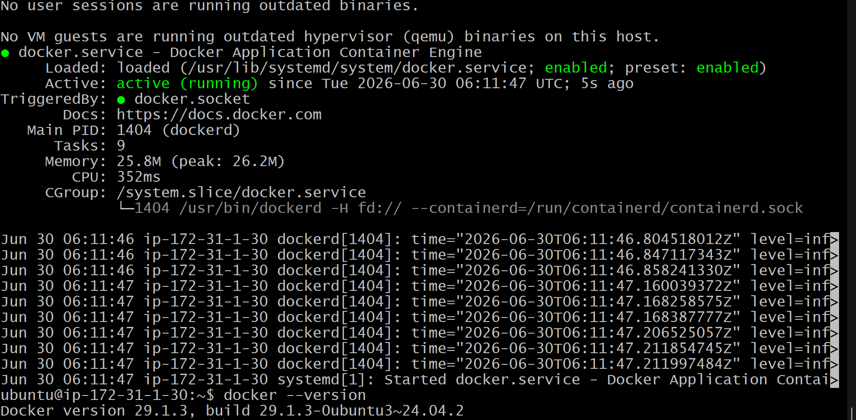
3.Task: Pull 5 Docker Images on an Ubuntu EC2 Instance
Objective
To download the following Docker images from Docker Hub:
- Nginx
- Apache Tomcat
- Ubuntu
- Jenkins
- SonarQube

Step 1: Connect to the EC2 Instance
Open the terminal and connect to your Ubuntu EC2 instance using SSH.
ssh -i ubuntu-key.pem ubuntu@<Public-IP>
Example:
ssh -i ubuntu-key.pem ubuntu@54.xx.xx.xx

Step 2: Verify Docker Installation
Check whether Docker is installed and running.
docker --version
sudo systemctl status docker
Expected output:
Active: active (running)

Step 3: Give Docker Permissions to the Ubuntu User
If you receive a permission denied error while running Docker commands, execute the following commands:
sudo usermod -aG docker ubuntu
newgrp docker
Verify:
docker ps
If no error is displayed, Docker permissions are configured successfully.

Step 4: Pull the Nginx Image
docker pull nginx

Step 5: Pull the Apache Tomcat Image
docker pull tomcat

Step 6: Pull the Ubuntu Image
docker pull ubuntu

Step 7: Pull the Jenkins Image
docker pull jenkins/jenkins:lts

Step 8: Pull the SonarQube Image
docker pull sonarqube

Step 9: Verified Downloaded Images
Display all downloaded Docker images.
docker images
Expected output:
REPOSITORY TAG IMAGE ID CREATED SIZE
nginx latest xxxxxxxxxxxx xx days ago xxxMB
tomcat latest xxxxxxxxxxxx xx days ago xxxMB
ubuntu latest xxxxxxxxxxxx xx days ago xxxMB
jenkins/jenkins lts xxxxxxxxxxxx xx days ago xxxMB
sonarqube latest xxxxxxxxxxxx xx days ago xxxMB

Commands Used
docker pull nginx
docker pull tomcat
docker pull ubuntu
docker pull jenkins/jenkins:lts
docker pull sonarqube
docker images

Result
✅ Successfully pulled the following Docker images on the Ubuntu EC2 instance:
- Nginx
- Apache Tomcat
- Ubuntu
- Jenkins
- SonarQube
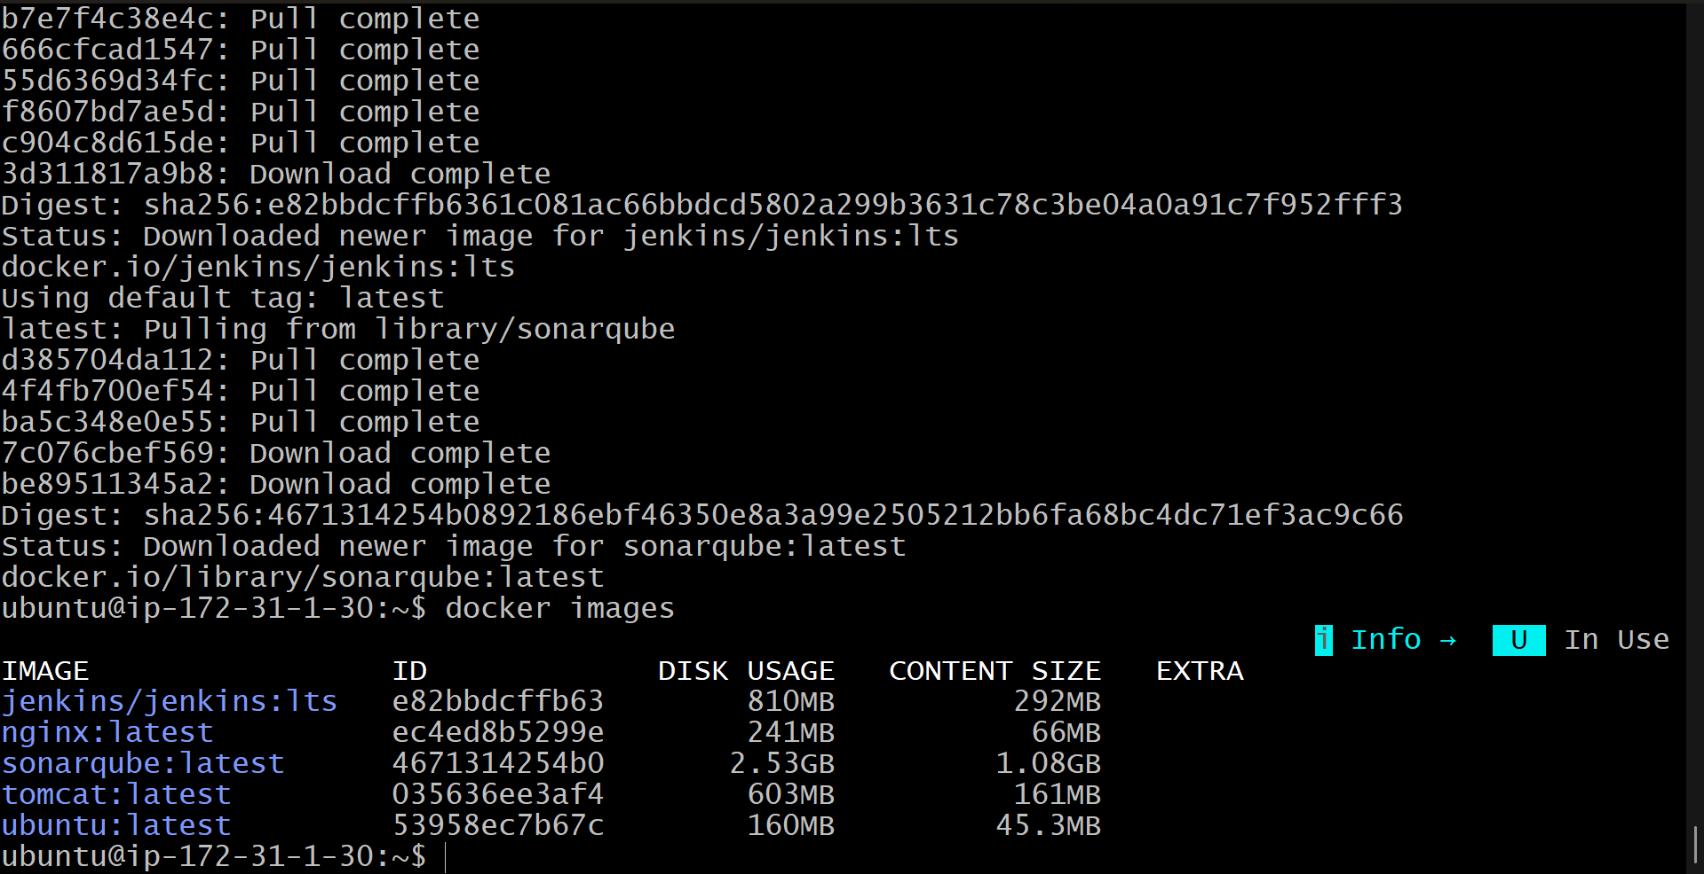

4.Task: Run an Nginx Container and Expose it on Port 81
Objective
To create and run an Nginx container and make it accessible on Port 81 of the EC2 instance.

Step 1: Verify the Nginx Image is Available
List all downloaded Docker images:
docker images
Ensure that the nginx image is present.

Step 2: Run the Nginx Container
Execute the following command to create and start the Nginx container:
docker run -d --name nginx-container -p 81:80 nginx
Command Explanation
- docker run → Creates and starts a new container.
- -d → Runs the container in detached mode (background).
- --name nginx-container → Assigns the name nginx-container to the container.
- -p 81:80 → Maps EC2 port 81 to container port 80.
- nginx → Docker image used to create the container.

Step 3: Verify the Container is Running
Check the running containers:
docker ps
Expected output:
CONTAINER ID IMAGE COMMAND STATUS PORTS
xxxxxxxxxxxx nginx "/docker-entrypoint…" Up xx seconds 0.0.0.0:81->80/tcp

Step 4: Verify Nginx from the EC2 Instance
Run the following command:
curl http://localhost:81
If Nginx is working correctly, HTML content containing Welcome to nginx! will be displayed.

Step 5: Configure the EC2 Security Group
To access Nginx from a browser:
- Open AWS Console.
- Go to EC2 Dashboard.
- Select your EC2 instance.
- Click on the attached Security Group.
- Select Edit Inbound Rules.
- Add the following rule:
Type | Protocol | Port Range | Source
Custom TCP | TCP | 81 | 0.0.0.0/0
- Click Save Rules.

Step 6: Access the Nginx Application
Open a web browser and enter:
http://<EC2-Public-IP>:81
Example:
http://54.xx.xx.xx:81
The Welcome to nginx! page should be displayed.

Commands Used
docker images
docker run -d --name nginx-container -p 81:80 nginx
docker ps
curl http://localhost:81

Result
✅ Successfully created and started an Nginx container.
✅ Exposed the container on Port 81 using Docker port mapping.
✅ Verified the application locally and through the browser using:
http://<EC2-Public-IP>:81
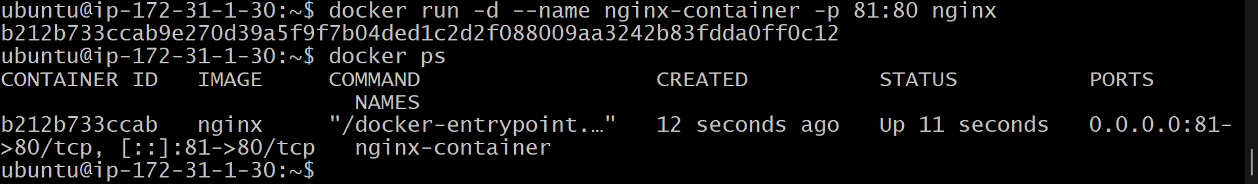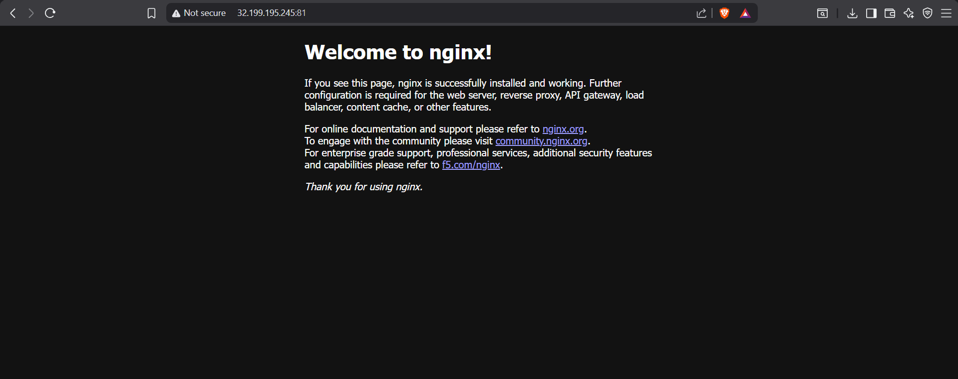
5.Task: Delete the Apache Tomcat Image from Local Docker Repository
Objective
To remove the Apache Tomcat Docker image from the local system.

Step 1: Display Available Docker Images
docker images
Identify the tomcat image from the list of available Docker images.

Step 2: Delete the Tomcat Image
Execute the following command:
docker rmi tomcat

Step 3: Verify Successful Deletion
The command output should be similar to:
Untagged: tomcat:latest
Deleted: sha256:035636ee3af432826bf0cd7082cfc982e8c228b0f954861bbe92624164fd9277
This confirms that the Apache Tomcat image has been removed successfully.

Step 4: Verify the Image is No Longer Present
Run:
docker images
Ensure that the tomcat image no longer appears in the list.

Commands Used
docker images
docker rmi tomcat
docker images

Result
✅ Successfully deleted the Apache Tomcat Docker image from the local Docker repository.
✅ Verified the deletion using the docker images command.
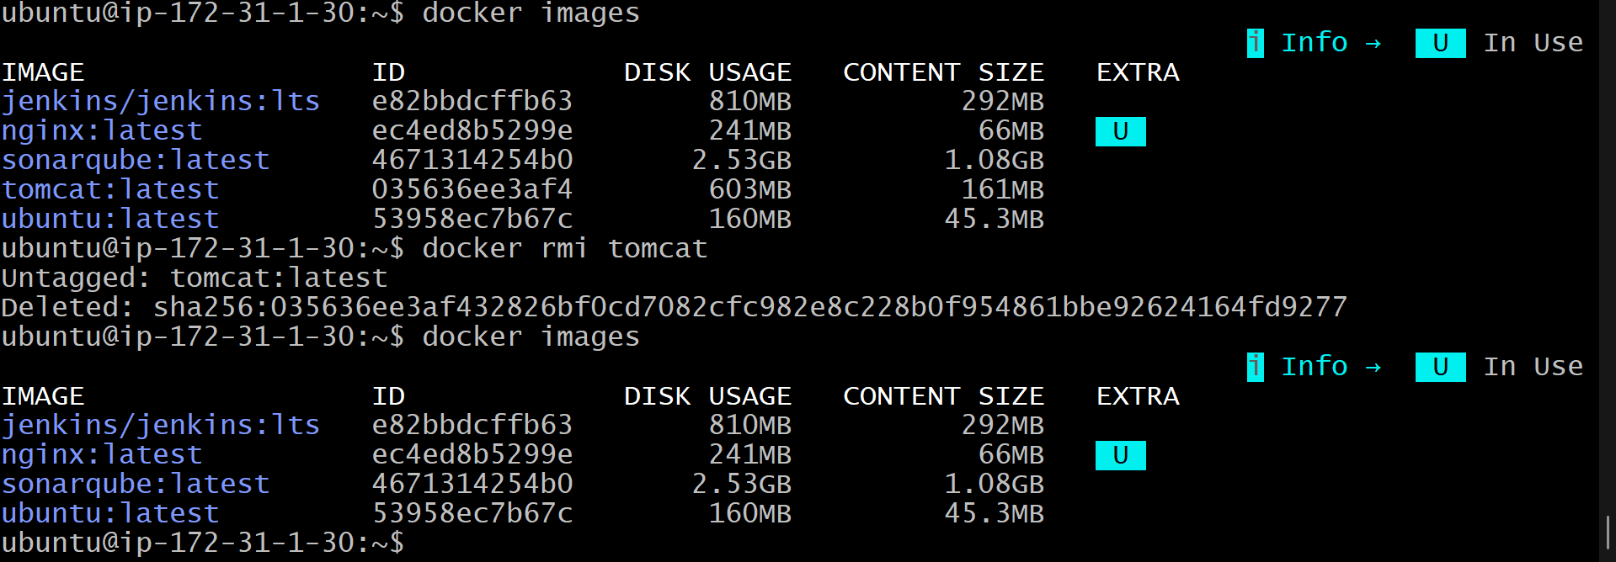

Task: Inspect the Jenkins and SonarQube Docker Images
Objective
6.Inspect the Jenkins image, SonarQube image
Step 1: Verify the Images are Available
Display all Docker images:
docker images
Ensure that the following images are present:
- jenkins/jenkins
- sonarqube

Step 2: Inspect the Jenkins Image
Execute the following command:
docker inspect jenkins/jenkins:lts
This command displays detailed information about the Jenkins image, including:
- Image ID
- Creation Date
- Architecture
- Environment Variables
- Entrypoint
- Working Directory
- Exposed Ports
- Labels and Metadata

Step 3: Inspect the SonarQube Image
Execute the following command:
docker inspect sonarqube
This command displays detailed information about the SonarQube image, including:
- Image ID
- Creation Date
- Architecture
- Environment Variables
- Entrypoint
- Exposed Ports
- Labels and Metadata

Commands Used
docker images
docker inspect jenkins/jenkins:lts
docker inspect sonarqube

Result
✅ Successfully inspected the Jenkins and SonarQube Docker images using the docker inspect command.
✅ Retrieved detailed metadata such as image ID, configuration details, environment variables, and exposed ports.
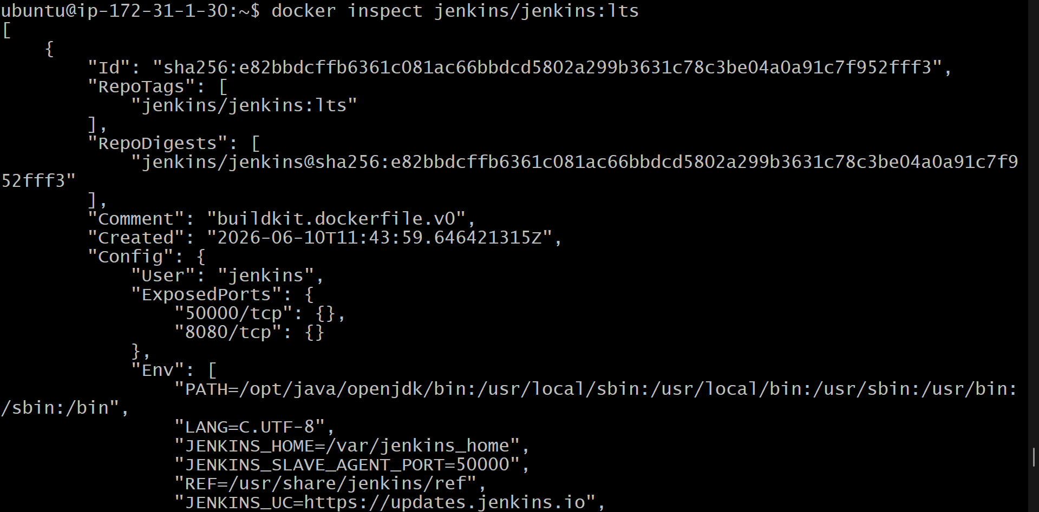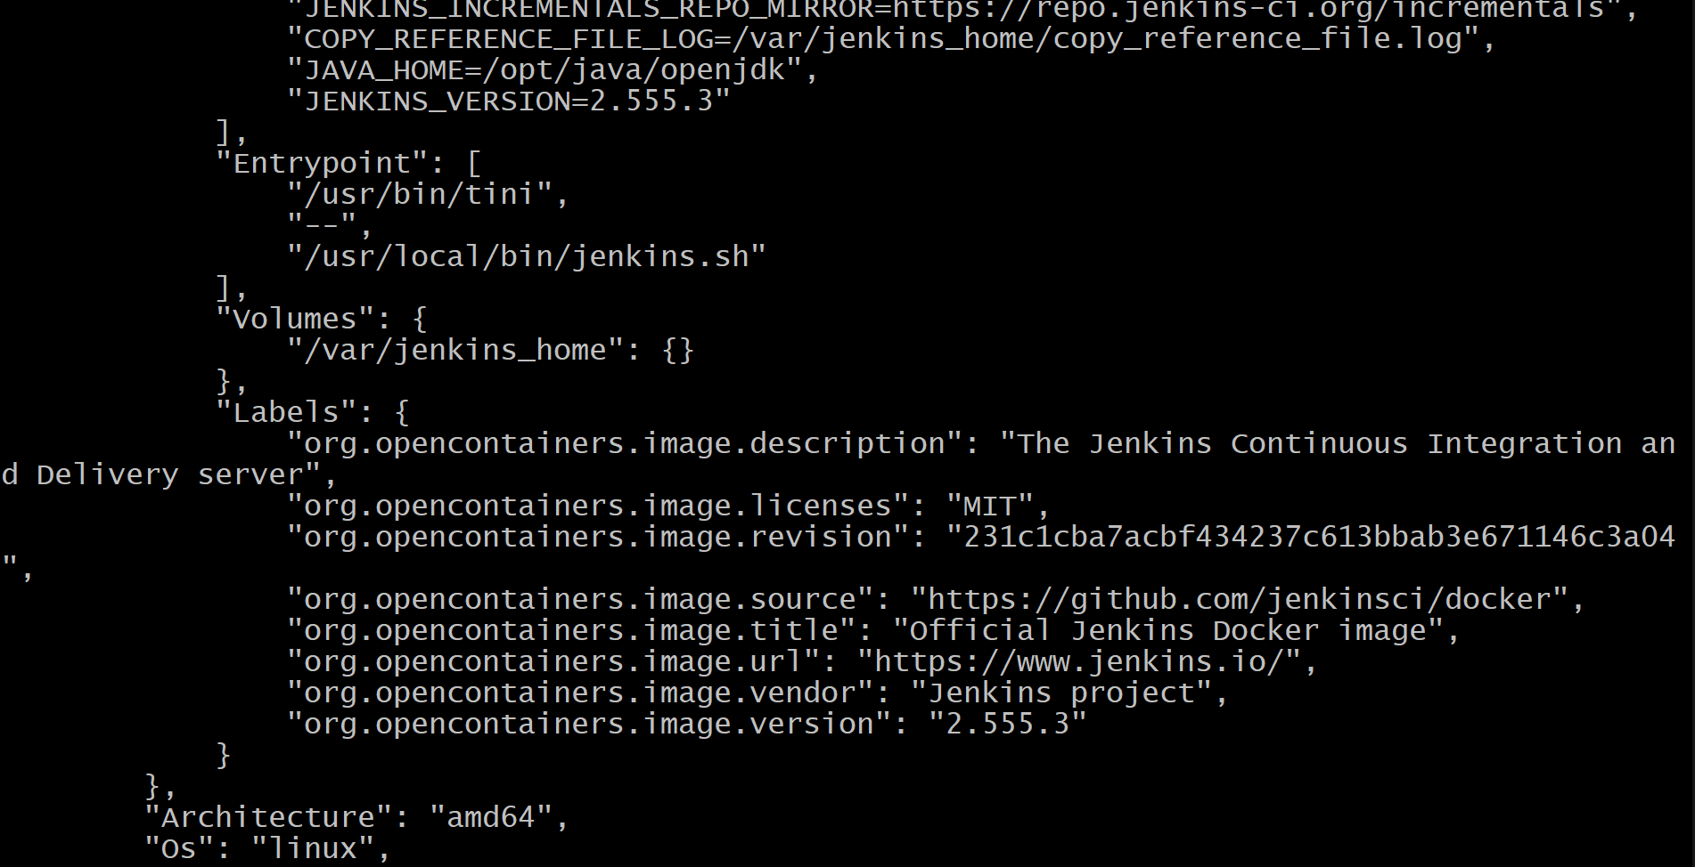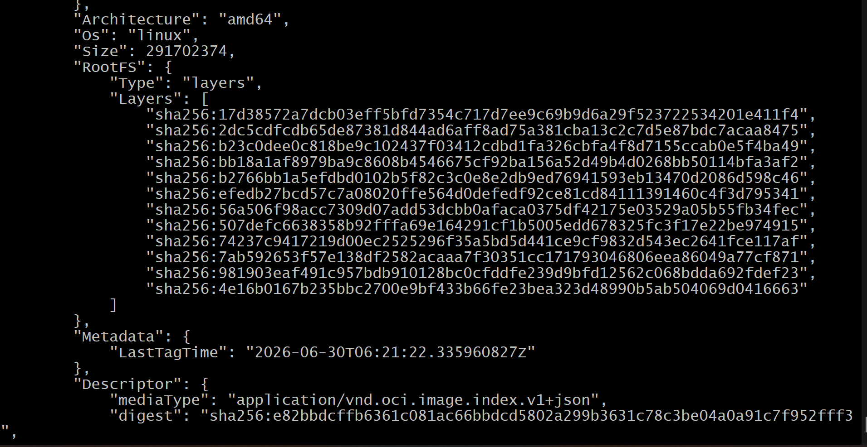
Task: Run a Jenkins Container and Execute a Sample Job
Objective
To run a Jenkins container using Docker and create a sample Jenkins freestyle job.

Step 1: Verify the Jenkins Image
Check whether the Jenkins image is available locally.
docker images
Ensure that the jenkins/jenkins:lts image is present.

Step 2: Run the Jenkins Container
Execute the following command to start the Jenkins container:
docker run -d --name jenkins-container -p 8080:8080 -p 50000:50000 jenkins/jenkins:lts
Command Explanation
- -d : Runs the container in detached mode.
- --name jenkins-container : Assigns the name jenkins-container.
- -p 8080:8080 : Maps Jenkins web interface to port 8080.
- -p 50000:50000 : Maps Jenkins agent communication port.

Step 3: Verify the Container is Running
Check the running containers:
docker ps
Verify that the Jenkins container is in the Up state.

Step 4: Configure the EC2 Security Group
Add the following inbound rule in the EC2 Security Group:
Type | Protocol | Port Range | Source
Custom TCP | TCP | 8080 | 0.0.0.0/0
Save the rule.

Step 5: Access Jenkins in the Browser
Open a browser and enter:
http://<EC2-Public-IP>:8080
The Jenkins Unlock page will be displayed.

Step 6: Retrieve the Initial Admin Password
Run the following command:
docker exec jenkins-container cat /var/jenkins_home/secrets/initialAdminPassword
Copy the generated password and paste it into the Jenkins Unlock page.

Step 7: Install Jenkins Plugins
- Click Install Suggested Plugins.
- Wait for the installation to complete.

Step 8: Create the First Admin User
Enter the following details:
- Username
- Password
- Full Name
- Email Address
Click Save and Continue.

Step 9: Create a Sample Job
- From the Jenkins Dashboard, click New Item.
- Enter the job name:
sample-job
- Select Freestyle Project.
- Click OK.

Step 10: Configure the Job
- Scroll to Build Steps.
- Click Add Build Step.
- Select Execute Shell.
- Enter the following commands:
echo "Hello from Jenkins"
date
hostname
- Click Save.

Step 11: Run the Job
- Click Build Now.
- Click the build number under Build History.
- Click Console Output.
Expected output:
Hello from Jenkins
Tue Jun 30 xx:xx:xx UTC 2026
ip-172-31-x-xx
Finished: SUCCESS

Commands Used
docker run -d --name jenkins-container -p 8080:8080 -p 50000:50000 jenkins/jenkins:lts
docker ps
docker exec jenkins-container cat /var/jenkins_home/secrets/initialAdminPassword

Result
✅ Successfully ran the Jenkins container using Docker.
✅ Accessed Jenkins on port 8080.
✅ Created and executed a sample freestyle job successfully.
