ASG
- Create one VPC in N. Virginia region.
Step 1: Log in to AWS Console
- Sign in to the AWS Management Console.
- In the top-right corner, select the N. Virginia (us-east-1) region.
Step 2: Open the VPC Dashboard
- Search for VPC in the AWS search bar.
- Click VPC to open the VPC Dashboard.
Step 3: Create a New VPC
- In the left navigation pane, click Your VPCs.
- Click Create VPC.
Step 4: Configure the VPC
- Select VPC only.
- Enter the following details:
  - Name tag: My-VPC
  - IPv4 CIDR block: 10.0.0.0/16
  - IPv6 CIDR block: No IPv6 CIDR Block
  - Tenancy: Default
- Click Create VPC.
Step 5: Verify the VPC
- Navigate to Your VPCs.
- Confirm that My-VPC appears in the list.

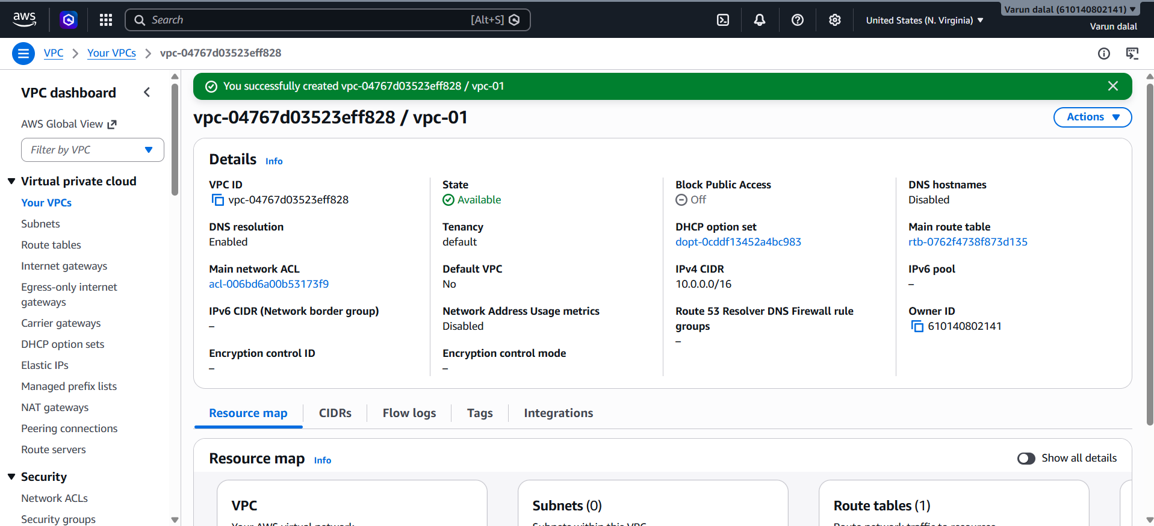

3.Create two subnets: one public subnet and one private subnet
Step 1: Open the VPC Dashboard
- Log in to the AWS Management Console.
- Navigate to VPC.
- In the left pane, click Subnets.
- Click Create subnet.

Step 2: Create the Public Subnet
- Select your VPC (My-VPC).
- Enter:
  - Subnet name: Public-Subnet
  - Availability Zone: us-east-1a
  - IPv4 CIDR block: 10.0.1.0/24
- Click Create subnet.

Step 3: Create the Private Subnet
- Click Create subnet again.
- Select the same VPC (My-VPC).
- Enter:
  - Subnet name: Private-Subnet
  - Availability Zone: us-east-1b
  - IPv4 CIDR block: 10.0.2.0/24
- Click Create subnet.

Step 4: Enable Auto-Assign Public IP for Public Subnet
- Select Public-Subnet.
- Click Actions → Edit subnet settings.
- Enable Auto-assign public IPv4 address.
- Click Save.

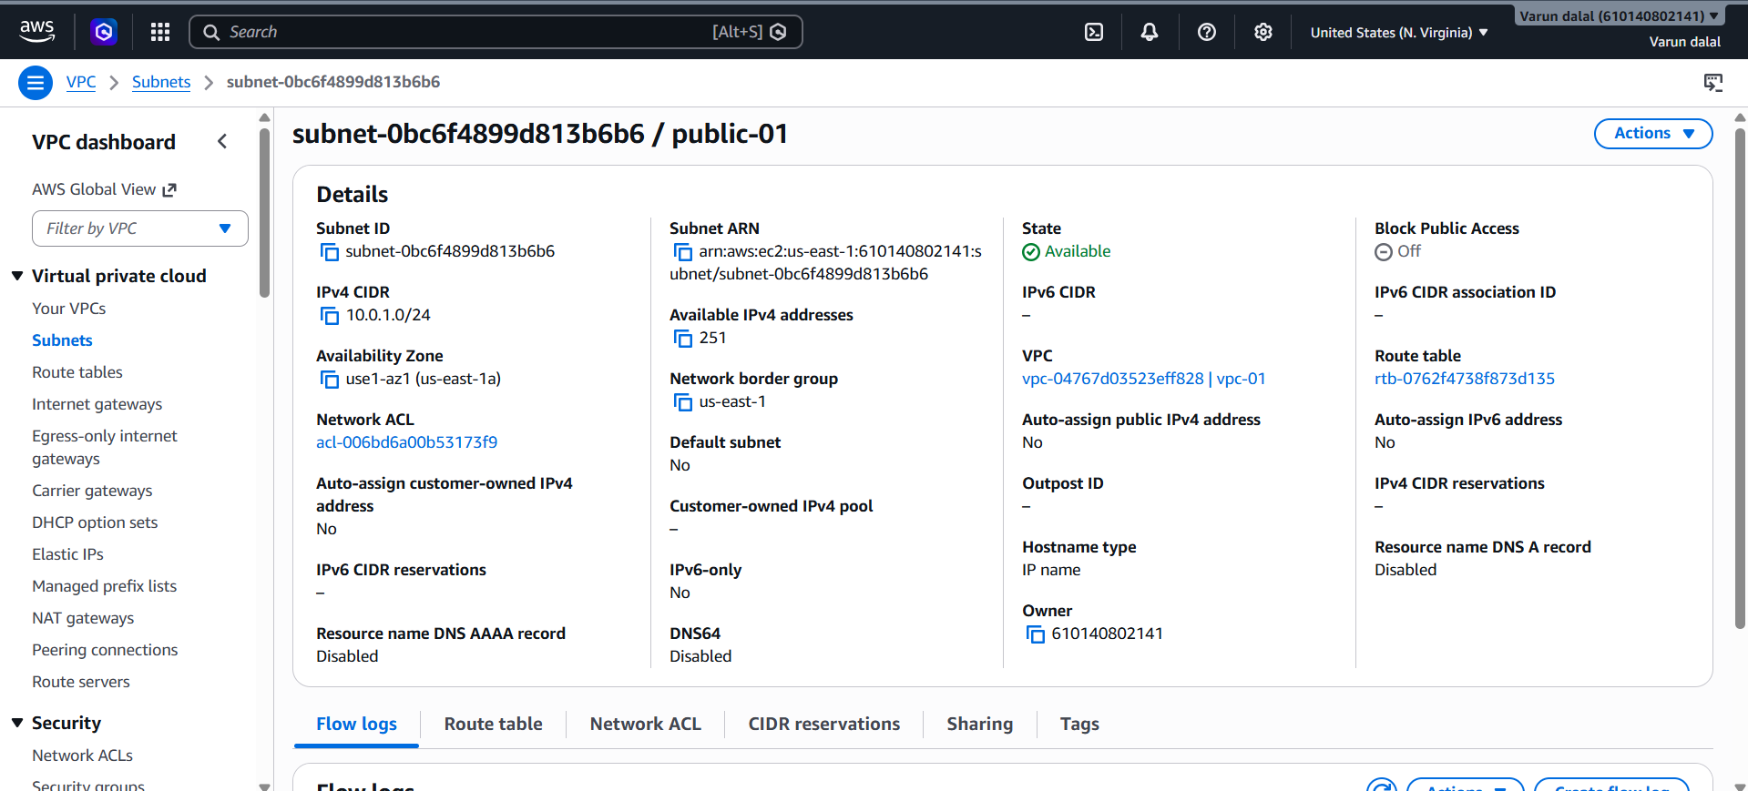

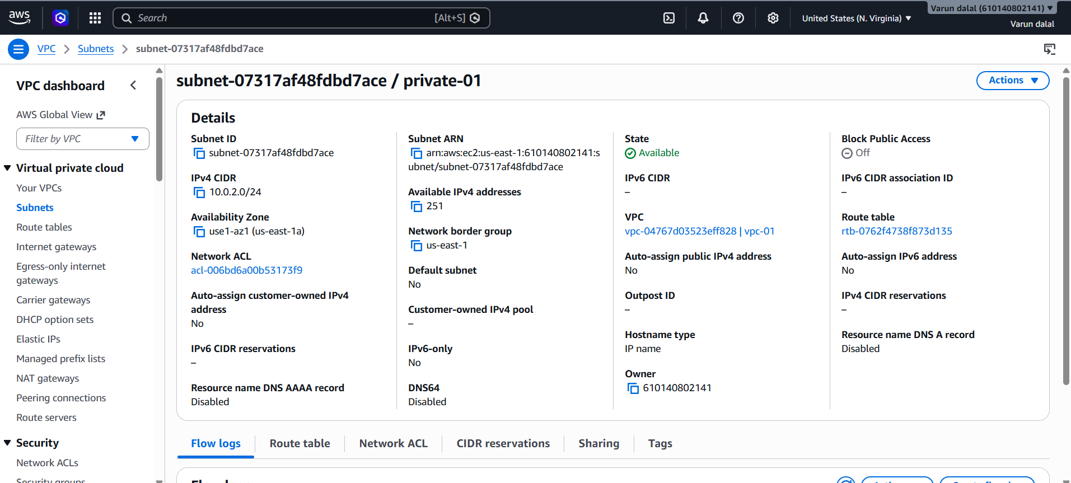Validation
Verify from AWS Console
- Go to VPC → Subnets.
- Confirm both subnets exist:
Subnet Name | CIDR Block | Availability Zone
Public-Subnet | 10.0.1.0/24 | us-east-1a
Private-Subnet | 10.0.2.0/24 | us-east-1b

3.Attach an IGW to the VPC
Objective
Create and attach an Internet Gateway (IGW) to the VPC so that resources in the public subnet can communicate with the internet.

Step 1: Open the VPC Dashboard
- Log in to the AWS Management Console.
- Navigate to VPC.
- In the left navigation pane, click Internet Gateways.

Step 2: Create an Internet Gateway
- Click Create internet gateway.
- Enter:
  - Name tag: My-IGW
- Click Create internet gateway.

Step 3: Attach the Internet Gateway to the VPC
- Select the newly created My-IGW.
- Click Actions → Attach to VPC.
- Select your VPC (My-VPC).
- Click Attach internet gateway.

Step 4: Verify the Attachment
- Go to Internet Gateways.
- Select My-IGW.
- Verify:
  - State = Attached
  - Attached VPC = My-VPC
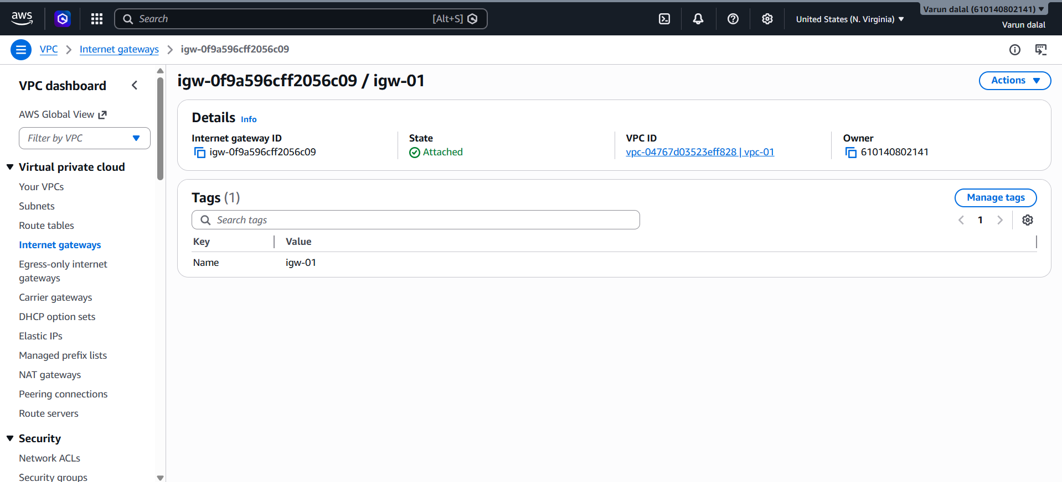

- Create one public route table (RT) and one private route table.
Objective
Create separate route tables for public and private subnets to control network traffic and enable internet access only for resources in the public subnet.

Step 1: Open Route Tables
- Log in to the AWS Management Console.
- Navigate to VPC.
- In the left pane, click Route Tables.

Step 2: Create the Public Route Table
- Click Create route table.
- Enter:
  - Name: Public-RT
  - VPC: My-VPC
- Click Create route table.

Step 3: Create the Private Route Table
- Click Create route table again.
- Enter:
  - Name: Private-RT
  - VPC: My-VPC
- Click Create route table.

Step 4: Add Internet Route to Public Route Table
- Select Public-RT.
- Open the Routes tab.
- Click Edit routes → Add route.
- Enter:
  - Destination: 0.0.0.0/0
  - Target: Internet Gateway (My-IGW)
- Click Save changes.

Step 5: Associate Public Subnet with Public Route Table
- Select Public-RT.
- Open Subnet Associations tab.
- Click Edit subnet associations.
- Select Public-Subnet.
- Click Save associations.

Step 6: Associate Private Subnet with Private Route Table
- Select Private-RT.
- Open Subnet Associations tab.
- Click Edit subnet associations.
- Select Private-Subnet.
- Click Save associations.

Validation
Verify Public Route Table
- Open Route Tables.
- Select Public-RT.
- Confirm:
  - Route: 0.0.0.0/0 → Internet Gateway
  - Associated Subnet: Public-Subnet
Verify Private Route Table
- Select Private-RT.
- Confirm:
  - No internet route (0.0.0.0/0)
  - Associated Subnet: Private-Subnet

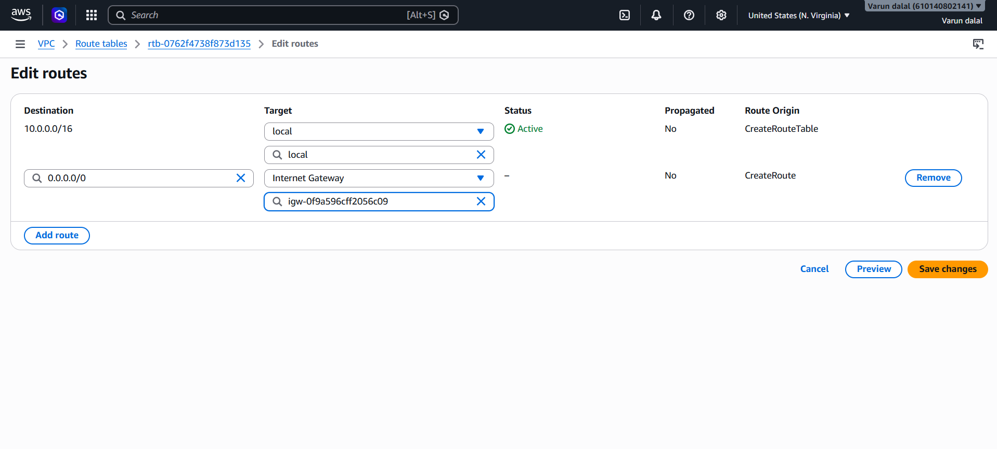

5. Deploy a NAT Gateway and Enable Internet Access for the Private Subnet
Objective
Create a NAT Gateway in the public subnet and configure the private route table to route internet-bound traffic through the NAT Gateway. This allows instances in the private subnet to access the internet for updates and downloads while remaining inaccessible from the internet.

Step 1: Allocate an Elastic IP (EIP)
- Open the VPC Console.
- In the left pane, click Elastic IPs.
- Click Allocate Elastic IP address.
- Leave the default settings.
- Click Allocate.
- Note the Allocation ID.

Step 2: Create a NAT Gateway
- In the VPC Console, click NAT Gateways.
- Click Create NAT Gateway.
- Enter:
  - Name: My-NAT-Gateway
  - Subnet: Public-Subnet (10.0.1.0/24)
  - Elastic IP: Select the EIP created in Step 1
- Click Create NAT Gateway.
- Wait until the status changes to Available.

Step 3: Update the Private Route Table
- Navigate to Route Tables.
- Select Private-RT.
- Open the Routes tab.
- Click Edit routes.
- Click Add route and enter:
  - Destination: 0.0.0.0/0
  - Target: NAT Gateway (My-NAT-Gateway)
- Click Save changes.

Step 4: Verify Subnet Association
- Open Private-RT.
- Go to Subnet Associations.
- Ensure Private-Subnet is associated with Private-RT.

Validation
Verify NAT Gateway
- Go to VPC → NAT Gateways.
- Confirm:
  - Name: My-NAT-Gateway
  - State: Available
  - Subnet: Public-Subnet
Verify Private Route Table
- Open Private-RT.
- Check the Routes tab.
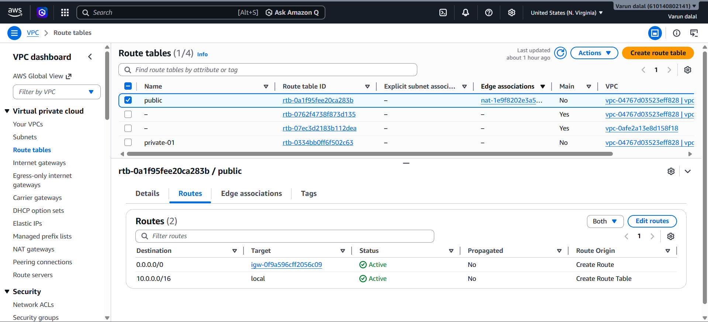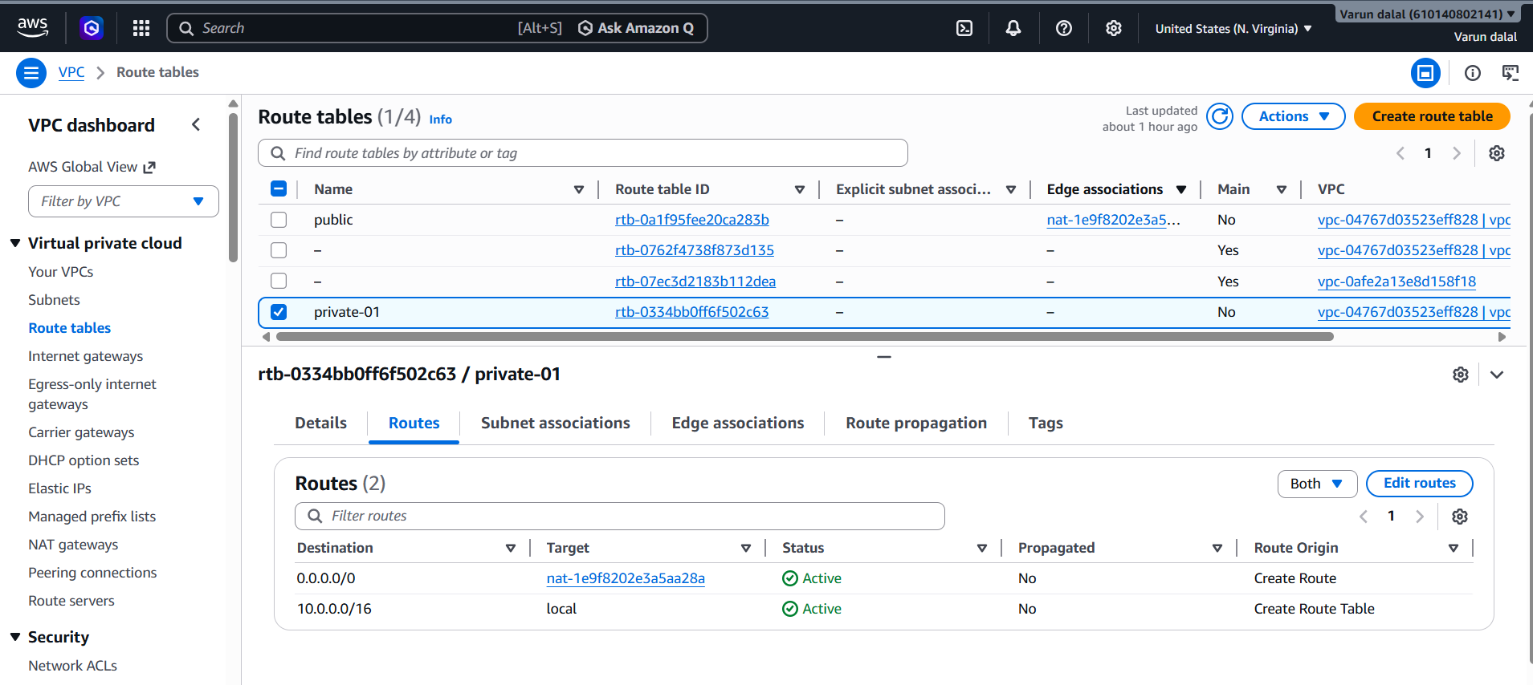

6: Create Two EC2 Instances (One in Public Subnet and One in Private Subnet)
Objective
Launch two EC2 instances:
- Public-EC2 in the Public Subnet
- Private-EC2 in the Private Subnet

Step 1: Launch Public EC2 Instance
- Go to EC2 Dashboard.
- Click Launch Instance.
- Configure:
  - Name: Public-EC2
  - AMI: Amazon Linux 2023
  - Instance Type: t2.micro (Free Tier eligible)
  - Key Pair: Create or select an existing key pair
- Under Network Settings:
  - VPC: My-VPC
  - Subnet: Public-Subnet
  - Auto-assign Public IP: Enable
- Create a Security Group:
  - Allow SSH (Port 22) from your IP
- Click Launch Instance.

Step 2: Launch Private EC2 Instance
- Click Launch Instance again.
- Configure:
  - Name: Private-EC2
  - AMI: Amazon Linux 2023
  - Instance Type: t2.micro
  - Key Pair: Same key pair
- Under Network Settings:
  - VPC: My-VPC
  - Subnet: Private-Subnet
  - Auto-assign Public IP: Disable
- Security Group:
  - Allow SSH (Port 22)
  - For better security, allow SSH only from the Public-EC2 security group
- Click Launch Instance.
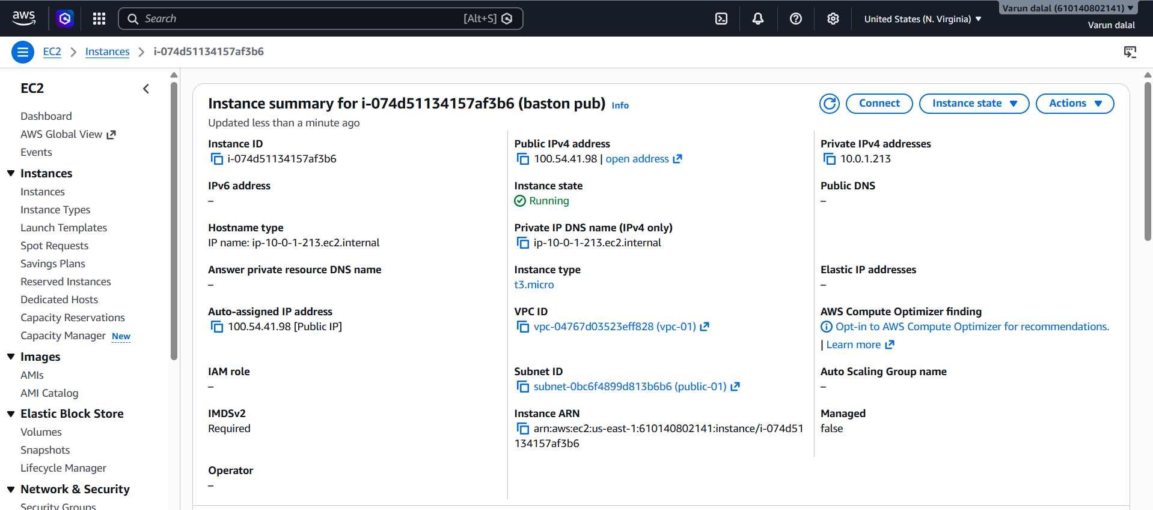

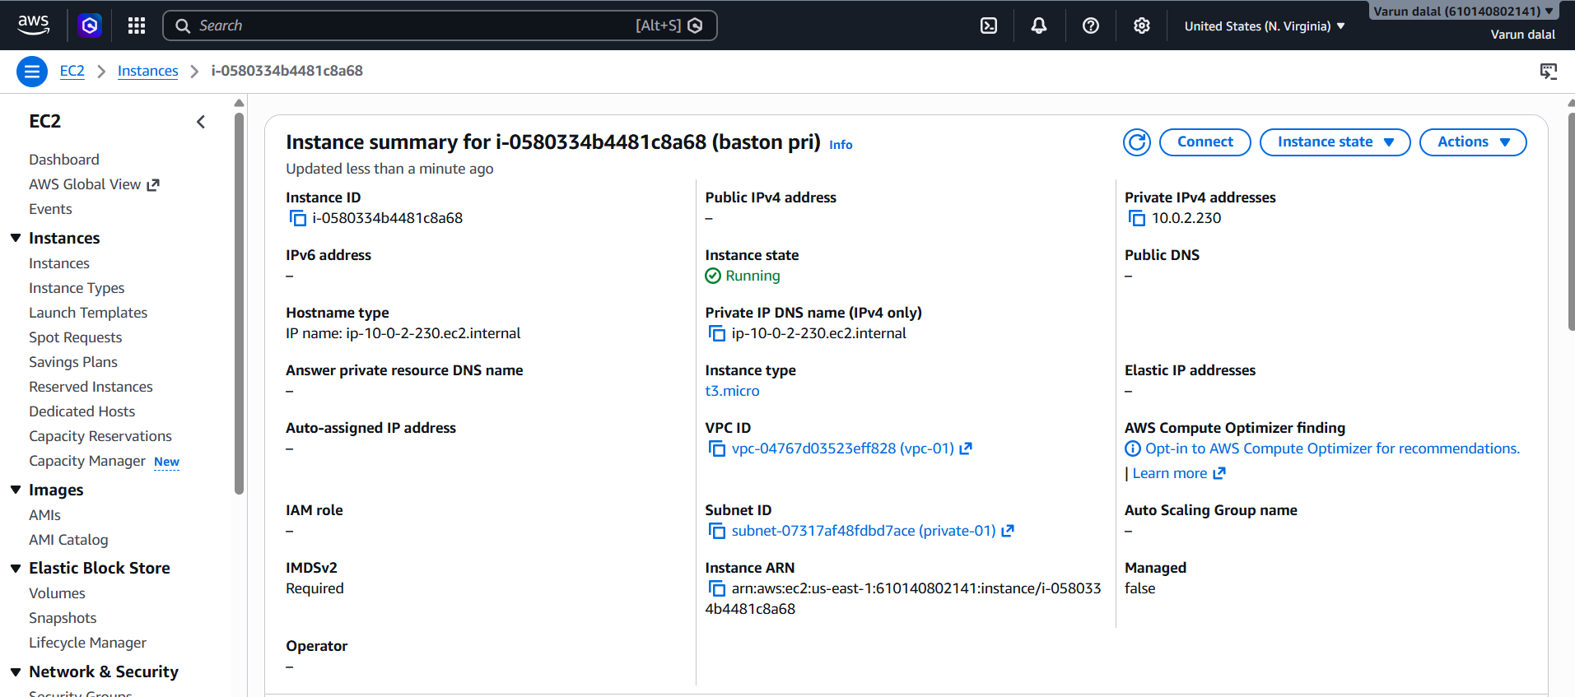

7.Deploy Apache server on both EC2 instances with a sample index.html file Task: Deploy Apache Server on Both EC2 Instances
Objective
Install and configure Apache (httpd) on both the Public and Private EC2 instances and host a sample index.html page.

Step 1: Connect to the EC2 Instance
Public EC2
ssh -i mykey.pem ec2-user@<PUBLIC-IP>
Private EC2 (via Public EC2)
ssh -i mykey.pem ec2-user@<PRIVATE-IP>

Step 2: Install Apache
Run on both instances:
sudo yum update -y
sudo yum install httpd -y
sudo systemctl start httpd
sudo systemctl enable httpd

Step 3: Create Sample Web Page
Public EC2
echo "<h1>Welcome to Public EC2 Instance</h1>" | sudo tee /var/www/html/index.html
Private EC2
echo "<h1>Welcome to Private EC2 Instance</h1>" | sudo tee /var/www/html/index.html

Step 4: Configure Security Groups
Public EC2
Allow:
- HTTP (Port 80) → 0.0.0.0/0
Private EC2
Allow:
- HTTP (Port 80) → VPC CIDR (10.0.0.0/16) or Public EC2 Security Group

Validation
Check Apache Status
sudo systemctl status httpd
Expected:
active (running)
Test Locally
curl localhost
Access Public EC2 in Browser
http://<PUBLIC-IP>
Expected Output:
Welcome to Public EC2 Instance
Test Private EC2 from Public EC2
curl http://<PRIVATE-IP>
Expected Output:
Welcome to Private EC2 Instance
Result
Apache is running on both EC2 instances, and each instance serves its own sample web page successfully.

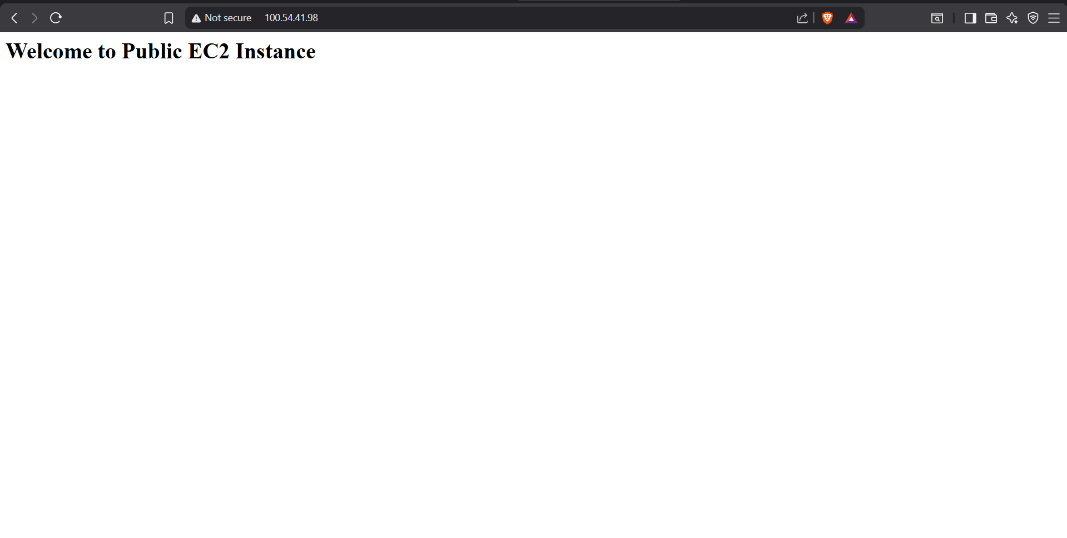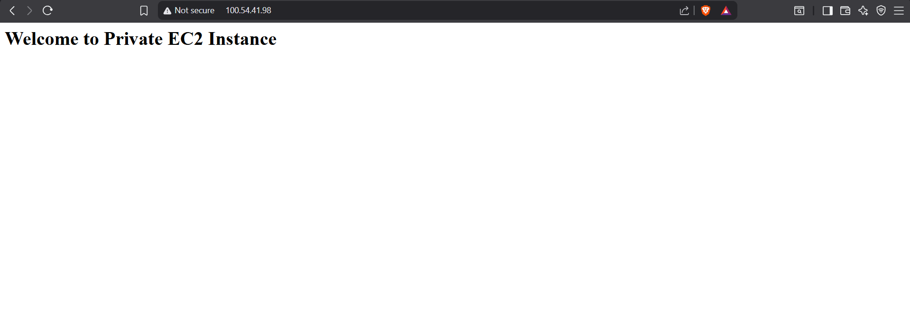

8.Create one application load balancer and attach it to both EC2 instances
Objective
Create an Application Load Balancer (ALB) to distribute incoming HTTP traffic across both EC2 instances (Public-EC2 and Private-EC2), improving availability and load distribution.

Step 1: Create a Target Group
- Go to EC2 Console → Target Groups.
- Click Create target group.
- Configure:
  - Target type: Instances
  - Name: My-Target-Group
  - Protocol: HTTP
  - Port: 80
  - VPC: My-VPC
- Click Next.
- Select both:
  - Public-EC2
  - Private-EC2
- Click Include as pending below.
- Click Create target group.

Step 2: Create Application Load Balancer
- Go to EC2 Console → Load Balancers.
- Click Create Load Balancer.
- Select Application Load Balancer.
- Configure:
  - Name: My-ALB
  - Scheme: Internet-facing
  - IP address type: IPv4

Step 3: Configure Network Mapping
Select:
- VPC: My-VPC
- Availability Zones:
  - Public-Subnet (us-east-1a)
  - Private-Subnet (or another public subnet if available)
Note: ALB should be placed in public subnets. AWS requires at least two Availability Zones for production setups.

Step 4: Configure Security Group
Create or select a security group with:
Type | Port | Source
HTTP | 80 | 0.0.0.0/0

Step 5: Configure Listener
- Protocol: HTTP
- Port: 80
- Forward to: My-Target-Group
Click Create Load Balancer.

Step 6: Verify Target Health
- Open Target Groups.
- Select My-Target-Group.
- Go to Targets tab.
- Wait until both instances show:
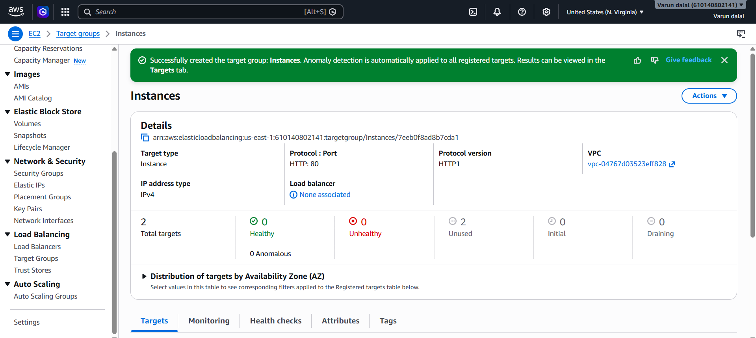
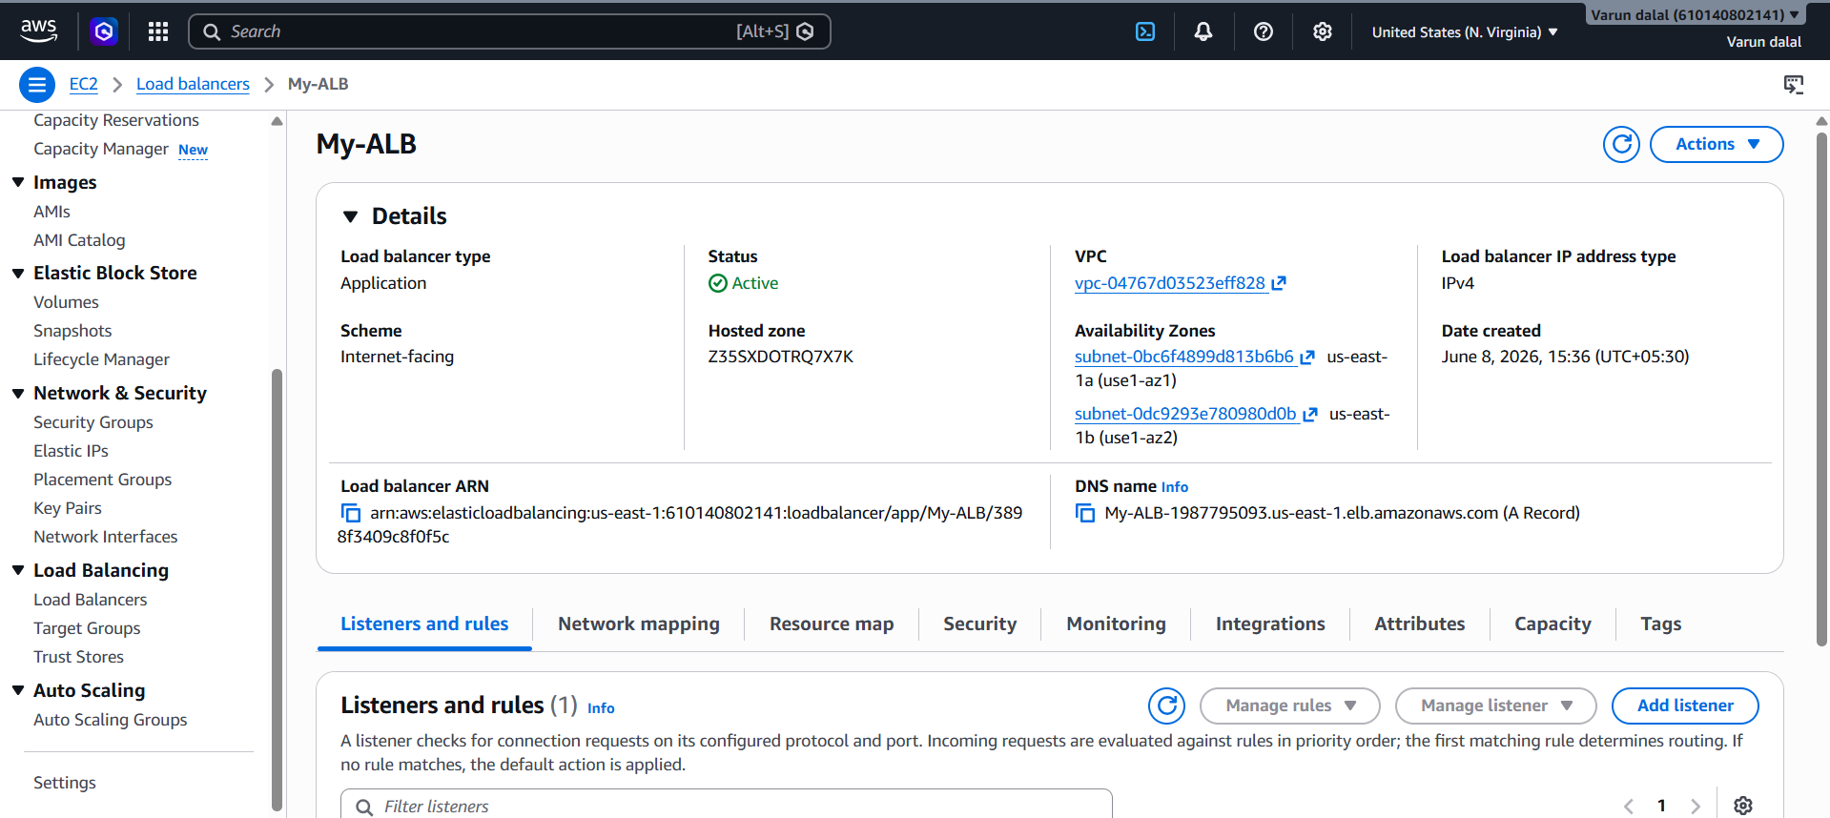

9.Store application load balancer logs in S3
Objective
Configure Application Load Balancer (ALB) Access Logs to store request logs in an Amazon S3 bucket for monitoring, troubleshooting, and auditing.

Step 1: Create an S3 Bucket
- Go to Amazon S3 → Create bucket.
- Enter a unique bucket name, for example:
my-alb-logs-bucket
- Select the same Region as your ALB (us-east-1).
- Leave other settings as default and click Create bucket.

Step 2: Add Bucket Policy
- Open the bucket.
- Go to Permissions → Bucket Policy.
Step 3: Enable ALB Access Logging
- Go to EC2 → Load Balancers.
- Select My-ALB.
- Open the Attributes tab.
- Click Edit.
- Under Monitoring, enable Access logs.
- Specify:
  - S3 bucket: my-alb-logs-bucket
  - Prefix (optional): alb-logs
- Click Save changes.
Step 5: Verify Logs
- Go to the S3 bucket.
- Navigate to:
AWSLogs/

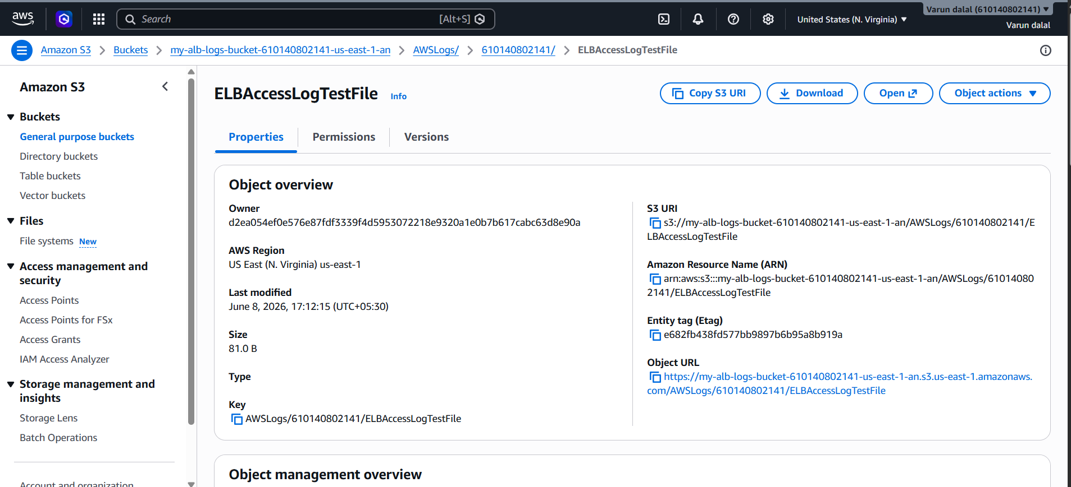

10.Store the VPC flow logs in a CloudWatch log group
Objective
Enable VPC Flow Logs and store the network traffic logs in an Amazon CloudWatch Log Group to monitor and troubleshoot traffic flowing in and out of your VPC.

Step 1: Create a CloudWatch Log Group
- Go to CloudWatch → Logs → Log groups.
- Click Create log group.
- Enter:
  - Log group name: VPC-Flow-Logs
- Click Create.

Step 2: Create an IAM Role for VPC Flow Logs
- Go to IAM → Roles → Create Role.
- Select AWS Service.
- Choose VPC Flow Logs as the use case.
- Attach the policy:
  - CloudWatchLogsFullAccess (for lab purposes)
- Name the role:
- VPCFlowLogsRole
- Click Create Role.

Step 3: Create VPC Flow Logs
- Go to VPC Console → Your VPCs.
- Select your VPC.
- Click Actions → Create Flow Log.
Configure:
- Filter: All
- Maximum aggregation interval: 1 minute
- Destination: Send to CloudWatch Logs
- Log group: VPC-Flow-Logs
- IAM Role: VPCFlowLogsRole
Click Create Flow Log.

Step 4: Generate Network Traffic
Generate some traffic in the VPC:
From an EC2 instance:
ping amazon.com -c 5
or
curl http://example.com
or access your ALB from a browser multiple times.

Step 5: Verify Flow Logs
- Go to CloudWatch → Logs → Log groups.
- Open:
- VPC-Flow-Logs
- Open the latest Log Stream.
You should see entries similar to:
2 123456789012 eni-0123456789abcdef0 10.0.1.10 8.8.8.8 45678 443 6 10 840 1717848000 1717848060 ACCEPT OK

Validation
The VPC Flow Logs configuration is successful when log streams are automatically created in the VPC-Flow-Logs CloudWatch Log Group and new entries appear after generating network traffic. The logs should show source IPs, destination IPs, ports, protocols, and whether the traffic was ACCEPTED or REJECTED. This confirms that network activity within the VPC is being captured and stored in CloudWatch Logs.
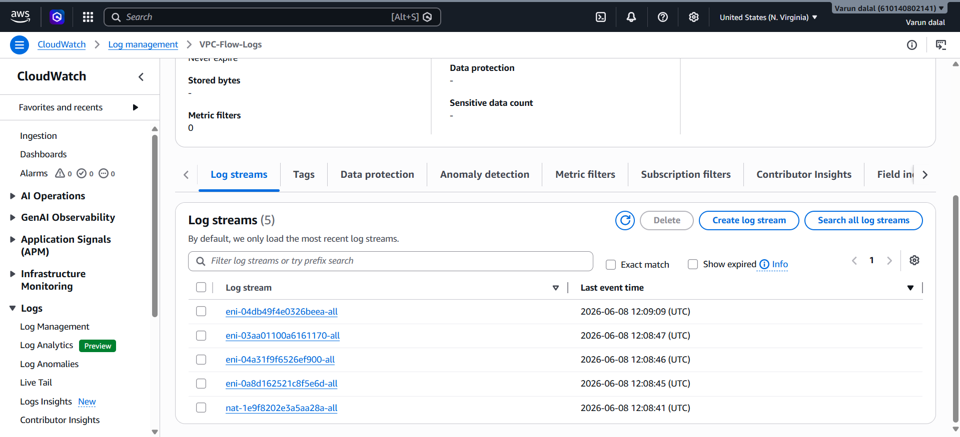

11. Create Monitoring Dashboards for CPU Utilization and Apache Service
Objective
Create a CloudWatch Dashboard to monitor:
- EC2 CPU Utilization
- Apache (httpd) Service status using CloudWatch Agent

Part 1: CPU Utilization Dashboard
Step 1: Open CloudWatch Dashboard
- Go to CloudWatch → Dashboards
- Click Create dashboard
- Dashboard name:
EC2-Monitoring-Dashboard
- Click Create dashboard

Step 2: Add CPU Utilization Widget
- Click Add widget
- Select Line
- Choose:
EC2 → Per-Instance Metrics → CPUUtilization
- Select your EC2 instances.
- Click Create widget.
- Click Save dashboard.

Part 2: Monitor Apache Service
CloudWatch does not monitor Apache service by default. Install and configure the CloudWatch Agent.

Step 1: Install CloudWatch Agent
On Amazon Linux:
sudo yum install amazon-cloudwatch-agent -y

Step 2: Create Agent Configuration
sudo /opt/aws/amazon-cloudwatch-agent/bin/amazon-cloudwatch-agent-config-wizard
Choose:
Collect metrics → Yes
Collect StatsD → No
Collect logs → Yes
For Apache log:
/var/log/httpd/access_log
/var/log/httpd/error_log

Step 3: Start CloudWatch Agent
sudo systemctl start amazon-cloudwatch-agent
sudo systemctl enable amazon-cloudwatch-agent
Check status:
sudo systemctl status amazon-cloudwatch-agent

Step 4: Create Apache Service Metric
Verify Apache service:
systemctl status httpd
You can configure the CloudWatch Agent to publish:
procstat_lookup_pid_count
for process:
httpd
This metric shows whether Apache is running.

Step 5: Add Apache Widget to Dashboard
- Go to CloudWatch → Dashboards
- Open EC2-Monitoring-Dashboard
- Click Add widget
- Select Line
- Choose:
CWAgent → procstat_lookup_pid_count
- Select the metric for:
httpd
- Save the dashboard.

Validation
CPU Monitoring
Generate CPU load:
yes > /dev/null &
yes > /dev/null &
The CPUUtilization graph should increase in the dashboard.
Apache Monitoring
Check Apache:
sudo systemctl status httpd
Stop Apache:
sudo systemctl stop httpd
Within a few minutes, the procstat_lookup_pid_count metric should drop to 0. Start Apache again:
sudo systemctl start httpd
The metric should return to 1 or more, confirming that the dashboard is monitoring the Apache service successfully.
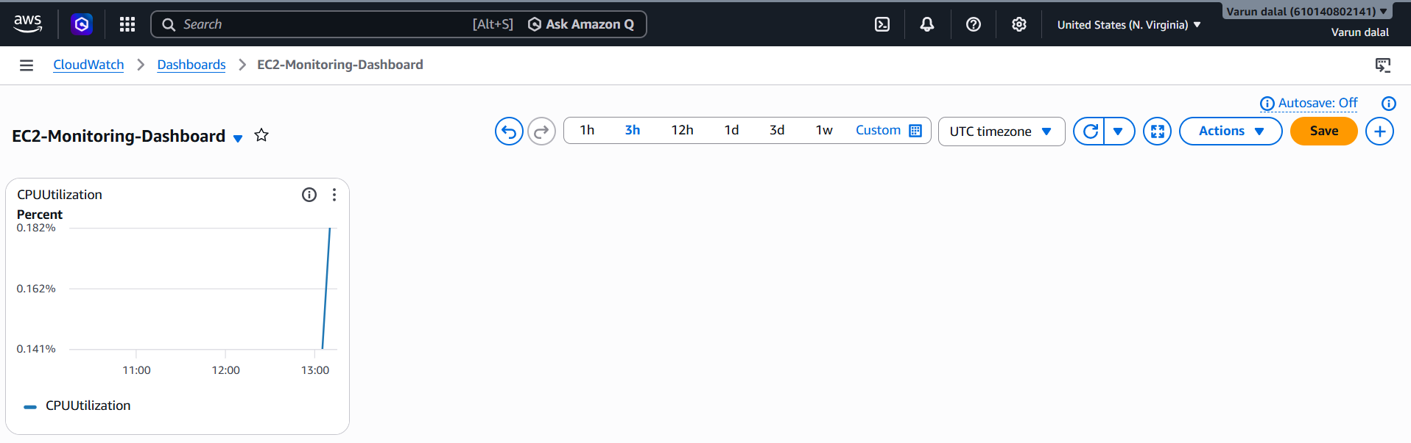

12. If CPU utilization is more than 70%, then it should trigger auto scaling and launch new instance.
Step 1: Create a Launch Template
- Open AWS Console → EC2 → Launch Templates.
- Click Create Launch Template.
- Enter:
  - Template Name: web-server-template
  - AMI: Amazon Linux 2
  - Instance Type: t2.micro (or as required)
  - Security Group: Select existing SG
  - Key Pair: Select existing key pair
- Click Create Launch Template.
Validation
Launch Template should appear in the Launch Templates list.

Step 2: Create an Auto Scaling Group
- Go to EC2 → Auto Scaling Groups.
- Click Create Auto Scaling Group.
- Select the Launch Template created above.
- Enter ASG Name: web-asg.
- Select:
  - VPC
  - At least two subnets in different AZs
- Set:
  - Desired Capacity: 1
  - Minimum Capacity: 1
  - Maximum Capacity: 3
- Click Next and create the ASG.
Validation
One EC2 instance should be running under the Auto Scaling Group.

Step 3: Create a Scale-Out Policy
- Open the Auto Scaling Group.
- Go to Automatic Scaling tab.
- Click Create Dynamic Scaling Policy.
- Configure:
  - Policy Type: Simple Scaling
  - Policy Name: CPU-ScaleOut
  - Metric: Average CPU Utilization
  - CloudWatch Alarm:
    - CPU Utilization > 70%
    - Period: 5 Minutes
    - Evaluation Period: 1
  - Action: Add 1 Capacity Unit
- Create the policy.
Validation
A CloudWatch alarm should be created and attached to the ASG.

Step 4: (Optional) Create Scale-In Policy
To avoid unnecessary costs:
- Create another scaling policy.
- Configure:
  - CPU Utilization < 30%
  - Remove 1 Capacity Unit
Validation
Instances should terminate automatically when CPU usage remains below 30%
