1.Create MariaDB DB on EC2
Create MariaDB Database on EC2
1. Connect to the EC2 Instance
ssh -i "your-key.pem" ec2-user@<PUBLIC-IP>
2. Update the Server
sudo dnf update -y
3. Install MariaDB
sudo dnf install mariadb105-server -y
4. Start MariaDB Service
sudo systemctl start mariadb
5. Enable MariaDB at Boot
sudo systemctl enable mariadb
6. Verify MariaDB Status
sudo systemctl status mariadb
7. Secure MariaDB Installation
sudo mysql_secure_installation
8. Login to MariaDB
sudo mysql -u root -p
9. Create a Database
CREATE DATABASE companydb;
10. Verify the Database
SHOW DATABASES;
11. Create a Database User
CREATE USER 'dbuser'@'%' IDENTIFIED BY 'Password@123';
12. Grant Permissions
GRANT ALL PRIVILEGES ON companydb.* TO 'dbuser'@'%';
FLUSH PRIVILEGES;
13. Exit MariaDB
EXIT;
14. Test User Login
mysql -u dbuser -p
15. Verify Access
SHOW DATABASES;
USE companydb;
Validation:
sudo systemctl status mariadb
Status should show active (running) and the companydb database should be visible when running SHOW DATABASES;.
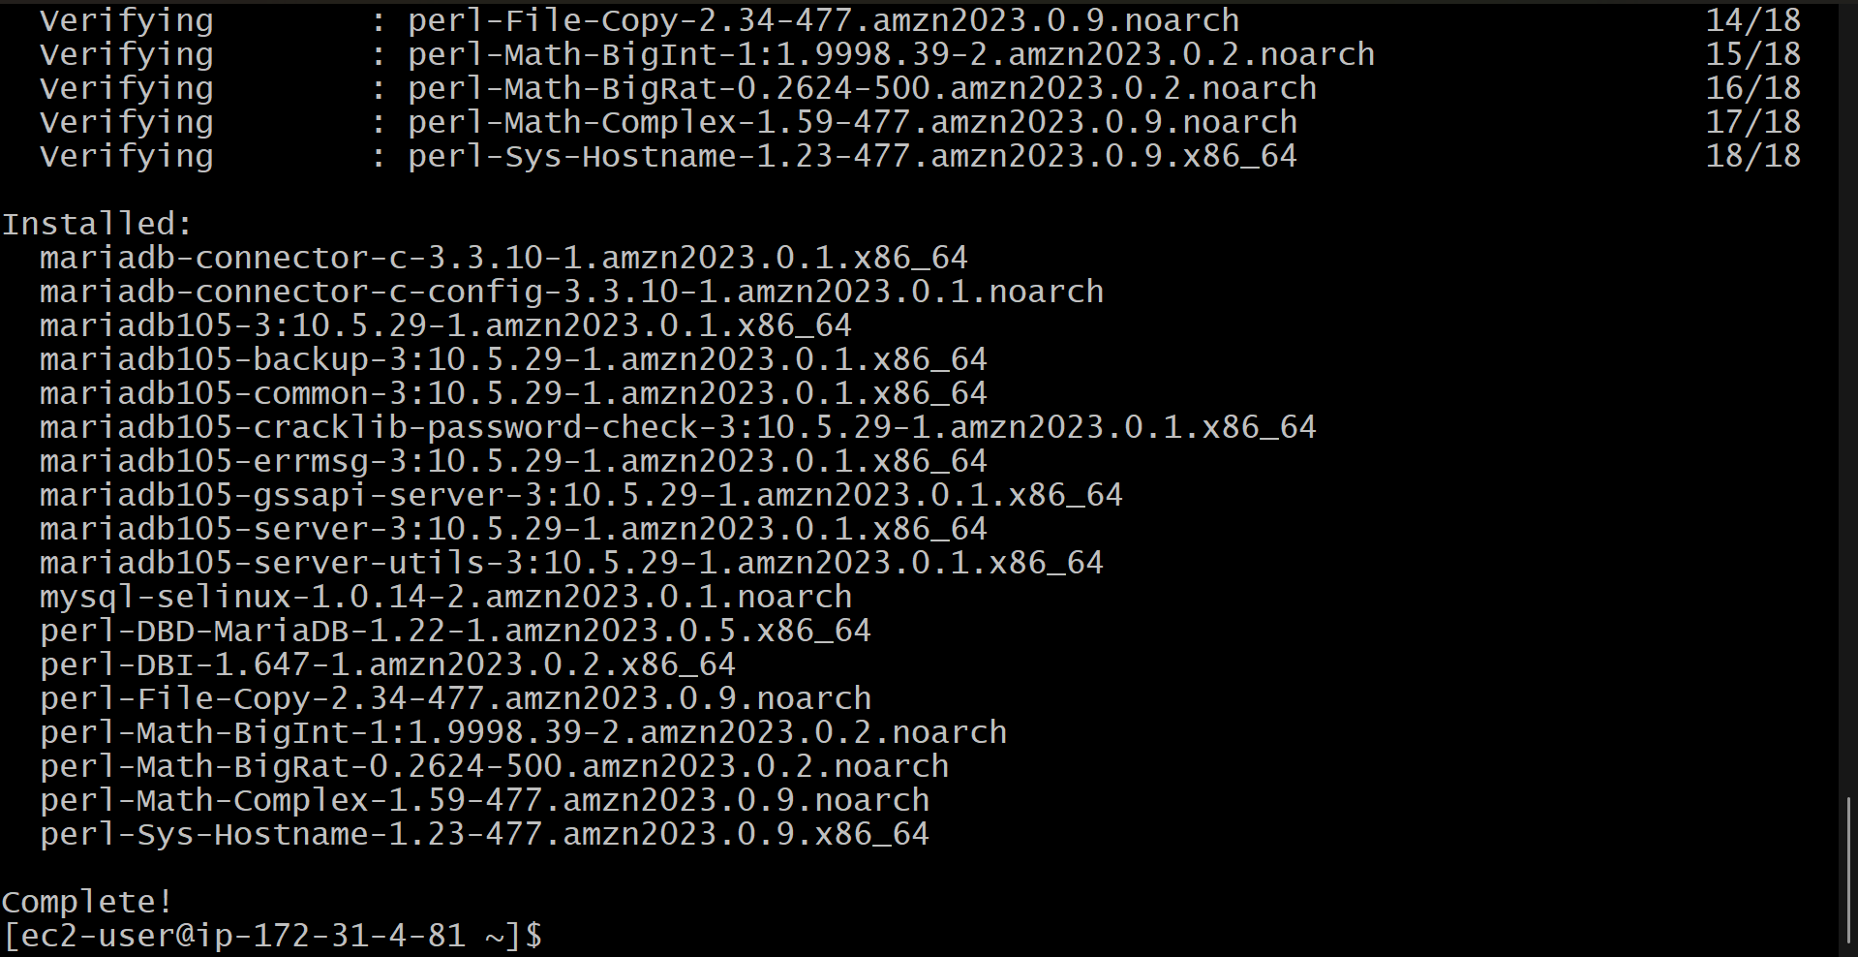

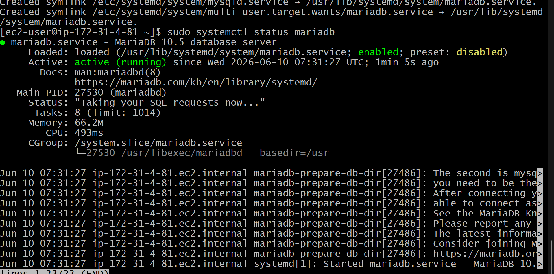

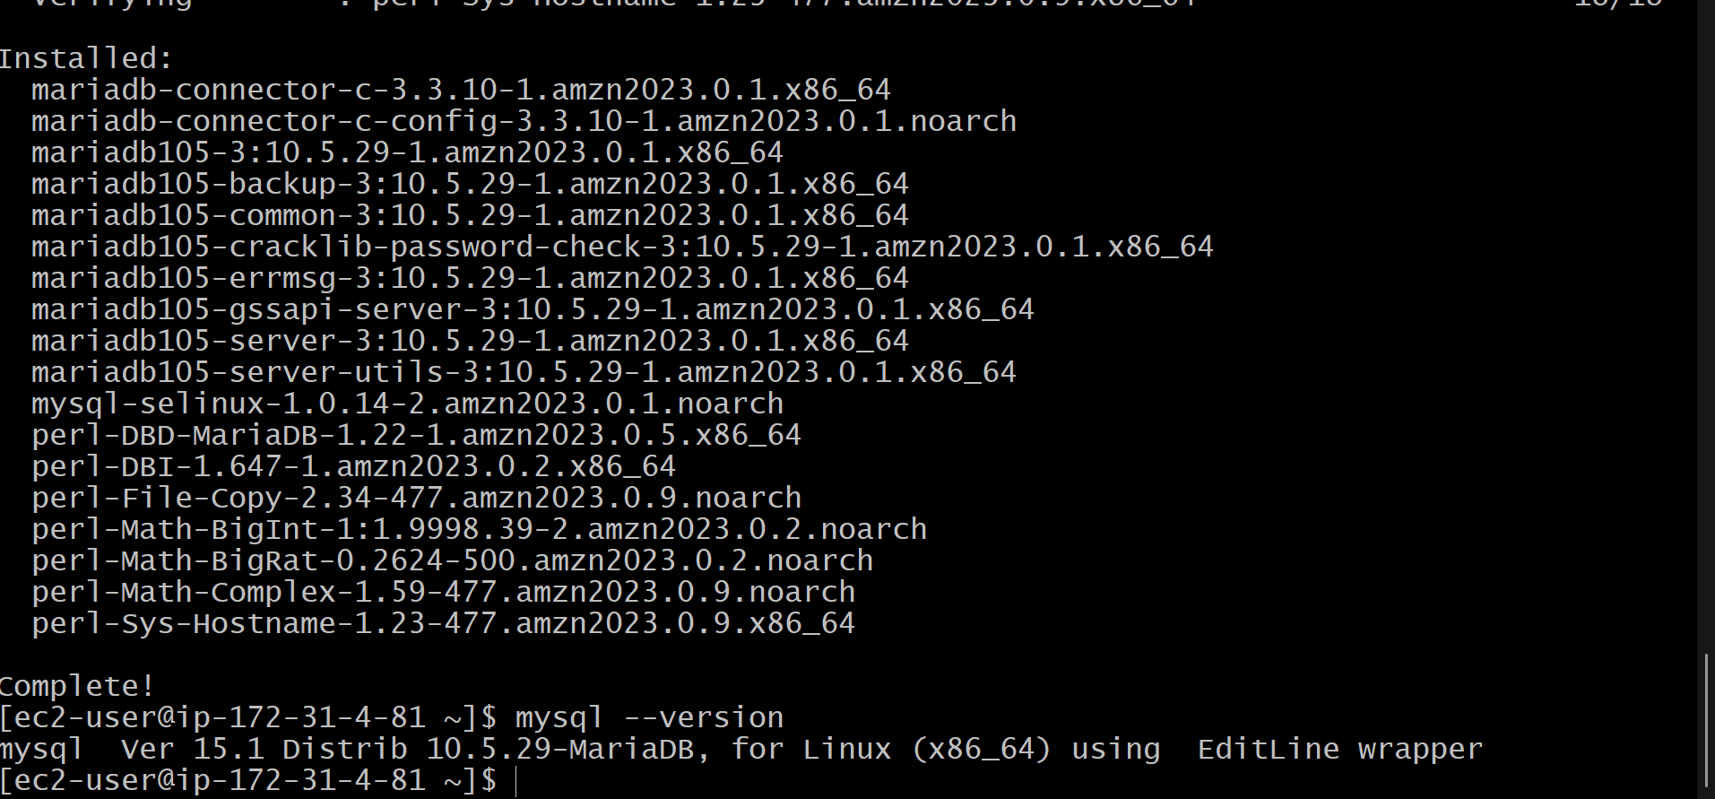

2.Insert some dummy dataInsert Dummy Data into MariaDB
1. Login to MariaDB
mysql -u dbuser -p
2. Select the Database
USE companydb;
3. Create a Table
CREATE TABLE employees (
emp_id INT AUTO_INCREMENT PRIMARY KEY,
emp_name VARCHAR(100),
department VARCHAR(50),
salary DECIMAL(10,2)
);
4. Insert Dummy Data
INSERT INTO employees (emp_name, department, salary) VALUES
('John Doe', 'IT', 55000),
('Jane Smith', 'HR', 45000),
('Michael Johnson', 'Finance', 60000),
('Emily Davis', 'Marketing', 50000),
('David Wilson', 'IT', 65000);
5. Verify the Data
SELECT * FROM employees;
Expected Output
+--------+-----------------+------------+----------+
| emp_id | emp_name | department | salary |
+--------+-----------------+------------+----------+
| 1 | John Doe | IT | 55000.00 |
| 2 | Jane Smith | HR | 45000.00 |
| 3 | Michael Johnson | Finance | 60000.00 |
| 4 | Emily Davis | Marketing | 50000.00 |
| 5 | David Wilson | IT | 65000.00 |
+--------+-----------------+------------+----------+
Validation
SELECT COUNT(*) FROM employees;
Expected result:
+----------+
| COUNT(*) |
+----------+
| 5 |
+----------+
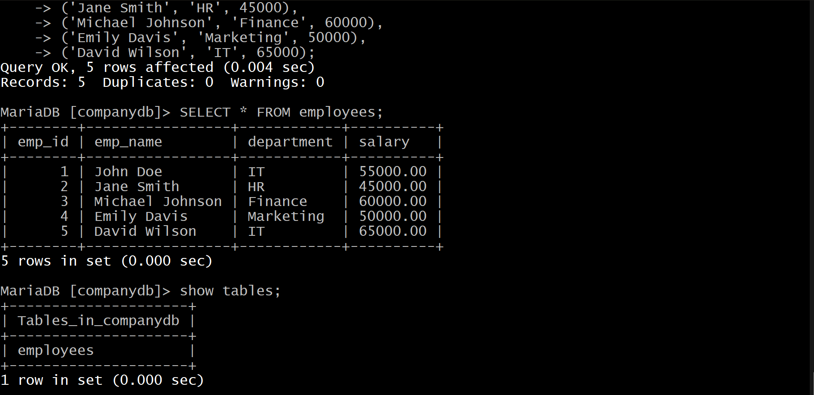

3. Take Backup of MariaDB Dummy Data on EC2
1. Exit MariaDB (if logged in)
EXIT;
2. Create a Backup Directory
mkdir -p ~/db-backups
3. Take Database Backup Using mysqldump
mysqldump -u root -p companydb > ~/db-backups/companydb_backup.sql
Enter the MariaDB root password when prompted.

4. Verify the Backup File
ls -lh ~/db-backups/
Expected output:
companydb_backup.sql

5. View Backup Contents
head -20 ~/db-backups/companydb_backup.sql
You should see SQL statements such as:
CREATE TABLE employees
INSERT INTO employees

6. (Optional) Compress the Backup
gzip ~/db-backups/companydb_backup.sql
Verify:
ls -lh ~/db-backups/
Output:
companydb_backup.sql.gz

Validation
Check that the backup file exists and is not empty:
du -h ~/db-backups/companydb_backup.sql*
If the .sql or .sql.gz file is present and contains the table definitions and employee records, the backup was created successfully.
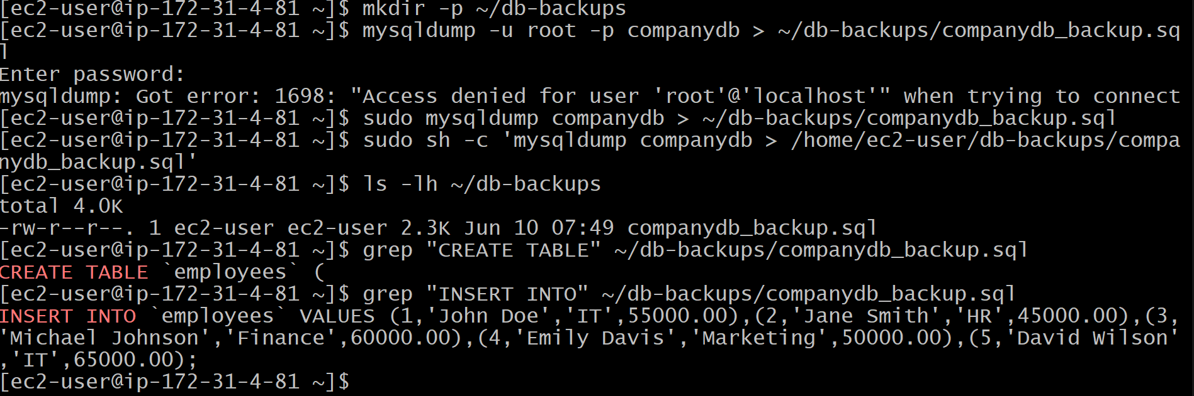

4. Launch MariaDB RDS Instance – Step by Step
1. Open RDS Console
- Sign in to AWS Console.
- Search for RDS.
- Click Create database.

2. Choose Database Creation Method
- Select Standard Create.

3. Select Engine
- Engine Type: MariaDB
- Choose the required MariaDB version.

4. Configure Database Settings
- DB Instance Identifier: mariadb-rds
- Master Username: admin
- Master Password: Create a strong password
- Confirm Password

5. Configure Instance
- DB Instance Class: db.t3.micro (or Free Tier eligible option)
- Storage Type: General Purpose SSD (gp3)
- Allocated Storage: 20 GB

6. Connectivity Settings
- Select the VPC where your EC2 instance exists.
- Public Access:
  - Yes (for testing)
  - No (recommended for production)
- Choose an existing DB Subnet Group or let AWS create one.
- Select/Create a Security Group.

7. Configure Security Group
Add an inbound rule:
Type | Port | Source
MySQL/Aurora | 3306 | EC2 Security Group or Your IP

8. Additional Configuration
- Initial Database Name: companydb
- Backup Retention: 7 days (or as required)
- Leave other settings as default.

9. Create Database
- Click Create Database.
- Wait until the status changes to Available.
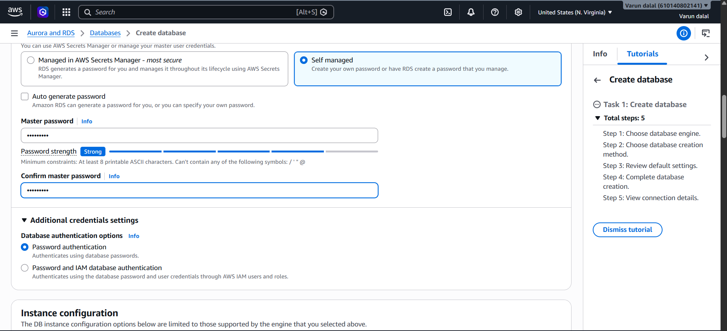
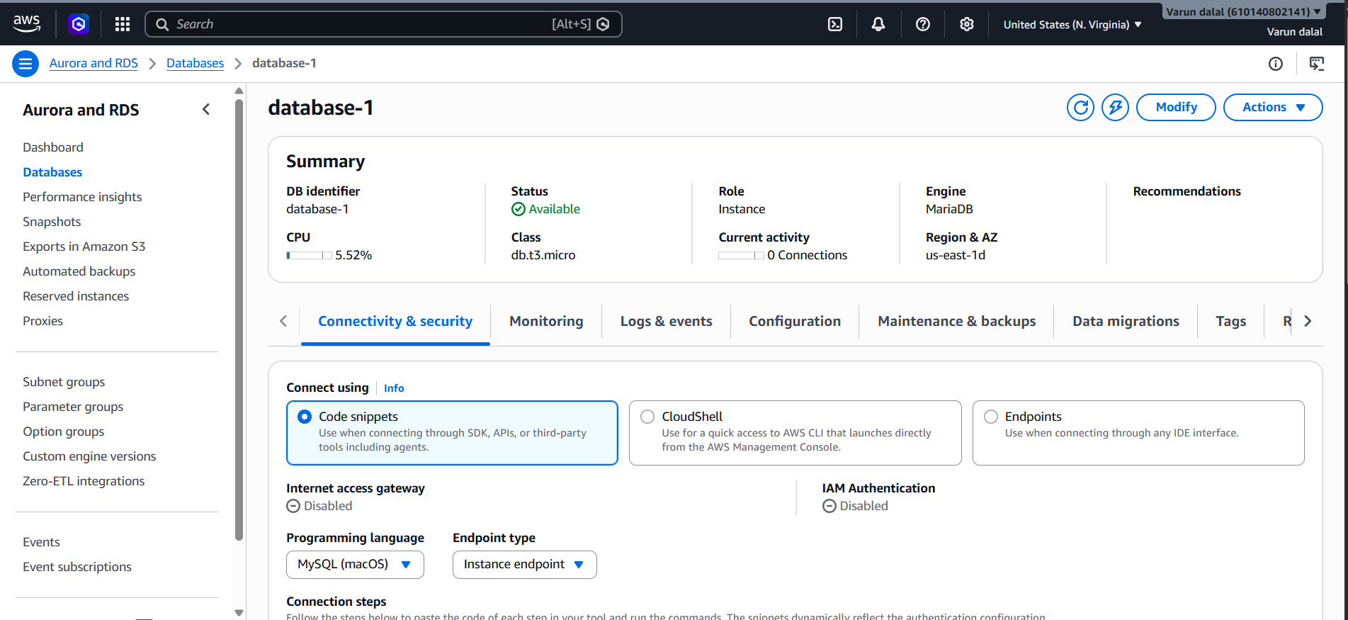

5.Migration from EC2 to RDS
Step 1: Exit RDS
EXIT;

Step 2: Verify Backup File on EC2
ls -lh ~/db-backups/companydb_backup.sql
Expected:
-rw-r--r-- companydb_backup.sql

Step 3: Import Backup into RDS
Run from the EC2 terminal:
mysql -h database-1.cex4o8syuhcn.us-east-1.rds.amazonaws.com \
-u admin -p \
--ssl \
companydb < ~/db-backups/companydb_backup.sql
Enter the RDS master password.
Note: If the import succeeds, the command will usually return to the prompt without displaying anything.

Step 4: Connect to RDS Again
mysql -h database-1.cex4o8syuhcn.us-east-1.rds.amazonaws.com \
-u admin -p \
--ssl

Step 5: Select the Database
USE companydb;

Step 6: Verify Tables
SHOW TABLES;
Expected:
+---------------------+
| Tables_in_companydb |
+---------------------+
| employees |
+---------------------+

Step 7: Verify Data
SELECT * FROM employees;
Expected: 5 employee records.

Step 8: Verify Record Count
SELECT COUNT(*) FROM employees;
Expected:
+----------+
| COUNT(*) |
+----------+
| 5 |
+----------+
If the Import Fails
Check whether your backup actually contains tables and data:
grep "CREATE TABLE" ~/db-backups/companydb_backup.sql
grep "INSERT INTO" ~/db-backups/companydb_backup.sql
If either command returns nothing, the backup may not contain the table/data and you'll need to create a fresh backup from the EC2 MariaDB instance before importing.
If you run the import command and get any error, paste the exact error message and I can help resolve it.
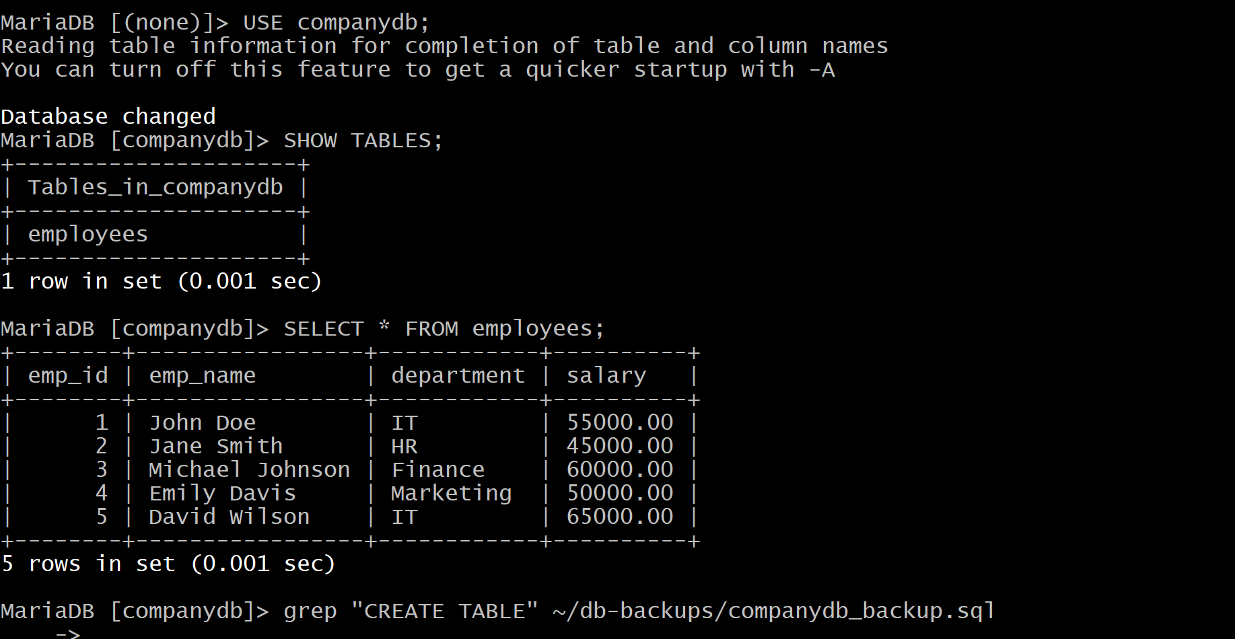

6.Install MySQL DB on EC2The error:
ERROR 2002 (HY000): Can't connect to local MySQL server through socket '/var/lib/mysql/mysql.sock' (13)
usually means MySQL is not running correctly or the socket file permissions are wrong.
Since you're now creating a new EC2 instance, I recommend not troubleshooting this old instance further.
On the New EC2 Instance
After installing MySQL, do these checks:
1. Initialize MySQL
sudo mysqld --initialize --user=mysql
2. Start MySQL
sudo systemctl start mysqld
3. Verify MySQL Started
sudo systemctl status mysqld
You should see:
Active: active (running)
4. Get Temporary Password
sudo grep 'temporary password' /var/log/mysqld.log
5. Login
mysql -u root -p
Enter the temporary password.

If You Want to Fix the Current Instance
Run these commands and paste the outputs:
sudo systemctl status mysqld
sudo ls -l /var/lib/mysql/mysql.sock
sudo tail -20 /var/log/mysqld.log
The (13) error is often a permissions issue on the socket, but because this instance has gone through MariaDB → MySQL migration attempts, starting fresh on a new EC2 is likely faster and cleaner for your lab.
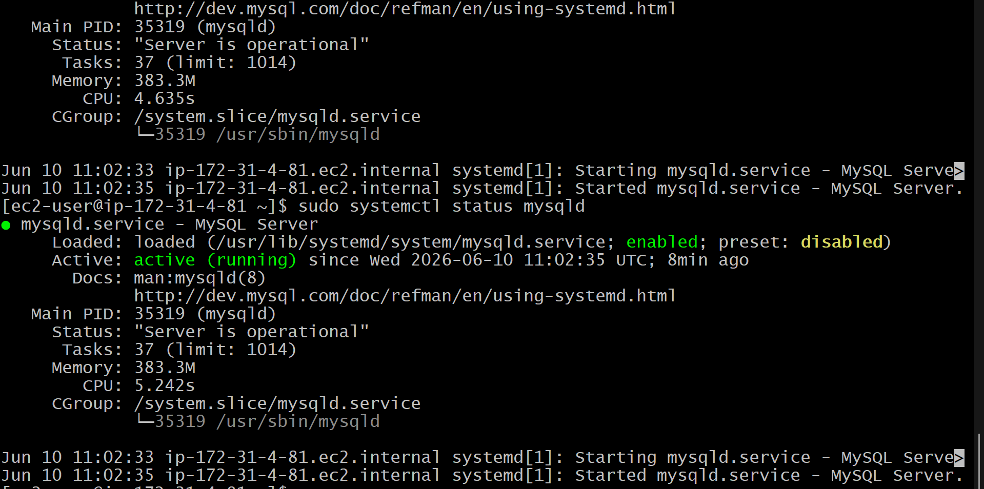

7. Launch MySQL RDS image
Step 1: Open RDS
- Sign in to AWS Console.
- Search for RDS.
- Click Databases → Create database.

Step 2: Choose Database Creation Method
- Select Standard Create.

Step 3: Select Engine
- Engine type: MySQL

Step 4: Choose Version
- Select MySQL 8.0 (or the version required by your lab).

Step 5: Choose Template
- Select Free Tier (recommended for labs).

Step 6: Configure DB Instance
DB Instance Identifier
mysql-rds
Master Username
admin
Master Password
Create a password, for example:
Password@123

Step 7: Instance Configuration
- DB Instance Class: db.t3.micro (or Free Tier eligible option)

Step 8: Storage
- Storage Type: General Purpose SSD (gp3)
- Allocated Storage: 20 GB

Step 9: Connectivity
- Select your VPC.
- Public Access: Yes
- Choose an existing Security Group or create a new one.

Step 10: Security Group Rule
In the RDS Security Group, add:
Type | Protocol | Port | Source
MySQL/Aurora | TCP | 3306 | My IP (for testing)
Or use your EC2 Security Group as the source if EC2 will connect to RDS.

Step 11: Additional Configuration
Initial Database Name
companydb
Leave the remaining settings as default.

Step 12: Create Database
Click Create Database.
Wait until the status becomes:
Available
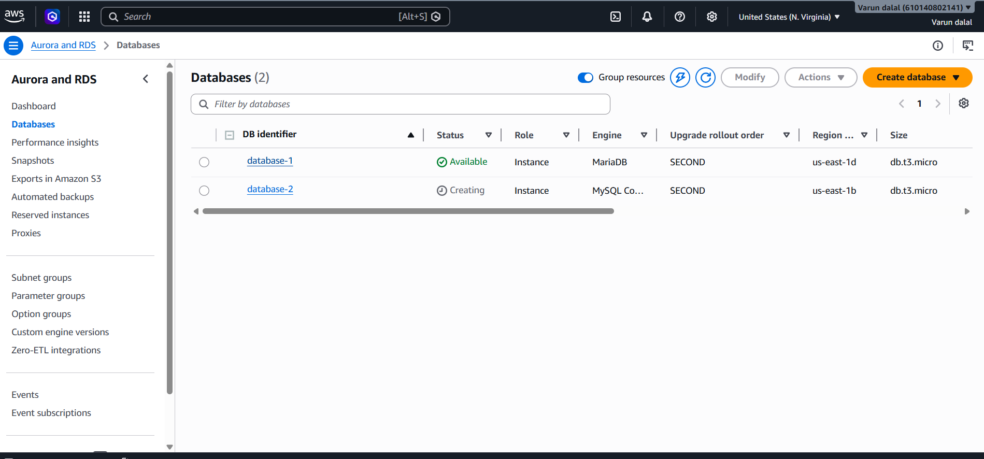
8. Configure Multi-AZ.
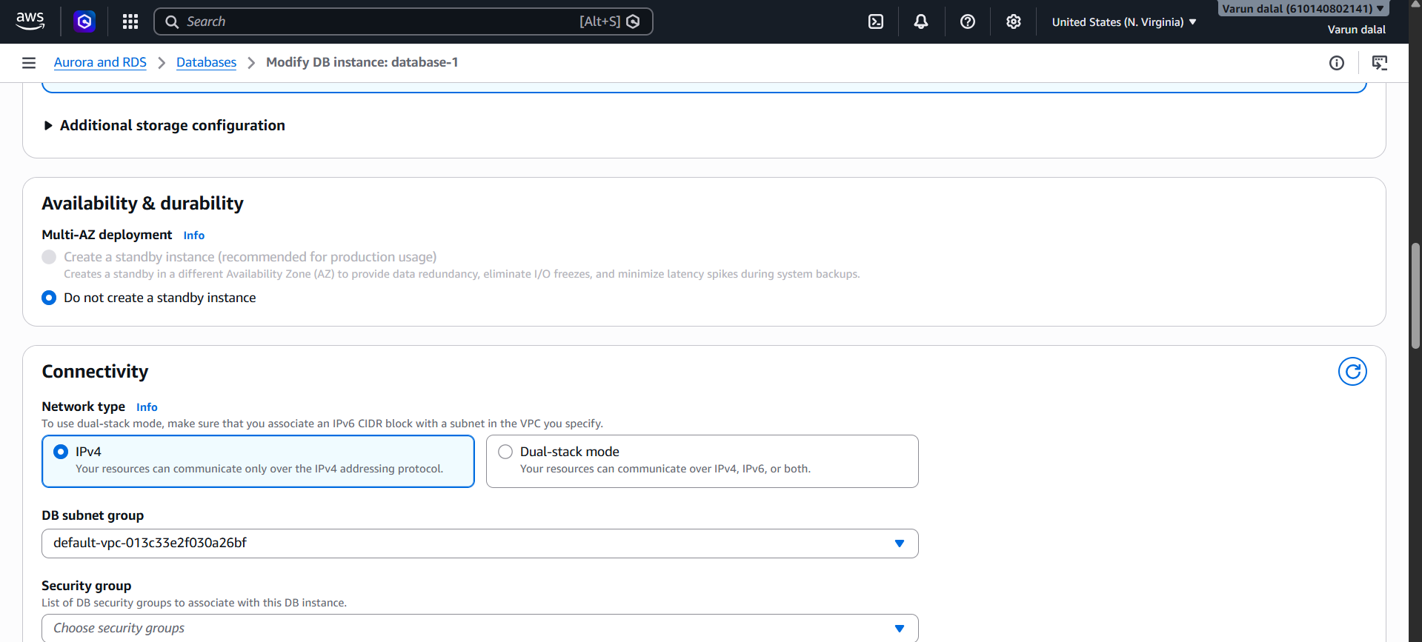

9.Take backup of DB and restore the DBObjective
Create a backup of a database and restore it to another database for recovery or migration purposes.

Step 1: Login to MariaDB
sudo mysql

Step 2: Create a Sample Database
CREATE DATABASE mydb;
USE mydb;
CREATE TABLE employees (
id INT PRIMARY KEY,
name VARCHAR(50)
);
INSERT INTO employees VALUES
(1,'John'),
(2,'David');
SELECT * FROM employees;
Expected Output:
+----+-------+
| id | name |
+----+-------+
| 1 | John |
| 2 | David |
+----+-------+
Exit MariaDB:
EXIT;

Step 3: Take Database Backup
sudo mysqldump mydb > mydb_backup.sql
Verify the backup file:
ls -lh mydb_backup.sql

Step 4: Create a Database for Restore
sudo mysql
CREATE DATABASE mydb_restore;
EXIT;

Step 5: Restore the Backup
sudo mysql mydb_restore < mydb_backup.sql

Step 6: Validate the Restore
Login to MariaDB:
sudo mysql
Use the restored database:
USE mydb_restore;
SHOW TABLES;
SELECT * FROM employees;
Expected Output:
+----+-------+
| id | name |
+----+-------+
| 1 | John |
| 2 | David |
+----+-------+

Validation
The task is successful if:
- mydb_backup.sql is created successfully.
- mydb_restore database is created.
- Backup is restored without errors.
- All tables and records are available in the restored database.
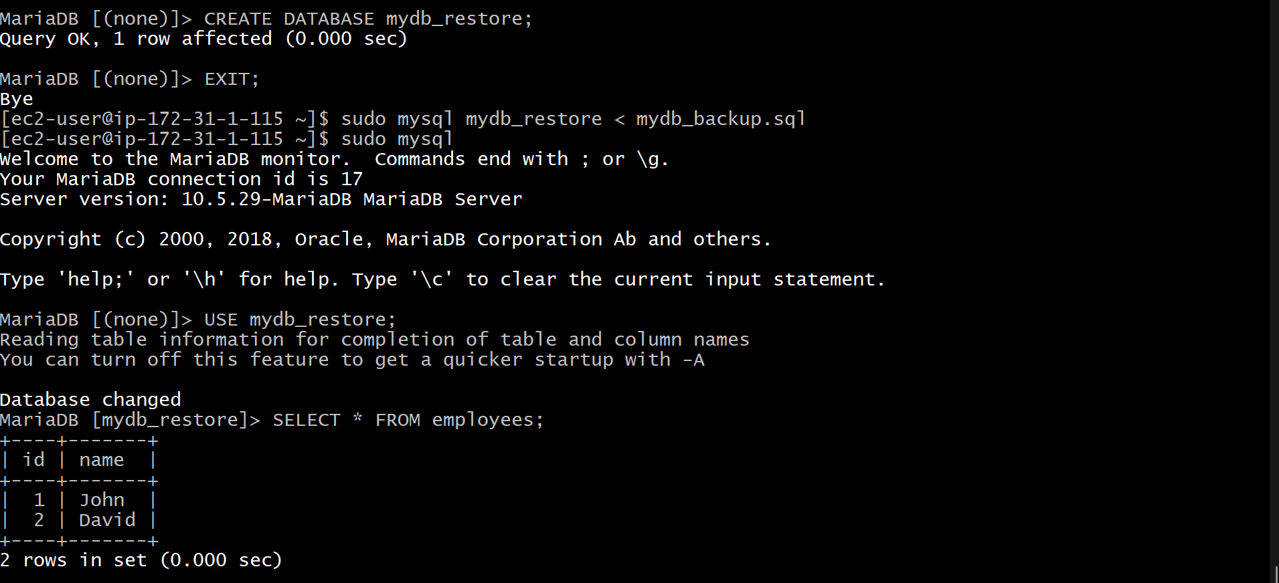

10. Create Read Replica in Amazon RDS MySQL
Objective
Create a Read Replica of an RDS MySQL database to offload read traffic and improve application performance.

Prerequisites
- An existing MySQL RDS instance (Primary DB)
- Automated backups enabled (Backup Retention Period > 0)
- RDS instance status should be Available

Step 1: Verify Automated Backups
- Open AWS Console.
- Go to Amazon RDS Console
- Select your primary DB instance.
- Click Modify.
- Under Backup, ensure Backup Retention Period is at least 1 day.
- Click Continue → Apply Immediately.

Step 2: Create Read Replica
- Go to RDS → Databases.
- Select the primary DB instance.
- Click Actions → Create Read Replica.
- Configure:
  - DB Instance Identifier: mydb-read-replica
  - Instance Class: Same as primary (or smaller for labs)
  - Multi-AZ: No (for lab environments)
  - VPC: Same as primary
  - Security Group: Same as primary
- Click Create Read Replica.

Step 3: Wait for Replica Creation
- Status will show Creating.
- After a few minutes, it changes to Available.
- The replica will have its own endpoint.

Step 4: Connect to Read Replica
Get the replica endpoint from the RDS console.
Example:
mysql -h mydb-read-replica.xxxxx.ap-south-1.rds.amazonaws.com -u admin -p

Step 5: Validate Replication
Connect to Primary DB
CREATE DATABASE testdb;
USE testdb;
CREATE TABLE employees(
id INT PRIMARY KEY,
name VARCHAR(50)
);
INSERT INTO employees VALUES (1,'John');
Connect to Read Replica
SHOW DATABASES;
USE testdb;
SELECT * FROM employees;
Expected Output:
+----+------+
| id | name |
+----+------+
| 1 | John |
+----+------+
The data should automatically appear on the replica.

Validation
The task is successful if:
- Read Replica status is Available.
- Replica has a separate endpoint.
- Data inserted into the primary database appears automatically in the replica.
- Queries can be executed successfully on the replica
