Here's a document version you can paste directly into your report.
Deploy an Application Using a Kubernetes Deployment with 3 Replicas and a Rolling Update Strategy
Step 1: Create the Deployment YAML File
Create a file named deployment.yaml and add the following configuration:
apiVersion: apps/v1
kind: Deployment
metadata:
name: my-app
spec:
replicas: 3
strategy:
type: RollingUpdate
rollingUpdate:
maxUnavailable: 1
maxSurge: 1
selector:
matchLabels:
app: my-app
template:
metadata:
labels:
app: my-app
spec:
containers:
- name: my-app
image: nginx:latest
ports:
- containerPort: 80
Step 2: Deploy the Application
Run the following command to create the Deployment:
kubectl apply -f deployment.yaml
Step 3: Verify the Deployment
Check whether the Deployment has been created successfully:
kubectl get deployments
Expected Output:
NAME READY UP-TO-DATE AVAILABLE AGE
my-app 3/3 3 3 10s
Step 4: Verify the Pods
Check the Pods created by the Deployment:
kubectl get pods
Expected Output:
NAME READY STATUS RESTARTS AGE
my-app-xxxxxxxxxx-abcde 1/1 Running 0 10s
my-app-xxxxxxxxxx-fghij 1/1 Running 0 10s
my-app-xxxxxxxxxx-klmno 1/1 Running 0 10s
Step 5: Check the Rollout Status
Verify that the Deployment has been rolled out successfully:
kubectl rollout status deployment/my-app
Expected Output:
deployment "my-app" successfully rolled out
Step 6: Perform a Rolling Update
Update the application image:
kubectl set image deployment/my-app my-app=nginx:1.27
Step 7: Monitor the Rolling Update
Check the progress of the rolling update:
kubectl rollout status deployment/my-app
Expected Output:
deployment "my-app" successfully rolled out
Step 8: Verify the Updated Pods
List the Pods again to confirm that new Pods have been created:
kubectl get pods
Step 9: View Deployment Details (Optional)
Display detailed information about the Deployment:
kubectl describe deployment my-app
Result
The Kubernetes Deployment named my-app was successfully created with 3 replicas. The RollingUpdate strategy ensures that the application is updated gradually without downtime by replacing Pods one at a time while keeping the application available throughout the update process.
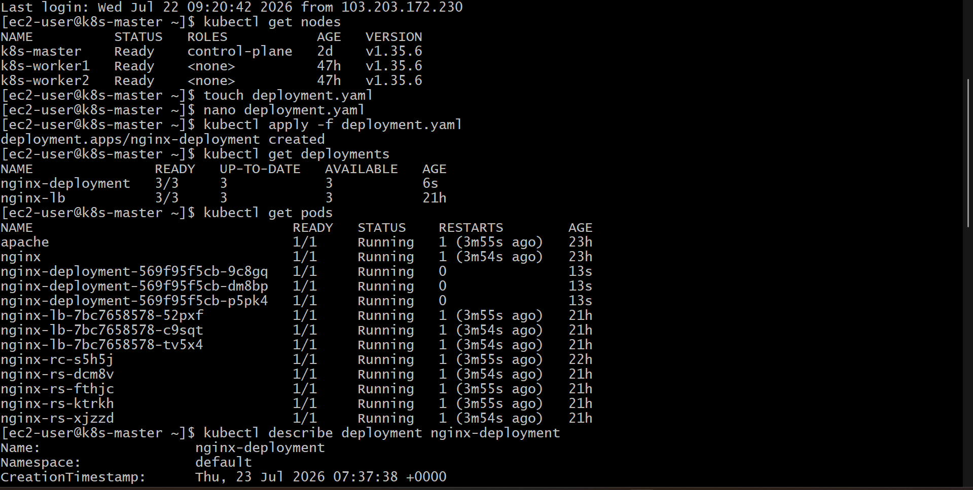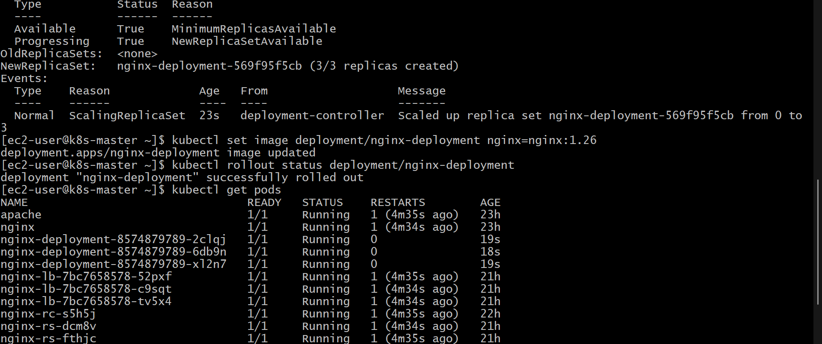

Configure a Kubernetes Deployment with a Recreate Strategy and Observe Downtime
Step 1: Create the Deployment YAML File
Create a file named recreate-deployment.yaml and add the following configuration:
apiVersion: apps/v1
kind: Deployment
metadata:
name: recreate-app
spec:
replicas: 3
strategy:
type: Recreate
selector:
matchLabels:
app: recreate-app
template:
metadata:
labels:
app: recreate-app
spec:
containers:
- name: recreate-app
image: nginx:latest
ports:
- containerPort: 80

Step 2: Deploy the Application
Apply the Deployment configuration:
kubectl apply -f recreate-deployment.yaml

Step 3: Verify the Deployment
Check the Deployment status:
kubectl get deployments
Expected output:
NAME READY UP-TO-DATE AVAILABLE AGE
recreate-app 3/3 3 3 10s

Step 4: Verify Running Pods
Check the Pods created by the Deployment:
kubectl get pods
Expected output:
NAME READY STATUS RESTARTS AGE
recreate-app-xxxxxxxxxx-abcde 1/1 Running 0 10s
recreate-app-xxxxxxxxxx-fghij 1/1 Running 0 10s
recreate-app-xxxxxxxxxx-klmno 1/1 Running 0 10s

Step 5: Update the Application Image
Perform an update to trigger the Recreate strategy:
kubectl set image deployment/recreate-app recreate-app=nginx:1.27

Step 6: Observe the Downtime
Monitor the Pods during the update:
kubectl get pods -w
During the update process, the existing Pods will be terminated first:
NAME READY STATUS AGE
recreate-app-xxxxxxxxxx-abcde 1/1 Terminating 20s
recreate-app-xxxxxxxxxx-fghij 1/1 Terminating 20s
recreate-app-xxxxxxxxxx-klmno 1/1 Terminating 20s
After the old Pods are removed, new Pods are created:
NAME READY STATUS AGE
recreate-app-xxxxxxxxxx-pqrst 1/1 Running 10s
recreate-app-xxxxxxxxxx-uvwxy 1/1 Running 10s
recreate-app-xxxxxxxxxx-zabcd 1/1 Running 10s

Step 7: Check Rollout Status
Verify that the update is completed:
kubectl rollout status deployment/recreate-app
Expected output:
deployment "recreate-app" successfully rolled out

Step 8: Verify the Deployment Details
View the Deployment configuration:
kubectl describe deployment recreate-app
Check the strategy type in the output:
StrategyType: Recreate

Observation
When the Recreate strategy is used, Kubernetes first terminates all existing Pods before creating new Pods with the updated configuration. This causes a temporary service interruption or downtime during the update process.
Unlike the RollingUpdate strategy, the Recreate strategy does not maintain old Pods while new Pods are starting. It is suitable for applications where running multiple versions simultaneously could cause issues, but it results in downtime during deployment updates.
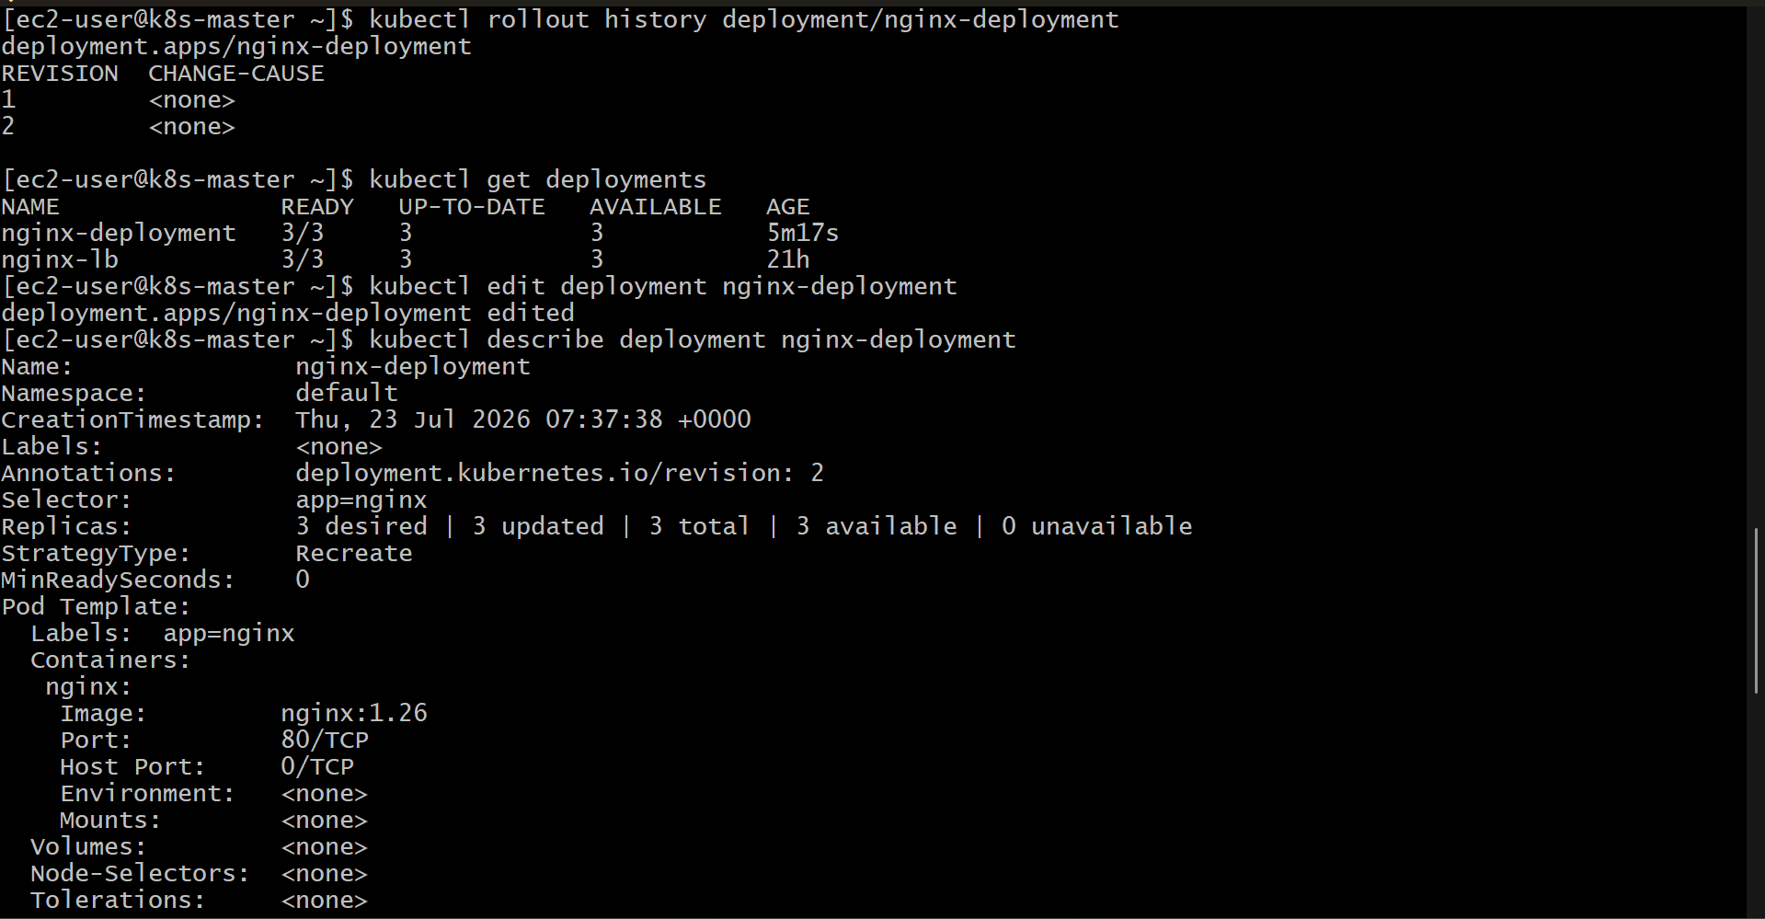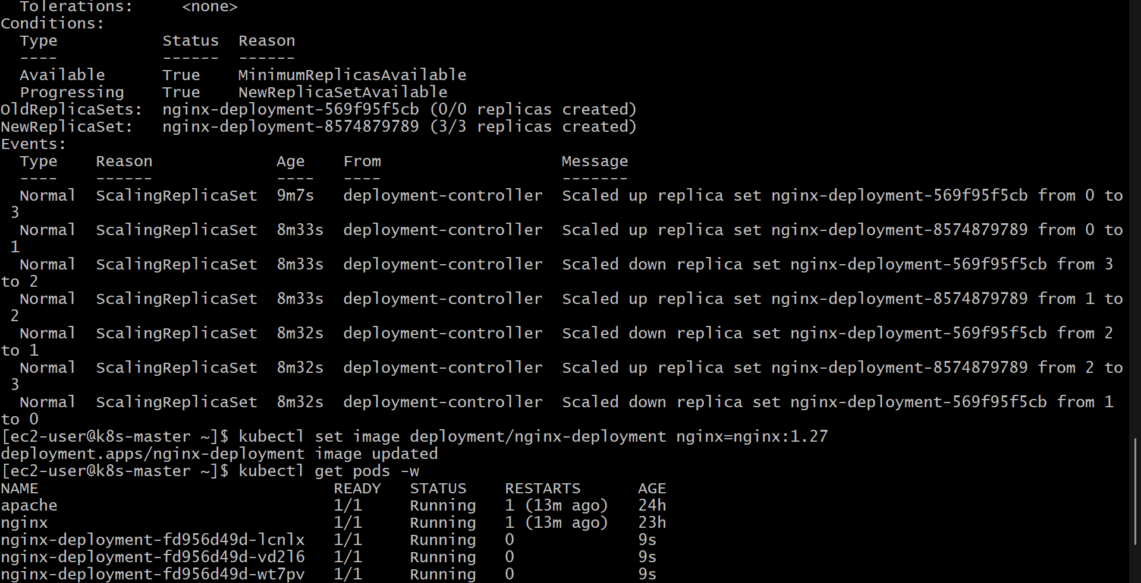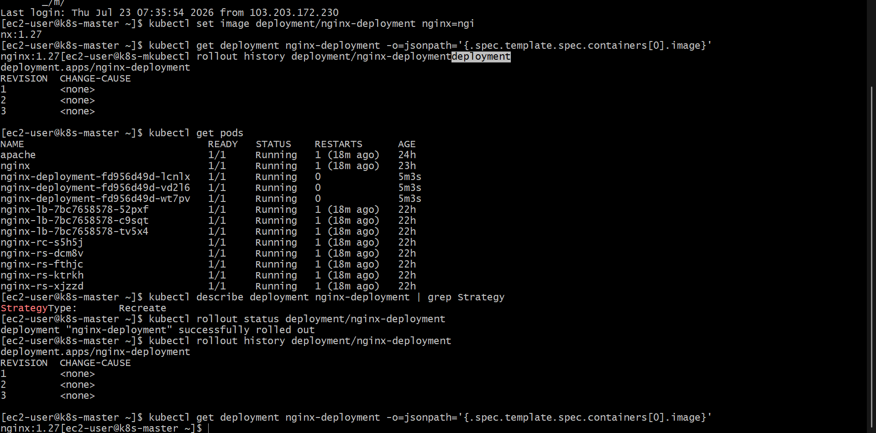
Update an Existing Kubernetes Deployment and Perform a Rollback to the Previous Version
Step 1: Check the Existing Deployment
First, verify the existing Deployment:
kubectl get deployments
Example output:
NAME READY UP-TO-DATE AVAILABLE AGE
my-app 3/3 3 3 5m

Step 2: Check the Current Deployment Image
View the current container image used by the Deployment:
kubectl get deployment my-app -o yaml
or:
kubectl describe deployment my-app

Step 3: Update the Deployment Image
Update the application image to a newer version:
kubectl set image deployment/my-app my-app=nginx:1.27
This command updates the container image and creates a new Deployment revision.

Step 4: Monitor the Deployment Update
Check the rollout status:
kubectl rollout status deployment/my-app
Expected output:
deployment "my-app" successfully rolled out

Step 5: View Deployment Revision History
Check the available rollout revisions:
kubectl rollout history deployment/my-app
Expected output:
deployment.apps/my-app
REVISION CHANGE-CAUSE
1 <none>
2 <none>
Revision 1 represents the previous version and Revision 2 represents the updated version.

Step 6: Check the Current Version
Verify the updated image:
kubectl get deployment my-app -o=jsonpath='{.spec.template.spec.containers[0].image}'
Example output:
nginx:1.27

Step 7: Roll Back to the Previous Version
Perform a rollback to the previous Deployment revision:
kubectl rollout undo deployment/my-app
Kubernetes will restore the Deployment to the previous configuration.

Step 8: Verify the Rollback Status
Check the rollback progress:
kubectl rollout status deployment/my-app
Expected output:
deployment "my-app" successfully rolled back

Step 9: Verify the Deployment Image After Rollback
Check the current image again:
kubectl get deployment my-app -o=jsonpath='{.spec.template.spec.containers[0].image}'
Example output:
nginx:latest

Step 10: Verify Running Pods
Check that the Pods have been recreated with the previous version:
kubectl get pods
Example output:
NAME READY STATUS RESTARTS AGE
my-app-xxxxxxxxxx-abcd 1/1 Running 0 30s
my-app-xxxxxxxxxx-efgh 1/1 Running 0 30s
my-app-xxxxxxxxxx-ijkl 1/1 Running 0 30s

Result
The existing Kubernetes Deployment was successfully updated to a new image version. A rollback operation was then performed, restoring the Deployment to its previous stable version. Kubernetes automatically recreated the Pods using the previous configuration while maintaining the desired replica count.
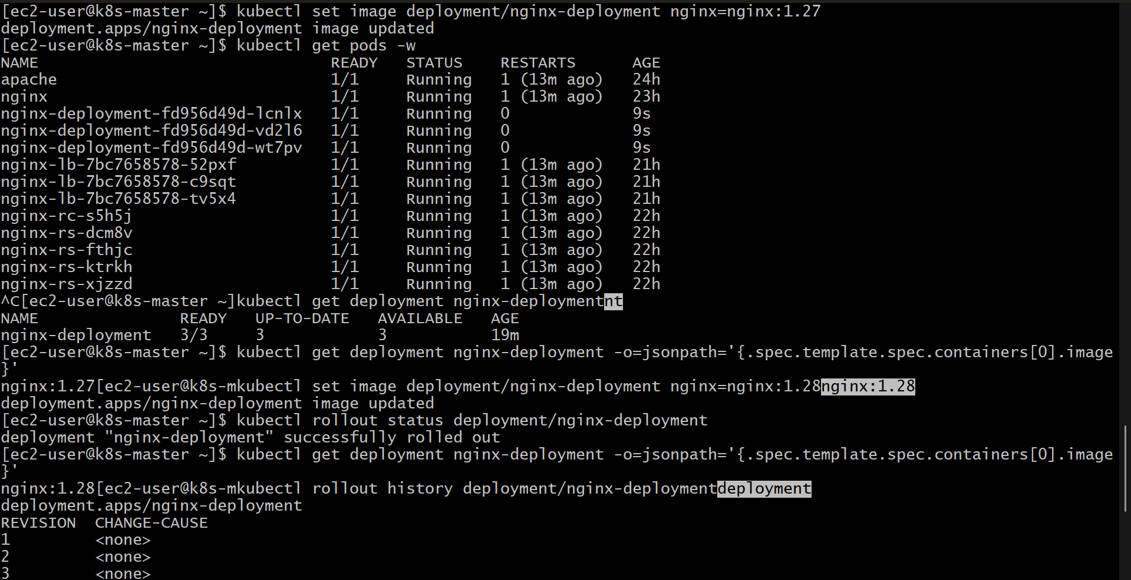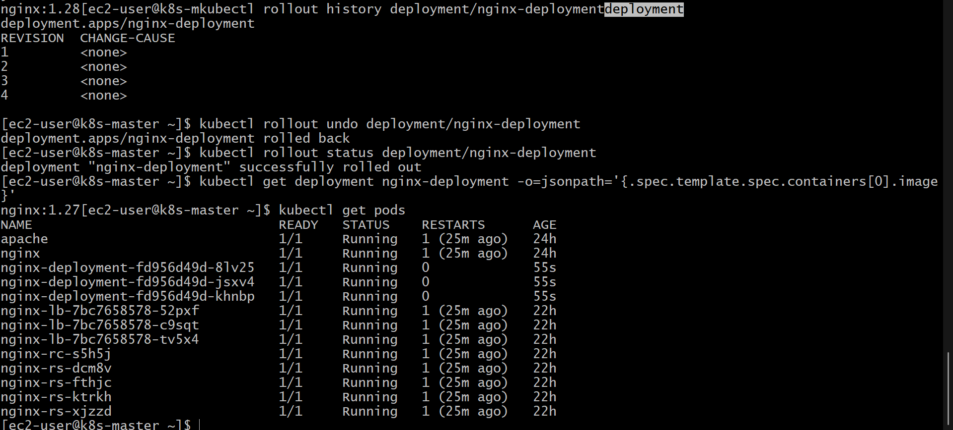
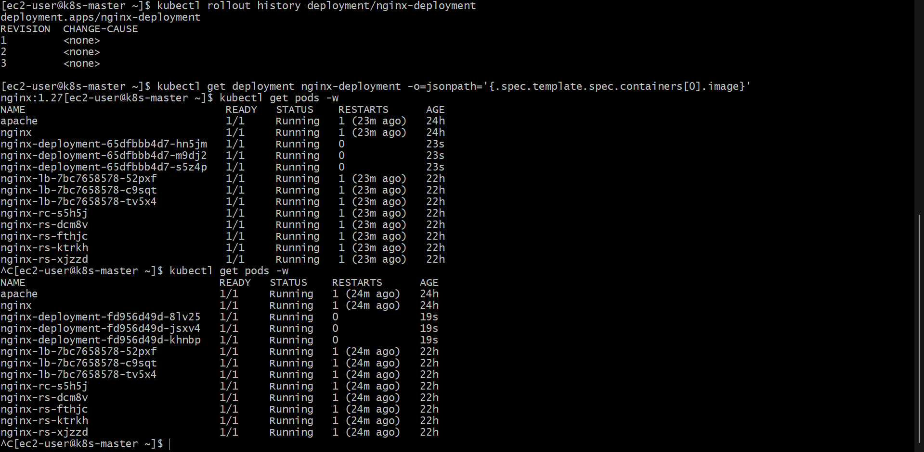
Modify a Kubernetes Deployment to Add Resource Requests and Limits for CPU and Memory
Step 1: Check the Existing Deployment
First, verify the existing Deployment:
kubectl get deployments
Example output:
NAME READY UP-TO-DATE AVAILABLE AGE
my-app 3/3 3 3 5m

Step 2: Edit the Deployment Configuration
Open the Deployment for editing:
kubectl edit deployment my-app
Add the following resources section under the container configuration:
resources:
requests:
cpu: "250m"
memory: "256Mi"
limits:
cpu: "500m"
memory: "512Mi"
The updated container section will look like this:
containers:
- name: my-app
image: nginx:latest
ports:
- containerPort: 80
resources:
requests:
cpu: "250m"
memory: "256Mi"
limits:
cpu: "500m"
memory: "512Mi"
Save and exit the editor.

Step 3: Apply the Updated Deployment
If the Deployment configuration is stored in a YAML file, update the file and apply it:
kubectl apply -f deployment.yaml
Kubernetes will automatically create a new ReplicaSet and update the Pods with the new resource configuration.

Step 4: Check the Deployment Rollout
Monitor the update process:
kubectl rollout status deployment/my-app
Expected output:
deployment "my-app" successfully rolled out

Step 5: Verify Resource Requests and Limits
Check the Deployment details:
kubectl describe deployment my-app
Look for the resource configuration:
Requests:
cpu: 250m
memory: 256Mi
Limits:
cpu: 500m
memory: 512Mi

Step 6: Verify the Pod Resource Configuration
Check the Pods created by the Deployment:
kubectl get pods
View detailed information about a Pod:
kubectl describe pod <pod-name>
Confirm that the resource requests and limits are applied.

Step 7: Check Resource Usage (Optional)
If the Metrics Server is installed, check current resource usage:
kubectl top pods
Example output:
NAME CPU(cores) MEMORY(bytes)
my-app-xxxxxxxxxx-abcd 20m 150Mi
my-app-xxxxxxxxxx-efgh 18m 145Mi
my-app-xxxxxxxxxx-ijkl 22m 152Mi

Resource Configuration Explanation
Resource | Request | Limit | Description
CPU | 250m | 500m | The Pod is guaranteed 250 millicores of CPU and can use up to 500 millicores.
Memory | 256Mi | 512Mi | The Pod is guaranteed 256 MiB of memory and can use up to 512 MiB.

Result
The Kubernetes Deployment was successfully modified to include CPU and memory resource requests and limits. The requests reserve the minimum resources required by the application, while the limits prevent the container from consuming resources beyond the defined maximum values.
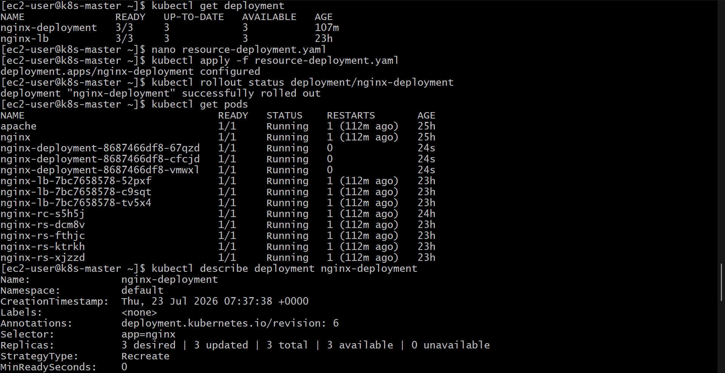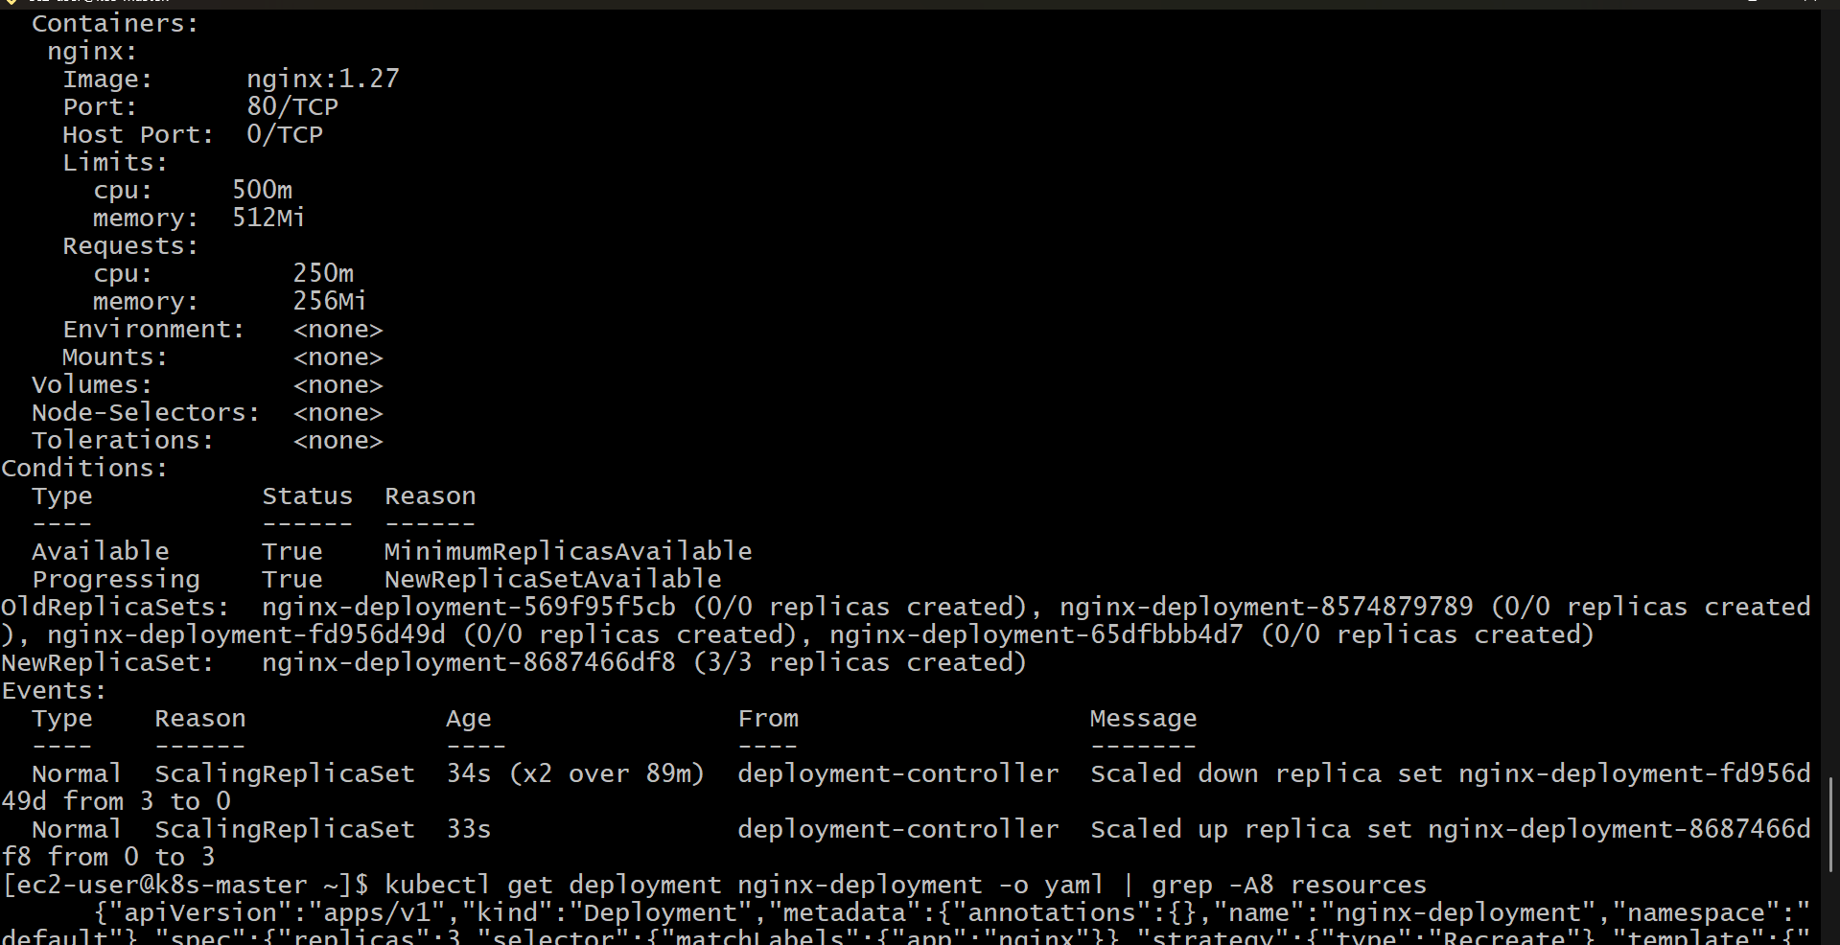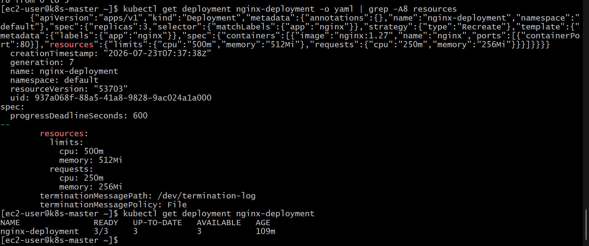

Create a Kubernetes Deployment with MaxSurge and MaxUnavailable Configurations
Step 1: Create the Deployment YAML File
Create a file named maxsurge-maxunavailable-deployment.yaml and add the following configuration:
apiVersion: apps/v1
kind: Deployment
metadata:
name: max-config-app
spec:
replicas: 3
strategy:
type: RollingUpdate
rollingUpdate:
maxSurge: 1
maxUnavailable: 1
selector:
matchLabels:
app: max-config-app
template:
metadata:
labels:
app: max-config-app
spec:
containers:
- name: max-config-app
image: nginx:latest
ports:
- containerPort: 80

Step 2: Deploy the Application
Apply the Deployment configuration:
kubectl apply -f maxsurge-maxunavailable-deployment.yaml

Step 3: Verify the Deployment
Check the Deployment status:
kubectl get deployments
Expected output:
NAME READY UP-TO-DATE AVAILABLE AGE
max-config-app 3/3 3 3 10s

Step 4: Check Running Pods
Verify that 3 Pods are running:
kubectl get pods
Expected output:
NAME READY STATUS RESTARTS AGE
max-config-app-xxxxxxxxxx-abcde 1/1 Running 0 10s
max-config-app-xxxxxxxxxx-fghij 1/1 Running 0 10s
max-config-app-xxxxxxxxxx-klmno 1/1 Running 0 10s

Step 5: Check Rolling Update Configuration
View the Deployment details:
kubectl describe deployment max-config-app
Verify the strategy configuration:
StrategyType: RollingUpdate
RollingUpdateStrategy:
MaxUnavailable: 1
MaxSurge: 1

Step 6: Perform a Rolling Update
Update the container image:
kubectl set image deployment/max-config-app max-config-app=nginx:1.27

Step 7: Monitor the Rolling Update
Watch the Pods during the update:
kubectl get pods -w
During the rollout:
- MaxSurge: 1 allows Kubernetes to create 1 additional Pod above the desired replica count.
- MaxUnavailable: 1 allows up to 1 Pod to be unavailable during the update.
Example rollout behavior:
Before update:
3 old Pods running

During update:
4 Pods may exist temporarily
1 old Pod is replaced

After update:
3 new Pods running

Step 8: Verify the Rollout Completion
Check the rollout status:
kubectl rollout status deployment/max-config-app
Expected output:
deployment "max-config-app" successfully rolled out

Step 9: Confirm the Final State
Verify the number of running Pods:
kubectl get pods
Expected result:
3 Pods running with the updated image version

Result
A Kubernetes Deployment was created with a RollingUpdate strategy using MaxSurge and MaxUnavailable configurations.
- MaxSurge: 1 allows one extra Pod to be created during an update, improving availability.
- MaxUnavailable: 1 ensures that only one Pod can be unavailable during the rollout.
- The Deployment updates Pods gradually while maintaining application availability.
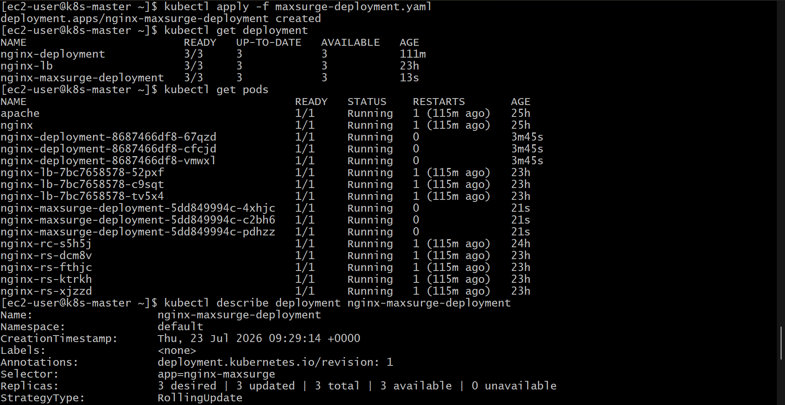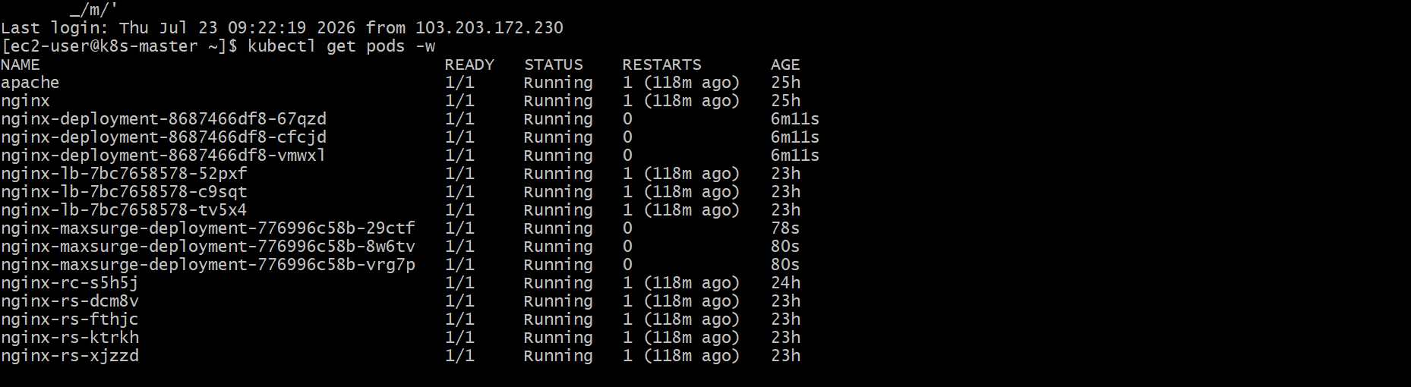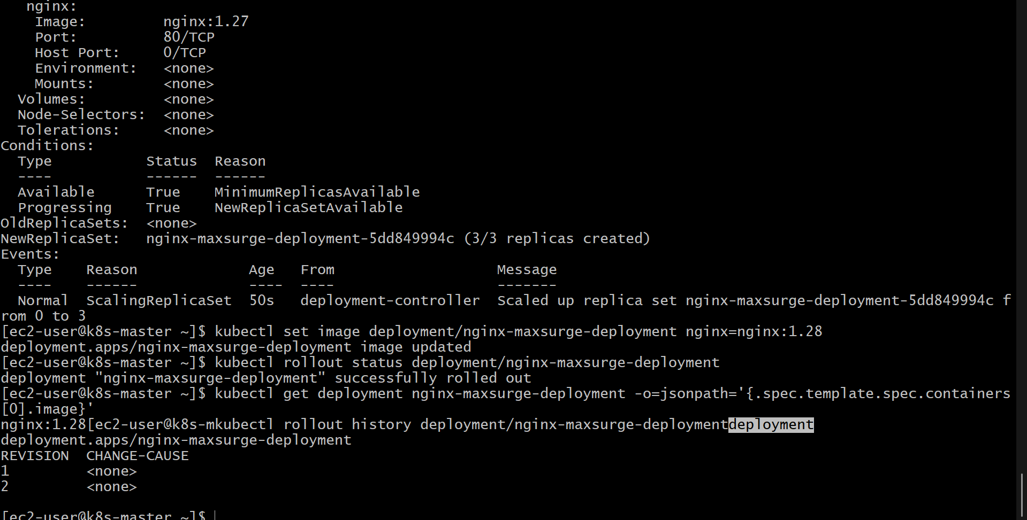

Set Up a Kubernetes Deployment with a Custom Revision History Limit
Step 1: Create the Deployment YAML File
Create a file named revision-history-deployment.yaml and add the following configuration:
apiVersion: apps/v1
kind: Deployment
metadata:
name: revision-app
spec:
replicas: 3
revisionHistoryLimit: 5
strategy:
type: RollingUpdate
rollingUpdate:
maxUnavailable: 1
maxSurge: 1
selector:
matchLabels:
app: revision-app
template:
metadata:
labels:
app: revision-app
spec:
containers:
- name: revision-app
image: nginx:latest
ports:
- containerPort: 80

Step 2: Deploy the Application
Apply the Deployment configuration:
kubectl apply -f revision-history-deployment.yaml

Step 3: Verify the Deployment
Check that the Deployment has been created:
kubectl get deployments
Expected output:
NAME READY UP-TO-DATE AVAILABLE AGE
revision-app 3/3 3 3 10s

Step 4: Check the Revision History Limit
View the Deployment details:
kubectl describe deployment revision-app
Look for the revision history configuration:
Annotations:
deployment.kubernetes.io/revision: 1
The Deployment is configured to keep the last 5 ReplicaSets as rollback history.

Step 5: Create Multiple Deployment Revisions
Update the image several times to create new revisions:
kubectl set image deployment/revision-app revision-app=nginx:1.27
Create another revision:
kubectl set image deployment/revision-app revision-app=nginx:1.28

Step 6: View Deployment Revision History
Check the available revisions:
kubectl rollout history deployment/revision-app
Example output:
deployment.apps/revision-app
REVISION CHANGE-CAUSE
1 <none>
2 <none>
3 <none>

Step 7: Verify Stored ReplicaSets
List ReplicaSets created by the Deployment:
kubectl get replicasets
Kubernetes will retain old ReplicaSets according to the value configured in:
revisionHistoryLimit: 5

Step 8: Perform a Rollback
Rollback to the previous Deployment version:
kubectl rollout undo deployment/revision-app

Step 9: Verify the Rollback
Check the rollout status:
kubectl rollout status deployment/revision-app
Expected output:
deployment "revision-app" successfully rolled out

Step 10: Confirm the Current Revision
View the current Deployment history:
kubectl rollout history deployment/revision-app

Result
A Kubernetes Deployment was configured with a custom revisionHistoryLimit value of 5.
- Kubernetes stores up to 5 previous ReplicaSets for rollback purposes.
- Older revisions beyond this limit are automatically removed.
- The stored revisions allow administrators to quickly roll back to a previous stable application version.
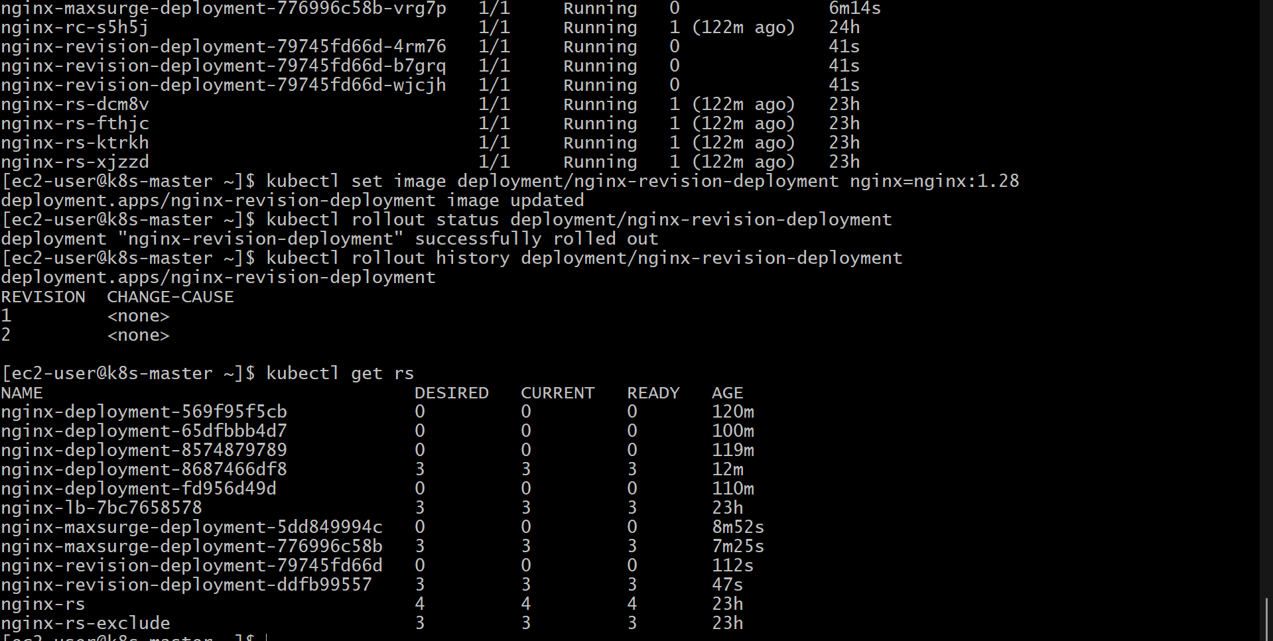
Set Up a Kubernetes Deployment with a Custom Revision History Limit
Step 1: Create the Deployment YAML File
Create a file named custom-revision-deployment.yaml and add the following configuration:
apiVersion: apps/v1
kind: Deployment
metadata:
name: custom-revision-app
spec:
replicas: 3
revisionHistoryLimit: 3
strategy:
type: RollingUpdate
selector:
matchLabels:
app: custom-revision-app
template:
metadata:
labels:
app: custom-revision-app
spec:
containers:
- name: custom-revision-app
image: nginx:latest
ports:
- containerPort: 80

Step 2: Deploy the Application
Apply the Deployment configuration:
kubectl apply -f custom-revision-deployment.yaml

Step 3: Verify the Deployment
Check the Deployment status:
kubectl get deployment
Expected output:
NAME READY UP-TO-DATE AVAILABLE AGE
custom-revision-app 3/3 3 3 10s

Step 4: Verify the Revision History Limit
Check the Deployment details:
kubectl describe deployment custom-revision-app
Confirm that the Deployment contains:
Revision History Limit: 3
The Deployment will keep only the last 3 old ReplicaSets for rollback purposes.

Step 5: Create New Deployment Revisions
Update the image to create a new revision:
kubectl set image deployment/custom-revision-app custom-revision-app=nginx:1.27
Create another revision:
kubectl set image deployment/custom-revision-app custom-revision-app=nginx:1.28

Step 6: View Deployment Revision History
Display the available revisions:
kubectl rollout history deployment/custom-revision-app
Example output:
deployment.apps/custom-revision-app

REVISION CHANGE-CAUSE
1 <none>
2 <none>
3 <none>

Step 7: Check ReplicaSets
List all ReplicaSets created by the Deployment:
kubectl get replicasets
The Deployment keeps only the number of previous ReplicaSets defined by:
revisionHistoryLimit: 3
Older revisions beyond this limit are automatically removed.

Step 8: Perform a Rollback
Rollback the Deployment to the previous version:
kubectl rollout undo deployment/custom-revision-app

Step 9: Verify the Rollback
Check the rollout status:
kubectl rollout status deployment/custom-revision-app
Expected output:
deployment "custom-revision-app" successfully rolled out

Result
A Kubernetes Deployment was successfully configured with a custom revisionHistoryLimit of 3.
- Kubernetes stores the last 3 Deployment revisions for rollback.
- Older revisions are automatically deleted to reduce resource usage.
- The retained revisions allow quick recovery if a newer deployment version causes issues.
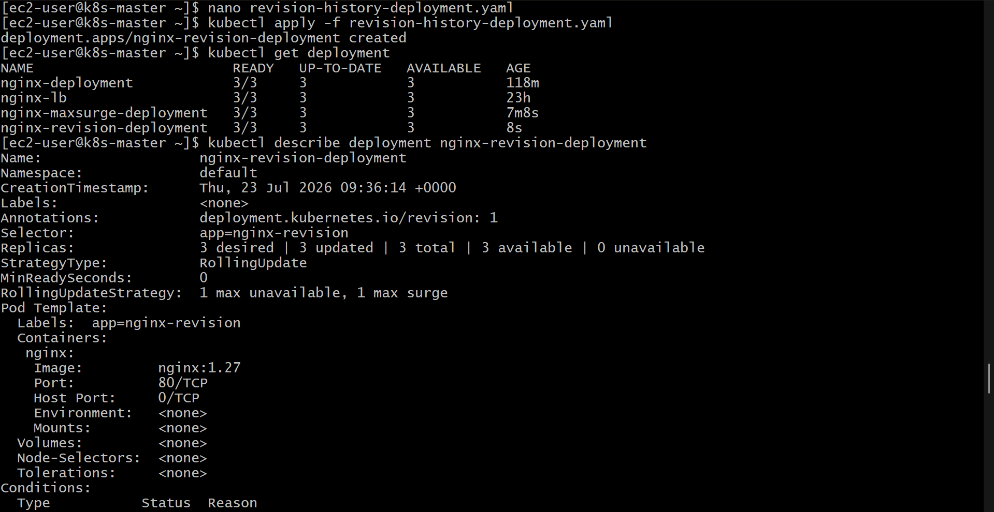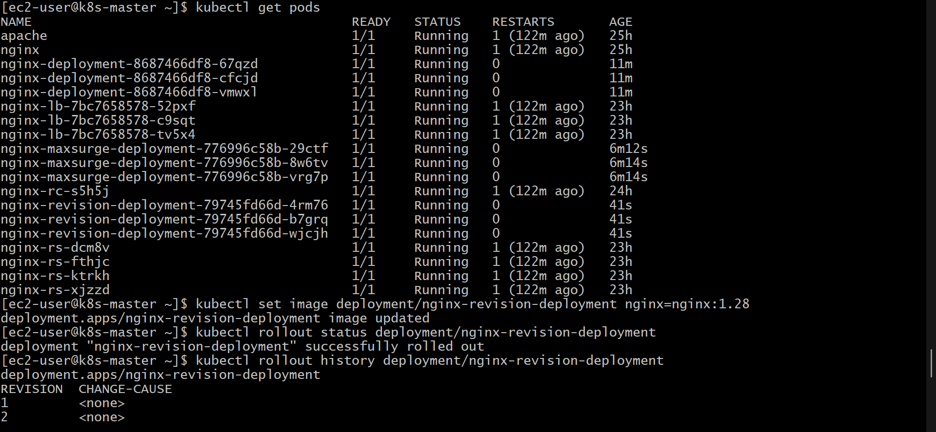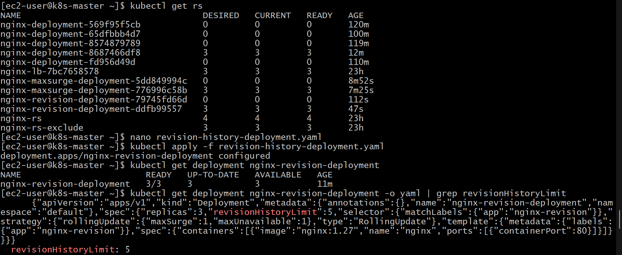

Pause a Kubernetes Deployment During an Update and Resume It
Step 1: Create a Deployment
Create a file named pause-resume-deployment.yaml and add the following configuration:
apiVersion: apps/v1
kind: Deployment
metadata:
name: pause-resume-app
spec:
replicas: 3
strategy:
type: RollingUpdate
selector:
matchLabels:
app: pause-resume-app
template:
metadata:
labels:
app: pause-resume-app
spec:
containers:
- name: pause-resume-app
image: nginx:latest
ports:
- containerPort: 80

Step 2: Deploy the Application
Apply the Deployment configuration:
kubectl apply -f pause-resume-deployment.yaml

Step 3: Verify the Deployment
Check the Deployment status:
kubectl get deployments
Expected output:
NAME READY UP-TO-DATE AVAILABLE AGE
pause-resume-app 3/3 3 3 10s

Step 4: Start an Update
Update the container image to create a new rollout:
kubectl set image deployment/pause-resume-app pause-resume-app=nginx:1.27

Step 5: Pause the Deployment
Pause the Deployment before the update completes:
kubectl rollout pause deployment/pause-resume-app
The Deployment will stop progressing with the current update. Existing changes are saved but not fully rolled out.

Step 6: Verify the Deployment is Paused
Check the Deployment status:
kubectl rollout status deployment/pause-resume-app
View Deployment details:
kubectl describe deployment pause-resume-app
The output will show that the Deployment is paused.
Example:
Paused: true

Step 7: Make Additional Changes While Paused (Optional)
While the Deployment is paused, additional updates can be made:
kubectl set image deployment/pause-resume-app pause-resume-app=nginx:1.28
These changes are recorded but are not applied until the Deployment is resumed.

Step 8: Resume the Deployment
Continue the rollout process:
kubectl rollout resume deployment/pause-resume-app
Kubernetes will continue updating the Pods using the latest Deployment configuration.

Step 9: Monitor the Rollout
Check the rollout progress:
kubectl rollout status deployment/pause-resume-app
Expected output:
deployment "pause-resume-app" successfully rolled out

Step 10: Verify the Final State
Check the running Pods:
kubectl get pods
Check the current image version:
kubectl get deployment pause-resume-app -o=jsonpath='{.spec.template.spec.containers[0].image}'
Expected output:
nginx:1.28

Result
The Deployment was successfully paused during an update and later resumed.
- Pause stops the rollout from progressing while allowing configuration changes.
- Resume continues the rollout and applies the latest Deployment configuration.
- This feature is useful when testing multiple changes together before completing a production rollout.
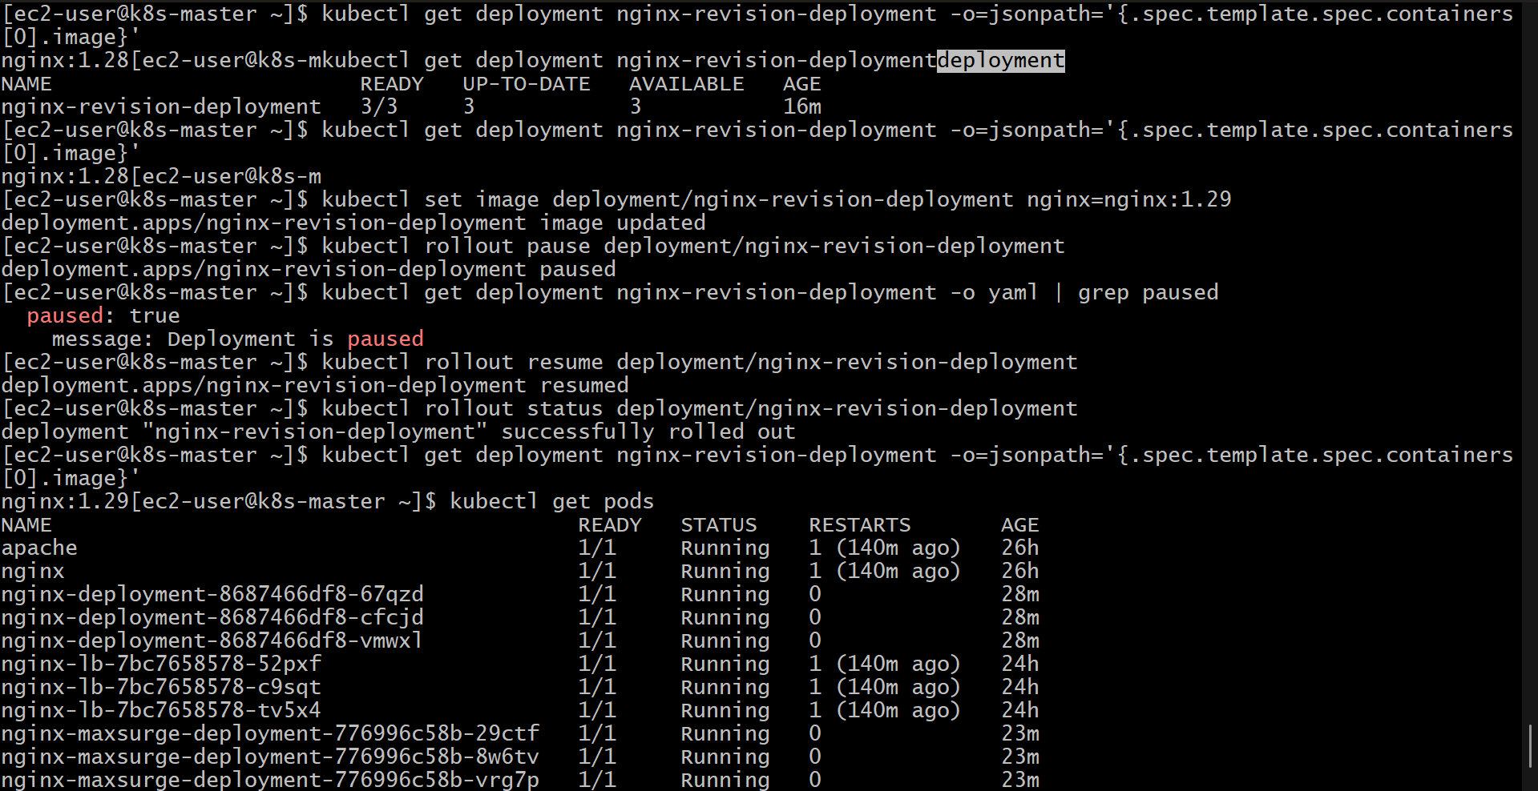

Create a Pod Using Resource Requests for Memory and CPU and Observe Scheduler Node Assignment
Step 1: Check Available Nodes
First, check the nodes available in the Kubernetes cluster:
kubectl get nodes
Example output:
NAME STATUS ROLES AGE
node-1 Ready worker 10d
node-2 Ready worker 10d

Step 2: Check Node Resource Availability
View the resources available on each node:
kubectl describe nodes
Look for the Capacity and Allocatable CPU and memory values.
Example:
Capacity:
cpu: 4
memory: 8Gi

Allocatable:
cpu: 4
memory: 8Gi

Step 3: Create a Pod YAML File with Resource Requests
Create a file named resource-request-pod.yaml and add the following configuration:
apiVersion: v1
kind: Pod
metadata:
name: resource-request-pod
spec:
containers:
- name: resource-container
image: nginx:latest
resources:
requests:
cpu: "1"
memory: "512Mi"
limits:
cpu: "2"
memory: "1Gi"
ports:
- containerPort: 80

Step 4: Deploy the Pod
Create the Pod using the YAML file:
kubectl apply -f resource-request-pod.yaml

Step 5: Check Pod Status
Verify that the Pod has been created:
kubectl get pods
Example output:
NAME READY STATUS AGE
resource-request-pod 1/1 Running 10s

Step 6: Observe Node Assignment
Check which node the Pod was scheduled on:
kubectl get pod resource-request-pod -o wide
Example output:
NAME READY STATUS IP NODE
resource-request-pod 1/1 Running 10.244.1.10 node-1
The NODE column shows the node selected by the Kubernetes scheduler.

Step 7: View Pod Scheduling Details
Describe the Pod:
kubectl describe pod resource-request-pod
Look for the scheduling event:
Events:
Type Reason Message
---- ------ -------
Normal Scheduled Successfully assigned default/resource-request-pod to node-1

Step 8: Verify Resource Requests on the Pod
Check the resource configuration:
kubectl describe pod resource-request-pod
Expected output:
Requests:
cpu: 1
memory: 512Mi

Limits:
cpu: 2
memory: 1Gi

Step 9: Check Node Resource Usage
If Metrics Server is installed, view node usage:
kubectl top nodes
Example output:
NAME CPU(cores) MEMORY(bytes)
node-1 1200m 2Gi
node-2 500m 1Gi

Observation
The Kubernetes scheduler uses the resource requests defined in the Pod specification to decide where to place the Pod.
- The Pod requests 1 CPU core and 512Mi memory.
- The scheduler checks available resources on each node.
- The Pod is assigned to a node that has enough available CPU and memory.
- Resource limits define the maximum resources the container can consume after scheduling.

Result
A Pod was successfully created with CPU and memory resource requests. The Kubernetes scheduler evaluated node availability and assigned the Pod to a suitable node based on the requested resources.
