Create a Namespace and Apply a ResourceQuota in Kubernetes
Objective
Create a Kubernetes namespace named dev-environment and apply a ResourceQuota that limits:
- Maximum Pods: 3
- Maximum Services: 2

Step 1: Create the Namespace
Run the following command:
kubectl create namespace dev-environment
Verify the namespace:
kubectl get namespaces
Expected output:
NAME STATUS AGE
default Active ...
dev-environment Active ...
kube-system Active ...

Step 2: Create the ResourceQuota YAML
Create a file named resourcequota.yaml with the following content:
apiVersion: v1
kind: ResourceQuota
metadata:
name: dev-environment-quota
namespace: dev-environment
spec:
hard:
pods: "3"
services: "2"

Step 3: Apply the ResourceQuota
Apply the configuration using:
kubectl apply -f resourcequota.yaml
Expected output:
resourcequota/dev-environment-quota created

Step 4: Verify the ResourceQuota
Check the quota:
kubectl get resourcequota -n dev-environment
View detailed information:
kubectl describe resourcequota dev-environment-quota -n dev-environment
Example output:
Name: dev-environment-quota
Namespace: dev-environment
Resource Used Hard
-------- ---- ----
pods 0 3
services 0 2

Result
The dev-environment namespace has been successfully created with a ResourceQuota enforcing the following limits:
Resource | Limit
Pods | 3
Services | 2
Any attempt to create more than 3 Pods or 2 Services within the dev-environment namespace will be rejected by Kubernetes until resources are deleted or the quota is increased.
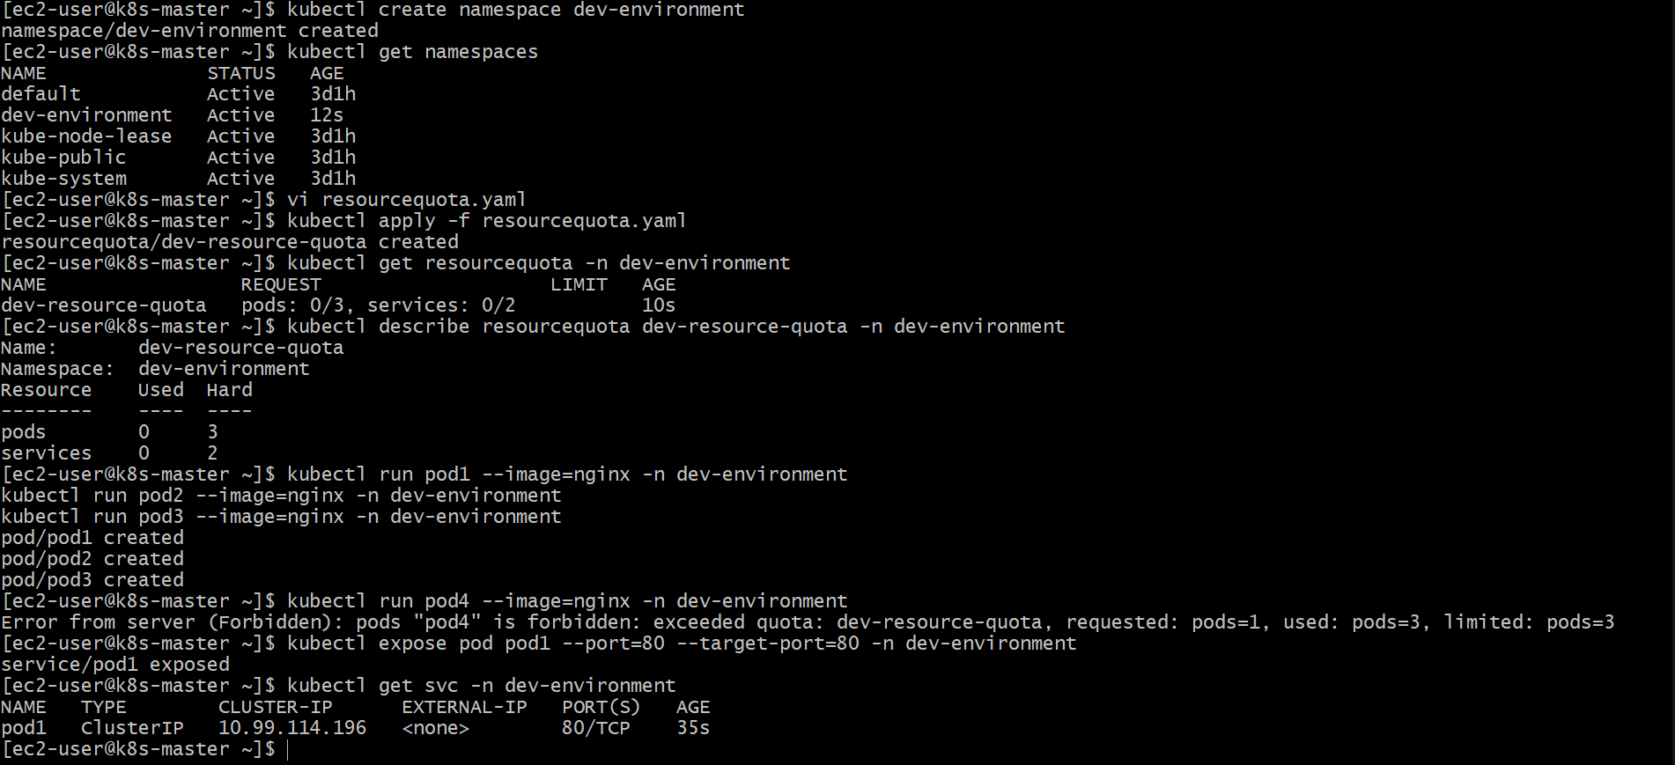

Create a Kubernetes Pod with Resource Requests and Limits
Objective
Create a Pod in the prod-environment namespace with the following resource configuration:
Resource | Request | Limit
CPU | 0.2 CPU | 0.5 CPU
Memory | 200Mi | 500Mi

Step 1: Create the Namespace
If the namespace does not already exist, create it:
kubectl create namespace prod-environment
Verify the namespace:
kubectl get namespaces

Step 2: Create the Pod YAML Manifest
Create a file named pod-resource.yaml:
apiVersion: v1
kind: Pod
metadata:
name: resource-demo-pod
namespace: prod-environment
spec:
containers:
- name: nginx-container
image: nginx
resources:
requests:
cpu: "0.2"
memory: "200Mi"
limits:
cpu: "0.5"
memory: "500Mi"

Step 3: Apply the Pod Configuration
Run:
kubectl apply -f pod-resource.yaml
Expected output:
pod/resource-demo-pod created

Step 4: Verify the Pod
Check the Pod status:
kubectl get pods -n prod-environment
Example output:
NAME READY STATUS AGE
resource-demo-pod 1/1 Running 30s

Step 5: Verify Resource Configuration
View the Pod details:
kubectl describe pod resource-demo-pod -n prod-environment
Expected resource section:
Requests:
cpu: 200m
memory: 200Mi

Limits:
cpu: 500m
memory: 500Mi

Result
The Pod resource-demo-pod has been successfully created in the prod-environment namespace with:
- CPU request: 0.2 CPU (200m)
- Memory request: 200Mi
- CPU limit: 0.5 CPU (500m)
- Memory limit: 500Mi
Kubernetes will reserve the requested resources for scheduling and prevent the container from exceeding the defined resource limits.
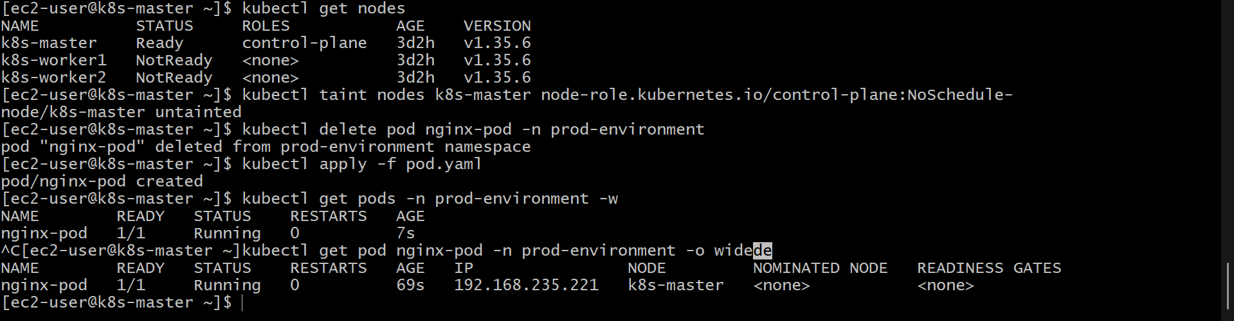
Configure Kubernetes LimitRange in staging-environment Namespace
Objective
Create a Kubernetes LimitRange in the staging-environment namespace that:
- Assigns default container limits:
  - CPU: 300m
  - Memory: 600Mi
- Enforces minimum and maximum CPU limits for containers.

Step 1: Create the Namespace
If the namespace does not exist, create it:
kubectl create namespace staging-environment
Verify the namespace:
kubectl get namespaces

Step 2: Create the LimitRange YAML Manifest
Create a file named limitrange.yaml:
apiVersion: v1
kind: LimitRange
metadata:
name: staging-resource-limits
namespace: staging-environment
spec:
limits:
- type: Container
default:
cpu: "300m"
memory: "600Mi"
min:
cpu: "100m"
max:
cpu: "1"

Step 3: Apply the LimitRange
Run:
kubectl apply -f limitrange.yaml
Expected output:
limitrange/staging-resource-limits created

Step 4: Verify the LimitRange
Check the LimitRange:
kubectl get limitrange -n staging-environment
View details:
kubectl describe limitrange staging-resource-limits -n staging-environment
Expected output:
Name: staging-resource-limits
Namespace: staging-environment

Type: Container
Default:
CPU: 300m
Memory: 600Mi

Min:
CPU: 100m

Max:
CPU: 1

Result
The staging-environment namespace now has a LimitRange configuration:
Resource | Configuration
Default CPU Limit | 300m
Default Memory Limit | 600Mi
Minimum CPU | 100m
Maximum CPU | 1 CPU
Any container created in this namespace without specified resource limits will automatically receive the default CPU and memory limits. Containers that request CPU outside the allowed range will be rejected by Kubernetes.
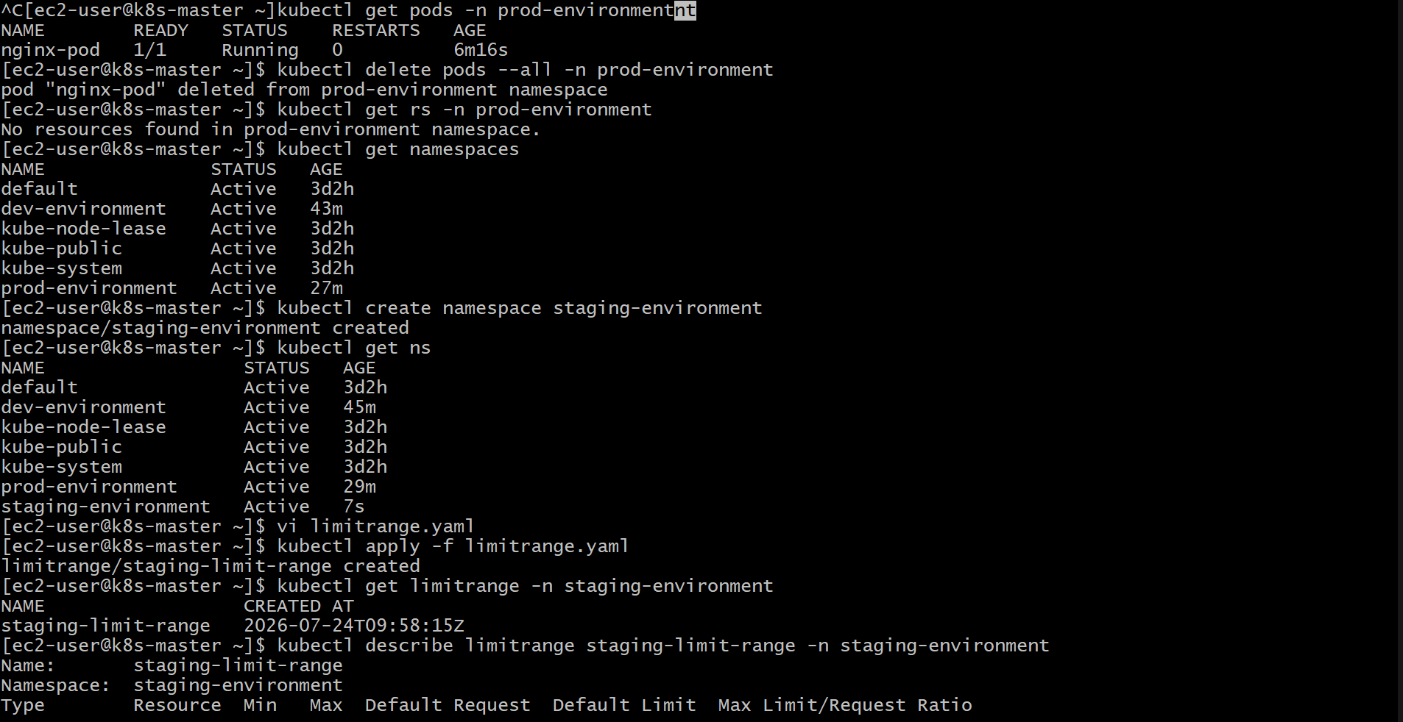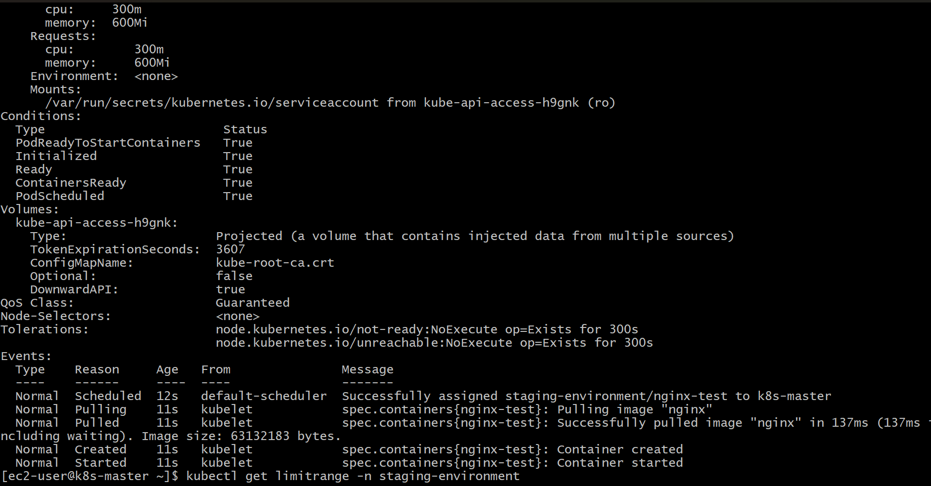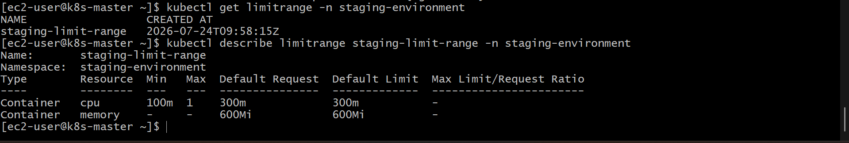

Kubernetes Service DNS Communication Between Namespaces
Objective
Perform the following tasks:
- Create a Pod in the default namespace.
- Create a NodePort Service to expose the Pod.
- Create another Pod in the test namespace.
- Communicate between the Pods using Kubernetes Service DNS.

Step 1: Create a Pod in the Default Namespace
Create a file named default-pod.yaml:
apiVersion: v1
kind: Pod
metadata:
name: nginx-default-pod
namespace: default
labels:
app: nginx
spec:
containers:
- name: nginx
image: nginx
ports:
- containerPort: 80
Apply the Pod:
kubectl apply -f default-pod.yaml
Verify:
kubectl get pods
Expected output:
NAME READY STATUS
nginx-default-pod 1/1 Running

Step 2: Create a NodePort Service in the Default Namespace
Create a file named nginx-nodeport.yaml:
apiVersion: v1
kind: Service
metadata:
name: nginx-service
namespace: default
spec:
type: NodePort
selector:
app: nginx
ports:
- port: 80
targetPort: 80
nodePort: 30080
Apply the Service:
kubectl apply -f nginx-nodeport.yaml
Verify:
kubectl get service
Example output:
NAME TYPE PORT(S)
nginx-service NodePort 80:30080/TCP

Step 3: Create the Test Namespace
Create the namespace:
kubectl create namespace test
Verify:
kubectl get namespaces

Step 4: Create a Pod in the Test Namespace
Create a file named test-pod.yaml:
apiVersion: v1
kind: Pod
metadata:
name: test-client-pod
namespace: test
spec:
containers:
- name: busybox
image: busybox
command:
- sleep
- "3600"
Apply:
kubectl apply -f test-pod.yaml
Verify:
kubectl get pods -n test
Expected output:
NAME READY STATUS
test-client-pod 1/1 Running

Step 5: Test Service DNS Communication
Kubernetes Service DNS format:
service-name.namespace.svc.cluster.local
The DNS name for the Nginx service is:
nginx-service.default.svc.cluster.local
Access the service from the test namespace Pod:
kubectl exec -it test-client-pod -n test -- sh
Inside the Pod, run:
wget -qO- nginx-service.default.svc.cluster.local
Expected output:
<!DOCTYPE html>
<html>
<head>
<title>Welcome to nginx!</title>
...
</html>
This confirms successful communication between namespaces using Service DNS.

Step 6: Verify DNS Resolution
Inside the test Pod:
nslookup nginx-service.default.svc.cluster.local
Example output:
Name: nginx-service.default.svc.cluster.local
Address: 10.x.x.x

Result
The Kubernetes environment now contains:
Component | Namespace | Purpose
nginx-default-pod | default | Application Pod
nginx-service | default | NodePort Service
test-client-pod | test | Client Pod
The Pod in the test namespace successfully communicates with the Pod in the default namespace using the Kubernetes Service DNS name:
nginx-service.default.svc.cluster.local
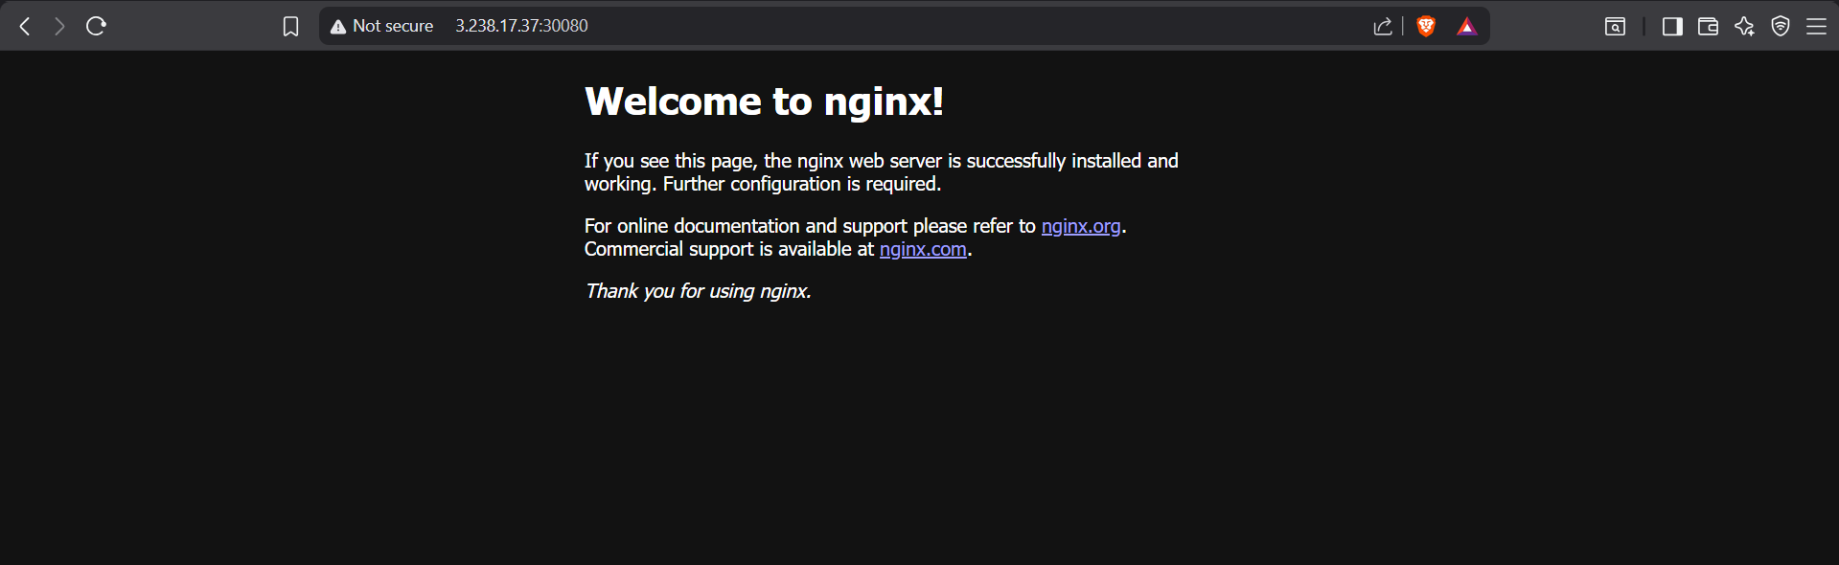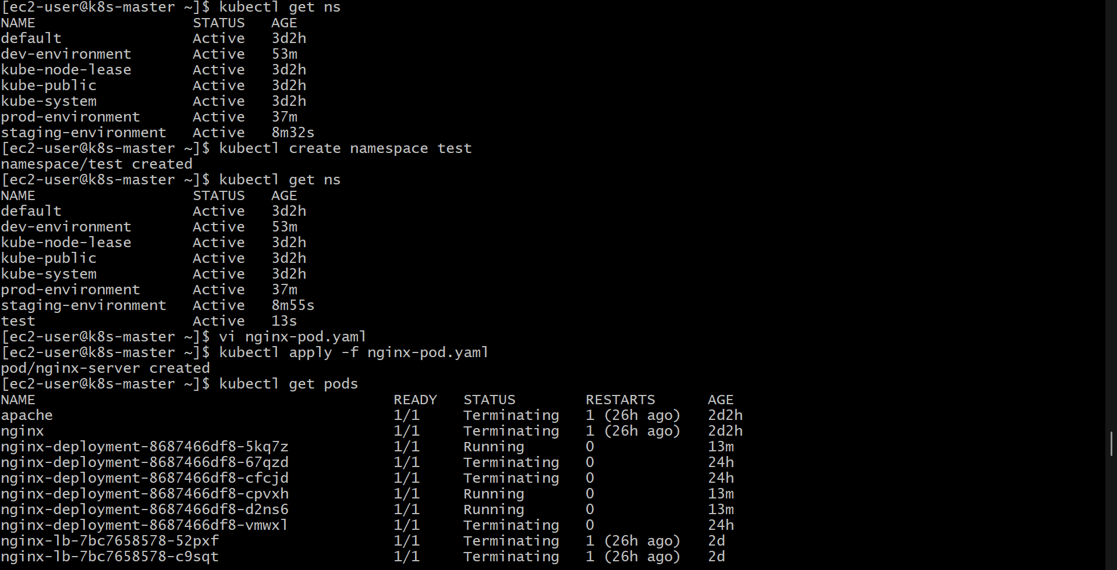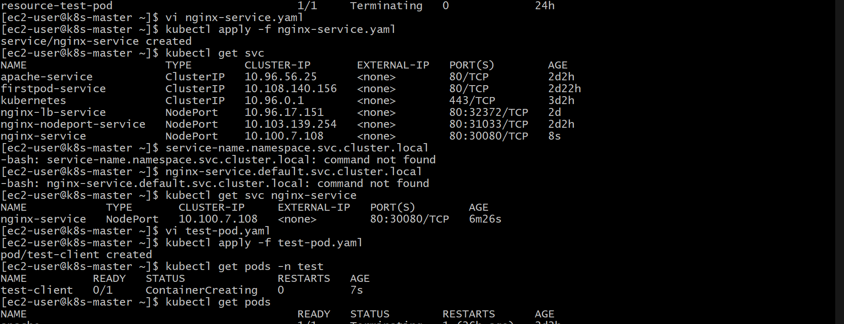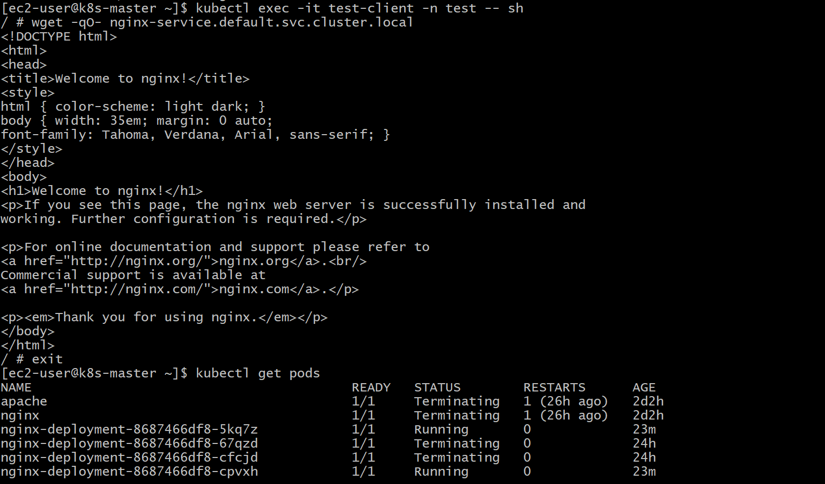
Configure Kubernetes LimitRange with Memory Limit/Request Ratio
Objective
Create a LimitRange in the performance-environment namespace that enforces a maximum memory limit/request ratio of 2.
Then test the configuration by creating a Pod with memory limits exceeding the allowed ratio.

Step 1: Create the Namespace
If the namespace does not exist, create it:
kubectl create namespace performance-environment
Verify:
kubectl get namespaces

Step 2: Create the LimitRange Configuration
Create a file named limitrange-memory-ratio.yaml:
apiVersion: v1
kind: LimitRange
metadata:
name: memory-ratio-limit
namespace: performance-environment
spec:
limits:
- type: Container
maxLimitRequestRatio:
memory: "2"
Explanation
- maxLimitRequestRatio.memory: "2" means:
Memory Limit / Memory Request <= 2
Examples:
Memory Request | Maximum Allowed Limit
200Mi | 400Mi
500Mi | 1Gi
1Gi | 2Gi

Step 3: Apply the LimitRange
Run:
kubectl apply -f limitrange-memory-ratio.yaml
Expected output:
limitrange/memory-ratio-limit created

Step 4: Verify the LimitRange
Check:
kubectl get limitrange -n performance-environment
View details:
kubectl describe limitrange memory-ratio-limit -n performance-environment
Expected output:
Type Resource Max Limit/Request Ratio
---- -------- ------------------------
Container memory 2

Step 5: Create a Pod with Invalid Memory Ratio
Create a file named invalid-memory-pod.yaml:
apiVersion: v1
kind: Pod
metadata:
name: invalid-memory-pod
namespace: performance-environment
spec:
containers:
- name: nginx
image: nginx
resources:
requests:
memory: "200Mi"
limits:
memory: "600Mi"
Ratio Calculation
Memory Limit / Memory Request

600Mi / 200Mi = 3
The allowed maximum ratio is:
2
Since:
3 > 2
Kubernetes should reject this Pod.

Step 6: Apply the Invalid Pod
Run:
kubectl apply -f invalid-memory-pod.yaml
Expected error:
Error from server (Forbidden):
Pod "invalid-memory-pod" is invalid:
memory max limit to request ratio per Container is 3, but the limit range requires it to be no greater than 2

Step 7: Create a Valid Pod
Create a corrected Pod manifest:
apiVersion: v1
kind: Pod
metadata:
name: valid-memory-pod
namespace: performance-environment
spec:
containers:
- name: nginx
image: nginx
resources:
requests:
memory: "200Mi"
limits:
memory: "400Mi"
Apply:
kubectl apply -f valid-memory-pod.yaml
Verify:
kubectl get pods -n performance-environment
Expected output:
NAME READY STATUS
valid-memory-pod 1/1 Running

Result
The performance-environment namespace now enforces:
Resource | Rule
Memory Limit/Request Ratio | Maximum 2
Testing confirmed:
- ❌ Pod with 600Mi limit and 200Mi request was rejected (ratio = 3)
- ✅ Pod with 400Mi limit and 200Mi request was accepted (ratio = 2)
The LimitRange successfully controls memory resource allocation ratios.
