Setup Minikube on Local Machine
Prerequisites
Before installing Minikube, make sure your system has:
- CPU: 2 or more cores
- RAM: Minimum 2 GB (4 GB+ recommended)
- Disk space: Minimum 20 GB free
- Internet connection
- Virtualization enabled in BIOS
You also need:
- kubectl installed
- A container runtime or hypervisor:
  - Docker (recommended)
  - VirtualBox
  - Hyper-V (Windows)

Step 1: Install kubectl
Linux
Download kubectl:
curl -LO "https://dl.k8s.io/release/$(curl -L -s https://dl.k8s.io/release/stable.txt)/bin/linux/amd64/kubectl"
Install:
sudo install -o root -g root -m 0755 kubectl /usr/local/bin/kubectl
Verify:
kubectl version --client

Step 2: Install Docker
Linux (Ubuntu)
Update packages:
sudo apt update
Install Docker:
sudo apt install docker.io -y
Start Docker:
sudo systemctl start docker
Enable Docker at boot:
sudo systemctl enable docker
Check Docker:
docker --version
Test Docker:
docker ps

Step 3: Install Minikube
Linux
Download Minikube:
curl -LO https://storage.googleapis.com/minikube/releases/latest/minikube-linux-amd64
Install Minikube:
sudo install minikube-linux-amd64 /usr/local/bin/minikube
Verify installation:
minikube version

Step 4: Start Minikube Cluster
Start Minikube using Docker driver:
minikube start --driver=docker
Expected output:
Done! kubectl is now configured to use "minikube" cluster

Step 5: Check Minikube Status
Run:
minikube status
Expected output:
host: Running
kubelet: Running
apiserver: Running
kubeconfig: Configured

Step 6: Verify Kubernetes Cluster
Check nodes:
kubectl get nodes
Expected output:
NAME STATUS ROLES AGE
minikube Ready control-plane 1m
Check cluster information:
kubectl cluster-info

Step 7: Open Kubernetes Dashboard (Optional)
Enable dashboard:
minikube dashboard
This opens the Kubernetes dashboard in your browser.

Step 8: Test Minikube with NGINX Pod
Create an NGINX pod:
kubectl run nginx --image=nginx
Check pod status:
kubectl get pods
Expected output:
NAME READY STATUS RESTARTS AGE
nginx 1/1 Running 0 30s
Expose the pod:
kubectl expose pod nginx --type=NodePort --port=80
Access NGINX:
minikube service nginx
A browser window will open with the NGINX page.

Step 9: Stop Minikube
To stop the cluster:
minikube stop

Step 10: Delete Minikube Cluster
To remove the cluster completely:
minikube delete

Useful Minikube Commands
Check status:
minikube status
View cluster IP:
minikube ip
SSH into Minikube node:
minikube ssh
List Minikube profiles:
minikube profile list
Start Minikube:
minikube start
Stop Minikube:
minikube stop
Delete Minikube:
minikube delete

Complete Installation Verification
Run these commands:
minikube version

kubectl version --client

minikube start --driver=docker

kubectl get nodes

kubectl get pods -A
If the node status is Ready, Minikube setup is completed successfully.
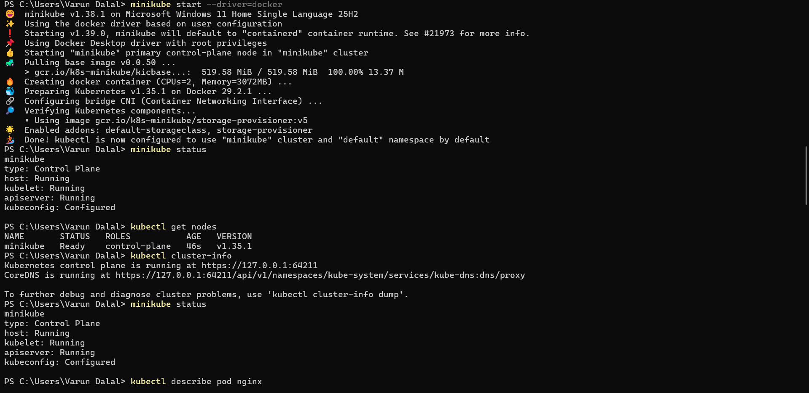

2.Setup Kubernetes (K8s) Master and Two Worker Nodes on Ubuntu
Architecture
We will create a Kubernetes cluster with:
Node | Hostname | Role
Master Node | k8s-master | Control Plane
Worker Node 1 | k8s-worker1 | Worker
Worker Node 2 | k8s-worker2 | Worker
Example IP addresses:
k8s-master 192.168.1.10
k8s-worker1 192.168.1.11
k8s-worker2 192.168.1.12
Requirements:
- Ubuntu 22.04/24.04
- Minimum 2 CPU and 2 GB RAM per node
- Root or sudo access
- All nodes can communicate with each other
- Unique hostname for each node

Step 1: Update All Nodes
Run on master and both worker nodes:
sudo apt update
sudo apt upgrade -y

Step 2: Set Hostnames
On Master Node
sudo hostnamectl set-hostname k8s-master
On Worker Node 1
sudo hostnamectl set-hostname k8s-worker1
On Worker Node 2
sudo hostnamectl set-hostname k8s-worker2
Logout and login again.

Step 3: Configure Host Resolution
Run on all nodes:
sudo nano /etc/hosts
Add:
192.168.1.10 k8s-master
192.168.1.11 k8s-worker1
192.168.1.12 k8s-worker2
Save the file.
Test connectivity:
ping k8s-master
ping k8s-worker1
ping k8s-worker2

Step 4: Disable Swap on All Nodes
Kubernetes requires swap to be disabled.
Run:
sudo swapoff -a
Disable permanently:
sudo sed -i '/ swap / s/^/#/' /etc/fstab
Verify:
free -h
Swap should show 0.

Step 5: Load Required Kernel Modules
Run on all nodes:
sudo modprobe overlay
sudo modprobe br_netfilter
Make permanent:
cat <<EOF | sudo tee /etc/modules-load.d/k8s.conf
overlay
br_netfilter
EOF

Step 6: Configure Network Parameters
Run on all nodes:
cat <<EOF | sudo tee /etc/sysctl.d/k8s.conf
net.bridge.bridge-nf-call-ip6tables = 1
net.bridge.bridge-nf-call-iptables = 1
net.ipv4.ip_forward = 1
EOF
Apply:
sudo sysctl --system

Step 7: Install Container Runtime (containerd)
Run on all nodes:
Install packages:
sudo apt install -y containerd
Create configuration:
sudo mkdir -p /etc/containerd
Generate config:
containerd config default | sudo tee /etc/containerd/config.toml
Enable Systemd cgroup:
sudo sed -i 's/SystemdCgroup = false/SystemdCgroup = true/' /etc/containerd/config.toml
Restart containerd:
sudo systemctl restart containerd
Enable at boot:
sudo systemctl enable containerd
Check status:
sudo systemctl status containerd

Step 8: Install Kubernetes Components
Run on all nodes:
Install required packages:
sudo apt install -y apt-transport-https ca-certificates curl
Add Kubernetes repository key:
curl -fsSL https://pkgs.k8s.io/core:/stable:/v1.30/deb/Release.key | sudo gpg --dearmor -o /etc/apt/keyrings/kubernetes.gpg
Add repository:
echo "deb [signed-by=/etc/apt/keyrings/kubernetes.gpg] https://pkgs.k8s.io/core:/stable:/v1.30/deb/ /" | sudo tee /etc/apt/sources.list.d/kubernetes.list
Install Kubernetes:
sudo apt update
sudo apt install -y kubelet kubeadm kubectl
Hold versions:
sudo apt-mark hold kubelet kubeadm kubectl
Enable kubelet:
sudo systemctl enable kubelet

Step 9: Initialize Kubernetes Master Node
Run only on master node:
sudo kubeadm init --pod-network-cidr=192.168.0.0/16
At the end, you will see a command similar to:
kubeadm join 192.168.1.10:6443 --token xxxxxx \
--discovery-token-ca-cert-hash sha256:xxxxxxxx
Copy this command. It will be used on worker nodes.

Step 10: Configure kubectl on Master
Run on master:
mkdir -p $HOME/.kube
Copy admin configuration:
sudo cp -i /etc/kubernetes/admin.conf $HOME/.kube/config
Set permissions:
sudo chown $(id -u):$(id -g) $HOME/.kube/config
Verify:
kubectl get nodes

Step 11: Install Pod Network (Calico)
Run on master:
kubectl apply -f https://docs.projectcalico.org/manifests/calico.yaml
Check:
kubectl get pods -n kube-system

Step 12: Join Worker Nodes
Run the join command copied from Step 9.
Example:
sudo kubeadm join 192.168.1.10:6443 --token xxxxxx \
--discovery-token-ca-cert-hash sha256:xxxxxxxx
Run this command on:
- k8s-worker1
- k8s-worker2

Step 13: Verify Cluster
Run on master:
kubectl get nodes
Expected output:
NAME STATUS ROLES AGE
k8s-master Ready control-plane 10m
k8s-worker1 Ready <none> 5m
k8s-worker2 Ready <none> 5m

Step 14: Deploy Test Application
Create NGINX deployment:
kubectl create deployment nginx --image=nginx
Check deployment:
kubectl get deployments
Check pods:
kubectl get pods -o wide
Expose service:
kubectl expose deployment nginx --type=NodePort --port=80
Check service:
kubectl get svc

Step 15: Remove Worker Node (Optional)
On worker node:
sudo kubeadm reset
On master:
kubectl delete node k8s-worker1
kubectl delete node k8s-worker2

Useful Kubernetes Commands
Check nodes:
kubectl get nodes
Check all pods:
kubectl get pods -A
Cluster information:
kubectl cluster-info
View services:
kubectl get svc
View deployments:
kubectl get deployments

Kubernetes Cluster Setup Completed
You now have:
- 1 Kubernetes control-plane node
- 2 worker nodes
- containerd runtime
- kubeadm-based Kubernetes cluster
- Calico networking
- Working kubectl access
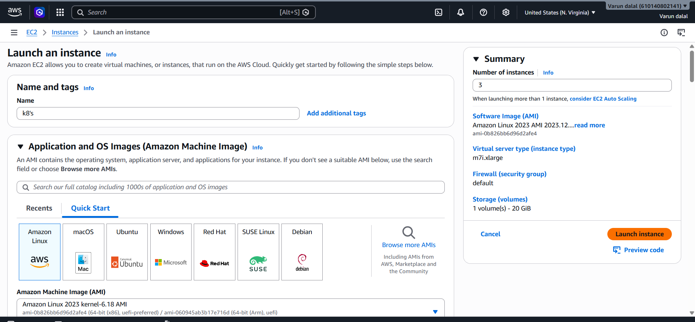
Master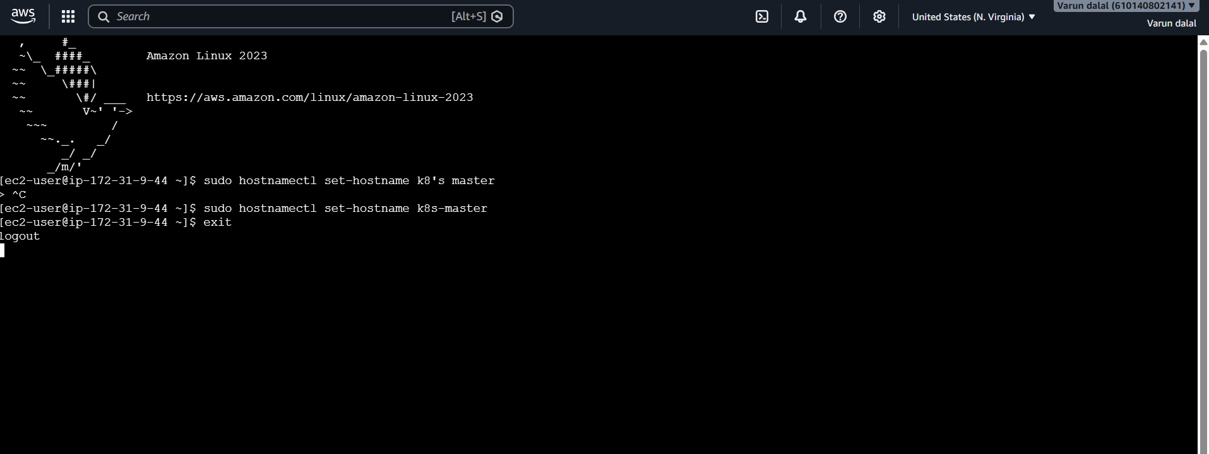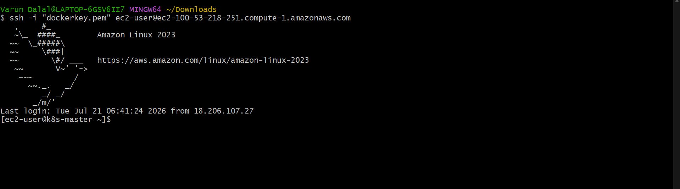
Worker-1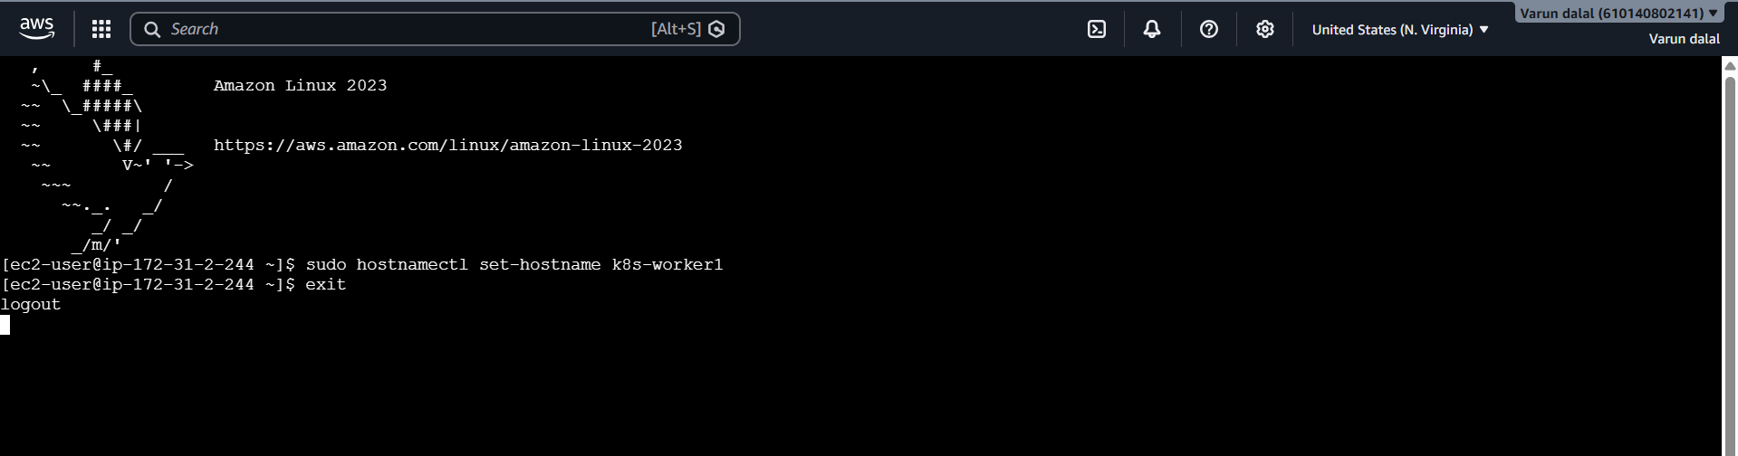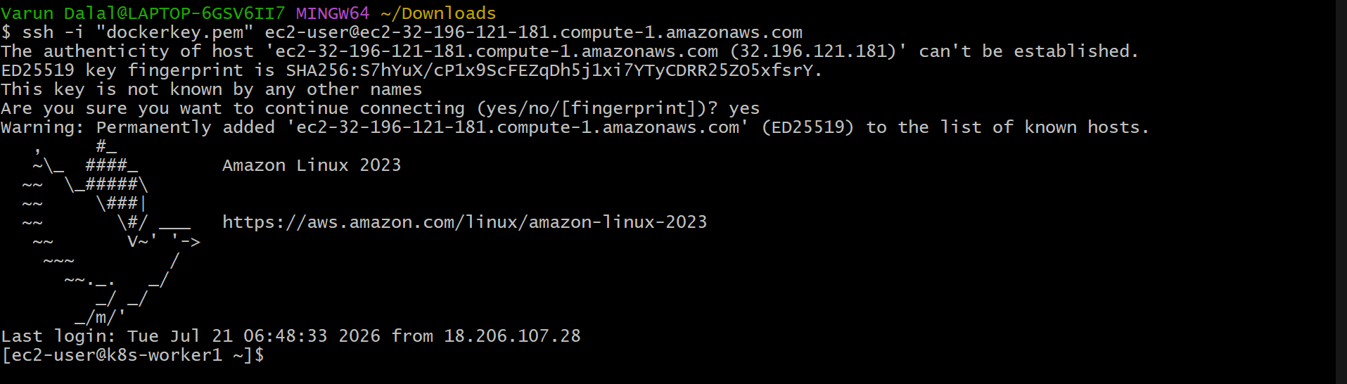
Worker-2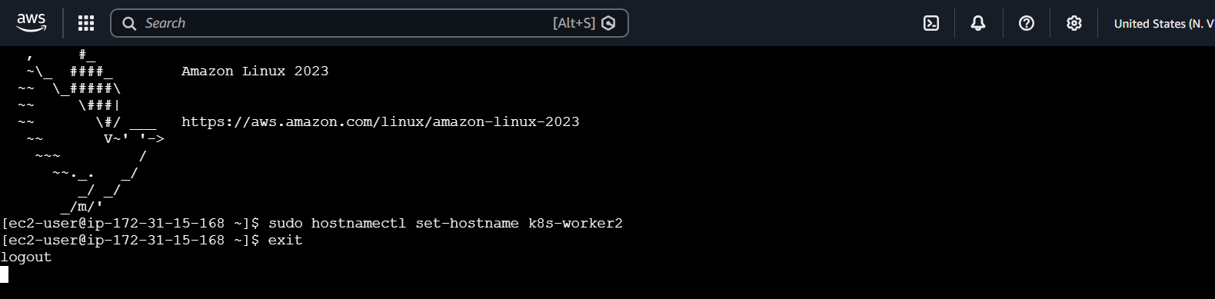
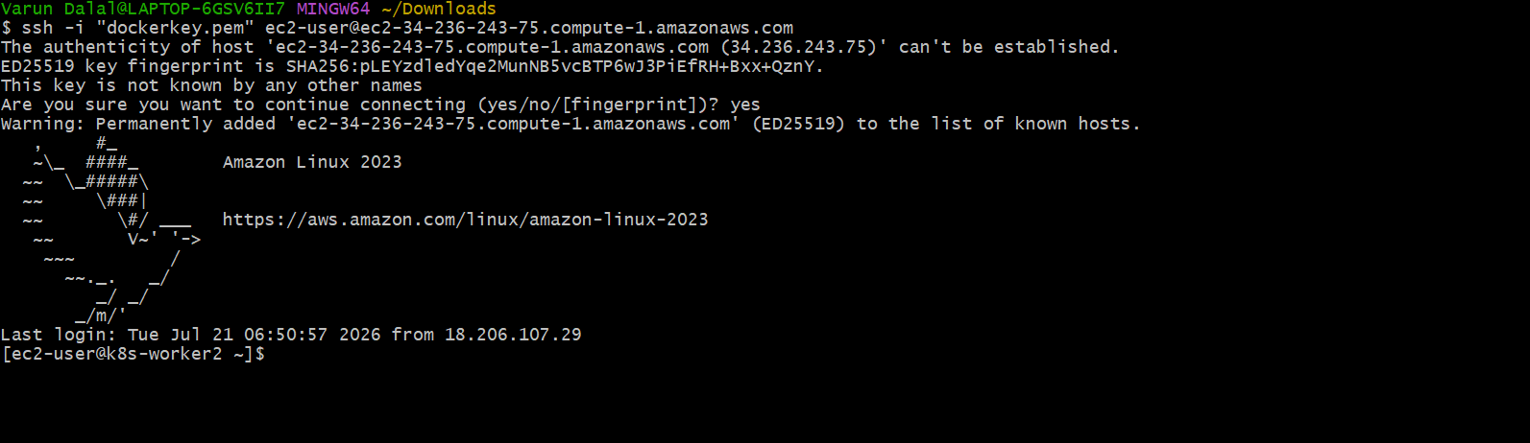
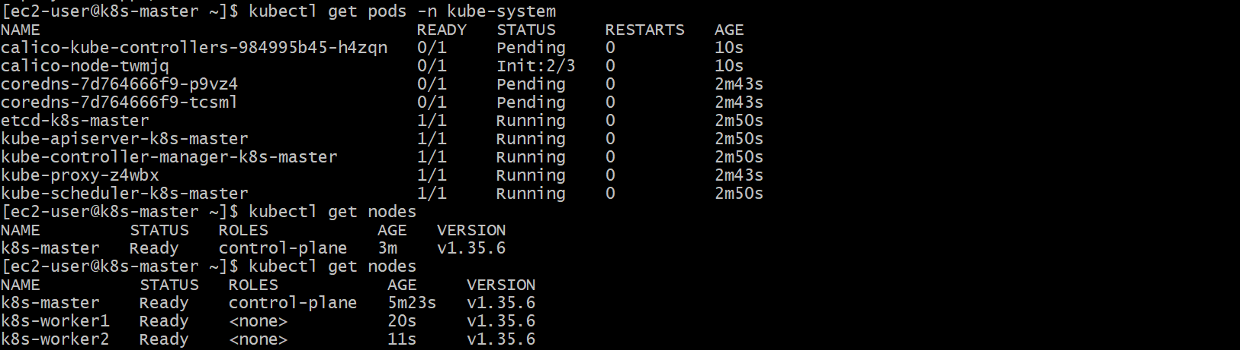

Task 3: Run One Nginx Pod
Objective
Deploy a single Nginx Pod in your Minikube Kubernetes cluster and verify that it is running successfully.
Steps Performed
1. Verified the Kubernetes cluster.
2. Created an Nginx Pod using the official Nginx image.
3. Verified the Pod reached the Running state.
4. Retrieved Pod details and IP address.
5. Accessed the Pod shell and verified the Nginx installation.
6. Exposed the Pod using a NodePort Service.
7. Accessed the Nginx welcome page through Minikube.
Commands used kubectl get nodes kubectl get pods kubectl run nginx –image=nginx kubectl get pod
Get Detailed Pod Information
Run:
kubectl describe pod nginx
Get the Pod IP Address
Run:
kubectl get pods -o wide
Execute Commands Inside the Pod
Open a shell inside the Nginx container:
kubectl exec -it nginx -- /bin/bash
Expose the Pod
Create a NodePort Service:
kubectl expose pod nginx --type=NodePort --port=80
Open Nginx in the Browser
Run:
minikube service nginx
This opens the Nginx welcome page in your default browser.
Validation
· Pod status is Running.
· Service is created successfully.
· Nginx is reachable in a web browser.
· kubectl commands execute without errors.
Outcome
A single Nginx Pod was successfully deployed on the Minikube Kubernetes cluster. The Pod is running, accessible through a NodePort Service, and serves the default Nginx web page, demonstrating successful application deployment on Kubernetes.

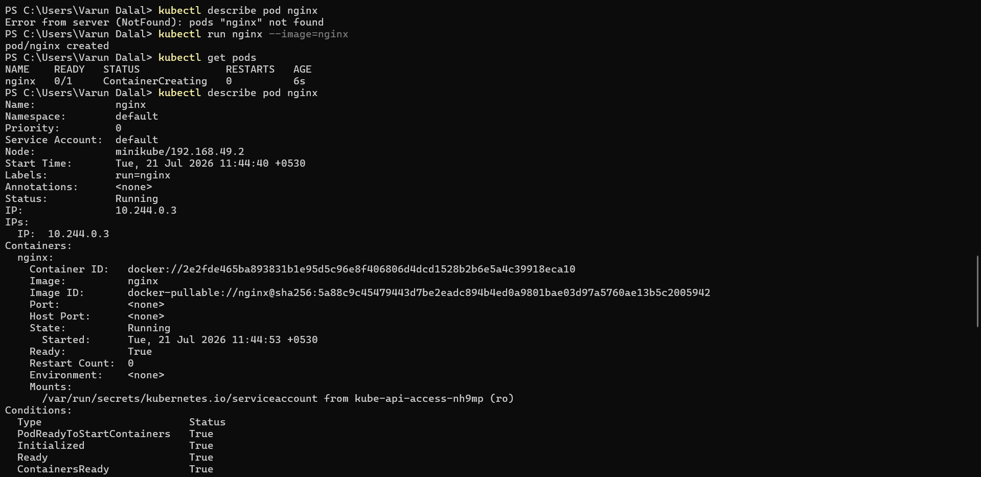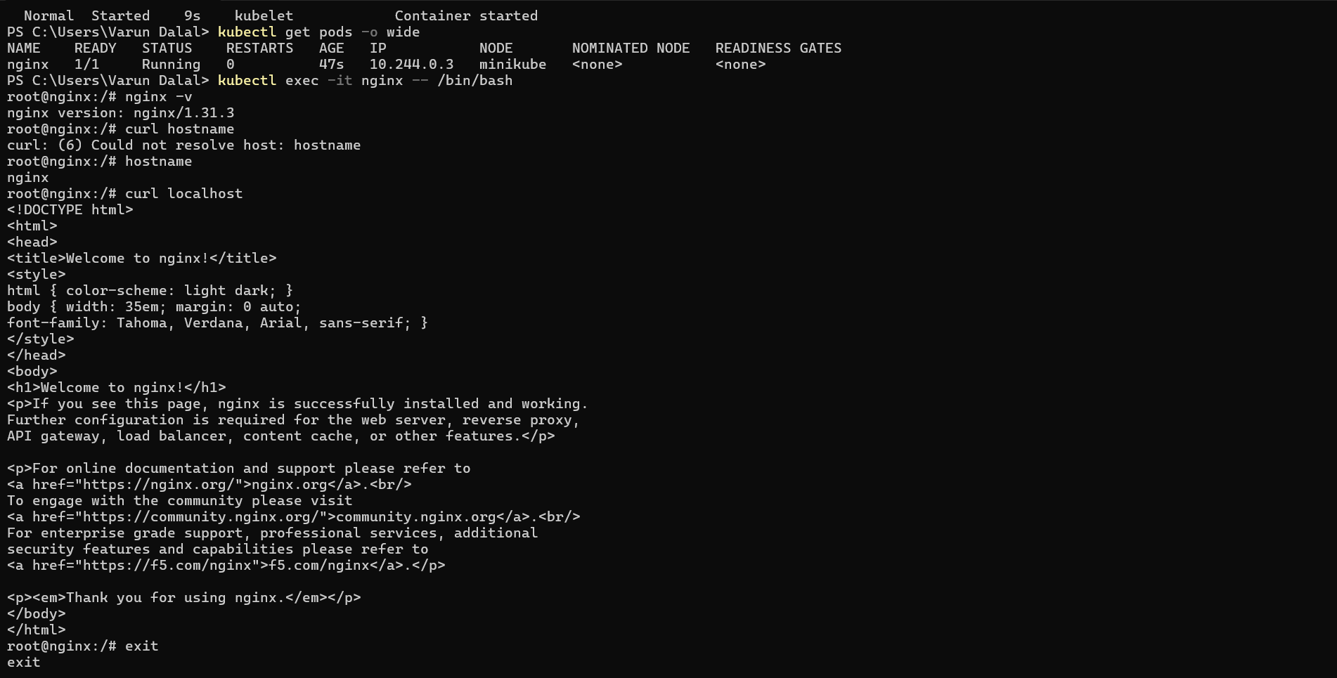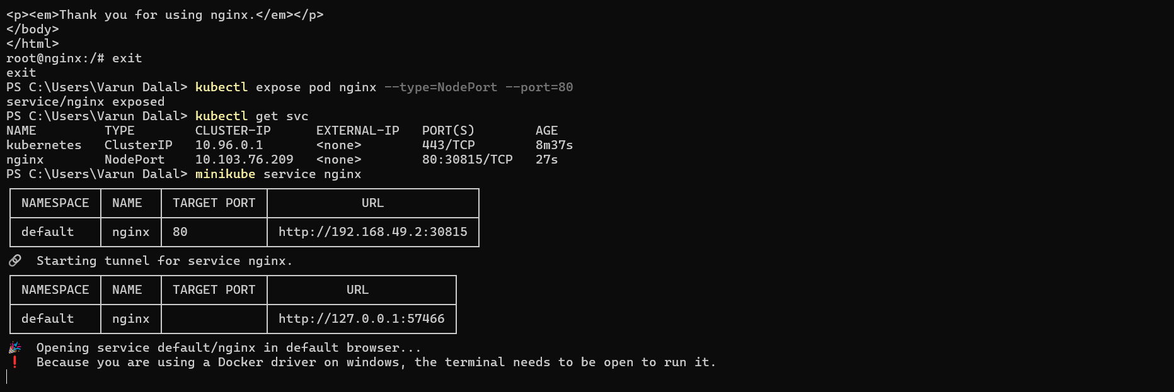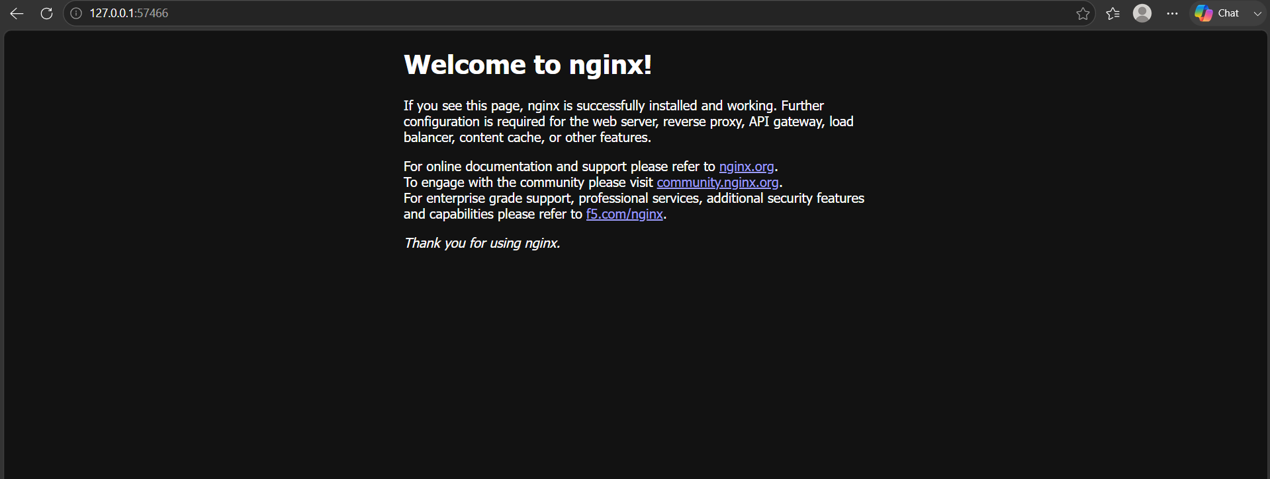

Here is a clean document format you can copy and paste:
Kubernetes Master (Control Plane) and Worker Node Components
Kubernetes Master / Control Plane Components
The Kubernetes Master (Control Plane) manages the Kubernetes cluster. It makes decisions about scheduling, maintaining the desired state, and controlling cluster operations.

1. kube-apiserver (API Server)
Role: Communication gateway of Kubernetes.
Functions:
- Acts as the entry point for all Kubernetes operations.
- Receives requests from kubectl and other components.
- Validates and processes API requests.
- Communicates with all Kubernetes components.
Memory Tip:
API Server = Front door of Kubernetes.

2. etcd
Role: Kubernetes database.
Functions:
- Stores the complete cluster state.
- Stores information about:
  - Nodes
  - Pods
  - Services
  - Configurations
  - Secrets
- Maintains consistency of cluster data.
Memory Tip:
etcd = Memory of Kubernetes.

3. kube-scheduler
Role: Pod placement manager.
Functions:
- Decides which worker node should run a pod.
- Checks:
  - CPU availability
  - Memory resources
  - Node requirements
  - Scheduling rules
Memory Tip:
Scheduler = Decides where pods run.

4. kube-controller-manager
Role: Maintains the desired cluster state.
Functions:
- Runs different controllers.
- Continuously monitors the cluster.
- Takes corrective actions when required.
Examples:
- Node Controller
- Deployment Controller
- ReplicaSet Controller
Memory Tip:
Controller = Keeps actual state equal to desired state.

5. Cloud Controller Manager (Optional)
Role: Cloud provider integration.
Functions:
- Connects Kubernetes with cloud platforms.
- Manages:
  - Load balancers
  - Cloud storage
  - Network routes
  - Cloud node lifecycle
Examples:
- AWS
- Azure
- Google Cloud

Kubernetes Worker Node Components
Worker nodes run the application workloads (Pods).

1. kubelet
Role: Node-level agent.
Functions:
- Runs on every worker node.
- Communicates with kube-apiserver.
- Ensures containers are running as instructed.
- Creates and manages pods.
Example:
If the master instructs a worker node to run an nginx pod, kubelet creates and manages that pod.
Memory Tip:
kubelet = Manager of pods on a node.

2. kube-proxy
Role: Network communication manager.
Functions:
- Runs on every worker node.
- Maintains network rules.
- Enables communication between:
  - Pods
  - Services
  - External users
Memory Tip:
kube-proxy = Kubernetes networking.

3. Container Runtime
Role: Runs containers.
Examples:
- containerd
- CRI-O
Functions:
- Pulls container images.
- Creates containers.
- Starts and stops containers.
Memory Tip:
Container Runtime = Engine that runs containers.

Kubernetes Architecture Overview
CONTROL PLANE (MASTER)

kube-apiserver
|
---------------------------------
| | |
etcd kube-scheduler controller-manager

|
Kubernetes API
|
---------------------------------

WORKER NODE 1 WORKER NODE 2

kubelet kubelet
kube-proxy kube-proxy
container runtime container runtime

Pods Pods

Interview Quick Revision
Master Components:
A E S C C
A - kube-apiserver
E - etcd
S - kube-scheduler
C - kube-controller-manager
C - cloud-controller-manager
Worker Components:
K K C
K - kubelet
K - kube-proxy
C - Container Runtime

