1.Create name user techie and provide sudo access
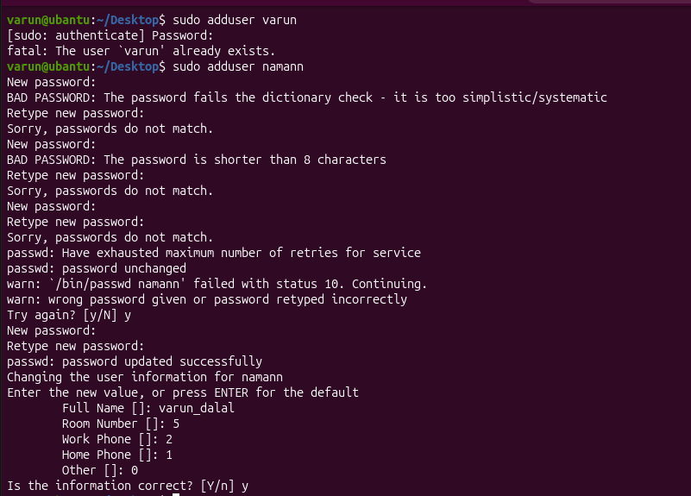

2 .Navigate to the home directory
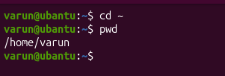
3. Create a new directory
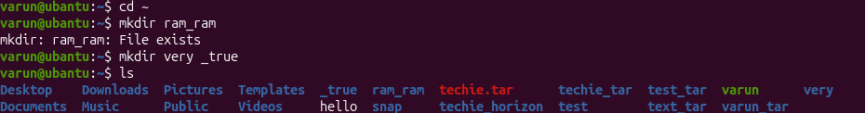
4. List the contents of a directory
5. Change the current directory
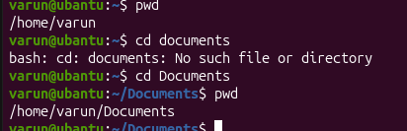
6. Create a new empty file. command step by step
7. View the contents of a file


8. Copy a file to another location
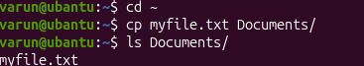
9. Move a file to another location.
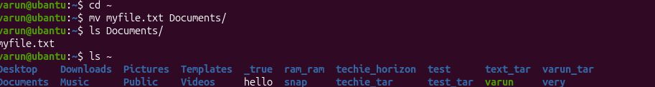
10. Rename a file.
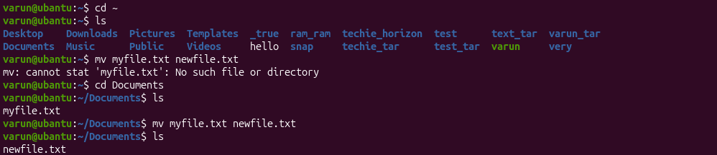
11.Delete a file
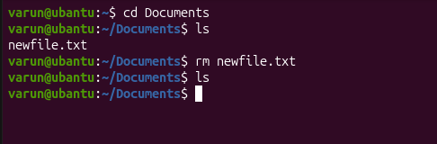
12. Grant or revoke permissions on a file or directory.
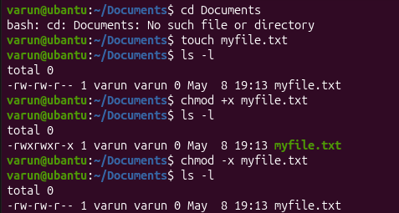
13. View the current date and time.
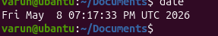
14. Check the system uptime
15. View the running processes.
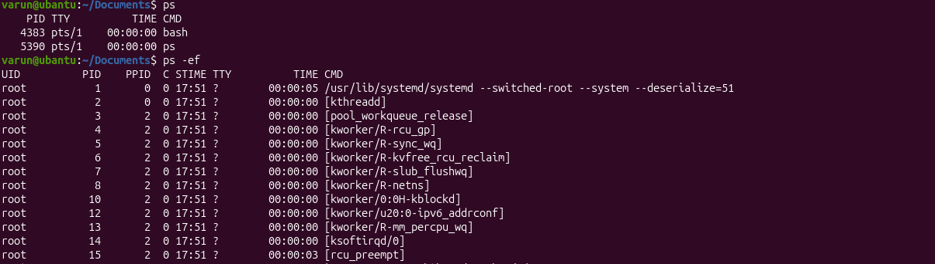
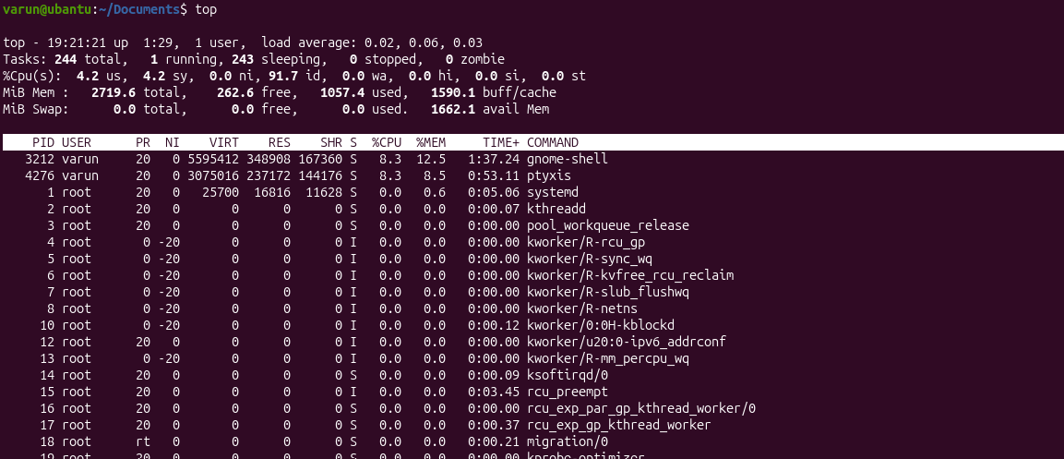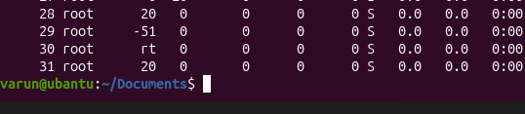
16. Kill a running process.
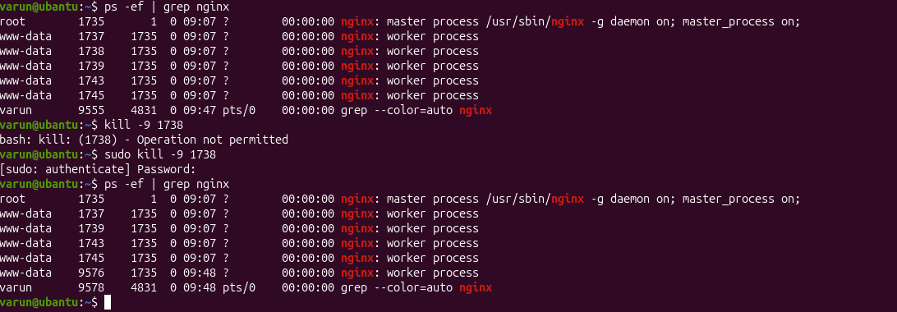

17. Install a package using the package manager (e.g., apt or yum).
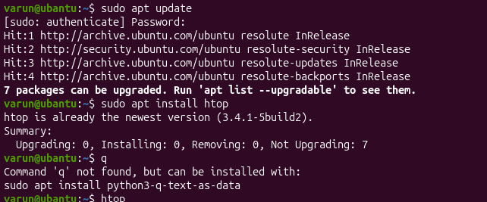
18. Update the system packages
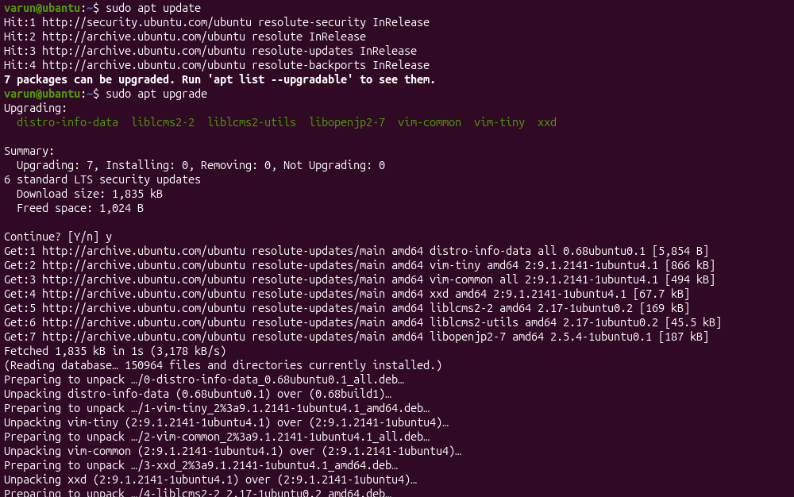
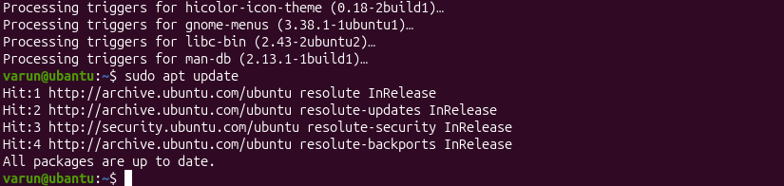

19. Create a symbolic link.
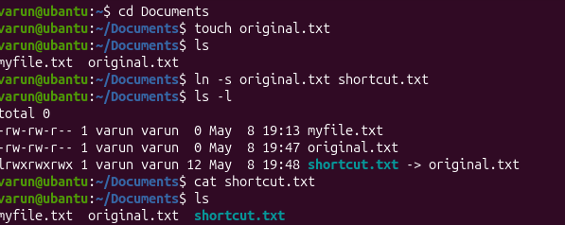

20. Search for files using the find command
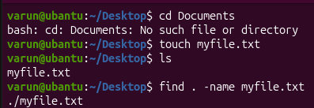
21. Compress and decompress files using tar
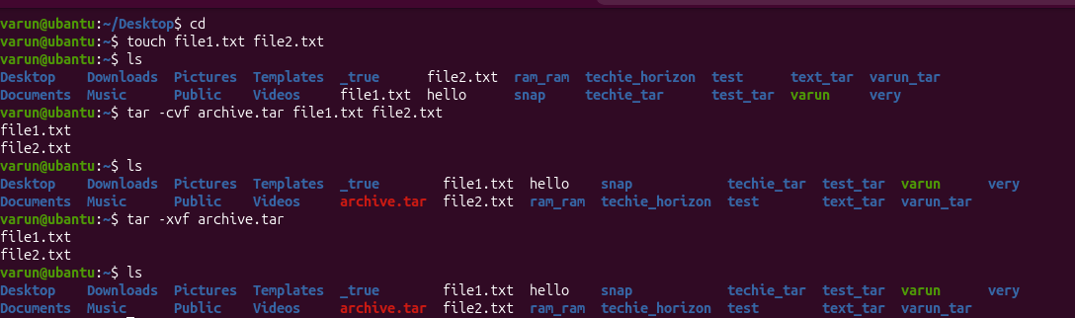
22. Monitor system resources with top or htop

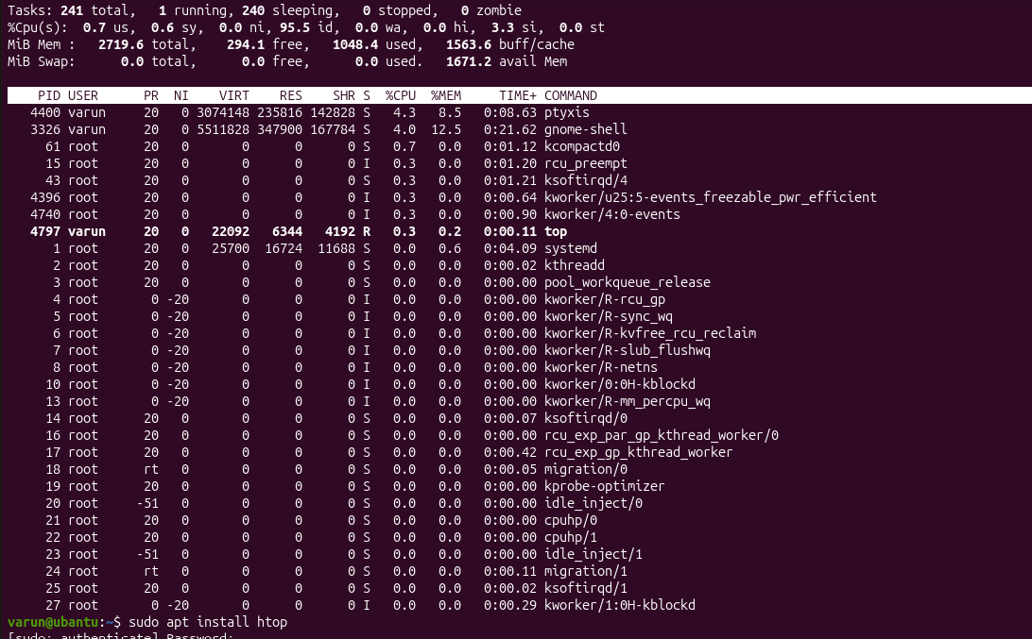
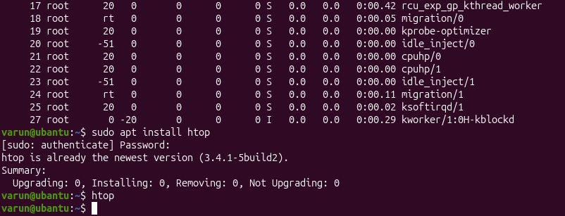
23. Create and manage user groups
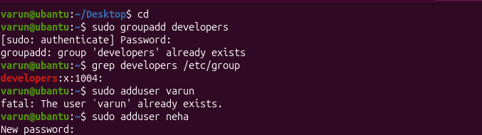
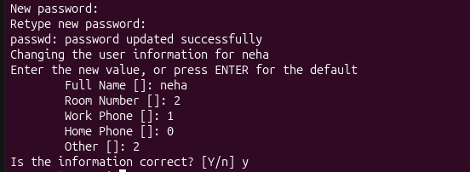

25. Monitor log files using tail or grep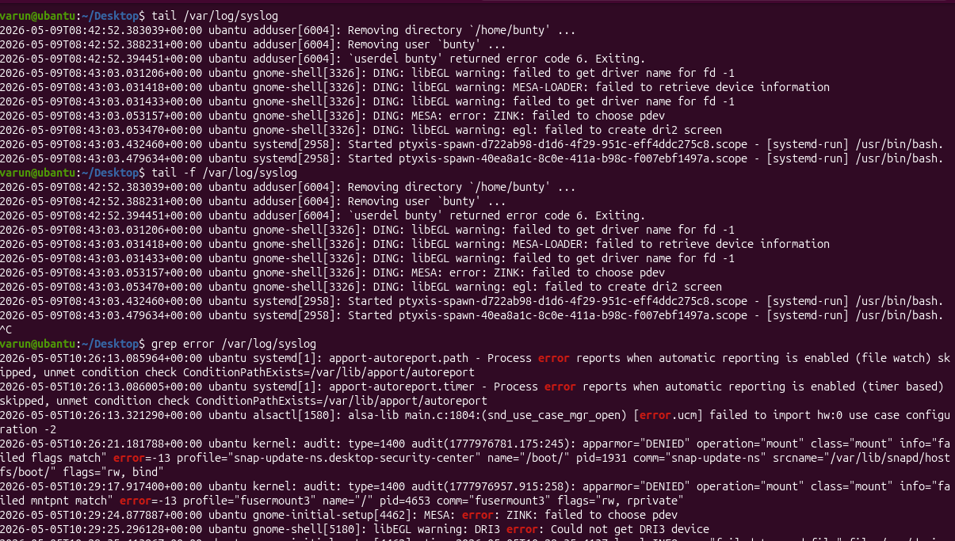
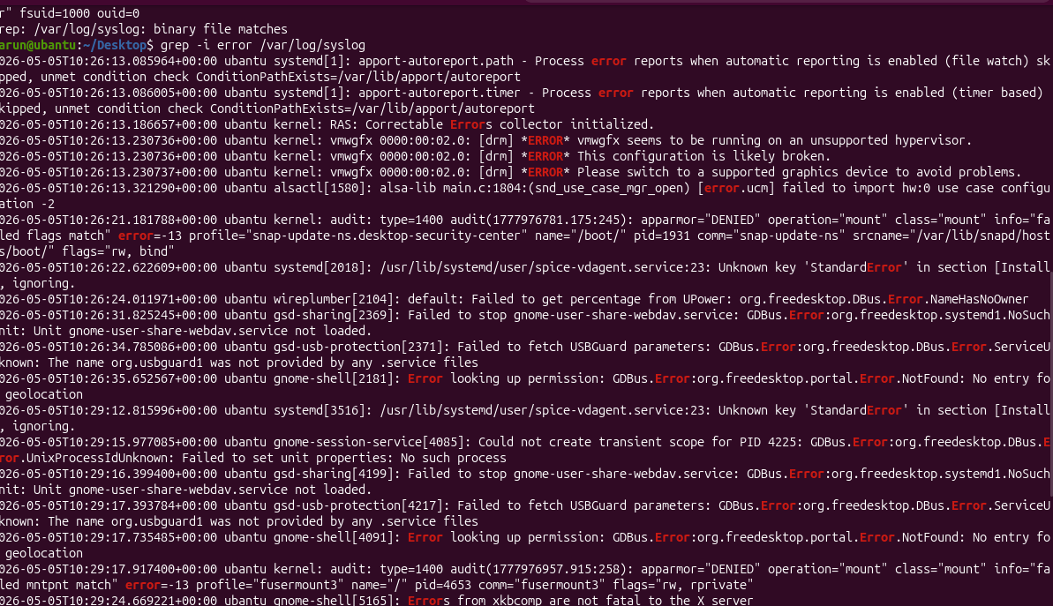
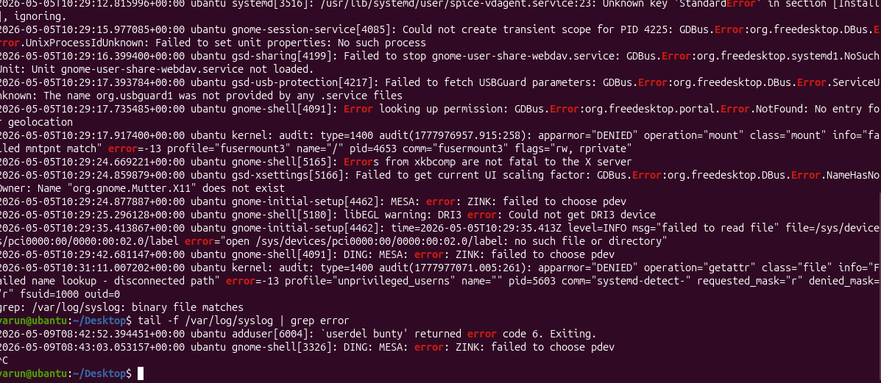
26. Set up a web server (e.g., Apache or Nginx)
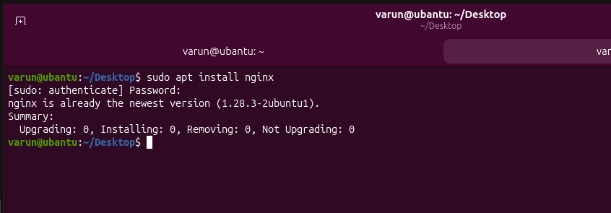

27. Configure and secure a MySQL Database
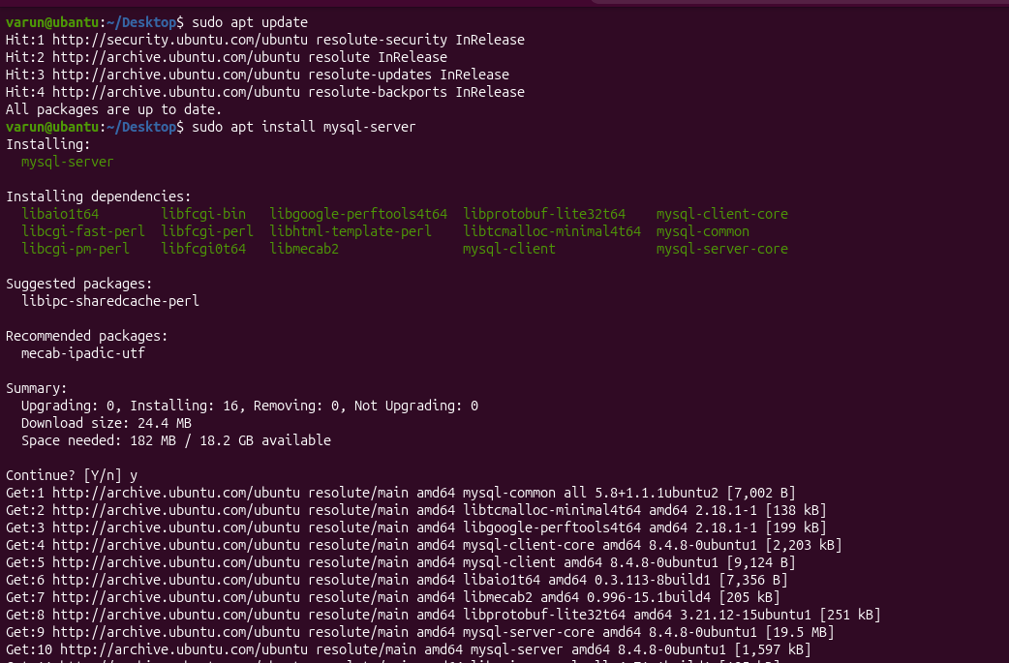
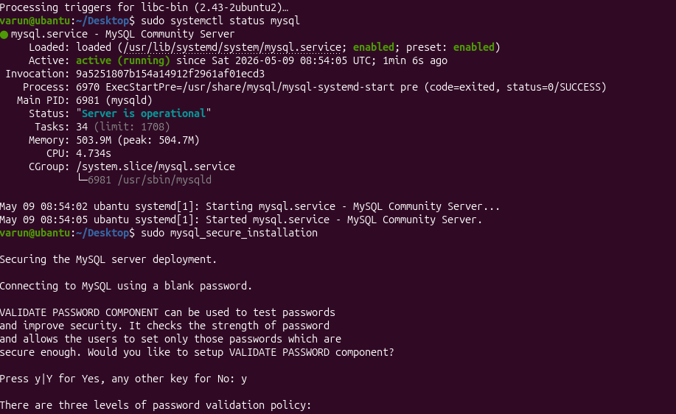
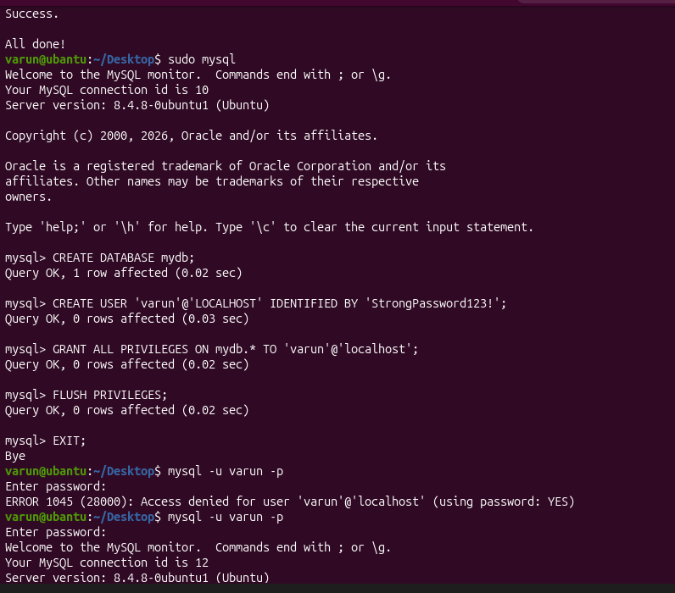
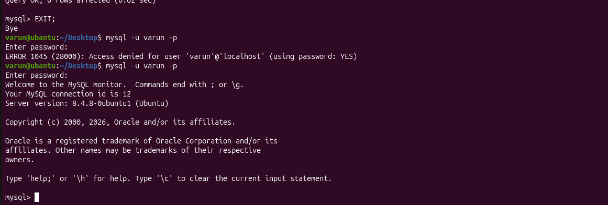

28.Set up an application server
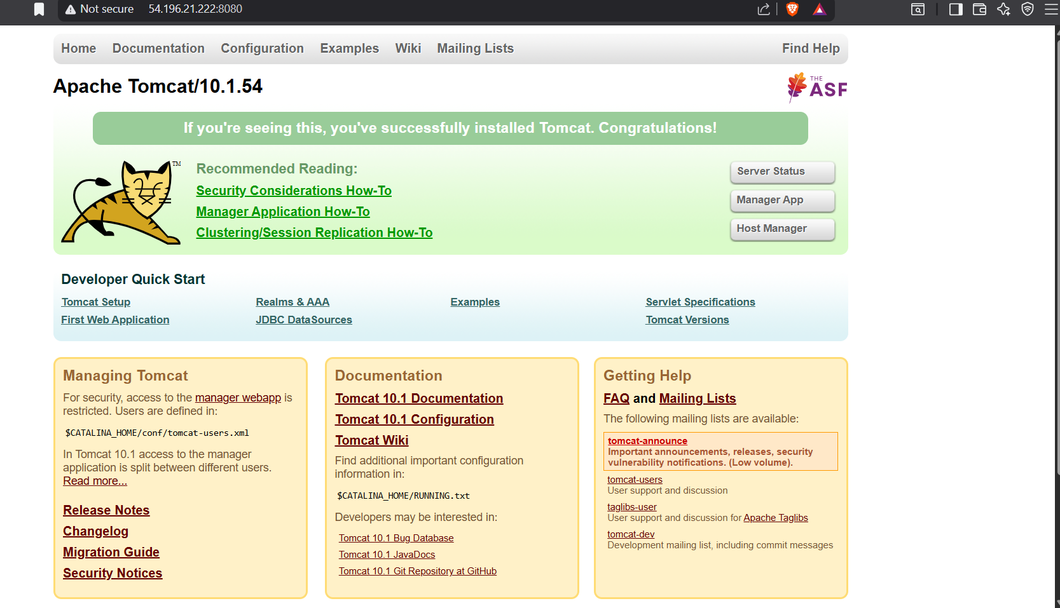

30. Print specific columns from a delimited file
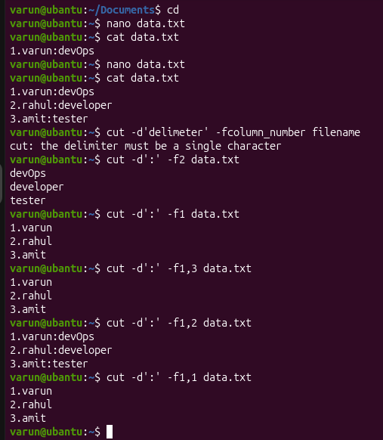

31.Filter and print lines based on a specific pattern or condition

32. Calculate and print the average, sum, or other statistics of a column.
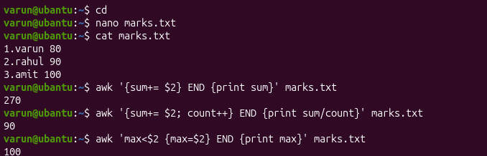

33. Perform string manipulation, such as extracting substrings or changing case
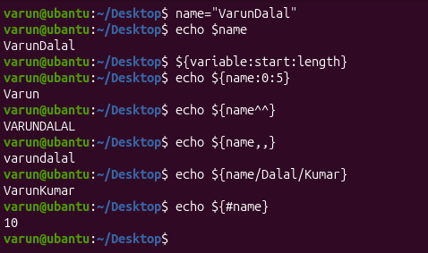
34. Count the occurrences of a specific pattern in a file.
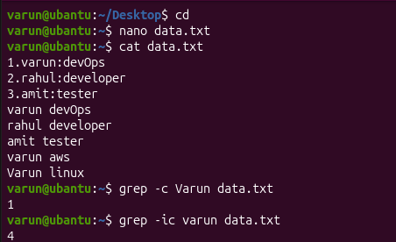

35. Sort lines based on a specific field or column.
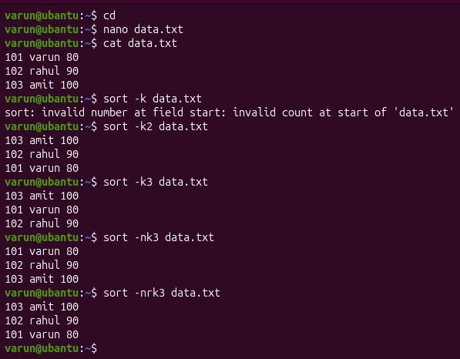
36. Merge multiple files based on a common field or column
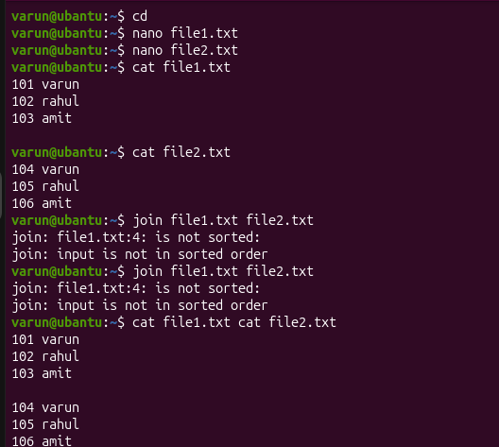

37. Substitute text in a file using search and replace
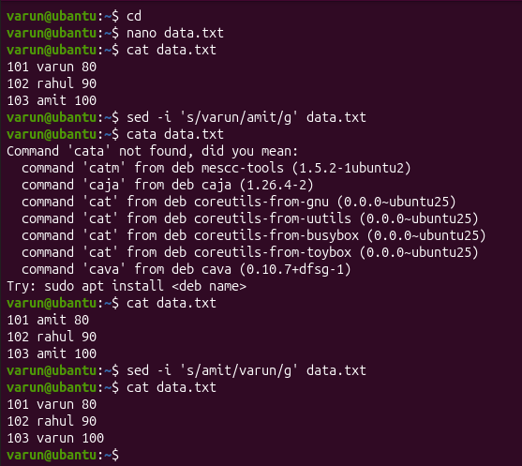
38. Delete specific lines based on a pattern or line number
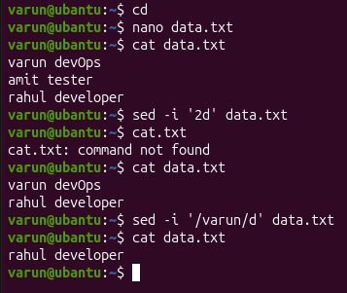

39. Append or insert text before or after a specific pattern or line.
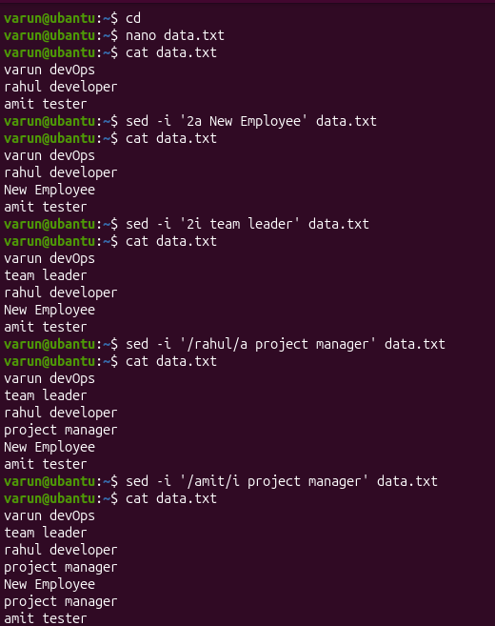

40. Print only specific lines from a file.
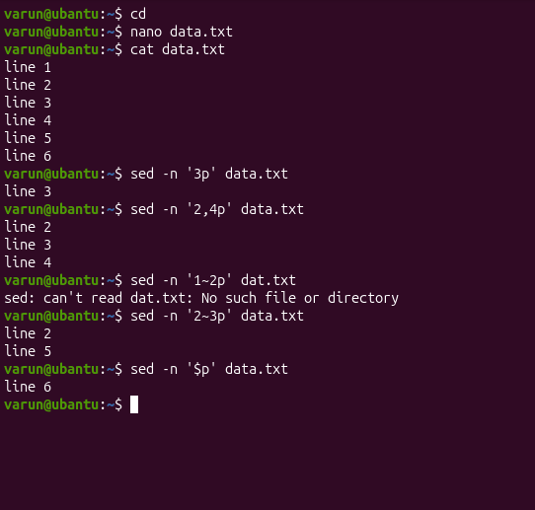

42. 5 use cases for AWK and 5 use cases for sed
