TERRAFORM-4
1.Execute the script shown in the videoSTEP 1 — Create Project Folder
Visual Studio / Git Bash:
mkdir terraform-local-demo
Go inside folder:
cd terraform-local-demo

terraform {
required_providers {
local = {
source = "hashicorp/local"
version = "2.3.0"
}
}
}
resource "local_file" "my-pet" {
filename = "pets.txt"
content = "I love cats!"
}

Explanation of Code
terraform block
Defines:
- Required providers
- Provider version
terraform {
required_providers {

local provider
Uses HashiCorp local provider.
source = "hashicorp/local"

resource block
Creates infrastructure resource.
resource "local_file" "my-pet"
Where:
- local_file → resource type
- my-pet → resource name

filename
Creates:
pets.txt

content
Writes inside file:
I love cats!

### Commands
Bash
terraform init
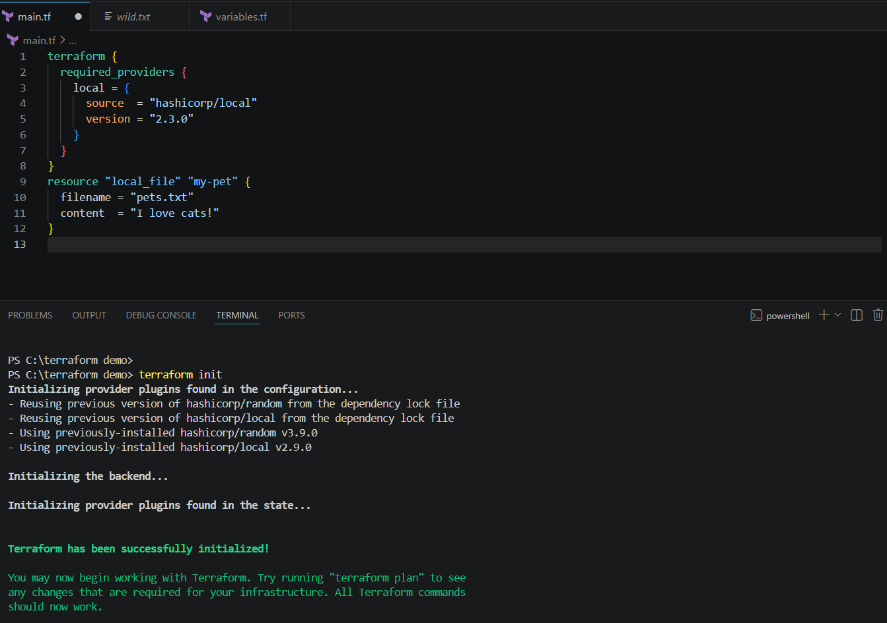
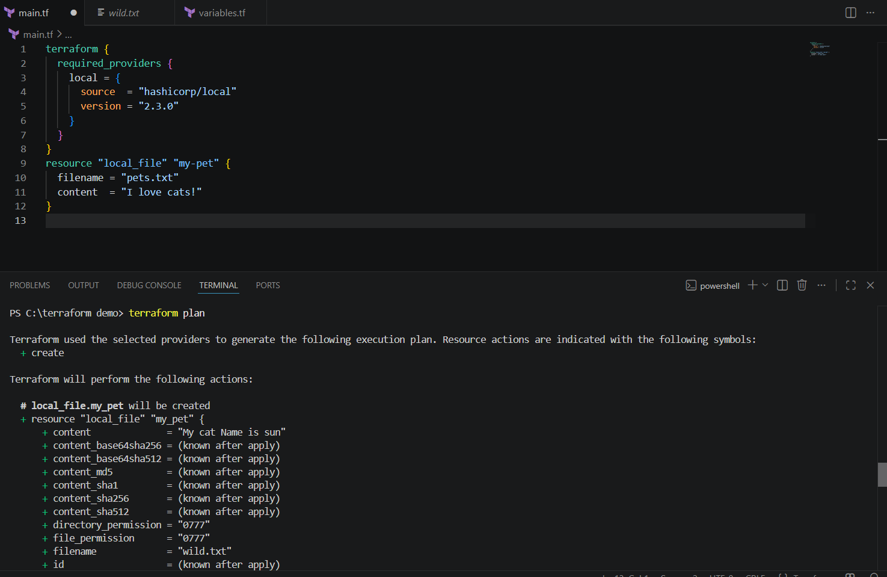
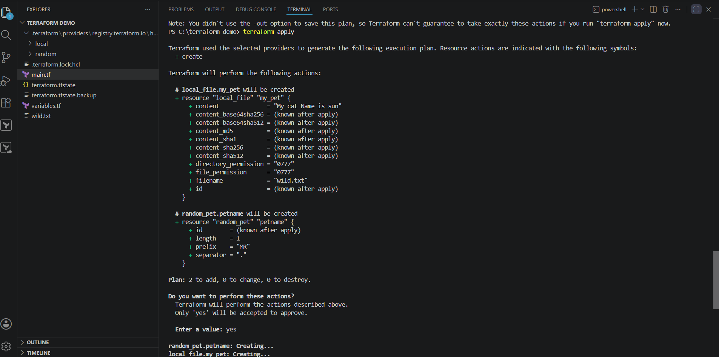

2. Terraform Variables Example
Now we will use:
- variables.tf
- List variables
- Multiple file creation using Terraform

Objective
Terraform will create:
pets.txt
cats.txt
dogs.txt
automatically.

Project Structure
terraform-variable-demo/
│
├── main.tf
├── variables.tf
└── terraform.tfvars (optional)

STEP 1 — Create Project Folder
mkdir terraform-variable-demo
Go inside:
cd terraform-variable-demo

STEP 2 — Create variables.tf
Create file:
vi variables.tf
Paste:
hcl
variable "filename" {
default = [
"pets.txt",
"cats.txt",
"dogs.txt"
]
}

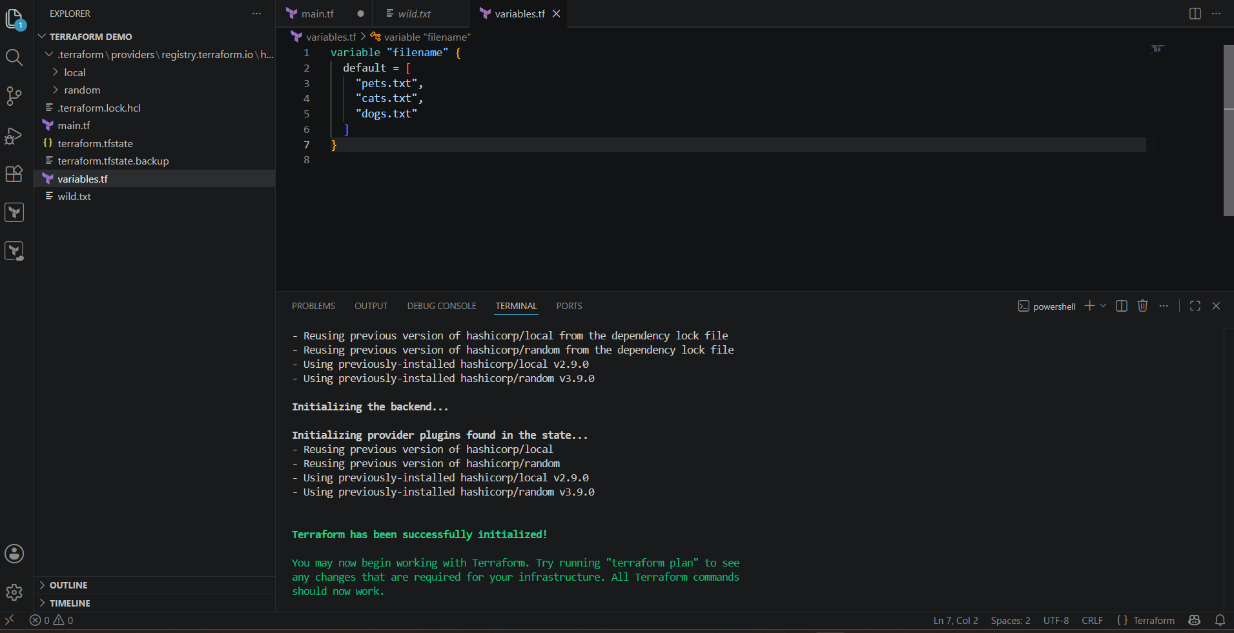
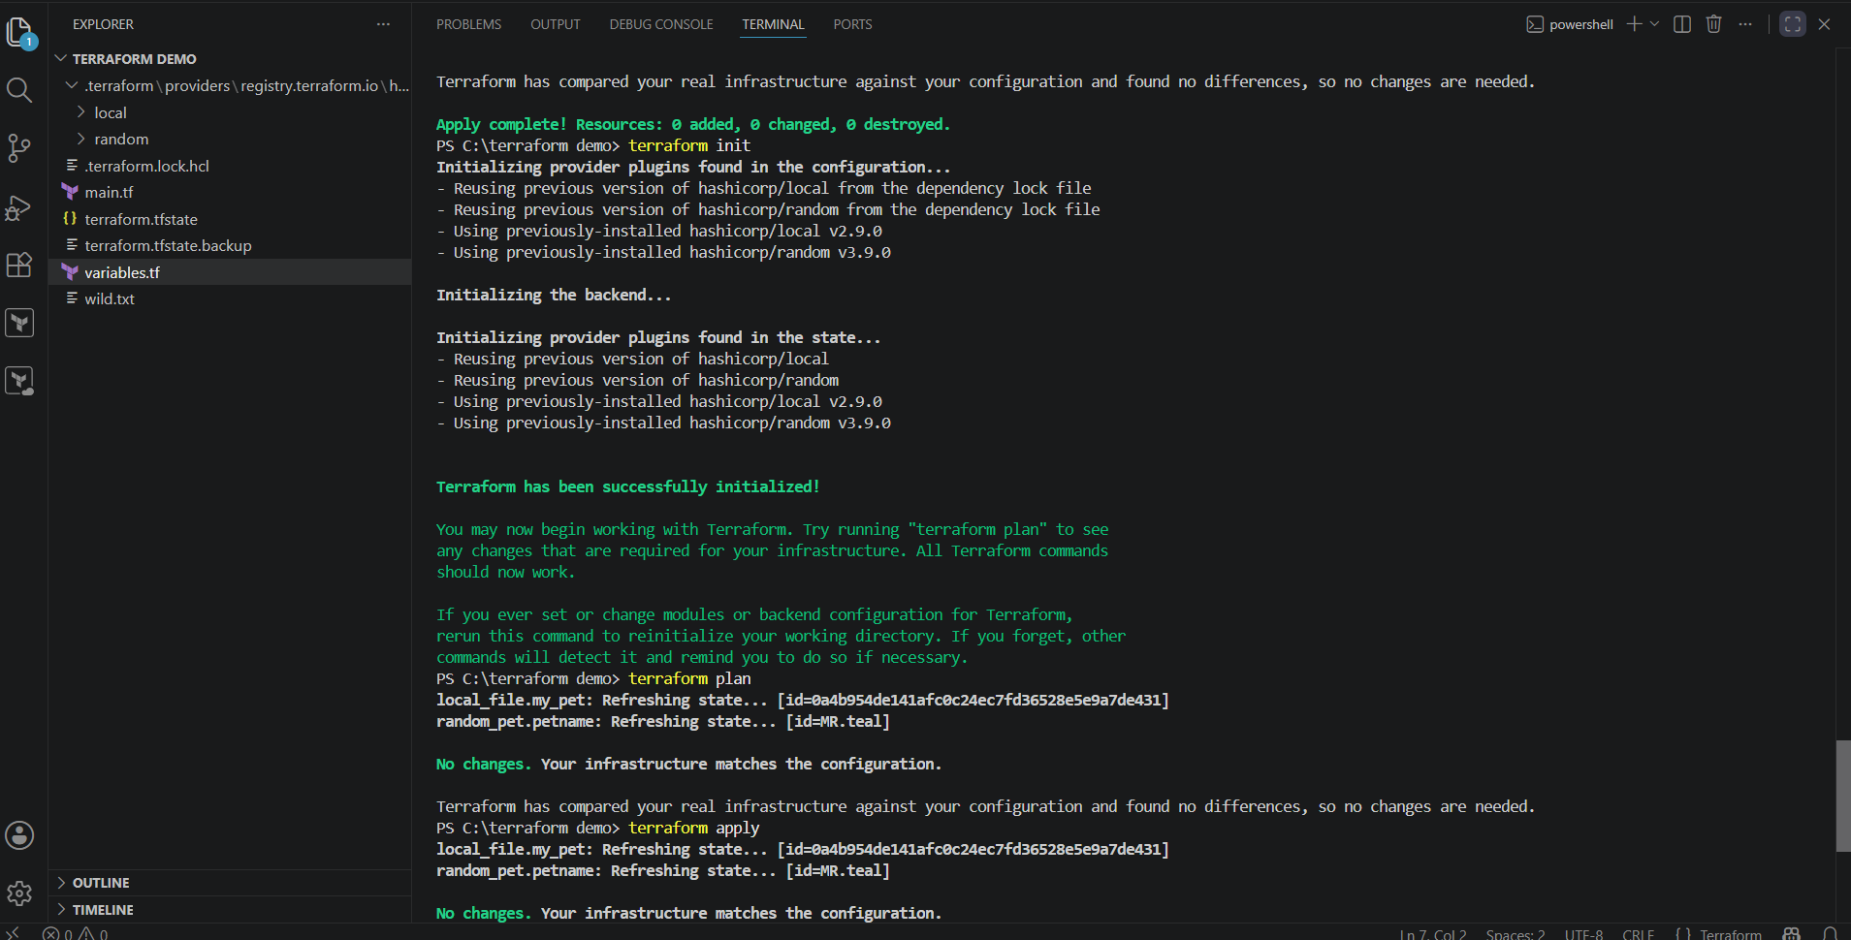
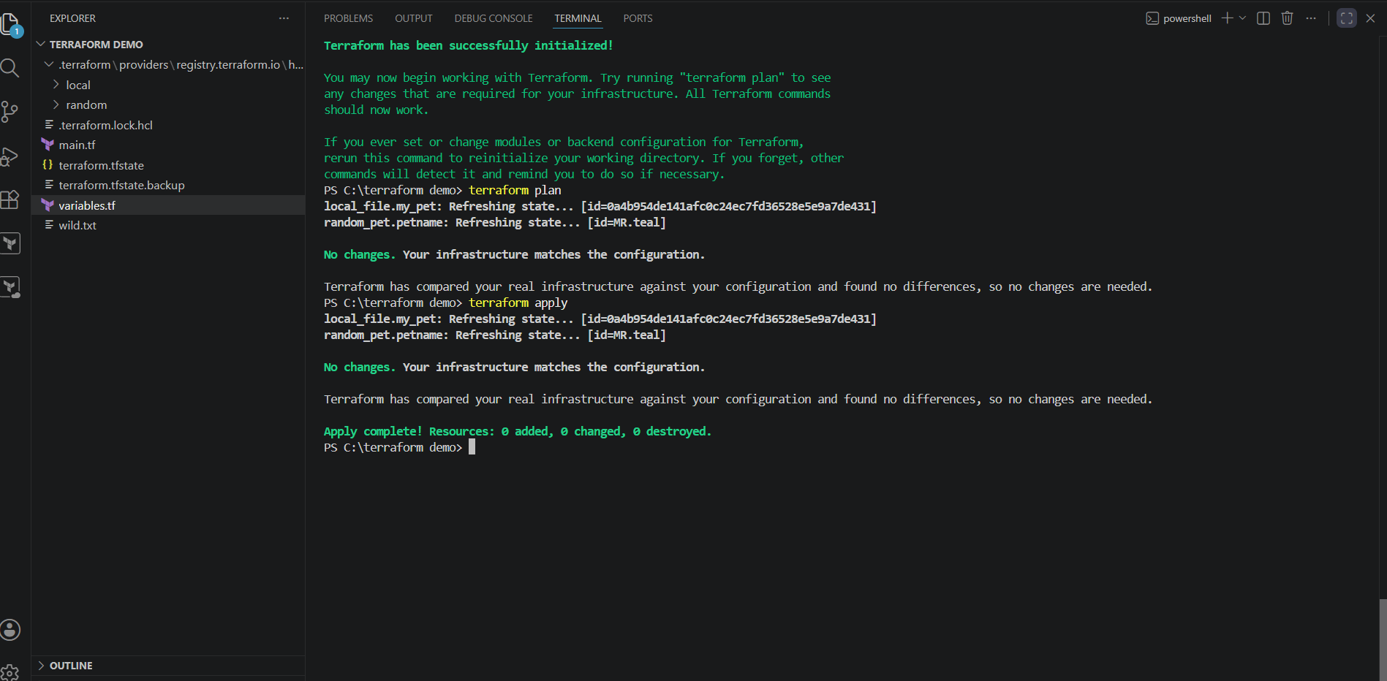

STEP 3 — Create main.tf
Create:
vi main.tf
Paste:
hcl
resource "local_file" "my-pet" {
filename = var.filename[count.index]
content = "I love cats!"
count = 3
}

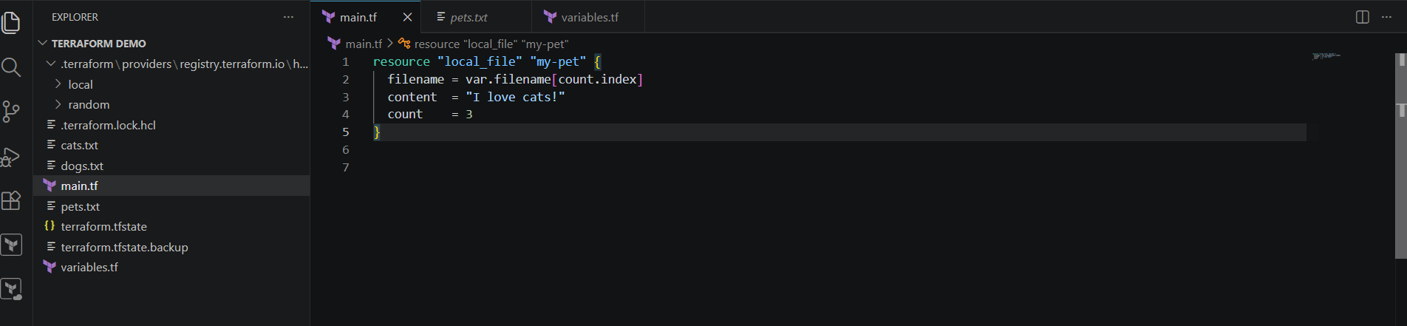
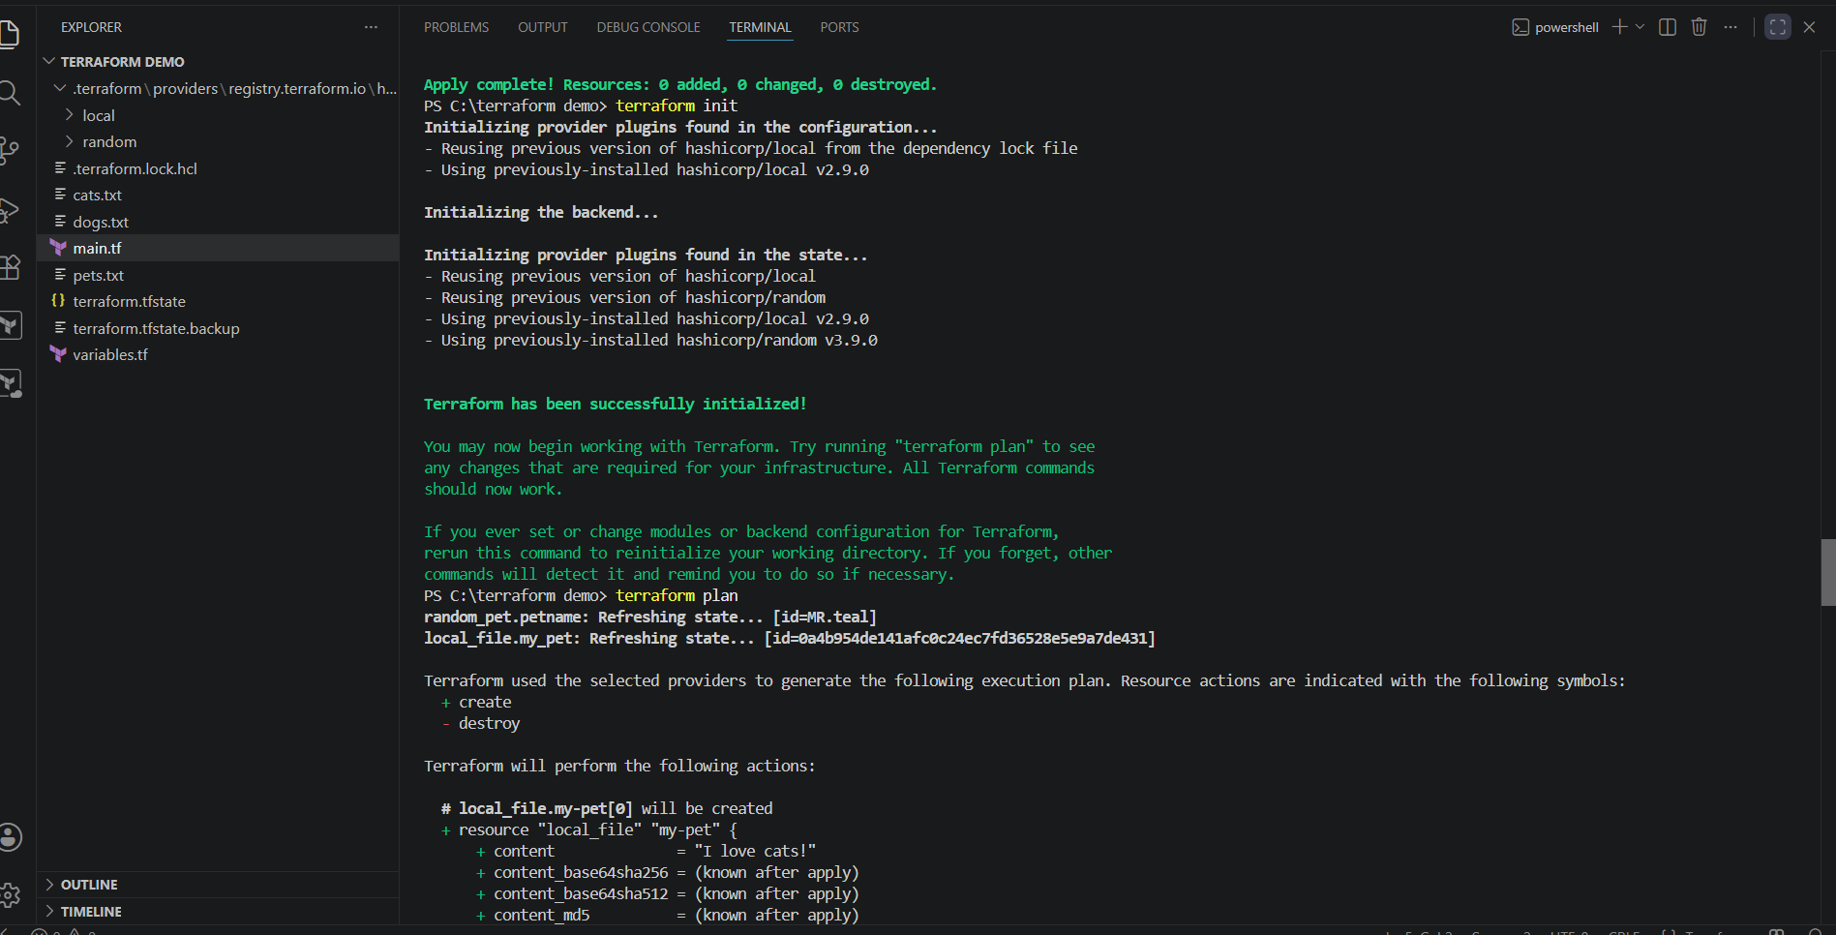
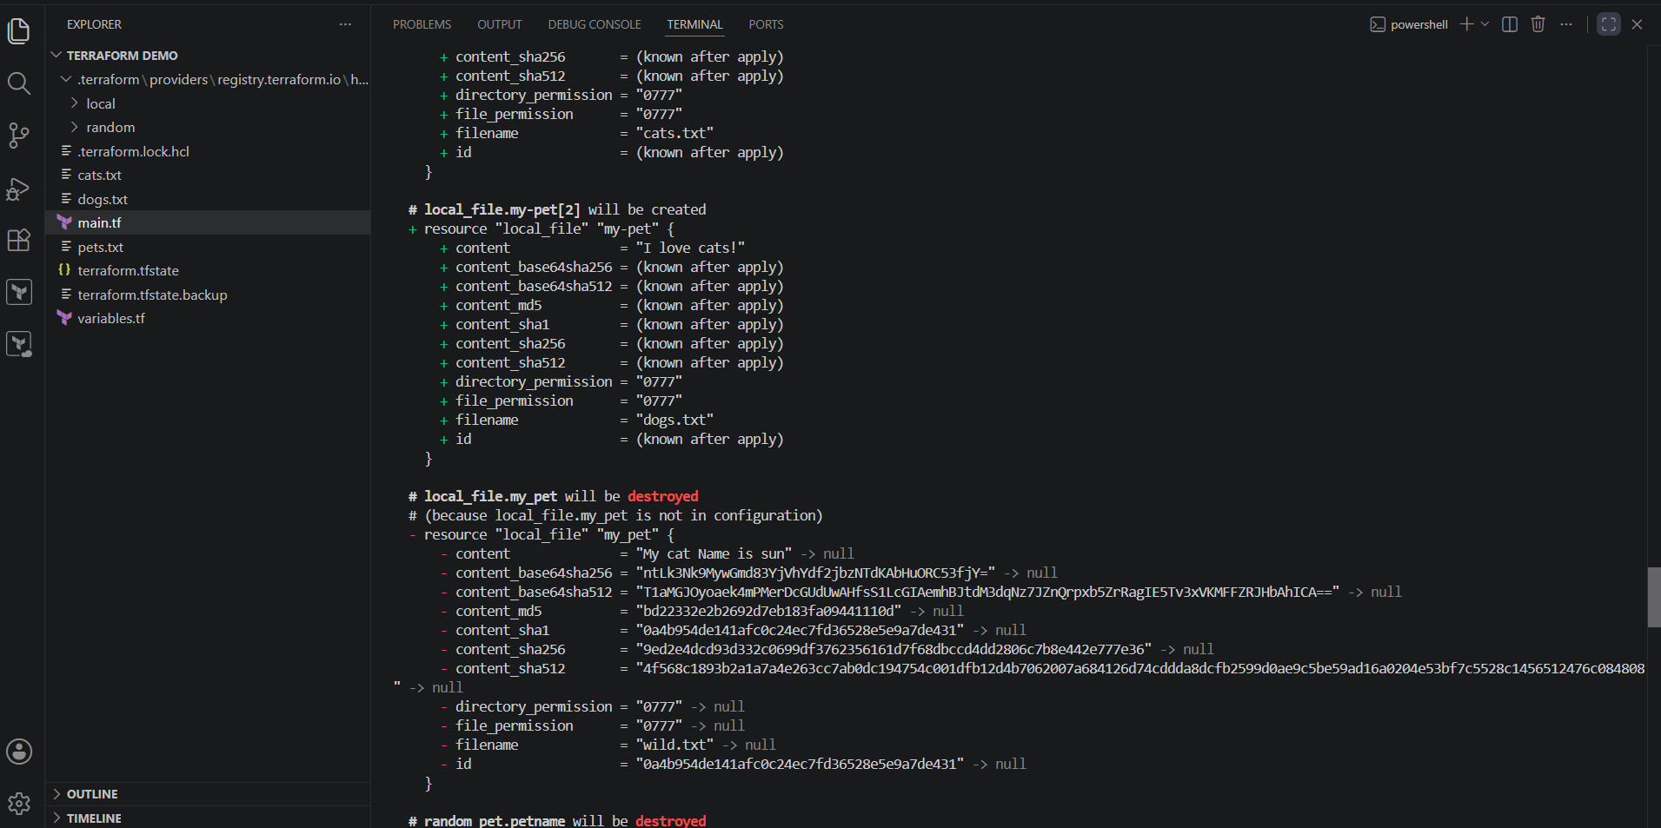
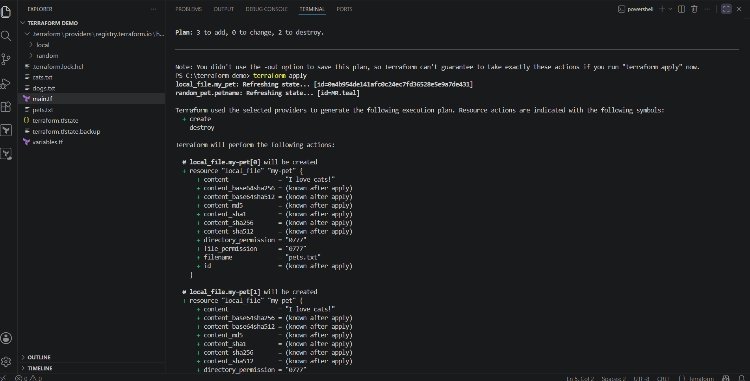
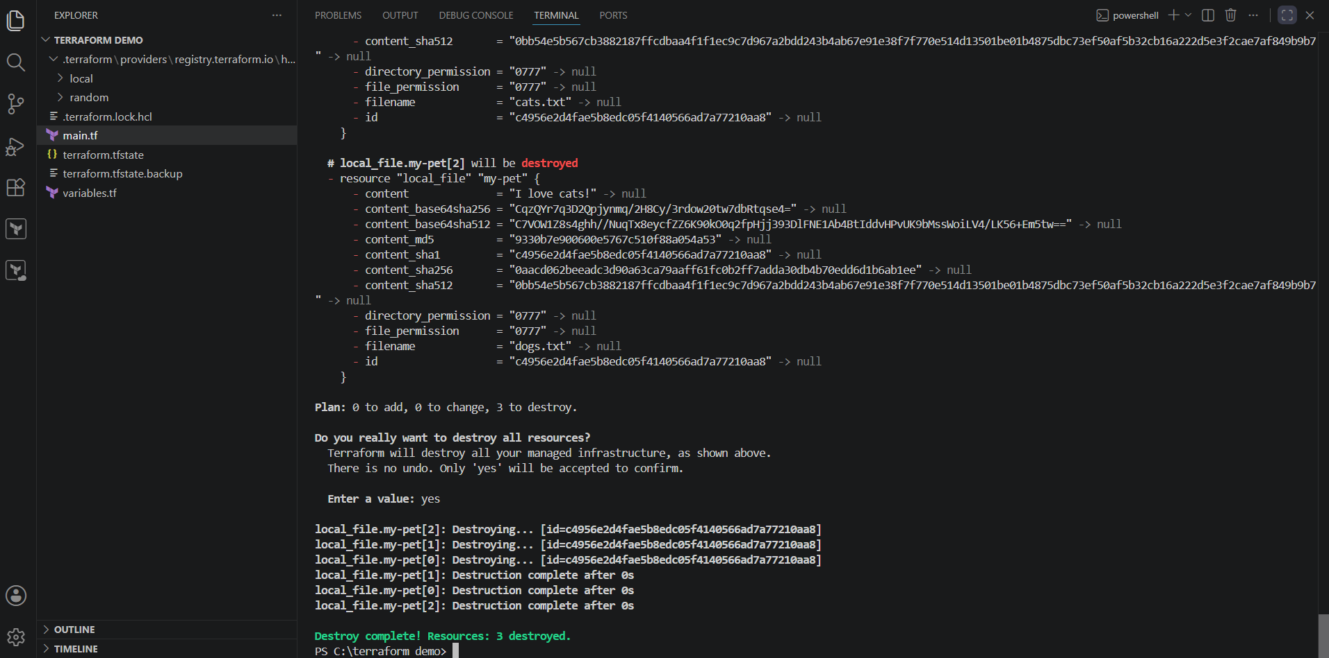
4) Terraform AWS IAM User Example
## Prerequisites
Install and configure AWS CLI:
Bash
aws configure
Provide:
* AWS Access Key
* AWS Secret Key
* Region
* Output format
## Create IAM User

### main.tf
hcl
resource "aws_iam_user" "Admin-user" {
name = "Varun_dalal"
tags = {
"Description" = "IT"
}
}
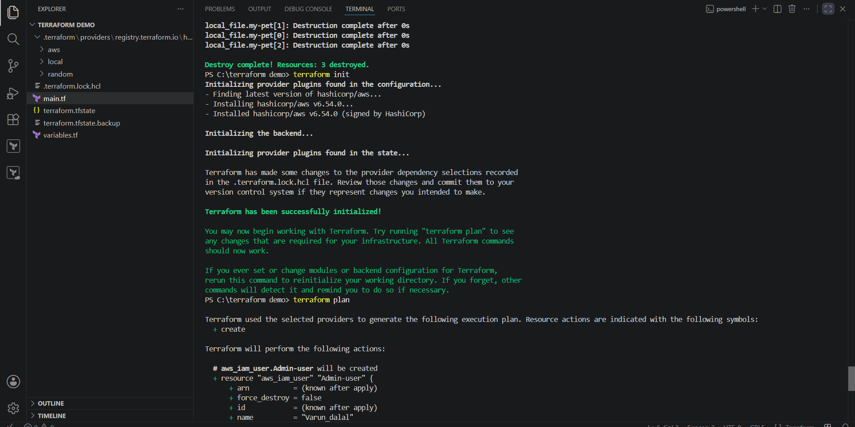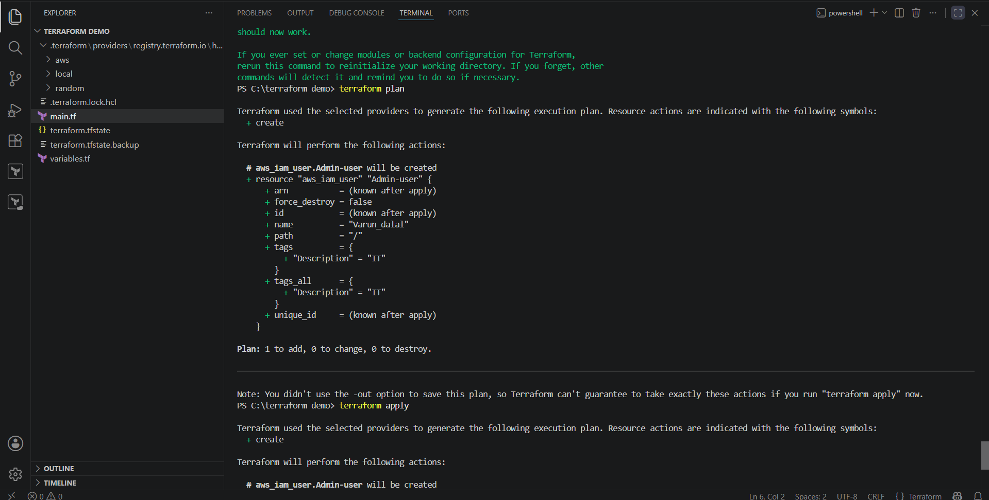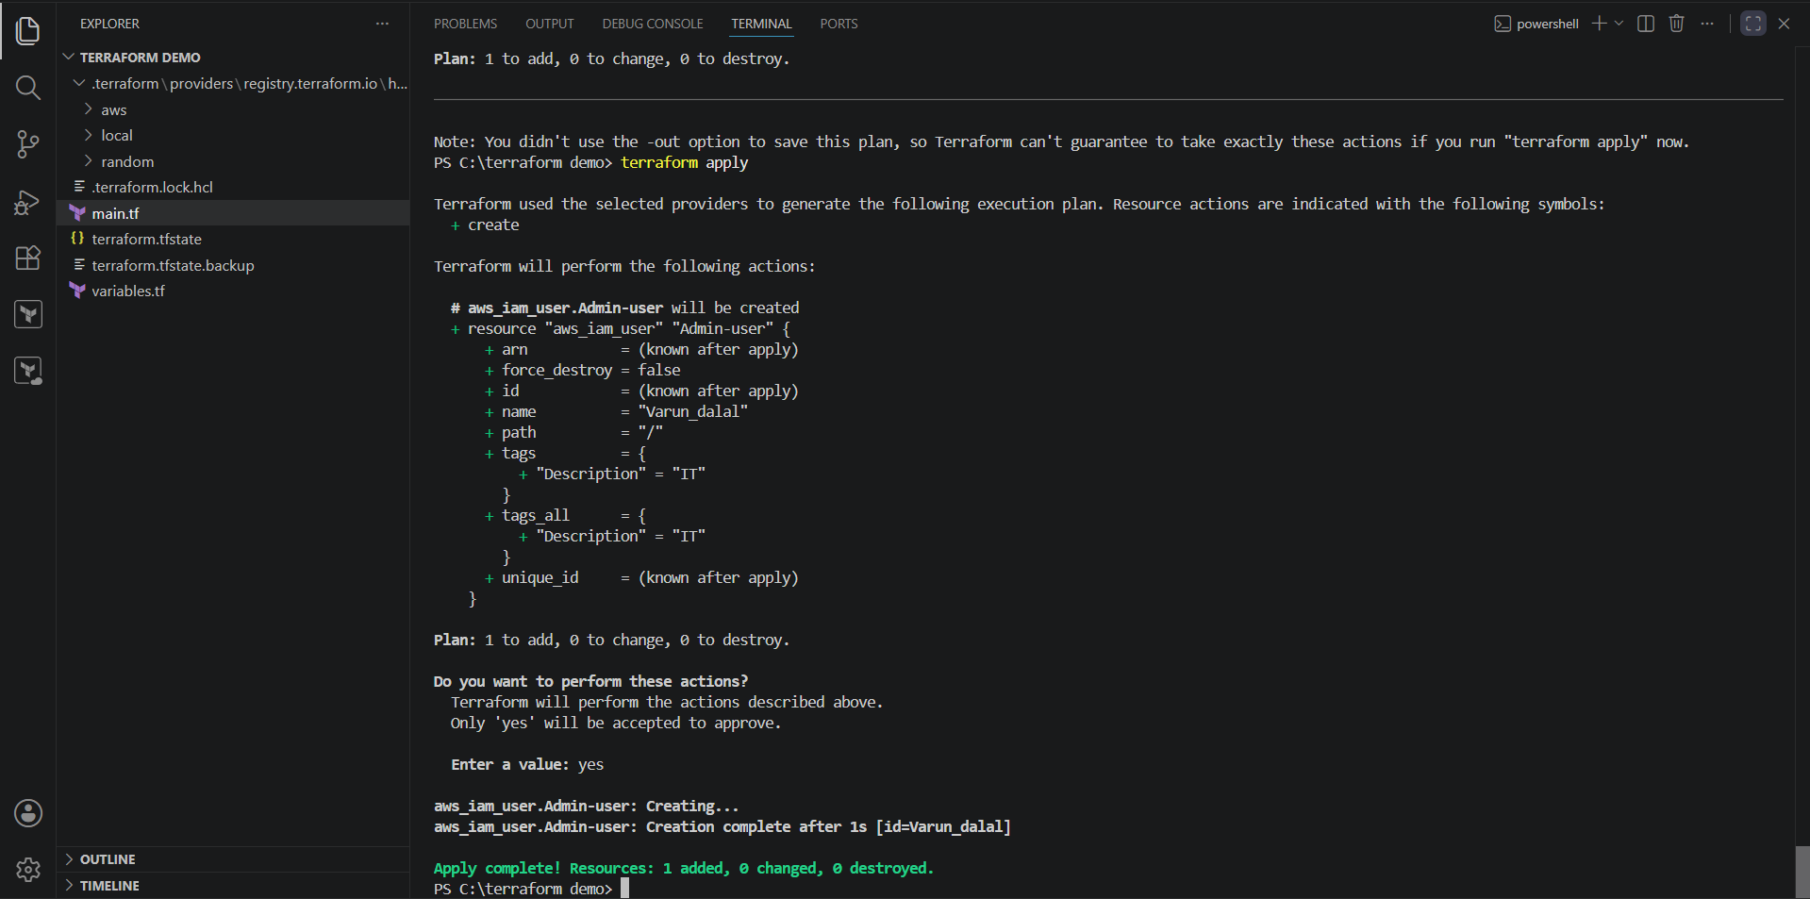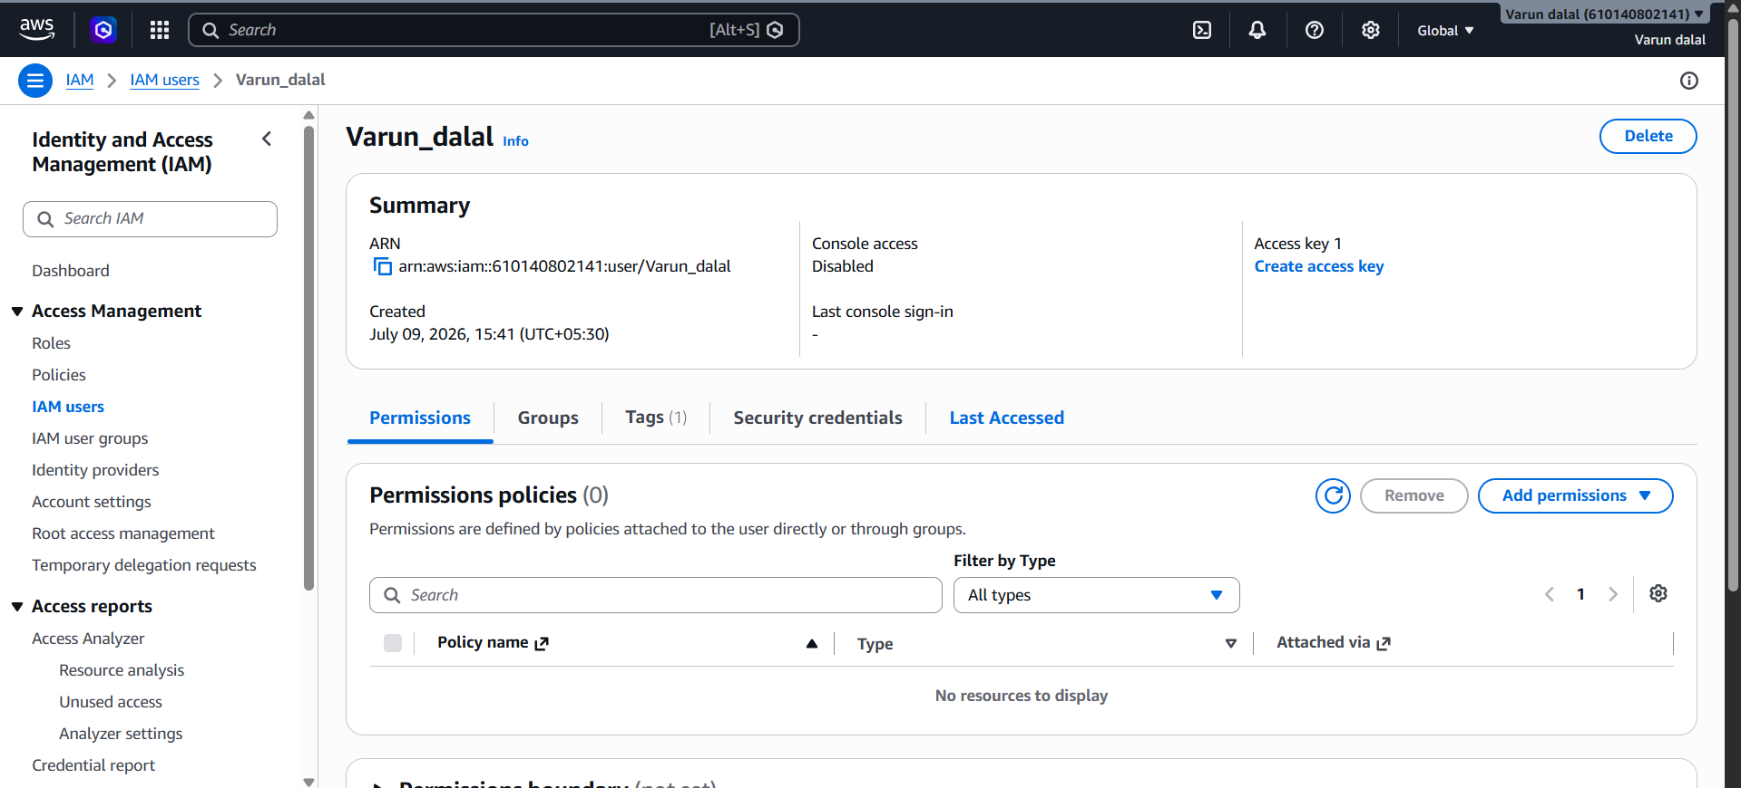

5) Create IAM Policy and Attach Policy

### main.tf

hcl
resource "aws_iam_user" "Admin-user" {
name = "lucy"
}
resource "aws_iam_policy" "adminuser" {
name = "AdminUser"
policy = <<EOF
{
"Version": "2012-10-17",
"Statement": [
{
"Effect": "Allow",
"Action": "*",
"Resource": "*"
}
]
}
EOF
}
resource "aws_iam_user_policy_attachment" "lucy-admin-access" {
user = aws_iam_user.Admin-user.name
policy_arn = aws_iam_policy.adminuser.arn
}
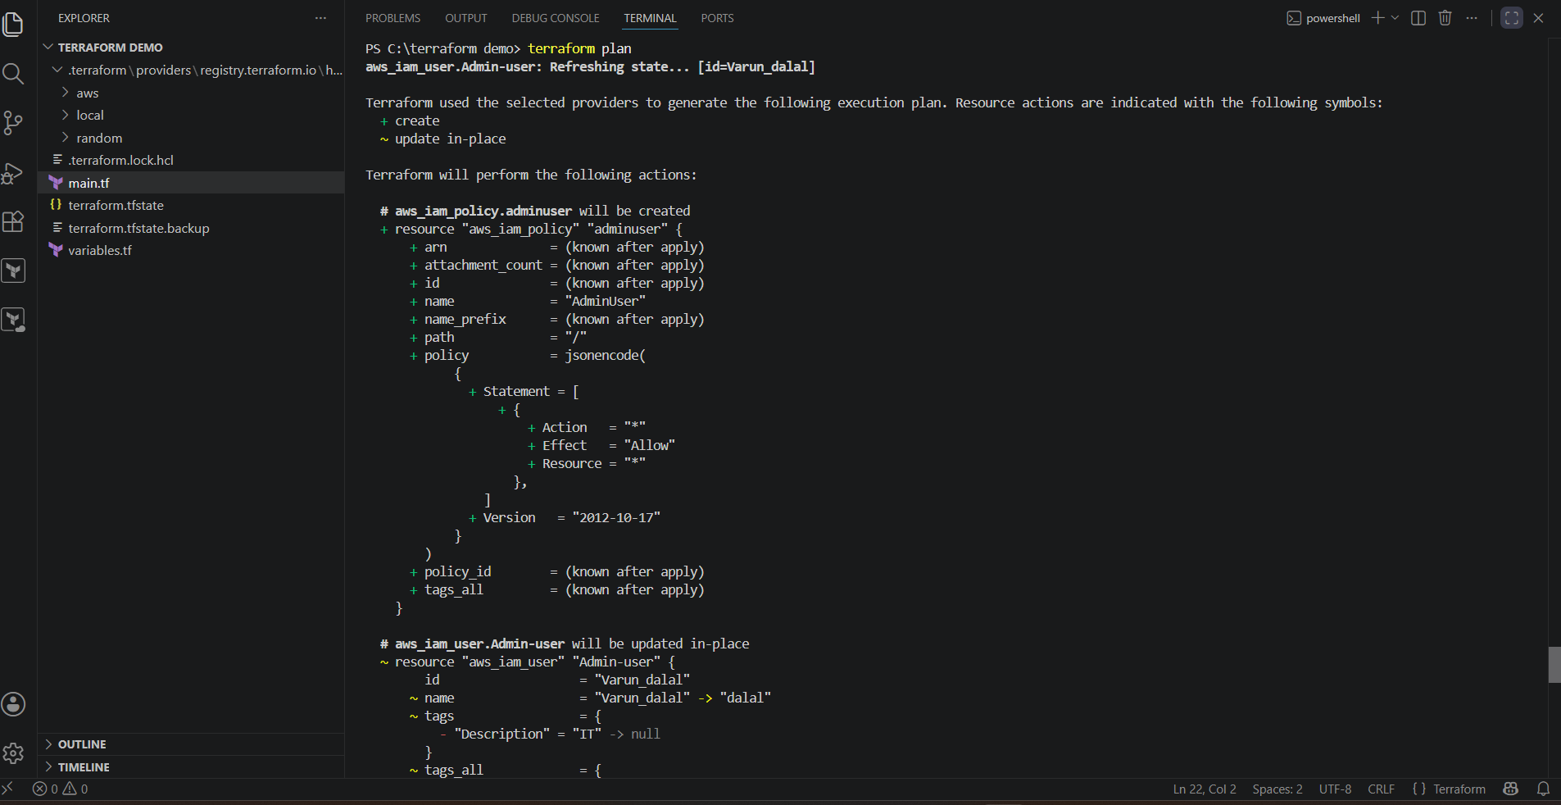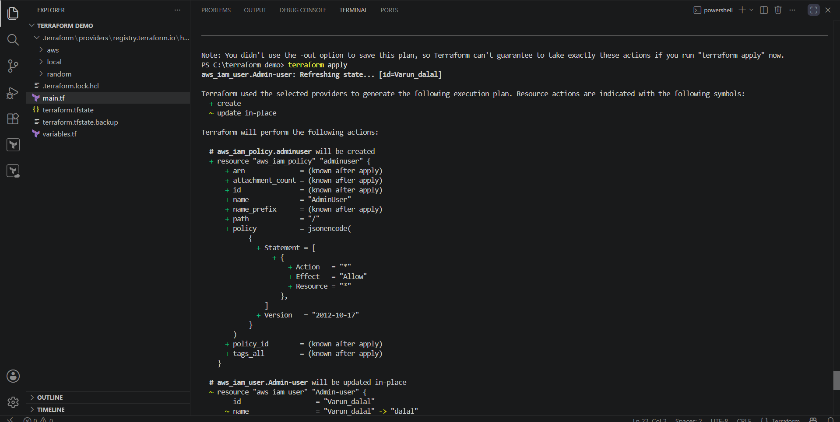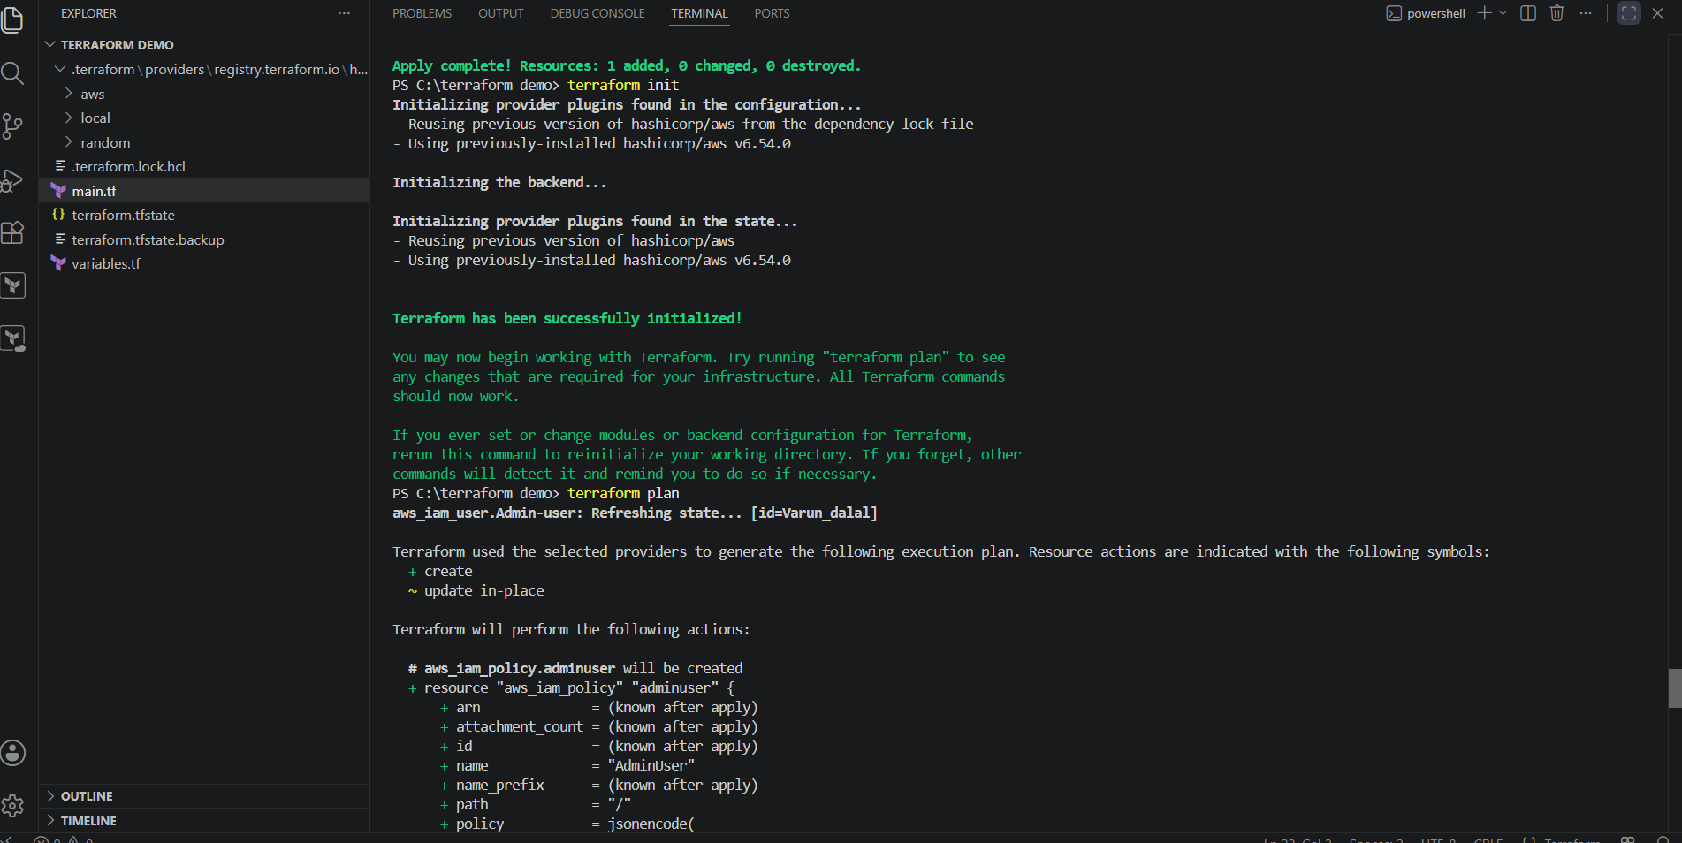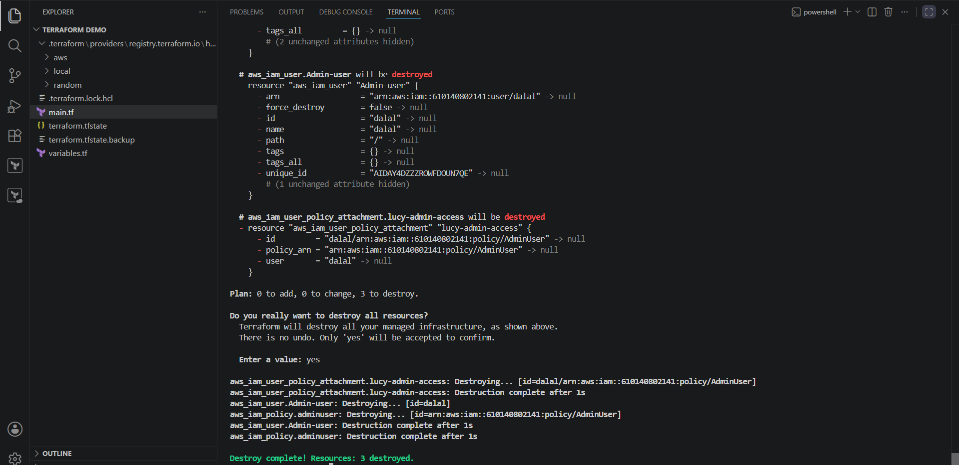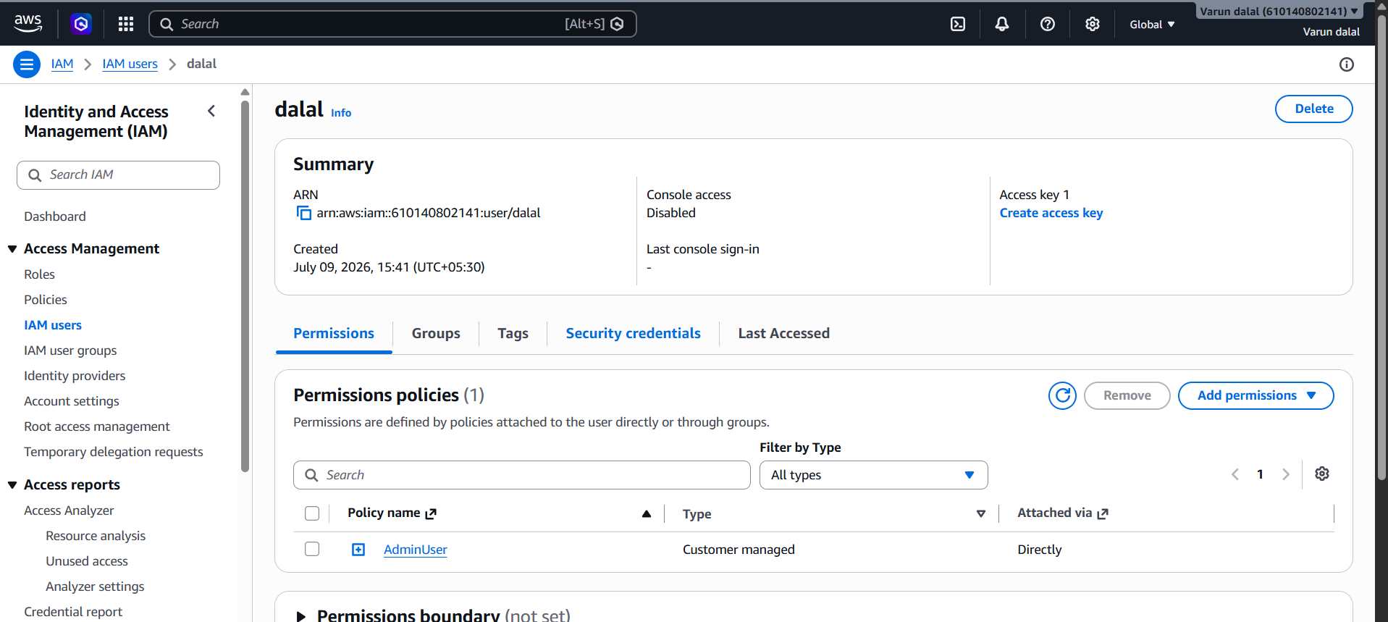

2) Integrate Terraform in Jenkins using the Terraform plugin
Integrate Terraform with Jenkins using the Terraform Plugin to automate infrastructure deployment through a Jenkins pipeline.

Prerequisites
- Jenkins installed and running
- Terraform installed on the Jenkins server
- Git installed
- GitHub repository containing Terraform code
- AWS credentials configured (if deploying to AWS)
- Jenkins administrator access

Step 1: Install the Terraform Plugin
- Go to Manage Jenkins → Plugins.
- Open the Available Plugins tab.
- Search for Terraform.
- Select Terraform Plugin.
- Click Install and restart Jenkins if prompted.

Step 2: Configure Terraform Tool
- Go to Manage Jenkins → Tools.
- Scroll down to Terraform Installations.
- Click Add Terraform.
- Enter:
  - Name: Terraform
  - Install automatically: Enable (or provide the Terraform installation path manually).
- Click Save.

Step 3: Configure AWS Credentials
If deploying to AWS:
- Configure AWS CLI on the Jenkins server:
aws configure
Enter:
- AWS Access Key
- AWS Secret Key
- Region
- Output format
Verify:
aws sts get-caller-identity

Step 4: Create a Terraform Project
Create a repository with the following main.tf file:
provider "aws" {
region = "us-east-1"
}

resource "aws_instance" "demo" {
ami = "ami-0c02fb55956c7d316"
instance_type = "t2.micro"

tags = {
Name = "Jenkins-Terraform"
}
}
Push the project to GitHub.

Step 5: Create a Pipeline Job
- Click New Item.
- Enter a job name.
- Select Pipeline.
- Click OK.

Step 6: Configure Source Code
Under Pipeline:
- Select Pipeline script from SCM.
- SCM: Git
- Repository URL: Your GitHub repository URL.
- Select Git credentials.
- Branch: main
- Script Path: Jenkinsfile
Click Save.

Step 7: Create the Jenkinsfile
Create a Jenkinsfile in the repository:
pipeline {
agent any

tools {
terraform 'Terraform'
}

stages {

stage('Checkout') {
steps {
git url: 'https://github.com/username/terraform-demo.git', branch: 'main'
}
}

stage('Terraform Init') {
steps {
sh 'terraform init'
}
}

stage('Terraform Validate') {
steps {
sh 'terraform validate'
}
}

stage('Terraform Plan') {
steps {
sh 'terraform plan'
}
}

stage('Terraform Apply') {
steps {
sh 'terraform apply -auto-approve'
}
}
}
}
Commit and push the Jenkinsfile.

Step 8: Build the Pipeline
- Open the Jenkins job.
- Click Build Now.
- Monitor the build in Console Output.

Step 9: Verify the Deployment
After the pipeline completes successfully:
- Log in to the AWS Console.
- Navigate to EC2 → Instances.
- Verify that the EC2 instance has been created.

Pipeline Workflow
Developer
│
▼
Push Terraform Code to GitHub
│
▼
Jenkins Pipeline
│
├── Checkout
├── Terraform Init
├── Terraform Validate
├── Terraform Plan
└── Terraform Apply
│
▼
AWS Infrastructure Created

Expected Output
Cloning repository...

Terraform has been successfully initialized!

Success! The configuration is valid.

Plan: 1 to add, 0 to change, 0 to destroy.

Apply complete!
Resources: 1 added, 0 changed, 0 destroyed.

Conclusion
Using the Terraform Plugin in Jenkins allows you to manage the Terraform installation as a Jenkins tool and execute Terraform commands from a pipeline. This integration automates infrastructure provisioning by performing Checkout → Init → Validate → Plan → Apply, ensuring a consistent and repeatable Infrastructure as Code (IaC) deployment process.
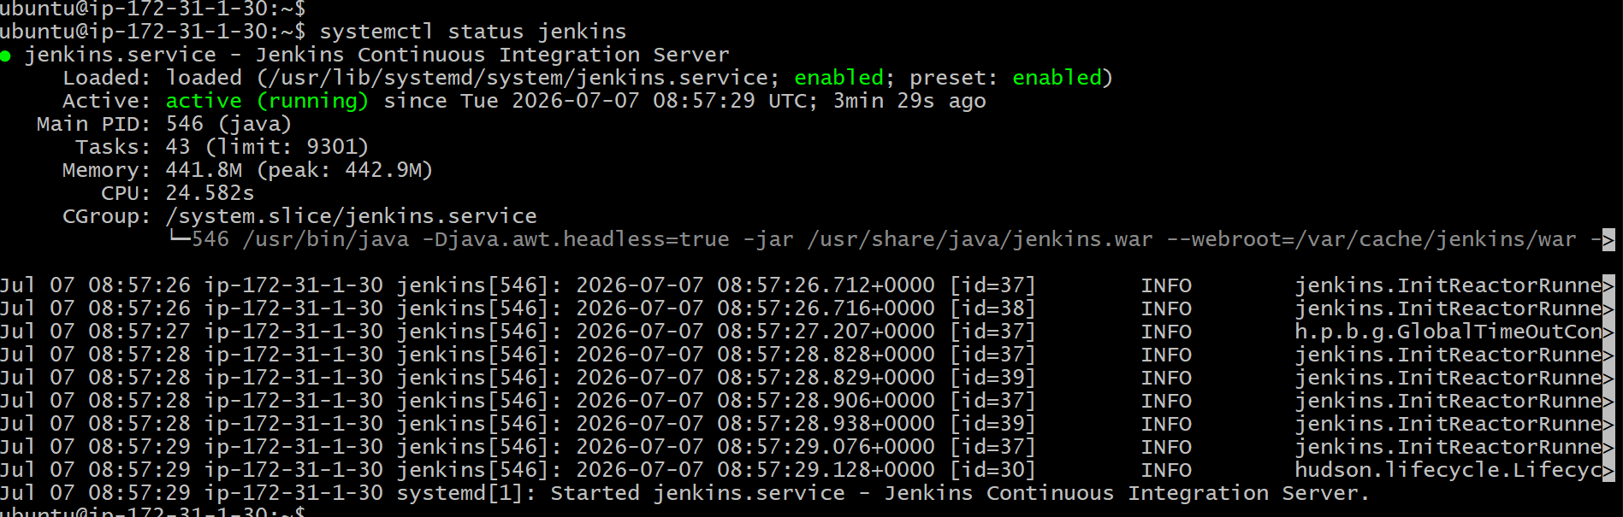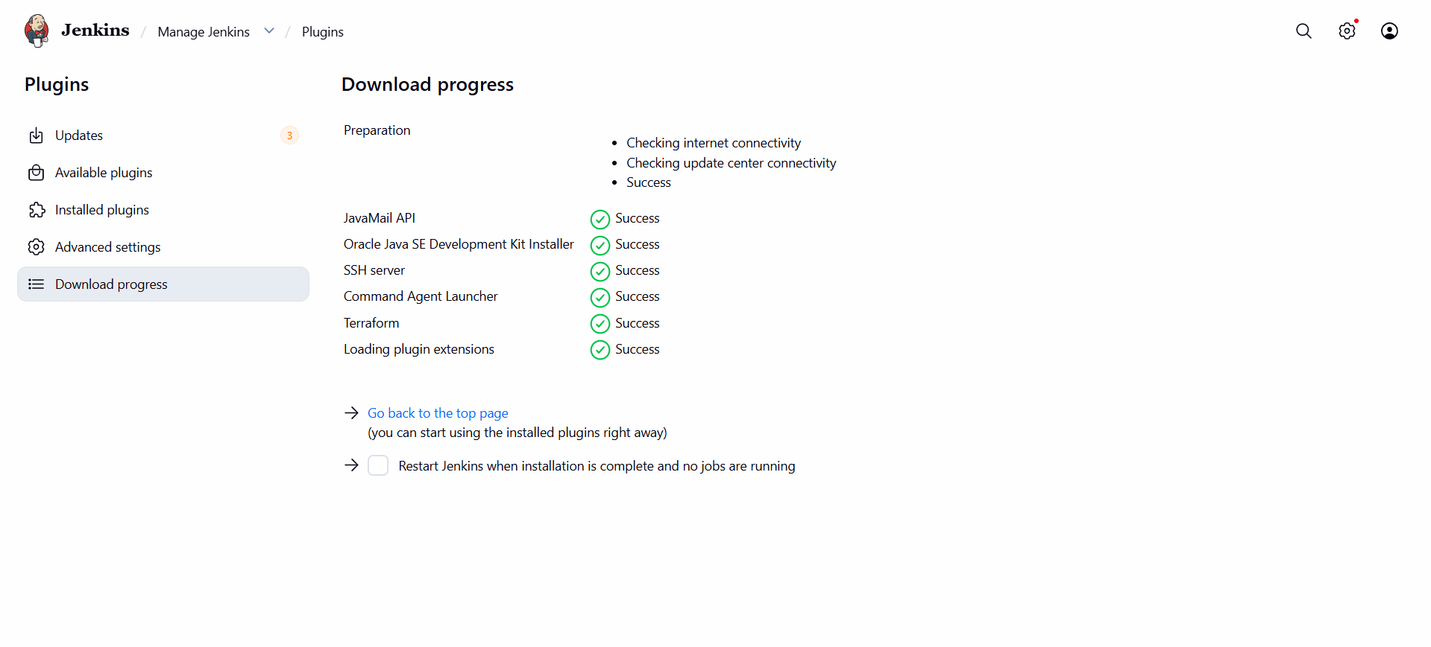
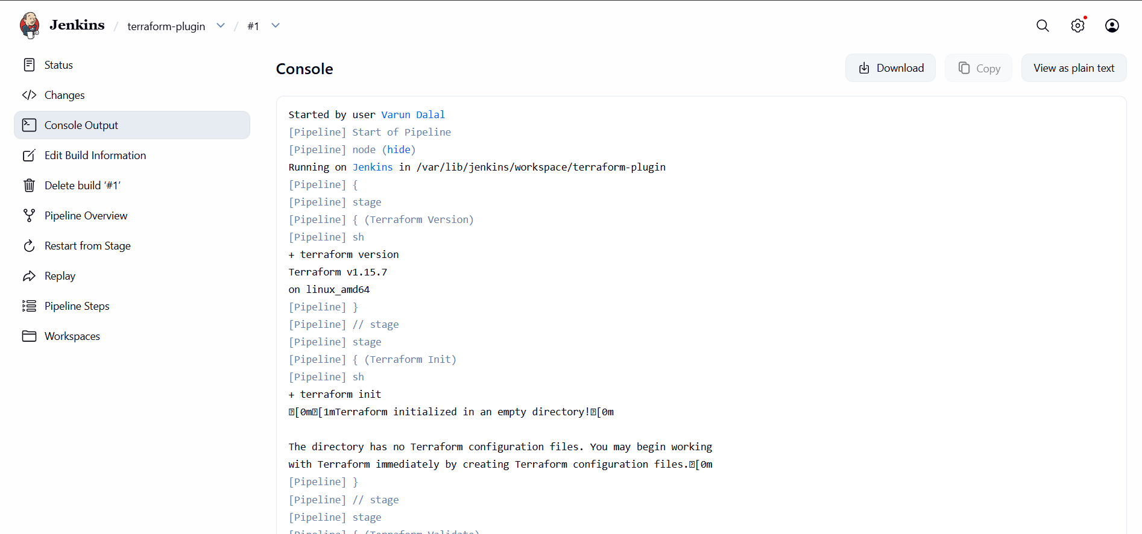

4.CI/CD Pipeline for Node.js Application using Jenkins
Application Repository:
https://github.com/betawins/Trading-UI.git

Objective
Create a Jenkins CI/CD Pipeline to:
- Clone the Node.js application from GitHub
- Install project dependencies
- Build the application
- Archive the build artifacts

Prerequisites
Before creating the pipeline, ensure the following are installed on the Jenkins server:
- Jenkins
- Git
- Node.js (v18 or above)
- npm
Verify installation:
git --version
node -v
npm -v
Example Output:
git version 2.43.0
v18.19.0
9.2.0

Step 1: Open Jenkins
Open your browser.
http://<Jenkins-IP>:8080
Login using Jenkins credentials.

Step 2: Create a New Pipeline Job
- Click New Item
- Enter Job Name
nodejs-CI-CD
- Select Pipeline
- Click OK

Step 3: Configure Pipeline
Scroll to Pipeline
Select
Definition

Pipeline Script

Step 4: Copy the Jenkins Pipeline
Paste the following pipeline script.
pipeline {
agent any

stages {

stage('Clean Workspace') {
steps {
deleteDir()
}
}

stage('Git Clone') {
steps {
git branch: 'master',
url: 'https://github.com/betawins/Trading-UI.git'
}
}

stage('Check Node') {
steps {
sh '''
node -v
npm -v
'''
}
}

stage('Install Dependencies') {
steps {
sh 'npm install'
}
}

stage('Build Application') {
steps {
sh '''
export NODE_OPTIONS=--openssl-legacy-provider
export CI=false
npm run build
'''
}
}

stage('Archive Artifacts') {
steps {
archiveArtifacts artifacts: 'build/**', fingerprint: true
}
}
}

post {
success {
echo 'Build completed successfully.'
}

failure {
echo 'Build failed.'
}
}
}
Click Save.

Step 5: Build the Pipeline
Click
Build Now

Step 6: Monitor Pipeline
Click
Build Number

↓

Console Output

Step 7: Pipeline Execution
The pipeline executes the following stages:
Stage 1 – Clean Workspace
Deletes previous workspace files.
deleteDir()

Stage 2 – Git Clone
Downloads the source code from GitHub.
Repository:
https://github.com/betawins/Trading-UI.git
Branch:
master

Stage 3 – Check Node
Checks installed Node.js and npm versions.
Commands:
node -v
npm -v

Stage 4 – Install Dependencies
Installs all required packages.
Command
npm install

Stage 5 – Build Application
Builds the production version of the React application.
Commands
export NODE_OPTIONS=--openssl-legacy-provider

export CI=false

npm run build
Why these variables?
- NODE_OPTIONS=--openssl-legacy-provider fixes compatibility issues with older React/Webpack projects on Node.js 18+.
- CI=false prevents React from treating ESLint warnings as build errors.

Stage 6 – Archive Artifacts
Archives the generated build files.
build/**
These artifacts can be downloaded later from Jenkins.

Step 8: Verify Build Folder
After successful execution, verify the build folder:
ls -la /var/lib/jenkins/workspace/nodejs-CI-CD/build
Expected Output:
asset-manifest.json
favicon.ico
index.html
manifest.json
robots.txt
static/

Step 9: Expected Console Output
Clean Workspace
↓
Git Clone
↓
Check Node
↓
Install Dependencies
↓
Build Application
↓
Archive Artifacts
↓
Build completed successfully.
↓
Finished: SUCCESS

Pipeline Workflow
Developer
│
▼
GitHub Repository
│
▼
Jenkins Pipeline
│
▼
Clean Workspace
│
▼
Git Clone
│
▼
npm install
│
▼
npm run build
│
▼
Archive Artifacts
│
▼
SUCCESS

Output
- Source code cloned from GitHub.
- Node.js dependencies installed.
- Production build created successfully.
- Build artifacts archived in Jenkins.
- Pipeline completed with SUCCESS status.

Conclusion
A Jenkins Declarative Pipeline was created for the Trading-UI Node.js application. The pipeline automatically cleans the workspace, clones the source code from GitHub, installs dependencies, builds the application using React, archives the generated build artifacts, and completes the CI process successfully. This provides an automated and repeatable build workflow suitable for continuous integration.

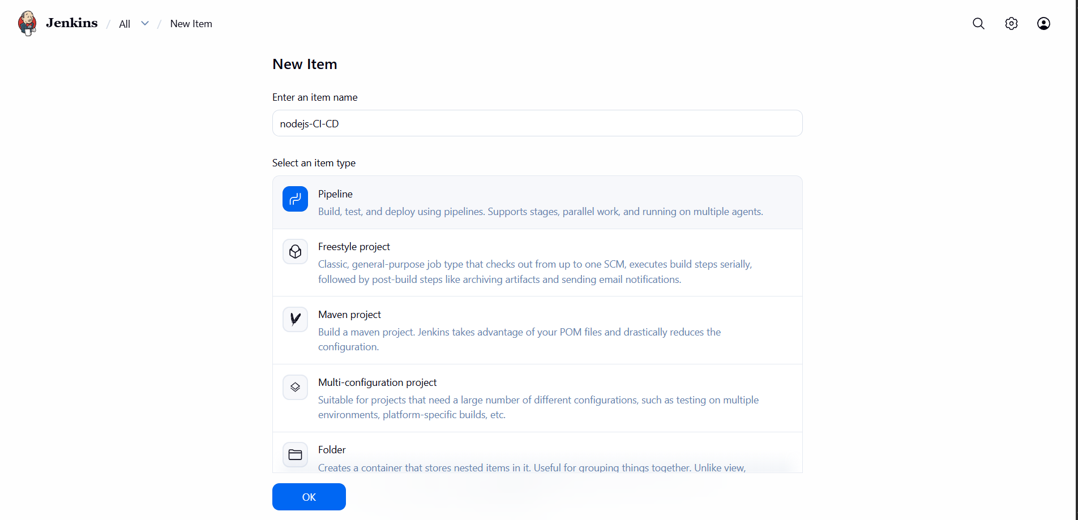
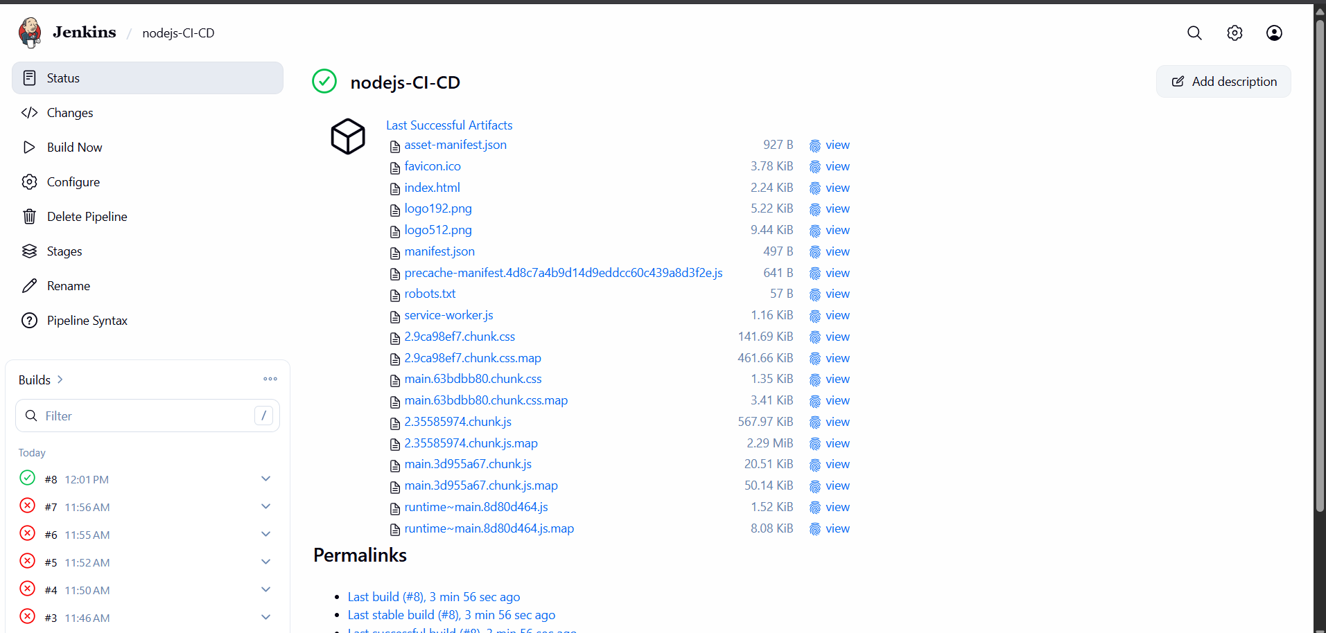

5.Explain 10 Maven Commands
1. mvn validate
Description
Checks whether the project structure and pom.xml file are correct before starting the build process.
Syntax
mvn validate
Use
- Verifies project configuration.
- Ensures all required information is available.

2. mvn compile
Description
Compiles the source code of the project.
Syntax
mvn compile
Use
- Compiles Java files from the src/main/java directory.
- Generates .class files in the target/classes directory.

3. mvn test
Description
Runs all unit test cases.
Syntax
mvn test
Use
- Executes tests located in src/test/java.
- Uses testing frameworks like JUnit or TestNG.

4. mvn package
Description
Compiles the code, runs tests, and packages the application.
Syntax
mvn package
Use
- Creates a JAR or WAR file.
- Stores the packaged file in the target directory.

5. mvn install
Description
Builds the project and installs the package into the local Maven repository.
Syntax
mvn install
Use
- Makes the artifact available for other local projects.
- Stores the package in the .m2 repository.

6. mvn clean
Description
Deletes all previously generated build files.
Syntax
mvn clean
Use
- Removes the target directory.
- Ensures a fresh build.

7. mvn clean install
Description
Deletes old files, builds the project, runs tests, packages the application, and installs it into the local repository.
Syntax
mvn clean install
Use
- Most commonly used command during development.
- Produces a clean and complete build.

8. mvn clean package
Description
Removes old build files and creates a new JAR/WAR package.
Syntax
mvn clean package
Use
- Creates a fresh deployment package.
- Commonly used before deployment.

9. mvn dependency:tree
Description
Displays all project dependencies in a tree structure.
Syntax
mvn dependency:tree
Use
- Identifies direct and transitive dependencies.
- Helps resolve dependency conflicts.

10. mvn site
Description
Generates project documentation.
Syntax
mvn site
Use
- Creates HTML reports.
- Includes project information, plugins, dependencies, and test reports.

Summary Table
Command | Purpose
mvn validate | Validate project configuration
mvn compile | Compile source code
mvn test | Execute unit tests
mvn package | Create JAR/WAR package
mvn install | Install package into local repository
mvn clean | Remove old build files
mvn clean install | Clean, build, test, and install
mvn clean package | Clean and create deployment package
mvn dependency:tree | Display project dependencies
mvn site | Generate project documentation
Conclusion
Maven commands automate the build process by compiling code, running tests, packaging applications, managing dependencies, generating documentation, and installing artifacts into the local repository. These commands are widely used in Java development and CI/CD pipelines with Jenkins.

