Create an EC2 Instance with HTTPD Installed Using Terraform
Objective
Provision an AWS EC2 instance with Apache HTTP Server installed automatically using Terraform.

Prerequisites
- AWS Account
- AWS CLI installed and configured
- Terraform installed
- An AWS EC2 Key Pair
- Basic knowledge of AWS and Terraform

Step 1: Create a Project Directory
mkdir terraform-demo
cd terraform-demo

Step 2: Create the Terraform Configuration
Create a file named main.tf and add the following code:
provider "aws" {
region = "us-east-1"
}

# Security Group
resource "aws_security_group" "web_sg" {
name = "web-security-group"

ingress {
from_port = 22
to_port = 22
protocol = "tcp"
cidr_blocks = ["0.0.0.0/0"]
}

ingress {
from_port = 80
to_port = 80
protocol = "tcp"
cidr_blocks = ["0.0.0.0/0"]
}

egress {
from_port = 0
to_port = 0
protocol = "-1"
cidr_blocks = ["0.0.0.0/0"]
}
}

# EC2 Instance
resource "aws_instance" "web_server" {
ami = "ami-xxxxxxxxxxxxxxxxx"
instance_type = "t2.micro"
key_name = "dockerkey"
vpc_security_group_ids = [aws_security_group.web_sg.id]

user_data = <<-EOF
#!/bin/bash
apt update -y
apt install -y apache2
systemctl enable apache2
systemctl start apache2
echo "Apache Installed using Terraform" > /var/www/html/index.html
EOF

tags = {
Name = "Terraform-HTTPD-Server"
}
}
Note: Replace the AMI ID and Key Pair name with your own values.

Step 3: Create Output File
Create output.tf
output "public_ip" {
value = aws_instance.web_server.public_ip
}

output "public_dns" {
value = aws_instance.web_server.public_dns
}

Step 4: Initialize Terraform
terraform init
Downloads the required AWS provider plugins.

Step 5: Format the Configuration
terraform fmt
Formats Terraform files.

Step 6: Validate the Configuration
terraform validate
Checks the configuration for syntax errors.

Step 7: Preview the Infrastructure
terraform plan
Displays the resources Terraform will create.

Step 8: Create the Infrastructure
terraform apply
Type:
yes
Terraform creates:
- Security Group
- EC2 Instance
- Apache Web Server

Step 9: Verify the Outputs
terraform output
Example:
public_ip = 32.xxx.xxx.xxx
public_dns = ec2-xx-xx-xx-xx.compute-1.amazonaws.com

Step 10: Access the Web Server
Open a web browser and enter:
http://<PUBLIC_IP>
Expected Output:
Apache Installed using Terraform

Step 11: Destroy the Infrastructure (Optional)
terraform destroy
Type:
yes
This removes all resources created by Terraform.

Conclusion
Using Terraform, we successfully provisioned an AWS EC2 instance, created a Security Group, installed Apache HTTP Server automatically using user_data, and accessed the web page through the instance's public IP. This demonstrates Infrastructure as Code (IaC) by automating infrastructure provisioning and configuration.
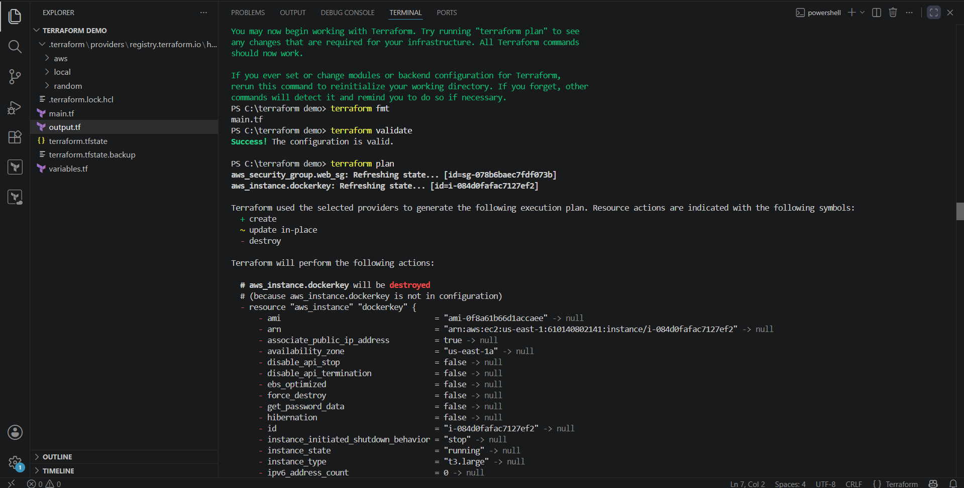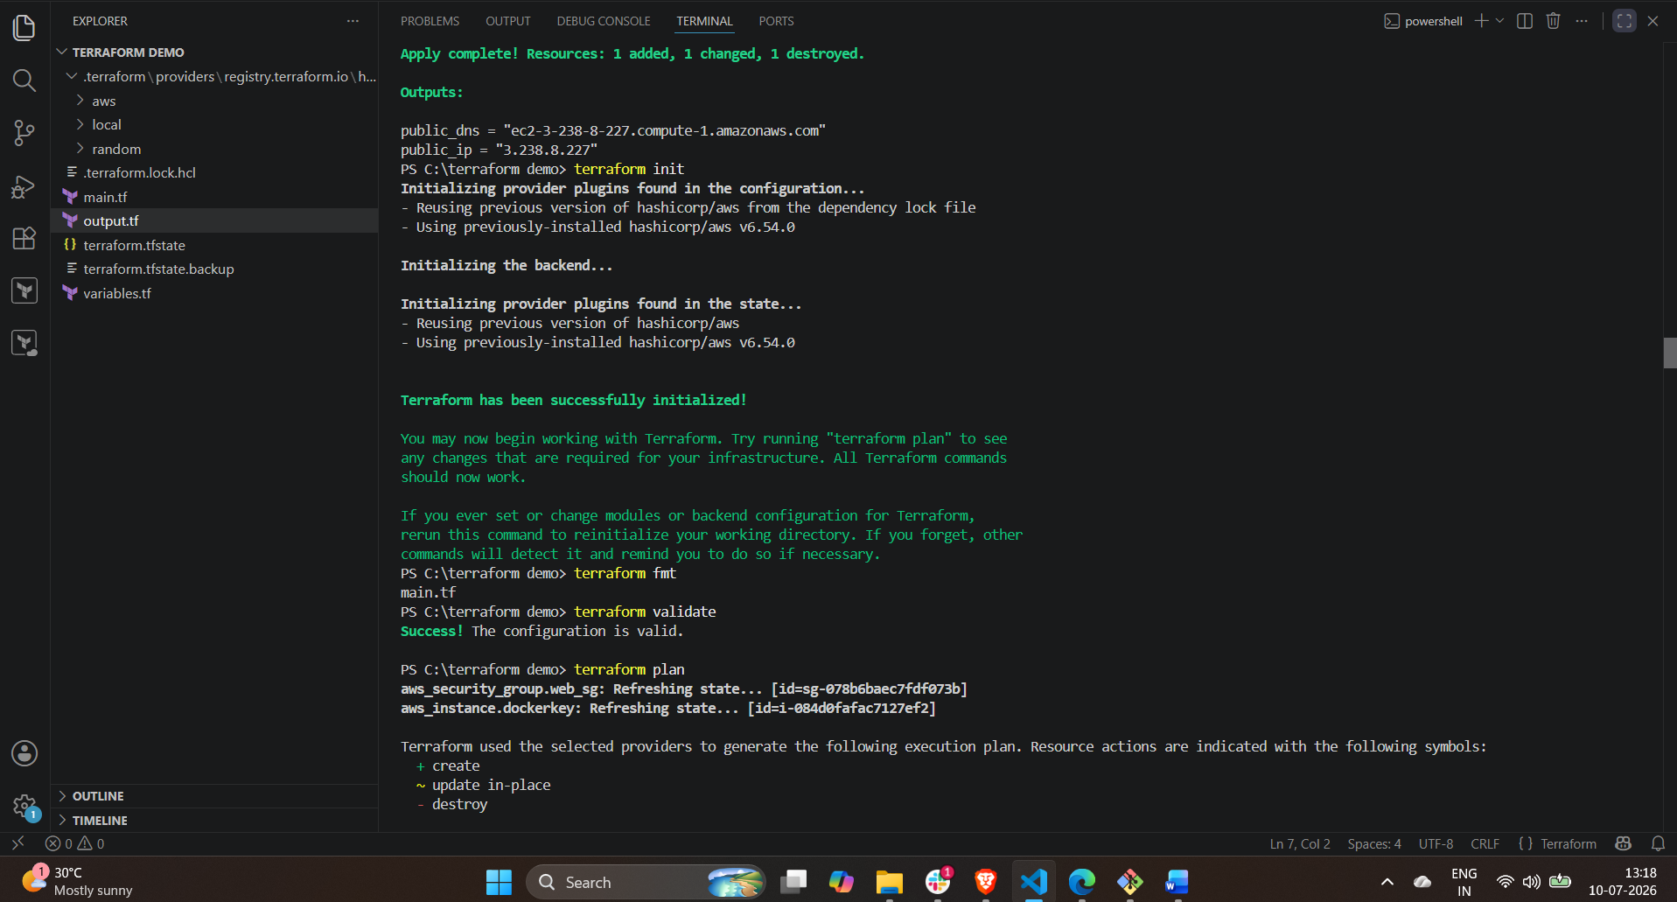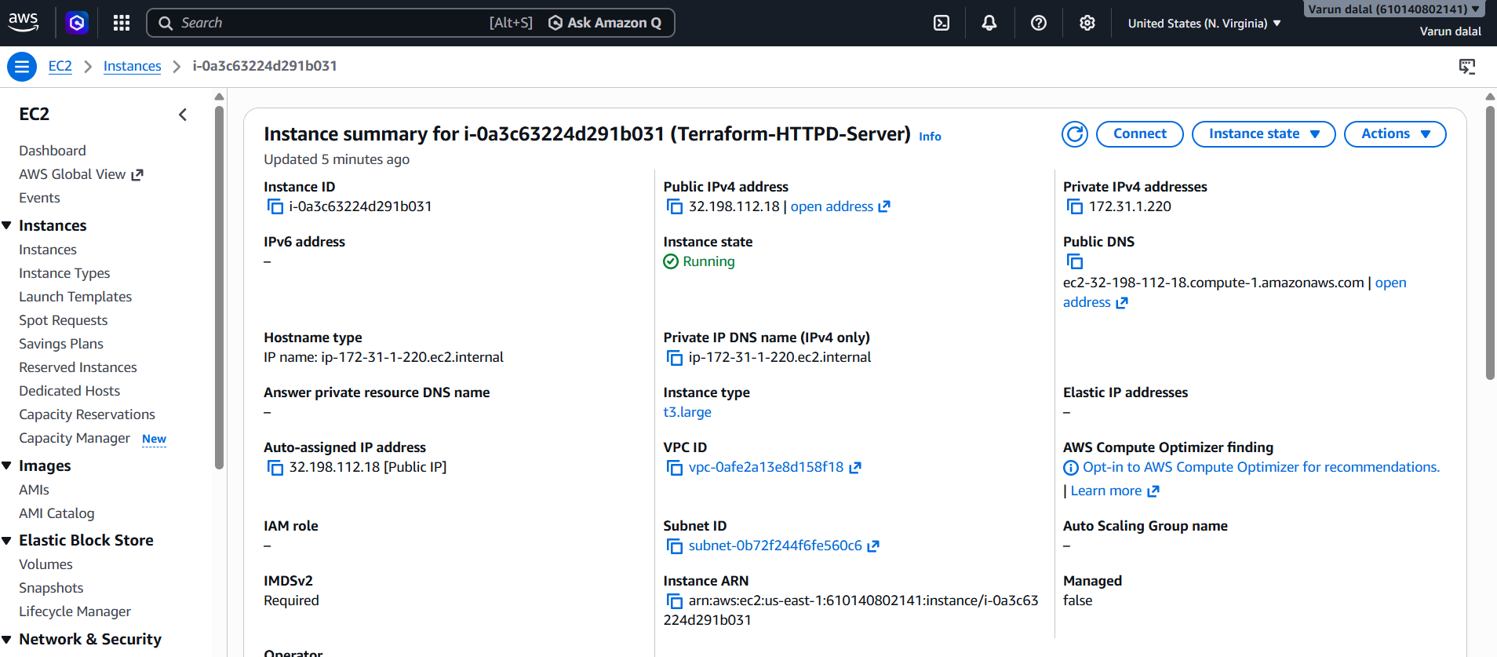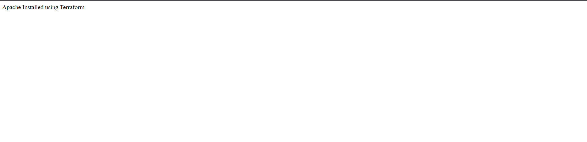

Task 4: Set Up S3 as Backend for Task 3
Objective
Configure Amazon S3 as the remote backend to store the Terraform state file for the EC2 instance with httpd installed.

Step 1: Create an S3 Bucket
- Log in to the AWS Management Console.
- Search for S3 and open it.
- Click Create bucket.
- Enter a unique bucket name.
Example:
terraform-state-varun1710
- Select the AWS Region:
us-east-1
- Leave the remaining settings as default.
- Click Create bucket.

Step 2: Update the Terraform Configuration
Open main.tf and add the following backend block at the top of the file.
terraform {
backend "s3" {
bucket = "terraform-state-varun1710"
key = "task3/terraform.tfstate"
region = "us-east-1"
}
}
Replace terraform-state-varun1710 with your S3 bucket name.

Step 3: Initialize Terraform
Run the following command:
terraform init
If you already have a local state file, Terraform will prompt you to migrate it.
Do you want to copy existing state to the new backend?
Type:
yes
Terraform will migrate the local terraform.tfstate file to the S3 bucket.

Step 4: Validate the Configuration
terraform validate
Expected output:
Success! The configuration is valid.

Step 5: Preview the Execution Plan
terraform plan
Terraform displays the execution plan and confirms that the state is being managed from the S3 backend.

Step 6: Apply the Configuration
terraform apply
Type:
yes
Terraform creates or updates the infrastructure and stores the state file in the S3 bucket.

Step 7: Verify the State File
- Open the AWS Console.
- Go to S3.
- Open your bucket.
- Navigate to:
task3/
You should see:
terraform.tfstate
This confirms that the Terraform state file is stored in Amazon S3.

Step 8: Verify Terraform State
Run:
terraform state list
Example output:
aws_instance.web_server
aws_security_group.web_sg

Project Structure
terraform-demo/
│── main.tf
│── variables.tf
└── output.tf

Result
- Created an Amazon S3 bucket to store the Terraform state file.
- Configured Terraform to use the S3 bucket as the remote backend.
- Migrated the local state file to Amazon S3.
- Verified that the state file is stored remotely and can be shared safely across team members.

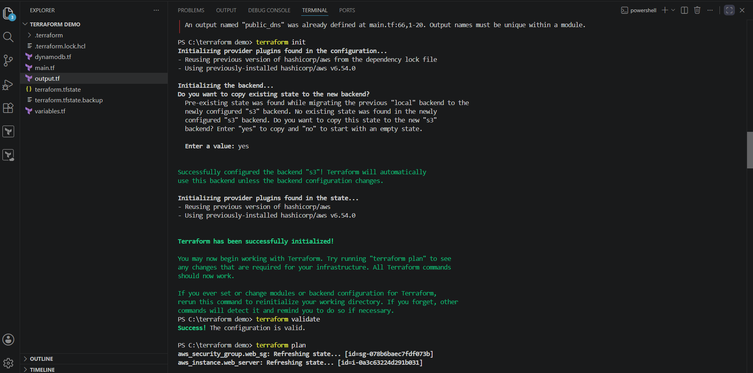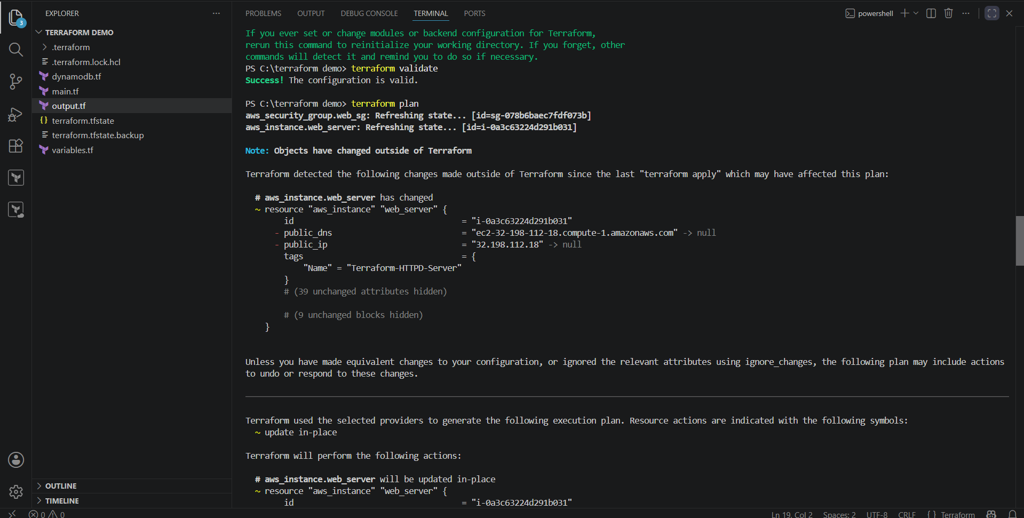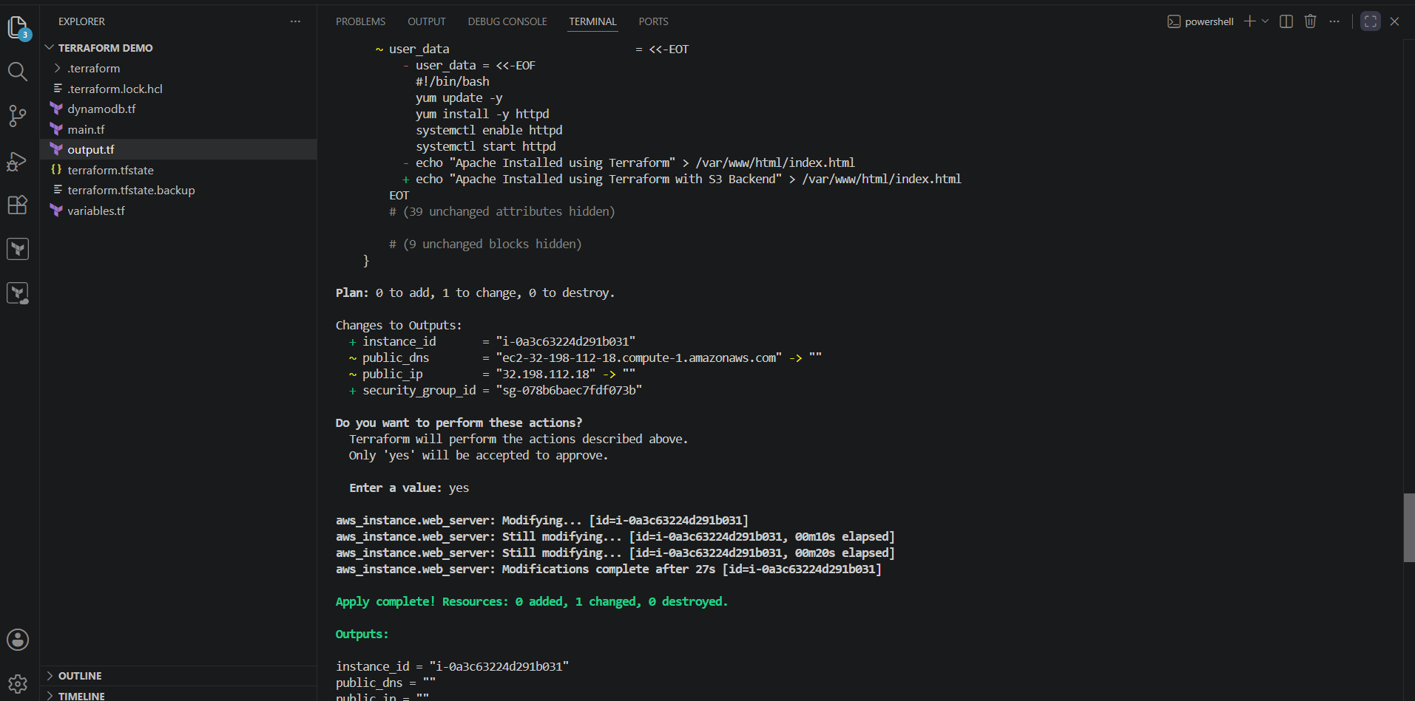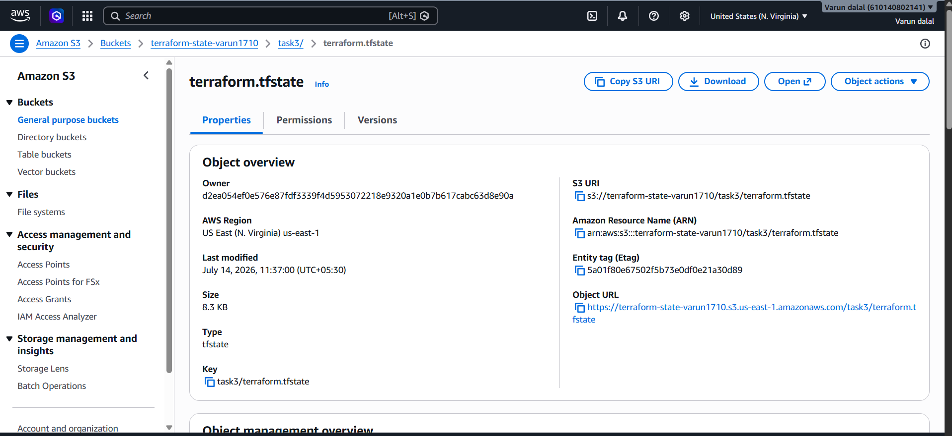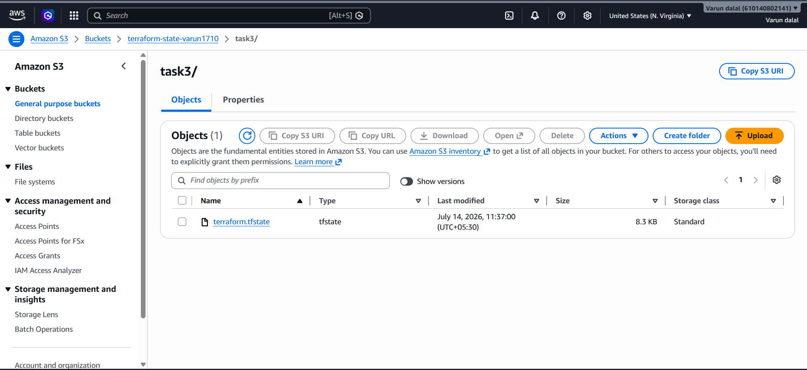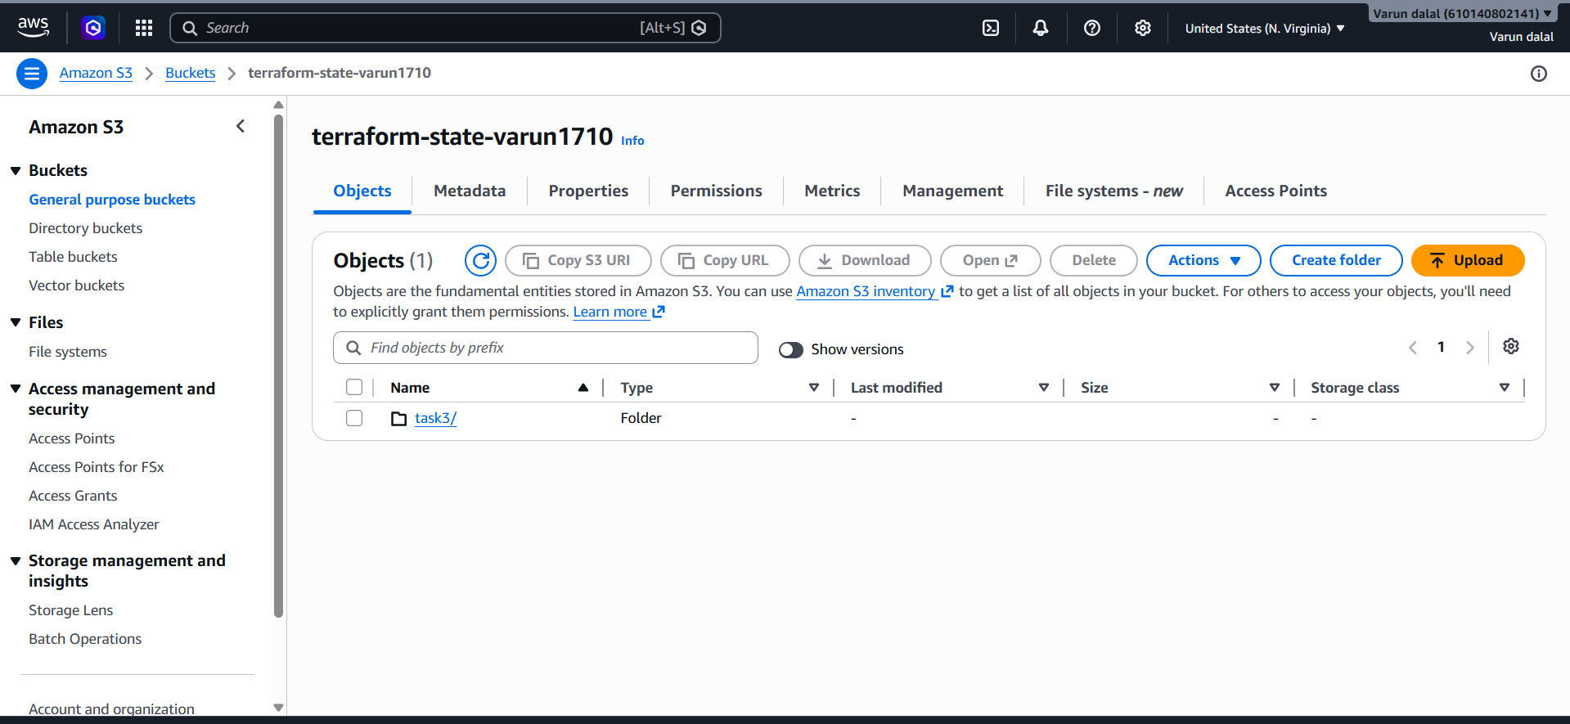

Task 5: Set Up DynamoDB Locking for Task 3
Objective
Configure Amazon DynamoDB for state locking to prevent multiple users from modifying the Terraform state file at the same time.

Step 1: Create a DynamoDB Table
- Log in to the AWS Management Console.
- Search for DynamoDB and open it.
- Click Create table.
- Enter the following details:
Setting | Value
Table name | terraform-lock-table
Partition key | LockID
Data type | String
- Select On-demand (PAY_PER_REQUEST) billing mode.
- Leave all other settings as default.
- Click Create table.
Wait until the table status changes to Active.

Step 2: Update the Terraform Backend
Open main.tf and modify the backend configuration.
terraform {
backend "s3" {
bucket = "terraform-state-varun1710"
key = "task3/terraform.tfstate"
region = "us-east-1"
dynamodb_table = "terraform-lock-table"
encrypt = true
}
}
Replace terraform-state-varun1710 with your S3 bucket name if it is different.

Step 3: Reinitialize Terraform
Run the following command:
terraform init -reconfigure
If prompted:
Do you want to copy existing state to the new backend?
Type:
yes
Terraform reconfigures the backend and enables state locking using DynamoDB.

Step 4: Validate the Configuration
Run:
terraform validate
Expected output:
Success! The configuration is valid.

Step 5: Verify the Infrastructure
Run:
terraform plan
Then run:
terraform apply
Type:
yes
Terraform will acquire a lock in the DynamoDB table before performing any operation and release it automatically when the operation is complete.

Step 6: Verify DynamoDB Locking
- Open the AWS Management Console.
- Go to DynamoDB.
- Open the table:
terraform-lock-table
- Click Explore table items.
During terraform apply or terraform destroy, Terraform creates a temporary LockID item in the table. After the operation completes, the lock entry is automatically removed.

Step 7: Verify S3 Backend
Open the S3 bucket and confirm that the state file is stored at:
task3/terraform.tfstate

Project Structure
terraform-demo/
│── main.tf
│── variables.tf
└── output.tf

Result
- Created a DynamoDB table for Terraform state locking.
- Updated the Terraform backend to use the DynamoDB table.
- Reinitialized Terraform with the new backend configuration.
- Verified that Terraform acquires and releases a state lock during operations.
- Ensured safe collaboration by preventing multiple users from modifying the same Terraform state simultaneously.

