Provision EC2, S3, and VPC using Terraform Modules
Step 1: Install Prerequisites
- Install Terraform.
- Install AWS CLI.
- Configure AWS credentials.
aws configure
Enter:
- AWS Access Key ID
- AWS Secret Access Key
- Default Region (e.g., us-east-1)
- Output Format (json)

Step 2: Create Project Structure
terraform-modules/
│
├── main.tf
├── variables.tf
├── outputs.tf
├── provider.tf
│
├── modules/
│ ├── vpc/
│ │ ├── main.tf
│ │ ├── variables.tf
│ │ └── outputs.tf
│ │
│ ├── ec2/
│ │ ├── main.tf
│ │ ├── variables.tf
│ │ └── outputs.tf
│ │
│ └── s3/
│ ├── main.tf
│ ├── variables.tf
│ └── outputs.tf

Step 3: Configure AWS Provider
Create provider.tf
provider "aws" {
region = "us-east-1"
}

Step 4: Create VPC Module
Inside modules/vpc
Resources:
- VPC
- Public Subnet
- Internet Gateway
- Route Table
- Route Table Association

Step 5: Create EC2 Module
Inside modules/ec2
Resources:
- Security Group
- EC2 Instance
- Key Pair (optional)
User Data:
- Install Apache (httpd)
- Start Apache service

Step 6: Create S3 Module
Inside modules/s3
Resources:
- S3 Bucket
- Versioning (optional)
- Tags

Step 7: Call Modules in Root main.tf
Create module blocks for:
module "vpc" {
source = "./modules/vpc"
}

module "ec2" {
source = "./modules/ec2"
}

module "s3" {
source = "./modules/s3"
}

Step 8: Initialize Terraform
terraform init
Terraform downloads the AWS provider and initializes all modules.

Step 9: Validate Configuration
terraform validate
Checks the configuration for syntax errors.

Step 10: Review Execution Plan
terraform plan
Displays the resources that Terraform will create.

Step 11: Provision Infrastructure
terraform apply
Type:
yes
Terraform provisions:
- VPC
- Public Subnet
- Internet Gateway
- Route Table
- Security Group
- EC2 Instance
- S3 Bucket

Step 12: Verify Resources
Log in to the AWS Console and verify:
- VPC → VPC and Subnet created
- EC2 → Instance is running
- S3 → Bucket created

Step 13: Access the EC2 Instance
ssh -i key.pem ubuntu@<Public-IP>
or (Amazon Linux)
ssh -i key.pem ec2-user@<Public-IP>

Step 14: View Outputs
terraform output
Example outputs:
- VPC ID
- Subnet ID
- EC2 Public IP
- S3 Bucket Name

Step 15: Destroy Resources (Optional)
terraform destroy
Type:
yes
This removes all AWS resources created by Terraform.

Outcome
After completing these steps, Terraform successfully provisions:
- A VPC with networking components
- An EC2 instance running inside the VPC
- An S3 bucket
- All resources are created using Terraform modules, making the infrastructure reusable and easier to manage.
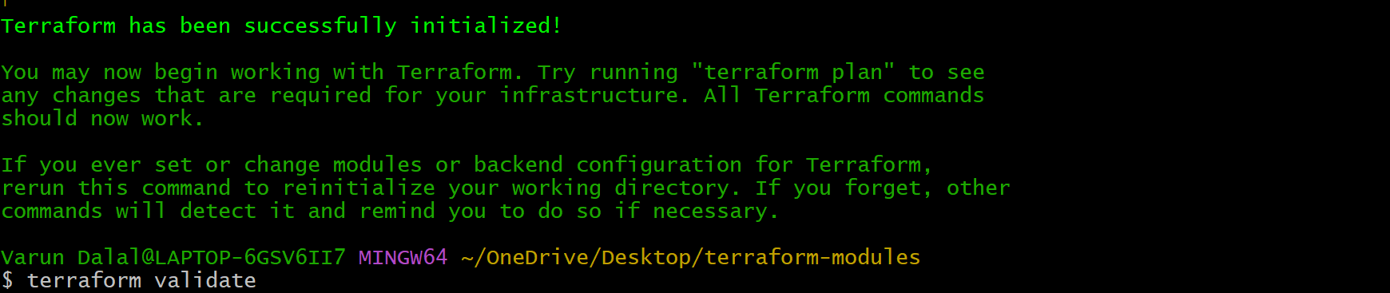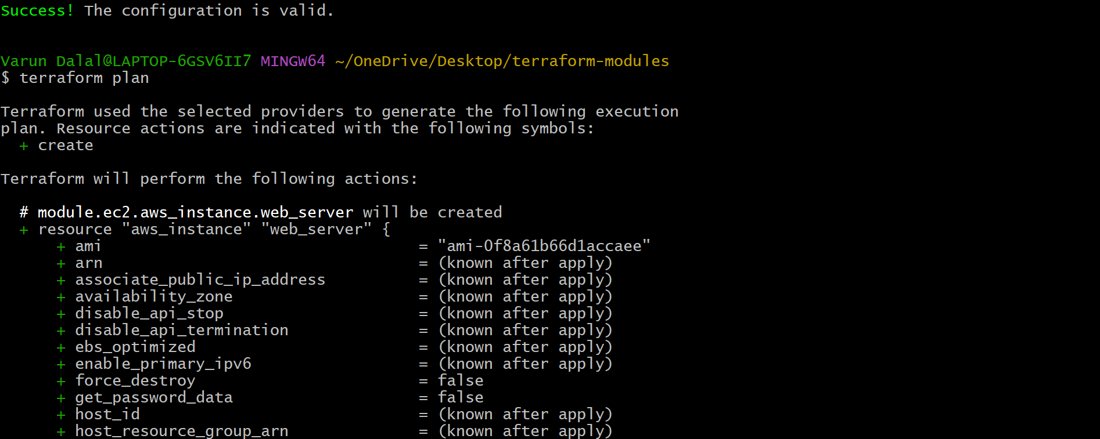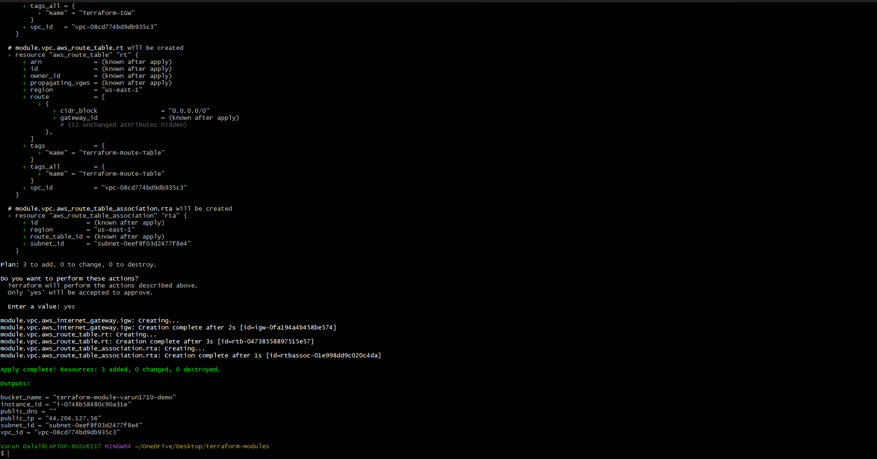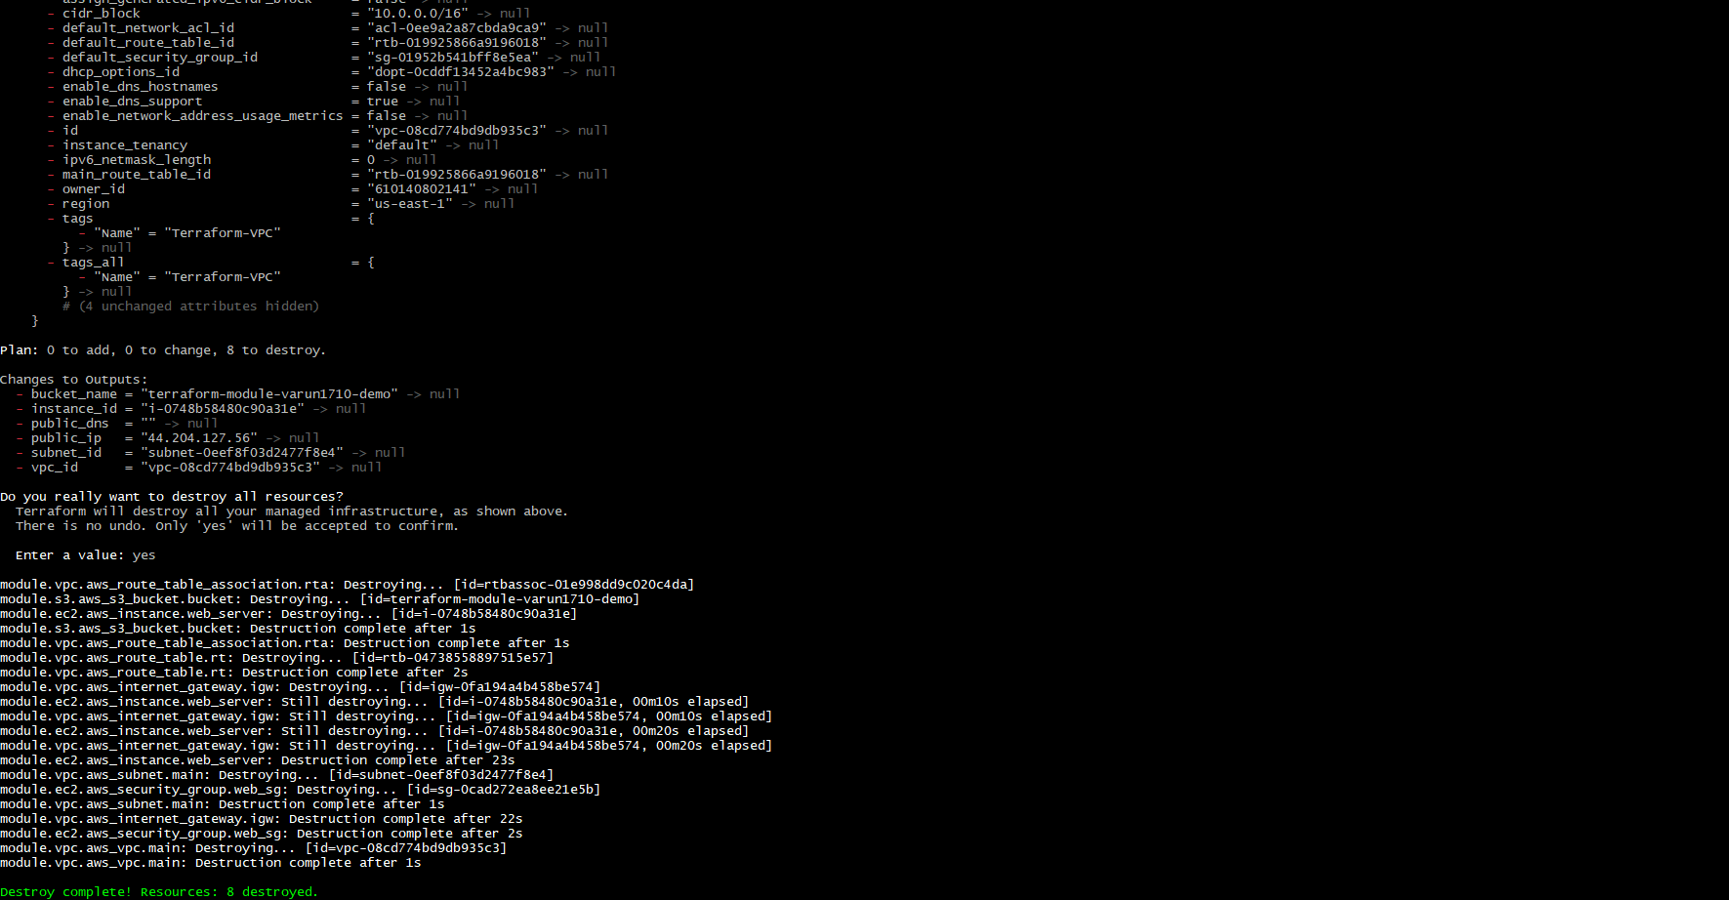

Provision EC2 for 3 Different Environments (Dev, Staging, and Prod) Using Terraform Workspaces
Objective
Create separate EC2 instances for Dev, Staging, and Production environments using a single Terraform configuration and manage them using Terraform Workspaces.

Step 1: Install Terraform
Verify Terraform installation:
terraform -version

Step 2: Create Terraform Project Directory
Create a project folder:
mkdir terraform-workspaces
cd terraform-workspaces
Project structure:
terraform-workspaces/

├── main.tf
├── output.tf
└── .terraform.lock.hcl

Step 3: Configure AWS Provider
Create main.tf file and add AWS provider configuration:
provider "aws" {
region = "eu-north-1"
}

Step 4: Define Environment Configuration Using Locals
Add environment-specific configurations:
locals {

env_config = {

dev = {
instance_type = "t3.micro"
name = "Dev-EC2"
}

staging = {
instance_type = "t3.micro"
name = "Staging-EC2"
}

prod = {
instance_type = "t3.small"
name = "Prod-EC2"
}

}

current_env = terraform.workspace

}

Step 5: Create EC2 Instance Resource
Add EC2 resource in main.tf:
resource "aws_instance" "web_server" {

ami = "ami-063f61adbae382edf"

instance_type = local.env_config[local.current_env].instance_type

tags = {

Name = local.env_config[local.current_env].name

Environment = local.current_env

}

}

Step 6: Create Terraform Output File
Create output.tf:
output "instance_id" {

description = "EC2 Instance ID"

value = aws_instance.web_server.id

}

output "public_ip" {

description = "EC2 Public IP"

value = aws_instance.web_server.public_ip

}

output "environment" {

description = "Current Workspace"

value = terraform.workspace

}

Step 7: Initialize Terraform
Initialize Terraform:
terraform init
If backend configuration changes:
terraform init -reconfigure

Step 8: Create Terraform Workspaces
Create separate workspaces for each environment:
Create Dev Workspace
terraform workspace new dev
Create Staging Workspace
terraform workspace new staging
Create Production Workspace
terraform workspace new prod

Step 9: Verify Workspaces
List available workspaces:
terraform workspace list
Output:
default
dev
staging
prod

Step 10: Deploy Dev Environment
Select Dev workspace:
terraform workspace select dev
Check configuration:
terraform plan
Create EC2 instance:
terraform apply -auto-approve
Created resources:
Environment : Dev
Instance Name : Dev-EC2
Instance Type : t3.micro

Step 11: Deploy Staging Environment
Select Staging workspace:
terraform workspace select staging
Deploy:
terraform apply -auto-approve
Created resources:
Environment : Staging
Instance Name : Staging-EC2
Instance Type : t3.micro

Step 12: Deploy Production Environment
Select Production workspace:
terraform workspace select prod
Deploy:
terraform apply -auto-approve
Created resources:
Environment : Production
Instance Name : Prod-EC2
Instance Type : t3.small

Step 13: Verify Current Workspace
Check active workspace:
terraform workspace show
Example:
prod

Step 14: Verify EC2 Instances
Go to:
AWS Console
↓
EC2
↓
Instances
Verify three EC2 instances:
Environment | EC2 Name | Instance Type
Dev | Dev-EC2 | t3.micro
Staging | Staging-EC2 | t3.micro
Prod | Prod-EC2 | t3.small

Step 15: Destroy Specific Environment
Example: Destroy Dev environment only:
terraform workspace select dev

terraform destroy -auto-approve
Destroy Production:
terraform workspace select prod

terraform destroy -auto-approve

Terraform Workspace Workflow
Terraform Init
|
|
Create Workspaces
|
|
Dev Workspace
|
Create Dev EC2
|
|
Staging Workspace
|
Create Staging EC2
|
|
Prod Workspace
|
Create Prod EC2

Result
✅ Created EC2 instances for three environments
✅ Used Terraform Workspaces for environment separation
✅ Maintained a single Terraform codebase
✅ Managed Dev, Staging, and Production independently
