1.Launch one EC2 using Amazon Linux 2 and install Apache using User Data
Objective
Automatically install and start Apache web server while launching EC2.
Outcome
Apache automatically installs during launch.
- Login to AWS Console
- Go to Amazon Web Services → EC2 → Launch Instance
- Name: AmazonLinux-Apache
- AMI: Amazon Linux 2
- Instance type: t2.micro
- Create/select key pair
- • Allow HTTP (Port 80) in Security Group
- • Launch instance

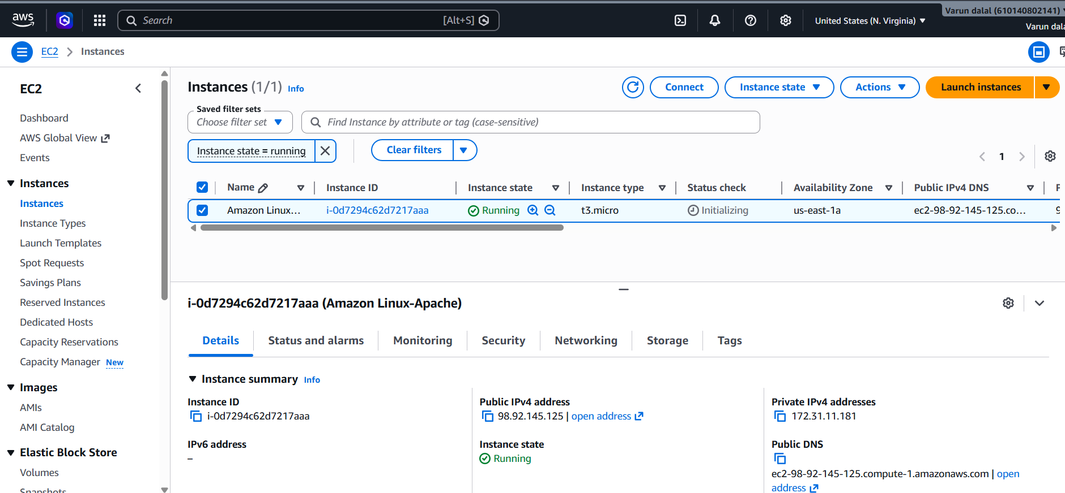

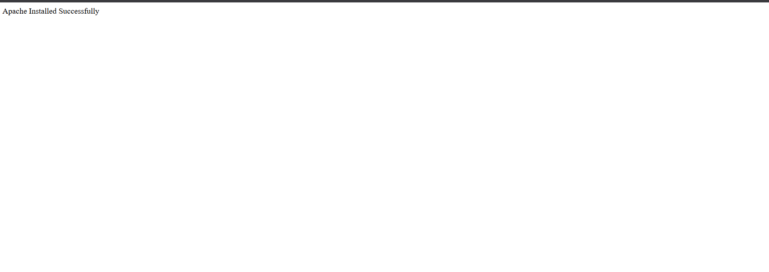

2. Launch one EC2 using Ubuntu and install Nginx using User Data
Objective
Automatically install Nginx server.
Outcome
Nginx installed automatically
- Launch new EC2
- Name: Ubuntu-Nginx
- AMI: Ubuntu Server
- Instance type: t2.micro
- • Allow HTTP (80)
- • Launch instance

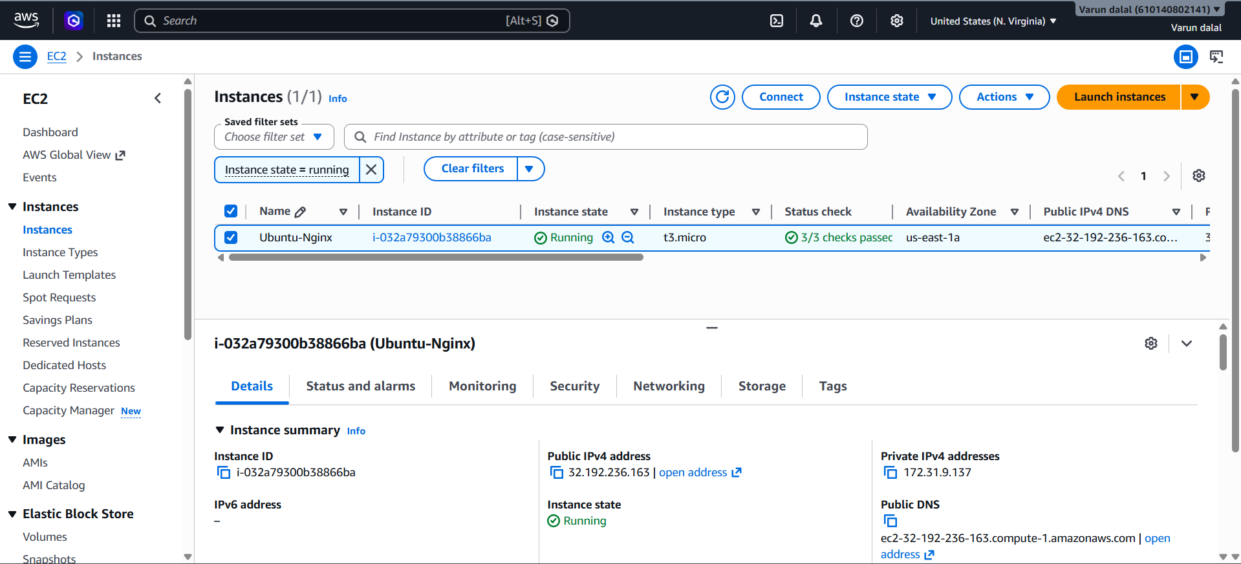



3 — Launch Windows Server and Install Tomcat
Objective
Host Java applications using Apache Tomcat on Windows EC2.
Outcome
Tomcat starts on port 8080.
Outcome
Tomcat starts on port 8080.
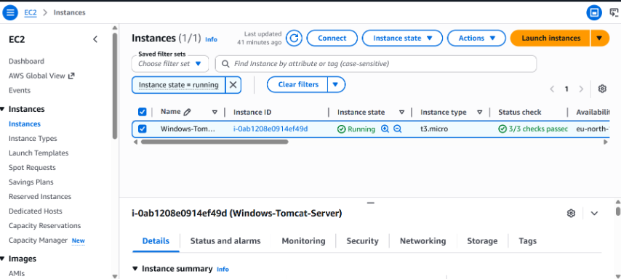

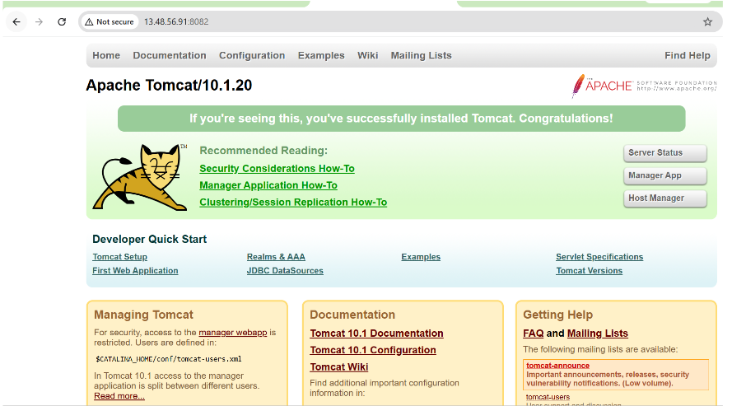

4. Take Snapshot of Instance Created in Task 1
Objective
Create backup of EC2 volume.
Outcome
Backup of volume created.
Validation
EC2 → Snapshots

- Go to EC2 → Instances
- Select Amazon Linux instance
- Storage tab → Click Volume ID
- Actions → Create Snapshot
- Give name:
Apache-Server-Snapshot
- Create Snapshot
Check under:
- EC2 → Snapshots

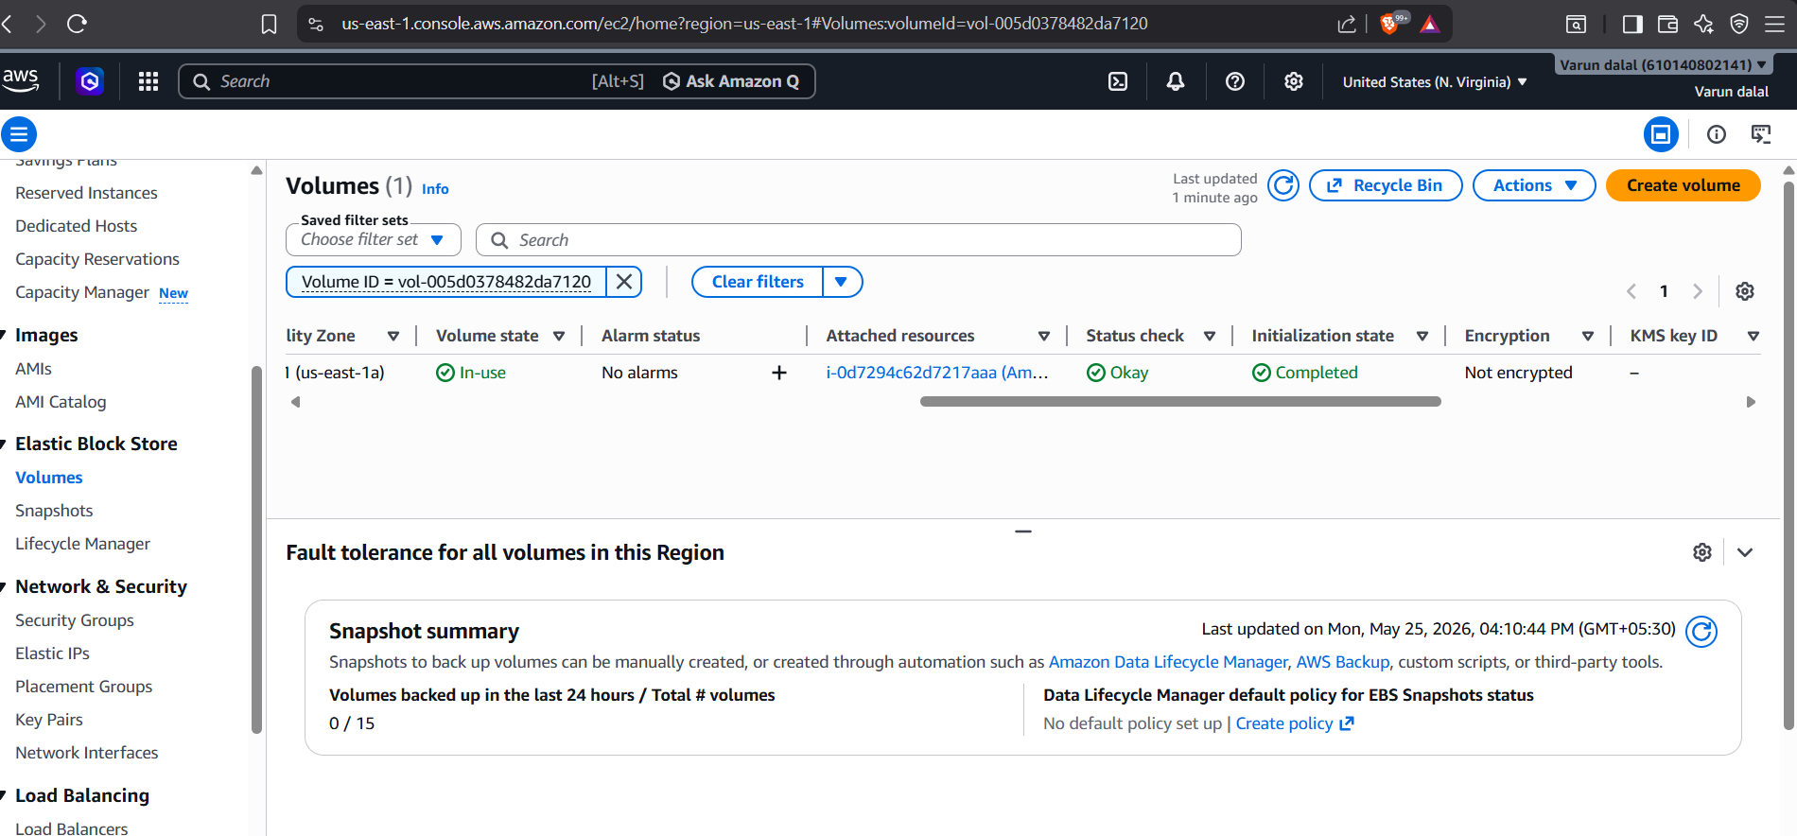

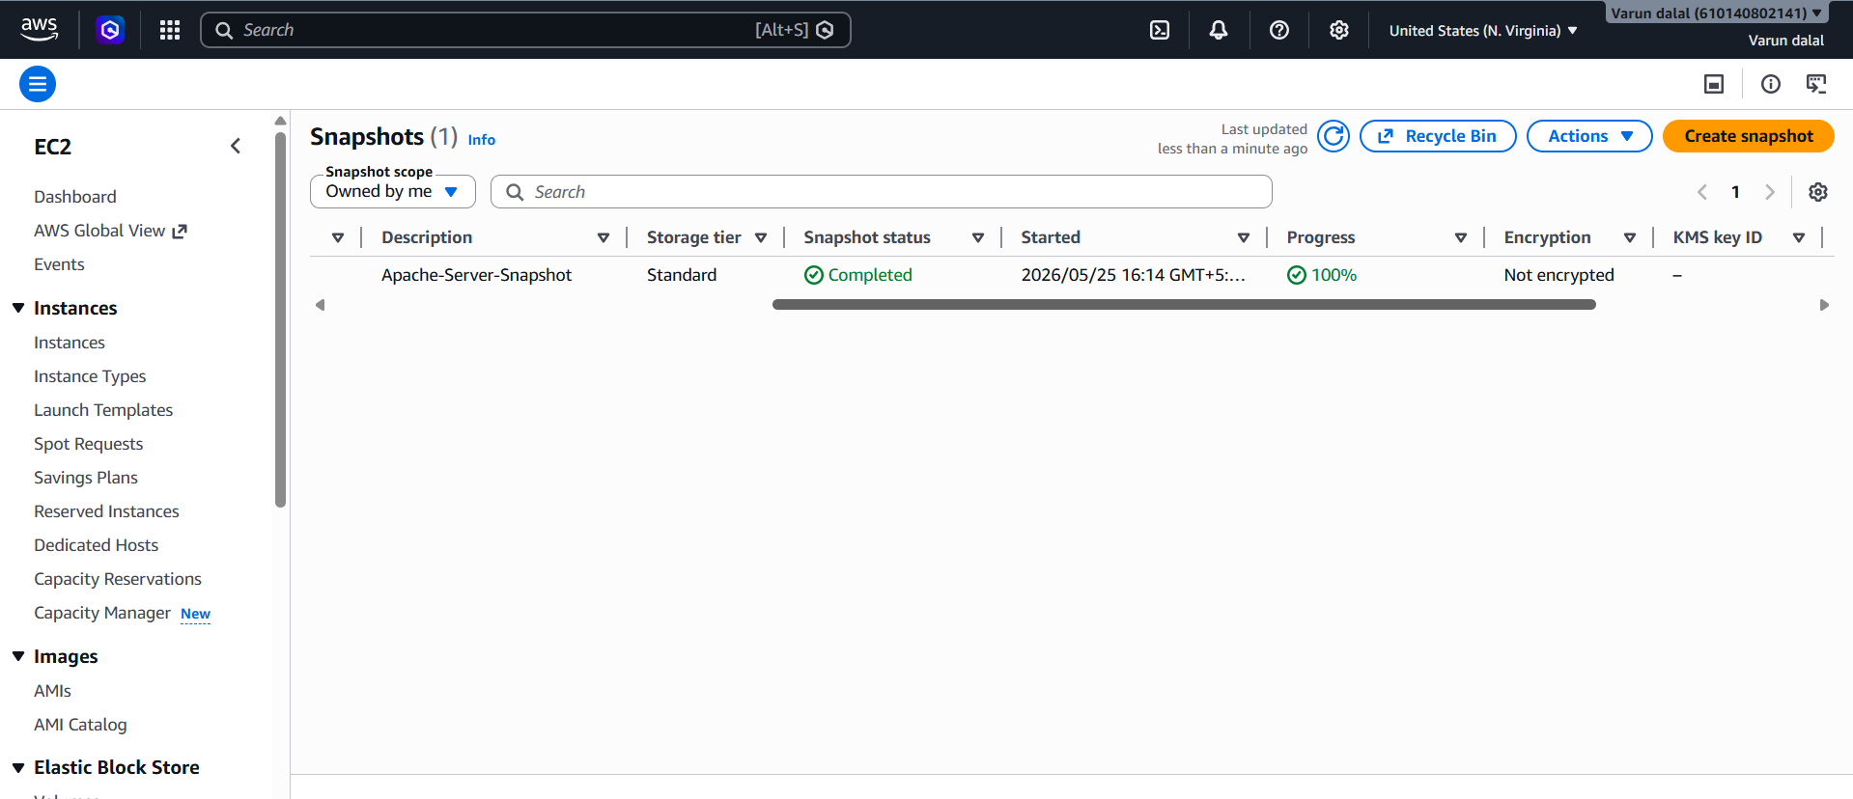

5. Assign Password less Authentication for EC2 Created in Task 2
Objective
Enable SSH login without password manually entering credentials every time.
What Happens Here?
SSH uses:
- Private key
- Public key
- Outcome
- SSH trusts local generated key.

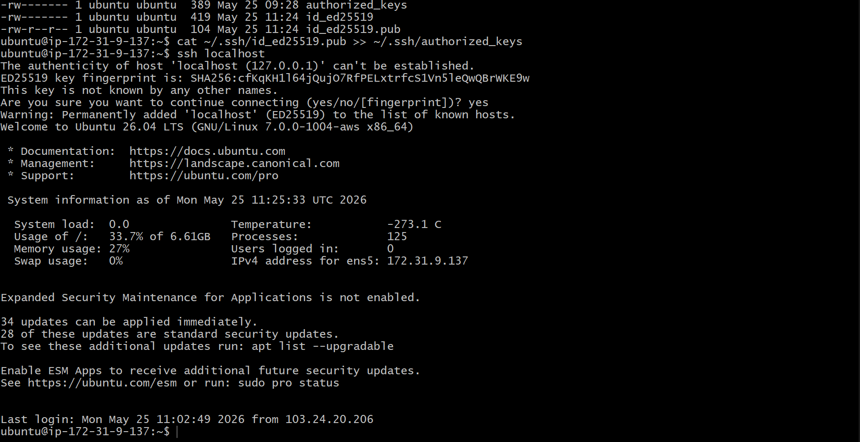

6.Launch EC2 using Spot Purchasing Option
Objective
Launch low-cost EC2

Outcome
EC2 launched at reduced price

Validation
EC2 dashboard shows:
Lifecycle: Spot

- Launch Instance
- Under Purchasing option:
  - Select Request Spot Instances
- Choose:
  - Amazon Linux 2
  - t2.micro
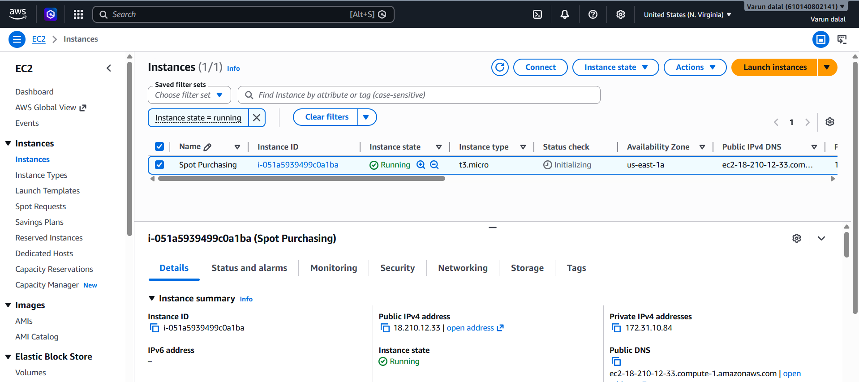

- Enable Termination Protection on Task 2 EC2
Objective
Prevent accidental deletion

Outcome
Instance protected from accidental termination.

Validation
Try terminating instance.

- Select Ubuntu EC2
- Actions → Instance Settings
- Click:
Change Termination Protection
- Enable
Now instance cannot be deleted accidentally.

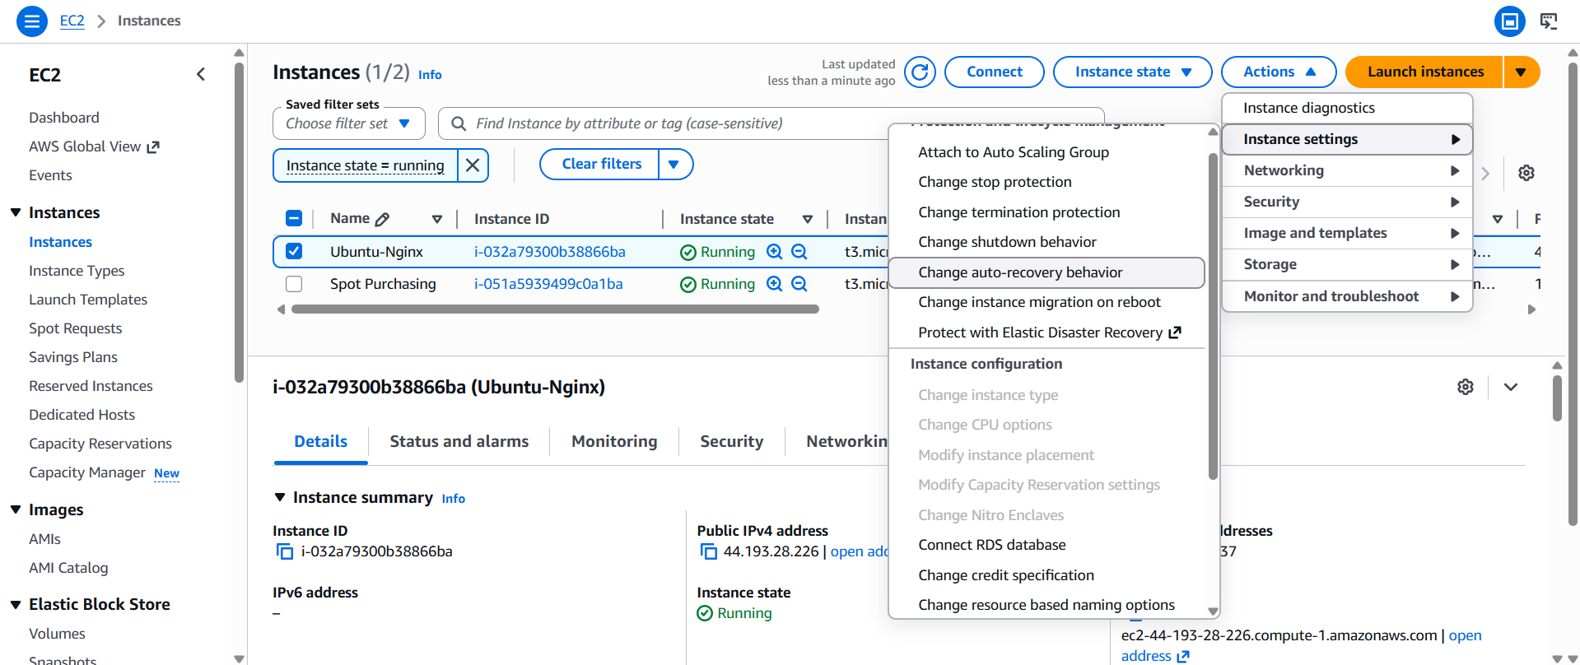

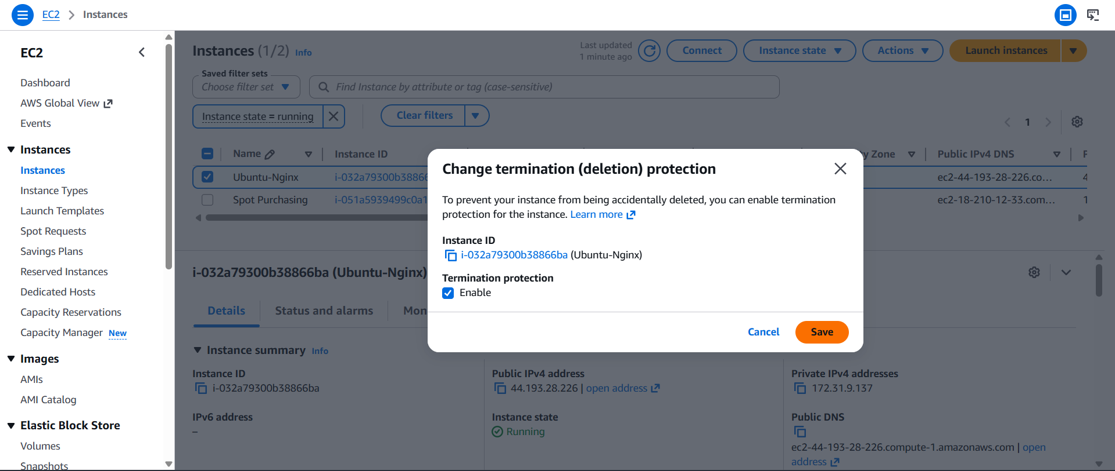

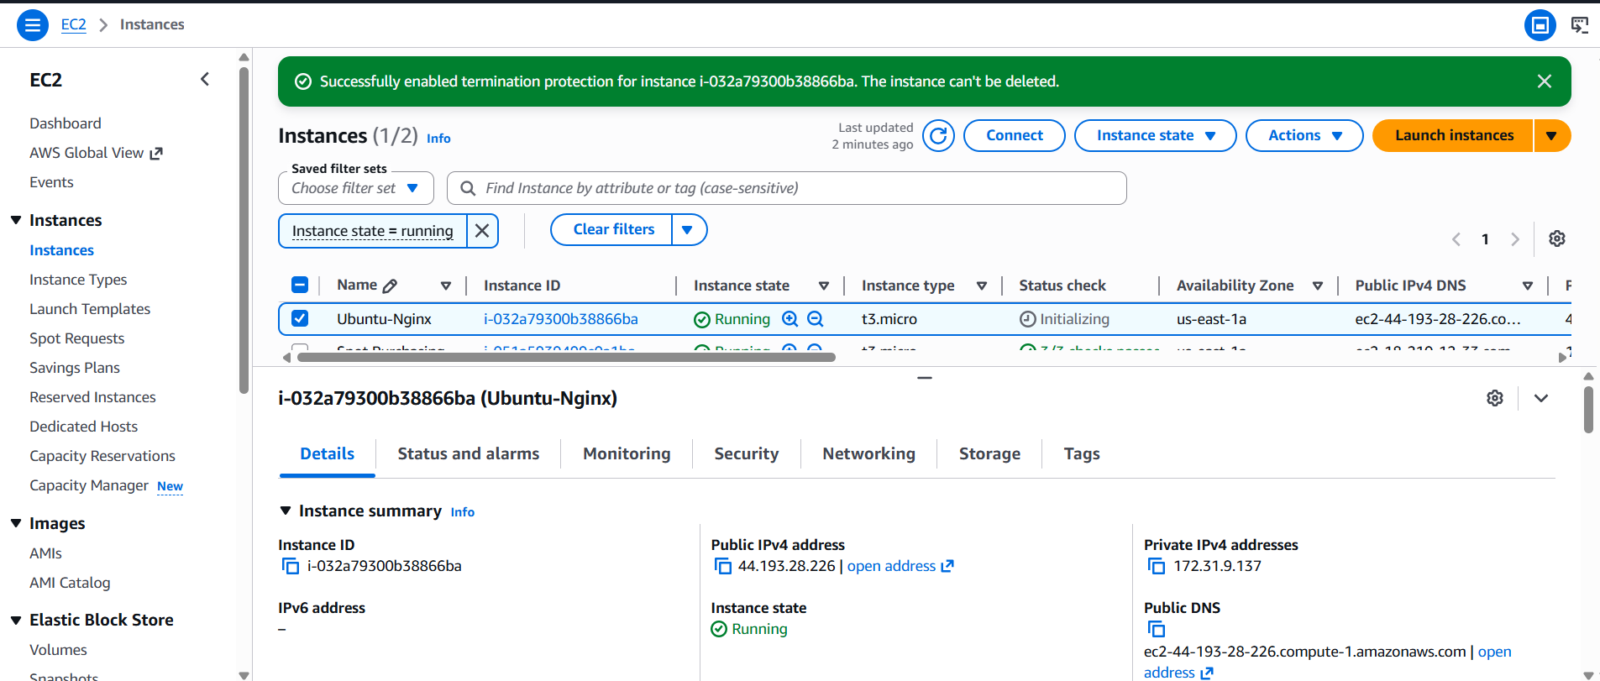

8.Launch EC2 Using AWS CLI
Objective
Launch EC2 using command line automation.

Outcome
EC2 launches through CLI.

Validation
Check instances:
aws ec2 describe-instances
Expected:
JSON output showing running EC2 instance.
