1)Execute the script shown in the video.
Step 1: Create Project Folder
Open VS Code → Create folder:
Terraform_basic
Inside it create:
main.tf
variables.tf
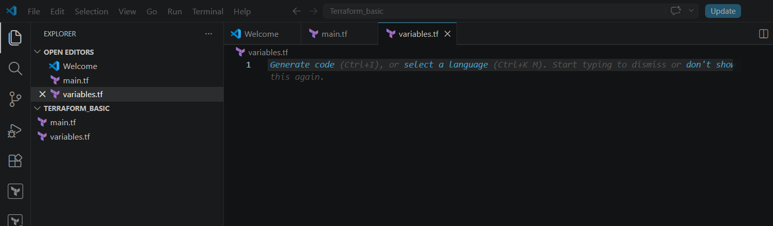

Step 2: Write main.tf
resource "local_file" "my_pet" {
filename = var.filename
content = var.content
}
resource "random_pet" "petname" {
prefix = var.prefix
separator = "."
length = "1"
}
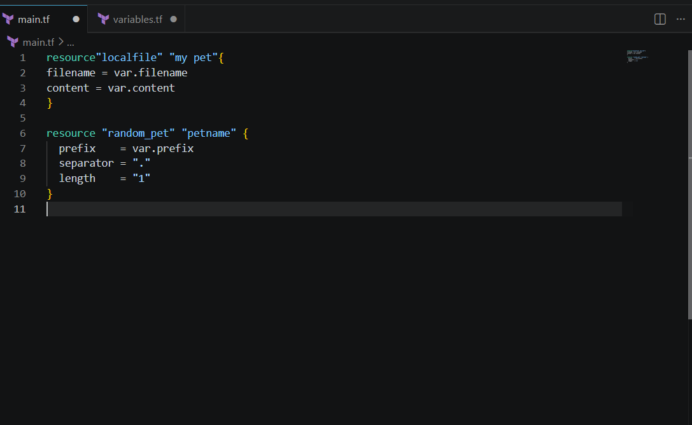
Step 3: Write variables.tf
Version 1 — Only Variable Declaration
variable "filename" {
}
variable "content" {
}
variable "prefix" {
}
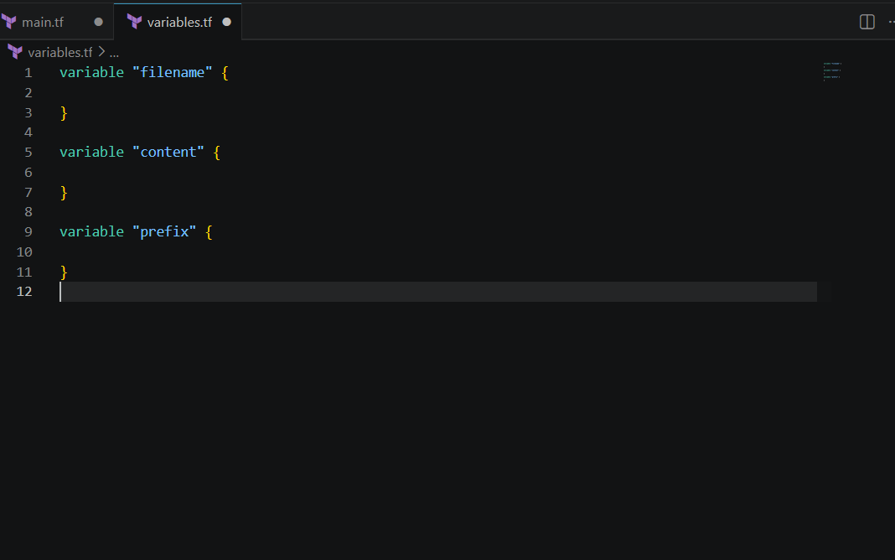
Step 4: Initialize Terraform
Open terminal inside VS Code:
terraform init
You will see:
Terraform has been successfully initialized!
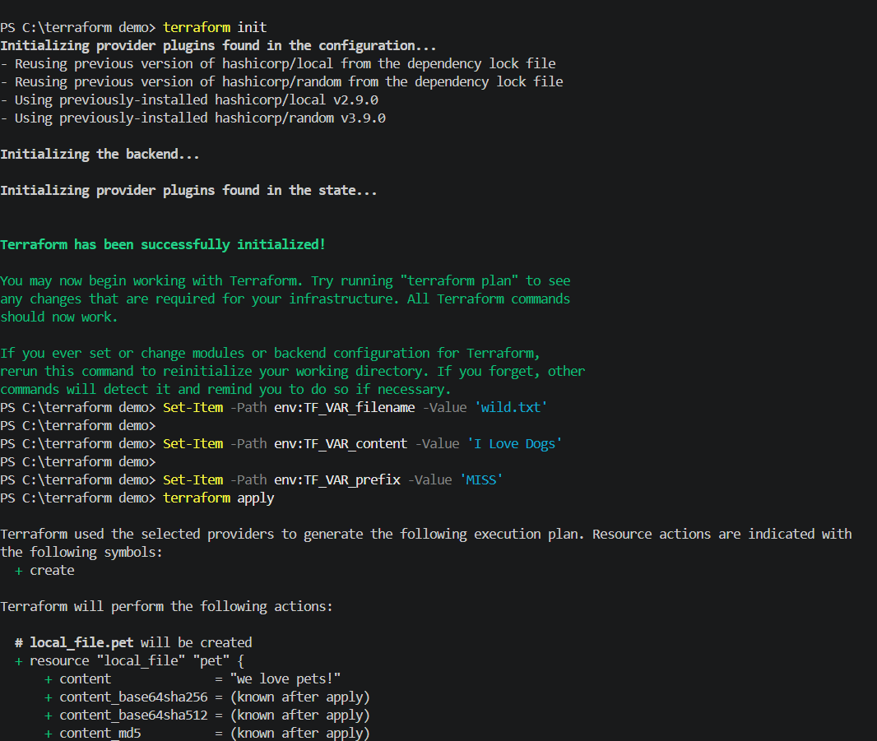
Now execute:
terraform apply
Type:
yes
Terraform creates:
wild.txt
with content:
My cat name is sun
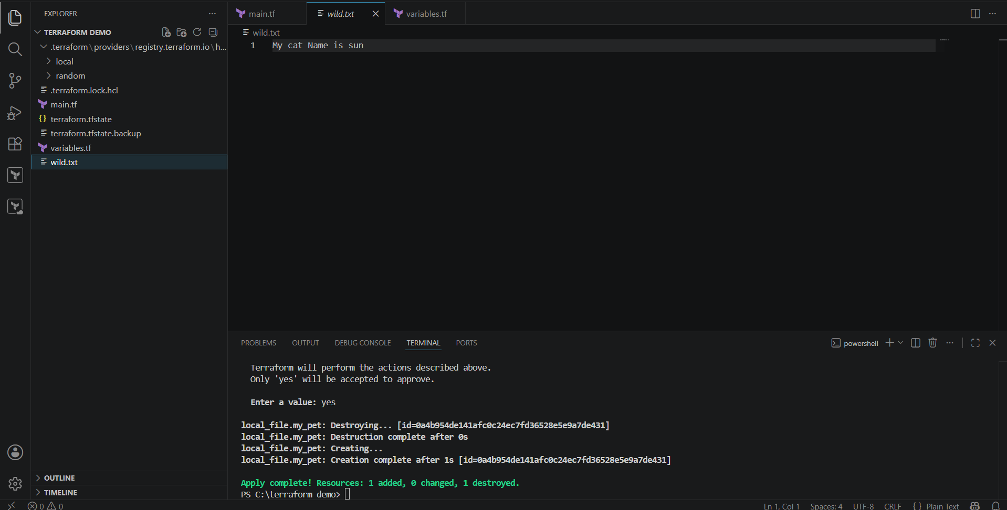

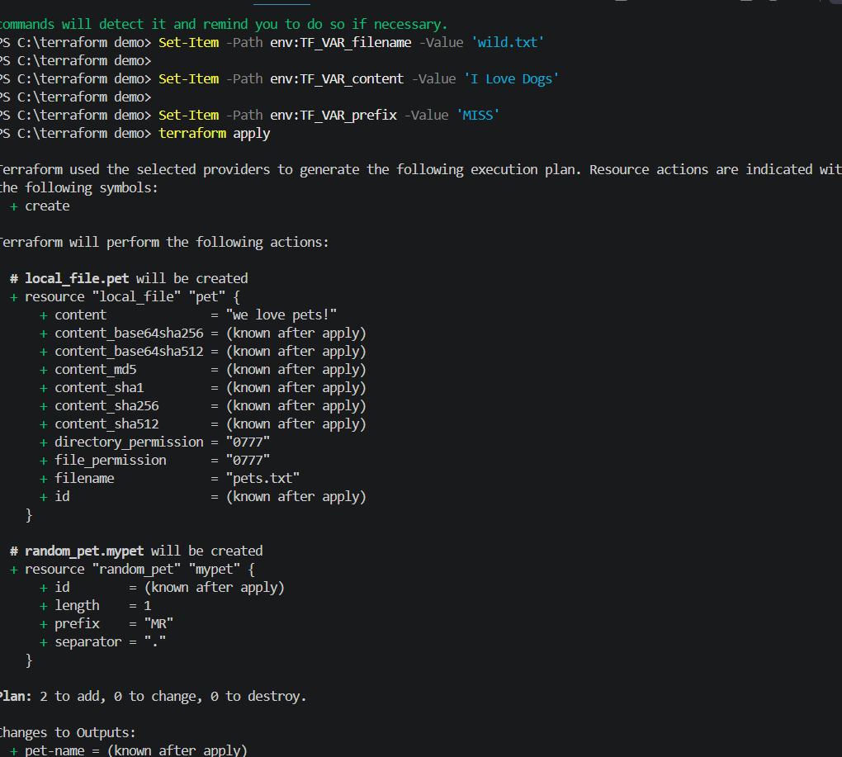
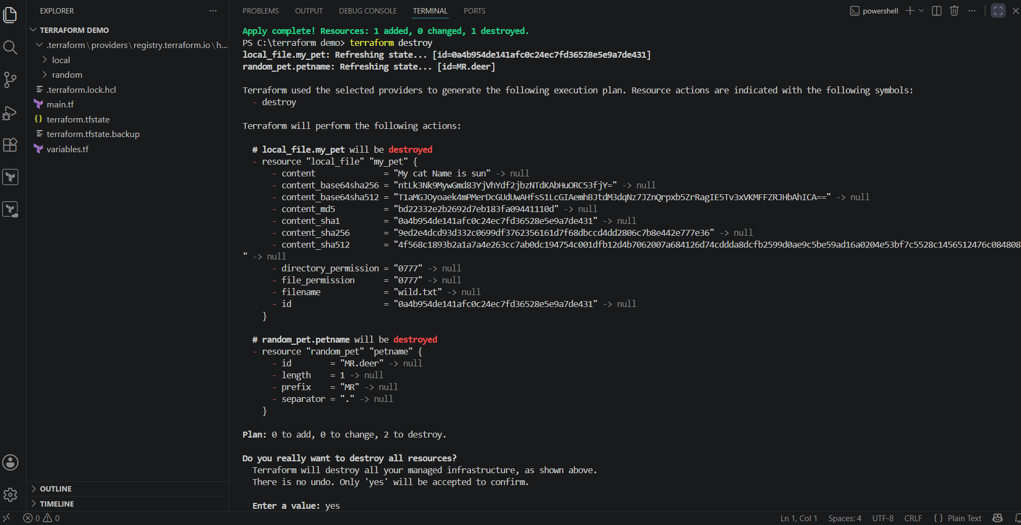
Final Folder Structure
Terraform_basic/
│
├── main.tf
├── variables.tf
├── terraform.tfstate
├── terraform.tfstate.backup
├── pets.txt
└── .terraform/

2) Integrate Terraform in Jenkins using the Terraform plugin
Integrate Terraform with Jenkins using the Terraform Plugin to automate infrastructure deployment through a Jenkins pipeline.

Prerequisites
- Jenkins installed and running
- Terraform installed on the Jenkins server
- Git installed
- GitHub repository containing Terraform code
- AWS credentials configured (if deploying to AWS)
- Jenkins administrator access

Step 1: Install the Terraform Plugin
- Go to Manage Jenkins → Plugins.
- Open the Available Plugins tab.
- Search for Terraform.
- Select Terraform Plugin.
- Click Install and restart Jenkins if prompted.

Step 2: Configure Terraform Tool
- Go to Manage Jenkins → Tools.
- Scroll down to Terraform Installations.
- Click Add Terraform.
- Enter:
  - Name: Terraform
  - Install automatically: Enable (or provide the Terraform installation path manually).
- Click Save.

Step 3: Configure AWS Credentials
If deploying to AWS:
- Configure AWS CLI on the Jenkins server:
aws configure
Enter:
- AWS Access Key
- AWS Secret Key
- Region
- Output format
Verify:
aws sts get-caller-identity

Step 4: Create a Terraform Project
Create a repository with the following main.tf file:
provider "aws" {
region = "us-east-1"
}

resource "aws_instance" "demo" {
ami = "ami-0c02fb55956c7d316"
instance_type = "t2.micro"

tags = {
Name = "Jenkins-Terraform"
}
}
Push the project to GitHub.

Step 5: Create a Pipeline Job
- Click New Item.
- Enter a job name.
- Select Pipeline.
- Click OK.

Step 6: Configure Source Code
Under Pipeline:
- Select Pipeline script from SCM.
- SCM: Git
- Repository URL: Your GitHub repository URL.
- Select Git credentials.
- Branch: main
- Script Path: Jenkinsfile
Click Save.

Step 7: Create the Jenkinsfile
Create a Jenkinsfile in the repository:
pipeline {
agent any

tools {
terraform 'Terraform'
}

stages {

stage('Checkout') {
steps {
git url: 'https://github.com/username/terraform-demo.git', branch: 'main'
}
}

stage('Terraform Init') {
steps {
sh 'terraform init'
}
}

stage('Terraform Validate') {
steps {
sh 'terraform validate'
}
}

stage('Terraform Plan') {
steps {
sh 'terraform plan'
}
}

stage('Terraform Apply') {
steps {
sh 'terraform apply -auto-approve'
}
}
}
}
Commit and push the Jenkinsfile.

Step 8: Build the Pipeline
- Open the Jenkins job.
- Click Build Now.
- Monitor the build in Console Output.

Step 9: Verify the Deployment
After the pipeline completes successfully:
- Log in to the AWS Console.
- Navigate to EC2 → Instances.
- Verify that the EC2 instance has been created.

Pipeline Workflow
Developer
│
▼
Push Terraform Code to GitHub
│
▼
Jenkins Pipeline
│
├── Checkout
├── Terraform Init
├── Terraform Validate
├── Terraform Plan
└── Terraform Apply
│
▼
AWS Infrastructure Created

Expected Output
Cloning repository...

Terraform has been successfully initialized!

Success! The configuration is valid.

Plan: 1 to add, 0 to change, 0 to destroy.

Apply complete!
Resources: 1 added, 0 changed, 0 destroyed.

Conclusion
Using the Terraform Plugin in Jenkins allows you to manage the Terraform installation as a Jenkins tool and execute Terraform commands from a pipeline. This integration automates infrastructure provisioning by performing Checkout → Init → Validate → Plan → Apply, ensuring a consistent and repeatable Infrastructure as Code (IaC) deployment process.
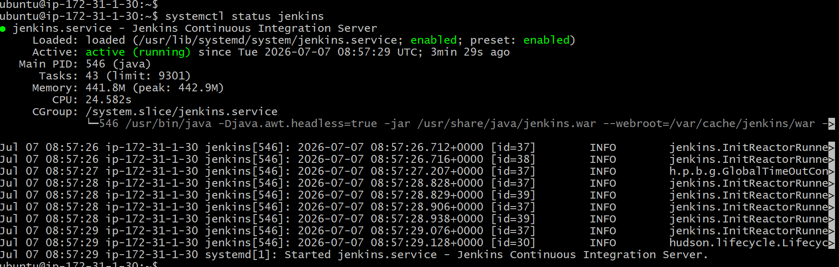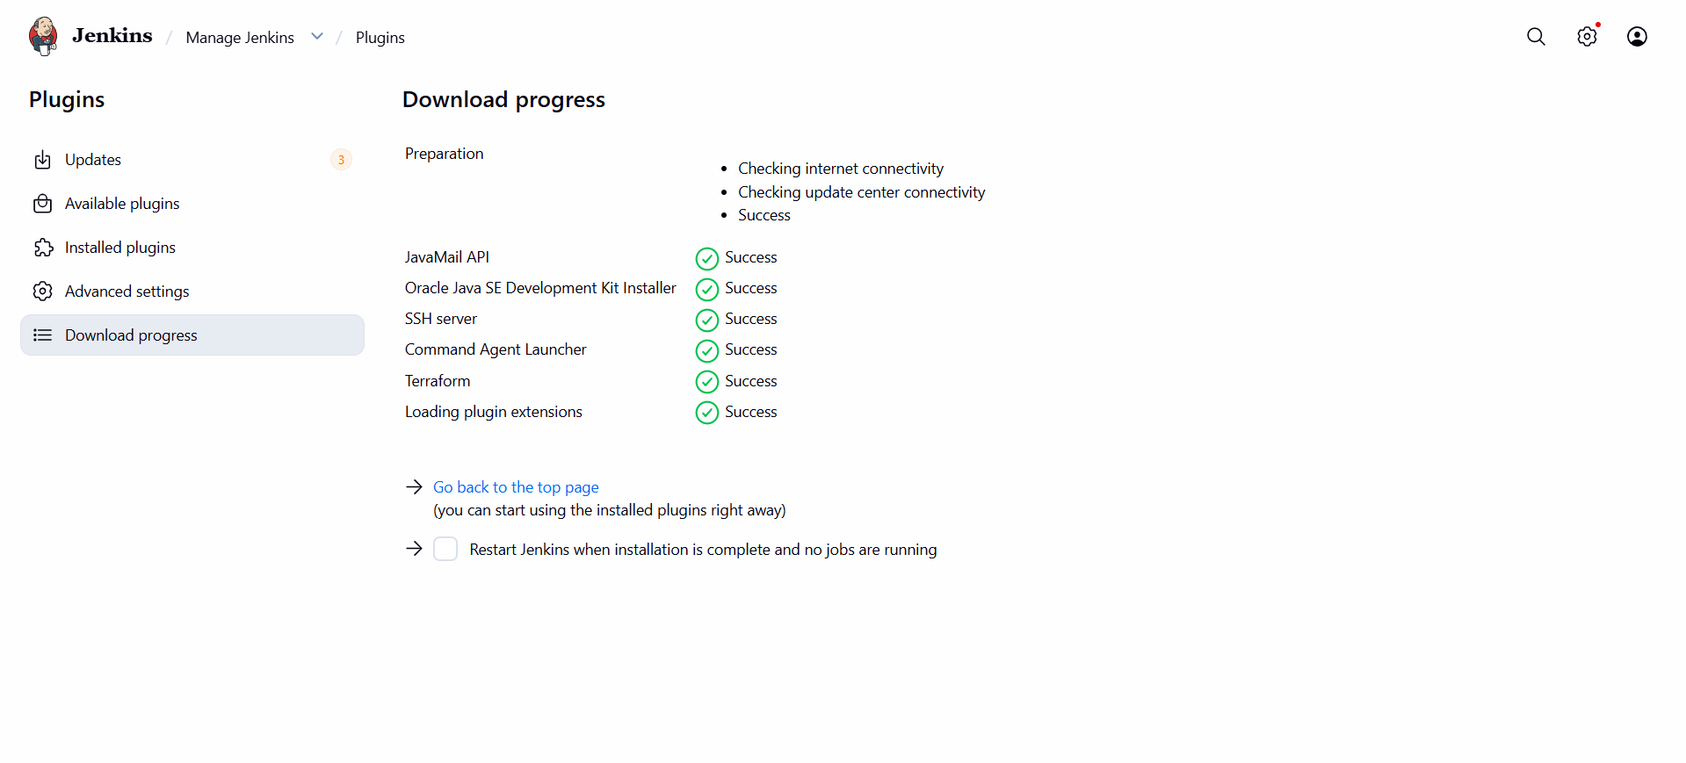
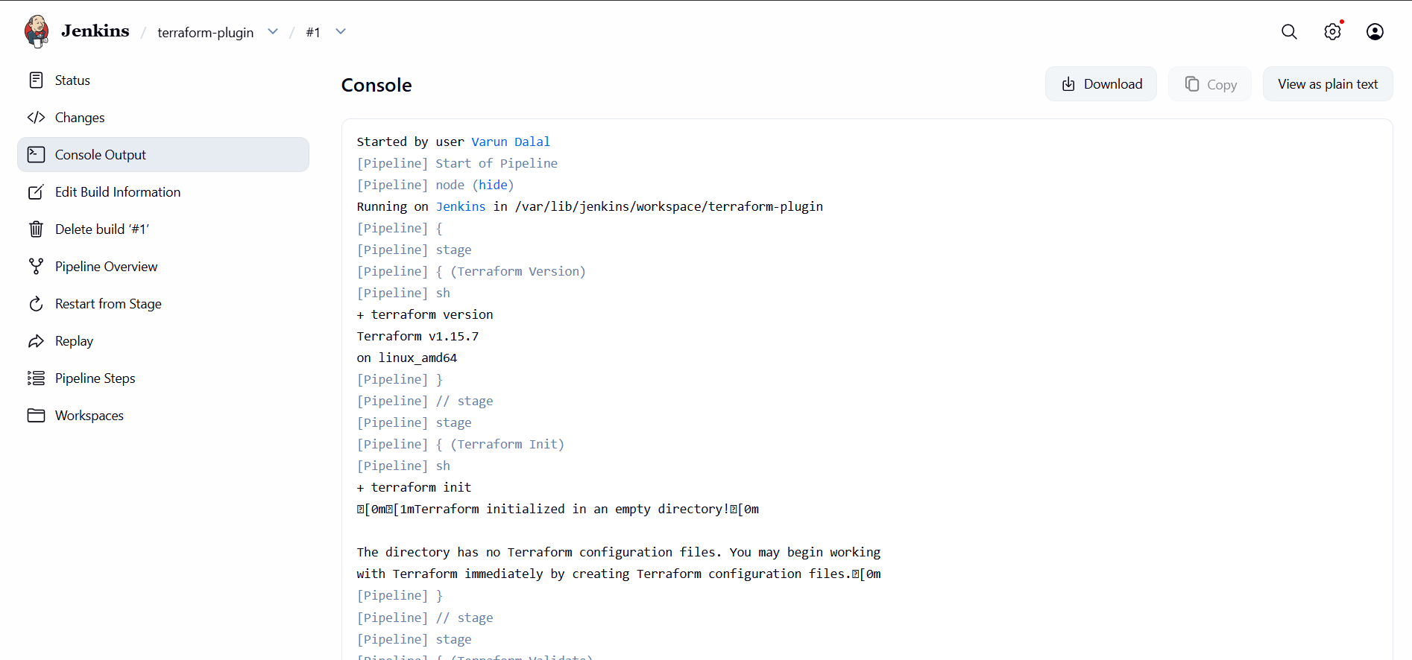

4.Create one Jenkins job using Maven Project for the code below with two stages:
Stage 1: Git clone
Stage 2: Maven Compilation Code: https://github.com/betawins/java-Working-app.git
Jenkins Maven Project Job – Git Clone and Maven Compilation
Objective
Create a Jenkins Maven Project that performs:
- Git Clone
- Maven Compilation
Git Repository:
https://github.com/betawins/java-Working-app.git

Prerequisites
- Jenkins installed and running.
- Git installed on the Jenkins server.
- Java (JDK) installed.
- Maven installed.
- Configure JDK and Maven in Manage Jenkins → Tools.

Step 1: Create a Maven Project
- Open Jenkins Dashboard.
- Click New Item.
- Enter the job name (e.g., java-working-app).
- Select Maven Project.
- Click OK.

Stage 1: Git Clone
Source Code Management
- Select Git.
- Repository URL:
https://github.com/betawins/java-Working-app.git
- Branch:
*/main
(If the repository uses master, enter */master.)

Stage 2: Maven Compilation
Build Section
In Goals and options, enter:
clean compile
This will:
- Clean previous build files.
- Download required dependencies.
- Compile the Java source code.

Save and Build
- Click Save.
- Click Build Now.
- Open Console Output.
Expected output:
Cloning the remote Git repository
Finished: SUCCESS

[INFO] Compiling source files...
[INFO] BUILD SUCCESS

Workflow
Start
│
▼
Git Clone
│
▼
Maven Clean
│
▼
Maven Compile
│
▼
BUILD SUCCESS

Result
The Jenkins Maven Project performs the following stages:
- Stage 1: Clones the project from GitHub.
- Stage 2: Executes mvn clean compile to compile the Java application successfully.

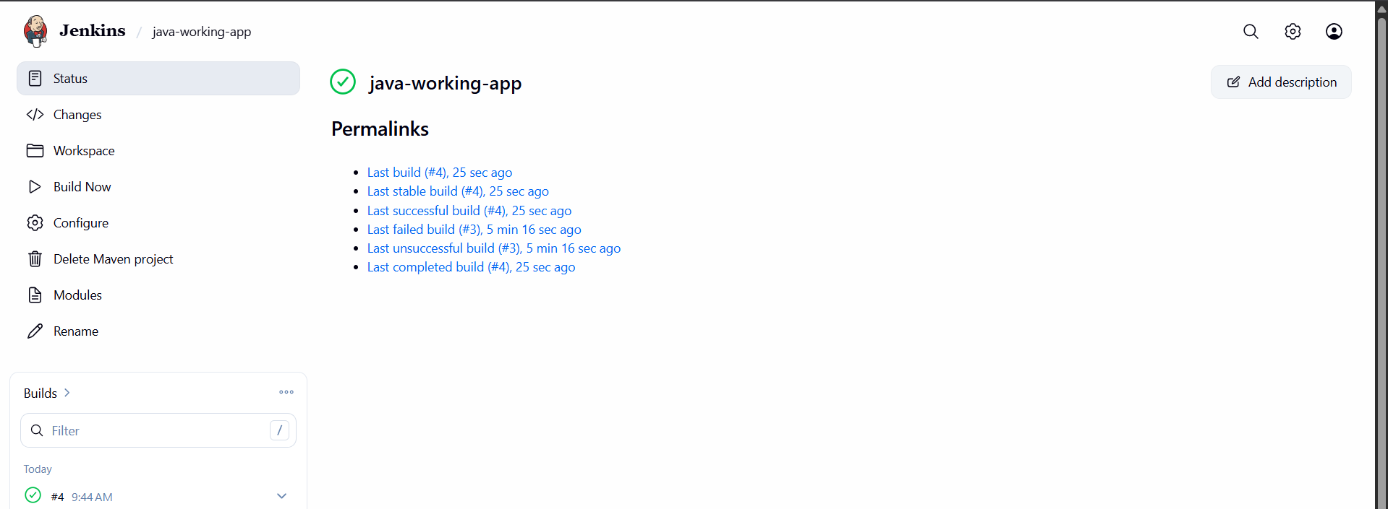

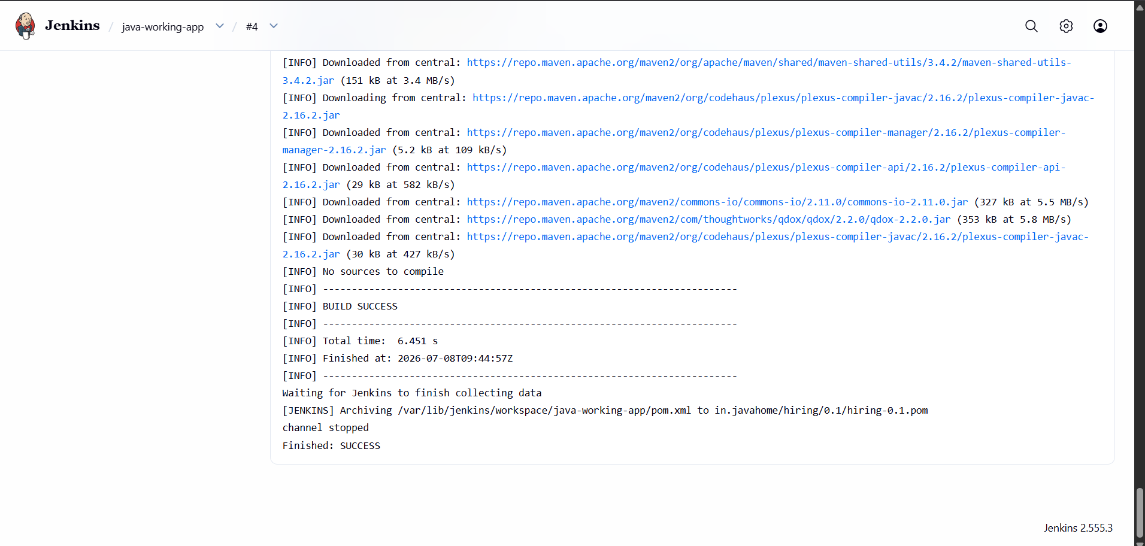

5.Jenkins Parameterized Job – Git Clone and Maven Compilation
Objective
Create a Parameterized Jenkins Freestyle Job that clones the Git repository and compiles the Java application using Maven.
Repository:
https://github.com/betawins/java-Working-app.git

Prerequisites
- Jenkins installed
- Git installed
- Java (JDK 17/21) installed
- Maven installed
- Git and Maven configured in Manage Jenkins → Tools

Step 1: Create a New Job
- Open Jenkins Dashboard.
- Click New Item.
- Enter the job name:
- java-working-app-parameterized
- Select Freestyle Project.
- Click OK.

Step 2: Enable Parameterized Build
- Under General, check This project is parameterized.
- Click Add Parameter → String Parameter.
Configure:
Name | Default Value | Description
BRANCH | main | Git branch to build

Stage 1: Git Clone
Source Code Management
- Select Git.
- Repository URL:
https://github.com/betawins/java-Working-app.git
- Branch Specifier:
*/${BRANCH}
This allows you to build any branch by entering its name when starting the job.

Stage 2: Maven Compilation
Build
Click Add Build Step → Invoke top-level Maven targets
- Maven Version: Select your configured Maven installation.
- Goals:
clean compile

Save and Build
- Click Save.
- Click Build with Parameters.
- Enter:
BRANCH = main
- Click Build.

Expected Console Output
Cloning the remote Git repository...
Checking out branch main...

[INFO] Scanning for projects...
[INFO] Compiling source files...
[INFO] BUILD SUCCESS

Workflow
Start
│
▼
Enter Branch Parameter
│
▼
Git Clone (main or specified branch)
│
▼
Maven Clean
│
▼
Maven Compile
│
▼
BUILD SUCCESS
Result
The parameterized Jenkins job performs the following stages:
- Stage 1: Clones the specified Git branch using the BRANCH parameter.
- Stage 2: Runs mvn clean compile to compile the Java application.

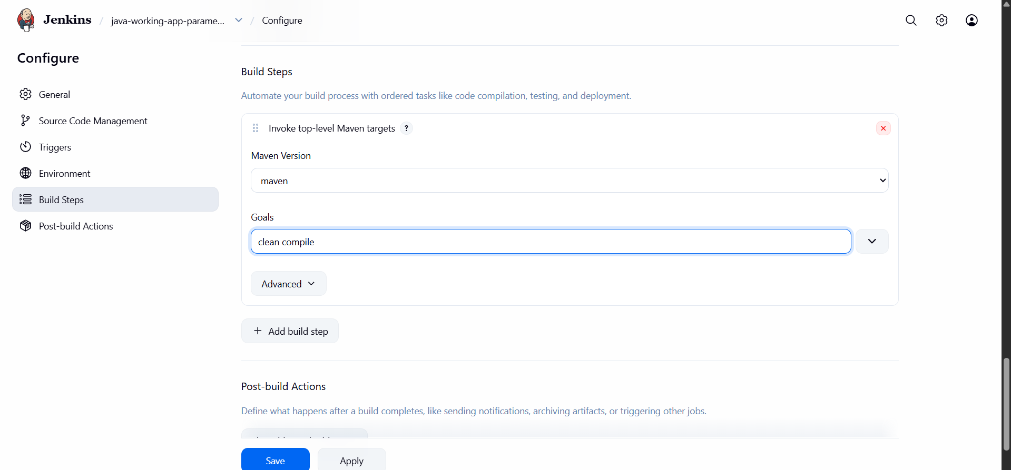

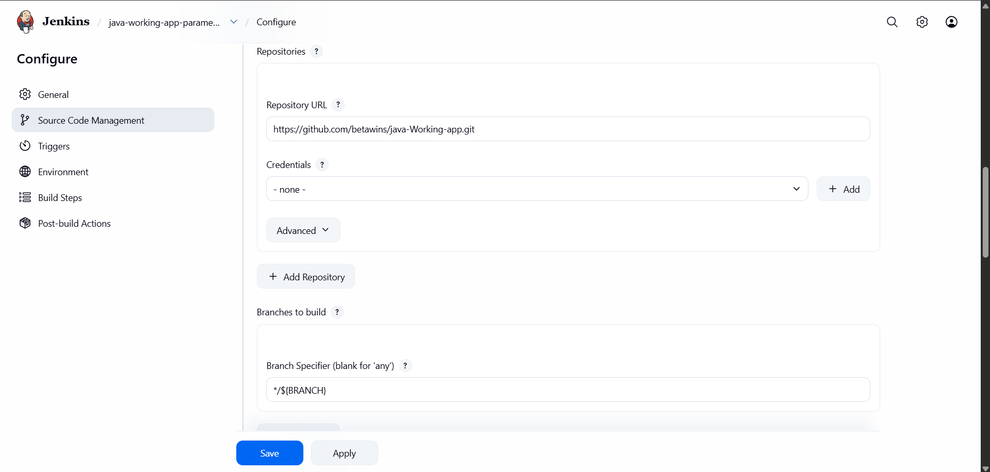

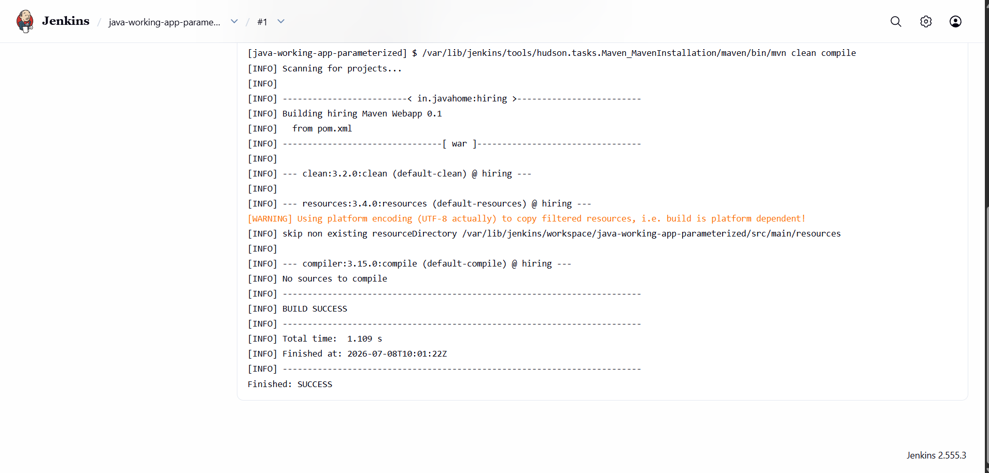

5.Global Variables in Jenkins
Global Variables are predefined variables that are available throughout a Jenkins Pipeline. They provide information about the build, job, workspace, Git repository, and Jenkins environment.
Common Jenkins Global Variables
Variable | Description
env | Accesses environment variables.
currentBuild | Provides information about the current build.
params | Accesses build parameters in a parameterized job.
BUILD_NUMBER | Current build number.
BUILD_ID | Unique ID of the current build.
JOB_NAME | Name of the Jenkins job.
BUILD_URL | URL of the current build.
WORKSPACE | Path to the Jenkins workspace.
JENKINS_HOME | Jenkins home directory.
NODE_NAME | Name of the agent/node executing the build.
GIT_BRANCH | Git branch being built (when using Git).
GIT_COMMIT | Commit ID of the checked-out source code.
Example Pipeline
pipeline {
agent any

stages {
stage('Display Variables') {
steps {
echo "Job Name: ${env.JOB_NAME}"
echo "Build Number: ${env.BUILD_NUMBER}"
echo "Workspace: ${env.WORKSPACE}"
echo "Branch: ${env.GIT_BRANCH}"
}
}
}
}
Benefits
- Access build and environment information.
- Use build parameters in pipelines.
- Make pipelines dynamic and reusable.
- Simplify scripting and automation.
Interview Answer
Global variables in Jenkins are predefined variables that are available throughout a pipeline. They provide information about the build, job, workspace, Git repository, and environment. Common examples include env, params, currentBuild, BUILD_NUMBER, JOB_NAME, WORKSPACE, GIT_BRANCH, and GIT_COMMIT.
