Implementation Steps
Step 1: Launch an EC2 Instance

• Launch an Ubuntu EC2 instance..
• Install Terraform on the EC2 instance..
• Install AWS CLI (if not already installed)..
• Configure AWS credentials using aws configure..

Step 2: Create a Terraform Project Directory

• Create a new project folder..
• Navigate to the project directory..

mkdir terraform-ec2
cd terraform-ec2

Step 3: Create Terraform Configuration File

• Create a file named main.tf..
• Define the AWS provider..
• Specify the AWS region..
• Configure the EC2 instance resource..
• Add the AMI ID, instance type, subnet ID, and instance name tag..
• Save the file..

Step 4: Format the Terraform Configuration

• Format the Terraform code to follow standard formatting..

terraform fmt

Step 5: Initialize Terraform

• Initialize the Terraform working directory..
• Download the required AWS provider plugins..
• Create the .terraform directory..

terraform init

Step 6: Validate the Configuration

• Validate the Terraform configuration syntax..
• Ensure there are no configuration errors..

terraform validate

Step 7: Review the Execution Plan

• Generate the execution plan..
• Review the resources that Terraform will create..

terraform plan

Step 8: Create the EC2 Instance

• Apply the Terraform configuration..
• Review the execution plan..
• Type yes to confirm deployment..

terraform apply

Step 9: Verify the Deployment

• Log in to the AWS Management Console..
• Navigate to EC2 → Instances..
• Verify that the EC2 instance is in the Running state..
• Confirm the instance name is terraform..

Step 10: Verify Terraform State

• Display the current Terraform state..

terraform show
• List the managed resources..

terraform state list

Step 11: Destroy the Infrastructure

• Destroy the EC2 instance created by Terraform..
• Confirm the deletion by typing yes..

terraform destroy

Step 12: Verify Resource Deletion

• Confirm that the EC2 instance has been terminated in the AWS Management Console..
• Ensure Terraform completes the destroy operation successfully. . Validation Checklist

• Terraform initialized successfully..
• AWS provider downloaded..
• Configuration formatted successfully..
• Configuration validated successfully..
• Execution plan reviewed..
• EC2 instance created..
• Instance visible in AWS Console..
• State file generated..
• EC2 instance destroyed successfully..

Expected Outcome
After completing this task:

• Terraform successfully provisions an EC2 instance named terraform..
• The full Terraform lifecycle (init, fmt, validate, plan, apply, show, state list, and destroy) is demonstrated..
• Infrastructure is created and removed using Infrastructure as Code (IaC), without manual actions in the AWS Console..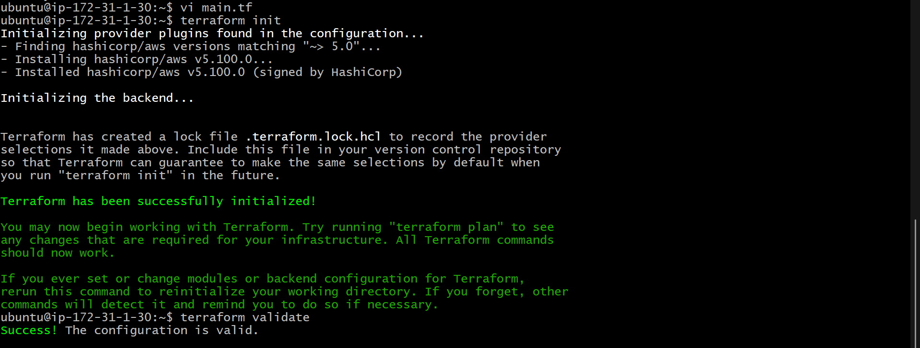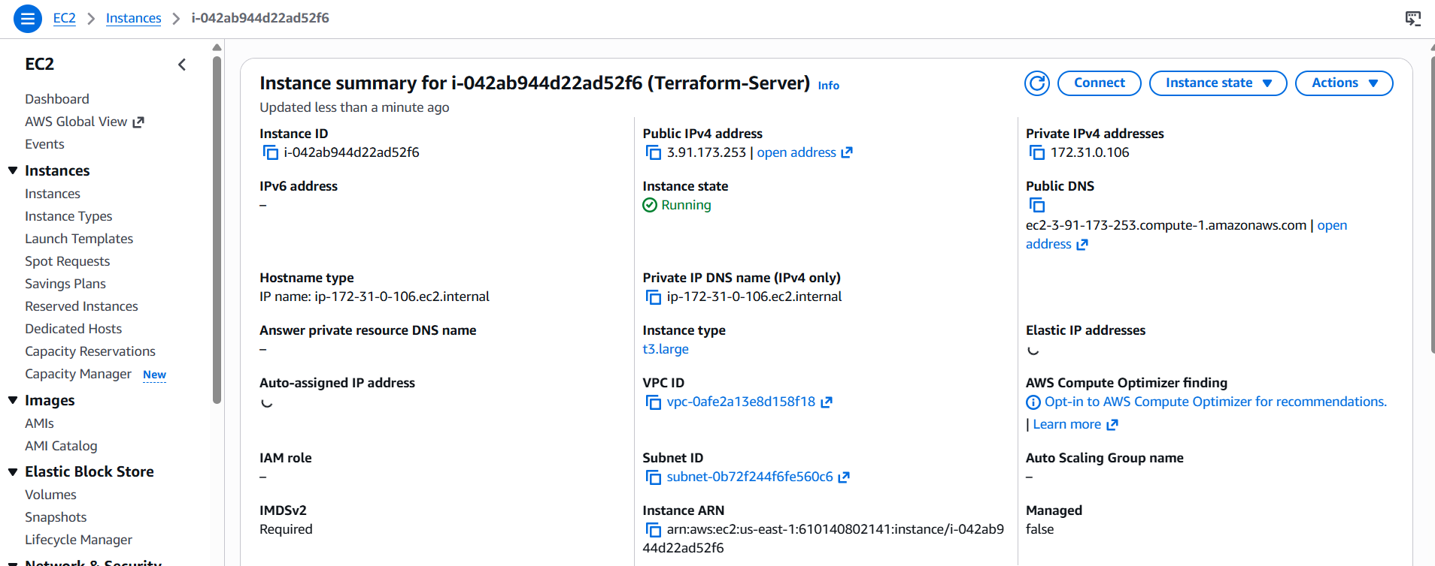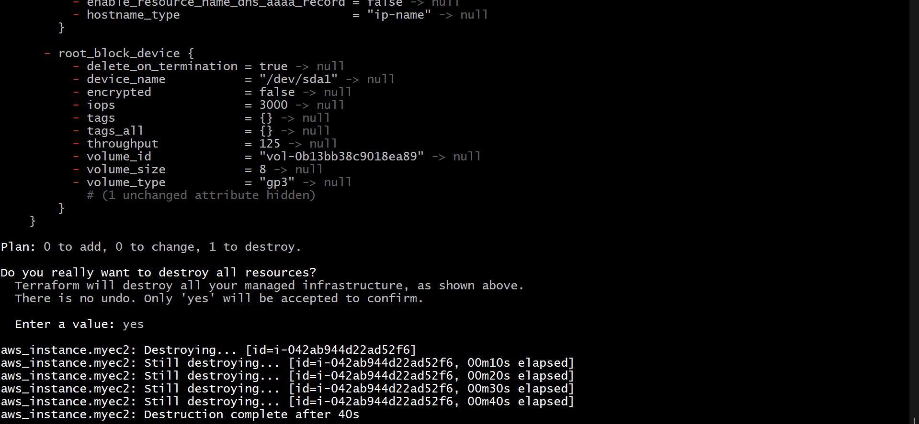3.Integrate Terraform in Jenkins Using the Terraform Plugin
Objective
Integrate Terraform with Jenkins using the Terraform Plugin to automate infrastructure deployment through a Jenkins pipeline.

Prerequisites
- Jenkins installed and running
- Terraform installed on the Jenkins server
- Git installed
- GitHub repository containing Terraform code
- AWS credentials configured (if deploying to AWS)
- Jenkins administrator access

Step 1: Install the Terraform Plugin
- Go to Manage Jenkins → Plugins.
- Open the Available Plugins tab.
- Search for Terraform.
- Select Terraform Plugin.
- Click Install and restart Jenkins if prompted.

Step 2: Configure Terraform Tool
- Go to Manage Jenkins → Tools.
- Scroll down to Terraform Installations.
- Click Add Terraform.
- Enter:
  - Name: Terraform
  - Install automatically: Enable (or provide the Terraform installation path manually).
- Click Save.

Step 3: Configure AWS Credentials
If deploying to AWS:
- Configure AWS CLI on the Jenkins server:
aws configure
Enter:
- AWS Access Key
- AWS Secret Key
- Region
- Output format
Verify:
aws sts get-caller-identity

Step 4: Create a Terraform Project
Create a repository with the following main.tf file:
provider "aws" {
region = "us-east-1"
}

resource "aws_instance" "demo" {
ami = "ami-0c02fb55956c7d316"
instance_type = "t2.micro"

tags = {
Name = "Jenkins-Terraform"
}
}
Push the project to GitHub.

Step 5: Create a Pipeline Job
- Click New Item.
- Enter a job name.
- Select Pipeline.
- Click OK.

Step 6: Configure Source Code
Under Pipeline:
- Select Pipeline script from SCM.
- SCM: Git
- Repository URL: Your GitHub repository URL.
- Select Git credentials.
- Branch: main
- Script Path: Jenkinsfile
Click Save.

Step 7: Create the Jenkinsfile
Create a Jenkinsfile in the repository:
pipeline {
agent any

tools {
terraform 'Terraform'
}

stages {

stage('Checkout') {
steps {
git url: 'https://github.com/username/terraform-demo.git', branch: 'main'
}
}

stage('Terraform Init') {
steps {
sh 'terraform init'
}
}

stage('Terraform Validate') {
steps {
sh 'terraform validate'
}
}

stage('Terraform Plan') {
steps {
sh 'terraform plan'
}
}

stage('Terraform Apply') {
steps {
sh 'terraform apply -auto-approve'
}
}
}
}
Commit and push the Jenkinsfile.

Step 8: Build the Pipeline
- Open the Jenkins job.
- Click Build Now.
- Monitor the build in Console Output.

Step 9: Verify the Deployment
After the pipeline completes successfully:
- Log in to the AWS Console.
- Navigate to EC2 → Instances.
- Verify that the EC2 instance has been created.

Pipeline Workflow
Developer
│
▼
Push Terraform Code to GitHub
│
▼
Jenkins Pipeline
│
├── Checkout
├── Terraform Init
├── Terraform Validate
├── Terraform Plan
└── Terraform Apply
│
▼
AWS Infrastructure Created

Expected Output
Cloning repository...

Terraform has been successfully initialized!

Success! The configuration is valid.

Plan: 1 to add, 0 to change, 0 to destroy.

Apply complete!
Resources: 1 added, 0 changed, 0 destroyed.

Conclusion
Using the Terraform Plugin in Jenkins allows you to manage the Terraform installation as a Jenkins tool and execute Terraform commands from a pipeline. This integration automates infrastructure provisioning by performing Checkout → Init → Validate → Plan → Apply, ensuring a consistent and repeatable Infrastructure as Code (IaC) deployment process.
