1). Install Terraform on your PC
Step 1: Download Terraform
- Open your browser.
- Go to the official Terraform download page:
https://developer.hashicorp.com/terraform/downloads
- Under Windows, click AMD64 (for most modern PCs).
- A ZIP file will be downloaded (for example, terraform_1.x.x_windows_amd64.zip).

Step 2: Extract the ZIP File
- Go to your Downloads folder.
- Right-click the downloaded ZIP file.
- Click Extract All...
- Choose a location, for example:
C:\Terraform
- Click Extract.
After extraction, you should have:
C:\Terraform\
terraform.exe

Step 3: Add Terraform to the PATH Environment Variable
- Press Windows + S.
- Search for Environment Variables.
- Click Edit the system environment variables.
- In the System Properties window, click Environment Variables.
- Under System variables, select Path.
- Click Edit.
- Click New.
- Add the Terraform folder path:
C:\Terraform
- Click OK on all windows to save the changes.

Step 4: Close and Reopen Command Prompt
If Command Prompt was already open, close it and open a new one.

Step 5: Verify the Installation
Open Command Prompt and run:
terraform version
If installed correctly, you'll see output similar to:
Terraform v1.13.x
on windows_amd64
This confirms Terraform is installed successfully.
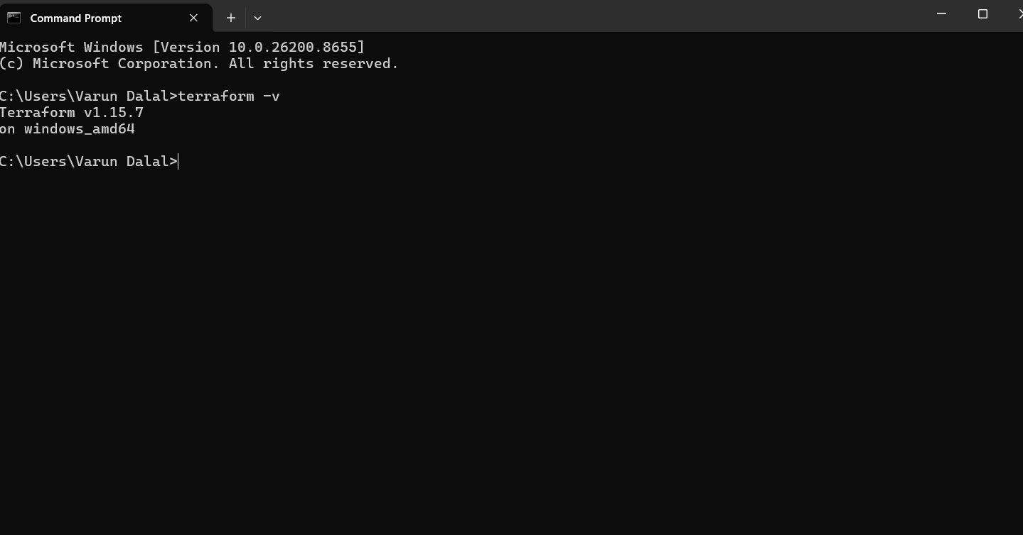

2.Execute Terraform Templates
Objective
Execute the Terraform templates demonstrated in the Terraform Basics session.

Step 1: Create a Project Folder
Create a folder named:
terraform-demo
Open this folder in Visual Studio Code.

Step 2: Create main.tf
Inside the project folder, create a file named:
main.tf
Paste the following code:
terraform {
required_providers {
local = {
source = "hashicorp/local"
}
random = {
source = "hashicorp/random"
}
}
}
resource "local_file" "pet" {
filename = "pets.txt"
content = "We love pets!"
}
resource "random_pet" "mypet" {
prefix = "MR"
separator = "."
length = 1
}
output "pet-name" {
value = random_pet.mypet.id
}
Save the file (Ctrl + S).

Step 3: Initialize Terraform
Open the VS Code terminal.
Run:
terraform init
Expected Output
Terraform has been successfully initialized!
This command:
- Downloads the required providers
- Creates the .terraform directory
- Creates .terraform.lock.hcl

Step 4: Validate the Configuration
Run:
terraform validate
Expected output:
Success! The configuration is valid.

Step 5: Format the Code
Run:
terraform fmt
This formats the Terraform code according to standard style.

Step 6: Preview the Changes
Run:
terraform plan
Terraform displays the resources it will create.
Example:
Plan: 2 to add, 0 to change, 0 to destroy.
Resources:
- local_file.pet
- random_pet.mypet

Step 7: Apply the Configuration
Run:
terraform apply
Terraform asks:
Do you want to perform these actions?
Type:
yes
Press Enter
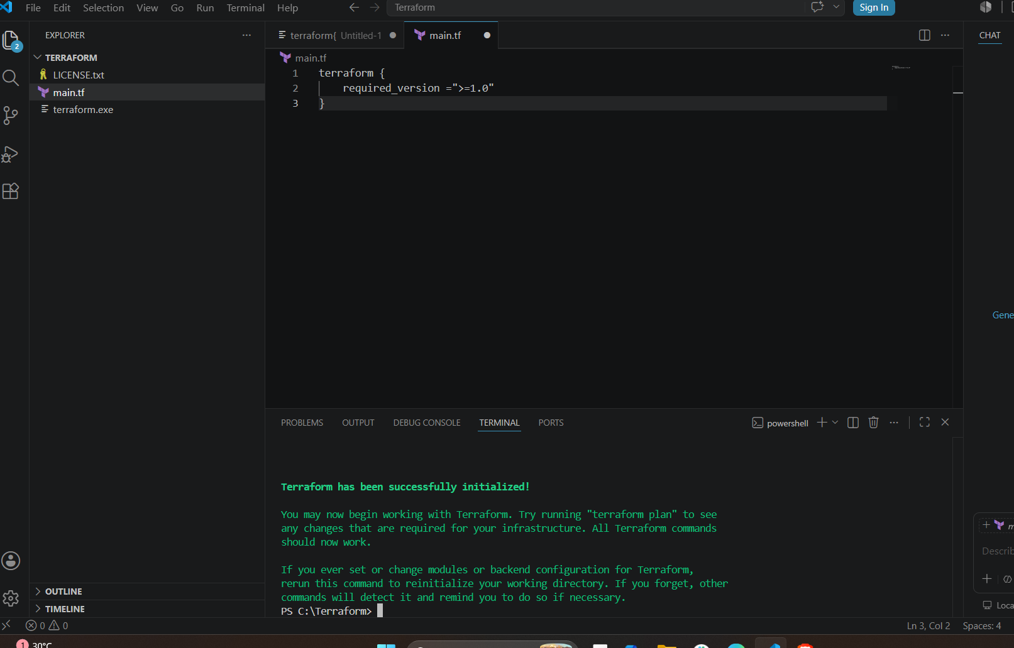
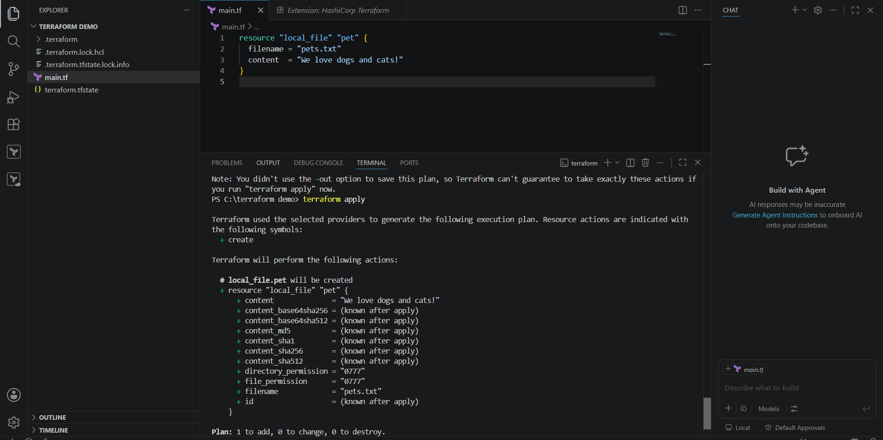

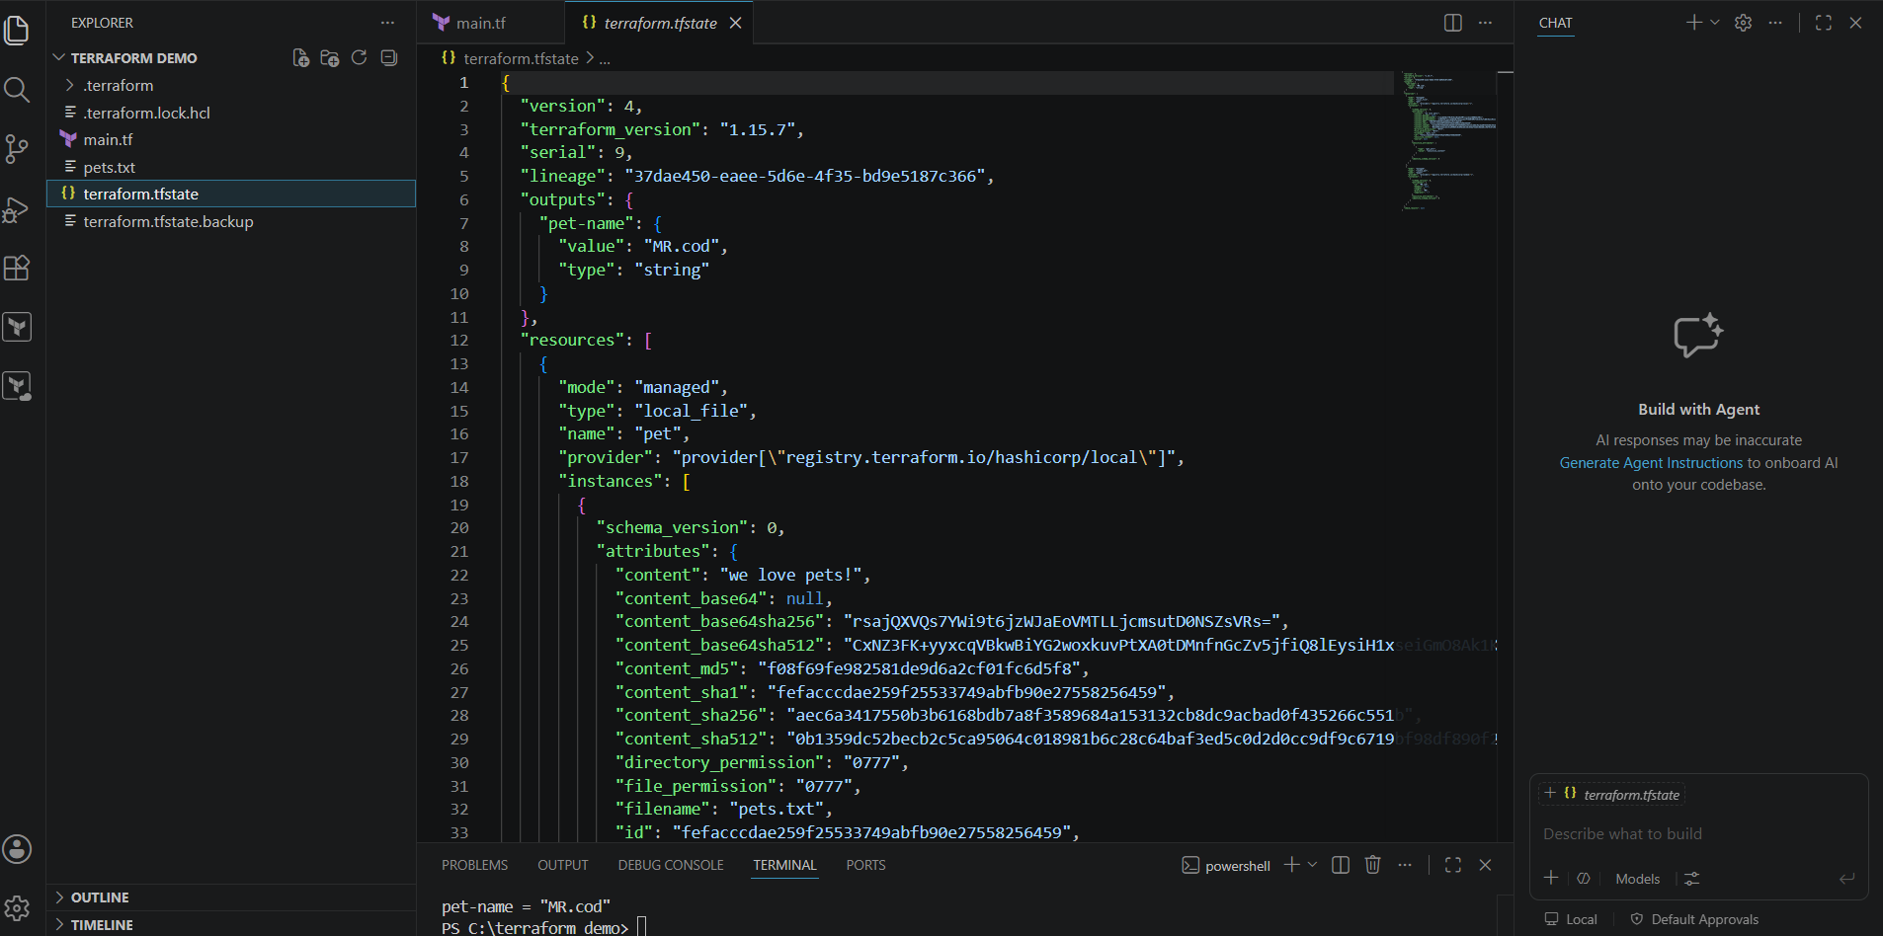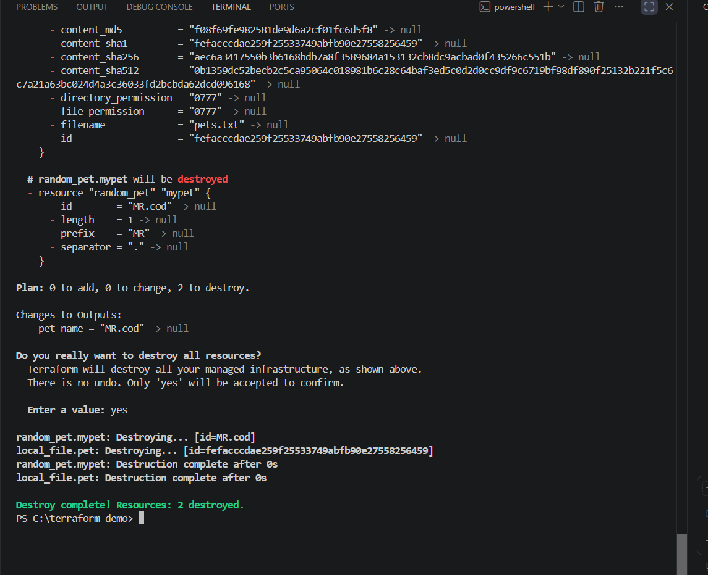

Terraform Init
Definition
terraform init is the first command that must be run in a Terraform project. It initializes the working directory and prepares it for use.
Purpose
- Downloads the required provider plugins.
- Creates the .terraform directory.
- Creates the .terraform.lock.hcl file.
- Initializes the backend (if configured).
- Prepares Terraform to execute the configuration.
Syntax
terraform init
Example Output
Initializing the backend...
Initializing provider plugins...
Terraform has been successfully initialized!
Key Points
- Run this command only once when starting a new project or after adding/changing providers.
- It does not create any infrastructure.

Terraform Plan
Definition
terraform plan generates an execution plan that shows what Terraform will do before making any changes.
Purpose
- Compares the Terraform configuration with the current infrastructure.
- Shows which resources will be created, modified, or destroyed.
- Helps verify changes before applying them.
Syntax
terraform plan
Example Output
Plan: 2 to add, 0 to change, 0 to destroy.
Key Points
- Does not create or modify resources.
- Used to preview infrastructure changes safely.

Terraform Apply
Definition
terraform apply executes the changes described in the execution plan and creates or updates the infrastructure.
Purpose
- Creates new resources.
- Updates existing resources.
- Saves resource information in the terraform.tfstate file.
Syntax
terraform apply
Terraform prompts for confirmation:
Do you want to perform these actions?
Type:
yes
Example Output
Apply complete!
Resources: 2 added, 0 changed, 0 destroyed.
Key Points
- Actually creates or updates the infrastructure.
- Updates the Terraform state file after successful execution.

Terraform Provider
Definition
A Terraform Provider is a plugin that enables Terraform to communicate with a specific cloud platform or service.
Purpose
- Connects Terraform to external platforms.
- Manages resources on cloud providers and other services.
- Downloads automatically during terraform init.
Examples of Providers
- AWS
- Azure
- Google Cloud Platform (GCP)
- Kubernetes
- Docker
- Local
- Random
Example Configuration
terraform {
required_providers {
local = {
source = "hashicorp/local"
}
random = {
source = "hashicorp/random"
}
}
}
provider "local" {}
provider "random" {}
Key Points
- Providers are downloaded automatically when you run terraform init.
- Each provider contains the resources and data sources for that platform.
- Without a provider, Terraform cannot communicate with the target infrastructure.

4.Integrating a Sample Terraform Template in Jenkins
Objective
Integrate a Terraform project with Jenkins so that Jenkins automatically runs Terraform commands to provision infrastructure.

Prerequisites
- Jenkins installed and running
- Terraform installed on Jenkins server
- Git installed
- AWS CLI configured (if deploying to AWS)
- AWS IAM user with required permissions
- GitHub repository containing Terraform code

Step 1: Create a Terraform Project
Create a directory:
mkdir terraform-demo
cd terraform-demo
Create a file named main.tf
provider "aws" {
region = "us-east-1"
}

resource "aws_instance" "demo" {
ami = "ami-0c02fb55956c7d316"
instance_type = "t2.micro"

tags = {
Name = "Jenkins-Terraform"
}
}
Commit and push the project to GitHub.

Step 2: Install Terraform on Jenkins
Check Terraform version:
terraform -version
If not installed:
sudo yum install -y yum-utils
sudo yum-config-manager --add-repo https://rpm.releases.hashicorp.com/AmazonLinux/hashicorp.repo
sudo yum install terraform -y
Verify:
terraform version

Step 3: Configure AWS Credentials
Configure AWS credentials on Jenkins server.
aws configure
Provide:
- Access Key
- Secret Key
- Region
- Output format
Verify:
aws sts get-caller-identity

Step 4: Install Required Jenkins Plugins
Go to:
Manage Jenkins → Plugins
Install:
- Git Plugin
- Pipeline Plugin
- Terraform Plugin (optional)
- Credentials Plugin
Restart Jenkins.

Step 5: Add Git Credentials
Go to:
Manage Jenkins → Credentials
Add:
- Username
- Personal Access Token (PAT)
Save credentials.

Step 6: Create a Pipeline Job
- Click New Item
- Enter Job Name
- Select Pipeline
- Click OK

Step 7: Configure Pipeline
Under Pipeline:
Choose
Pipeline script from SCM
SCM
Git
Repository URL
https://github.com/username/terraform-demo.git
Select credentials.
Branch:
main
Script Path:
Jenkinsfile
Save.

Step 8: Create Jenkinsfile
Create a file named Jenkinsfile in the repository.
pipeline {
agent any

stages {

stage('Checkout') {
steps {
git url: 'https://github.com/username/terraform-demo.git', branch: 'main'
}
}

stage('Terraform Init') {
steps {
sh 'terraform init'
}
}

stage('Terraform Validate') {
steps {
sh 'terraform validate'
}
}

stage('Terraform Plan') {
steps {
sh 'terraform plan'
}
}

stage('Terraform Apply') {
steps {
sh 'terraform apply -auto-approve'
}
}
}
}
Commit and push the Jenkinsfile.

Step 9: Build the Pipeline
Click:
Build Now
Jenkins executes:
- Clone Repository
- Terraform Init
- Terraform Validate
- Terraform Plan
- Terraform Apply

Step 10: Verify Infrastructure
Login to AWS Console.
Go to:
EC2 → Instances
Verify that the EC2 instance has been created successfully.

Pipeline Flow
Developer
│
▼
Push Terraform Code
│
▼
GitHub Repository
│
▼
Jenkins Pipeline
│
├── Checkout
├── Terraform Init
├── Validate
├── Plan
└── Apply
│
▼
AWS Infrastructure Created

Expected Console Output
Cloning repository...

Terraform has been successfully initialized!

Success! The configuration is valid.

Plan: 1 to add, 0 to change, 0 to destroy.

Apply complete!
Resources: 1 added, 0 changed, 0 destroyed.

Conclusion
This integration automates Terraform deployments using Jenkins. Every time the pipeline runs, Jenkins fetches the Terraform code from GitHub, initializes Terraform, validates the configuration, generates an execution plan, and applies the infrastructure changes automatically.
