1.Jenkins CI/CD Pipeline Using Freestyle Job and Docker Containers
Objective
Set up a Jenkins CI/CD pipeline using a Freestyle Job with the following stages:
- Git Clone
- SonarQube Integration
- Maven Compilation
- Nexus Artifactory Upload
- Slack Notification
- Deploy on Tomcat
Source Code:
https://github.com/betawins/hiring-app.git

Step 1: Create a Docker Network
docker network create cicd-network
Verify:
docker network ls

Step 2: Run Jenkins Container
docker run -d \
--name jenkins \
--network cicd-network \
-p 8080:8080 \
-p 50000:50000 \
-v jenkins_home:/var/jenkins_home \
jenkins/jenkins:lts
Get the Jenkins password:
docker exec jenkins cat /var/jenkins_home/secrets/initialAdminPassword
Open:
http://<EC2-Public-IP>:8080
Install Suggested Plugins.

Step 3: Run SonarQube Container
docker run -d \
--name sonarqube \
--network cicd-network \
-p 9000:9000 \
sonarqube:lts-community
Open:
http://<EC2-Public-IP>:9000
Login:
Username: admin
Password: admin
Generate a token:
Administration → Security → Users → Tokens

Step 4: Run Nexus Container
docker run -d \
--name nexus \
--network cicd-network \
-p 8081:8081 \
sonatype/nexus3
Open:
http://<EC2-Public-IP>:8081
Get the password:
docker exec nexus cat /nexus-data/admin.password
Create two repositories:
- maven-releases
- maven-snapshots
For maven-snapshots:
Version Policy: Snapshot
Deployment Policy: Allow Redeploy

Step 5: Run Tomcat Container
docker run -d \
--name tomcat \
--network cicd-network \
-p 8082:8080 \
tomcat:9
Verify:
http://<EC2-Public-IP>:8082

Step 6: Install Required Jenkins Plugins
Go to:
Manage Jenkins → Plugins
Install:
- Git Plugin
- Maven Integration Plugin
- SonarQube Scanner Plugin
- Nexus Artifact Uploader Plugin
- Slack Notification Plugin
- Deploy to Container Plugin
Restart Jenkins.

Step 7: Configure Maven
Manage Jenkins → Tools
Add:
Name: maven
Install Automatically: ✓
Save.

Step 8: Configure SonarQube
Manage Jenkins → System → SonarQube Servers
Add:
Name: SonarQube
Server URL: http://sonarqube:9000
Authentication Token: <SONAR_TOKEN>
Save.

Step 9: Configure Slack
Create an Incoming Webhook in Slack.
Manage Jenkins → System → Slack
Provide:
Workspace URL
Webhook URL
Channel Name
Save.

Step 10: Create Freestyle Job
New Item → Freestyle Project
Name:
hiring-app-cicd
Click OK.

Stage 1: Git Clone
Source Code Management → Git
Repository URL:
https://github.com/betawins/hiring-app.git
Branch:
*/main
Save.

Stage 2: SonarQube Analysis
Build → Execute Shell
mvn sonar:sonar \
-Dsonar.projectKey=hiring-app \
-Dsonar.host.url=http://sonarqube:9000 \
-Dsonar.login=<SONAR_TOKEN>

Stage 3: Maven Compilation
Build → Invoke Top-Level Maven Targets
Goals:
clean package
WAR file generated:
target/hiring.war

Stage 4: Nexus Artifactory Upload
Important
Edit pom.xml:
<version>0.1-SNAPSHOT</version>
Commit and push:
git add .
git commit -m "Changed to snapshot version"
git push origin main
In Jenkins:
Post Build Actions → Nexus Artifact Uploader
Repository:
maven-snapshots
Configuration:
GroupId : in.javahome
ArtifactId : hiring
Version : 0.1-SNAPSHOT
Type : war
File : target/hiring.war
Save.

Stage 5: Deploy on Tomcat
Add Build Step → Execute Shell
docker cp target/hiring.war tomcat:/usr/local/tomcat/webapps/
docker restart tomcat
Wait for deployment.
Application URL:
http://<EC2-Public-IP>:8082/hiring

Stage 6: Slack Notification
Post Build Actions → Slack Notifications
Enable:
- Notify Build Start
- Notify Success
- Notify Failure
Save.

Build Now
Click:
Build Now
Expected Flow:
Git Clone
↓
SonarQube Analysis
↓
Maven Build
↓
Nexus Upload
↓
Deploy to Tomcat
↓
Slack Notification

Verification URLs
Jenkins:
http://:8081
SonarQube:
http://:9000
Nexus:
http://:8082
Tomcat Application:
http://:8080
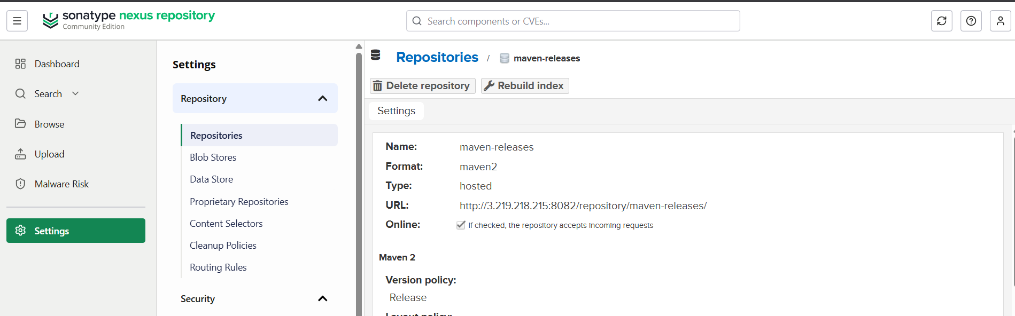
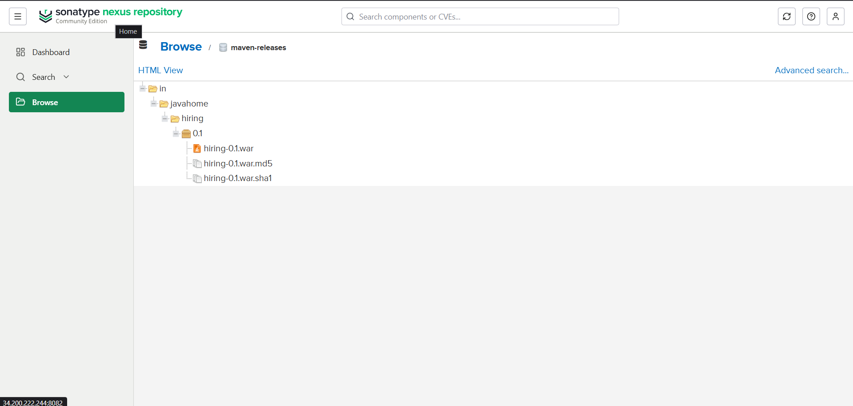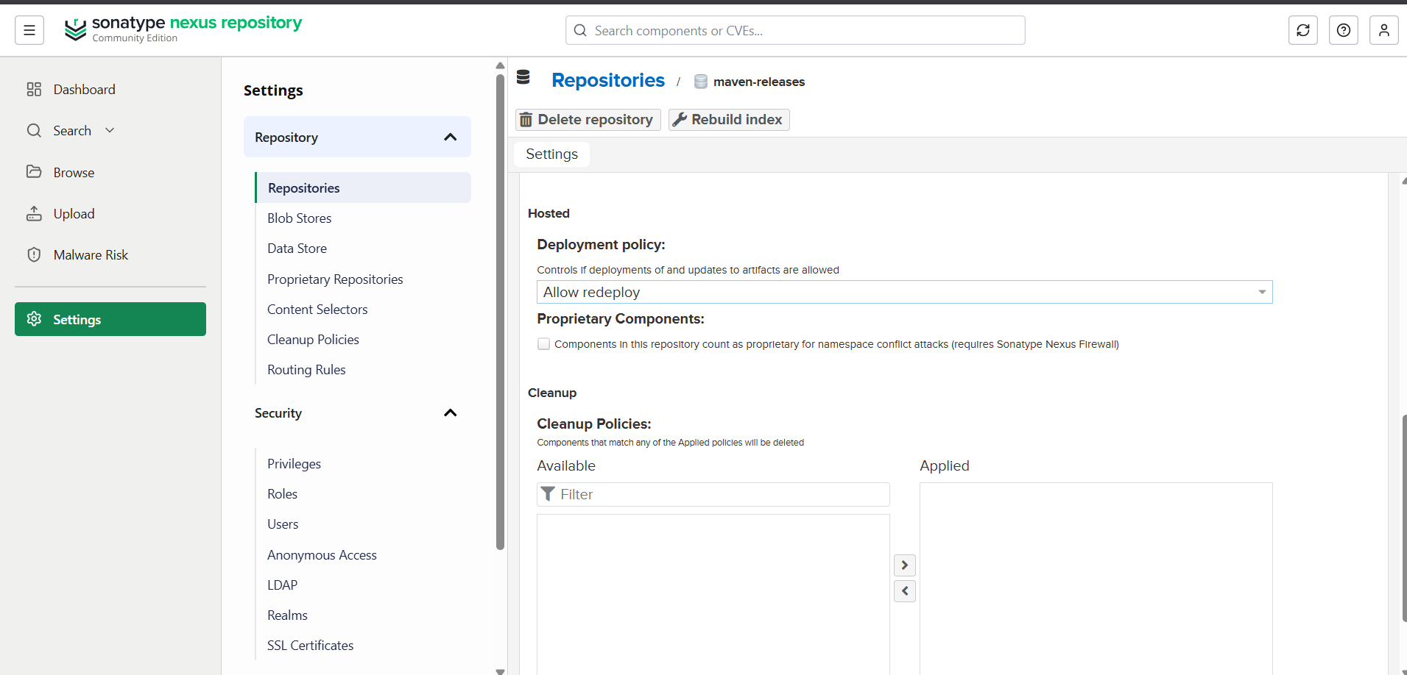
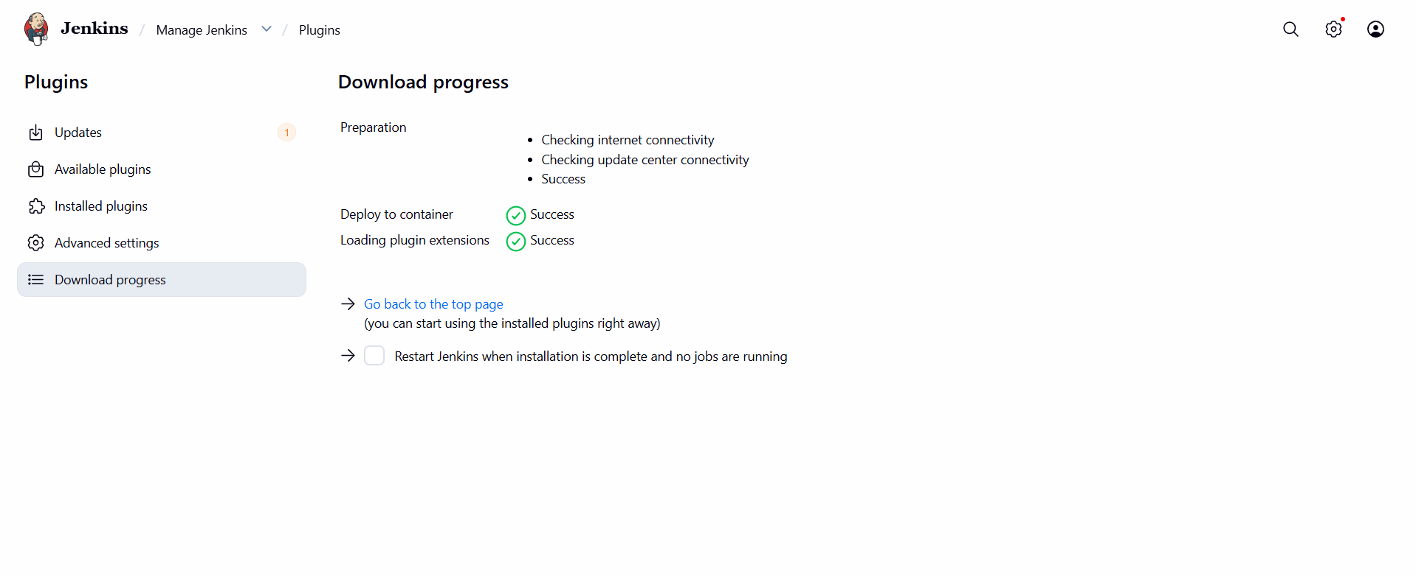
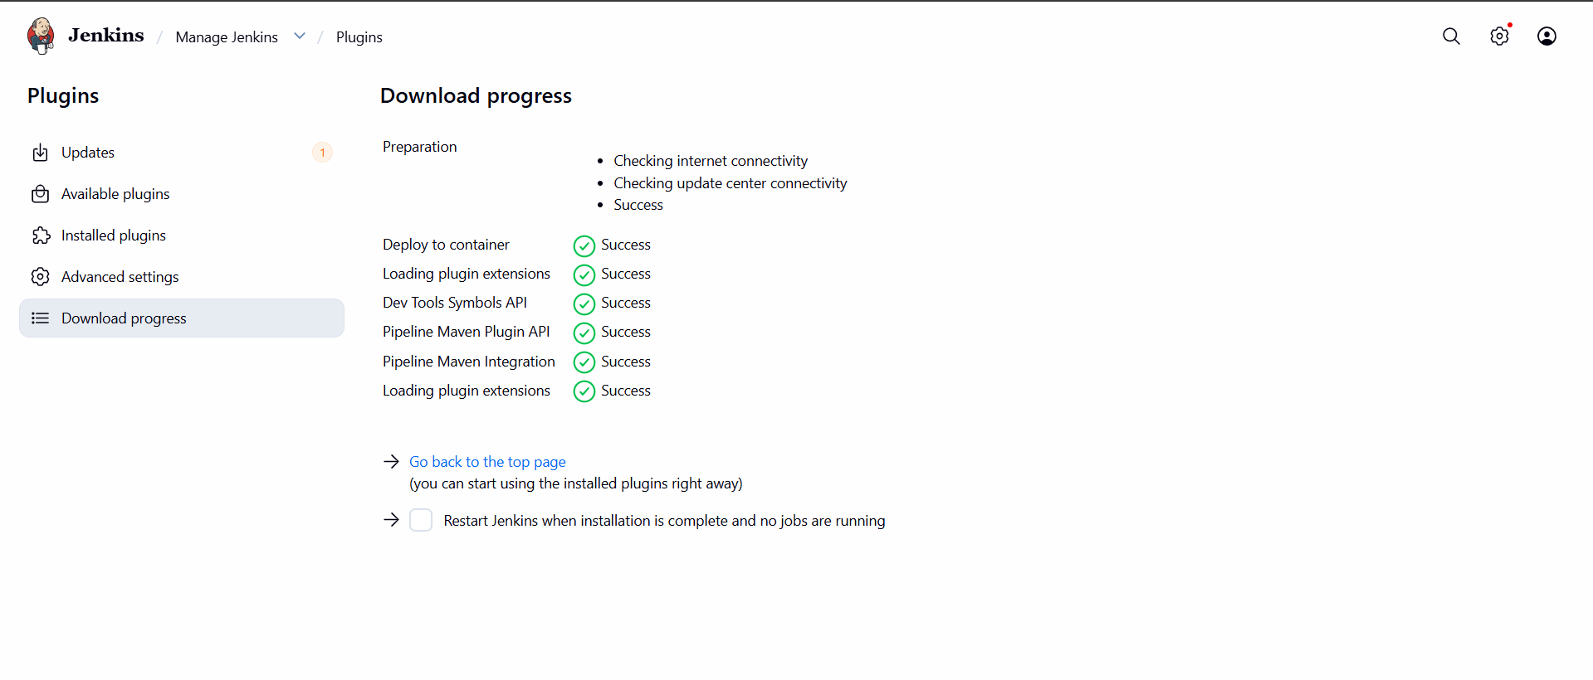
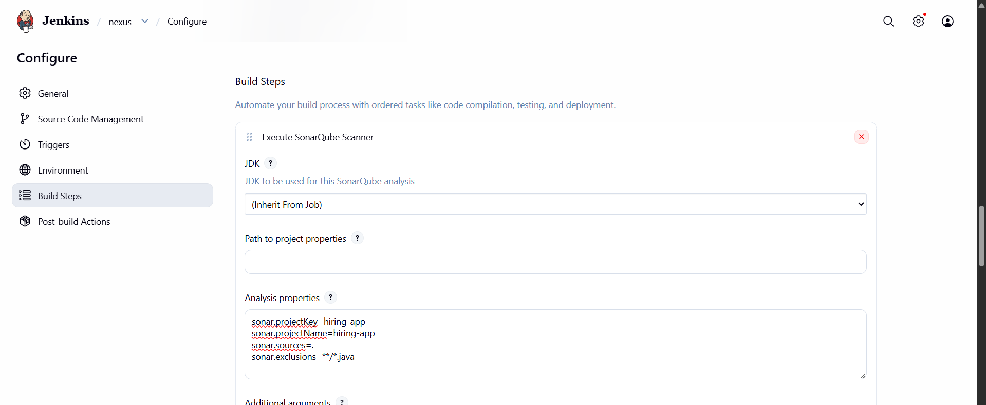
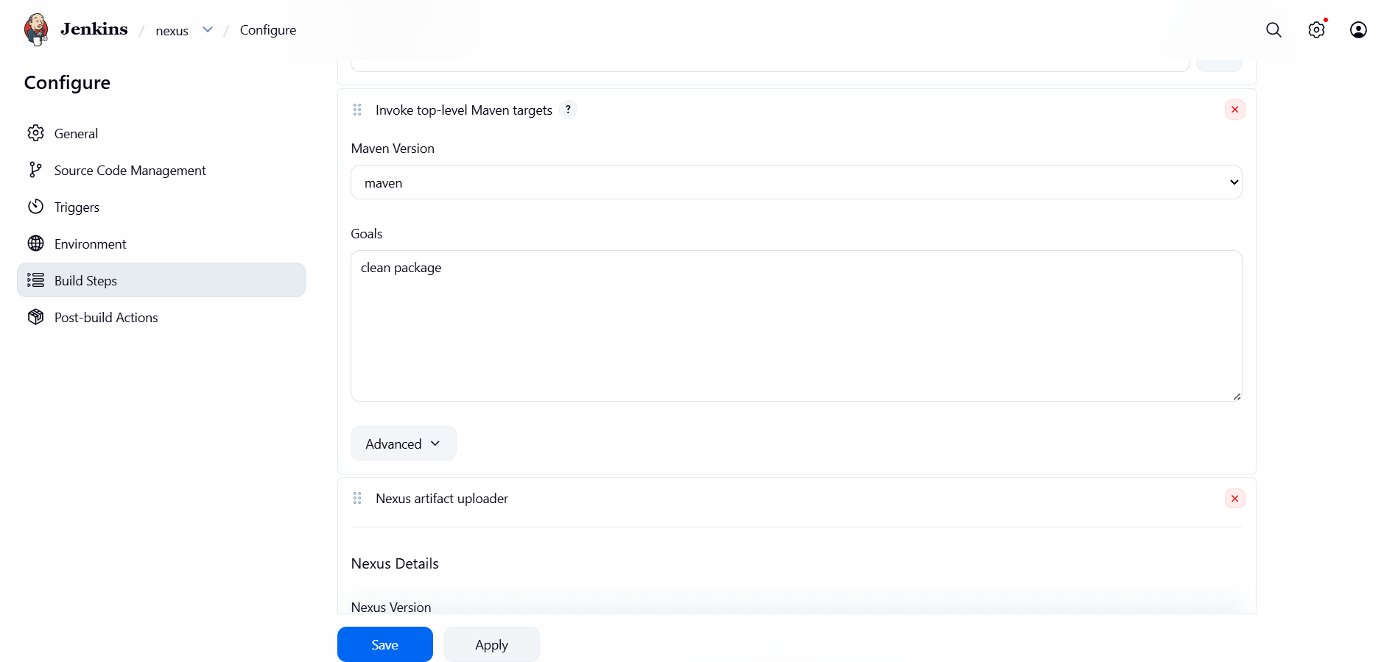
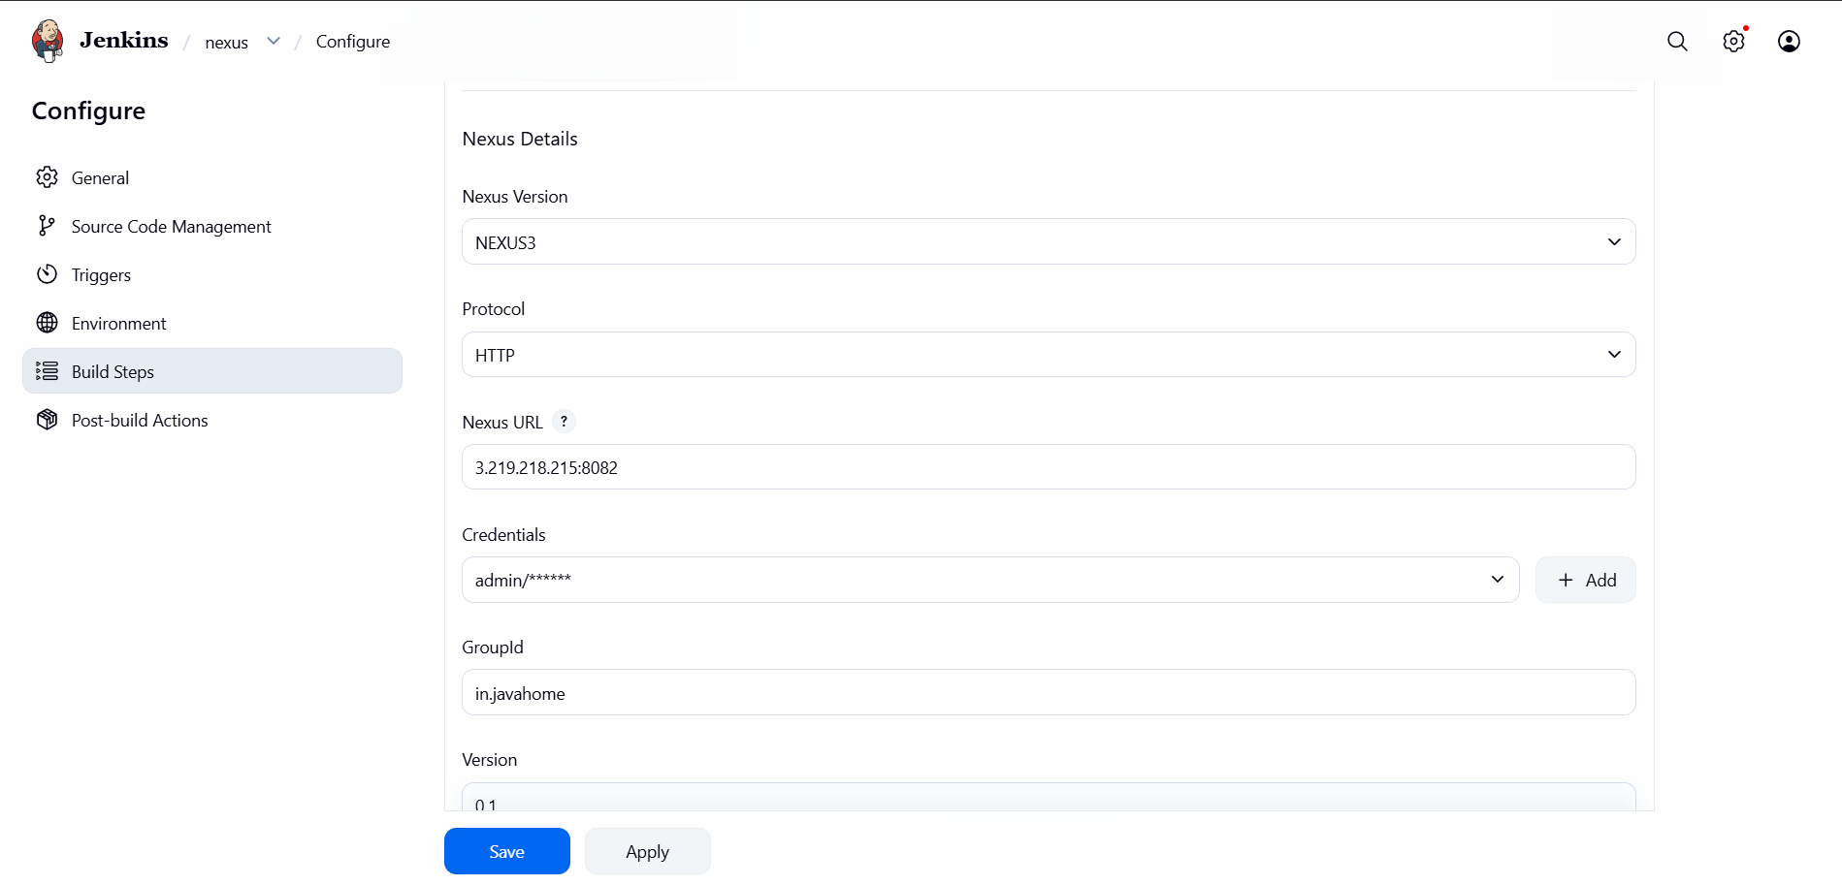
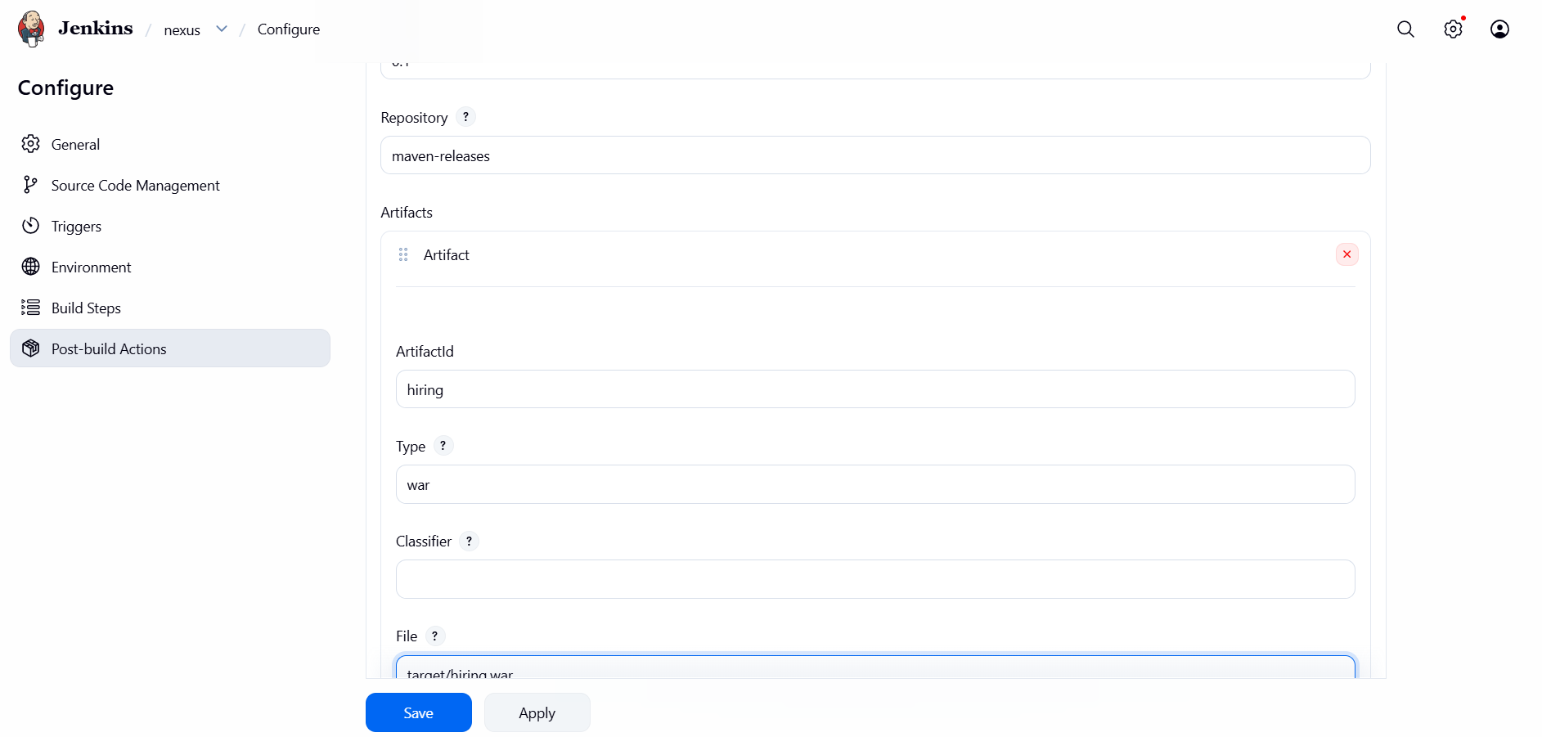
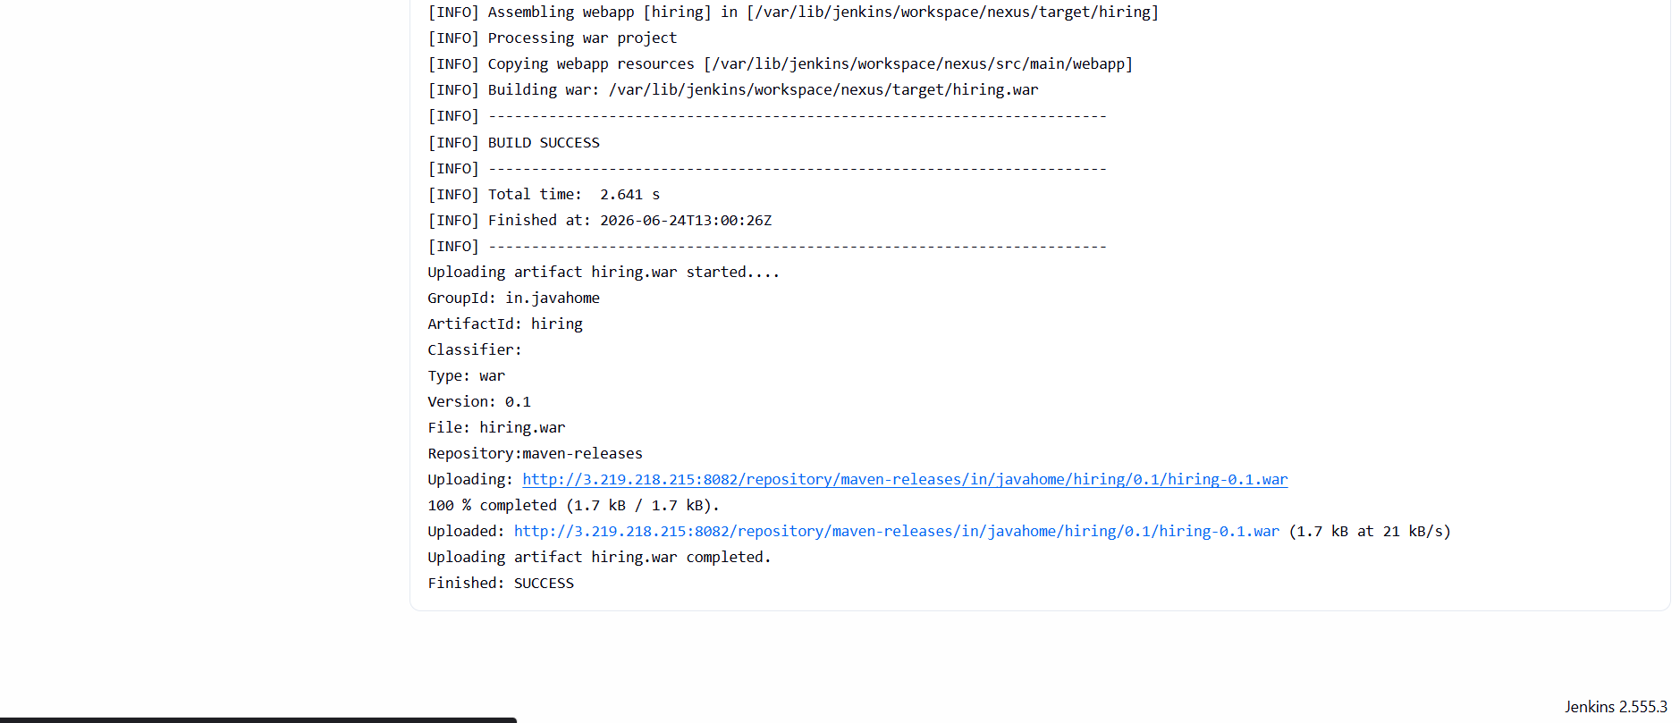
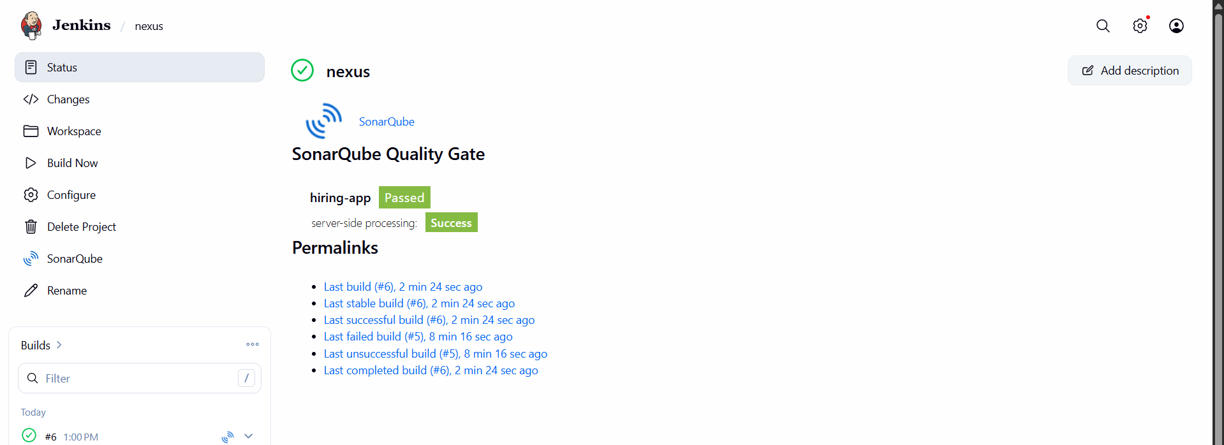

2) Setup a Jenkins CICD pipeline using Declarative pipeline using feature-1.1 branch.
Source Code: https://github.com/betawins/sabear_simplecutomerapp/tree/feature-1.1
stages:
- Git Clone
- SonarQube Integration
- Maven Compilation
- Nexus Artifactory
- Slack Notification
- Deploy On tomcat
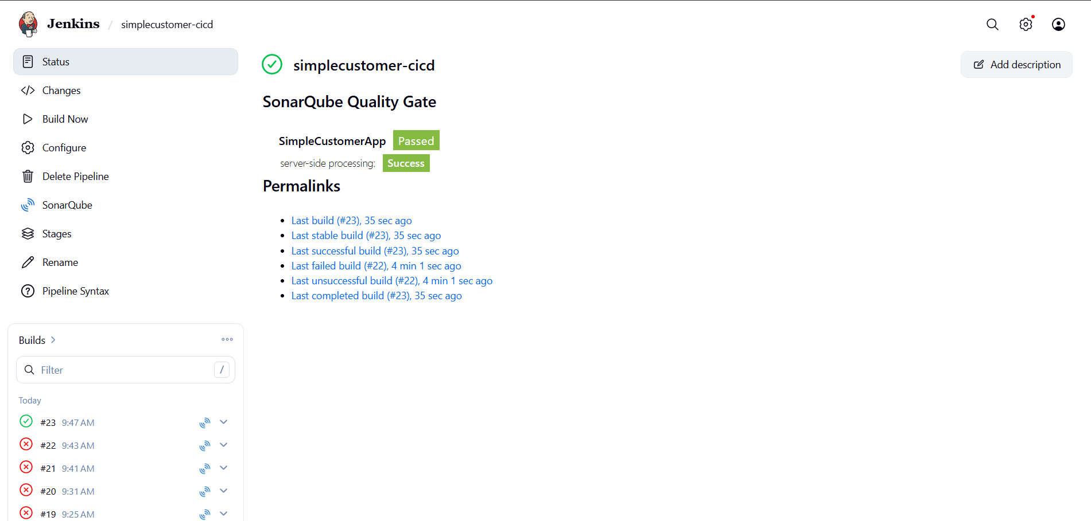
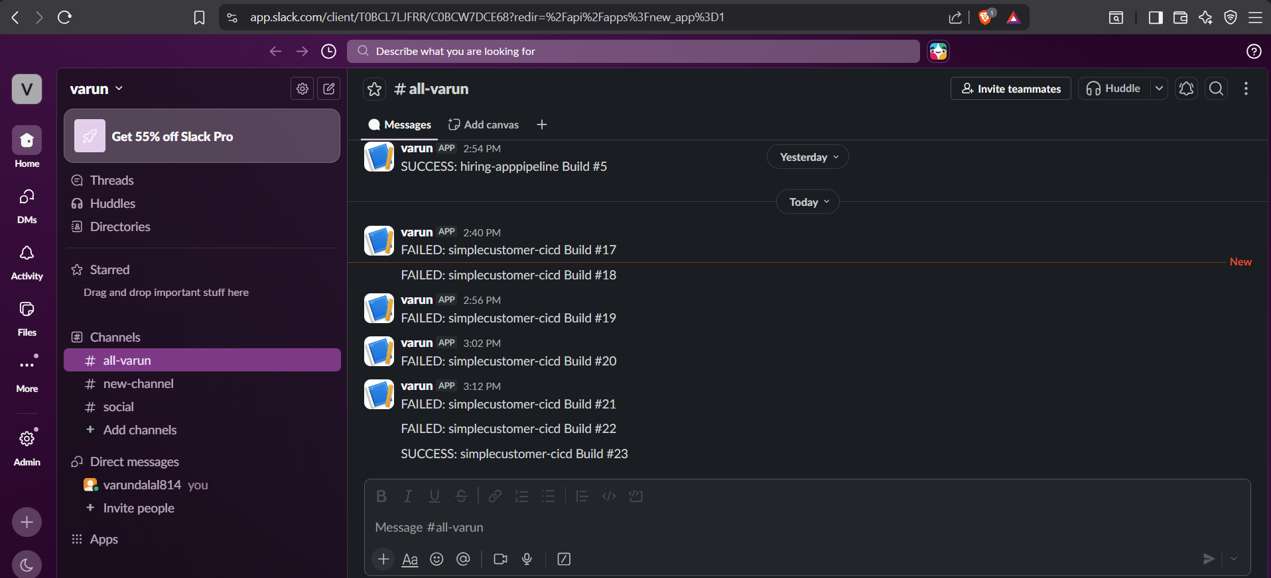

3) Setup a Jenkins CICD pipeline using Scripted pipeline using feature-1.1 branch.
Source Code: https://github.com/betawins/sabear_simplecutomerapp/tree/feature-1.1
stages:
- Git Clone
- SonarQube Integration
- Maven Compilation
- Nexus Artifactory
- Slack Notification
- Deploy On tomcat
1. Objective
The objective of this task is to build a CI/CD pipeline using Jenkins Scripted Pipeline that automates the process of:
- Fetching source code from GitHub
- Building the application using Maven
- Performing code quality analysis using SonarQube
- Uploading build artifacts to Nexus Repository
- Sending notifications to Slack
- Deploying the application on Tomcat (Docker container)

2. Prerequisites
Before creating the pipeline, ensure the following tools are installed and configured:
Jenkins Setup:
- Jenkins server installed and running
- Required plugins installed (Git, Maven, SonarQube, Nexus, Slack, Docker integration)
Tool Configurations:
- Maven configured in Jenkins Global Tool Configuration
- SonarQube server configured and connected with Jenkins
- Nexus Repository Manager accessible
- Docker installed and running on Jenkins machine
- Tomcat container running inside Docker

3. Pipeline Stages
The CI/CD pipeline consists of the following stages:

Stage 1: Git Clone
- Jenkins pulls the source code from GitHub repository
- The branch used is: feature-1.1
- This ensures the latest code is used for the build

Stage 2: Maven Compilation
- Maven is used to compile the source code
- It downloads dependencies and builds the application
- A WAR file is generated after successful build

Stage 3: SonarQube Integration
- Code is analyzed using SonarQube
- It checks for:
  - Code quality issues
  - Bugs and vulnerabilities
  - Code smells
- A quality report is generated in SonarQube dashboard

Stage 4: Nexus Artifactory Upload
- The generated WAR file is identified from the build workspace
- The artifact is uploaded to Nexus Repository Manager
- Versioning is managed using Jenkins build number
- This ensures centralized artifact storage

Stage 5: Slack Notification
- After build completion, Jenkins sends notifications to Slack
- Two types of notifications are sent:
  - Success message if pipeline passes
  - Failure message if pipeline fails
- This helps in real-time monitoring

Stage 6: Deploy on Tomcat (Docker)
- The generated WAR file is copied into Tomcat container
- The Tomcat container is restarted
- Application becomes accessible through browser
- Ensures automated deployment after build success

4. Pipeline Execution Flow
The pipeline runs in the following order:
- Git Clone
- Maven Compilation
- SonarQube Analysis
- Nexus Upload
- Deployment on Tomcat
- Slack Notification

5. Expected Outcome
After successful execution:
- Code is pulled from GitHub
- Application is built successfully
- Code quality is verified
- WAR file is stored in Nexus
- Application is deployed on Tomcat
- Slack notification confirms success

6. Conclusion
This CI/CD pipeline demonstrates end-to-end automation using Jenkins Scripted Pipeline. It improves:
- Deployment speed
- Code quality assurance
- Continuous integration and delivery
- Team communication through Slack alerts
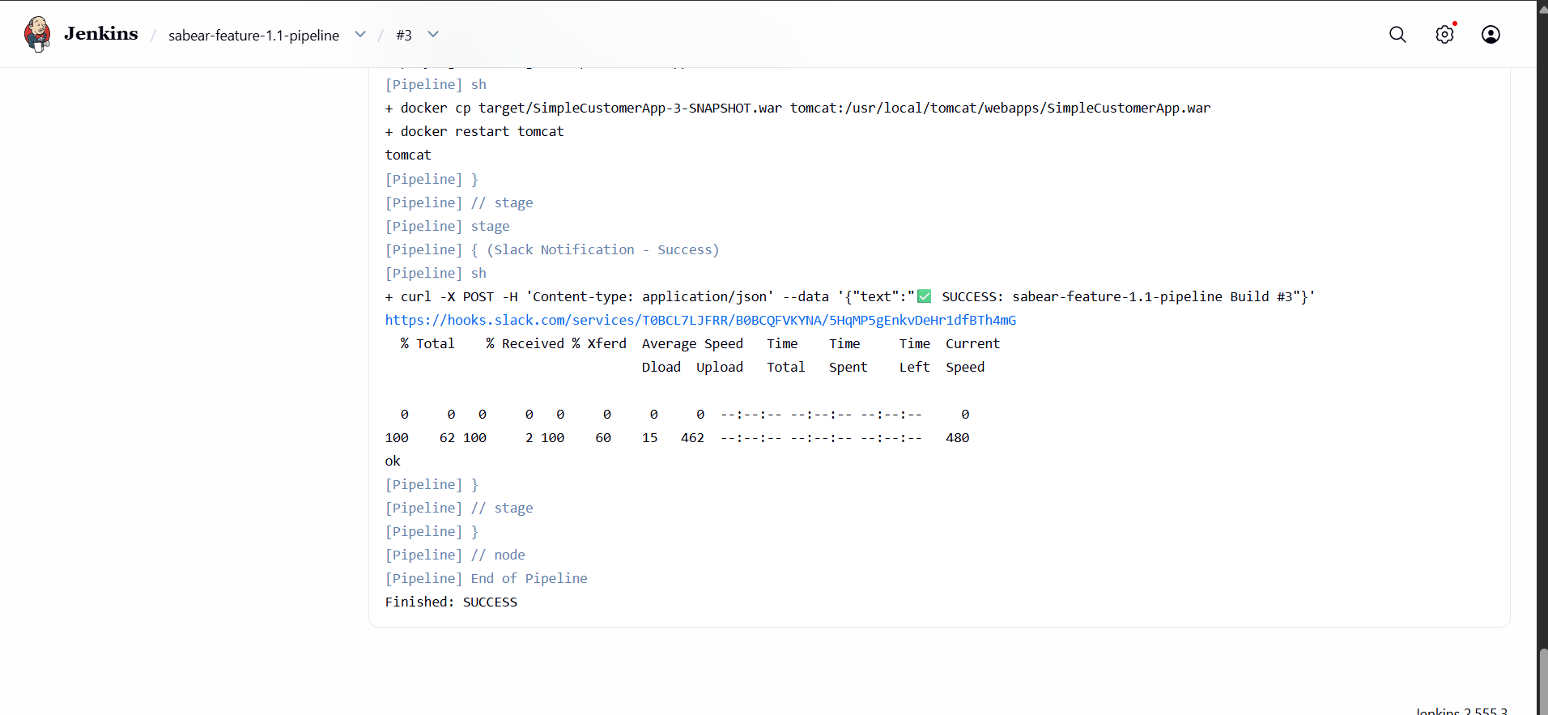

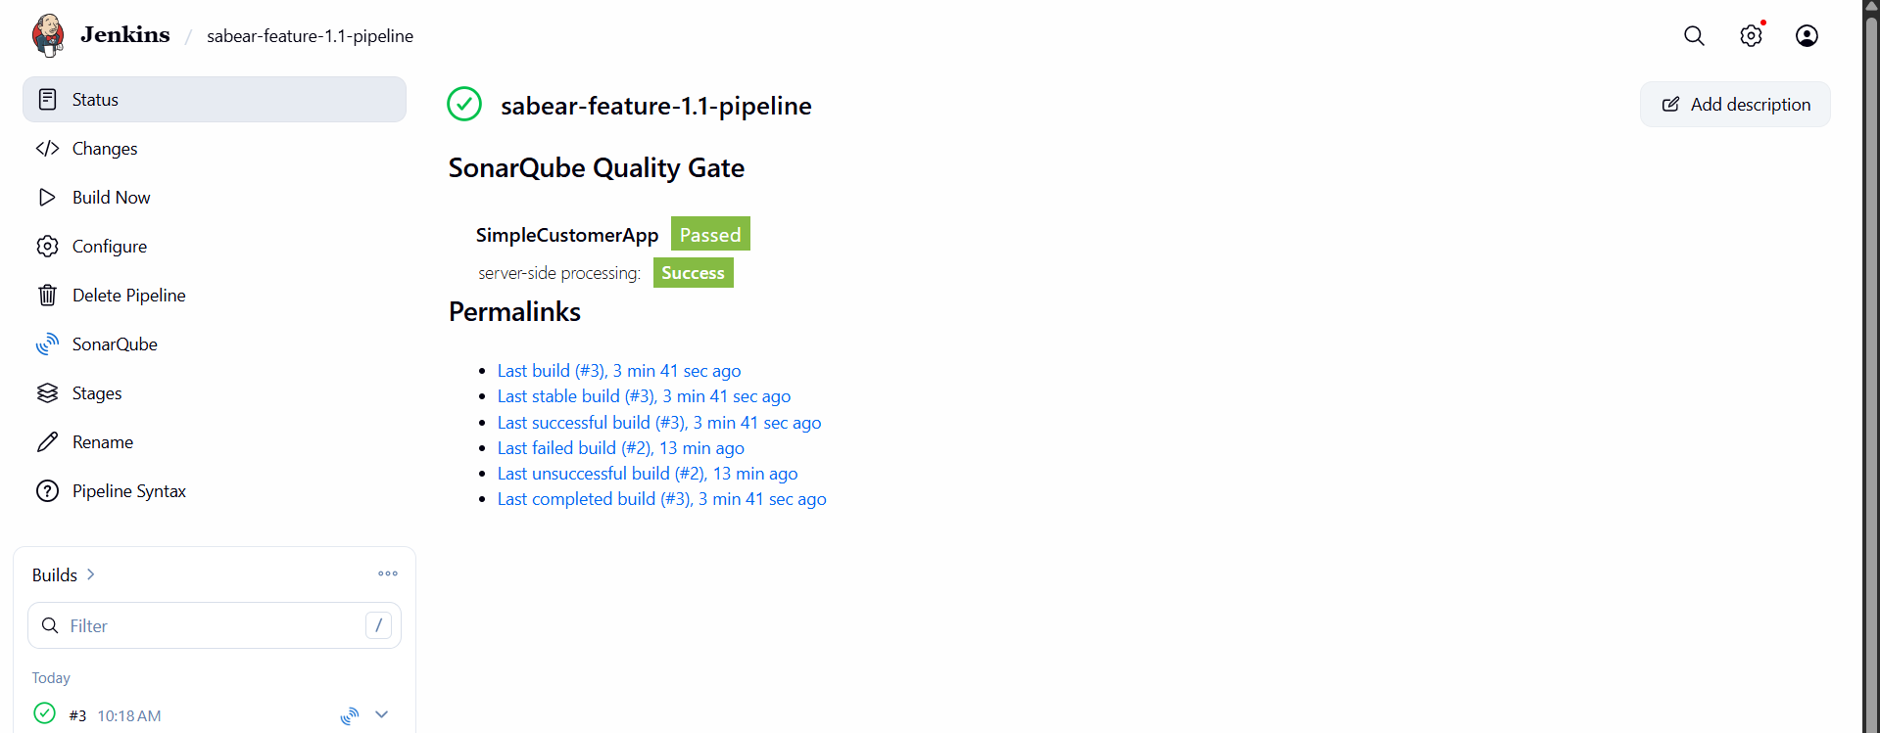

Write sample skeleton of pipelines
  - Declarative Pipeline Skeleton:
STEP 1: Create Pipeline Job in Jenkins
- Open Jenkins Dashboard
- Click New Item
- Enter job name: Declarative-Pipeline-Project
- Select Pipeline
- Click OK

STEP 2: Connect Git Repository
- Go to Pipeline section
- Select Pipeline script from SCM
- Choose Git
- Enter GitHub repository URL
- Select branch (main or feature branch)
- Save configuration

STEP 3: Configure Required Tools in Jenkins
Go to Manage Jenkins → Global Tool Configuration
- Configure JDK
- Configure Maven
- Configure Git

STEP 4: Checkout Stage (Git Clone)
- Jenkins pulls code automatically from GitHub using SCM configuration
- Ensure repository and branch are correct

STEP 5: Build Stage
- Maven goal: clean compile
- Purpose: Compiles the source code

STEP 6: Test Stage
- Maven goal: test
- Purpose: Runs unit test cases and generates reports

STEP 7: Package Stage
- Maven goal: clean package
- Purpose: Creates WAR or JAR file
- Output is stored in target folder

STEP 8: SonarQube Analysis (Optional)
- Configure SonarQube server in Jenkins
- Add server URL and token
- Run analysis in pipeline
- Review quality report

STEP 9: Artifact Storage (Optional)
Choose one:
- Nexus Repository
- Artifactory
Purpose: Upload generated WAR/JAR file

STEP 10: Deployment Stage
Option A: Tomcat Deployment
- Copy WAR file to /opt/tomcat/webapps/
- Restart Tomcat
- Access application in browser
Option B: Docker Deployment
- Build Docker image
- Run container
- Expose required port

STEP 11: Notification Stage
Configure Slack or Email notifications
- Notify on Success
- Notify on Failure

STEP 12: Run Pipeline
- Click Build Now
- Check Console Output
- Verify all stages executed successfully

STEP 13: Verify Application
Open browser:
http://<server-ip>:8080/<application-name>

FINAL OUTPUT
- Code cloned from GitHub
- Build successful
- Tests executed
- Package created (WAR/JAR)
- Optional SonarQube analysis done
- Optional artifact stored
- Application deployed
- Notifications sent
- Application running successfully

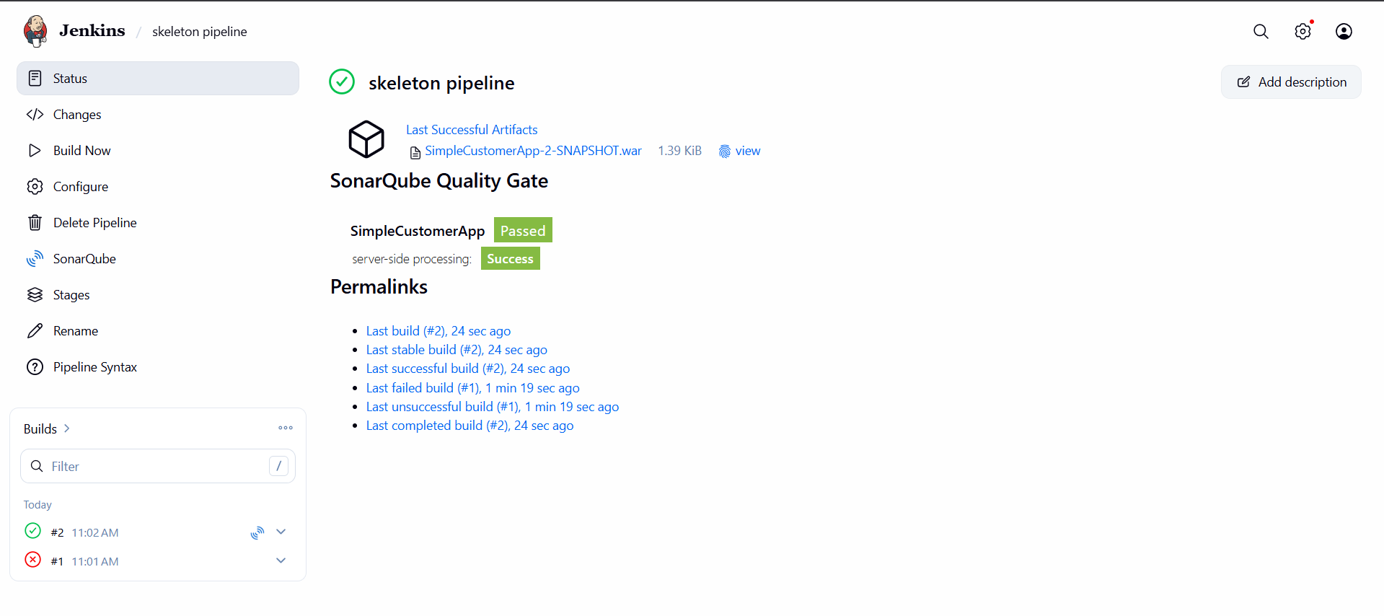

2. Scripted Pipeline Skeleton
Objective:
Create a Jenkins CI/CD pipeline using a Scripted Pipeline to automate the build, test, and deployment process of an application.

Step 1: Create a Pipeline Job
- Open Jenkins Dashboard.
- Click New Item.
- Enter the job name: Scripted-Pipeline-Project.
- Select Pipeline.
- Click OK.

Step 2: Configure Required Tools
Go to Manage Jenkins → Global Tool Configuration and configure:
- JDK installation
- Maven installation
- Git installation
Save the configuration.

Step 3: Prepare the Source Code Repository
- Create or use an existing Git repository.
- Ensure the repository contains:
  - Application source code
  - pom.xml file (for Maven projects)
  - Jenkinsfile for the Scripted Pipeline

Step 4: Configure Source Code Management
- Open the Jenkins Pipeline job.
- Scroll to the Pipeline section.
- Select Pipeline script from SCM.
- Choose Git as SCM.
- Enter the repository URL.
- Specify the branch to build.
- Save the job.

Step 5: Implement the Git Clone Stage
Purpose:
- Download the source code from the Git repository into the Jenkins workspace.
Expected Outcome:
- Source code is successfully cloned.

Step 6: Implement the Build Stage
Purpose:
- Compile the application source code.
Maven Goal:
clean compile
Expected Outcome:
- Source code compiles successfully without errors.

Step 7: Implement the Test Stage
Purpose:
- Execute unit test cases.
Maven Goal:
test
Expected Outcome:
- All test cases pass successfully.

Step 8: Implement the Package Stage
Purpose:
- Generate the application artifact.
Maven Goal:
clean package
Expected Outcome:
- A .jar or .war file is created inside the target directory.

Step 9: Integrate SonarQube (Optional)
Purpose:
- Perform static code analysis.
Configuration Steps:
- Install the SonarQube plugin in Jenkins.
- Configure the SonarQube server.
- Add the authentication token.
- Run code analysis during the pipeline.
Expected Outcome:
- A code quality report is generated.

Step 10: Upload Artifact to Repository (Optional)
Purpose:
- Store the generated artifact.
Artifact Repositories:
- Nexus Repository
- Artifactory
Expected Outcome:
- The generated artifact is uploaded successfully.

Step 11: Deploy the Application
Option 1: Deploy on Tomcat
- Copy the generated .war file to the Tomcat webapps directory.
- Restart Tomcat.
- Verify the application is running.
Option 2: Deploy Using Docker
- Build the Docker image.
- Run the Docker container.
- Expose the required application port.
- Verify the application is accessible.

Step 12: Configure Notifications
Purpose:
- Notify users about pipeline execution status.
Notification Methods:
- Slack
- Email
Notifications should be sent for:
- Successful builds
- Failed builds

Step 13: Execute the Pipeline
- Open the Jenkins job.
- Click Build Now.
- Monitor the build using Console Output.

Step 14: Verify the Deployment
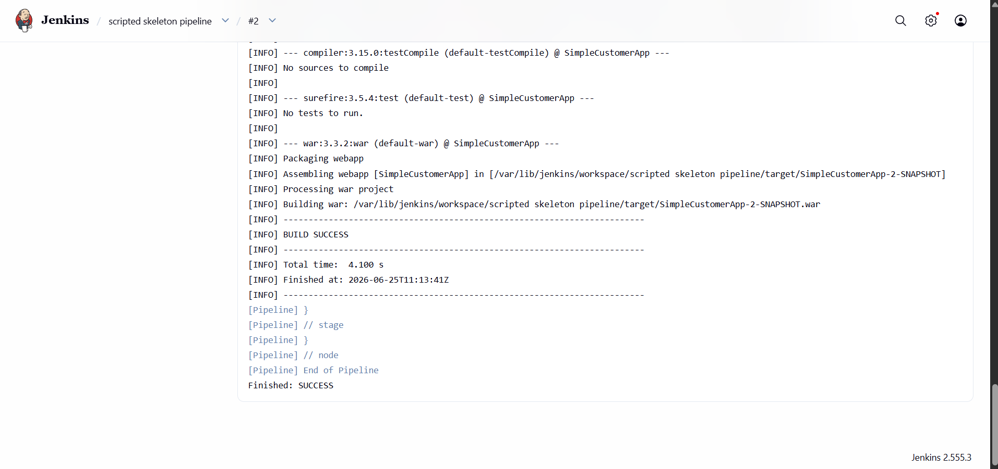

Create a Parameterized Job in Jenkins
Aim
To create a Parameterized Job in Jenkins that clones the source code from GitHub and executes a build.
Source Code Repository:
https://github.com/betawins/spring3-mvc-maven-xml-hello-world-1.git

Prerequisites
- Jenkins server installed and running.
- Git installed on the Jenkins server.
- Jenkins administrator access.
- Internet connectivity to access the GitHub repository.

Step 1: Log in to Jenkins
- Open a web browser.
- Access Jenkins using:
http://<JENKINS_SERVER_IP>:8080
- Enter the Jenkins username and password.

Step 2: Create a New Job
- On the Jenkins Dashboard, click New Item.
- Enter the job name:
Spring3-Parameterized-Job
- Select Freestyle Project.
- Click OK.

Step 3: Enable Parameterized Build
- Under the General section, select:
This project is parameterized
- Click Add Parameter.
- Select String Parameter.
Configure the parameter as follows:
Parameter | Value
Name | BRANCH_NAME
Default Value | master
Description | Enter the Git branch name to build

Step 4: Configure Source Code Management
- Select Source Code Management.
- Choose Git.
- Enter the Repository URL:
https://github.com/betawins/spring3-mvc-maven-xml-hello-world-1.git
- In Branches to Build, enter:
*/${BRANCH_NAME}
This allows the user to provide the branch name during the build.

Step 5: Configure Build Step
- Scroll to the Build section.
- Click:
Add Build Step → Execute Shell
- Enter the following commands:
- echo "Parameterized Job Executed Successfully"
- echo "Building Branch: $BRANCH_NAME"
- pwd
ls -la

Step 6: Save the Job
Click Save.

Step 7: Build with Parameters
- Open the job:
Spring3-Parameterized-Job
- Click:
Build with Parameters
- Enter:
BRANCH_NAME = master
- Click Build.

Step 8: Verify Build Status
- Click the latest build number.
- Open Console Output.
- Verify that the build completed successfully.
Expected output:
Parameterized Job Executed Successfully
Building Branch: master
Finished: SUCCESS

Result
Successfully created a Parameterized Job in Jenkins that:
- Accepts the branch name as a parameter.
- Clones the source code from GitHub.
- Executes the build successfully.
- Displays the build status as SUCCESS.
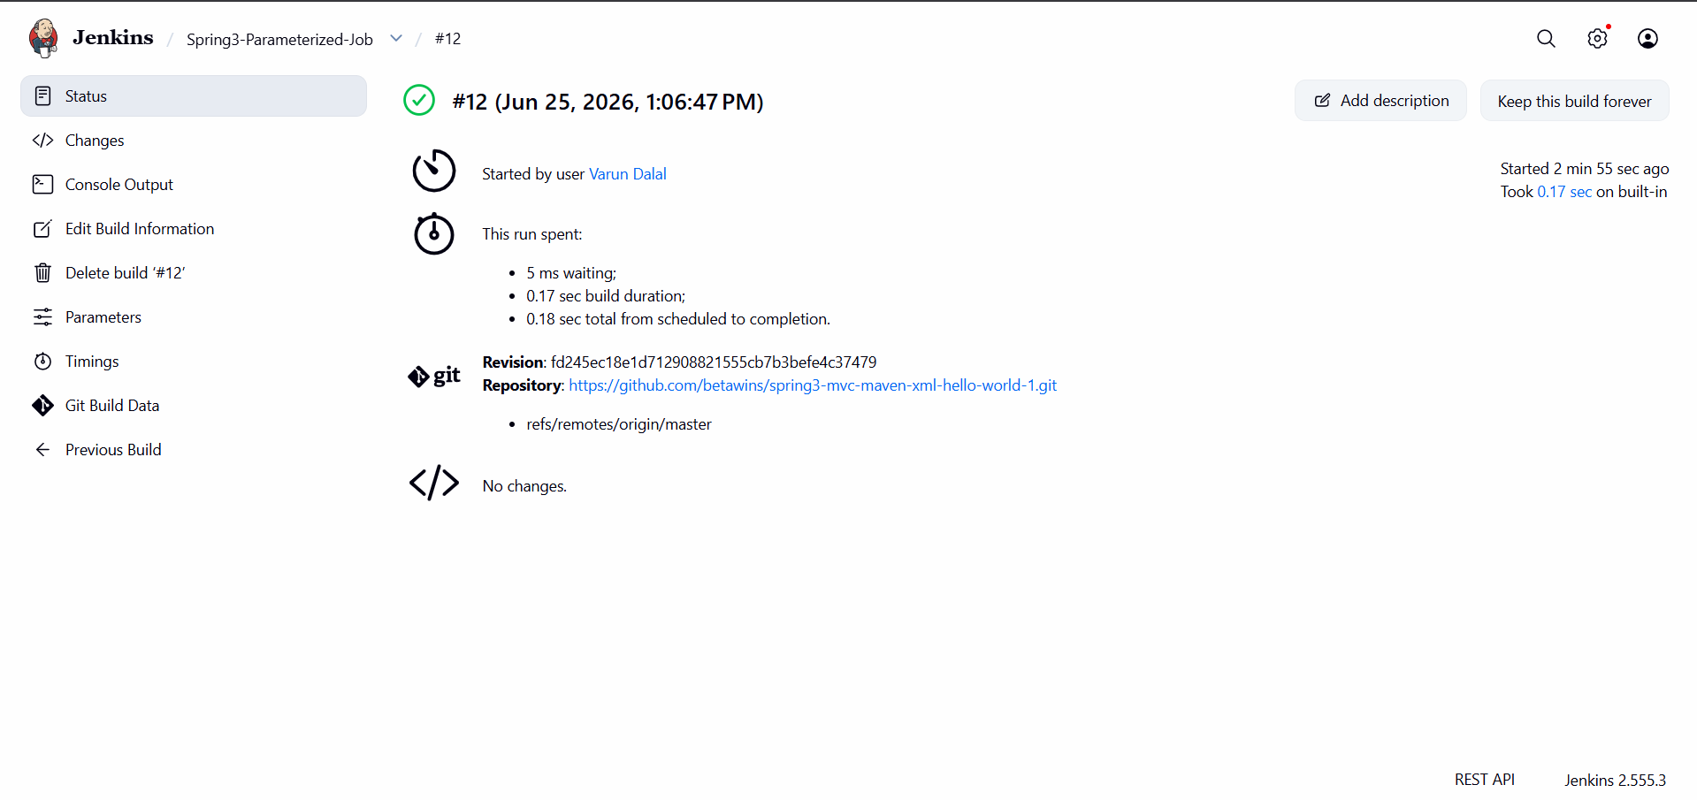

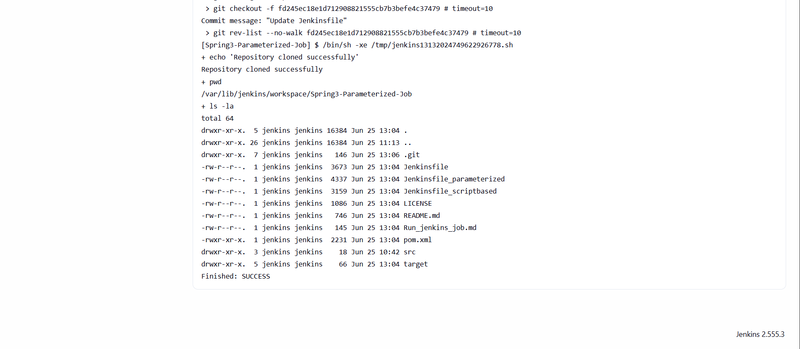

Jenkins-04 Assignment Documentation (Without Scripts)
Objective
Perform Jenkins CI/CD tasks using Freestyle Jobs, Declarative Pipelines, Scripted Pipelines, Parameterized Jobs, and Jenkins Agents (Slave Machines).

Prerequisites
Before starting, install and configure the following:
- Jenkins
- Java (17 or 21)
- Maven
- Git
- Docker
- SonarQube
- Nexus Repository Manager
- Apache Tomcat
- Slack Integration

Required Jenkins Plugins
Go to:
Manage Jenkins → Plugins → Available Plugins
Install:
- Git Plugin
- Pipeline Plugin
- Docker Plugin
- Docker Pipeline Plugin
- Maven Integration Plugin
- SonarQube Scanner Plugin
- Nexus Artifact Uploader Plugin
- Deploy to Container Plugin
- Slack Notification Plugin
- SSH Agent Plugin
- SSH Build Agents Plugin
- Pipeline Utility Steps Plugin
Restart Jenkins after installing the plugins.

Task 1: Setup Jenkins CI/CD Pipeline Using Freestyle Job with Docker Containers
Source Code:
https://github.com/betawins/hiring-app.git
Steps
Step 1: Create Docker Containers
Create containers for:
- Jenkins
- SonarQube
- Nexus
- Tomcat
Step 2: Create a Freestyle Job
- Dashboard → New Item
- Enter Job Name
- Select Freestyle Project
- Click OK
Step 3: Configure Git Repository
- Open Source Code Management
- Select Git
- Enter repository URL.
- Configure the branch.
Step 4: Configure Build Stages
The job should perform the following stages:
- Git Clone
- SonarQube Integration
- Maven Compilation
- Nexus Artifact Upload
- Slack Notification
- Deploy to Tomcat
Step 5: Save and Build
Verify:
- SonarQube analysis is completed.
- Artifact is uploaded to Nexus.
- Application is deployed on Tomcat.
- Slack notification is received.

Task 2: Setup Jenkins CI/CD Pipeline Using Declarative Pipeline
Source Code:
https://github.com/betawins/sabear_simplecutomerapp/tree/feature-1.1
Steps
Step 1
- Dashboard → New Item
- Select Pipeline
- Enter Job Name.
Step 2
Choose:
- Pipeline Definition
- Pipeline Script
Step 3
Configure the following stages:
- Git Clone
- SonarQube Integration
- Maven Compilation
- Nexus Artifact Upload
- Slack Notification
- Deploy on Tomcat
Step 4
Save and run the pipeline.

Task 3: Setup Jenkins CI/CD Pipeline Using Scripted Pipeline
Source Code:
https://github.com/betawins/sabear_simplecutomerapp/tree/feature-1.1
Steps
Step 1
- Dashboard → New Item
- Select Pipeline
- Enter Job Name.
Step 2
Choose:
- Pipeline Definition
- Pipeline Script
Step 3
Configure the following stages:
- Git Clone
- SonarQube Integration
- Maven Compilation
- Nexus Artifact Upload
- Slack Notification
- Deploy on Tomcat
Step 4
Save and execute the pipeline.

Task 4: Sample Skeleton of Pipelines
A Jenkins Pipeline generally contains:
- Agent Definition
- Stages
- Steps
- Post Actions
- Environment Variables
- Parameters
- Credentials

Task 5: Create a Parameterized Job
Source Code:
https://github.com/betawins/spring3-mvc-maven-xml-hello-world-1.git
Steps
Step 1
- Dashboard → New Item
- Select Freestyle Project
- Enter Job Name.
Step 2
Enable:
This project is parameterized
Step 3
Create Parameters
String Parameter
- Parameter Name: Branch Name
Choice Parameter
- Parameter Name: Environment
- Values:
  - DEV
  - QA
  - PROD
Boolean Parameter
- Parameter Name: Deploy
Step 4
Configure:
- Git Repository
- Branch Selection using parameter value.
Step 5
Add build steps.
Step 6
Save the job.
Step 7
Click:
Build with Parameters
Provide values and run the build.

Task 6: Setup One Slave Machine (Jenkins Agent)
Step 1
Create another EC2 instance.
Recommended:
- Amazon Linux 2023
- t2.micro instance

Step 2
Install Java on the Agent Machine.
Verify Java installation.

Step 3
Create a Jenkins working directory.

Step 4
Generate SSH keys on Jenkins Master.

Step 5
Copy the public key to the Agent machine.

Step 6
Add SSH Credentials in Jenkins.
Navigate to:
Manage Jenkins → Credentials
Add:
- SSH Username with Private Key.

Step 7
Create a New Node.
Navigate to:
Manage Jenkins → Nodes
Create:
- Permanent Agent
Configure:
- Node Name
- Remote Root Directory
- Labels
- Usage
- Launch Method using SSH
- Host IP
- Credentials

Step 8
Launch the Agent.
Verify that the node status becomes:
Online

Recommended Jenkins Documentation
Pipeline Documentation:
https://www.jenkins.io/doc/book/pipeline/
Environment Variables:
https://www.jenkins.io/doc/book/pipeline/jenkinsfile/#using-environment-variables
Parameters:
https://www.jenkins.io/doc/book/pipeline/syntax/#parameters
Credentials:
https://www.jenkins.io/doc/book/pipeline/jenkinsfile/#handling-credentials

Deliverables
- Freestyle Pipeline Screenshot
- Declarative Pipeline Screenshot
- Scripted Pipeline Screenshot
- Parameterized Job Screenshot
- Jenkins Agent Screenshot
- SonarQube Screenshot
- Nexus Repository Screenshot
- Tomcat Deployment Screenshot
- Slack Notification Screenshot
