1.Install Jenkins and run Jenkins on port number 8081
Objective
Install Jenkins on an AWS EC2 instance and configure it to run on port 8081 instead of the default port 8080.
Prerequisites
- AWS EC2 Instance (Amazon Linux 2 / Amazon Linux 2023)
- Security Group attached to the EC2 instance
- SSH access to the instance

Step 1: Connect to the EC2 Instance
Connect to the EC2 instance using SSH.
ssh -i <key.pem> ec2-user@<Public-IP>

Step 2: Update the System Packages
Update all installed packages to the latest version.
sudo yum update -y

Step 3: Install Java
Jenkins requires Java to run.
sudo yum install java-17-amazon-corretto -y
Verify the installation:
java -version
Expected Output:
openjdk version "17.x.x"

Step 4: Add the Jenkins Repository
Download the Jenkins repository file.
sudo wget -O /etc/yum.repos.d/jenkins.repo https://pkg.jenkins.io/redhat-stable/jenkins.repo
Import the Jenkins GPG key.
sudo rpm --import https://pkg.jenkins.io/redhat-stable/jenkins.io-2023.key

Step 5: Install Jenkins
Install Jenkins using the package manager.
sudo yum install jenkins -y
Verify the installation:
jenkins --version

Step 6: Configure Jenkins to Use Port 8081
Open the Jenkins service configuration file.
sudo vi /usr/lib/systemd/system/jenkins.service
Locate the following line:
Environment="JENKINS_PORT=8080"
Change it to:
Environment="JENKINS_PORT=8081"
Save and exit the file.

Step 7: Reload Systemd Configuration
Reload the systemd daemon to apply the changes.
sudo systemctl daemon-reload

Step 8: Start Jenkins Service
Start the Jenkins service.
sudo systemctl start jenkins
Enable Jenkins to start automatically after a reboot.
sudo systemctl enable jenkins

Step 9: Verify Jenkins Service Status
Check whether Jenkins is running successfully.
sudo systemctl status jenkins
Expected Output:
active (running)

Step 10: Configure Security Group
Add a new inbound rule in the EC2 Security Group.
Type | Protocol | Port Range | Source
Custom TCP | TCP | 8081 | 0.0.0.0/0
Save the rule.

Step 11: Verify Jenkins is Listening on Port 8081
Run the following command:
sudo ss -tulnp | grep 8081
Expected Output:
tcp LISTEN 0 50 *:8081 *:*

Step 12: Retrieve the Initial Jenkins Password
Get the Jenkins administrator password.
sudo cat /var/lib/jenkins/secrets/initialAdminPassword
Copy the displayed password.

Step 13: Access Jenkins Web Interface
Open a web browser and navigate to:
http://<EC2-Public-IP>:8081
Example:
http://54.xx.xx.xx:8081
Paste the initial administrator password when prompted.

Result
Jenkins was successfully installed and configured to run on port 8081. The Jenkins dashboard is accessible through the EC2 public IP address on port 8081.

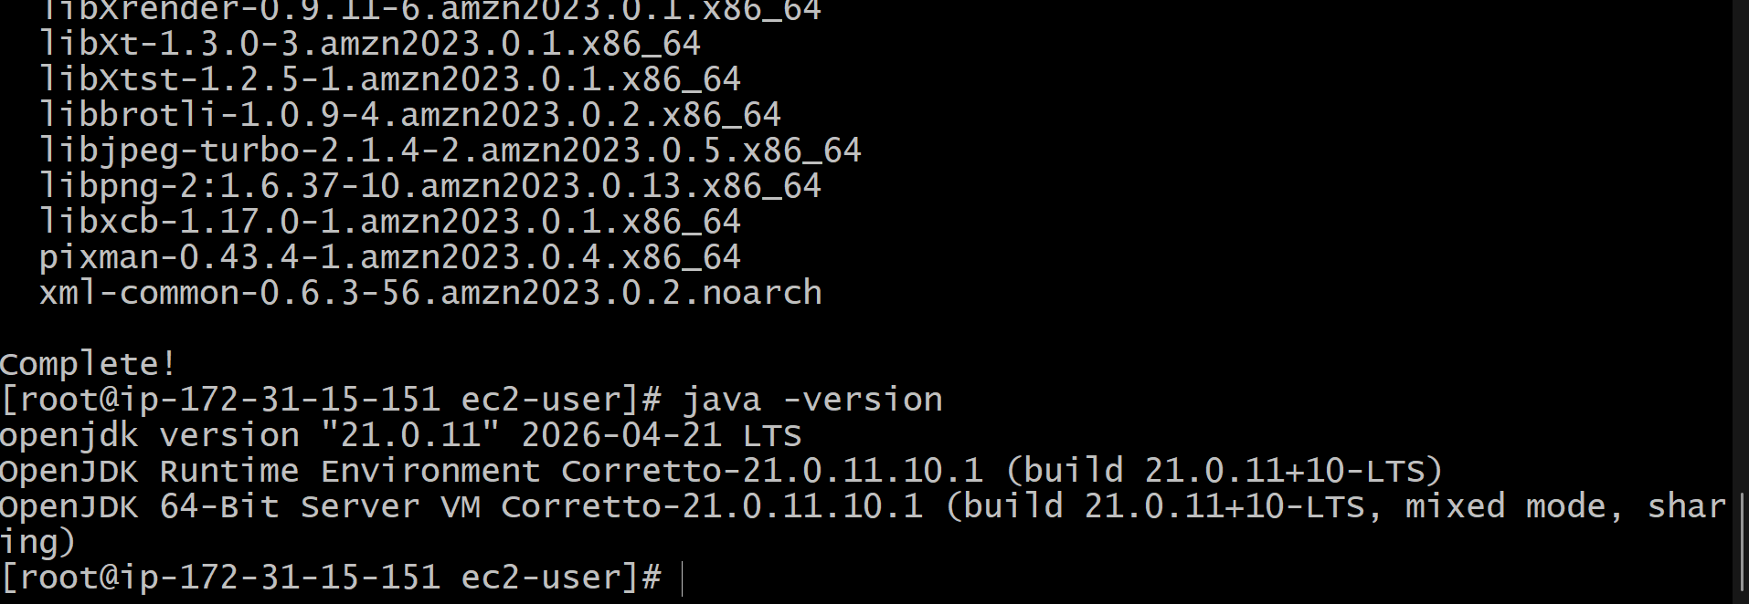
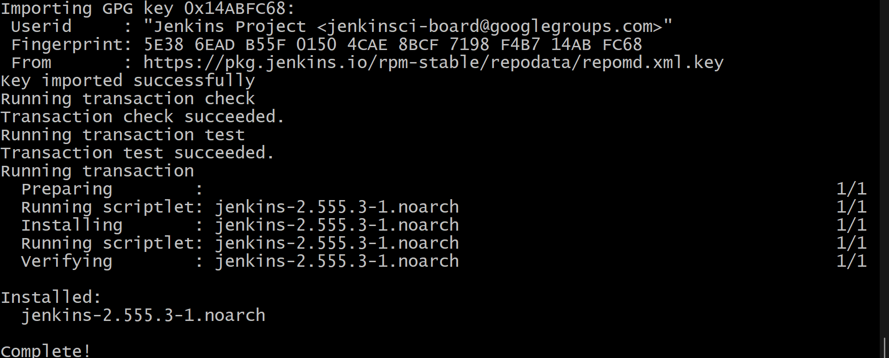
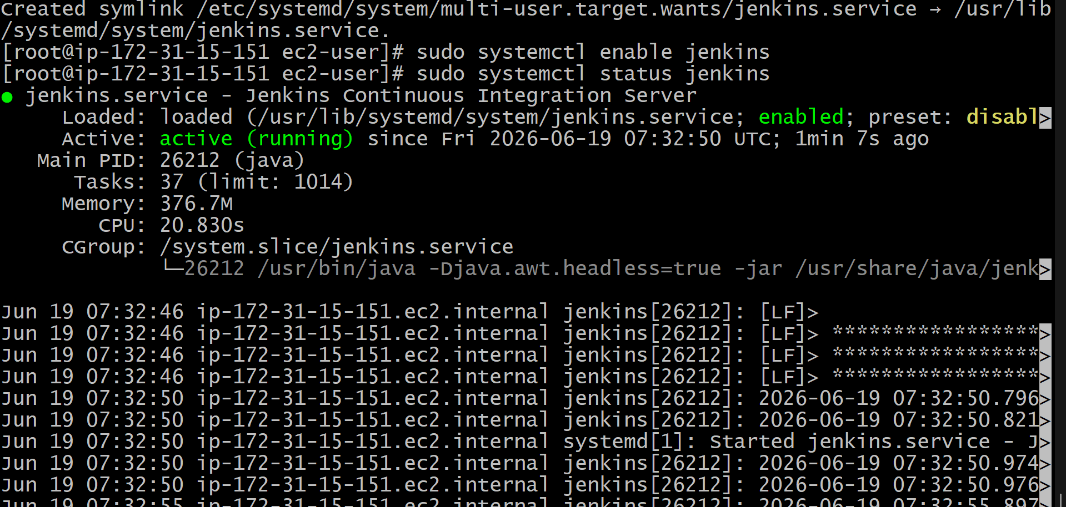
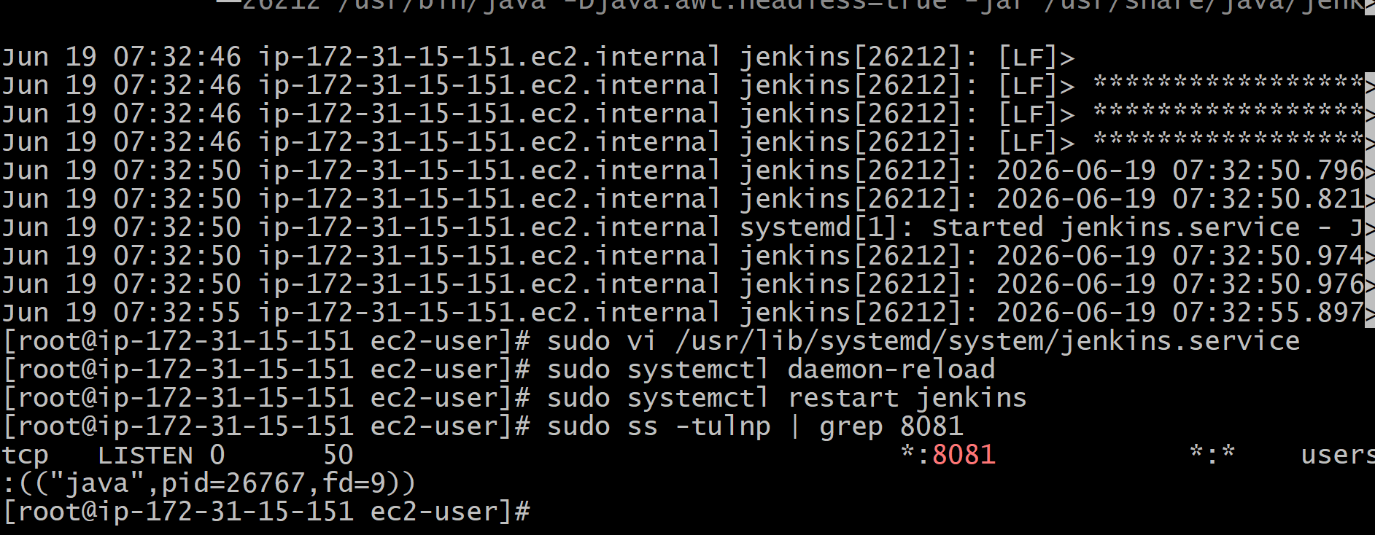
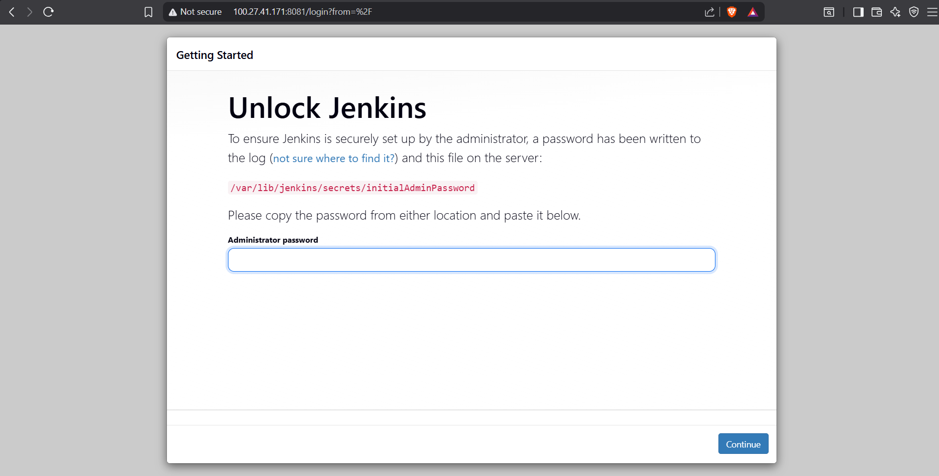

Task 2: Secure Jenkins Server
Objective
Implement security best practices to protect the Jenkins server from unauthorized access and potential security threats.
Prerequisites
- Jenkins installed and running on EC2
- Administrator access to Jenkins
- AWS EC2 Security Group configured

Step 1: Configure Jenkins Authentication
Purpose
Enable user authentication so that only authorized users can access Jenkins.
Procedure
- Log in to Jenkins as an administrator.
- Navigate to:
Manage Jenkins → Security → Security Configuration
- Under Authentication, select:
Jenkins' own user database
- Check:
  - Allow users to sign up (Optional)
  - Enable Security
- Click Save.
Result
Users must authenticate before accessing Jenkins.

Step 2: Configure Authorization
Purpose
Restrict user permissions based on roles and responsibilities.
Procedure
- Navigate to:
Manage Jenkins → Security → Security Configuration
- Under Authorization, select:
Matrix-based security
- Create users and assign permissions such as:
  - Overall Read
  - Job Read
  - Job Build
  - Job Configure
  - Administer
- Save the configuration.
Result
Only authorized users can perform administrative actions.

Step 3: Disable Anonymous Access
Purpose
Prevent unauthorized users from accessing Jenkins.
Procedure
- Navigate to:
Manage Jenkins → Security
- Ensure that anonymous users do not have:
  - Overall Read
  - Job Read
  - Build permissions
- Save the configuration.
Result
Anonymous access is blocked.

Step 4: Change Default Admin Password
Purpose
Reduce the risk of unauthorized access.
Procedure
- Click on the administrator account.
- Select:
Configure
- Enter a strong password containing:
  - Uppercase letters
  - Lowercase letters
  - Numbers
  - Special characters
- Save changes.
Result
Administrator account is secured with a strong password.

Step 5: Restrict Network Access Using Security Groups
Purpose
Limit access to Jenkins from trusted IP addresses.
Procedure
- Open AWS Console.
- Navigate to:
EC2 → Security Groups
- Edit the inbound rule for Jenkins.
Example:
Type | Protocol | Port | Source
Custom TCP | TCP | 8081 | My IP
- Remove unnecessary public access.
Result
Only trusted users can access Jenkins.

Step 6: Install Recommended Security Plugins
Purpose
Enhance Jenkins security.
Procedure
- Navigate to:
Manage Jenkins → Plugins
- Install the following plugins:
  - Role-based Authorization Strategy
  - OWASP Markup Formatter
  - Audit Trail
  - Credentials Plugin
- Restart Jenkins if required.
Result
Additional security controls are enabled.

Step 7: Configure Credentials Management
Purpose
Securely store passwords, API keys, and secrets.
Procedure
- Navigate to:
Manage Jenkins → Credentials
- Select:
Global Credentials
- Add credentials such as:
  - SSH Keys
  - AWS Access Keys
  - Username/Password
- Save credentials.
Result
Sensitive information is securely stored.

Step 8: Enable CSRF Protection
Purpose
Protect Jenkins from Cross-Site Request Forgery attacks.
Procedure
- Navigate to:
Manage Jenkins → Security
- Verify that:
Prevent Cross Site Request Forgery Exploits is enabled.
- Save changes.
Result
CSRF protection is active.

Step 9: Keep Jenkins Updated
Purpose
Protect Jenkins from known vulnerabilities.
Procedure
Check for updates regularly.
sudo yum update jenkins -y
Restart Jenkins after updating.
sudo systemctl restart jenkins
Result
Latest security patches are applied.

Step 10: Verify Jenkins Security
Validation Checklist
- Jenkins authentication enabled
- Anonymous access disabled
- Strong admin password configured
- Security Group restricted
- Security plugins installed
- Credentials stored securely
- CSRF protection enabled
- Jenkins updated to latest version

Result
The Jenkins server has been secured by implementing authentication, authorization, network restrictions, credential management, CSRF protection, and security best practices. This reduces the risk of unauthorized access and improves the overall security posture of the Jenkins environment.
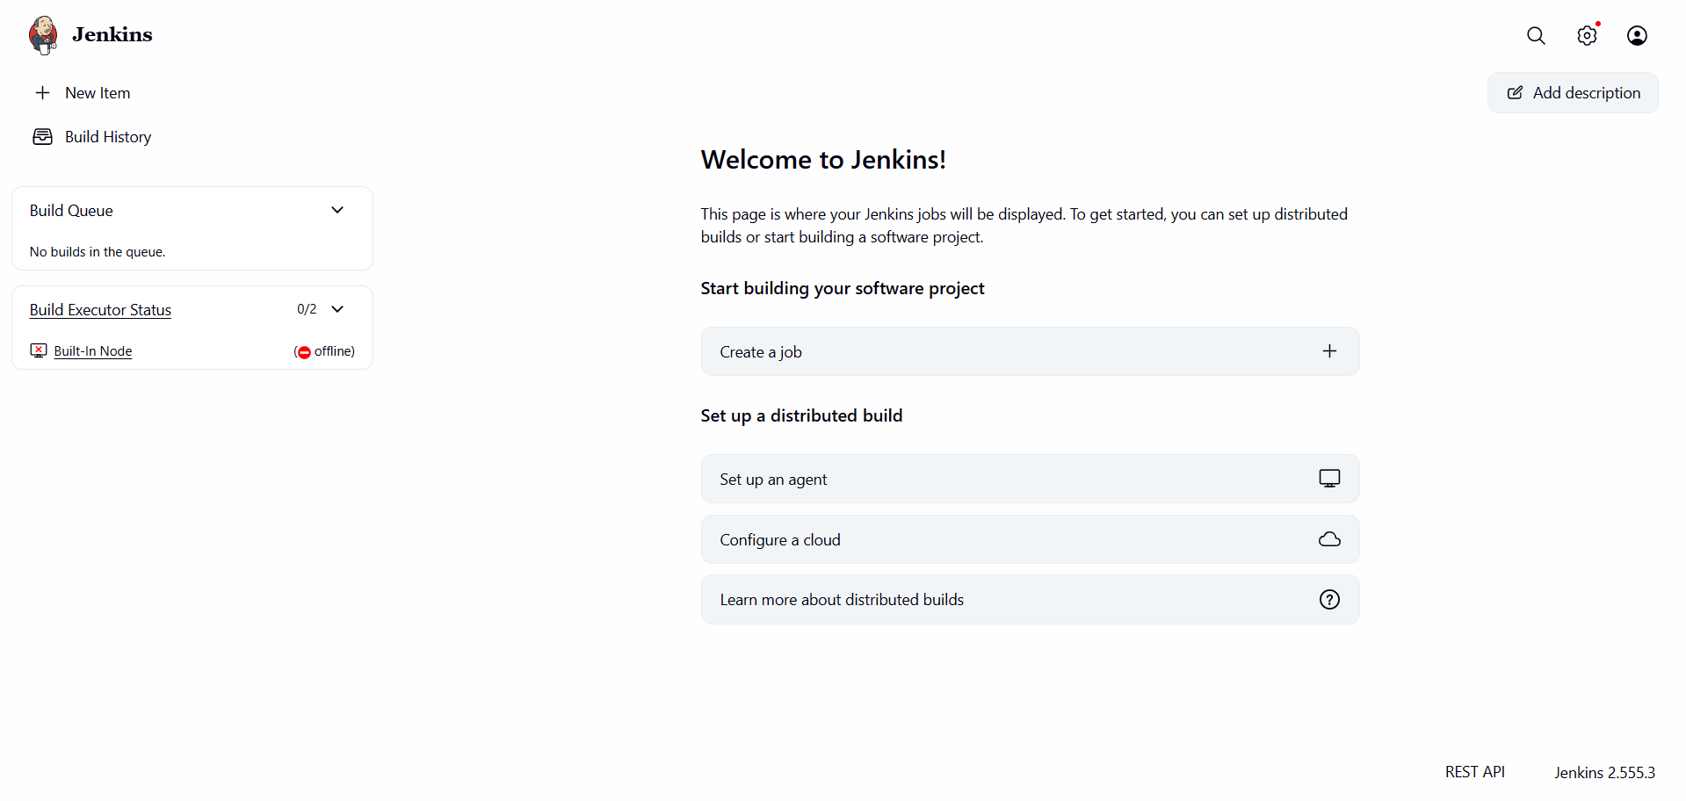

3.Creating DevOps and Testing Users with Limited Access in Jenkins
Objective
Create two users, DevOps and Testing, in Jenkins and assign limited permissions using Matrix-Based Security.

Step 1: Log in to Jenkins
- Open Jenkins in a web browser.
http://<EC2-PUBLIC-IP>:8081
- Log in using the administrator account.

Step 2: Create the DevOps User
- Navigate to Manage Jenkins.
- Click Users.
- Click Create User.
- Enter the following details:
Field | Value
Username | DevOps
Password | DevOps@123
Confirm Password | DevOps@123
Full Name | DevOps User
Email Address | devops@example.com
- Click Create User.
Result
The DevOps user is successfully created.

Step 3: Create the Testing User
- Navigate to Manage Jenkins → Users.
- Click Create User.
- Enter the following details:
Field | Value
Username | Testing
Password | Testing@123
Confirm Password | Testing@123
Full Name | Testing User
Email Address | testing@example.com
- Click Create User.
Result
The Testing user is successfully created.

Step 4: Configure Matrix-Based Security
- Navigate to Manage Jenkins.
- Click Security.
- Under Authorization, select Matrix-Based Security.
Result
The permission matrix is displayed.

Step 5: Assign Administrator Permissions
- Locate the administrator account (Varun Dalal).
- Select Overall → Administer.
Result
The administrator receives full Jenkins permissions.

Step 6: Assign Permissions to DevOps User
- Locate DevOps user in the permission matrix.
- Enable the following permissions:
Category | Permission
Overall | Read
Job | Read
Job | Build
Result
The DevOps user can view and build jobs but cannot modify Jenkins settings.

Step 7: Assign Permissions to Testing User
- Locate Testing user in the permission matrix.
- Enable the following permissions:
Category | Permission
Overall | Read
Job | Read
Result
The Testing user can only view jobs and cannot build or configure jobs.

Step 8: Disable Anonymous Access
- Locate the Anonymous row.
- Ensure that no permissions are selected.
Result
Unauthenticated users cannot access Jenkins.

Step 9: Save the Configuration
- Click Save at the bottom of the Security Configuration page.
Result
All user permissions are applied successfully.

Verification
DevOps User
- Can log in to Jenkins.
- Can view jobs.
- Can build jobs.
- Cannot access Manage Jenkins.
Testing User
- Can log in to Jenkins.
- Can view jobs.
- Cannot build jobs.
- Cannot access Manage Jenkins.
Administrator
- Has full access to Jenkins.
- Can manage users, jobs, plugins, and security settings.

Conclusion
Successfully created DevOps and Testing users in Jenkins and assigned limited permissions using Matrix-Based Security. Anonymous access was disabled, and administrative access was restricted to the Jenkins administrator account. 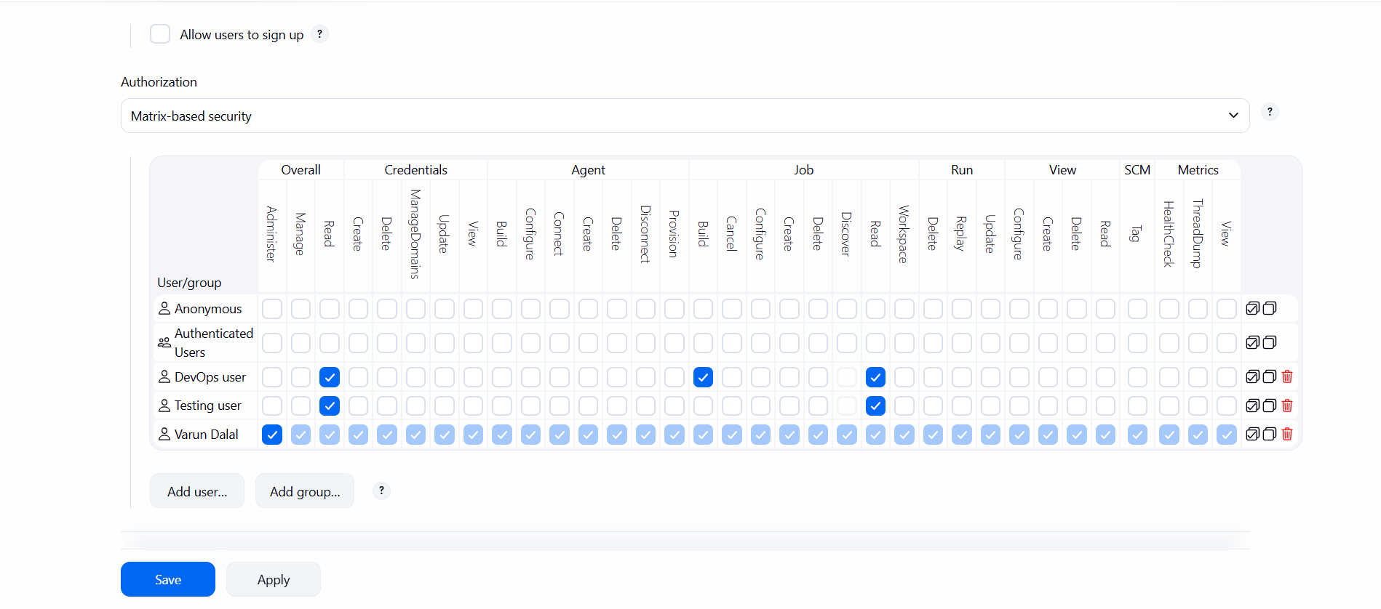
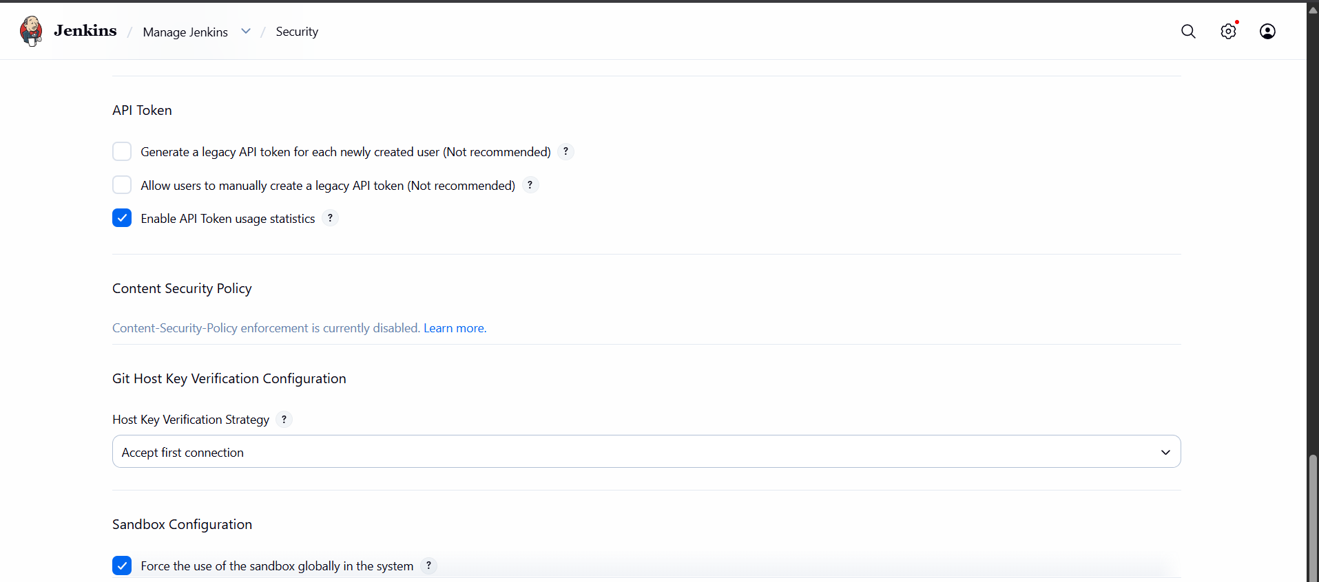

4.Configure Labels and Restrict Jenkins Jobs to Execute Based on Labels Only
Objective
Configure Jenkins node labels and restrict jobs so they run only on specific labeled nodes.

Step 1: Login to Jenkins
- Open Jenkins in a browser.
http://<EC2-PUBLIC-IP>:8081
- Login using the Administrator account.
Result
Jenkins Dashboard is displayed.

Step 2: Configure a Label on the Built-In Node
- Navigate to Manage Jenkins.
- Click Nodes.
- Select Built-In Node.
- Click Configure.
- Locate the Labels field.
Enter a label name:
devops-server
- Click Save.
Result
The Built-In Node is now assigned the label devops-server.

Step 3: Verify the Label
- Navigate to Manage Jenkins → Nodes.
- Open Built-In Node.
- Verify that the label appears as:
devops-server
Result
The node is successfully labeled.

Step 4: Create a New Jenkins Job
- From the Jenkins Dashboard, click New Item.
- Enter the job name:
Label-Test-Job
- Select Freestyle Project.
- Click OK.
Result
A new Jenkins job is created.

Step 5: Restrict the Job to a Specific Label
- Open the job configuration page.
- Click Configure.
- Under General, select:
Restrict where this project can be run
- In the Label Expression field, enter:
devops-server
- Click Save.
Result
The job can now execute only on nodes that have the label devops-server.

Step 6: Add a Build Step
- Open the job configuration.
- Scroll to Build Steps.
- Click Add Build Step.
- Select Execute Shell.
Add the following command:
echo "Job is running on devops-server label"
hostname
- Click Save.
Result
The job is configured for execution.

Step 7: Build the Job
- Open the job.
- Click Build Now.
- Open Build History.
- Click the build number.
- Select Console Output.
Expected Output:
Job is running on devops-server label
Result
The job successfully executes on the labeled node.

Step 8: Verify Label Restriction
- Edit the job.
- Change the label expression to:
testing-server
- Save the job.
- Click Build Now.
Expected Result:
There are no nodes with the label 'testing-server'
or
Still waiting to schedule task
Result
The job does not run because no node matches the specified label.

Verification
Node Label
devops-server
Job Restriction
Restrict where this project can be run = Enabled
Label Expression = devops-server
Build Status
SUCCESS

Conclusion
Successfully configured Jenkins node labels and restricted jobs to run only on nodes matching the specified label. This ensures that jobs execute on designated infrastructure and provides better workload management and control.

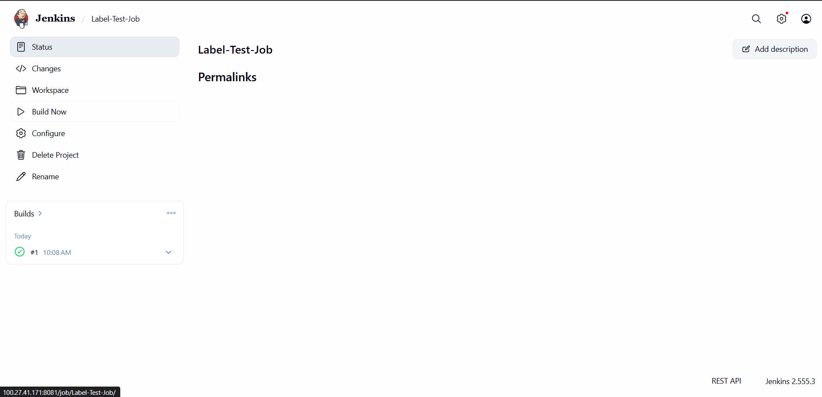
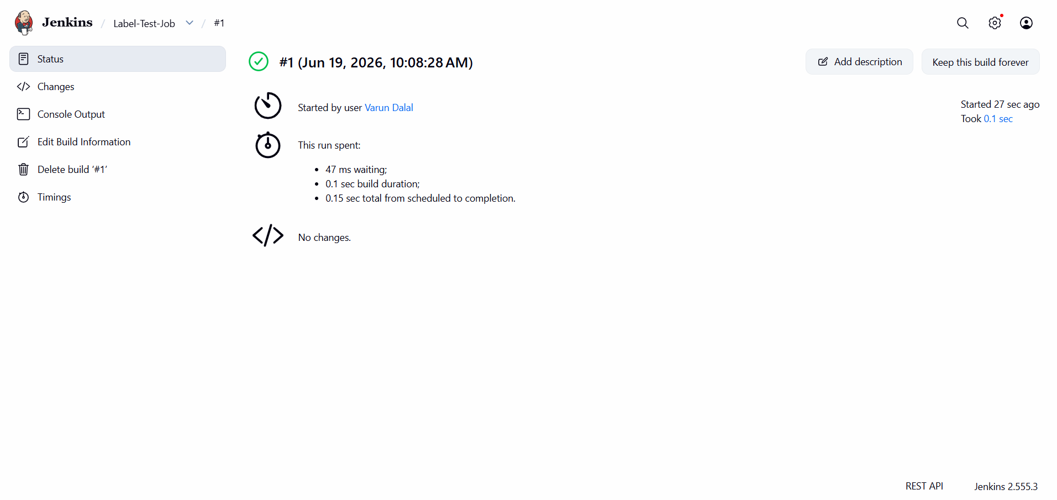

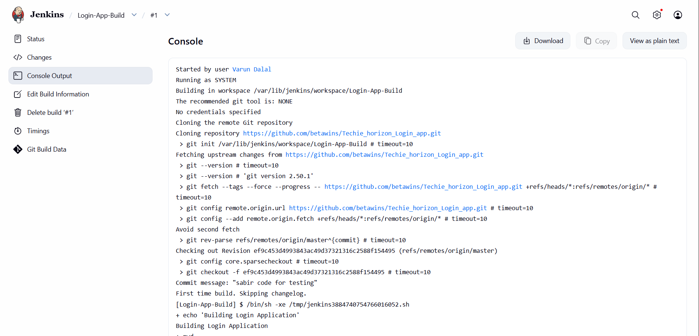
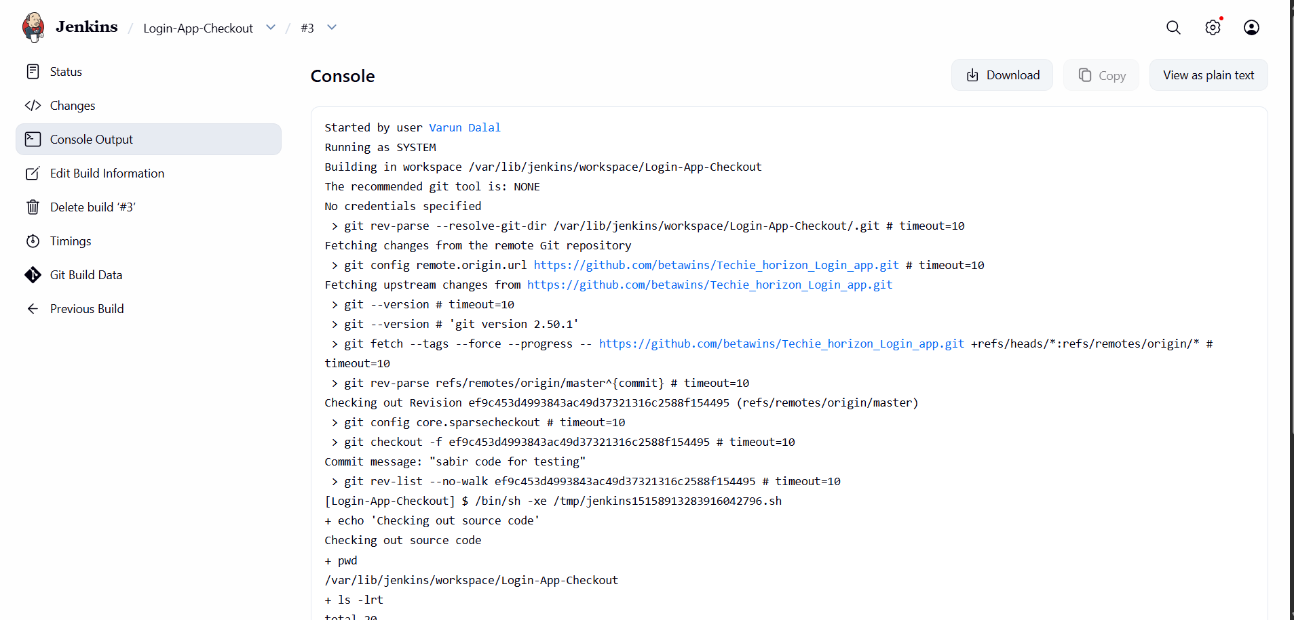
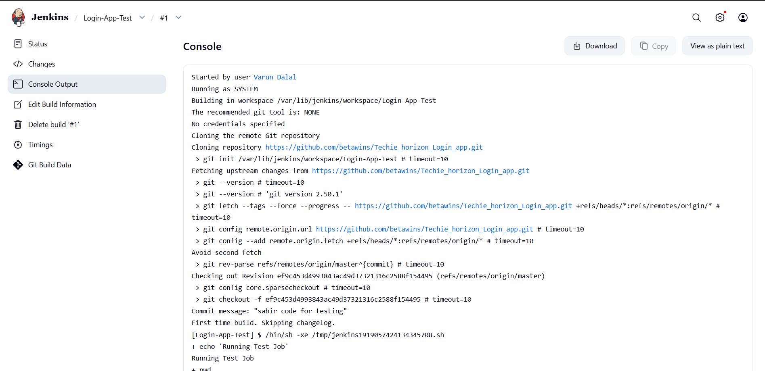
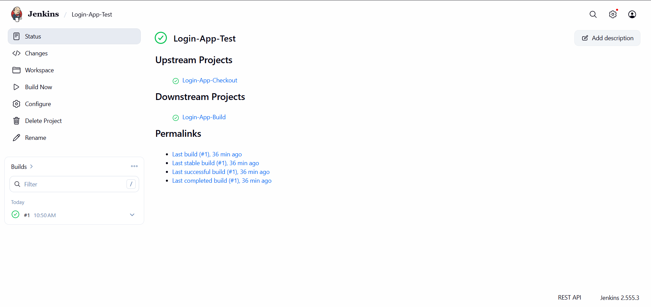
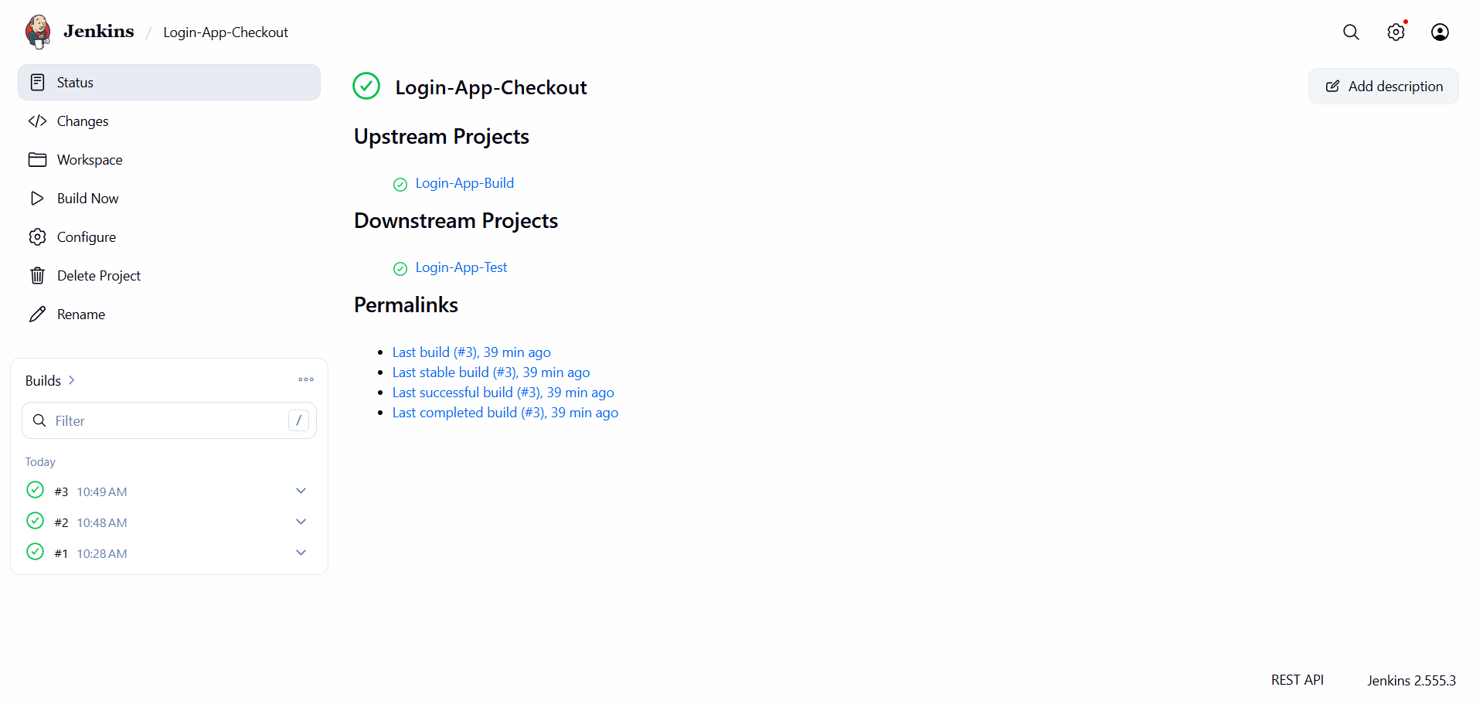
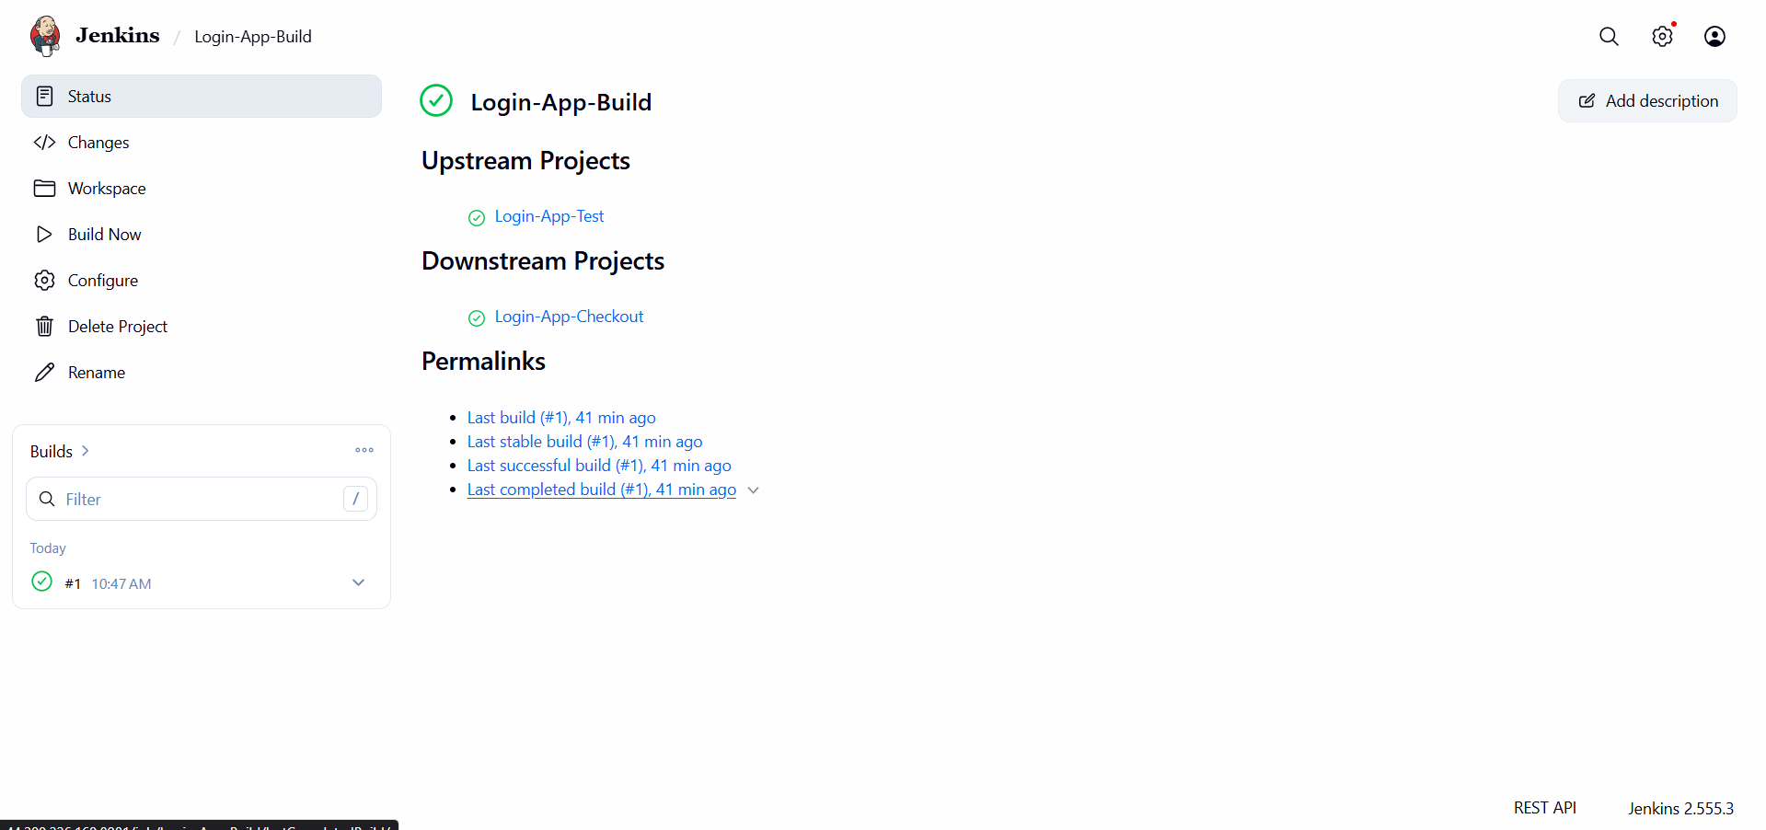

6.Task: Configure Jenkins Job for GitHub Private Repository Access
Objective
Configure a Jenkins job to access and build source code from a private GitHub repository using a GitHub Personal Access Token (PAT).

Problem Encountered
While building the Jenkins job, the following error was observed:
remote: Invalid username or token.
Password authentication is not supported for Git operations.
fatal: Authentication failed
Root Cause
The Jenkins job was unable to authenticate with the private GitHub repository because:
- Invalid GitHub Personal Access Token (PAT)
- Incorrect GitHub username
- Credentials not configured in Jenkins
- PAT missing required permissions
- Expired or revoked token

Step 1: Generate GitHub Personal Access Token (PAT)
- Log in to GitHub.
- Navigate to:
Profile → Settings → Developer Settings → Personal Access Tokens → Tokens (Classic)
- Click Generate New Token (Classic).
- Provide a token name:
Jenkins-Private-Repo-Access
- Select the following permissions:
repo
workflow (optional)
- Click Generate Token.
- Copy and save the generated token securely.
Result
A GitHub Personal Access Token is generated for repository authentication.

Step 2: Add GitHub Credentials in Jenkins
- Open Jenkins Dashboard.
- Navigate to:
Manage Jenkins → Credentials
- Select:
System → Global Credentials → Add Credentials
- Configure the credentials as follows:
Field | Value
Kind | Username with Password
Username | varundalal17-hash
Password | GitHub Personal Access Token
ID | github-private
Description | GitHub Private Repository Access
- Click Create.
Result
GitHub credentials are securely stored in Jenkins.

Step 3: Configure Jenkins Job
- Open the Jenkins Job.
- Click Configure.
- Under Source Code Management, select Git.
Repository URL
https://github.com/varundalal17-hash/Varun-Dalal-1.git
Credentials
Select:
github-private
from the credentials dropdown.
Branch Specifier
*/main
or
*/master
depending on the repository branch.
- Click Save.
Result
Jenkins is configured to authenticate and access the private repository.

Step 4: Verify Repository Access
Log in to the Jenkins EC2 instance and run:
git ls-remote https://github.com/varundalal17-hash/Varun-Dalal-1.git
When prompted:
Username: varundalal17-hash
Password: <GitHub Personal Access Token>
Result
Repository references are displayed successfully, confirming access.

Step 5: Build the Jenkins Job
- Open the Jenkins job.
- Click Build Now.
- Open Console Output.
Expected Output
Cloning the remote Git repository
Fetching upstream changes
Finished: SUCCESS
Result
Jenkins successfully clones the private repository and completes the build.

Verification Checklist
Verification Item | Status
GitHub PAT created | ✅
PAT includes repo permission | ✅
Jenkins credentials configured | ✅
Repository URL configured correctly | ✅
Credentials selected in Jenkins job | ✅
Build executed successfully | ✅
Console Output shows SUCCESS | ✅

Conclusion
Successfully configured Jenkins to access a private GitHub repository using a GitHub Personal Access Token (PAT). The Jenkins job authenticated with GitHub, cloned the repository, and completed the build successfully.
This format is suitable for project submission and training documentation.

