1.Create a Simple Pod Using YAML
Objective
Create a Kubernetes Pod named firstpod using a YAML file with an Nginx container. Verify the Pod creation and check the container logs.
Step 1: Create Pod YAML File
Create a file named firstpod.yaml and add the following configuration:
apiVersion: v1
kind: Pod
metadata:
name: firstpod
labels:
app: nginx
spec:
containers:
- name: nginx-container
image: nginx
ports:
- containerPort: 80
Step 2: Deploy the Pod
Apply the YAML file using the following command:
kubectl apply -f firstpod.yaml
Step 3: Verify Pod Creation
Check the status of the Pod:
kubectl get pods
Expected output:
NAME READY STATUS RESTARTS AGE
firstpod 1/1 Running 0 ...
Step 4: Check Container Logs
View the logs of the Nginx container using:
kubectl logs firstpod
Expected output will display Nginx startup logs, similar to:
/docker-entrypoint.sh: /docker-entrypoint.d/ is not empty, will attempt to perform configuration
/docker-entrypoint.sh: Configuration complete; ready for start up
Step 5: Delete the Pod (Optional)
To remove the Pod after completing the task:
kubectl delete pod firstpod
Result
A Pod named firstpod was successfully created with an Nginx container. The Pod status was verified using kubectl get pods, and the container logs were checked using kubectl logs firstpod.
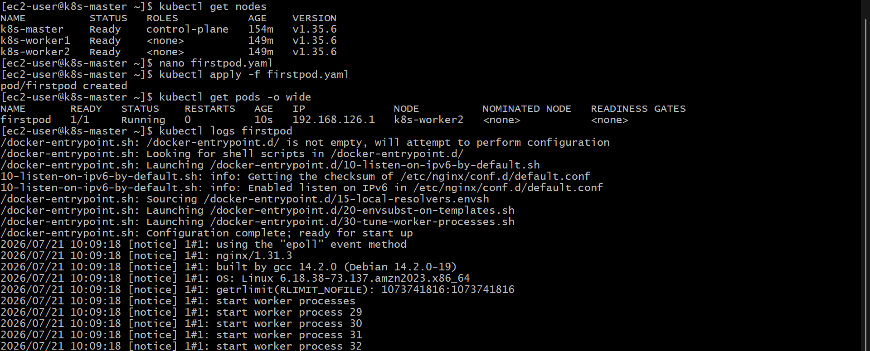

2.Set Environment Variables in a Kubernetes Pod
Objective
Create a Kubernetes Pod with custom environment variables, deploy it, and verify that the environment variables are correctly set inside the container.
Step 1: Create Pod YAML File
Create a file named pod-env.yaml and add the following configuration:
apiVersion: v1
kind: Pod
metadata:
name: env-demo-pod
labels:
app: env-demo
spec:
containers:
- name: env-container
image: nginx
env:
- name: myname
value: "sabair"
- name: City
value: "Hyderabad"
Step 2: Deploy the Pod
Apply the YAML file using the following command:
kubectl apply -f pod-env.yaml
Step 3: Check Pod Status
Verify that the Pod is running:
kubectl get pods
Expected output:
NAME READY STATUS RESTARTS AGE
env-demo-pod 1/1 Running 0 ...
Step 4: Check Environment Variables Inside the Pod
Run the following command to view the environment variables:
kubectl exec env-demo-pod -- env
Step 5: Verify the Output
The output should contain the following variables:
myname=sabair
City=Hyderabad
This confirms that the environment variables have been successfully configured and are available inside the Pod container.
Step 6: Delete the Pod (Optional)
To remove the Pod after testing:
kubectl delete pod env-demo-pod
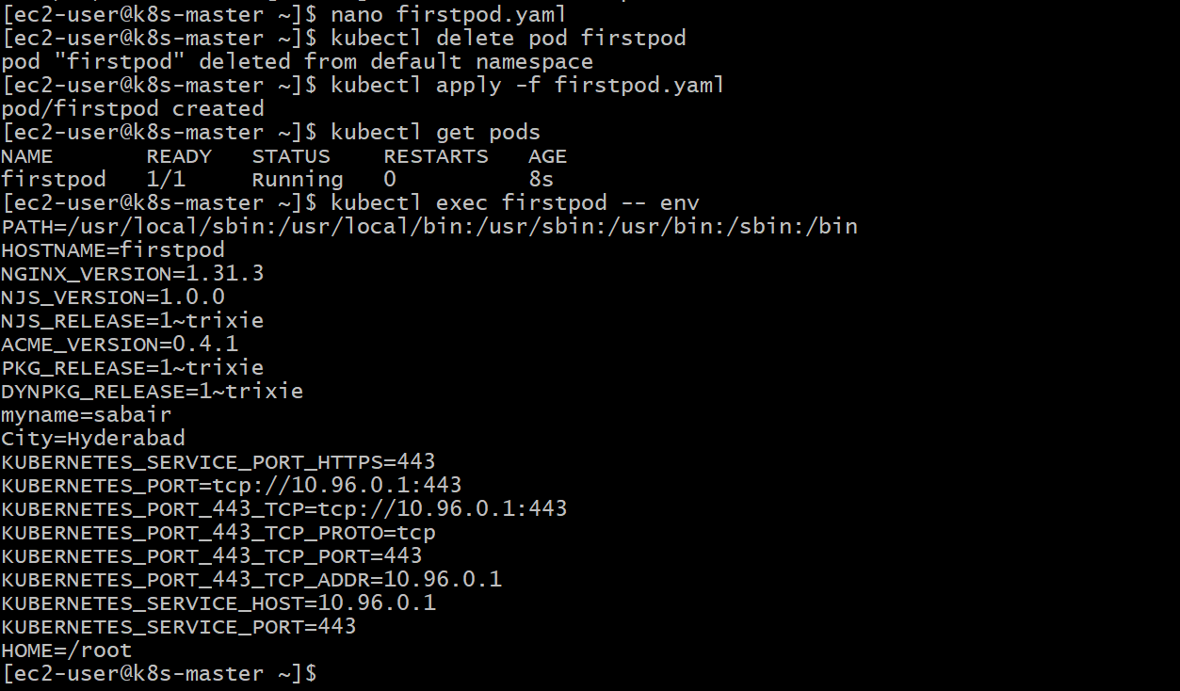

3.Deploy a Pod with Commands (Args) in YAML
Objective
Create a Kubernetes Pod using YAML with container arguments that instruct the container to sleep for 50 seconds. Deploy the Pod and verify that the arguments are correctly passed to the container.
Step 1: Create Pod YAML File
Create a file named pod-args.yaml and add the following configuration:
apiVersion: v1
kind: Pod
metadata:
name: sleep-pod
labels:
app: sleep
spec:
containers:
- name: sleep-container
image: busybox
args:
- "sleep"
- "50"
Step 2: Deploy the Pod
Apply the YAML file using the following command:
kubectl apply -f pod-args.yaml
Step 3: Verify Pod Status
Check whether the Pod is running:
kubectl get pods
Expected output:
NAME READY STATUS RESTARTS AGE
sleep-pod 1/1 Running 0 ...
Step 4: Verify Container Arguments
Use the following command to check the Pod details:
kubectl describe pod sleep-pod
In the output, verify the Args section:
Containers:
sleep-container:
Image: busybox
Args:
sleep
50
This confirms that the container received the argument to execute the sleep 50 command.
Step 5: Delete the Pod (Optional)
To remove the Pod after testing:
kubectl delete pod sleep-pod
Result
A Kubernetes Pod was successfully deployed with container arguments configured to run the sleep command for 50 seconds. The arguments were verified using kubectl describe pod.
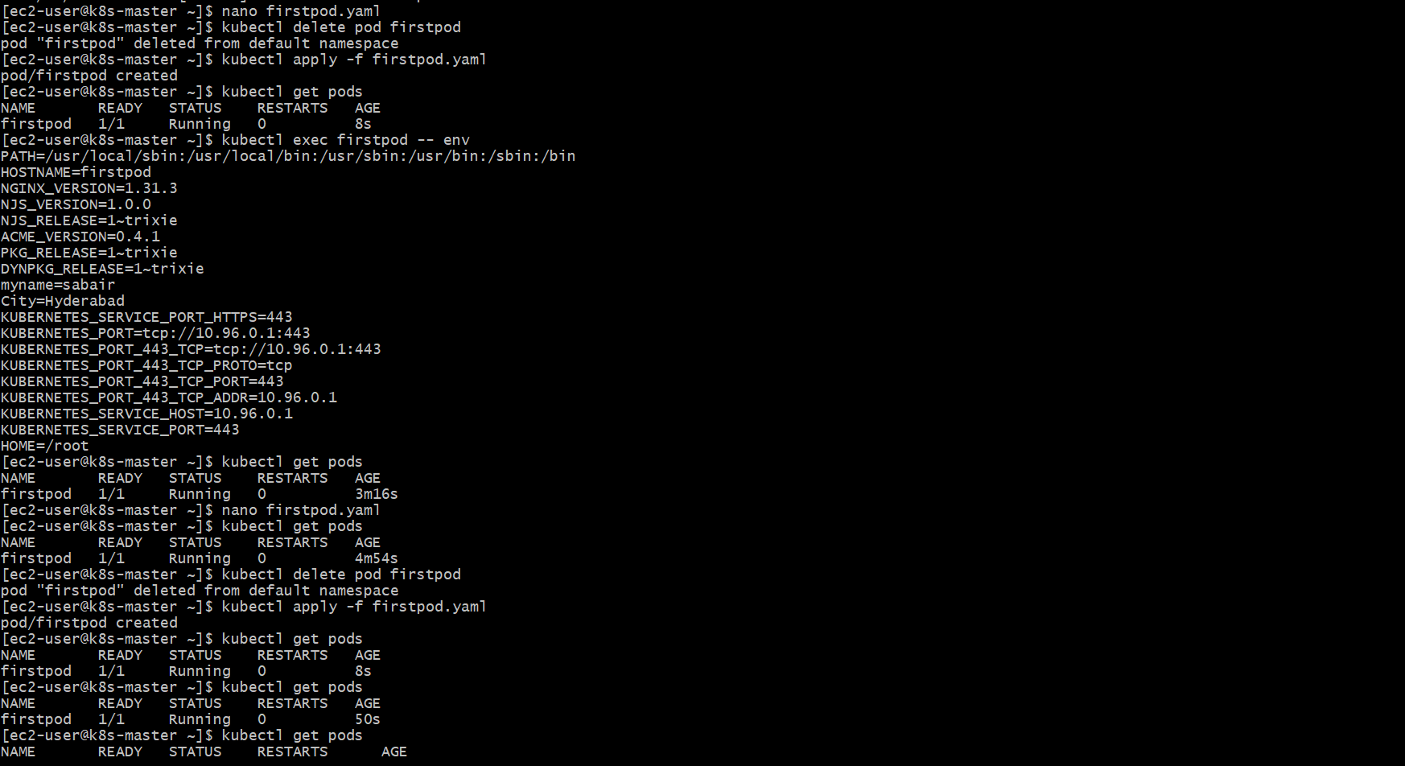

4.Create a Pod with Two Containers
Objective
Create a Kubernetes Pod containing two Nginx containers. Access both containers using kubectl exec and verify that both containers share the same network namespace and can communicate with each other.
Step 1: Create Pod YAML File
Create a file named two-container-pod.yaml and add the following configuration:
apiVersion: v1
kind: Pod
metadata:
name: two-nginx-pod
labels:
app: two-nginx
spec:
containers:
- name: nginx-container-1
image: nginx
ports:
- containerPort: 80

- name: nginx-container-2
image: nginx
ports:
- containerPort: 80
Step 2: Deploy the Pod
Apply the YAML file using the following command:
kubectl apply -f two-container-pod.yaml
Step 3: Verify Pod Creation
Check the Pod status:
kubectl get pods
Expected output:
NAME READY STATUS RESTARTS AGE
two-nginx-pod 2/2 Running 0 ...
The 2/2 READY status confirms that both containers are running successfully.
Step 4: Check Container Details
View the Pod details:
kubectl describe pod two-nginx-pod
Verify that both containers are listed:
Containers:
nginx-container-1
nginx-container-2
Step 5: Access the First Container
Open a shell inside the first container:
kubectl exec -it two-nginx-pod -c nginx-container-1 -- /bin/bash
Install curl (if required):
apt update
apt install curl -y
Test communication with the second container:
curl localhost
Expected output:
Welcome to nginx!
Step 6: Access the Second Container
Open a shell inside the second container:
kubectl exec -it two-nginx-pod -c nginx-container-2 -- /bin/bash
Run:
curl localhost
Expected output:
Welcome to nginx!
Step 7: Verify Shared Network
Both containers inside the same Pod share the same network namespace and IP address. Communication can be verified using:
kubectl exec two-nginx-pod -c nginx-container-1 -- hostname -i
and
kubectl exec two-nginx-pod -c nginx-container-2 -- hostname -i
Both commands should return the same IP address.
Result
A Kubernetes Pod with two Nginx containers was successfully created. Both containers were accessed using kubectl exec, and communication was verified through the shared Pod network namespace.
Step 8: Delete the Pod (Optional)
kubectl delete pod two-nginx-pod
You can paste this directly into your Kubernetes practical record or assignment.
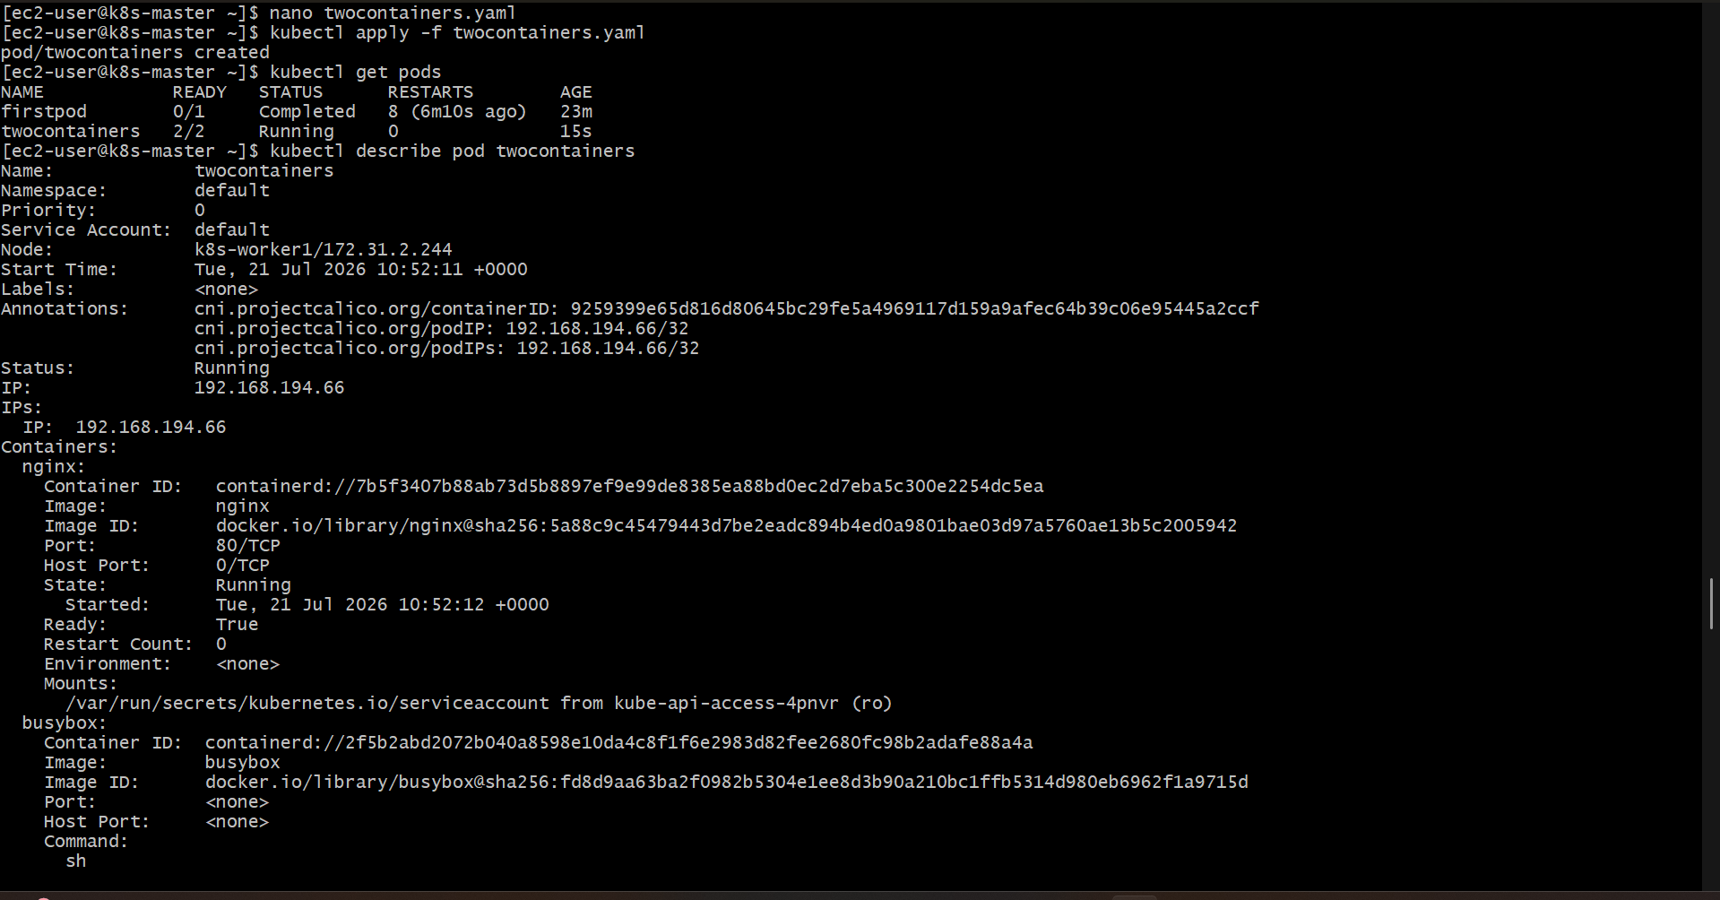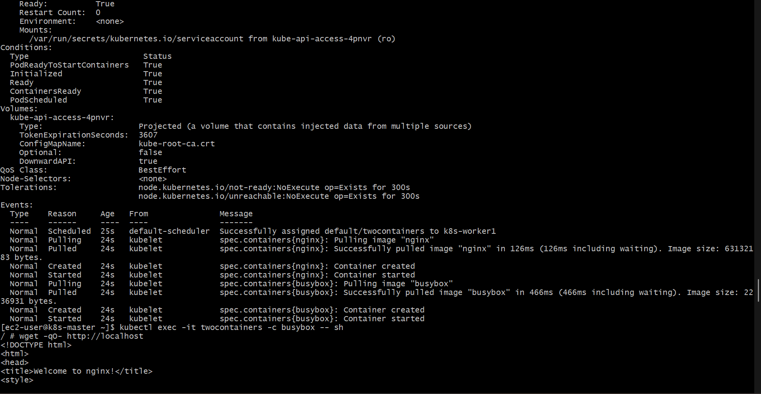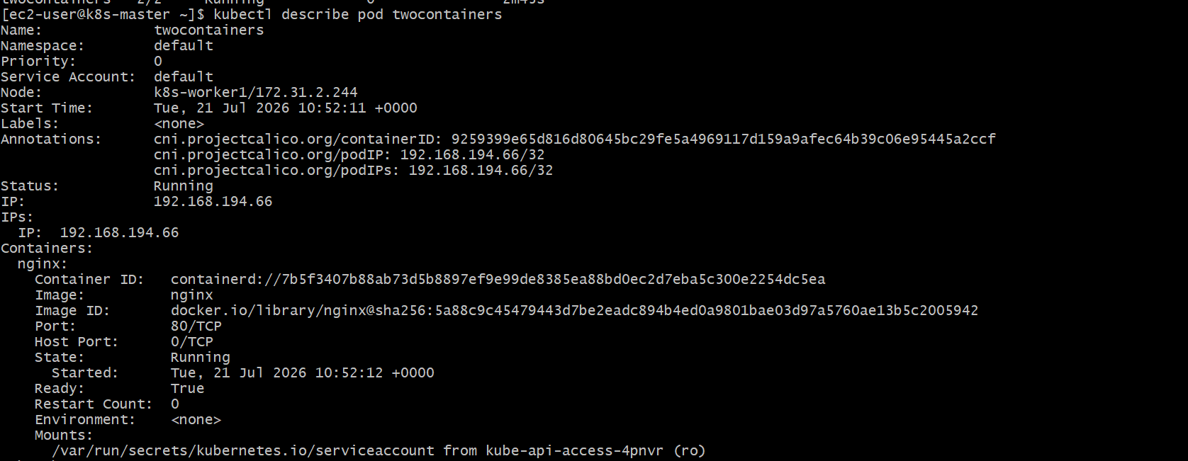

5.Set Up an Init Container in a Pod
Objective
Create a Kubernetes Pod with an init container that sleeps for 30 seconds before the main container starts. Deploy the Pod and verify the init container's execution using kubectl describe pod and kubectl logs.
Step 1: Create Pod YAML File
Create a file named init-container-pod.yaml and add the following configuration:
apiVersion: v1
kind: Pod
metadata:
name: init-demo-pod
labels:
app: init-demo
spec:
initContainers:
- name: init-sleep
image: busybox
command: ["sh", "-c", "echo 'Init container started'; sleep 30; echo 'Init container completed'"]

containers:
- name: nginx-container
image: nginx
ports:
- containerPort: 80
Step 2: Deploy the Pod
Apply the YAML file:
kubectl apply -f init-container-pod.yaml
Step 3: Verify Pod Status
Check the Pod status:
kubectl get pods
Expected output while the init container is running:
NAME READY STATUS RESTARTS AGE
init-demo-pod 0/1 Init:0/1 0 ...
After approximately 30 seconds:
NAME READY STATUS RESTARTS AGE
init-demo-pod 1/1 Running 0 ...
Step 4: Verify Init Container Execution
Describe the Pod:
kubectl describe pod init-demo-pod
In the output, verify the Init Containers section:
Init Containers:
init-sleep:
State: Terminated
Reason: Completed
This confirms that the init container completed successfully before the main container started.
Step 5: Check Init Container Logs
View the logs of the init container:
kubectl logs init-demo-pod -c init-sleep
Expected output:
Init container started
Init container completed
Step 6: Verify Main Container
Confirm that the main container is running:
kubectl get pods
Expected output:
NAME READY STATUS RESTARTS AGE
init-demo-pod 1/1 Running 0 ...
Step 7: Delete the Pod (Optional)
kubectl delete pod init-demo-pod
Result
A Kubernetes Pod was successfully created with an init container that delayed the startup of the main container by 30 seconds. The init container execution was verified using kubectl describe pod, and its successful completion was confirmed through kubectl logs.
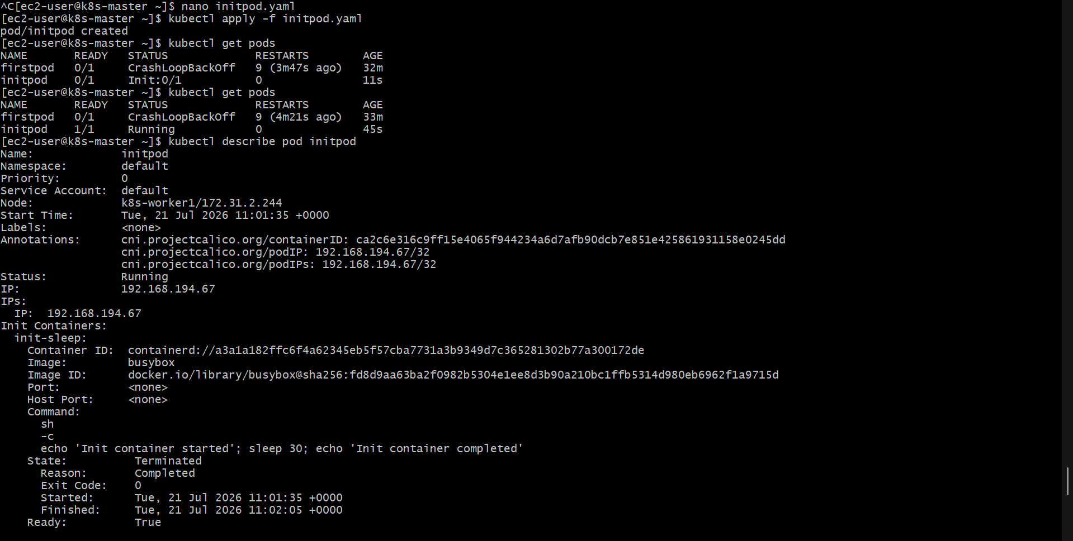
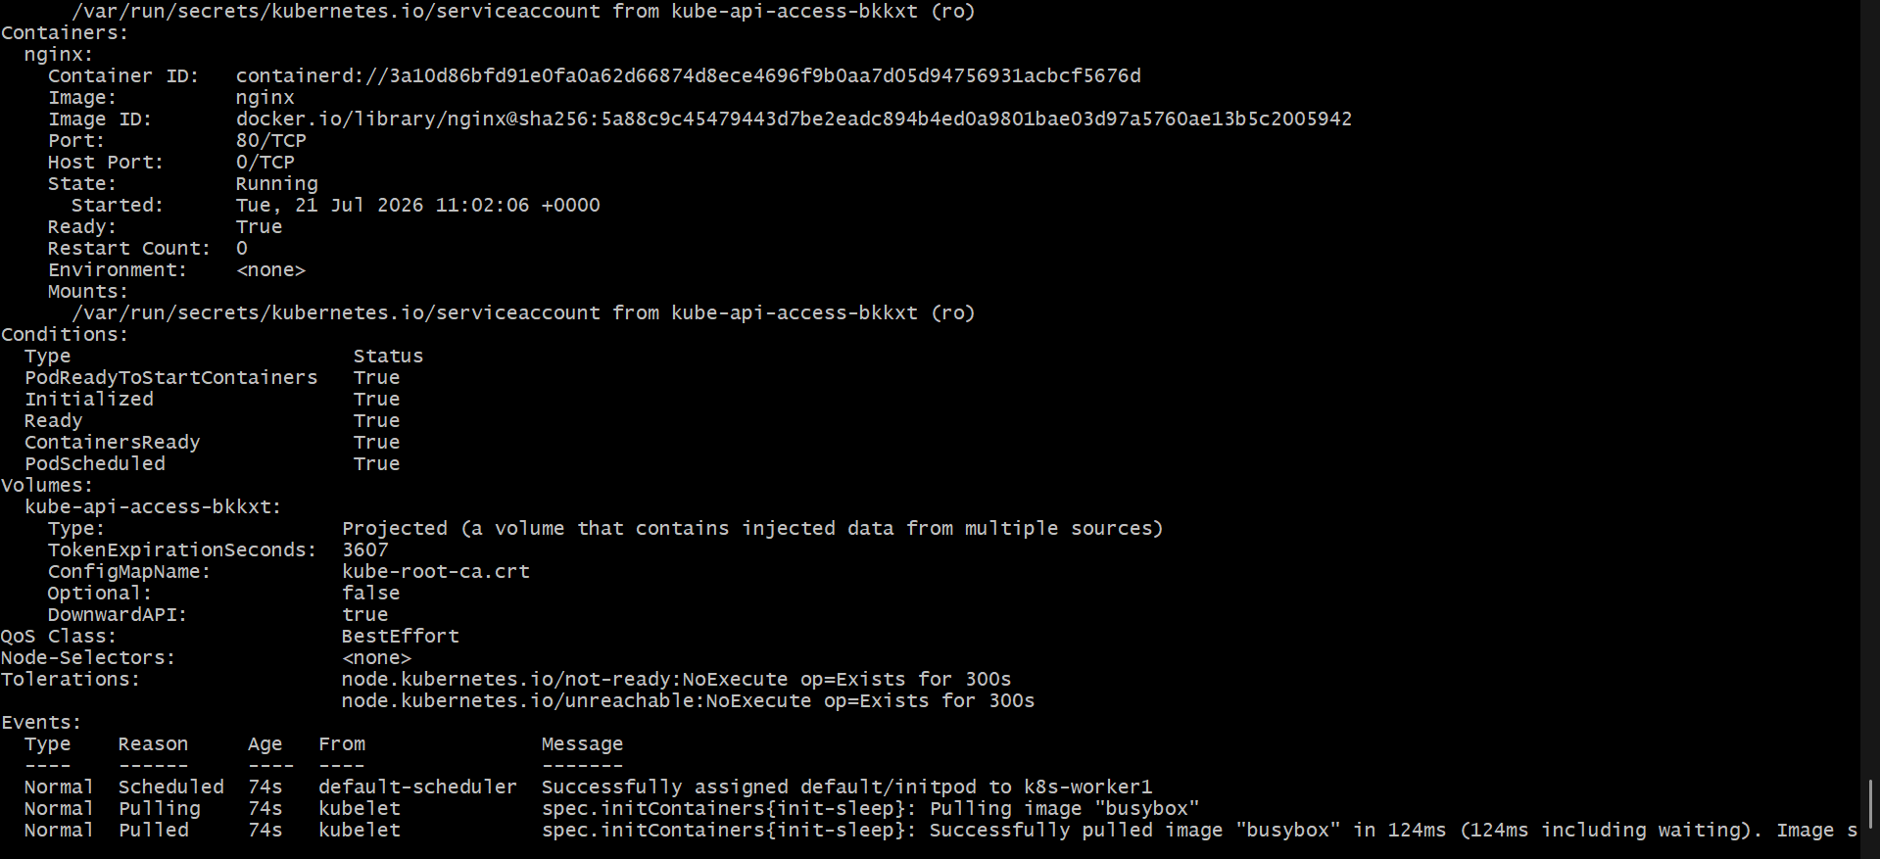
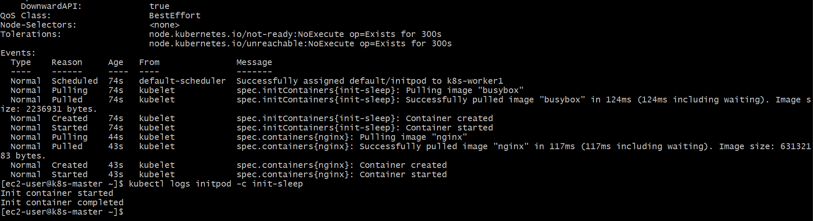

6. Run a Dry Run Command to Generate YAML
Objective
Generate a Pod YAML definition using the kubectl run command with the --dry-run=client -o yaml option. Modify the generated YAML by adding labels and environment variables, then deploy the Pod.
Step 1: Generate the YAML File
Run the following command to generate the Pod YAML without creating the Pod:
kubectl run nginx --image=nginx --dry-run=client -o yaml > nginx-pod.yaml
This command creates a file named nginx-pod.yaml.
Step 2: Modify the Generated YAML
Edit the nginx-pod.yaml file and update it as shown below:
apiVersion: v1
kind: Pod
metadata:
name: nginx
labels:
app: nginx
environment: development
spec:
containers:
- name: nginx
image: nginx
env:
- name: myname
value: "sabair"
- name: City
value: "Hyderabad"
ports:
- containerPort: 80
Step 3: Deploy the Pod
Apply the modified YAML file:
kubectl apply -f nginx-pod.yaml
Step 4: Verify Pod Creation
Check the Pod status:
kubectl get pods
Expected output:
NAME READY STATUS RESTARTS AGE
nginx 1/1 Running 0 ...
Step 5: Verify Labels
Display the labels assigned to the Pod:
kubectl get pod nginx --show-labels
Expected output:
NAME READY STATUS RESTARTS AGE LABELS
nginx 1/1 Running 0 ... app=nginx,environment=development
Step 6: Verify Environment Variables
Check that the environment variables are set inside the container:
kubectl exec nginx -- env
Expected output includes:
myname=sabair
City=Hyderabad
Step 7: Delete the Pod (Optional)
kubectl delete pod nginx
Result
A Pod YAML definition was successfully generated using the kubectl run --dry-run=client -o yaml command. The YAML was modified by adding custom labels and environment variables, deployed successfully, and verified using kubectl get pods, kubectl get pod --show-labels, and kubectl exec -- env.
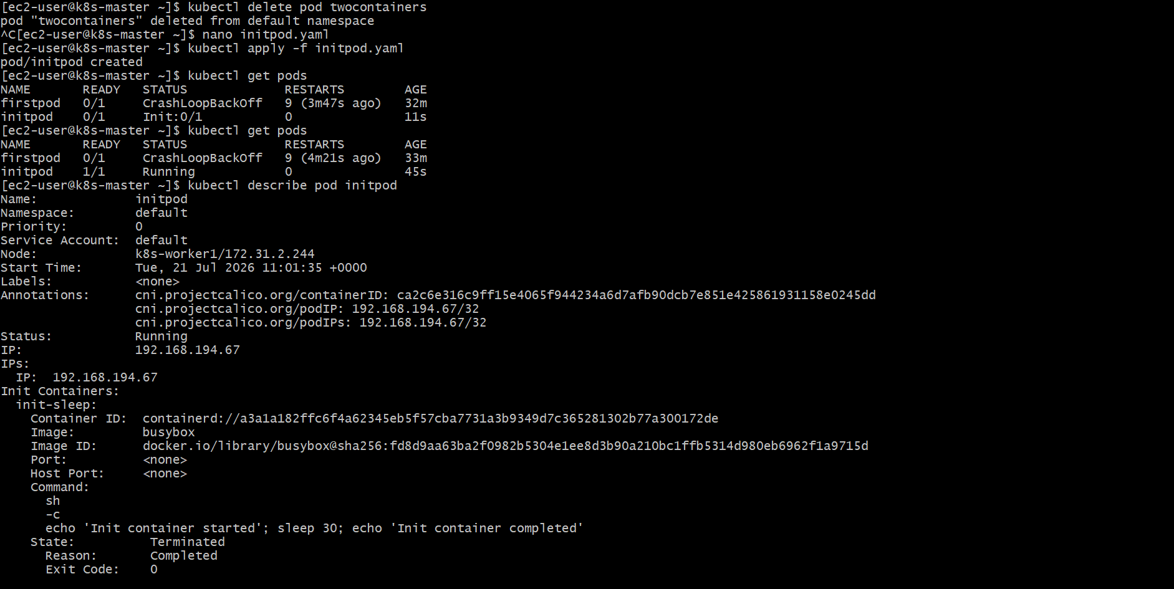
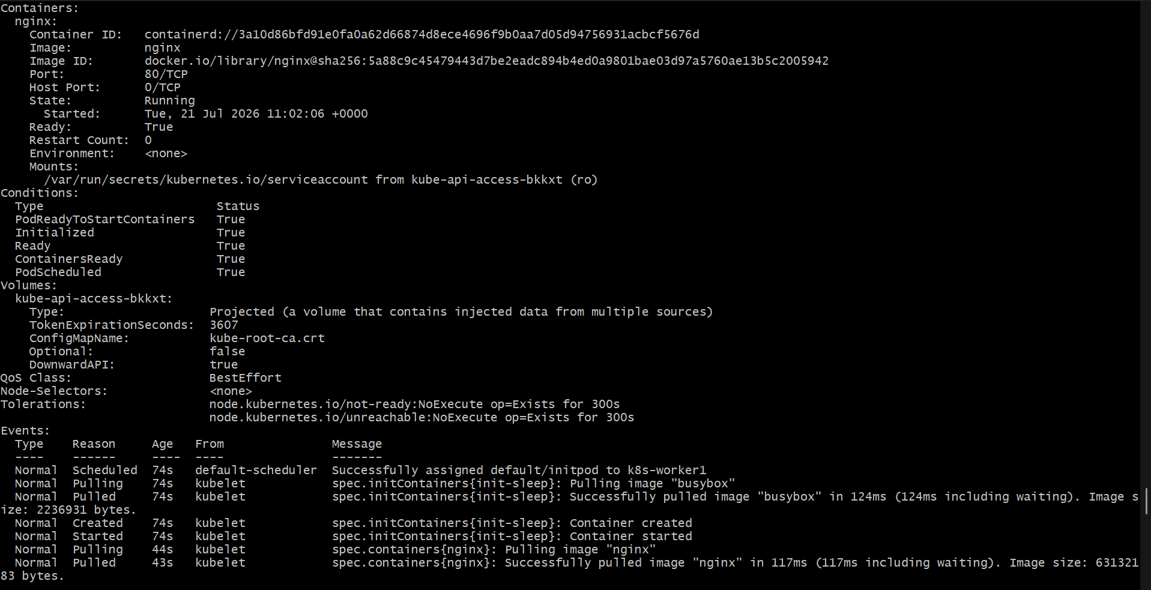
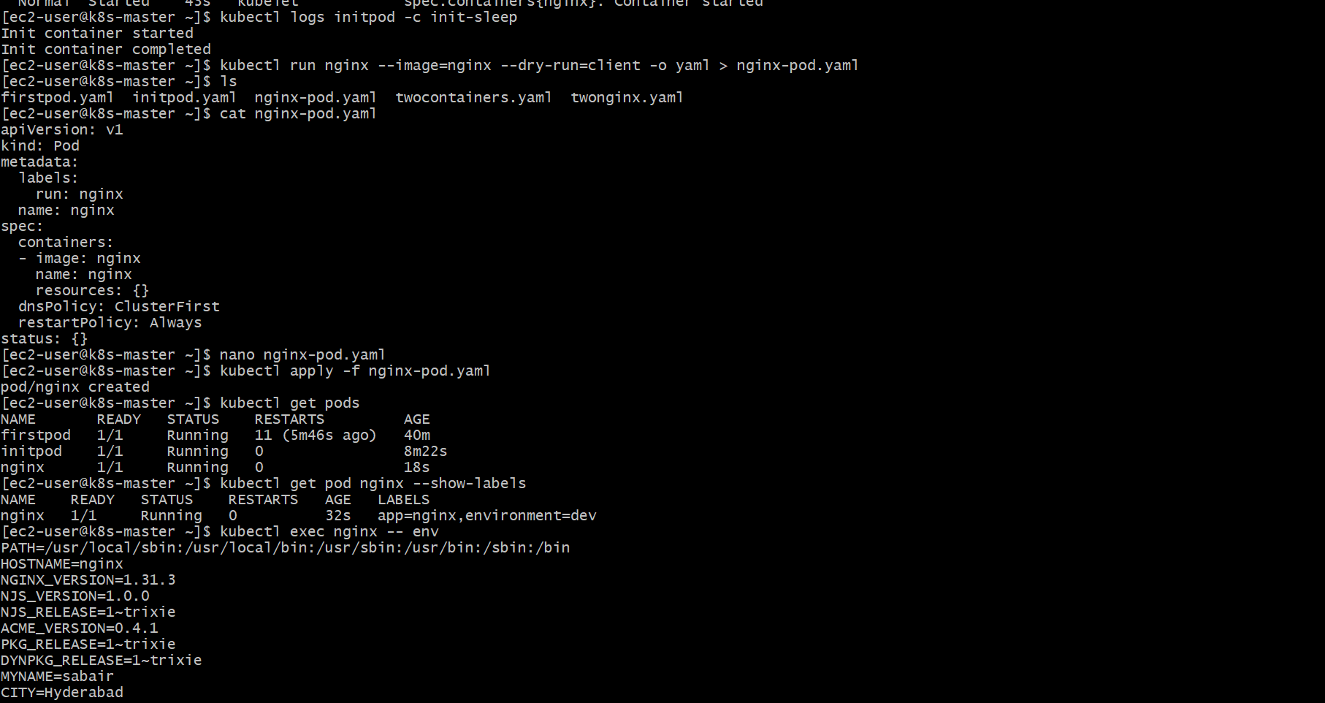
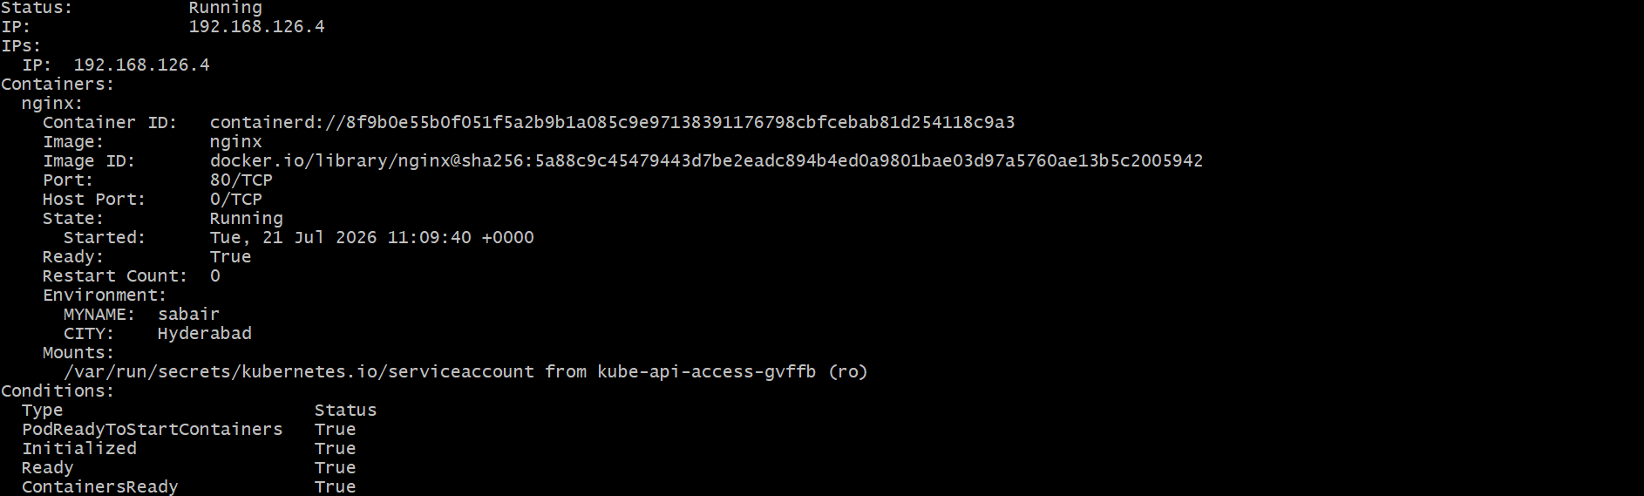

7. Use kubectl apply vs kubectl create
Objective
Create a Kubernetes Pod using a YAML file. Deploy it first using kubectl create -f, then modify the YAML file and redeploy it using kubectl apply -f. Understand the difference between kubectl create and kubectl apply.
Step 1: Create Pod YAML File
Create a file named pod-create-apply.yaml and add the following configuration:
apiVersion: v1
kind: Pod
metadata:
name: create-apply-pod
labels:
app: nginx
spec:
containers:
- name: nginx-container
image: nginx:1.24
ports:
- containerPort: 80
Step 2: Deploy Using kubectl create
Create the Pod using:
kubectl create -f pod-create-apply.yaml
Verify the Pod creation:
kubectl get pods
Expected output:
NAME READY STATUS RESTARTS AGE
create-apply-pod 1/1 Running 0 ...
Step 3: Check Current Image Version
Verify the image used by the Pod:
kubectl describe pod create-apply-pod
Output:
Containers:
nginx-container:
Image: nginx:1.24
Step 4: Modify the YAML File
Edit pod-create-apply.yaml and change the image version:
Before:
image: nginx:1.24
After:
image: nginx:1.25
Updated YAML:
apiVersion: v1
kind: Pod
metadata:
name: create-apply-pod
labels:
app: nginx
spec:
containers:
- name: nginx-container
image: nginx:1.25
ports:
- containerPort: 80
Step 5: Redeploy Using kubectl apply
Apply the modified YAML:
kubectl apply -f pod-create-apply.yaml
Step 6: Verify the Change
Check the Pod details:
kubectl describe pod create-apply-pod
Verify the updated image:
Containers:
nginx-container:
Image: nginx:1.25
Step 7: Compare kubectl create and kubectl apply
kubectl create
Command:
kubectl create -f pod-create-apply.yaml
- Creates the Kubernetes resource for the first time.
- If the resource already exists, it returns an error.
- It does not manage future changes to the YAML file.
Example:
Error from server (AlreadyExists): pods "create-apply-pod" already exists
kubectl apply
Command:
kubectl apply -f pod-create-apply.yaml
- Creates the resource if it does not exist.
- Updates the existing resource with changes from the YAML file.
- Maintains the desired configuration state.
Example:
pod/create-apply-pod configured
Step 8: Delete the Pod (Optional)
kubectl delete pod create-apply-pod
Result
A Kubernetes Pod was created using kubectl create -f. After modifying the YAML file, the updated configuration was applied using kubectl apply -f. The image version change was verified using kubectl describe pod, demonstrating that kubectl apply is used for managing updates to existing resources.
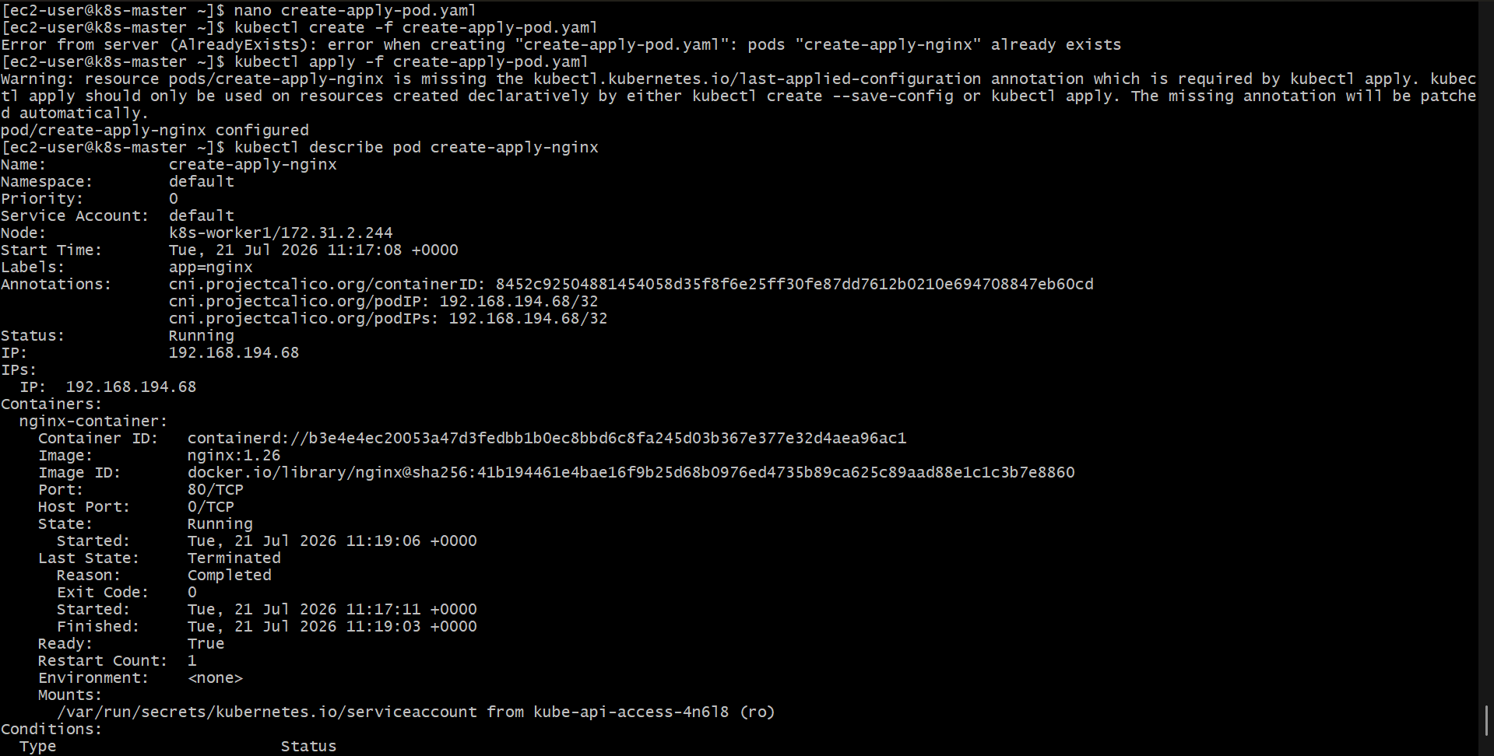
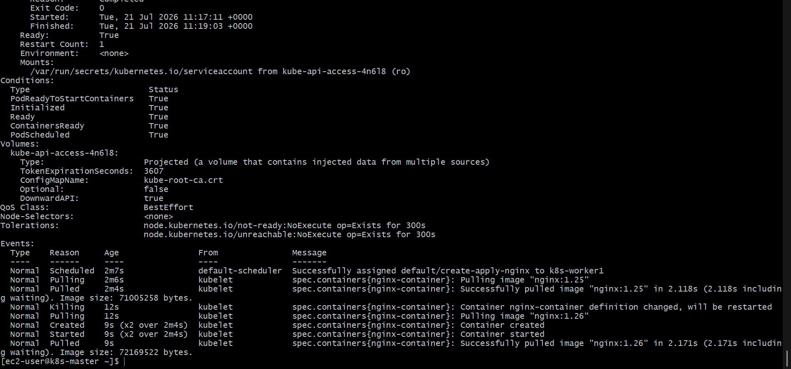
8. Edit an Existing Pod Configuration
Objective
Modify an existing running Pod configuration using kubectl edit pod <pod_name>. Update the container image or environment variables and verify the changes using kubectl exec.
Step 1: Create a Pod YAML File
Create a file named edit-pod.yaml with the following configuration:
apiVersion: v1
kind: Pod
metadata:
name: edit-demo-pod
labels:
app: nginx
spec:
containers:
- name: nginx-container
image: nginx:1.24
env:
- name: myname
value: "sabair"
- name: City
value: "Hyderabad"
ports:
- containerPort: 80
Step 2: Deploy the Pod
Create the Pod using:
kubectl apply -f edit-pod.yaml
Verify that the Pod is running:
kubectl get pods
Expected output:
NAME READY STATUS RESTARTS AGE
edit-demo-pod 1/1 Running 0 ...
Step 3: Edit the Running Pod Configuration
Use the following command to edit the Pod:
kubectl edit pod edit-demo-pod
The YAML configuration will open in the default editor.
Modify the environment variable value:
Before:
env:
- name: City
value: "Hyderabad"
After:
env:
- name: City
value: "Bangalore"
Save and exit the editor.
Step 4: Verify the Changes
Check the Pod details:
kubectl describe pod edit-demo-pod
Verify the updated configuration.
Step 5: Check Environment Variables
Access the container:
kubectl exec -it edit-demo-pod -- /bin/bash
Run:
env
Verify the updated variable:
myname=sabair
City=Bangalore
Step 6: Verify Container Image
Check the image used by the container:
kubectl describe pod edit-demo-pod
Expected output:
Containers:
nginx-container:
Image: nginx:1.24
Note
Some Pod fields, such as container images and environment variables, cannot always be modified directly on an existing Pod because Pods are mostly immutable. If Kubernetes rejects the change, delete and recreate the Pod with the updated YAML file:
kubectl delete pod edit-demo-pod
kubectl apply -f edit-pod.yaml
Result
The running Pod configuration was edited using kubectl edit pod. The updated environment variables or container configuration were verified using kubectl describe and kubectl exec.
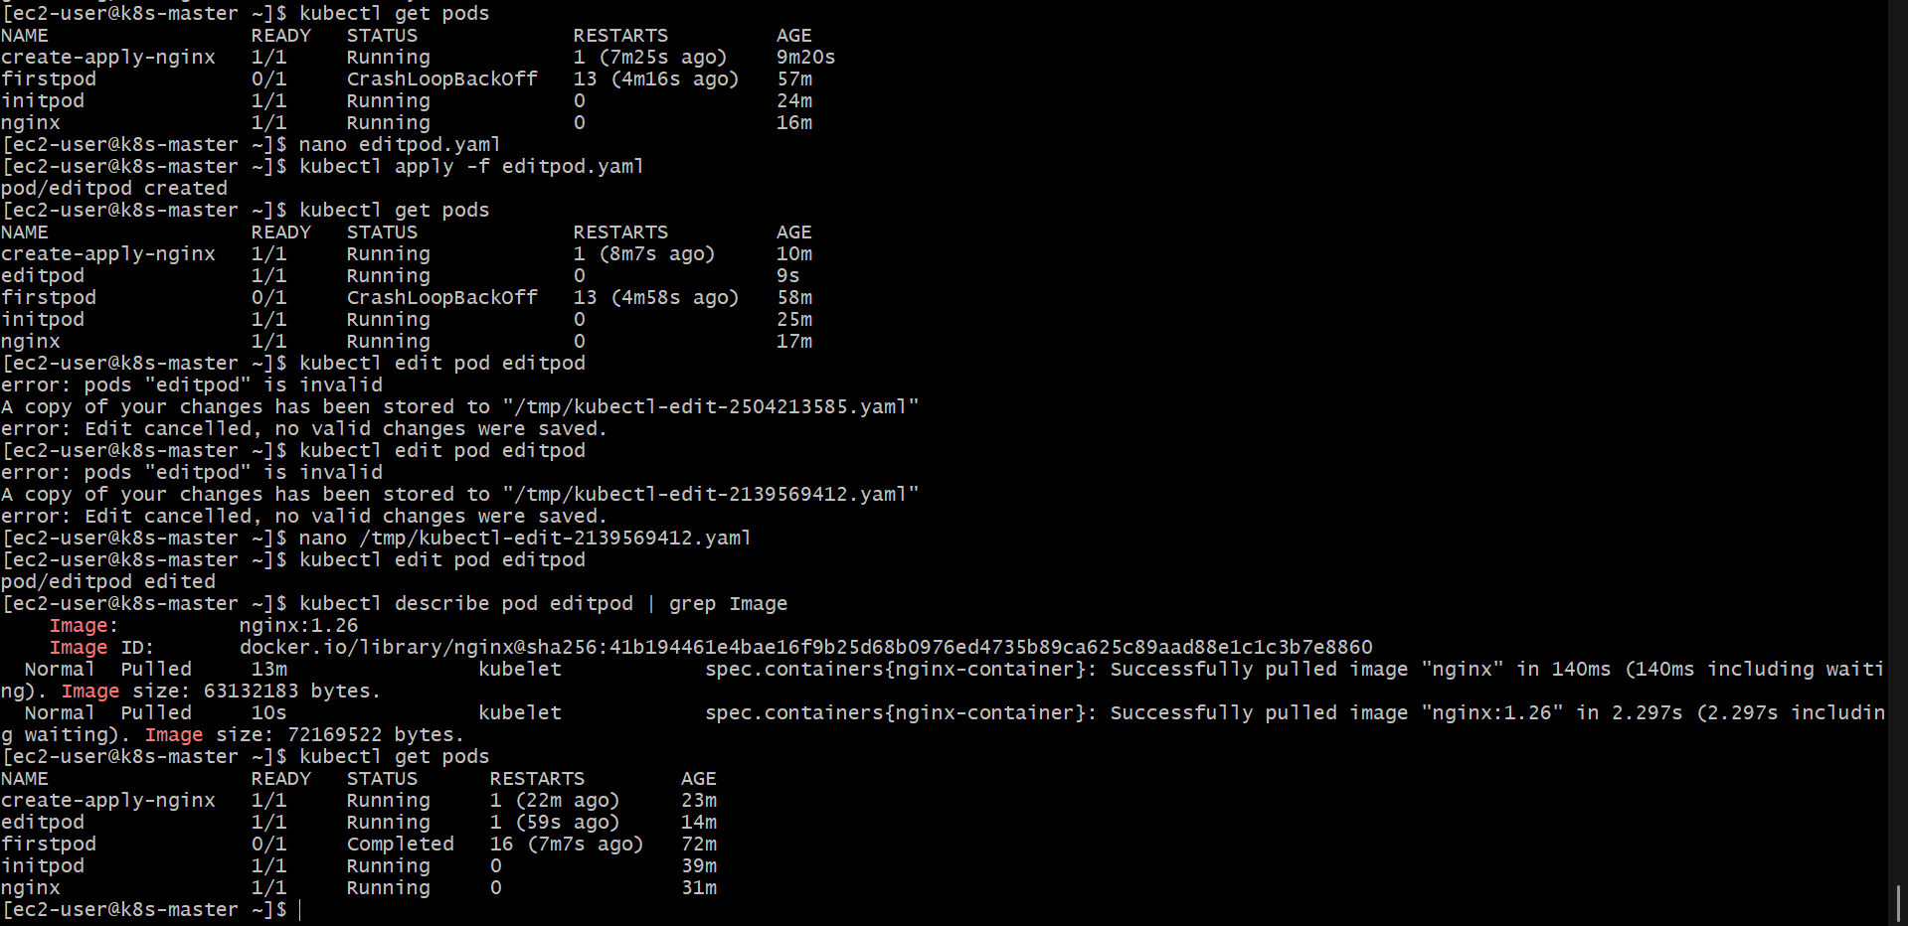

9. Expose a Pod Using a Service (ClusterIP)
Objective
Create a Kubernetes Service of type ClusterIP to expose the existing firstpod on port 80. Verify the Service creation using kubectl get svc.
Step 1: Create Pod YAML File (If Not Already Created)
Create a file named firstpod.yaml:
apiVersion: v1
kind: Pod
metadata:
name: firstpod
labels:
app: nginx
spec:
containers:
- name: nginx-container
image: nginx
ports:
- containerPort: 80
Deploy the Pod:
kubectl apply -f firstpod.yaml
Verify the Pod is running:
kubectl get pods
Expected output:
NAME READY STATUS RESTARTS AGE
firstpod 1/1 Running 0 ...
Step 2: Create Service YAML File
Create a file named firstpod-service.yaml and add the following configuration:
apiVersion: v1
kind: Service
metadata:
name: firstpod-service
spec:
selector:
app: nginx
ports:
- protocol: TCP
port: 80
targetPort: 80
type: ClusterIP
Step 3: Deploy the Service
Apply the Service YAML file:
kubectl apply -f firstpod-service.yaml
Step 4: Verify the Service
Check the created Service:
kubectl get svc
Expected output:
NAME TYPE CLUSTER-IP EXTERNAL-IP PORT(S) AGE
firstpod-service ClusterIP 10.x.x.x <none> 80/TCP ...
Step 5: Describe the Service
To view detailed Service information:
kubectl describe svc firstpod-service
Verify the following details:
Type: ClusterIP
Port: 80/TCP
TargetPort: 80
Selector: app=nginx
Step 6: Test Service Connectivity (Optional)
Run a temporary Pod inside the cluster:
kubectl run test-pod --image=busybox --rm -it -- sh
Access the Service:
wget -qO- firstpod-service
Expected output:
Welcome to nginx!
Step 7: Delete Resources (Optional)
Delete the Service:
kubectl delete svc firstpod-service
Delete the Pod:
kubectl delete pod firstpod
Result
A ClusterIP Service was successfully created to expose firstpod on port 80. The Service was verified using kubectl get svc, and connectivity was tested within the Kubernetes cluster.
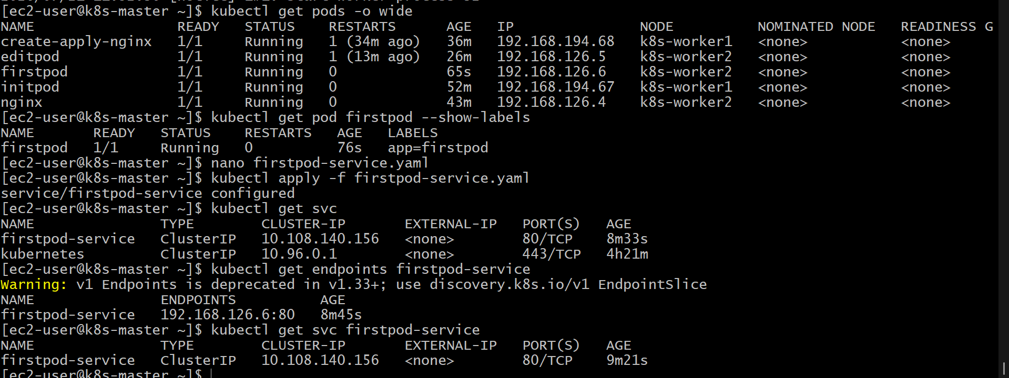

10. Pod with Resource Limits and Requests
Objective
Create a Kubernetes Pod with containers that have CPU and memory resource requests and limits. Deploy the Pod and verify the resource configurations using kubectl describe pod.
Step 1: Create Pod YAML File
Create a file named resource-pod.yaml and add the following configuration:
apiVersion: v1
kind: Pod
metadata:
name: resource-demo-pod
labels:
app: nginx
spec:
containers:
- name: nginx-container-1
image: nginx
resources:
requests:
cpu: "250m"
memory: "256Mi"
limits:
cpu: "500m"
memory: "512Mi"
ports:
- containerPort: 80

- name: nginx-container-2
image: nginx
resources:
requests:
cpu: "200m"
memory: "128Mi"
limits:
cpu: "400m"
memory: "256Mi"
ports:
- containerPort: 80
Step 2: Deploy the Pod
Apply the YAML file:
kubectl apply -f resource-pod.yaml
Step 3: Verify Pod Status
Check whether the Pod is running:
kubectl get pods
Expected output:
NAME READY STATUS RESTARTS AGE
resource-demo-pod 2/2 Running 0 ...
Step 4: Verify Resource Requests and Limits
Use the following command to view Pod details:
kubectl describe pod resource-demo-pod
Check the Limits and Requests section:
Expected output:
Containers:
nginx-container-1:
Limits:
cpu: 500m
memory: 512Mi
Requests:
cpu: 250m
memory: 256Mi

nginx-container-2:
Limits:
cpu: 400m
memory: 256Mi
Requests:
cpu: 200m
memory: 128Mi
Step 5: Check Resource Usage (Optional)
If Metrics Server is installed, check current resource usage:
kubectl top pod resource-demo-pod
Example output:
NAME CPU(cores) MEMORY(bytes)
resource-demo-pod 10m 20Mi
Step 6: Delete the Pod (Optional)
kubectl delete pod resource-demo-pod
Result
A Kubernetes Pod with two Nginx containers was successfully created with defined CPU and memory resource requests and limits. The configurations were verified using kubectl describe pod.
