Creating a ClusterIP Service for an Apache Web Server Pod in Kubernetes
Step 1: Create an Apache Deployment
First, create a deployment that runs an Apache web server pod.
Create a file named apache-deployment.yaml:
apiVersion: apps/v1
kind: Deployment
metadata:
name: apache-deployment
labels:
app: apache
spec:
replicas: 1
selector:
matchLabels:
app: apache
template:
metadata:
labels:
app: apache
spec:
containers:
- name: apache
image: httpd:latest
ports:
- containerPort: 80
Apply the deployment:
kubectl apply -f apache-deployment.yaml
Verify that the Apache pod is running:
kubectl get pods
Expected output:
NAME READY STATUS RESTARTS AGE
apache-deployment-xxxxxxxxxx-xxxxx 1/1 Running 0 30s

Step 2: Create a ClusterIP Service
A ClusterIP service provides internal access to the Apache pod inside the Kubernetes cluster.
Create a file named apache-service.yaml:
apiVersion: v1
kind: Service
metadata:
name: apache-service
spec:
type: ClusterIP
selector:
app: apache
ports:
- protocol: TCP
port: 80
targetPort: 80
Apply the service:
kubectl apply -f apache-service.yaml

Step 3: Verify the ClusterIP Service
Check the created service:
kubectl get services
Example output:
NAME TYPE CLUSTER-IP EXTERNAL-IP PORT(S) AGE
apache-service ClusterIP 10.96.45.120 <none> 80/TCP 10s
The CLUSTER-IP address is accessible only within the Kubernetes cluster.

Step 4: Describe the Service
To view detailed information about the service:
kubectl describe service apache-service
Example output:
Name: apache-service
Type: ClusterIP
IP: 10.96.45.120
Port: 80/TCP
TargetPort: 80/TCP
Endpoints: <apache-pod-ip>:80
Selector: app=apache

Step 5: Test the ClusterIP Service
Create a temporary test pod inside the cluster:
kubectl run test-pod --image=busybox --restart=Never -- sleep 3600
Access the Apache service from the test pod:
kubectl exec -it test-pod -- wget -qO- http://apache-service
Expected output:
<html>
<head>
<title>Test Page for the Apache HTTP Server</title>
</head>
<body>
...
</body>
</html>
This confirms that the Apache web server is accessible through the ClusterIP service.

Step 6: Delete Test Resources (Optional)
Remove the temporary test pod:
kubectl delete pod test-pod
Remove the Apache deployment and service:
kubectl delete -f apache-deployment.yaml
kubectl delete -f apache-service.yaml

Summary
- A Deployment was created to run an Apache web server pod.
- A ClusterIP Service was created to provide internal communication to the Apache pod.
- The service routes traffic from port 80 of the ClusterIP to port 80 of the Apache container.
- The service can only be accessed by resources inside the Kubernetes cluster.
You can paste this directly into your documentation. If you need it in a lab manual format with Objective, Prerequisites, Commands, Output, and Result sections, I can convert it as well.
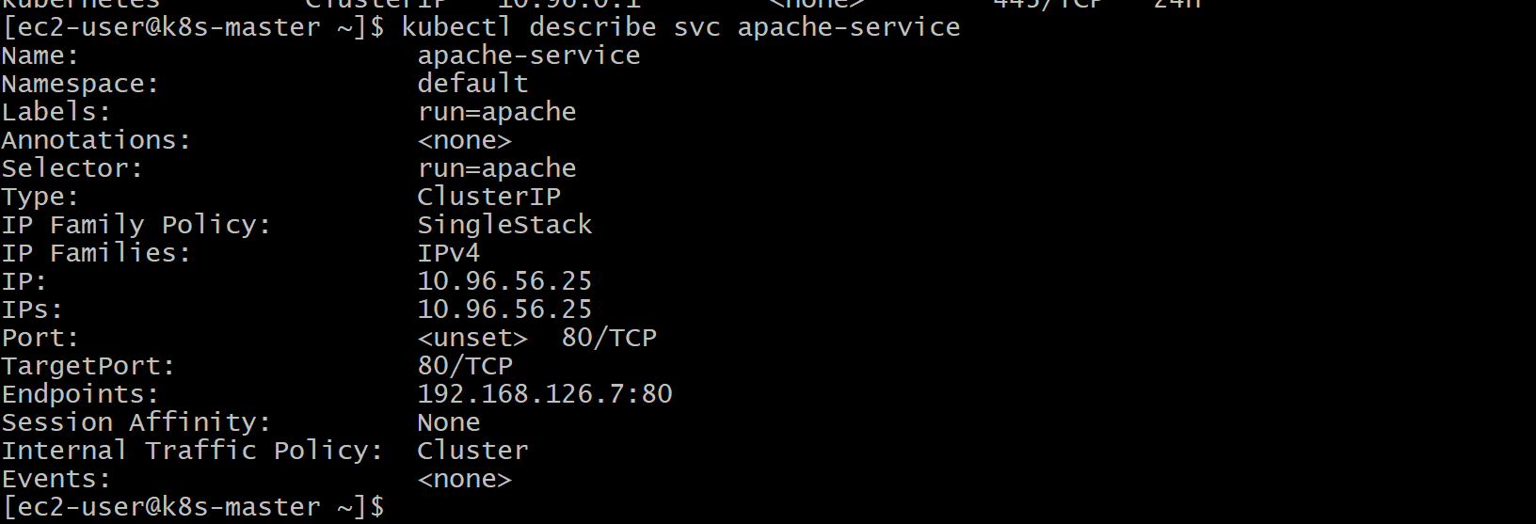
Exposing an Nginx Pod Externally Using a NodePort Service in Kubernetes
Objective
To deploy an Nginx web server pod and expose it externally using a Kubernetes NodePort service.

Step 1: Create an Nginx Deployment
First, create a deployment to run an Nginx pod.
Create a file named nginx-deployment.yaml:
apiVersion: apps/v1
kind: Deployment
metadata:
name: nginx-deployment
labels:
app: nginx
spec:
replicas: 1
selector:
matchLabels:
app: nginx
template:
metadata:
labels:
app: nginx
spec:
containers:
- name: nginx
image: nginx:latest
ports:
- containerPort: 80
Apply the deployment:
kubectl apply -f nginx-deployment.yaml
Verify that the Nginx pod is running:
kubectl get pods
Expected output:
NAME READY STATUS RESTARTS AGE
nginx-deployment-xxxxxxxxxx-xxxxx 1/1 Running 0 30s

Step 2: Create a NodePort Service
A NodePort service exposes the application externally by opening a port on each Kubernetes node.
Create a file named nginx-nodeport-service.yaml:
apiVersion: v1
kind: Service
metadata:
name: nginx-nodeport-service
spec:
type: NodePort
selector:
app: nginx
ports:
- protocol: TCP
port: 80
targetPort: 80
nodePort: 30080
Apply the service:
kubectl apply -f nginx-nodeport-service.yaml

Step 3: Verify the NodePort Service
Check the service details:
kubectl get services
Expected output:
NAME TYPE CLUSTER-IP EXTERNAL-IP PORT(S) AGE
nginx-nodeport-service NodePort 10.96.25.120 <none> 80:30080/TCP 10s
Explanation:
- Port 80 is the service port inside the cluster.
- Port 30080 is the external NodePort available on Kubernetes nodes.
- The service forwards traffic from NodePort 30080 to the Nginx container port 80.

Step 4: Get the Node IP Address
Find the IP address of the Kubernetes node:
kubectl get nodes -o wide
Example output:
NAME STATUS ROLES INTERNAL-IP
node1 Ready worker 192.168.1.10
The application can be accessed using:
http://<Node-IP>:30080
Example:
http://192.168.1.10:30080

Step 5: Test the Nginx Application
Open a browser and access:
http://<Node-IP>:30080
Expected result:
Welcome to nginx!
This confirms that the Nginx pod is successfully exposed externally using the NodePort service.

Step 6: View Service Details
To get detailed information about the service:
kubectl describe service nginx-nodeport-service
Example output:
Name: nginx-nodeport-service
Type: NodePort
Port: 80/TCP
TargetPort: 80/TCP
NodePort: 30080/TCP
Selector: app=nginx
Endpoints: <nginx-pod-ip>:80

Step 7: Delete Resources (Optional)
Delete the deployment:
kubectl delete -f nginx-deployment.yaml
Delete the NodePort service:
kubectl delete -f nginx-nodeport-service.yaml

Result
The Nginx web server pod was deployed successfully and exposed externally using a Kubernetes NodePort service. The application can now be accessed from outside the cluster using:
http://<Node-IP>:30080
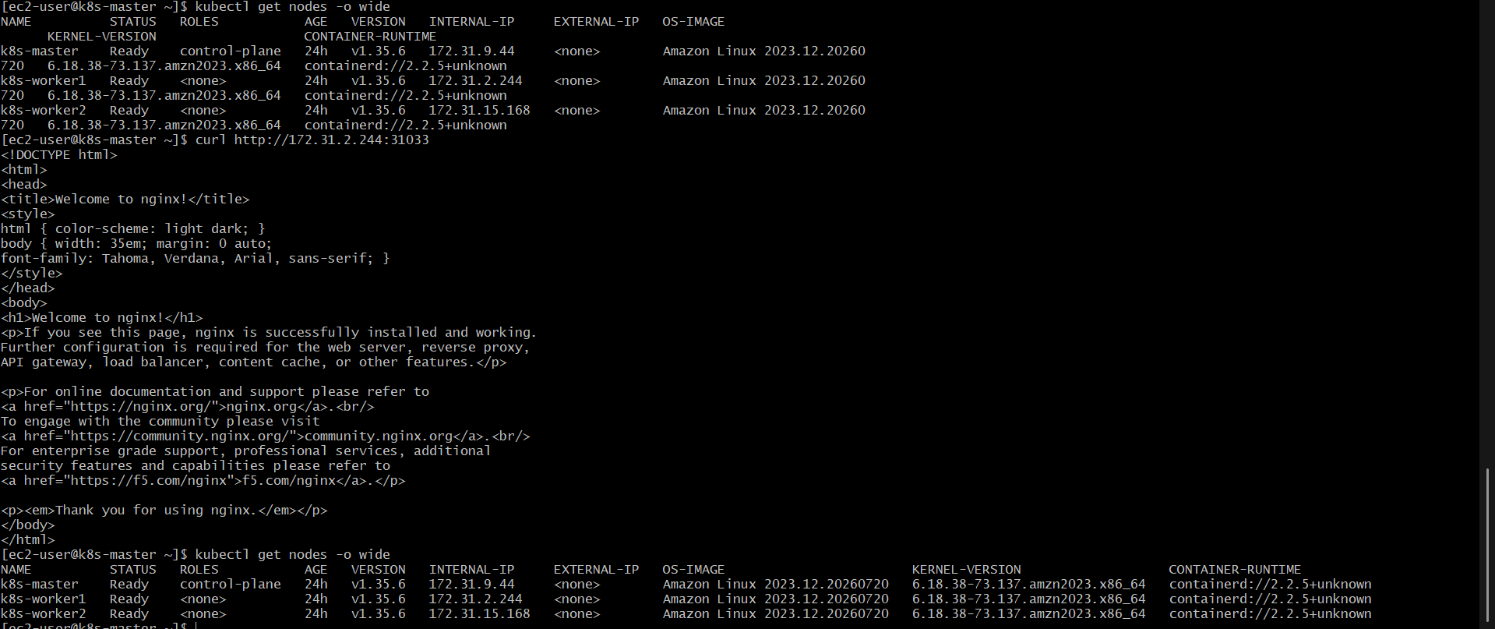

Deploying a ReplicationController to Maintain 3 Replicas of an Nginx Pod in Kubernetes
Objective
To create a Kubernetes ReplicationController that ensures three replicas of an Nginx pod are always running.

Step 1: Create a ReplicationController YAML File
Create a file named nginx-replicationcontroller.yaml:
apiVersion: v1
kind: ReplicationController
metadata:
name: nginx-rc
spec:
replicas: 3
selector:
app: nginx
template:
metadata:
labels:
app: nginx
spec:
containers:
- name: nginx
image: nginx:latest
ports:
- containerPort: 80

Step 2: Create the ReplicationController
Apply the ReplicationController configuration:
kubectl apply -f nginx-replicationcontroller.yaml

Step 3: Verify the ReplicationController
Check the created ReplicationController:
kubectl get replicationcontroller
Expected output:
NAME DESIRED CURRENT READY AGE
nginx-rc 3 3 3 30s
Explanation:
- DESIRED: Number of replicas requested.
- CURRENT: Number of pods currently created.
- READY: Number of pods running and ready.

Step 4: Check the Nginx Pods
List all pods created by the ReplicationController:
kubectl get pods
Expected output:
NAME READY STATUS RESTARTS AGE
nginx-rc-xxxxx 1/1 Running 0 30s
nginx-rc-yyyyy 1/1 Running 0 30s
nginx-rc-zzzzz 1/1 Running 0 30s
The ReplicationController creates and manages three identical Nginx pods.

Step 5: Describe the ReplicationController
To view detailed information:
kubectl describe replicationcontroller nginx-rc
Example output:
Name: nginx-rc
Namespace: default
Selector: app=nginx
Replicas: 3 current / 3 desired
Pods Status: 3 Running / 3 Ready
Pod Template:
Labels: app=nginx
Containers:
nginx:
Image: nginx:latest
Port: 80/TCP

Step 6: Test Self-Healing Capability
Delete one Nginx pod:
kubectl delete pod <pod-name>
Example:
kubectl delete pod nginx-rc-xxxxx
Check the pods again:
kubectl get pods
Expected result:
NAME READY STATUS RESTARTS AGE
nginx-rc-yyyyy 1/1 Running 0 2m
nginx-rc-zzzzz 1/1 Running 0 2m
nginx-rc-aaaaa 1/1 Running 0 10s
The ReplicationController automatically creates a new pod to maintain the desired count of three replicas.

Step 7: Delete the ReplicationController (Optional)
Remove the ReplicationController and its pods:
kubectl delete -f nginx-replicationcontroller.yaml

Result
A Kubernetes ReplicationController was successfully deployed to maintain three replicas of an Nginx pod. The ReplicationController automatically manages pod creation, deletion, and replacement to ensure that three Nginx instances remain available.
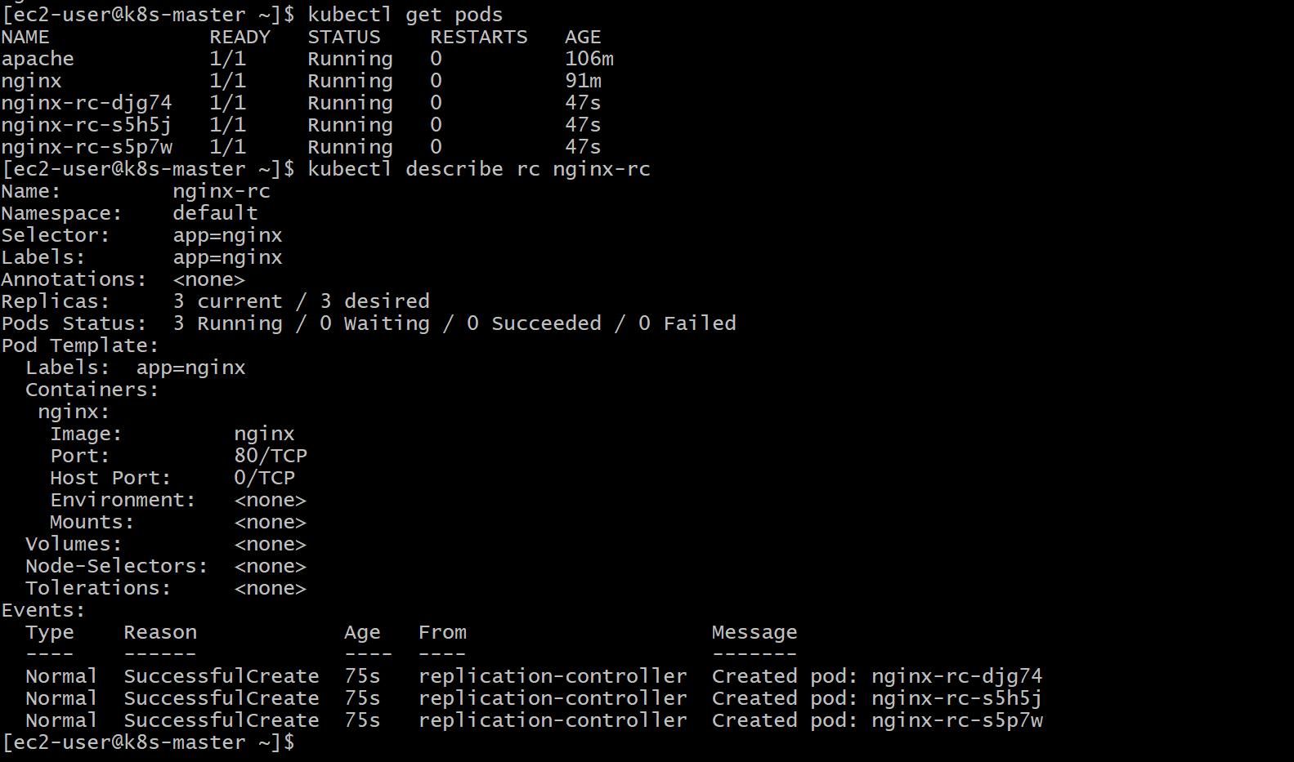

Scaling a ReplicationController from 3 Replicas to 5 Replicas in Kubernetes
Objective
To increase the number of Nginx pod replicas managed by an existing ReplicationController from 3 to 5.

Step 1: Check the Current ReplicationController Status
Verify the current number of replicas:
kubectl get replicationcontroller
Expected output:
NAME DESIRED CURRENT READY AGE
nginx-rc 3 3 3 5m
The ReplicationController is currently maintaining 3 Nginx pod replicas.

Step 2: Scale the ReplicationController
Use the kubectl scale command to increase the replicas from 3 to 5:
kubectl scale replicationcontroller nginx-rc --replicas=5
Output:
replicationcontroller/nginx-rc scaled

Step 3: Verify the Updated Replica Count
Check the ReplicationController status:
kubectl get replicationcontroller
Expected output:
NAME DESIRED CURRENT READY AGE
nginx-rc 5 5 5 6m
The ReplicationController is now managing 5 Nginx pod replicas.

Step 4: Verify the New Pods
List all Nginx pods:
kubectl get pods
Expected output:
NAME READY STATUS RESTARTS AGE
nginx-rc-xxxxx 1/1 Running 0 6m
nginx-rc-yyyyy 1/1 Running 0 6m
nginx-rc-zzzzz 1/1 Running 0 6m
nginx-rc-aaaaa 1/1 Running 0 30s
nginx-rc-bbbbb 1/1 Running 0 30s
Two additional Nginx pods are created automatically by the ReplicationController.

Step 5: Verify Detailed Information
Describe the ReplicationController:
kubectl describe replicationcontroller nginx-rc
Example output:
Name: nginx-rc
Selector: app=nginx
Replicas: 5 current / 5 desired
Pods Status: 5 Running / 5 Ready

Step 6: Verify Self-Healing After Scaling
Delete one Nginx pod:
kubectl delete pod <pod-name>
Check the pods:
kubectl get pods
The ReplicationController automatically creates a replacement pod to maintain 5 running replicas.

Result
The ReplicationController was successfully scaled from 3 replicas to 5 replicas. Kubernetes automatically created additional Nginx pods and continued maintaining the desired replica count.

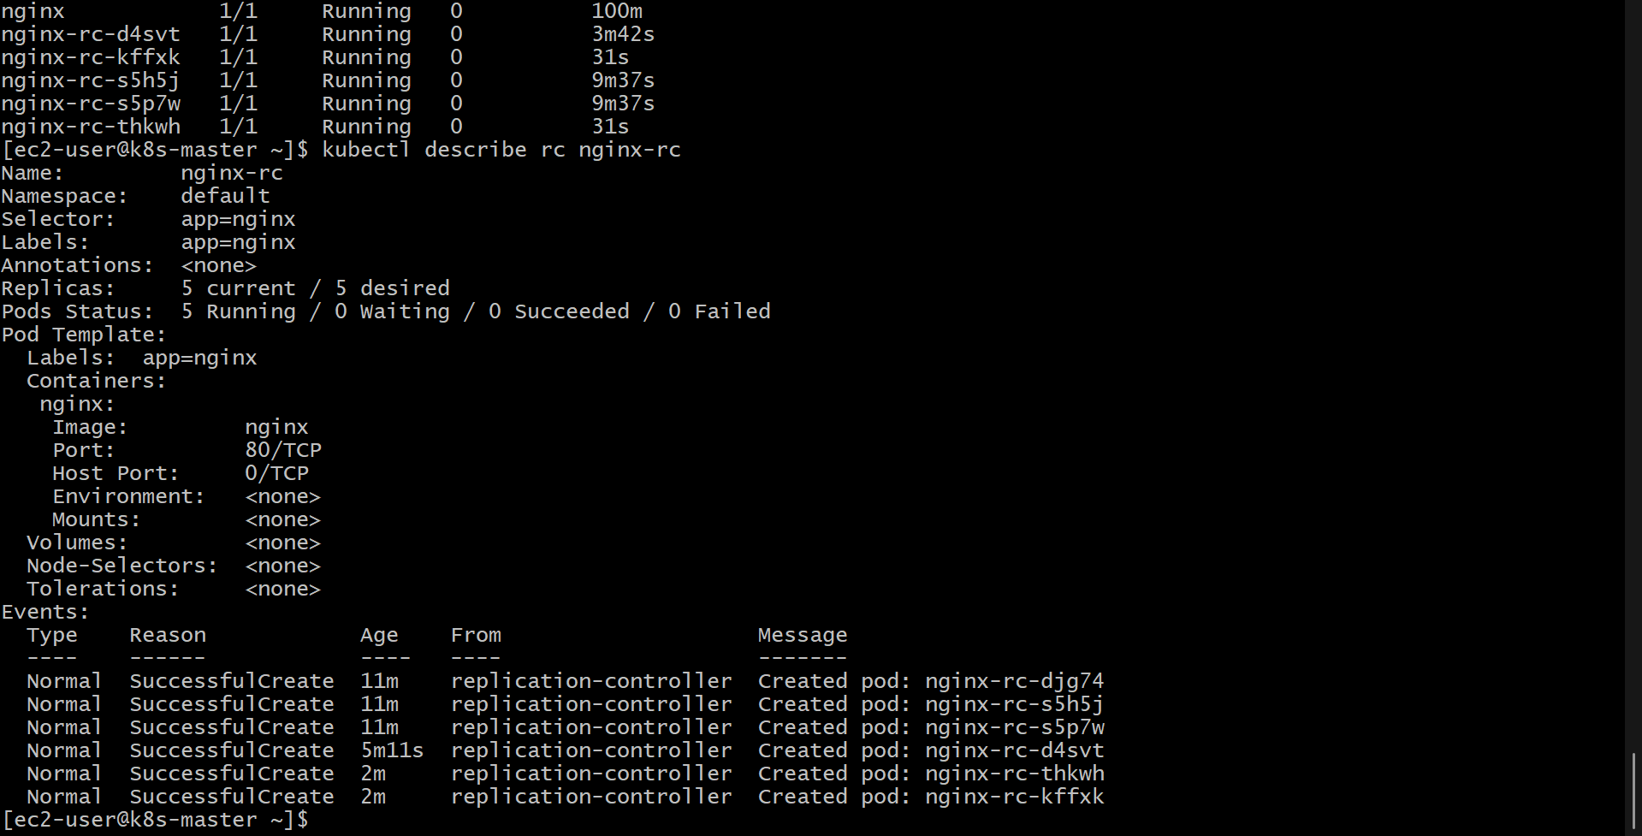

Creating a ReplicaSet to Manage Pods Based on Multiple Labels (prod and test) in Kubernetes
Objective
To create a Kubernetes ReplicaSet that manages pods using multiple labels such as environment: prod and environment: test.

Step 1: Create a ReplicaSet YAML File
Create a file named nginx-replicaset.yaml:
apiVersion: apps/v1
kind: ReplicaSet
metadata:
name: nginx-replicaset
labels:
app: nginx
spec:
replicas: 4
selector:
matchExpressions:
- key: environment
operator: In
values:
- prod
- test
template:
metadata:
labels:
app: nginx
environment: prod
spec:
containers:
- name: nginx
image: nginx:latest
ports:
- containerPort: 80
Explanation:
- replicas: 4 → Maintains four Nginx pod replicas.
- matchExpressions → Allows the ReplicaSet to manage pods with multiple label values.
- environment: prod and environment: test → Pods with either label value can be selected.
- operator: In → Matches any value from the provided list.

Step 2: Create the ReplicaSet
Apply the ReplicaSet configuration:
kubectl apply -f nginx-replicaset.yaml
Output:
replicaset.apps/nginx-replicaset created

Step 3: Verify the ReplicaSet
Check the ReplicaSet status:
kubectl get replicaset
Expected output:
NAME DESIRED CURRENT READY AGE
nginx-replicaset 4 4 4 30s

Step 4: Check the Created Pods
List the pods with their labels:
kubectl get pods --show-labels
Expected output:
NAME READY STATUS LABELS
nginx-replicaset-xxxxx 1/1 Running app=nginx,environment=prod
nginx-replicaset-yyyyy 1/1 Running app=nginx,environment=prod
nginx-replicaset-zzzzz 1/1 Running app=nginx,environment=prod
nginx-replicaset-aaaaa 1/1 Running app=nginx,environment=prod

Step 5: Create Pods with Different Labels (Optional Test)
Create a test pod with the environment=test label:
Create a file named test-pod.yaml:
apiVersion: v1
kind: Pod
metadata:
name: nginx-test-pod
labels:
environment: test
spec:
containers:
- name: nginx
image: nginx:latest
ports:
- containerPort: 80
Apply it:
kubectl apply -f test-pod.yaml

Step 6: Verify ReplicaSet Selector
Check the ReplicaSet details:
kubectl describe replicaset nginx-replicaset
Example output:
Name: nginx-replicaset
Selector: environment in (prod,test)
Replicas: 4 current / 4 desired
Pods Status: 4 Running / 4 Ready

Step 7: Test Self-Healing
Delete one managed pod:
kubectl delete pod <pod-name>
Check the pods:
kubectl get pods
The ReplicaSet automatically creates a new pod to maintain the required replica count.

Step 8: Delete the ReplicaSet (Optional)
Delete the ReplicaSet and its managed pods:
kubectl delete -f nginx-replicaset.yaml

Result
A Kubernetes ReplicaSet was successfully created to manage Nginx pods using label-based selection. The ReplicaSet uses label selectors to identify pods with the prod and test environment labels and ensures the required number of replicas are always running.
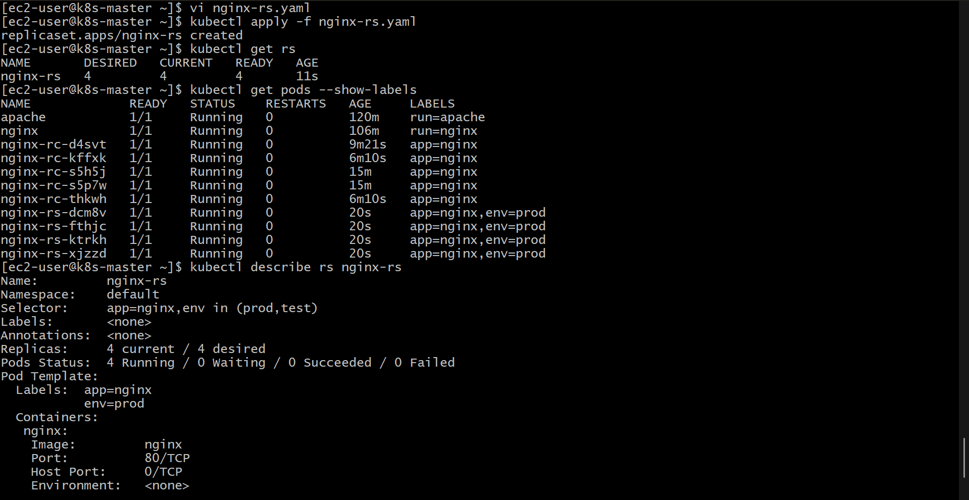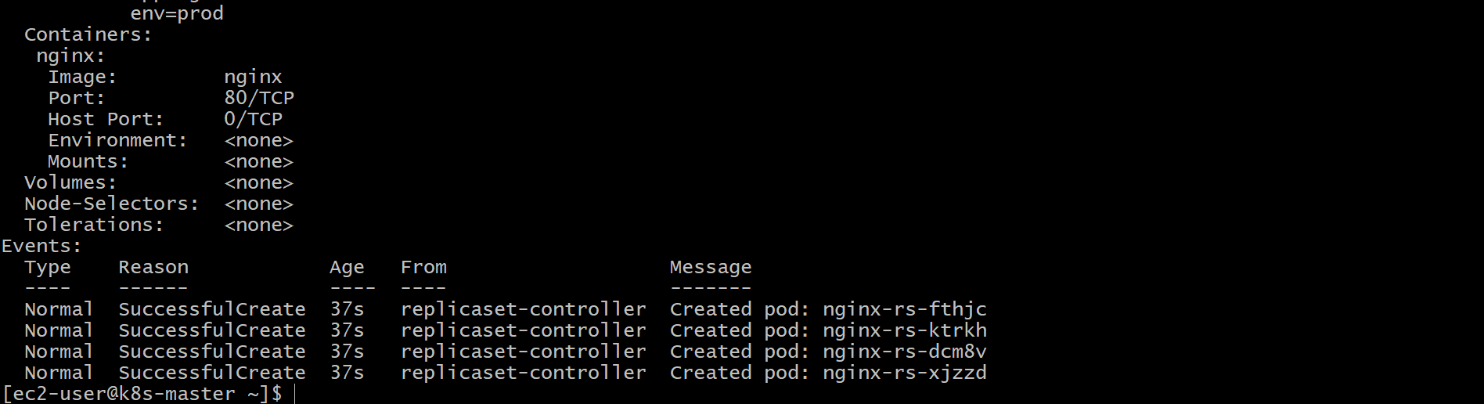

Deploying a ReplicaSet That Excludes Pods with the Label backend in Kubernetes
Objective
To create a Kubernetes ReplicaSet that manages Nginx pods while excluding pods that have the label app=backend.

Step 1: Create a ReplicaSet YAML File
Create a file named nginx-replicaset-exclude.yaml:
apiVersion: apps/v1
kind: ReplicaSet
metadata:
name: nginx-replicaset
labels:
app: nginx
spec:
replicas: 3
selector:
matchExpressions:
- key: app
operator: NotIn
values:
- backend
template:
metadata:
labels:
app: frontend
spec:
containers:
- name: nginx
image: nginx:latest
ports:
- containerPort: 80

Explanation
- replicas: 3 → Ensures that three Nginx pods are running.
- matchExpressions → Used to create advanced label selection rules.
- operator: NotIn → Excludes pods that have the specified label value.
- values: backend → Pods with the label app=backend are not managed by this ReplicaSet.
- The ReplicaSet manages only pods that do not have the backend label value.

Step 2: Create the ReplicaSet
Apply the ReplicaSet configuration:
kubectl apply -f nginx-replicaset-exclude.yaml
Expected output:
replicaset.apps/nginx-replicaset created

Step 3: Verify the ReplicaSet
Check the ReplicaSet status:
kubectl get replicaset
Expected output:
NAME DESIRED CURRENT READY AGE
nginx-replicaset 3 3 3 30s

Step 4: Check Managed Pods and Labels
View all pods with their labels:
kubectl get pods --show-labels
Expected output:
NAME READY STATUS LABELS
nginx-replicaset-xxxxx 1/1 Running app=frontend
nginx-replicaset-yyyyy 1/1 Running app=frontend
nginx-replicaset-zzzzz 1/1 Running app=frontend
The ReplicaSet manages these pods because they do not have the excluded app=backend label.

Step 5: Test the Exclusion Rule
Create a pod with the backend label:
Create a file named backend-pod.yaml:
apiVersion: v1
kind: Pod
metadata:
name: backend-pod
labels:
app: backend
spec:
containers:
- name: nginx
image: nginx:latest
Apply it:
kubectl apply -f backend-pod.yaml
Check pods:
kubectl get pods --show-labels
Example output:
NAME READY STATUS LABELS
nginx-replicaset-xxxxx 1/1 Running app=frontend
nginx-replicaset-yyyyy 1/1 Running app=frontend
nginx-replicaset-zzzzz 1/1 Running app=frontend
backend-pod 1/1 Running app=backend
The ReplicaSet does not manage the backend-pod because it matches the excluded label.

Step 6: Describe the ReplicaSet
View ReplicaSet details:
kubectl describe replicaset nginx-replicaset
Example output:
Name: nginx-replicaset
Selector: app notin (backend)
Replicas: 3 current / 3 desired
Pods Status: 3 Running / 3 Ready

Step 7: Delete Resources (Optional)
Delete the ReplicaSet:
kubectl delete -f nginx-replicaset-exclude.yaml
Delete the test backend pod:
kubectl delete -f backend-pod.yaml

Result
A Kubernetes ReplicaSet was successfully deployed with a label selector that excludes pods having the app=backend label. The ReplicaSet maintains three Nginx pods while ignoring backend-labeled pods.
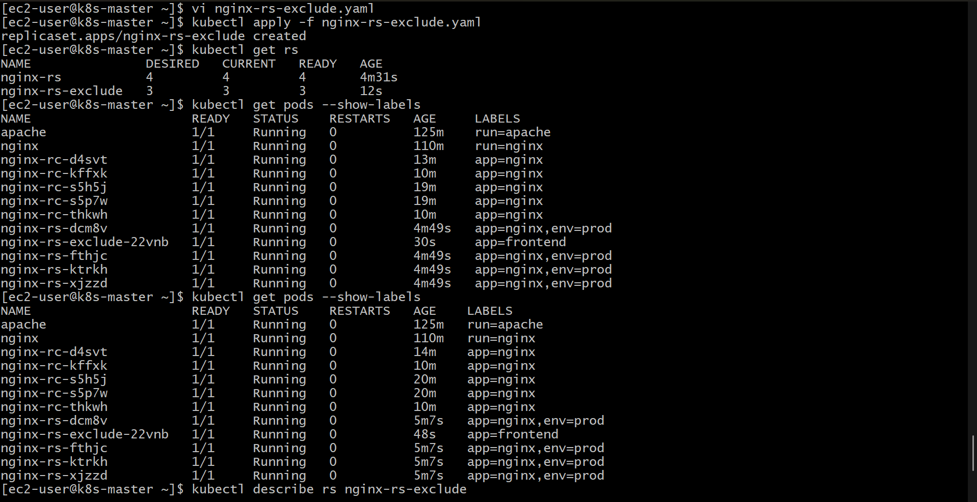
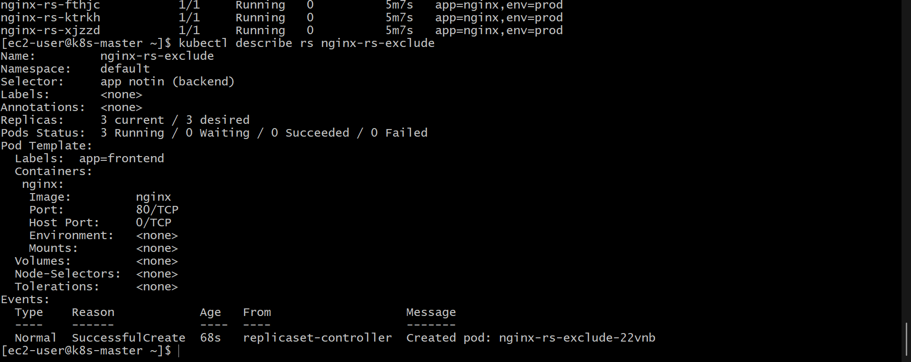
Testing Load Balancing Across Multiple Pods Using a NodePort Service in Kubernetes
Objective
To deploy multiple Nginx pods and verify load balancing using a Kubernetes NodePort service.

Step 1: Create an Nginx Deployment with Multiple Replicas
Create a file named nginx-deployment.yaml:
apiVersion: apps/v1
kind: Deployment
metadata:
name: nginx-deployment
labels:
app: nginx
spec:
replicas: 3
selector:
matchLabels:
app: nginx
template:
metadata:
labels:
app: nginx
spec:
containers:
- name: nginx
image: nginx:latest
ports:
- containerPort: 80
Apply the deployment:
kubectl apply -f nginx-deployment.yaml

Step 2: Verify Multiple Nginx Pods
Check the running pods:
kubectl get pods -o wide
Expected output:
NAME READY STATUS IP
nginx-deployment-xxxxx 1/1 Running 10.244.1.5
nginx-deployment-yyyyy 1/1 Running 10.244.1.6
nginx-deployment-zzzzz 1/1 Running 10.244.2.7
Three Nginx pods are running with the same label:
app=nginx

Step 3: Create a NodePort Service
Create a file named nginx-nodeport-service.yaml:
apiVersion: v1
kind: Service
metadata:
name: nginx-nodeport-service
spec:
type: NodePort
selector:
app: nginx
ports:
- protocol: TCP
port: 80
targetPort: 80
nodePort: 30080
Apply the service:
kubectl apply -f nginx-nodeport-service.yaml

Step 4: Verify the NodePort Service
Check the service:
kubectl get service
Expected output:
NAME TYPE CLUSTER-IP EXTERNAL-IP PORT(S)
nginx-nodeport-service NodePort 10.96.120.10 <none> 80:30080/TCP
The service exposes the Nginx application externally through port 30080.

Step 5: Check Service Endpoints
Verify that the service is connected to all Nginx pods:
kubectl get endpoints nginx-nodeport-service
Expected output:
NAME ENDPOINTS
nginx-nodeport-service 10.244.1.5:80,10.244.1.6:80,10.244.2.7:80
The service distributes traffic across these three pod endpoints.

Step 6: Get the Kubernetes Node IP
Find the node IP address:
kubectl get nodes -o wide
Example:
NAME STATUS INTERNAL-IP
node1 Ready 192.168.1.10
Access the service using:
http://192.168.1.10:30080

Step 7: Test Load Balancing
Send multiple requests to the NodePort service:
for i in {1..10}; do curl http://<Node-IP>:30080; done
Example:
for i in {1..10}; do curl http://192.168.1.10:30080; done
The requests are distributed among the available Nginx pods by the Kubernetes service.

Step 8: Verify Traffic Distribution Using Pod Logs
Check the pods:
kubectl get pods
View logs from individual pods:
kubectl logs <pod-name>
Example:
kubectl logs nginx-deployment-xxxxx
kubectl logs nginx-deployment-yyyyy
kubectl logs nginx-deployment-zzzzz
Each pod receives requests, confirming that load balancing is working.

Step 9: Test Service Availability After Pod Failure
Delete one Nginx pod:
kubectl delete pod <pod-name>
Check pods again:
kubectl get pods
The Deployment automatically creates a replacement pod, and the NodePort service continues routing traffic to available pods.

Step 10: Delete Resources (Optional)
Delete the deployment:
kubectl delete -f nginx-deployment.yaml
Delete the service:
kubectl delete -f nginx-nodeport-service.yaml

Result
Multiple Nginx pods were deployed and exposed using a NodePort service. The Kubernetes service successfully distributed incoming requests across multiple pods, demonstrating load balancing and high availability.
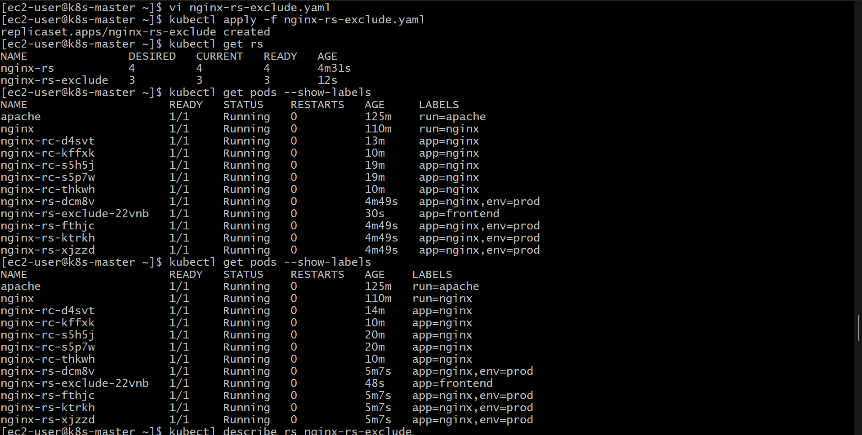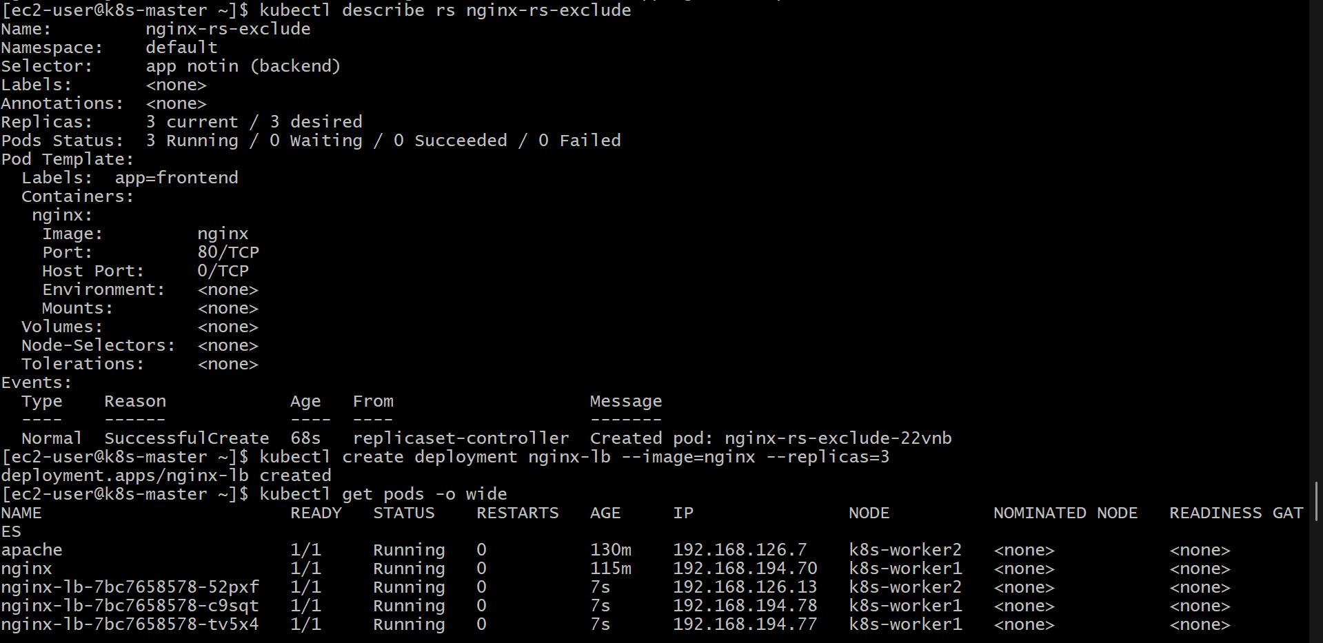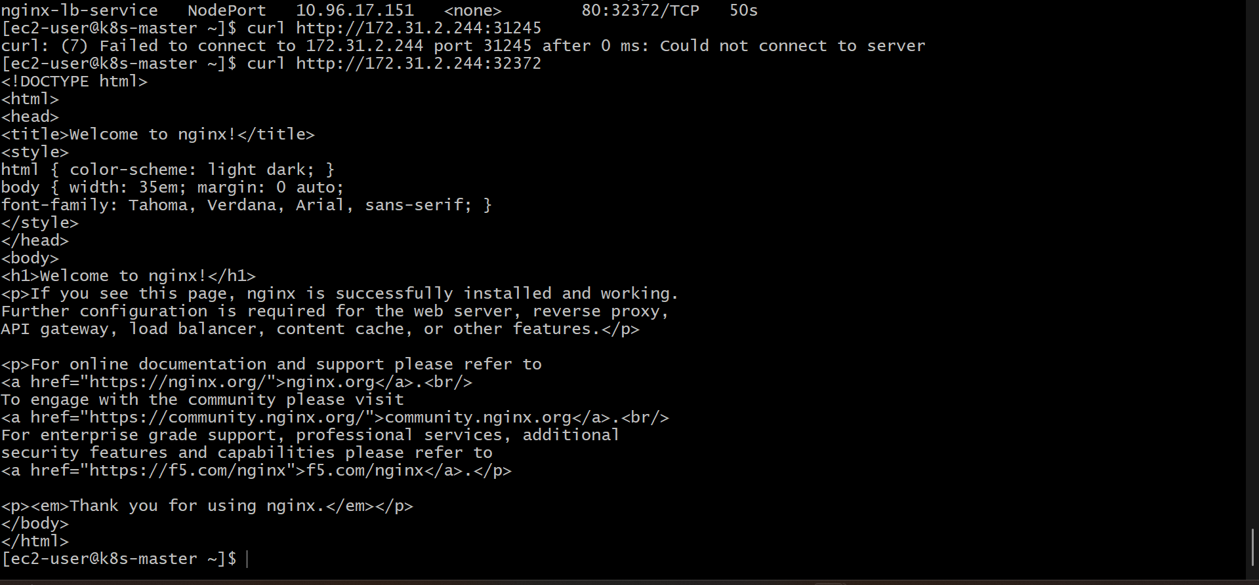

Deleting a ReplicationController Without Affecting Running Pods in Kubernetes
Objective
To delete a Kubernetes ReplicationController while keeping the pods it manages running.

Step 1: Check the Existing ReplicationController
List all ReplicationControllers:
kubectl get replicationcontroller
Example output:
NAME DESIRED CURRENT READY AGE
nginx-rc 3 3 3 10m
Verify the pods managed by the ReplicationController:
kubectl get pods
Example output:
NAME READY STATUS RESTARTS AGE
nginx-rc-xxxxx 1/1 Running 0 10m
nginx-rc-yyyyy 1/1 Running 0 10m
nginx-rc-zzzzz 1/1 Running 0 10m

Step 2: Delete the ReplicationController Only
Use the --cascade=orphan option to remove the ReplicationController while leaving its pods running:
kubectl delete replicationcontroller nginx-rc --cascade=orphan
Expected output:
replicationcontroller "nginx-rc" deleted

Step 3: Verify the ReplicationController Is Deleted
Check the ReplicationControllers:
kubectl get replicationcontroller
Expected output:
No resources found
The ReplicationController has been removed.

Step 4: Verify the Pods Are Still Running
Check the pods:
kubectl get pods
Expected output:
NAME READY STATUS RESTARTS AGE
nginx-rc-xxxxx 1/1 Running 0 11m
nginx-rc-yyyyy 1/1 Running 0 11m
nginx-rc-zzzzz 1/1 Running 0 11m
The pods continue running because they were orphaned from the ReplicationController.

Step 5: Verify Pod Ownership (Optional)
Check the pod details:
kubectl describe pod <pod-name>
Before deletion, the pod owner reference points to the ReplicationController. After using --cascade=orphan, the owner reference is removed.

Step 6: Delete the Orphaned Pods (Optional)
If the pods are no longer required, delete them manually:
kubectl delete pod <pod-name>
Or delete all Nginx pods using labels:
kubectl delete pods -l app=nginx

Result
The ReplicationController was successfully deleted without deleting the running pods. The pods continued to run independently after being orphaned from their controller.
