Experiment: Create a ConfigMap from a Directory and Inject Variables into a Pod as Environment Variables
Objective
To create a Kubernetes ConfigMap from a directory containing multiple configuration files and inject the ConfigMap values into a Pod as environment variables.

Prerequisites
- Kubernetes cluster (Minikube, Kind, or any Kubernetes cluster)
- kubectl installed and configured
- Basic knowledge of Kubernetes resources

Step 1: Create a Directory with Configuration Files
Create a directory and add the configuration files.
mkdir app-config

echo "mysql" > app-config/DB_HOST
echo "3306" > app-config/DB_PORT
echo "production" > app-config/APP_ENV
Verify the directory contents:
ls app-config
Expected Output:
APP_ENV
DB_HOST
DB_PORT

Step 2: Create a ConfigMap from the Directory
Create the ConfigMap using the following command:
kubectl create configmap app-config --from-file=app-config/

Step 3: Verify the ConfigMap
List all ConfigMaps:
kubectl get configmaps
View ConfigMap details:
kubectl describe configmap app-config
Or display it in YAML format:
kubectl get configmap app-config -o yaml
Expected Output (partial):
data:
APP_ENV: production
DB_HOST: mysql
DB_PORT: "3306"

Step 4: Create a Pod Manifest
Create a file named pod.yaml.
apiVersion: v1
kind: Pod
metadata:
name: env-demo
spec:
containers:
- name: app
image: nginx
env:
- name: DB_HOST
valueFrom:
configMapKeyRef:
name: app-config
key: DB_HOST
- name: DB_PORT
valueFrom:
configMapKeyRef:
name: app-config
key: DB_PORT
- name: APP_ENV
valueFrom:
configMapKeyRef:
name: app-config
key: APP_ENV

Step 5: Create the Pod
Deploy the Pod.
kubectl apply -f pod.yaml
Verify that the Pod is running.
kubectl get pods
Expected Output:
NAME READY STATUS RESTARTS AGE
env-demo 1/1 Running 0 20s

Step 6: Verify the Environment Variables
Display all environment variables inside the Pod.
kubectl exec env-demo -- env
Or display only the required variables.
kubectl exec env-demo -- printenv | grep -E 'DB_HOST|DB_PORT|APP_ENV'
Expected Output:
DB_HOST=mysql
DB_PORT=3306
APP_ENV=production

Alternative Method (Using envFrom)
Instead of defining each environment variable separately, you can import all ConfigMap keys at once.
apiVersion: v1
kind: Pod
metadata:
name: env-demo
spec:
containers:
- name: app
image: nginx
envFrom:
- configMapRef:
name: app-config
Apply the Pod.
kubectl apply -f pod.yaml
Verify the environment variables.
kubectl exec env-demo -- printenv
All ConfigMap keys will automatically be available as environment variables inside the container.

Result
A ConfigMap was successfully created from a directory containing multiple configuration files. The ConfigMap values were injected into the Pod as environment variables, and the variables were successfully verified from within the running container.

Conclusion
This experiment demonstrated how to create a ConfigMap from a directory using the --from-file option and use it to provide configuration values to a Kubernetes Pod as environment variables. Using ConfigMaps separates application configuration from the container image, making applications easier to configure, maintain, and deploy across different environments.
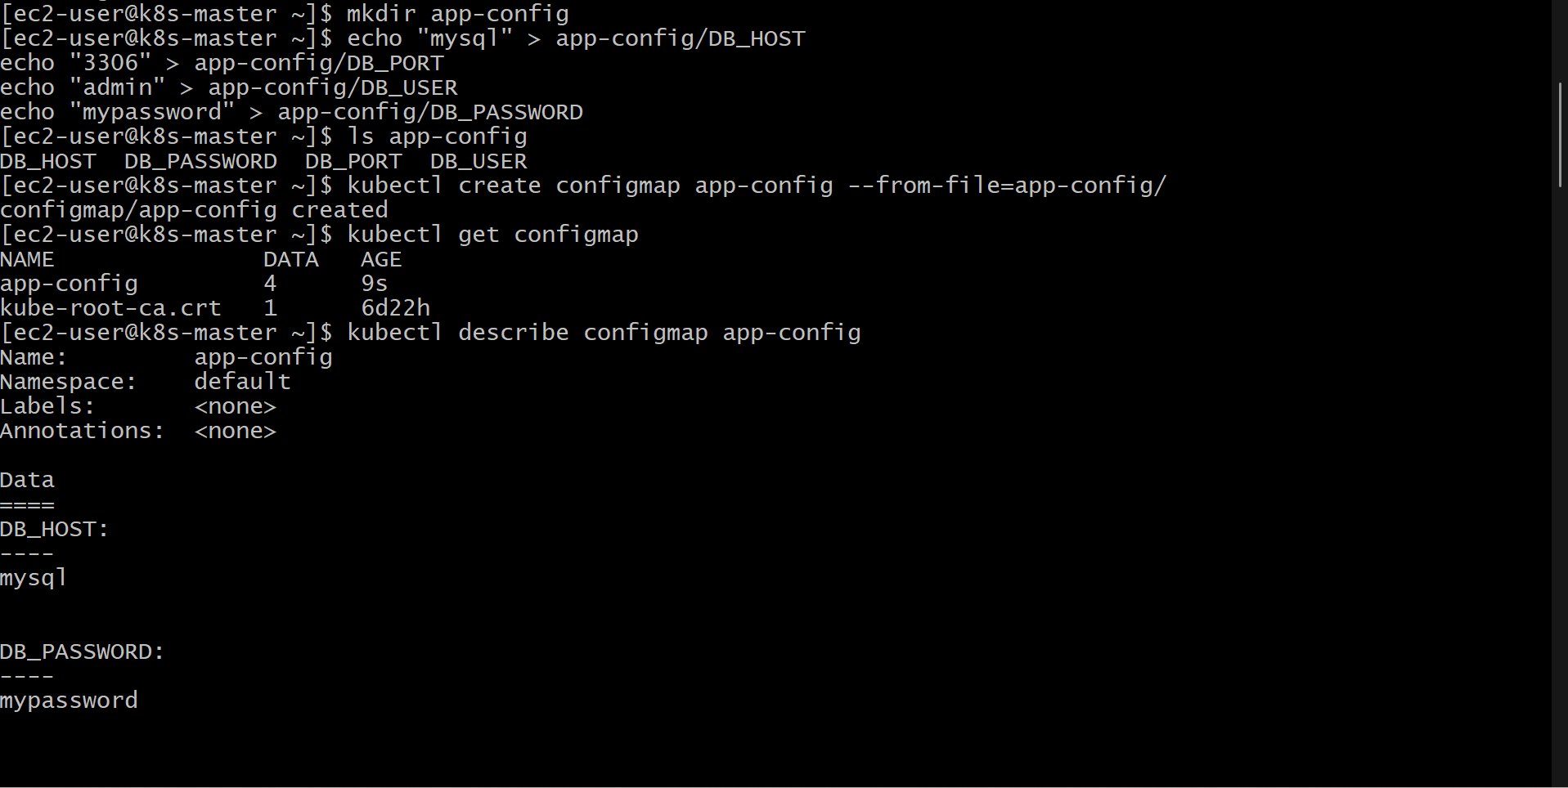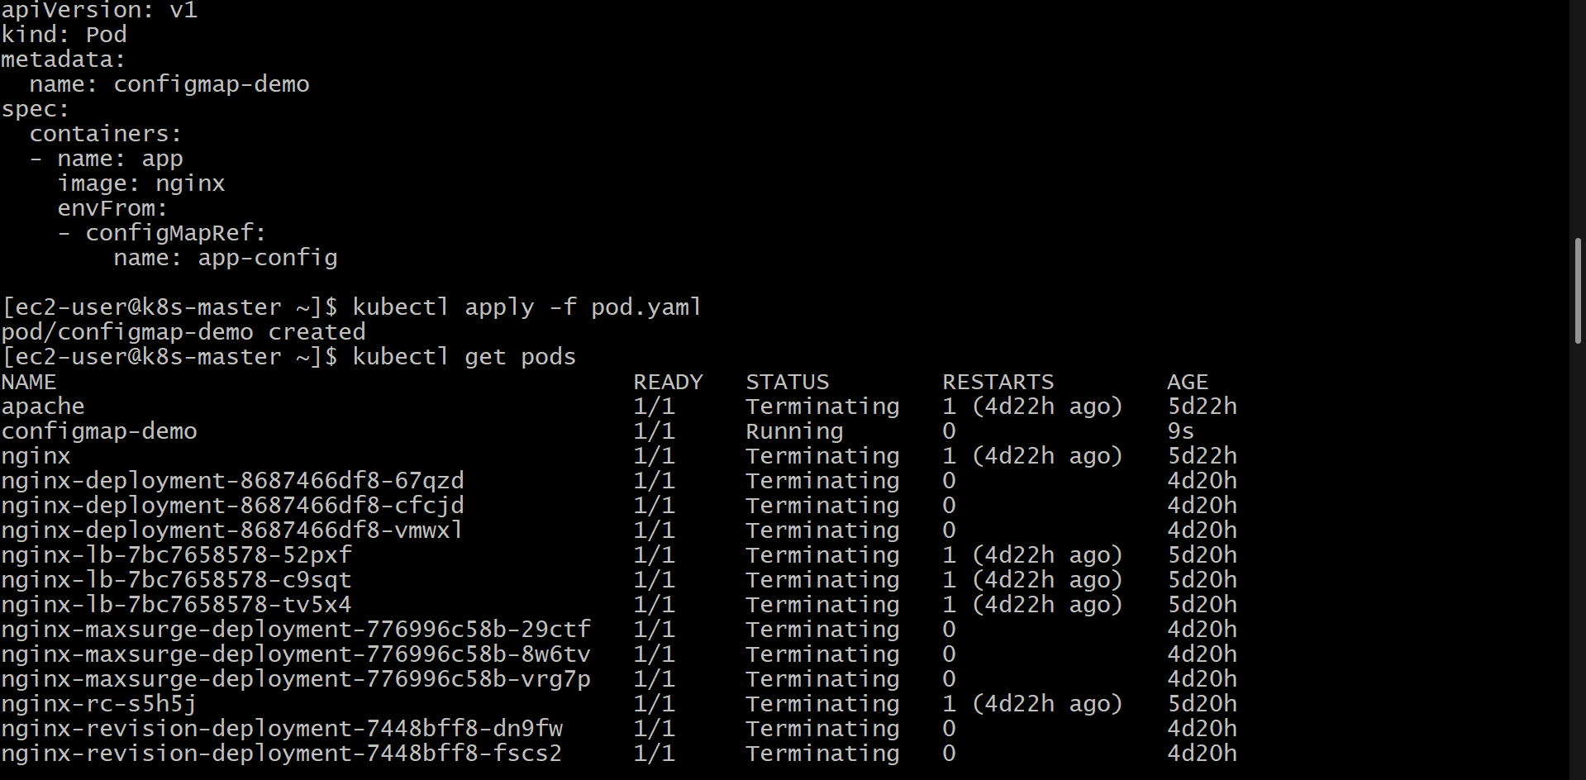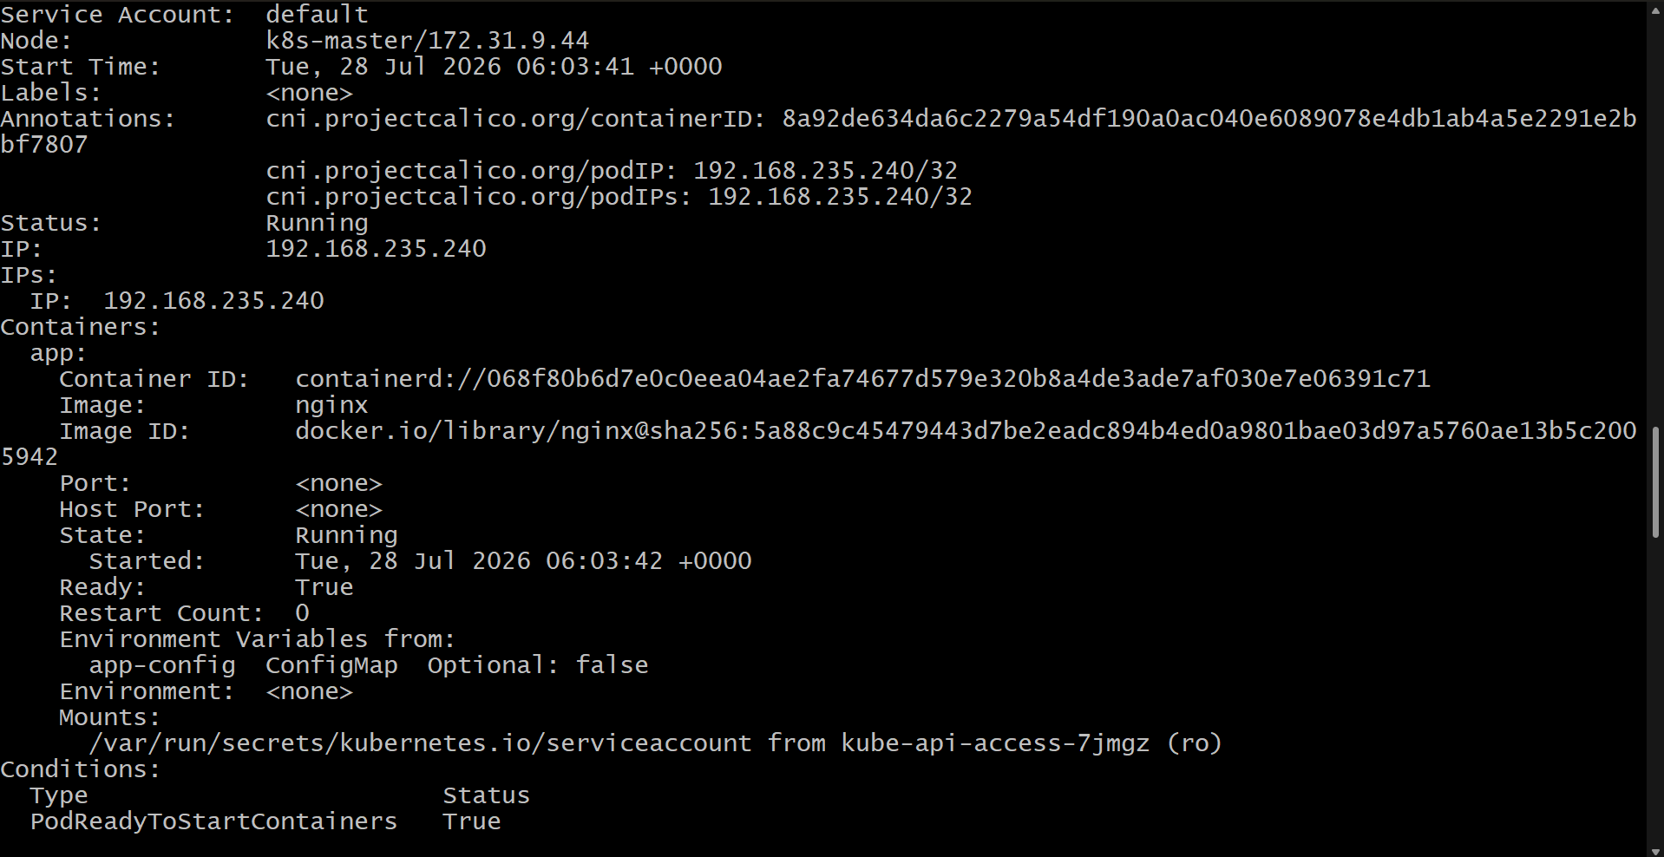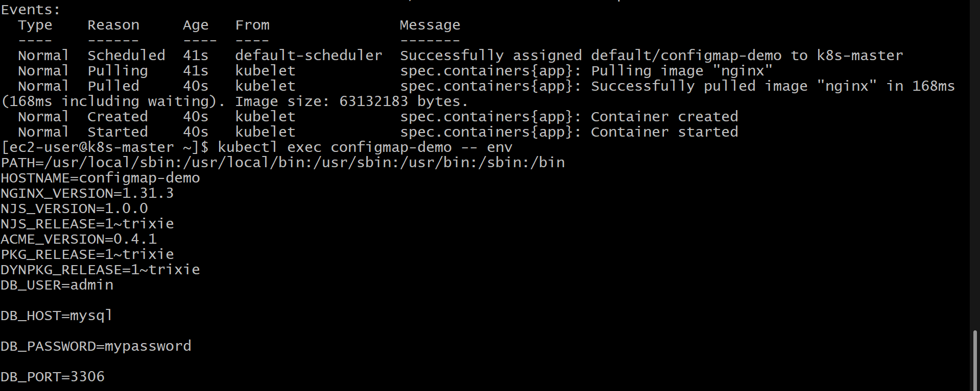

Experiment: Create a ConfigMap from a File and Mount it as a Volume Inside a Pod
Objective
To create a Kubernetes ConfigMap from a configuration file and mount it as a volume inside a Pod so that the configuration data is available as files within the container.

Prerequisites
- Kubernetes cluster (Minikube, Kind, or any Kubernetes cluster)
- kubectl installed and configured
- Basic knowledge of Kubernetes resources

Step 1: Create a Configuration File
Create a configuration file named app.properties.
cat <<EOF > app.properties
DB_HOST=mysql
DB_PORT=3306
APP_ENV=production
EOF
Verify the file contents.
cat app.properties
Expected Output:
DB_HOST=mysql
DB_PORT=3306
APP_ENV=production

Step 2: Create a ConfigMap from the File
Create a ConfigMap using the configuration file.
kubectl create configmap app-config --from-file=app.properties

Step 3: Verify the ConfigMap
List all ConfigMaps.
kubectl get configmaps
View the ConfigMap details.
kubectl describe configmap app-config
Or display it in YAML format.
kubectl get configmap app-config -o yaml
Expected Output (partial):
data:
app.properties: |
DB_HOST=mysql
DB_PORT=3306
APP_ENV=production

Step 4: Create a Pod Manifest
Create a file named pod.yaml.
apiVersion: v1
kind: Pod
metadata:
name: config-volume-demo
spec:
containers:
- name: app
image: nginx
volumeMounts:
- name: config-volume
mountPath: /etc/config
readOnly: true
volumes:
- name: config-volume
configMap:
name: app-config
Note: The ConfigMap is mounted at /etc/config, and each key in the ConfigMap becomes a file inside this directory.

Step 5: Create the Pod
Deploy the Pod.
kubectl apply -f pod.yaml
Verify that the Pod is running.
kubectl get pods
Expected Output:
NAME READY STATUS RESTARTS AGE
config-volume-demo 1/1 Running 0 20s

Step 6: Verify the Mounted Files
List the files inside the mounted directory.
kubectl exec config-volume-demo -- ls /etc/config
Expected Output:
app.properties
Display the contents of the mounted file.
kubectl exec config-volume-demo -- cat /etc/config/app.properties
Expected Output:
DB_HOST=mysql
DB_PORT=3306
APP_ENV=production

Step 7: Verify the Volume Mount
Describe the Pod to verify that the ConfigMap is mounted as a volume.
kubectl describe pod config-volume-demo
The output should show the ConfigMap mounted under the Volumes and Mounts sections.

Result
A ConfigMap was successfully created from a configuration file and mounted as a volume inside a Kubernetes Pod. The configuration data was available as a file inside the container and was successfully verified.

Conclusion
This experiment demonstrated how to create a ConfigMap from a file and mount it as a volume inside a Kubernetes Pod. When mounted as a volume, each key in the ConfigMap is exposed as a file, allowing applications to read configuration data directly from the file system. This approach separates configuration from application code and enables easier configuration management without rebuilding container images
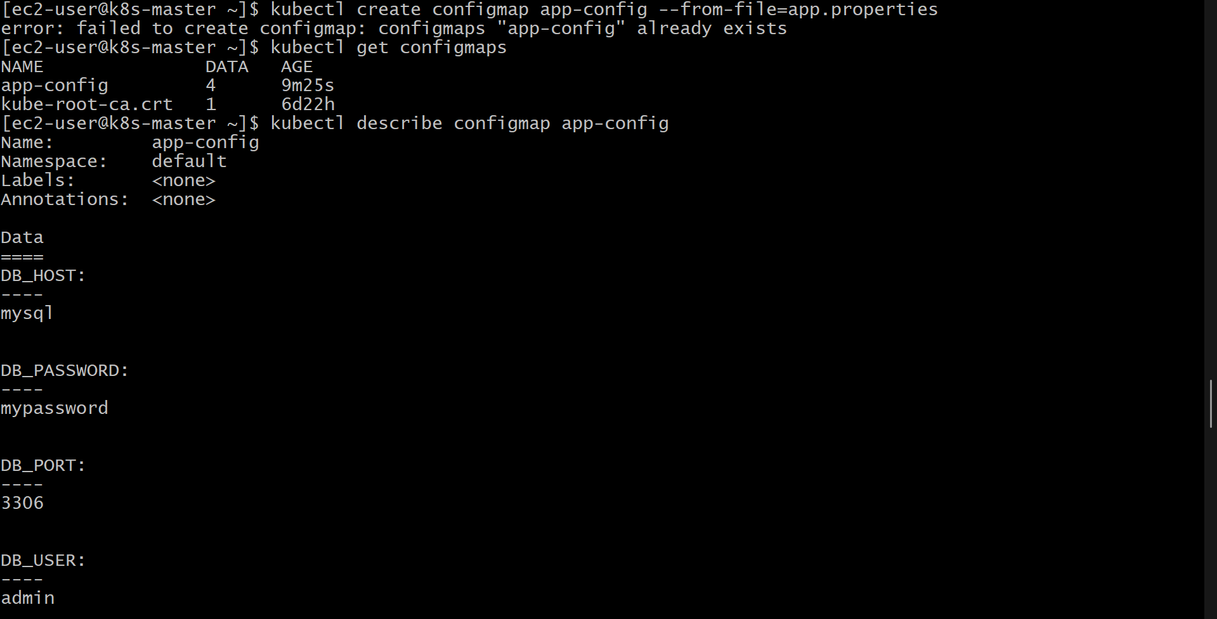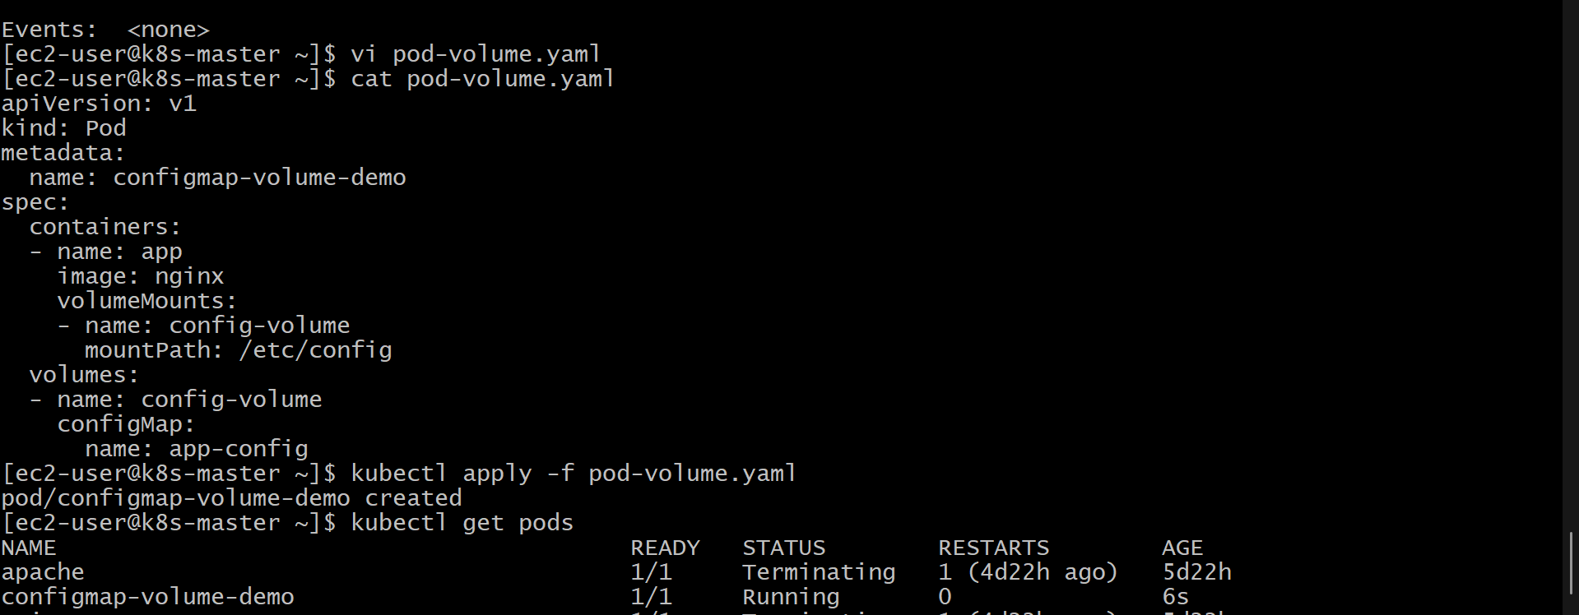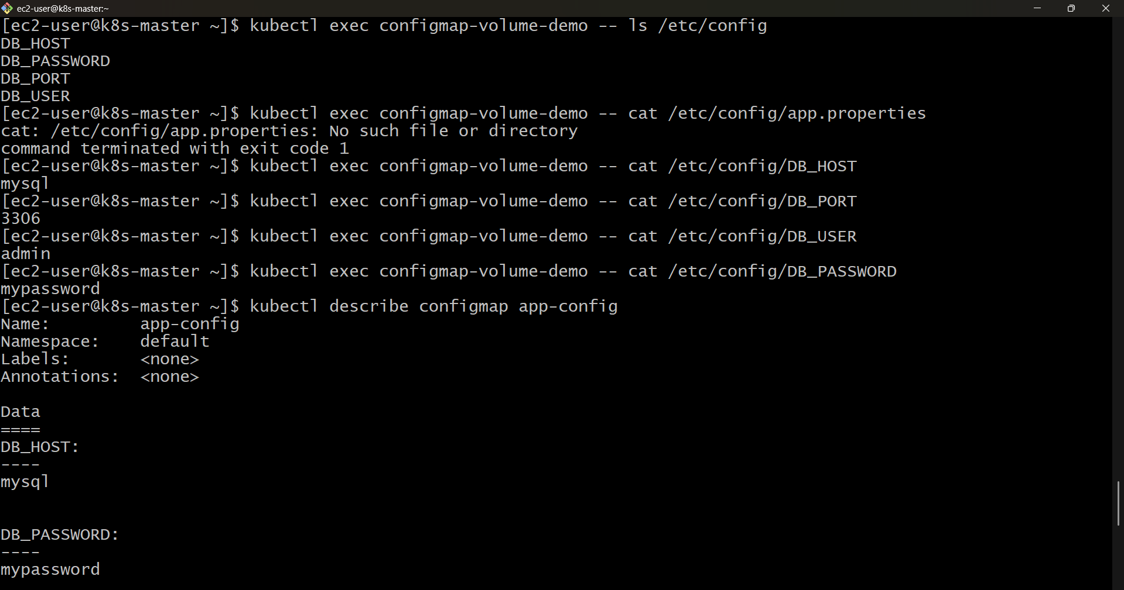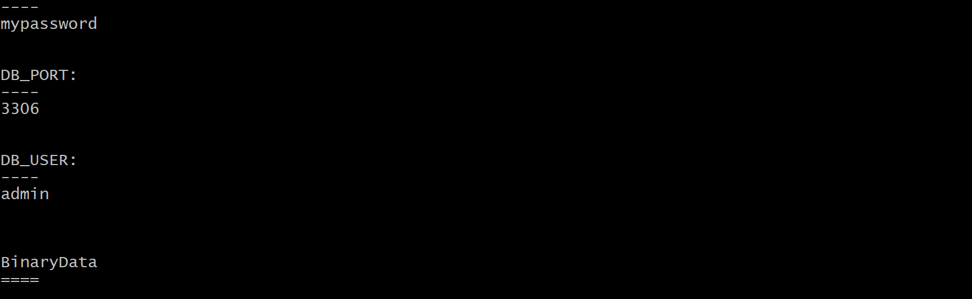

Experiment: Create a Secret with Sensitive Information and Inject it into a Pod as Environment Variables
Objective
To create a Kubernetes Secret containing sensitive information (username and password) and inject the secret values into a Pod as environment variables.

Prerequisites
- Kubernetes cluster (Minikube, Kind, or any Kubernetes cluster)
- kubectl installed and configured
- Basic knowledge of Kubernetes resources

Step 1: Create a Secret
Create a Secret containing a username and password.
kubectl create secret generic app-secret \
--from-literal=username=admin \
--from-literal=password=MySecret123

Step 2: Verify the Secret
List all Secrets.
kubectl get secrets
View the Secret details.
kubectl describe secret app-secret
View the Secret in YAML format.
kubectl get secret app-secret -o yaml
Expected Output (partial):
apiVersion: v1
kind: Secret
metadata:
name: app-secret
type: Opaque
data:
password: TXlTZWNyZXQxMjM=
username: YWRtaW4=
Note: Secret values are Base64 encoded, not encrypted.

Step 3: Create a Pod Manifest
Create a file named pod.yaml.
apiVersion: v1
kind: Pod
metadata:
name: secret-env-demo
spec:
containers:
- name: app
image: nginx
env:
- name: USERNAME
valueFrom:
secretKeyRef:
name: app-secret
key: username
- name: PASSWORD
valueFrom:
secretKeyRef:
name: app-secret
key: password

Step 4: Create the Pod
Deploy the Pod.
kubectl apply -f pod.yaml
Verify that the Pod is running.
kubectl get pods
Expected Output:
NAME READY STATUS RESTARTS AGE
secret-env-demo 1/1 Running 0 20s

Step 5: Verify the Environment Variables
Display the environment variables inside the Pod.
kubectl exec secret-env-demo -- env
Or display only the required variables.
kubectl exec secret-env-demo -- printenv | grep -E 'USERNAME|PASSWORD'
Expected Output:
USERNAME=admin
PASSWORD=MySecret123

Step 6: Verify the Secret from Kubernetes
Display the Secret in YAML format.
kubectl get secret app-secret -o yaml
Decode the username.
echo "YWRtaW4=" | base64 --decode
Expected Output:
admin
Decode the password.
echo "TXlTZWNyZXQxMjM=" | base64 --decode
Expected Output:
MySecret123

Alternative Method (Import All Secret Keys as Environment Variables)
Instead of defining each environment variable individually, you can import all Secret keys at once.
apiVersion: v1
kind: Pod
metadata:
name: secret-env-demo
spec:
containers:
- name: app
image: nginx
envFrom:
- secretRef:
name: app-secret
Apply the Pod.
kubectl apply -f pod.yaml
Verify the environment variables.
kubectl exec secret-env-demo -- printenv
All Secret keys (username and password) will automatically be available as environment variables inside the container.

Result
A Kubernetes Secret containing sensitive information (username and password) was successfully created. The Secret values were injected into the Pod as environment variables and verified from within the running container.

Conclusion
This experiment demonstrated how to create a Kubernetes Secret to securely store sensitive information and inject it into a Pod as environment variables. Secrets help separate confidential data from application code and configuration, making applications more secure and easier to manage. By using secretKeyRef or envFrom, applications can securely access credentials without hardcoding them into container images or Pod specifications.
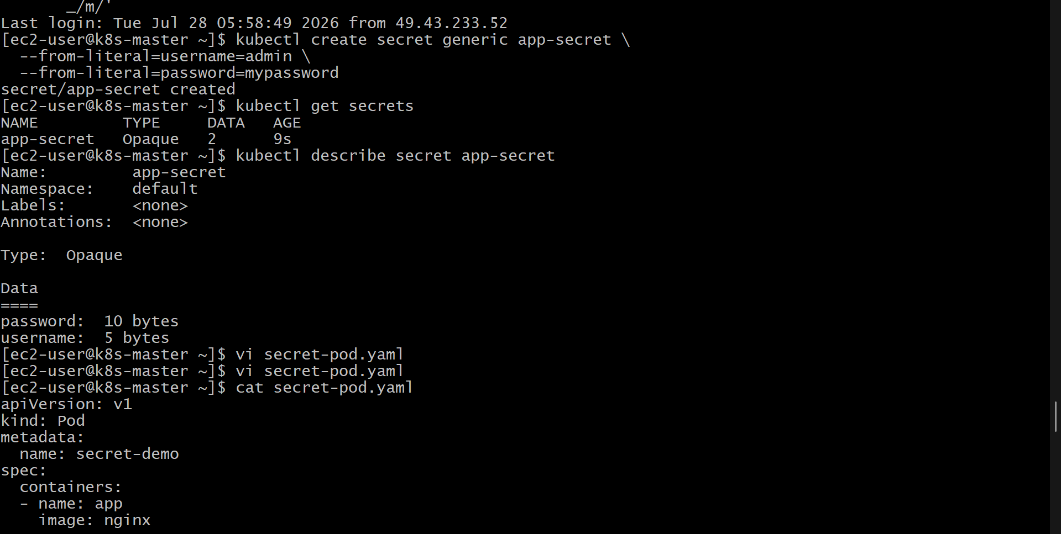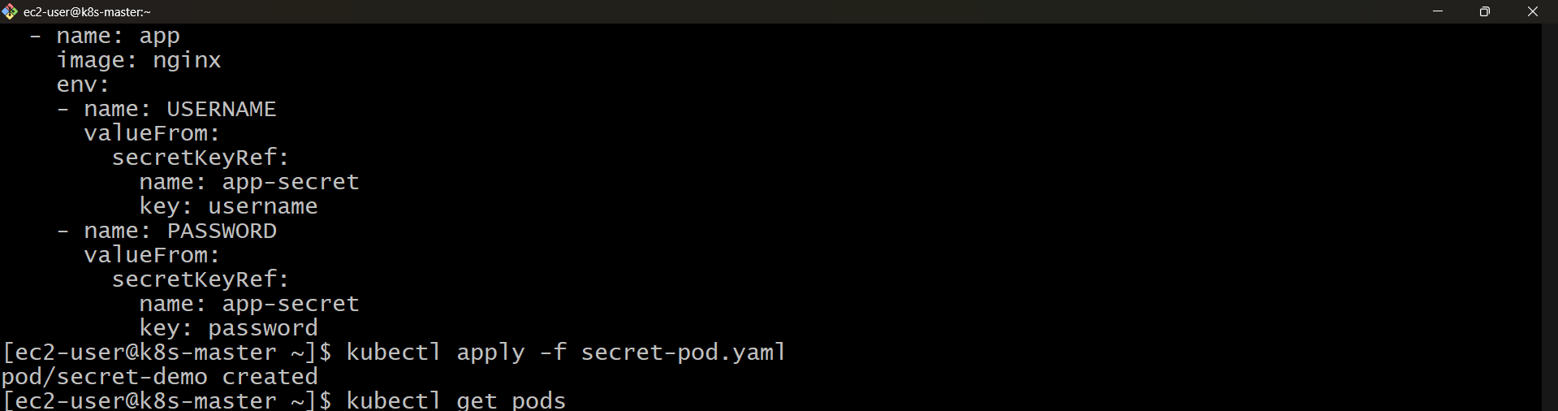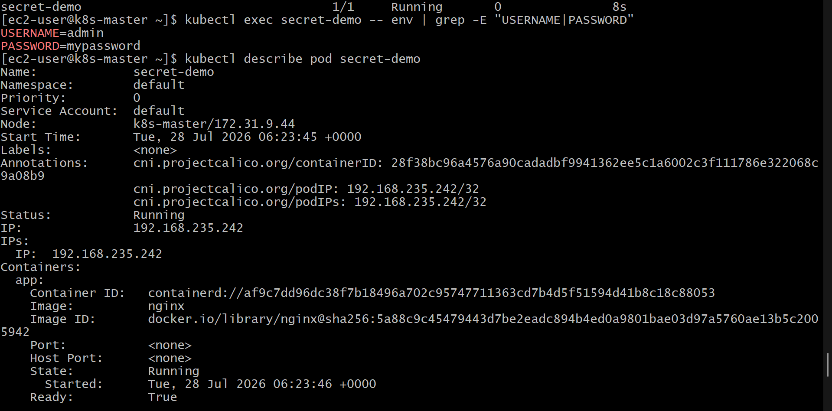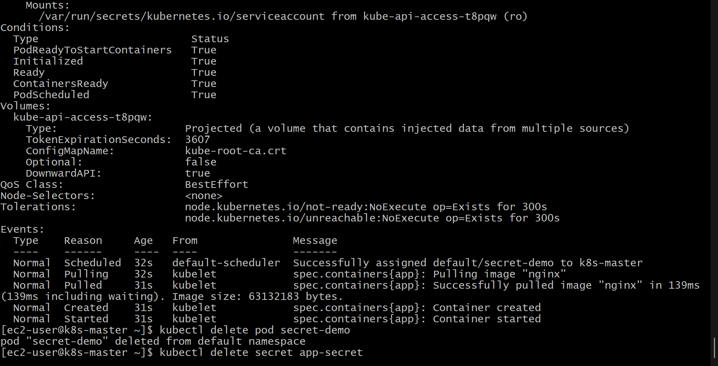
Experiment: Create a Secret Using a YAML File and Mount it as a Volume Inside a Pod
Objective
To create a Kubernetes Secret using a YAML manifest file, mount the Secret as a volume inside a Pod, and verify that the sensitive Secret values are available as files inside the container.

Prerequisites
- Kubernetes cluster (Minikube, Kind, or any Kubernetes cluster)
- kubectl installed and configured
- Basic understanding of Kubernetes Pods and Secrets

Step 1: Create a Secret YAML File
Create a file named secret.yaml.
apiVersion: v1
kind: Secret
metadata:
name: app-secret
type: Opaque
data:
username: YWRtaW4=
password: TXlTZWNyZXQxMjM=
Explanation
- username contains the Base64 encoded value of admin.
- password contains the Base64 encoded value of MySecret123.
- Kubernetes Secrets require values to be Base64 encoded.
To encode values manually:
echo -n "admin" | base64
Output:
YWRtaW4=
echo -n "MySecret123" | base64
Output:
TXlTZWNyZXQxMjM=

Step 2: Create the Secret
Apply the Secret YAML file.
kubectl apply -f secret.yaml

Step 3: Verify the Secret
List the Secrets.
kubectl get secrets
Expected Output:
NAME TYPE DATA AGE
app-secret Opaque 2 20s
View Secret details.
kubectl describe secret app-secret

Step 4: Create a Pod YAML File to Mount the Secret
Create a file named pod.yaml.
apiVersion: v1
kind: Pod
metadata:
name: secret-volume-demo
spec:
containers:
- name: app
image: nginx
volumeMounts:
- name: secret-volume
mountPath: /etc/secret
readOnly: true
volumes:
- name: secret-volume
secret:
secretName: app-secret
Explanation
- The Secret app-secret is mounted as a volume.
- Each Secret key becomes a file inside /etc/secret.
- The file names are the Secret keys (username and password).

Step 5: Create the Pod
Deploy the Pod.
kubectl apply -f pod.yaml
Check the Pod status.
kubectl get pods
Expected Output:
NAME READY STATUS RESTARTS AGE
secret-volume-demo 1/1 Running 0 20s

Step 6: Verify Secret Files Inside the Pod
List the mounted Secret files.
kubectl exec secret-volume-demo -- ls /etc/secret
Expected Output:
password
username

Step 7: Verify Specific Secret Values
Check the username file.
kubectl exec secret-volume-demo -- cat /etc/secret/username
Expected Output:
admin
Check the password file.
kubectl exec secret-volume-demo -- cat /etc/secret/password
Expected Output:
MySecret123

Step 8: Verify the Mounted Secret Volume
Describe the Pod.
kubectl describe pod secret-volume-demo
Check the output under:
Volumes:
secret-volume:
Type: Secret
SecretName: app-secret

Mounts:
/etc/secret from secret-volume

Result
A Kubernetes Secret was successfully created using a YAML file and mounted as a volume inside a Pod. The Secret values were exposed as files inside the container and verified successfully.

Conclusion
This experiment demonstrated how to create a Kubernetes Secret using a YAML manifest and mount it as a volume inside a Pod. Each Secret key was automatically converted into a file within the mounted directory, allowing applications to securely access sensitive information such as usernames and passwords without storing them directly in application code or container images.
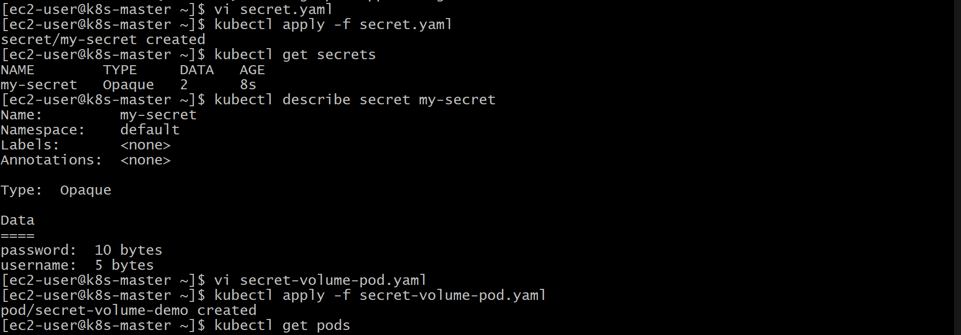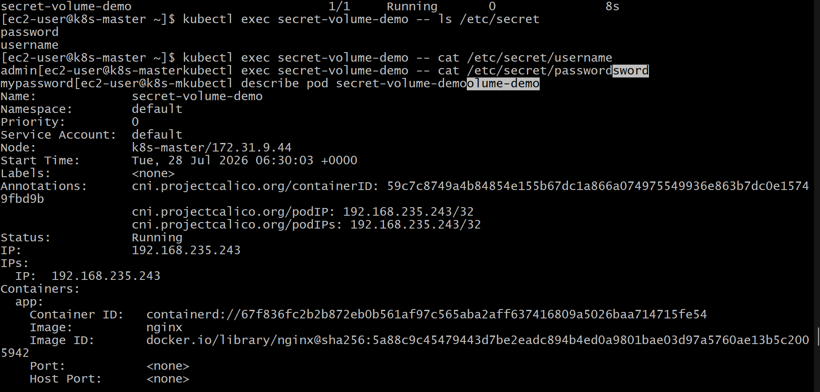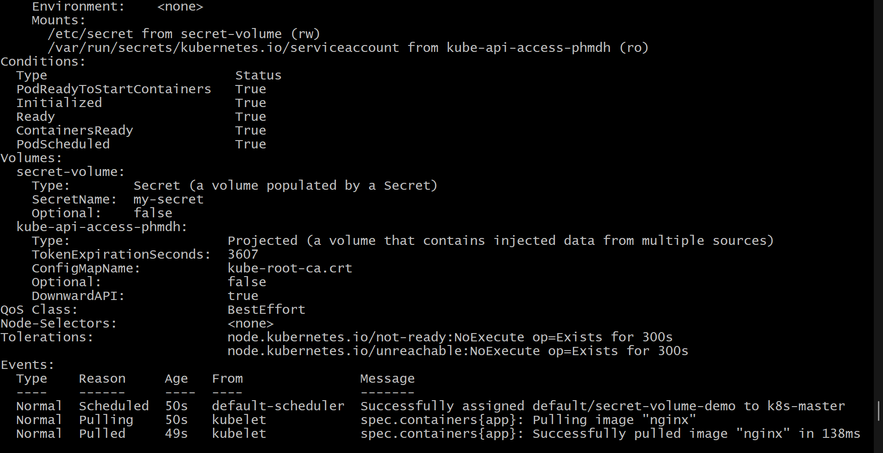

Experiment: Inject a ConfigMap as Environment Variables and a Secret as Files into the Same Pod
Objective
To create a Kubernetes ConfigMap and Secret, inject the ConfigMap values into a Pod as environment variables, mount the Secret as files inside the Pod, and verify that both configuration data and sensitive information are accessible within the container.

Prerequisites
- Kubernetes cluster (Minikube, Kind, or any Kubernetes cluster)
- kubectl installed and configured
- Basic knowledge of Kubernetes ConfigMaps, Secrets, and Pods

Step 1: Create a ConfigMap
Create a ConfigMap containing application configuration values.
kubectl create configmap app-config \
--from-literal=APP_ENV=production \
--from-literal=APP_PORT=8080

Verify the ConfigMap
kubectl get configmap
View ConfigMap details:
kubectl describe configmap app-config
Expected Output:
Data
====
APP_ENV:
production
APP_PORT:
8080

Step 2: Create a Secret YAML File
Create a file named secret.yaml.
apiVersion: v1
kind: Secret
metadata:
name: app-secret
type: Opaque
data:
username: YWRtaW4=
password: TXlTZWNyZXQxMjM=
Explanation
- username is the Base64 encoded value of admin.
- password is the Base64 encoded value of MySecret123.
To encode values:
echo -n "admin" | base64
Output:
YWRtaW4=
echo -n "MySecret123" | base64
Output:
TXlTZWNyZXQxMjM=

Step 3: Create the Secret
Apply the Secret YAML file.
kubectl apply -f secret.yaml

Verify the Secret
kubectl get secrets
View Secret details:
kubectl describe secret app-secret

Step 4: Create a Pod Manifest
Create a file named pod.yaml.
apiVersion: v1
kind: Pod
metadata:
name: config-secret-demo
spec:
containers:
- name: app
image: nginx

# Inject ConfigMap values as environment variables
env:
- name: APP_ENV
valueFrom:
configMapKeyRef:
name: app-config
key: APP_ENV

- name: APP_PORT
valueFrom:
configMapKeyRef:
name: app-config
key: APP_PORT

# Mount Secret as files
volumeMounts:
- name: secret-volume
mountPath: /etc/secret
readOnly: true

volumes:
- name: secret-volume
secret:
secretName: app-secret

Step 5: Create the Pod
Deploy the Pod.
kubectl apply -f pod.yaml
Check Pod status:
kubectl get pods
Expected Output:
NAME READY STATUS RESTARTS AGE
config-secret-demo 1/1 Running 0 20s

Step 6: Verify ConfigMap Environment Variables
Check the environment variables inside the Pod.
kubectl exec config-secret-demo -- printenv | grep -E 'APP_ENV|APP_PORT'
Expected Output:
APP_ENV=production
APP_PORT=8080

Step 7: Verify Secret Files
List the Secret files mounted inside the Pod.
kubectl exec config-secret-demo -- ls /etc/secret
Expected Output:
password
username

Verify Secret Values
Check the username file:
kubectl exec config-secret-demo -- cat /etc/secret/username
Output:
admin
Check the password file:
kubectl exec config-secret-demo -- cat /etc/secret/password
Output:
MySecret123

Step 8: Verify Pod Configuration
Describe the Pod:
kubectl describe pod config-secret-demo
Verify:
- ConfigMap values are injected as environment variables.
- Secret is mounted as a volume at /etc/secret.
Expected sections:
Environment:
APP_ENV: production
APP_PORT: 8080

Mounts:
/etc/secret from secret-volume

Result
A ConfigMap and Secret were successfully created and used together in the same Kubernetes Pod. The ConfigMap values were injected as environment variables, while the Secret values were mounted as files inside the container. Both configuration sources were verified and accessible from within the Pod.

Conclusion
This experiment demonstrated how Kubernetes can manage application configuration and sensitive information separately. ConfigMaps are suitable for non-confidential configuration data and can be injected as environment variables, while Secrets are used for sensitive data and can be mounted securely as files. Using both together allows applications to access required configuration and credentials without embedding them directly into container images.
