Kubernetes Lab: Create and Test a Pod with an EmptyDir Volume
Objective
- Create a Kubernetes Pod with an emptyDir volume.
- Mount the volume inside a container.
- Write data into the volume.
- Verify that the data is shared and stored inside the Pod.
- Understand that the emptyDir volume exists only during the Pod lifecycle.

Step 1: Create the Pod Manifest with EmptyDir Volume
Create a file named emptydir-pod.yaml and add the following YAML configuration:
apiVersion: v1
kind: Pod
metadata:
name: emptydir-pod
spec:
containers:
- name: nginx
image: nginx
volumeMounts:
- name: shared-storage
mountPath: /data

volumes:
- name: shared-storage
emptyDir: {}

Explanation
- emptyDir creates an empty directory when the Pod is assigned to a node.
- The volume is created on the node where the Pod runs.
- The volume is shared between containers inside the same Pod.
- Data stored in emptyDir is deleted when the Pod is removed.

Step 2: Create the Pod
Deploy the Pod using the YAML file:
kubectl apply -f emptydir-pod.yaml
Expected Output:
pod/emptydir-pod created

Step 3: Verify Pod Status
Check the Pod status:
kubectl get pods
Example Output:
NAME READY STATUS RESTARTS AGE
emptydir-pod 1/1 Running 0 30s
The Pod is running successfully.

Step 4: Verify the EmptyDir Volume
Describe the Pod:
kubectl describe pod emptydir-pod
Look for the volume section:
Volumes:
shared-storage:
Type: EmptyDir
This confirms that the Pod is using an emptyDir volume.

Step 5: Write Data into the EmptyDir Volume
Access the container shell:
kubectl exec -it emptydir-pod -- /bin/bash
Inside the container, create a test file:
echo "Hello from EmptyDir volume" > /data/test.txt
Verify the file:
cat /data/test.txt
Expected Output:
Hello from EmptyDir volume
Exit from the container:
exit

Step 6: Verify Data from the Pod
Run the following command from outside the container:
kubectl exec emptydir-pod -- cat /data/test.txt
Expected Output:
Hello from EmptyDir volume
This confirms that data is stored in the mounted emptyDir volume.

Step 7: Check the Volume Mount
Verify the mounted volume:
kubectl exec emptydir-pod -- df -h
Example Output:
Filesystem Size Used Avail Use% Mounted on
/dev/... ... ... ... ... /data
The /data directory is backed by the emptyDir volume.

Step 8: Delete and Recreate the Pod
Delete the Pod:
kubectl delete pod emptydir-pod
Create it again:
kubectl apply -f emptydir-pod.yaml
Check the file again:
kubectl exec emptydir-pod -- cat /data/test.txt
Expected Output:
cat: /data/test.txt: No such file or directory
The file is deleted because emptyDir storage exists only for the lifetime of the Pod.

Step 9: Cleanup
Delete the Pod:
kubectl delete pod emptydir-pod

Summary
Commands Used
kubectl apply -f emptydir-pod.yaml

kubectl get pods

kubectl describe pod emptydir-pod

kubectl exec -it emptydir-pod -- /bin/bash

echo "Hello from EmptyDir volume" > /data/test.txt

kubectl exec emptydir-pod -- cat /data/test.txt

kubectl delete pod emptydir-pod

YAML File: emptydir-pod.yaml
apiVersion: v1
kind: Pod
metadata:
name: emptydir-pod
spec:
containers:
- name: nginx
image: nginx
volumeMounts:
- name: shared-storage
mountPath: /data

volumes:
- name: shared-storage
emptyDir: {}

Conclusion
In this lab, a Kubernetes Pod was created with an emptyDir volume. The volume was mounted inside the container, and data was successfully written and retrieved from it. After deleting and recreating the Pod, the data was lost because emptyDir storage is temporary and exists only during the Pod's lifecycle.
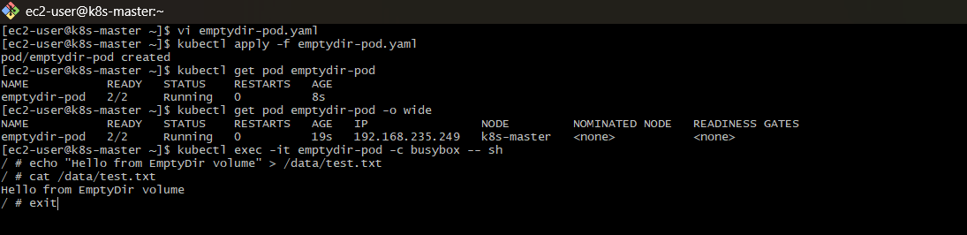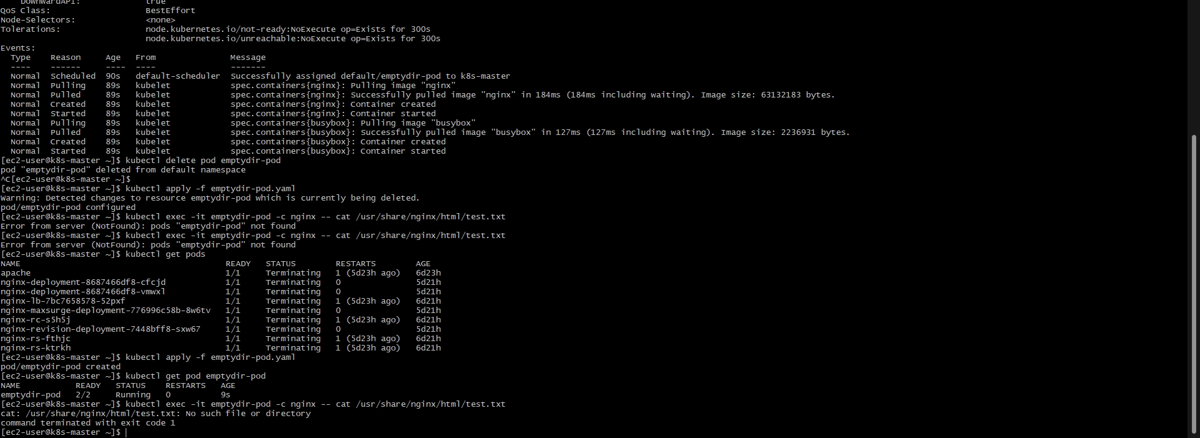

Kubernetes Lab: Configure a HostPath Volume and Validate Data Persistence
Objective
- Configure a Kubernetes Pod with a hostPath volume.
- Mount a directory from the Kubernetes node into the Pod.
- Write data to the mounted volume.
- Delete and recreate the Pod.
- Verify that data persists because it is stored on the host node.

Step 1: Check Available Nodes
List the nodes in the Kubernetes cluster:
kubectl get nodes
Example Output:
NAME STATUS ROLES AGE VERSION
master Ready control-plane 10d v1.31.0
worker1 Ready <none> 10d v1.31.0
Choose the node where the Pod will run (for example, worker1).

Step 2: Create a Directory on the Node
SSH into the Kubernetes node where the Pod will run:
ssh worker1
Create a directory on the host:
sudo mkdir -p /data/hostpath
Add test permissions:
sudo chmod 777 /data/hostpath
Exit from the node:
exit

Step 3: Create the Pod Manifest with HostPath Volume
Create a file named hostpath-pod.yaml and add the following YAML:
apiVersion: v1
kind: Pod
metadata:
name: hostpath-pod
spec:
containers:
- name: nginx
image: nginx
volumeMounts:
- name: host-storage
mountPath: /data

volumes:
- name: host-storage
hostPath:
path: /data/hostpath
type: Directory

Explanation
- hostPath mounts a file or directory from the node's filesystem into the Pod.
- The directory /data/hostpath exists on the Kubernetes node.
- Any data written inside /data in the container is stored on the node.
- Data remains available even after the Pod is deleted and recreated on the same node.

Step 4: Create the Pod
Deploy the Pod:
kubectl apply -f hostpath-pod.yaml
Expected Output:
pod/hostpath-pod created

Step 5: Verify Pod Status
Check the Pod:
kubectl get pods -o wide
Example Output:
NAME READY STATUS NODE
hostpath-pod 1/1 Running worker1
Confirm that the Pod is running on the node where the hostPath directory was created.

Step 6: Write Data into the HostPath Volume
Access the Pod shell:
kubectl exec -it hostpath-pod -- /bin/bash
Create a test file:
echo "Data stored in HostPath volume" > /data/test.txt
Verify the file:
cat /data/test.txt
Expected Output:
Data stored in HostPath volume
Exit the container:
exit

Step 7: Verify Data on the Kubernetes Node
SSH into the node where the Pod is running:
ssh worker1
Check the hostPath directory:
cat /data/hostpath/test.txt
Expected Output:
Data stored in HostPath volume
This confirms that the data is stored on the host machine.

Step 8: Delete the Pod
Delete the Pod:
kubectl delete pod hostpath-pod
Verify that the Pod is deleted:
kubectl get pods

Step 9: Recreate the Pod
Create the Pod again:
kubectl apply -f hostpath-pod.yaml
Verify the Pod is running:
kubectl get pods -o wide

Step 10: Validate Data Persistence
Check whether the previous data still exists:
kubectl exec hostpath-pod -- cat /data/test.txt
Expected Output:
Data stored in HostPath volume
The data is still available because it was stored on the node's filesystem, not inside the Pod.

Step 11: Cleanup
Delete the Pod:
kubectl delete pod hostpath-pod
Remove the hostPath directory from the node:
sudo rm -rf /data/hostpath

Summary
Commands Used
kubectl get nodes

kubectl apply -f hostpath-pod.yaml

kubectl get pods -o wide

kubectl exec -it hostpath-pod -- /bin/bash

echo "Data stored in HostPath volume" > /data/test.txt

kubectl exec hostpath-pod -- cat /data/test.txt

kubectl delete pod hostpath-pod

YAML File: hostpath-pod.yaml
apiVersion: v1
kind: Pod
metadata:
name: hostpath-pod
spec:
containers:
- name: nginx
image: nginx
volumeMounts:
- name: host-storage
mountPath: /data

volumes:
- name: host-storage
hostPath:
path: /data/hostpath
type: Directory

Conclusion
In this lab, a Kubernetes Pod was configured with a hostPath volume. Data written inside the Pod was stored directly on the Kubernetes node filesystem. After deleting and recreating the Pod, the data remained available, demonstrating that hostPath provides persistence beyond the Pod lifecycle as long as the Pod runs on the same node.
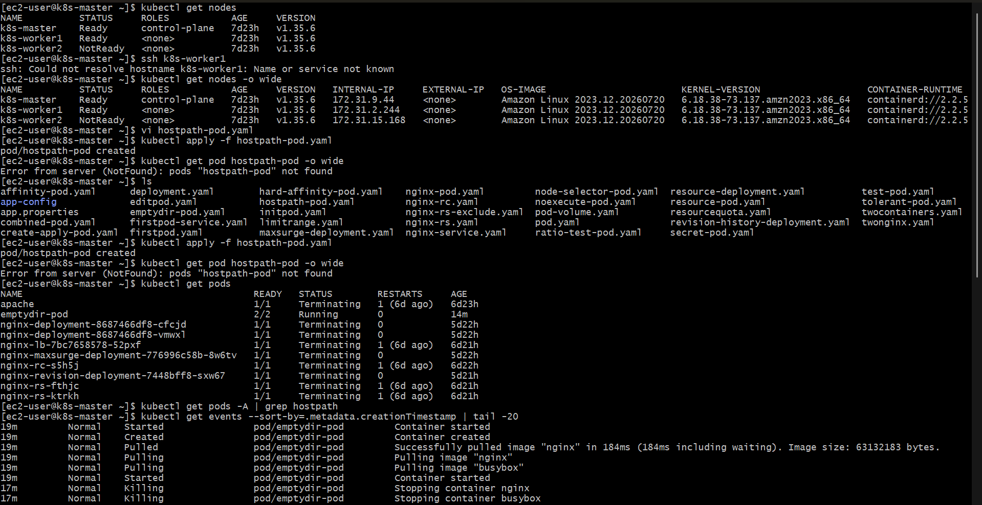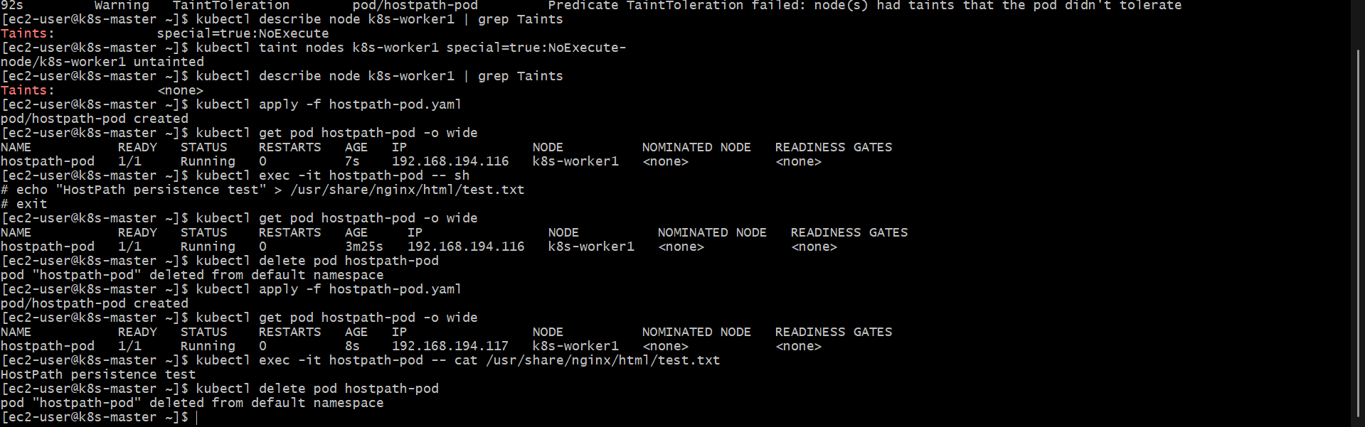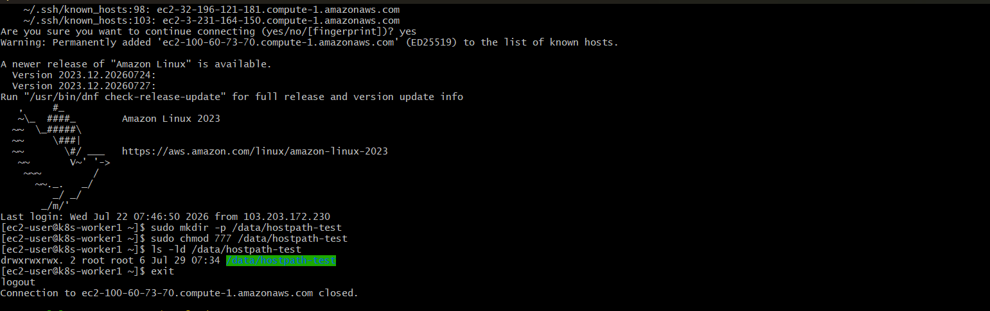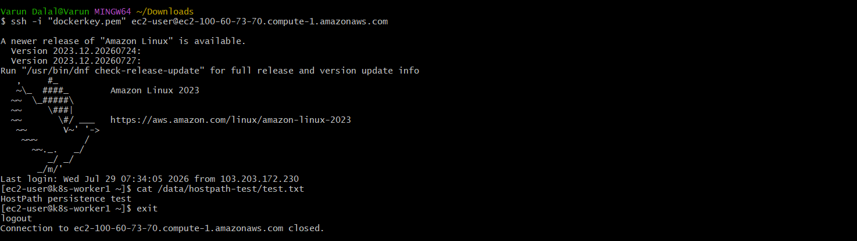

Kubernetes Lab: Deploy an Amazon EBS Volume Using Persistent Volume and Persistent Volume Claim (PVC)
Objective
- Create an Amazon EBS volume for Kubernetes storage.
- Configure a Persistent Volume (PV) using the EBS volume.
- Create a Persistent Volume Claim (PVC) to request storage.
- Mount the PVC into a Pod.
- Verify data persistence using the EBS-backed storage.

Prerequisites
Before starting, ensure:
- A Kubernetes cluster is running on Amazon EKS.
- Worker nodes are running on AWS EC2 instances.
- AWS CLI is configured.
- EBS CSI Driver is installed in the cluster.
Verify the EBS CSI Driver:
kubectl get pods -n kube-system | grep ebs
Example Output:
ebs-csi-controller-xxxxx Running
ebs-csi-node-xxxxx Running

Step 1: Create an Amazon EBS Volume
Login to AWS Console:
- Open EC2 Dashboard.
- Go to Elastic Block Store → Volumes.
- Click Create Volume.
- Select:
  - Volume Type: gp3
  - Size: 10 GiB
  - Availability Zone: Same AZ as your Kubernetes worker node.
- Click Create Volume.
After creation, note the EBS Volume ID.
Example:
vol-0123456789abcdef0

Step 2: Check Kubernetes Worker Node Availability Zone
Find the node details:
kubectl get nodes -o wide
Check the Availability Zone:
kubectl describe node <worker-node-name> | grep topology.kubernetes.io/zone
Ensure the EBS volume is created in the same Availability Zone.

Step 3: Create Persistent Volume (PV)
Create a file named ebs-pv.yaml:
apiVersion: v1
kind: PersistentVolume
metadata:
name: ebs-pv
spec:
capacity:
storage: 10Gi

accessModes:
- ReadWriteOnce

persistentVolumeReclaimPolicy: Retain

storageClassName: ebs-sc

awsElasticBlockStore:
volumeID: vol-0123456789abcdef0
fsType: ext4
Replace:
vol-0123456789abcdef0
with your actual AWS EBS Volume ID.

Step 4: Create the Persistent Volume
Apply the PV configuration:
kubectl apply -f ebs-pv.yaml
Expected Output:
persistentvolume/ebs-pv created
Verify the PV:
kubectl get pv
Example Output:
NAME CAPACITY ACCESS MODES STATUS STORAGECLASS
ebs-pv 10Gi RWO Available ebs-sc

Step 5: Create Persistent Volume Claim (PVC)
Create a file named ebs-pvc.yaml:
apiVersion: v1
kind: PersistentVolumeClaim
metadata:
name: ebs-pvc

spec:
accessModes:
- ReadWriteOnce

resources:
requests:
storage: 10Gi

storageClassName: ebs-sc

Step 6: Create the PVC
Apply the PVC:
kubectl apply -f ebs-pvc.yaml
Expected Output:
persistentvolumeclaim/ebs-pvc created
Verify the PVC:
kubectl get pvc
Example Output:
NAME STATUS VOLUME CAPACITY
ebs-pvc Bound ebs-pv 10Gi
The PVC is successfully bound to the Persistent Volume.

Step 7: Create a Pod Using the PVC
Create a file named ebs-pod.yaml:
apiVersion: v1
kind: Pod
metadata:
name: ebs-test-pod

spec:
containers:
- name: nginx
image: nginx

volumeMounts:
- name: ebs-storage
mountPath: /data

volumes:
- name: ebs-storage
persistentVolumeClaim:
claimName: ebs-pvc

Step 8: Deploy the Pod
Create the Pod:
kubectl apply -f ebs-pod.yaml
Expected Output:
pod/ebs-test-pod created
Check Pod status:
kubectl get pods -o wide
Example Output:
NAME READY STATUS NODE
ebs-test-pod 1/1 Running worker-node

Step 9: Test Data Persistence
Access the Pod:
kubectl exec -it ebs-test-pod -- /bin/bash
Create a test file:
echo "Data stored in Amazon EBS volume" > /data/test.txt
Verify the file:
cat /data/test.txt
Expected Output:
Data stored in Amazon EBS volume
Exit:
exit

Step 10: Delete and Recreate the Pod
Delete the Pod:
kubectl delete pod ebs-test-pod
Create it again:
kubectl apply -f ebs-pod.yaml
Verify the Pod:
kubectl get pods

Step 11: Verify Data Persistence
Check the previously created file:
kubectl exec ebs-test-pod -- cat /data/test.txt
Expected Output:
Data stored in Amazon EBS volume
The data remains available because it is stored on the Amazon EBS volume.

Step 12: Cleanup
Delete the Pod:
kubectl delete pod ebs-test-pod
Delete PVC:
kubectl delete pvc ebs-pvc
Delete PV:
kubectl delete pv ebs-pv
Delete the EBS volume from AWS Console if it is no longer required.

Summary
Commands Used
kubectl get nodes -o wide

kubectl apply -f ebs-pv.yaml

kubectl get pv

kubectl apply -f ebs-pvc.yaml

kubectl get pvc

kubectl apply -f ebs-pod.yaml

kubectl get pods -o wide

kubectl exec -it ebs-test-pod -- /bin/bash

kubectl delete pod ebs-test-pod

YAML File: ebs-pv.yaml
apiVersion: v1
kind: PersistentVolume
metadata:
name: ebs-pv
spec:
capacity:
storage: 10Gi
accessModes:
- ReadWriteOnce
persistentVolumeReclaimPolicy: Retain
storageClassName: ebs-sc
awsElasticBlockStore:
volumeID: vol-0123456789abcdef0
fsType: ext4

YAML File: ebs-pvc.yaml
apiVersion: v1
kind: PersistentVolumeClaim
metadata:
name: ebs-pvc
spec:
accessModes:
- ReadWriteOnce
resources:
requests:
storage: 10Gi
storageClassName: ebs-sc

YAML File: ebs-pod.yaml
apiVersion: v1
kind: Pod
metadata:
name: ebs-test-pod
spec:
containers:
- name: nginx
image: nginx
volumeMounts:
- name: ebs-storage
mountPath: /data

volumes:
- name: ebs-storage
persistentVolumeClaim:
claimName: ebs-pvc

Conclusion
In this lab, an Amazon EBS volume was integrated with Kubernetes using a Persistent Volume (PV) and Persistent Volume Claim (PVC). The PVC provided storage access to the Pod, and data written to the mounted volume remained available even after the Pod was deleted and recreated, demonstrating persistent storage using Amazon EBS.
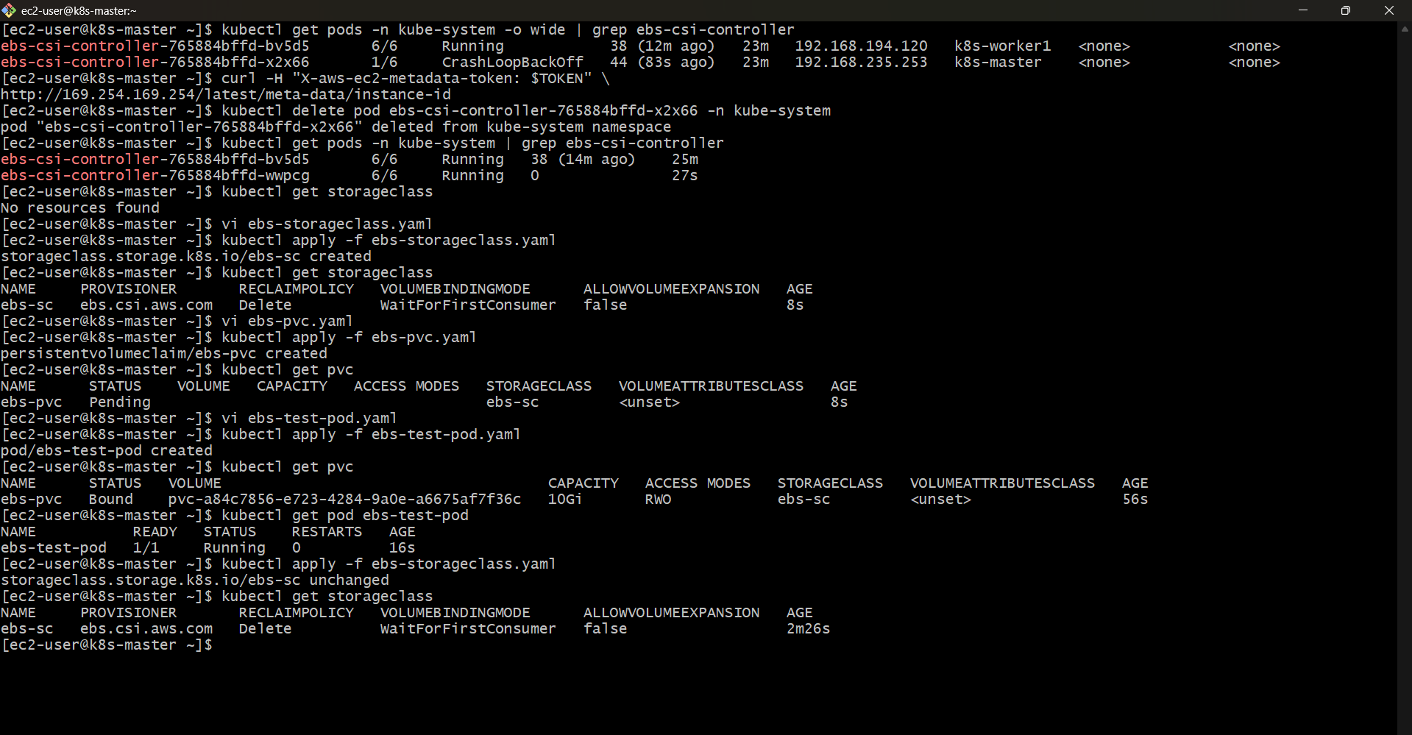

Kubernetes Lab: Implement and Test Liveness and Readiness Probes in a Pod
Objective
- Create a Kubernetes Pod with Liveness Probe and Readiness Probe.
- Verify that the Liveness Probe restarts an unhealthy container.
- Verify that the Readiness Probe controls whether a Pod receives traffic.
- Test probe behavior by modifying the application state.

Step 1: Understand Kubernetes Probes
Liveness Probe
A Liveness Probe checks whether the application inside a container is running correctly.
- If the probe fails, Kubernetes restarts the container.
- Used to detect application failures.
Example:
- Application becomes stuck or stops responding.
- Kubernetes automatically restarts the container.

Readiness Probe
A Readiness Probe checks whether a container is ready to receive traffic.
- If the probe fails, Kubernetes removes the Pod from Service endpoints.
- The container continues running.
Example:
- Application is starting.
- Application temporarily cannot handle requests.

Step 2: Create a Pod Manifest with Probes
Create a file named probe-pod.yaml:
apiVersion: v1
kind: Pod
metadata:
name: probe-test-pod

spec:
containers:
- name: nginx
image: nginx

ports:
- containerPort: 80

livenessProbe:
httpGet:
path: /
port: 80
initialDelaySeconds: 10
periodSeconds: 5

readinessProbe:
httpGet:
path: /
port: 80
initialDelaySeconds: 5
periodSeconds: 5

Explanation of Configuration
Liveness Probe Configuration
livenessProbe:
httpGet:
path: /
port: 80
- Kubernetes sends an HTTP request to /.
- If the request fails repeatedly, the container is restarted.

Readiness Probe Configuration
readinessProbe:
httpGet:
path: /
port: 80
- Kubernetes checks whether the application is ready.
- Failed readiness checks remove the Pod from Service traffic.

Timing Parameters
Parameter | Description
initialDelaySeconds | Time to wait before starting the probe
periodSeconds | Frequency of probe checks

Step 3: Create the Pod
Deploy the Pod:
kubectl apply -f probe-pod.yaml
Expected Output:
pod/probe-test-pod created

Step 4: Verify Pod Status
Check the Pod:
kubectl get pods
Example Output:
NAME READY STATUS
probe-test-pod 1/1 Running
The Pod is running and both probes are successful.

Step 5: Verify Probe Configuration
Describe the Pod:
kubectl describe pod probe-test-pod
Look for:
Liveness:
http-get http://:80/
Initial Delay: 10s
Period: 5s

Readiness:
http-get http://:80/
Initial Delay: 5s
Period: 5s

Step 6: Test Readiness Probe Failure
Access the container:
kubectl exec -it probe-test-pod -- /bin/bash
Move the default nginx page:
mv /usr/share/nginx/html/index.html /usr/share/nginx/html/index.html.bak
Create a failing response:
echo "Application Not Ready" > /usr/share/nginx/html/index.html
Exit:
exit
Check Pod status:
kubectl get pods
The Pod may show:
NAME READY STATUS
probe-test-pod 0/1 Running
Explanation:
- The container is still running.
- The Pod is marked as not ready.
- Traffic will not be sent to this Pod.

Step 7: Restore Readiness
Access the Pod:
kubectl exec -it probe-test-pod -- /bin/bash
Restore the nginx page:
mv /usr/share/nginx/html/index.html.bak /usr/share/nginx/html/index.html
Exit:
exit
Check status:
kubectl get pods
Expected:
NAME READY STATUS
probe-test-pod 1/1 Running
The Pod becomes ready again.

Step 8: Test Liveness Probe Failure
Install a command to simulate failure by stopping nginx:
kubectl exec -it probe-test-pod -- /bin/bash
Stop nginx:
nginx -s stop
Exit:
exit

Step 9: Observe Container Restart
Check Pod status:
kubectl get pods
Example:
NAME READY STATUS
probe-test-pod 1/1 Running
Check restart count:
kubectl get pods
Example:
NAME READY STATUS RESTARTS
probe-test-pod 1/1 Running 1
Explanation:
- Liveness probe detected that nginx was not responding.
- Kubernetes restarted the container automatically.

Step 10: Check Probe Events
View Pod events:
kubectl describe pod probe-test-pod
Example:
Events:

Warning Unhealthy
Liveness probe failed

Normal Killing
Container failed liveness probe, restarting

Step 11: Cleanup
Delete the Pod:
kubectl delete pod probe-test-pod

Summary
Commands Used
kubectl apply -f probe-pod.yaml

kubectl get pods

kubectl describe pod probe-test-pod

kubectl exec -it probe-test-pod -- /bin/bash

kubectl get pods

kubectl delete pod probe-test-pod

YAML File: probe-pod.yaml
apiVersion: v1
kind: Pod
metadata:
name: probe-test-pod

spec:
containers:
- name: nginx
image: nginx

ports:
- containerPort: 80

livenessProbe:
httpGet:
path: /
port: 80
initialDelaySeconds: 10
periodSeconds: 5

readinessProbe:
httpGet:
path: /
port: 80
initialDelaySeconds: 5
periodSeconds: 5

Conclusion
In this lab, Liveness and Readiness Probes were configured for a Kubernetes Pod. The Readiness Probe controlled whether the Pod received traffic, while the Liveness Probe detected application failure and automatically restarted the container. These probes help Kubernetes maintain application availability and reliability.
