YUVAINTERN

Data Cleaning and
Preliminary Analysis with R
Week 1 Internship Report
Virtual R Data Analyst Intern
Submitted by: Damagatla Varun Kumar
Dataset: Hotel Booking Demand
Analysis environment: R 4.6.1 / RStudio
Submission date: 2 October 2026

1. Executive Summary
This report documents a preliminary data-cleaning and exploratory-analysis workflow for the Hotel Booking Demand dataset using R. The work included importing and inspecting the data, identifying missing values and placeholder strings, treating missing entries, checking duplicate rows, detecting potential outliers with the interquartile range (IQR) method, creating normalized variables, encoding selected categorical variables, and exploring booking cancellation patterns and numerical correlations.
The analysis initially contained 119,390 rows and 32 columns. The working cleaned dataset contained 87,396 rows and 34 columns after the performed cleaning and creation of two normalized variables. The final checks reported zero missing cells and zero exact duplicate rows. Because 31,994 exact duplicate rows were removed, this reduction is an important methodological limitation and should be considered when interpreting all subsequent results.

2. Objectives
- Select a public dataset containing numerical and categorical variables.
- Inspect data types, dimensions, summaries, missing values, and duplicate rows.
- Apply and document missing-value treatment and data transformations.
- Identify potential outliers without automatically deleting legitimate extreme observations.
- Explore booking status, hotel type, distributions, and numerical correlations.
- Save reproducible R outputs and visual evidence for the internship submission.

3. Dataset Overview
The selected dataset is Hotel Booking Demand, a tabular dataset of hotel booking records. The analysis uses variables including hotel, lead_time, arrival-date fields, length-of-stay fields, adults, children, ADR (average daily rate), market/channel information, special requests, and is_canceled. It contains both categorical and numerical variables, making it suitable for data cleaning and preliminary analysis.
Dataset source: Hotel Booking Demand dataset by Nuno Antonio, Ana de Almeida, and Luis Nunes, published through the article 'Hotel booking demand datasets' in Data in Brief (2019). Dataset landing page: https://doi.org/10.1016/j.dib.2018.11.126. The CSV file used in this analysis was available locally as data/hotel_bookings.csv.

4. R Environment and Packages
The analysis was performed in R 4.6.1 using RStudio. Packages used in the workflow included readr/tidyverse for data import and manipulation, janitor for column-name cleaning, ggplot2 for charts, naniar for missing-value visualization, and corrplot for the correlation heatmap.
Package setup code:
install.packages(c("tidyverse", "janitor", "naniar", "corrplot"))
library(tidyverse)
library(janitor)
library(naniar)
library(corrplot)

5. Import and Initial Inspection
The CSV was imported and column names were standardized with clean_names(). The user-observed initial dimensions were 119,390 rows and 32 columns.
hotel_raw <- read_csv(
"data/hotel_bookings.csv",
show_col_types = FALSE
) %>%
clean_names()
dim(hotel_raw)
names(hotel_raw)
str(hotel_raw)
summary(hotel_raw)
Initial inspection results: 119,390 records and 32 columns. The initial actual missing-value scan identified four missing cells in children. Further inspection found the text placeholder "NULL" in agent and company; converting these placeholders to real missing values exposed additional missingness.

6. Data Cleaning and Preprocessing

6.1 Missing values and placeholders
Literal "NULL" strings in character columns were converted to proper R missing values using na_if(). Missing children values were imputed with the median, which was 0 in the observed R session. Missing agent and company identifiers were assigned the category "Unknown". The remaining 452 missing country entries were also assigned "Unknown". The final quality check reported zero missing cells.
hotel_clean <- hotel_raw %>%
mutate(across(
where(is.character),
~ na_if(trimws(.x), "NULL")
))
children_median <- median(hotel_clean$children, na.rm = TRUE)
hotel_clean$children[is.na(hotel_clean$children)] <- children_median
hotel_clean$agent[is.na(hotel_clean$agent)] <- "Unknown"
hotel_clean$company[is.na(hotel_clean$company)] <- "Unknown"
hotel_clean$country[is.na(hotel_clean$country)] <- "Unknown"
sum(is.na(hotel_clean))
Final observed output: Total missing cells = 0.

6.2 Duplicate rows
The workflow counted 31,994 exact duplicate rows and removed them using distinct(). The resulting dataset had 87,396 rows. No exact duplicate rows remained after this operation.
rows_before <- nrow(hotel_clean)
hotel_clean <- hotel_clean %>% distinct()
rows_after <- nrow(hotel_clean)
cat("Rows before:", rows_before, "\n")
cat("Rows after:", rows_after, "\n")
cat("Duplicates removed:", rows_before - rows_after, "\n")
Limitation: Identical rows may represent repeated records or legitimate bookings; without a booking identifier or source-specific validation, they cannot automatically be assumed erroneous. Results in this report describe the deduplicated working dataset, not the full original dataset.

6.3 Outlier detection
Potential outliers were identified with the 1.5 × IQR rule. The observed counts were 2,396 for lead_time and 2,490 for ADR. These values were retained rather than removed automatically.
count_iqr_outliers <- function(x) {
q1 <- quantile(x, 0.25, na.rm = TRUE)
q3 <- quantile(x, 0.75, na.rm = TRUE)
iqr_value <- IQR(x, na.rm = TRUE)
lower <- q1 - 1.5 * iqr_value
upper <- q3 + 1.5 * iqr_value
sum(x < lower | x > upper, na.rm = TRUE)
}
The descriptive statistics also showed a maximum ADR of 5,400 and a maximum adult count of 55. These unusual values should be reviewed against the data dictionary and source records before any decision to remove or alter them.

6.4 Normalization
Min-max normalization was applied to lead_time and ADR, creating lead_time_normalized and adr_normalized. The observed normalized variables ranged from 0 to 1. The final dataset contained 34 columns, consistent with adding two normalized columns to the 32 original columns.
min_max_normalize <- function(x) {
min_value <- min(x, na.rm = TRUE)
max_value <- max(x, na.rm = TRUE)
if (max_value == min_value) return(rep(0, length(x)))
(x - min_value) / (max_value - min_value)
}
hotel_clean <- hotel_clean %>%
mutate(
lead_time_normalized = min_max_normalize(lead_time),
adr_normalized = min_max_normalize(adr)
)
Note: Earlier proposed code also mentioned normalizing stay-length variables, but the final summary supplied for this report contains only the two normalized variables listed above.

6.5 Categorical encoding
A separate one-hot encoded dataset was prepared for selected categorical fields: hotel, meal, market_segment, distribution_channel, and customer_type. The intended approach was to convert these columns to factors and use model.matrix(~ . - 1, data = categorical_data). The encoded file should be verified in the RStudio output folder before submission.
categorical_data <- hotel_clean %>%
select(hotel, meal, market_segment,
distribution_channel, customer_type) %>%
mutate(across(everything(), as.factor))
encoded_data <- as.data.frame(
model.matrix(~ . - 1, data = categorical_data)
)
write.csv(encoded_data,
"outputs/hotel_categorical_encoded.csv",
row.names = FALSE)

7. Descriptive Statistics
The following statistics are taken from the R console output shared during the analysis. Values are rounded for readability.
Variable | Mean | Median | SD | Minimum | Maximum
lead_time | 79.9 | 49 | 86.1 | 0 | 737
stays_in_weekend_nights | 1.01 | 1 | 1.03 | 0 | 19
stays_in_week_nights | 2.63 | 2 | 2.05 | 0 | 50
adults | 1.88 | 2 | 0.627 | 0 | 55
children | 0.139 | 0 | 0.456 | 0 | 10
adr | 106 | 98.10 | 55.0 | 0 | 5,400
total_of_special_requests | 0.699 | 0 | 0.832 | 0 | 5
is_canceled | 0.275 | 0 | 0.446 | 0 | 1
Interpretation: The median lead time was 49 days. The median weekday stay was two nights, and the median number of adults was two. ADR had a mean of approximately 106 and a median of 98.10; the mean being higher than the median is consistent with some higher-rate observations influencing the mean.

8. Exploratory Data Analysis

8.1 Booking cancellation status
In the cleaned dataset, 63,371 records (72.5%) were not canceled and 24,025 (27.5%) were canceled.
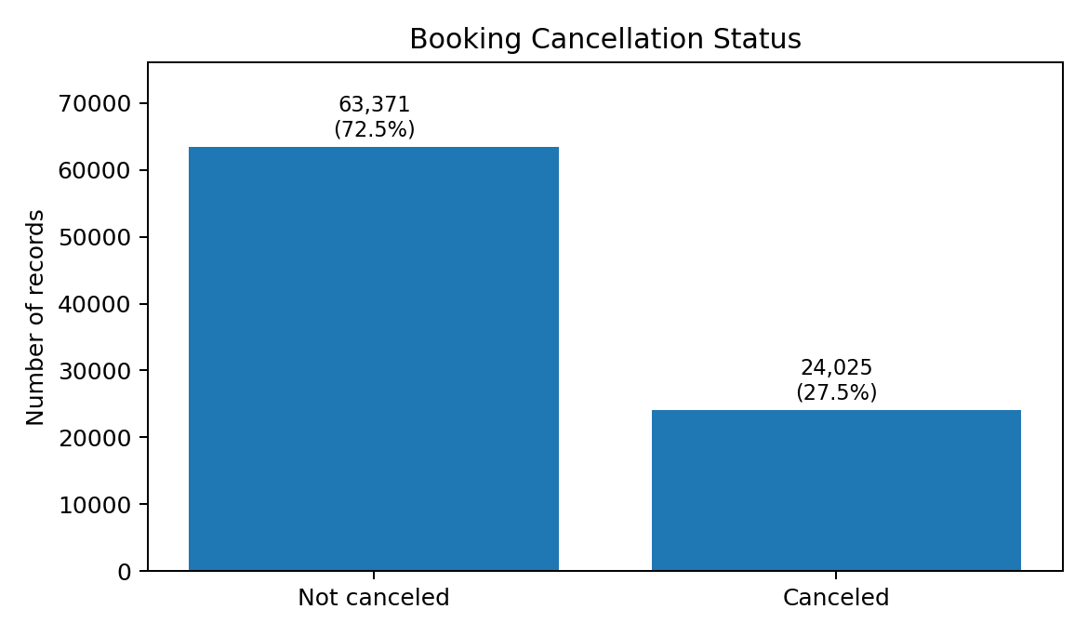

8.2 Records by hotel type
City Hotel represented 53,428 records (61.1%), while Resort Hotel represented 33,968 records (38.9%).
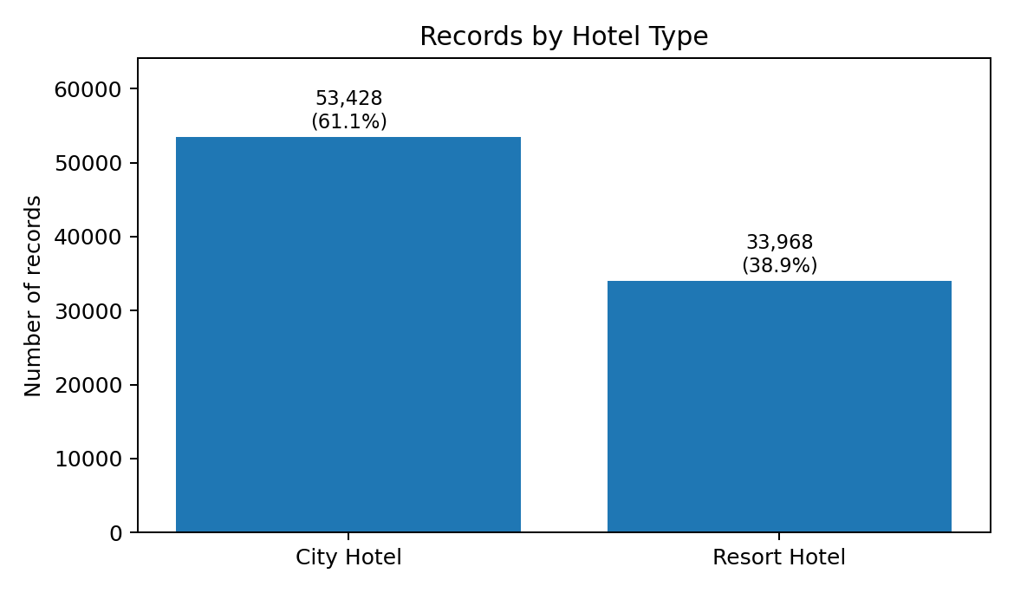

8.3 Cancellation rate by hotel type
The cancellation rate was 30.0% for City Hotel (16,049 canceled records out of 53,428) and 23.5% for Resort Hotel (7,976 out of 33,968). The observed difference was approximately 6.5 percentage points. This is descriptive and does not explain the cause of the difference.
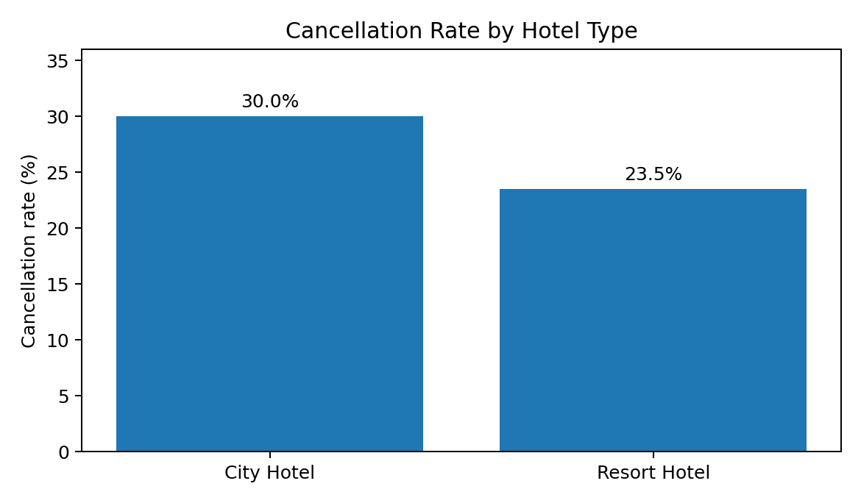

8.4 Lead-time and ADR distributions
Histograms were generated in R for lead_time and ADR, and boxplots were generated for both variables. The figures should be retained from the RStudio outputs folder and can be inserted as additional evidence. The supplied console output confirms that the plotting commands and ggsave calls ran, but the actual R-generated images were not available for inclusion in this document.

8.5 Correlation analysis
Pearson correlations were calculated for selected numerical variables using pairwise complete observations. Selected correlations from the R output are shown below.
Variable pair | r | Interpretation
Weekend nights and weekday nights | 0.56 | Moderate positive association
Children and ADR | 0.33 | Positive association
Lead time and weekday nights | 0.31 | Positive association
Adults and ADR | 0.25 | Positive association
Lead time and cancellation | 0.18 | Weak positive association
ADR and cancellation | 0.13 | Weak positive association
Special requests and cancellation | -0.12 | Weak negative association
The strongest positive relationship among the selected variables was between weekend nights and weekday nights (r = 0.56). Correlation indicates linear association and does not establish causation. The heatmap was saved in R as outputs/correlation_heatmap.png.

9. Key Findings
- The deduplicated working dataset contains 87,396 records and 34 columns.
- Missing values were handled, and the final quality check reported zero missing cells.
- The IQR method flagged 2,396 lead-time values and 2,490 ADR values as potential outliers; they were retained.
- Not-canceled records made up 72.5% of the cleaned dataset; canceled records made up 27.5%.
- City Hotel represented 61.1% of records and Resort Hotel 38.9%.
- The observed cancellation rate was 30.0% for City Hotel and 23.5% for Resort Hotel.
- Weekend-night and weekday-night counts had the strongest selected correlation (r = 0.56).

10. Limitations and Further Work
- Removing 31,994 exact duplicates materially reduced the dataset. Compare deduplicated and non-deduplicated results and confirm the dataset documentation before treating duplicates as errors.
- The extreme ADR and adults values require validation against source documentation before being corrected or removed.
- Only lead_time and ADR are evidenced as normalized in the final descriptive-statistics output.
- The encoded CSV should be checked to confirm it was created and saved successfully.
- These are preliminary descriptive analyses; they do not establish causal relationships or predict future cancellations.

11. Conclusion
This task provided practical experience in importing, inspecting, cleaning, transforming, and exploring a real-world booking dataset with R. The work produced a cleaned CSV, descriptive-statistics table, correlation matrix, heatmap, and exploratory charts. The results indicate that cancellation patterns differ between the two hotel types in the deduplicated data and that length-of-stay variables are positively associated. Before using the findings for operational decisions, duplicate handling and unusual observations should be validated against the dataset documentation.

Appendix A. Reproducibility and Output Files
The R project should retain the source CSV in data/ and save generated artifacts in outputs/. Key outputs used or referenced in this report include:
- hotel_bookings_cleaned.csv
- descriptive_statistics.csv
- correlation_matrix.csv
- correlation_heatmap.png
- missing_values.png
- lead_time_boxplot.png and adr_boxplot.png
- cancellation_status.png
- bookings_by_hotel.png
- lead_time_distribution.png and adr_distribution.png
- cancellation_rate_by_hotel.png
- hotel_categorical_encoded.csv (verify before submission)
Prepared from the R console outputs supplied during the Week 1 analysis. Aggregate chart figures in this document were recreated from the exact counts and percentages shown in those outputs; distribution plots and the correlation heatmap should be included from the RStudio outputs folder when available.

