AICTE | IBM SkillsBuild
Data Analytics with AI Internship 2026
PROJECT REPORT
Customer Churn Prediction using Data Analytics and Machine Learning
A data-driven study of the IBM Telco Customer Churn dataset
Submitted by | Varun Krishna Dhanave
College / University | Visvesvaraya Technological University
Branch / Year | Electronics & Communication Engg (2024)
Internship Program | IBM SkillsBuild Data Analytics with AI
Conducted by | BharatCares in association with AICTE
Submission Date | September 2026

Table of Contents
Table of Contents 2
Abstract 3
1. Introduction 4
1.1 Background 4
1.2 Problem Statement 4
1.3 Objectives 4
1.4 Scope 4
2. Dataset Description 5
3. Tools and Technologies 5
4. Methodology 6
4.1 Data Cleaning 6
4.2 Feature Engineering 6
4.3 Preprocessing and Train-Test Split 6
4.4 Models 6
4.5 Evaluation Metrics 7
4.6 Hyperparameter Tuning 7
5. Exploratory Data Analysis 8
5.1 Overall Churn 8
5.2 Contract, Internet Service and Payment Method 8
5.3 Tenure 9
5.4 Monthly and Total Charges 10
5.5 Other Categorical Features 11
5.6 Correlation 12
6. Model Building and Results 13
6.1 Model Comparison 13
6.2 Hyperparameter Tuning 14
6.3 Final Model Evaluation 14
6.4 Choosing the Decision Threshold 15
7. Model Explainability 16
8. Customer Risk Scoring 17
9. Business Insights and Recommendations 18
10. Limitations and Future Work 18
10.1 Limitations 18
10.2 Future Work 18
11. Conclusion 19
12. References 20
Appendix: Project Files and How to Run 20

Abstract
Customer churn, the loss of customers to competitors or cancellation, is one of the most expensive problems in the telecommunications industry because acquiring a new customer costs far more than retaining an existing one. This project uses the IBM Telco Customer Churn dataset, containing 7,043 customers and 21 attributes, to understand the causes of churn and to build a model that predicts which customers are most likely to leave.
The work follows a complete data analytics workflow: data cleaning, exploratory data analysis, feature engineering, model building with Logistic Regression, Random Forest and Gradient Boosting, hyperparameter tuning, model explanation using permutation importance, and customer risk scoring. The overall churn rate is 26.5%. Contract type, customer tenure, internet service type, payment method and the presence of technical-support services emerge as the strongest drivers.
The final tuned Gradient Boosting model achieves a ROC-AUC of 0.846 and an accuracy of 0.796 on unseen customers. Customers labelled High risk by the model actually churned 71.9% of the time, compared with only 9.7% for Low-risk customers, showing that the model can be used to prioritise retention efforts. The report closes with practical business recommendations, limitations and directions for future work.

1. Introduction

1.1 Background
Telecommunications is a highly competitive, subscription-based industry. Customers can switch providers easily, and each lost customer removes recurring revenue. Industry studies consistently report that retaining an existing customer is significantly cheaper than acquiring a new one, so telecom companies invest heavily in understanding and reducing churn.
Data analytics and machine learning make it possible to move from reacting to churn after it happens to predicting it in advance, so that a retention team can contact at-risk customers with a timely offer.

1.2 Problem Statement
Given a customer's demographic information, subscribed services and billing details, determine (a) which factors are associated with churn and (b) whether the customer is likely to churn, so that the company can act before the customer leaves.

1.3 Objectives
- Clean and prepare the Telco customer data for analysis.
- Perform exploratory data analysis to identify the patterns and factors linked to churn.
- Build and compare machine learning classification models to predict churn.
- Evaluate models with metrics suited to an imbalanced problem (recall, F1-score, ROC-AUC).
- Explain which features drive the model's predictions.
- Convert model output into High / Medium / Low customer risk segments.
- Recommend practical retention strategies based on the findings.

1.4 Scope
The project is a supervised binary classification task on a single, static snapshot of customer data. It covers analysis, modelling and interpretation; it does not include deployment to a live system or a cost-benefit study of retention offers.

2. Dataset Description
The project uses the publicly available IBM Telco Customer Churn dataset, published in IBM's GitHub repository (telco-customer-churn-on-icp4d) and also available on Kaggle. Each row represents one customer of a fictional telecom company.
- Size: 7,043 customers and 21 columns.
- Target variable: Churn (Yes / No). 1,869 customers (26.5%) churned and 5,174 (73.5%) stayed.
- Feature groups: customer demographics, subscribed services, and account / billing information.
Table 1: Description of dataset columns
Column | Description | Type
customerID | Unique customer identifier (dropped before modelling) | Text
gender | Male or Female | Categorical
SeniorCitizen | Whether the customer is a senior citizen | Categorical
Partner | Whether the customer has a partner | Categorical
Dependents | Whether the customer has dependents | Categorical
tenure | Number of months the customer has stayed with the company | Numeric
PhoneService | Whether the customer has phone service | Categorical
MultipleLines | Whether the customer has multiple phone lines | Categorical
InternetService | Internet provider type: DSL, Fiber optic or No | Categorical
OnlineSecurity | Online security add-on | Categorical
OnlineBackup | Online backup add-on | Categorical
DeviceProtection | Device protection add-on | Categorical
TechSupport | Technical support add-on | Categorical
StreamingTV | Streams TV content | Categorical
StreamingMovies | Streams movies | Categorical
Contract | Month-to-month, One year or Two year | Categorical
PaperlessBilling | Whether billing is paperless | Categorical
PaymentMethod | Electronic check, Mailed check, Bank transfer or Credit card | Categorical
MonthlyCharges | Amount charged each month | Numeric
TotalCharges | Total amount charged over the customer's lifetime | Numeric
Churn | Whether the customer left in the last month (target) | Target

3. Tools and Technologies
Table 2: Technologies used
Tool / Library | Purpose
Python 3 | Programming language for the whole project
Google Colab | Interactive development environment combining code, output and explanations
pandas and NumPy | Data loading, cleaning, transformation and numerical operations
Matplotlib and Seaborn | Creating charts for exploratory analysis and model evaluation
scikit-learn | Preprocessing pipelines, machine learning models, cross-validation, GridSearchCV, evaluation metrics and permutation importance
GitHub | Version control and public hosting of the project files

4. Methodology
The project follows the standard data analytics lifecycle. Every step is implemented in the accompanying Jupyter Notebook so that the results can be reproduced end to end.

4.1 Data Cleaning
- TotalCharges was stored as text. Converting it to numeric exposed 11 blank values.
- All 11 blank rows had a tenure of 0, meaning brand-new customers who had not yet been billed. They were therefore filled with 0 rather than a mean or median.
- SeniorCitizen (coded 0/1) was mapped to No/Yes for consistency with the other yes/no columns.
- customerID was removed before modelling, and the target Churn was encoded as 1 (Yes) and 0 (No).
- No duplicate rows or duplicate customer IDs were found.

4.2 Feature Engineering
- NumAddOnServices: count of add-on services (online security, backup, device protection, tech support, streaming TV and movies) that a customer subscribes to.
- AvgChargePerMonth: TotalCharges divided by tenure, capturing what the customer has actually paid per month (monthly charge is used for tenure 0).

4.3 Preprocessing and Train-Test Split
The data was split 80% / 20% into training (5,634 customers) and test (1,409 customers) sets using stratification so that both sets keep the same 26.5% churn ratio. A scikit-learn ColumnTransformer standardised numeric features and one-hot encoded categorical features. Wrapping preprocessing and model in a single Pipeline ensures that no information from the test set leaks into training.

4.4 Models
- Logistic Regression: a simple, interpretable baseline.
- Random Forest: an ensemble of decision trees that captures non-linear relationships.
- Gradient Boosting: builds trees sequentially, each correcting the errors of the previous ones; often strongest on tabular data.
Because only about a quarter of customers churn, class_weight = "balanced" was used for Logistic Regression and Random Forest so that the minority (churn) class receives more attention.

4.5 Evaluation Metrics
Accuracy alone is misleading for imbalanced data: a model that predicts "no churn" for everyone would already be about 73% accurate while finding no churners. The following metrics were therefore used:
- Precision: of the customers flagged as churners, the share who really churn.
- Recall: of the customers who really churn, the share the model catches.
- F1-score: the harmonic mean of precision and recall.
- ROC-AUC: how well the model ranks churners above non-churners across all thresholds (0.5 = random, 1.0 = perfect).

4.6 Hyperparameter Tuning
GridSearchCV with 5-fold stratified cross-validation, optimising ROC-AUC, was used to tune the regularisation strength of Logistic Regression and the number of trees, learning rate and tree depth of Gradient Boosting.

5. Exploratory Data Analysis

5.1 Overall Churn
Of the 7,043 customers, 1,869 (26.5%) churned. The classes are imbalanced, which motivated the choice of evaluation metrics described in Section 4.5.
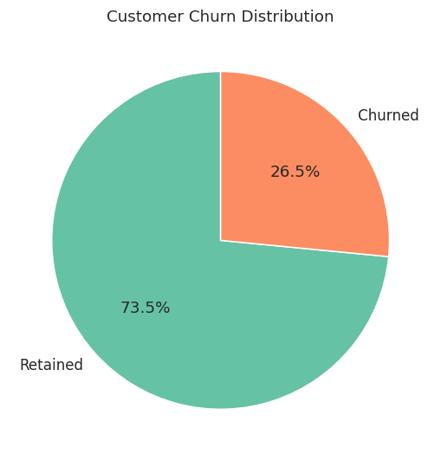
Figure 1: Distribution of churned and retained customers

5.2 Contract, Internet Service and Payment Method
Three account attributes show very large differences in churn.
- Contract: month-to-month customers churn at 42.7%, one-year customers at 11.3% and two-year customers at only 2.8%.
- Internet service: fiber optic customers churn at 41.9%, compared with 19.0% for DSL and 7.4% for customers without internet service.
- Payment method: electronic check users churn at 45.3%, while customers paying automatically by bank transfer or credit card churn at about 15-17%.
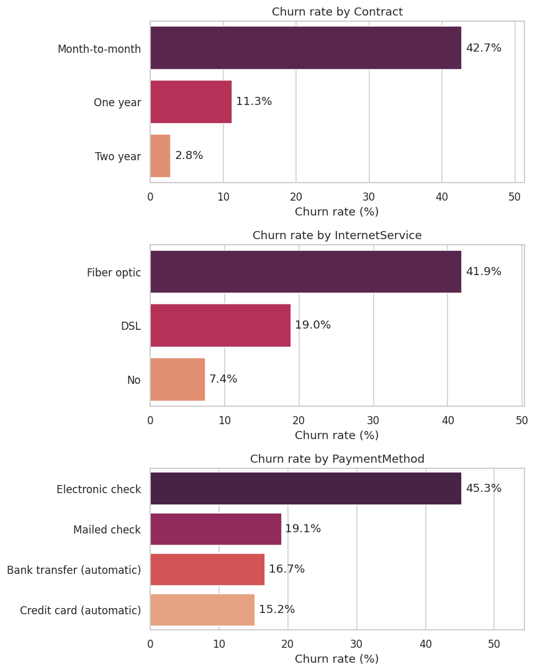
Figure 2: Churn rate by contract, internet service and payment method

5.3 Tenure
Churn is heavily concentrated among new customers. Customers in their first 12 months churn at 47.4%; this falls to 28.7% for 13-24 months, 20.4% for 25-48 months, 14.4% for 49-60 months and just 6.6% beyond five years. The average tenure of churned customers is 18.0 months, compared with 37.6 months for retained customers.
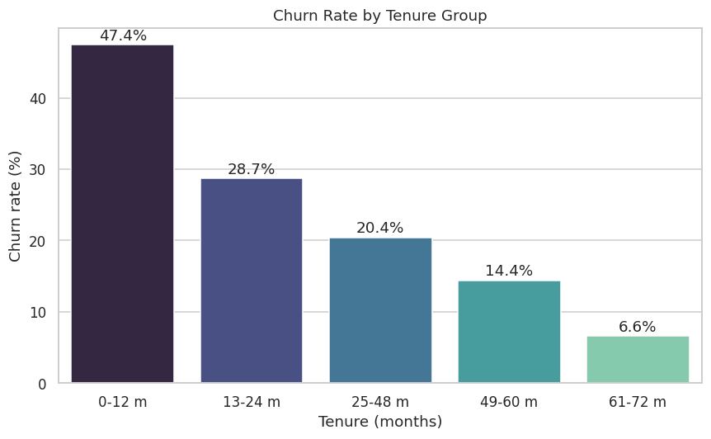
Figure 3: Churn rate by tenure group

5.4 Monthly and Total Charges
Churned customers pay more each month on average (74.4 vs 61.3), yet their total charges are lower (1,531.8 vs 2,549.9) because they stay for a shorter time. The distributions confirm that churn is concentrated among customers with high monthly charges and short tenure.
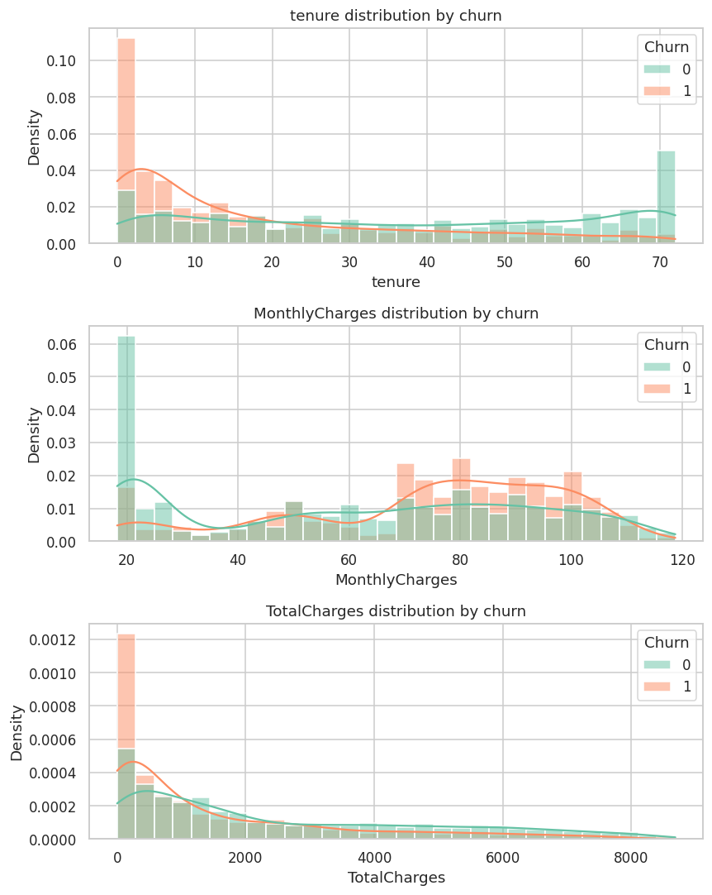
Figure 4: Distribution of tenure, monthly charges and total charges by churn

5.5 Other Categorical Features
Customers without Tech Support (41.6%) or Online Security (41.8%) churn far more than those who have these services (15.2% and 14.6%). Senior citizens churn at 41.7% compared with 23.6% for non-seniors. Gender has no meaningful effect (26.9% female vs 26.2% male), and phone service has almost no effect.
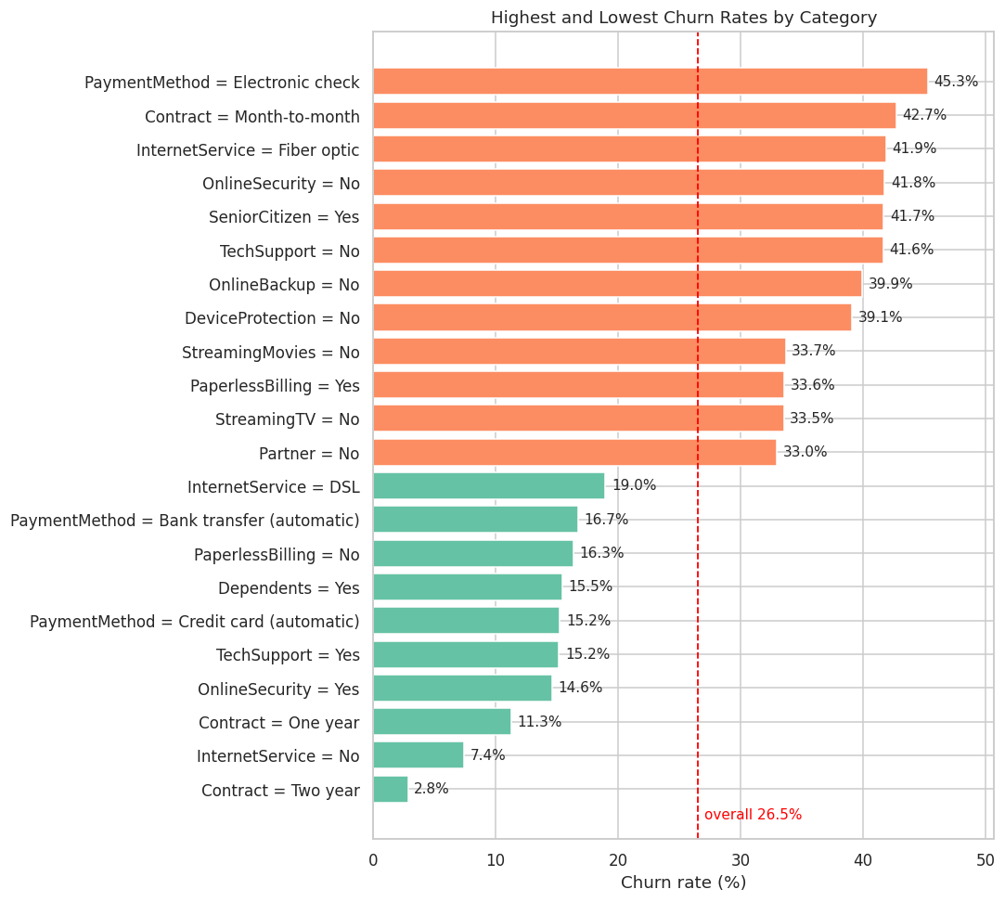
Figure 5: Highest and lowest churn rates across categories (red line = overall average)

5.6 Correlation
Tenure and total charges are strongly and positively correlated, as expected, since total charges accumulate over time. Tenure has a negative correlation with churn, consistent with the earlier finding that long-standing customers rarely leave.
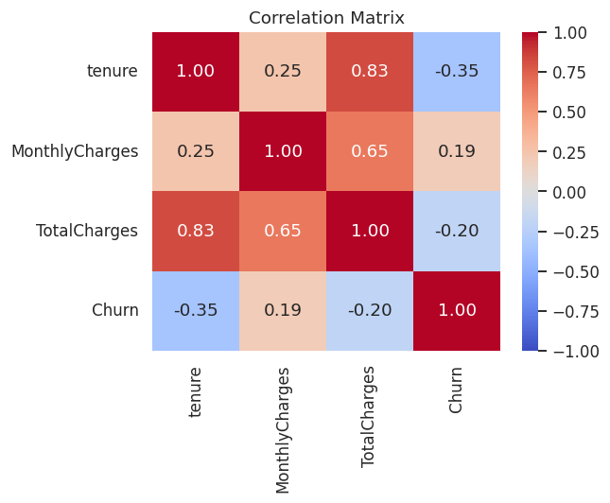
Figure 6: Correlation matrix of numeric features

6. Model Building and Results

6.1 Model Comparison
All three baseline models were trained on the training set with 5-fold cross-validation and evaluated on the held-out test set of 1,409 customers.
Table 3: Baseline model performance on the test set
Model | Accuracy | Precision | Recall | F1-Score | ROC-AUC | CV AUC
Logistic Regression | 0.740 | 0.506 | 0.786 | 0.616 | 0.842 | 0.846
Random Forest | 0.761 | 0.534 | 0.778 | 0.633 | 0.844 | 0.846
Gradient Boosting | 0.797 | 0.655 | 0.497 | 0.565 | 0.843 | 0.847

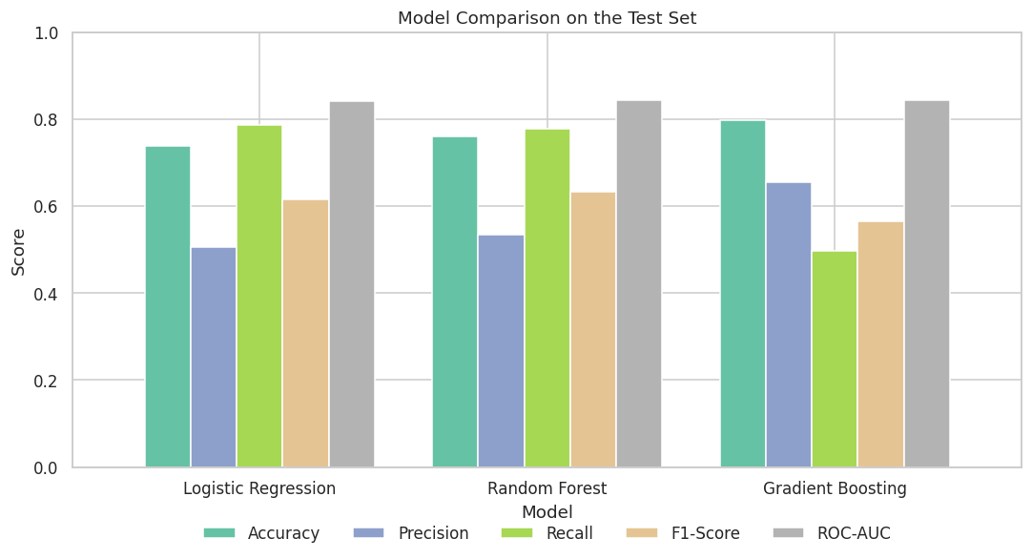
Figure 7: Comparison of models on the test set
The three models rank customers almost equally well (ROC-AUC between 0.842 and 0.844). They differ in how they balance precision and recall at the default 0.5 threshold. Logistic Regression and Random Forest, which use class weights, catch about 78% of churners but flag many customers who would have stayed. Gradient Boosting is more conservative: higher accuracy and precision, but it catches only about half of the churners.
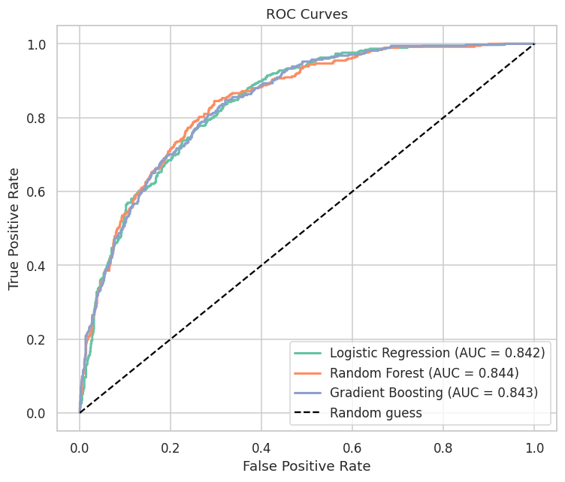
Figure 8: ROC curves of the three models

6.2 Hyperparameter Tuning
Table 4: Performance of tuned models on the test set
Model | Accuracy | Precision | Recall | F1-Score | ROC-AUC
Logistic Regression (tuned) | 0.739 | 0.505 | 0.783 | 0.614 | 0.841
Gradient Boosting (tuned) | 0.796 | 0.655 | 0.487 | 0.558 | 0.846

Tuning changed the results only slightly. The tuned Gradient Boosting model achieved the highest ROC-AUC (0.846) and was selected as the final model. The differences between models are small, so the choice of model matters less than the choice of decision threshold discussed below.

6.3 Final Model Evaluation
On the 1,409 unseen test customers (374 actual churners), the final model correctly identified 182 churners (true positives) and 939 loyal customers (true negatives). It missed 192 churners (false negatives) and wrongly flagged 96 loyal customers (false positives), giving an accuracy of 79.6%, precision of 65.5% and recall of 48.7%.
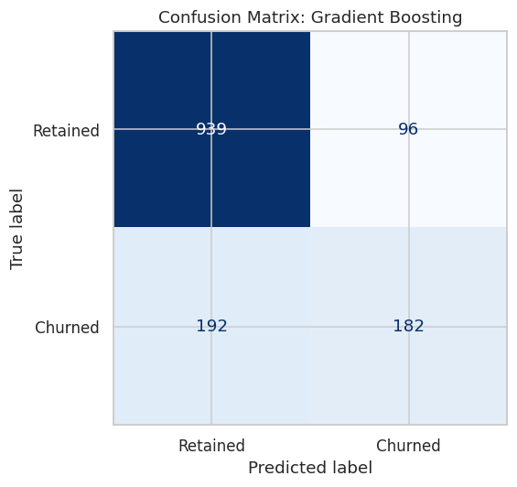
Figure 9: Confusion matrix of the final model (threshold 0.5)

6.4 Choosing the Decision Threshold
By default a customer is flagged when the predicted churn probability is at least 0.5. In a retention setting, missing a churner (lost revenue) usually costs more than contacting a customer who would have stayed, so a lower threshold is often preferable. The table below shows the trade-off.
Table 5: Precision-recall trade-off at different thresholds
Threshold | Precision | Recall | F1-Score | Customers flagged
0.3 | 0.526 | 0.778 | 0.628 | 553
0.4 | 0.603 | 0.628 | 0.615 | 390
0.5 | 0.655 | 0.487 | 0.558 | 278
0.6 | 0.719 | 0.356 | 0.476 | 185
0.7 | 0.804 | 0.219 | 0.345 | 102

Lowering the threshold to 0.3 raises recall from 48.7% to 77.8% and gives the best F1-score (0.628), at the cost of lower precision (52.6%). The business can pick the threshold according to the cost of a retention offer versus the value of a retained customer.

7. Model Explainability
To understand what the model relies on, permutation importance was computed on the original columns of the test set. Each feature is shuffled in turn, and the resulting drop in ROC-AUC measures how much the model depends on it.
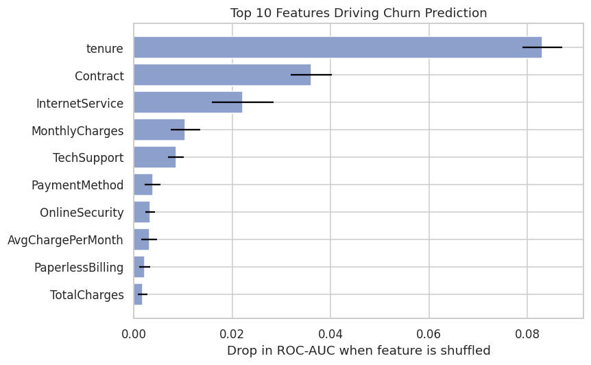
Figure 10: Top 10 features by permutation importance
Table 6: Top 10 features by permutation importance
Rank | Feature | Drop in ROC-AUC
1 | tenure | 0.0830
2 | Contract | 0.0361
3 | InternetService | 0.0221
4 | MonthlyCharges | 0.0105
5 | TechSupport | 0.0085
6 | PaymentMethod | 0.0038
7 | OnlineSecurity | 0.0033
8 | AvgChargePerMonth | 0.0031
9 | PaperlessBilling | 0.0022
10 | TotalCharges | 0.0018

Tenure is by far the most important predictor, followed by Contract type and InternetService. Monthly charges and TechSupport come next. This agrees with the exploratory analysis: short-tenure, month-to-month, fiber-optic customers without technical support form the highest-risk group.

8. Customer Risk Scoring
To make the model directly usable by a retention team, each test customer's predicted churn probability was converted into a risk segment: Low (below 0.3), Medium (0.3 to 0.6) and High (above 0.6).
Table 7: Actual churn rate by predicted risk segment
Risk segment | Customers | Actual churn rate (%) | Avg. monthly charges
Low | 856 | 9.7 | 57.21
Medium | 368 | 42.9 | 72.54
High | 185 | 71.9 | 79.11

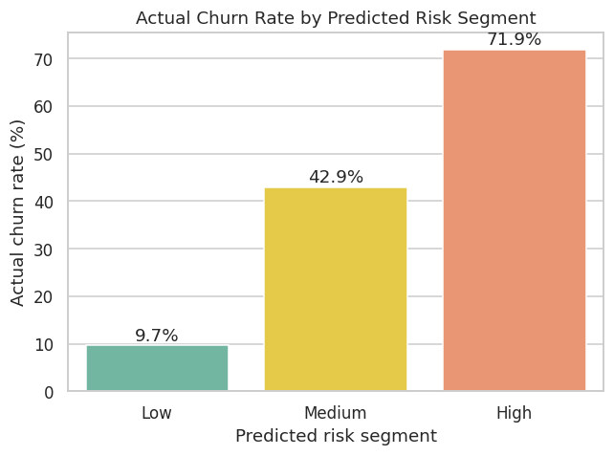
Figure 11: Actual churn rate by predicted risk segment
The segmentation separates customers very clearly. The 185 High-risk customers churned 71.9% of the time, roughly 2.7 times the overall average of 26.5%, whereas the 856 Low-risk customers churned only 9.7% of the time. Focusing retention effort on the High and Medium segments would reach most churners while leaving most loyal customers undisturbed. The notebook also exports a list of the ten highest-risk customers as an example of an actionable output.

9. Business Insights and Recommendations
- Move customers to longer contracts. Month-to-month customers churn at 42.7% versus 2.8% for two-year contracts. Offer discounts, free upgrades or loyalty benefits to customers who commit to 1- or 2-year plans.
- Invest in the first year. Almost half of customers in their first 12 months leave. A structured onboarding programme, a check-in call after the first few months and early-life offers can reduce this.
- Bundle support services. Customers without Tech Support or Online Security churn nearly three times as often. Offering these free or discounted, especially to fiber optic customers, targets the most at-risk group.
- Investigate fiber optic service quality and pricing. Fiber customers churn at 41.9% and pay higher monthly charges; the cause may be price sensitivity or service issues and should be examined.
- Encourage automatic payments. Electronic-check customers churn at 45.3% compared with about 15-17% for automatic payment methods. A small billing incentive for switching to automatic payment is a low-cost intervention.
- Operationalise the model. Score all customers monthly and give the High-risk list to the retention team first, using a threshold chosen from the cost of an offer versus the value of a retained customer.

10. Limitations and Future Work

10.1 Limitations
- The dataset is a single snapshot, so changes in customer behaviour over time cannot be studied.
- The data is from a single (fictional) company, and patterns may differ elsewhere.
- No cost or revenue values for retention offers are available, so the threshold could not be optimised financially.
- The associations found are correlations; they do not prove that changing a factor (for example, contract type) would cause a customer to stay.

10.2 Future Work
- Try additional algorithms such as XGBoost or LightGBM and use SMOTE or other resampling methods.
- Use SHAP values for customer-level explanations of each prediction.
- Add time-based data (usage, complaints, support calls) to detect early warning signals.
- Deploy the model as a web dashboard, for example with Streamlit, so business users can score customers interactively.
- Run A/B tests of retention offers to measure real financial impact.

11. Conclusion
This project demonstrated a complete data analytics and machine learning workflow on the IBM Telco Customer Churn dataset. The exploratory analysis showed that churn is driven mainly by short tenure, month-to-month contracts, fiber optic service, electronic-check payment and the absence of technical-support and security services. The predictive models reached a ROC-AUC of about 0.85, and the final tuned Gradient Boosting model produced risk segments that separate likely churners from loyal customers very effectively (71.9% actual churn in the High-risk group against 9.7% in the Low-risk group).
Beyond model accuracy, the project shows how analytics can be turned into action: identifying who is at risk, understanding why, and recommending targeted retention strategies. With time-based data, cost information and deployment, the same approach could form the basis of a real customer retention system.

12. References
- IBM. Telco Customer Churn dataset. GitHub repository: https://github.com/IBM/telco-customer-churn-on-icp4d
- Kaggle. Telco Customer Churn (BlastChar): https://www.kaggle.com/datasets/blastchar/telco-customer-churn
- scikit-learn developers. scikit-learn: Machine Learning in Python, documentation: https://scikit-learn.org/stable/
- pandas development team. pandas documentation: https://pandas.pydata.org/docs/
- Waskom, M. seaborn: statistical data visualization: https://seaborn.pydata.org/
- Hunter, J. D. Matplotlib: A 2D graphics environment: https://matplotlib.org/
- IBM SkillsBuild learning platform: https://skillsbuild.org/

Appendix: Project Files and How to Run
Table 8: Project deliverables
File | Description
Varun_Krishna_Dhanave_CustomerChurnPrediction.ipynb | Complete project code with outputs
requirements.txt | Python libraries required to run the project
YourName_ProjectReport.docx | This project report
README.md | Project overview, dataset link and run instructions
data/ | Dataset (Telco-Customer-Churn.csv)
images/, results/ | Charts and result tables generated by the notebook

To reproduce the results in Google Colab, first upload the project files or clone the project repository into Colab. Install the required libraries using:
!pip install -r requirements.txt
Open the .ipynb notebook in Google Colab and select Runtime > Restart session and run all.
A fixed random seed of 42 is used throughout the notebook to ensure that the results are consistent and repeatable across multiple runs.

