SET 20

1. Design and implement a C program using Recursive Descent Parsing for the
following grammar:
S → aA
A → bA | c
Verify the following input:
abab
Display the sequence of parsing operations and the final result.
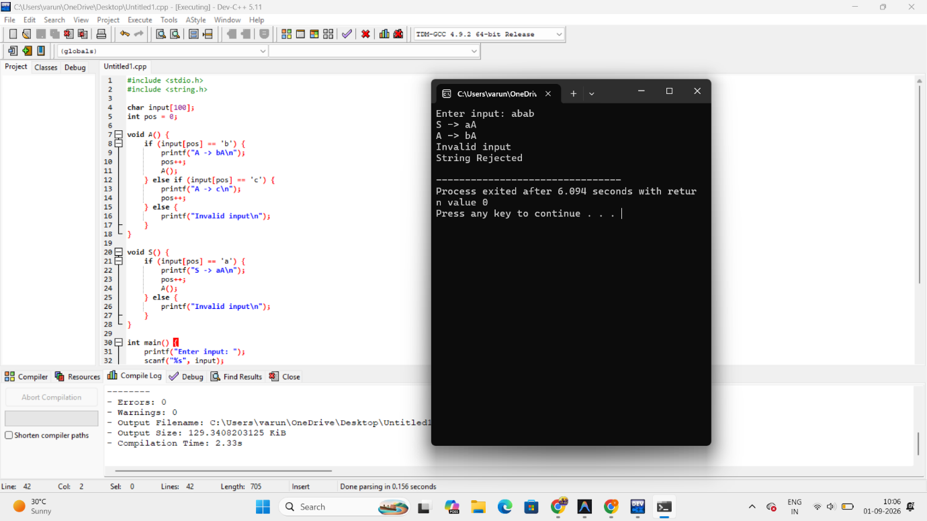

2. Design and implement a C program for a simple code generator that converts the
following Three-Address Code into target instructions:
t1 = a + b
t2 = t1 - c
x = t2
Display the corresponding assembly-like instructions.
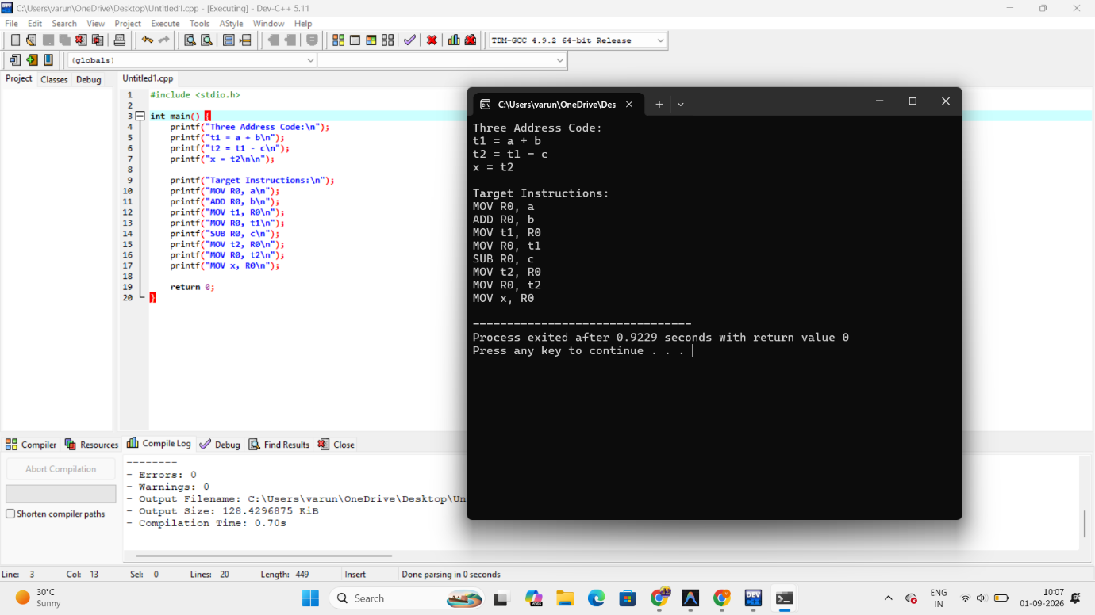

3. Write a LEX Program to check the email address is valid or not.
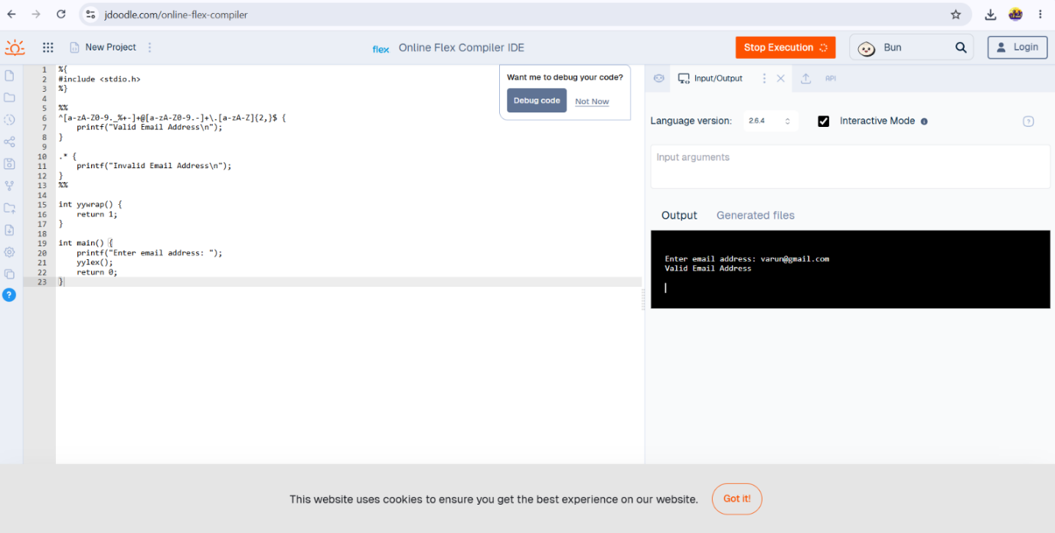

4. Write a LEX program to identify even and odd integers from the given input.
