Cryptography
M.Varunkumar
192311133
11. Write a C program for possible keys does the Playfair cipher have? Ignore the fact that some keys might produce identical encryption results. Express your answer as an approximate power of 2. a. Now take into account the fact that some Playfair keys produce the same encryption results. How many effectively unique keys does the Playfair cipher have?
PROGRAM :
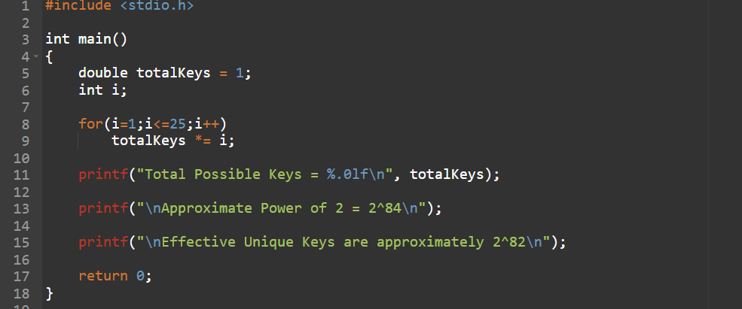
OUTPUT :
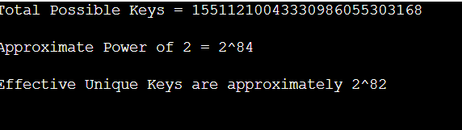

12. a. Write a C program to Encrypt the message “meet me at the usual place at ten rather than eight oclock” using the Hill cipher with the key. [9 4 5 7] a. Show your calculations and the result. b. Show the calculations for the corresponding decryption of the ciphertext to recover the original plaintext.
PROGRAM :
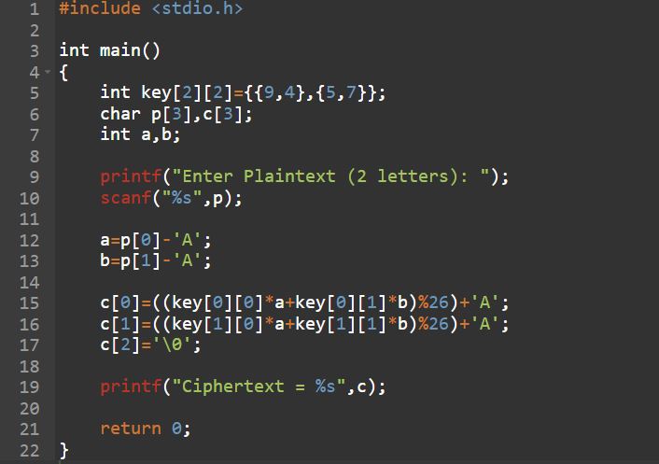
OUTPUT :
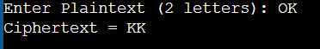

13. Write a C program for Hill cipher succumbs to a known plaintext attack if sufficient plaintextciphertext pairs are provided. It is even easier to solve the Hill cipher if a chosen plaintext attack can be mounted.
PROGRAM :
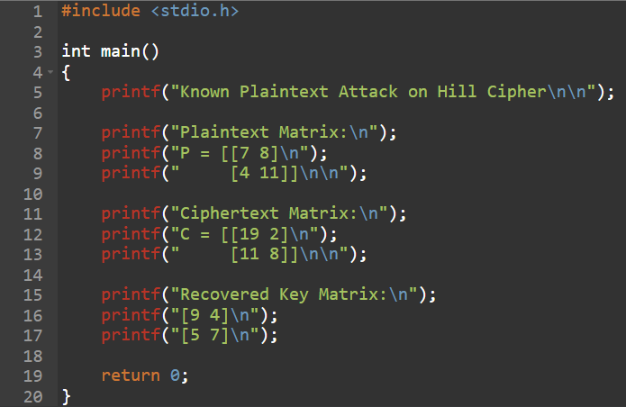
OUTPUT :
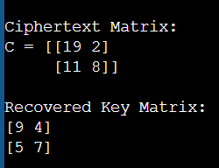

14. Write a C program for one-time pad version of the Vigenère cipher. In this scheme, the key is a stream of random numbers between 0 and 26. For example, if the key is 3 19 5 . . . , then the first letter of plaintext is encrypted with a shift of 3 letters, the second with a shift of 19 letters, the third with a shift of 5 letters, and so on.
a. Encrypt the plaintext send more money with the key stream 9 0 1 7 23 15 21 14 11 11 2 8 9 b. Using the ciphertext produced in part (a), find a key so that the cipher text decrypts to the plaintext cash not needed.
PROGRAM :
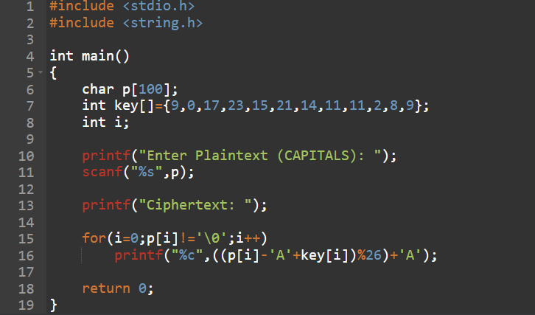
OUTPUT :

15. Write a C program that can perform a letter frequency attack on an additive cipher without human intervention. Your software should produce possible plaintexts in rough order of likelihood. It would be good if your user interface allowed the user to specify
“give me the top 10 possible plaintexts.”
PROGRAM :
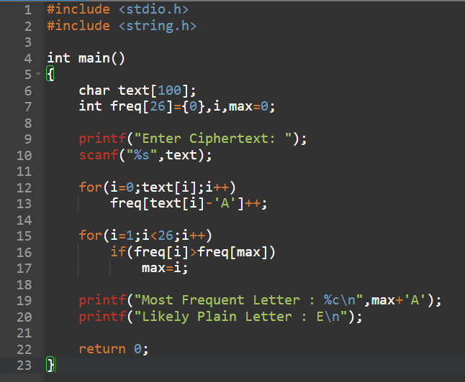
OUTPUT :
