Cryptography
M.Varunkumar
192311133

- Write a C program for Caesar cipher involves replacing each letter of the alphabet with the letter
standing k places further down the alphabet, for k in the range 1 through 25.

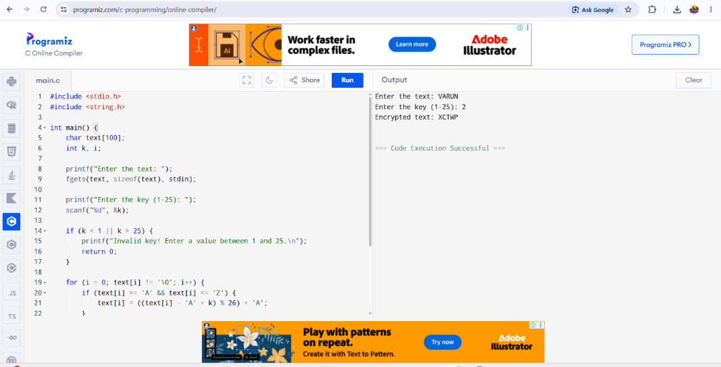

- Write a C program for monoalphabetic substitution cipher maps a plaintext alphabet to a ciphertext
alphabet, so that each letter of the plaintext alphabet maps to a single unique letter of the ciphertext
alphabet.



- Write a C program for Playfair algorithm is based on the use of a 5 X 5 matrix of letters constructed
using a keyword. Plaintext is encrypted two letters at a time using this matrix.

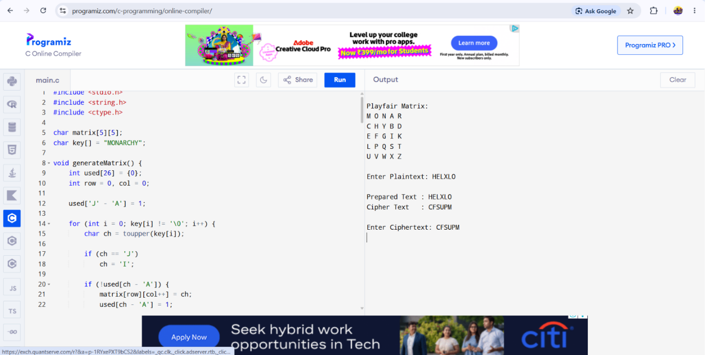

- Write a C program for polyalphabetic substitution cipher uses a separate monoalphabetic substitution
cipher for each successive letter of plaintext, depending on a key.

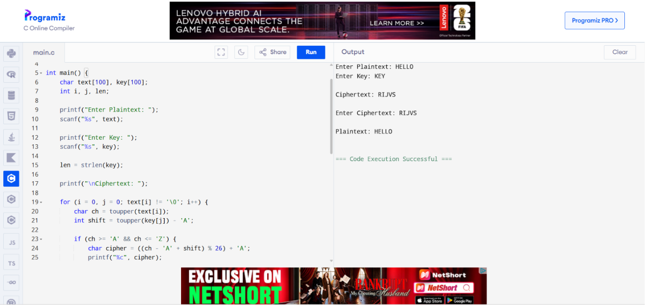

- Write a C program for generalization of the Caesar cipher, known as the affine Caesar cipher, has the
following form: For each plaintext letter p, substitute the ciphertext letter C: C = E([a, b], p) = (ap + b)
mod 26 A basic requirement of any encryption algorithm is that it be one-to-one. That is, if p q, then
E(k, p) E(k, q). Otherwise, decryption is impossible, because more than one plaintext character maps into
the same ciphertext character. The affine Caesar cipher is not one-to-one for all values of a. For example,
for a = 2 and b = 3, then E([a, b], 0) = E([a, b], 13) = 3.
- Are there any limitations on the value of b?
- Determine which values of a are not allowed.

