**SECTION 10**

DP_10.1

SUBQUERY:

SELECT job_id

FROM jobs

WHERE job_id IN

(SELECT jobid

FROM emploY

WHERE ename IN

(SELECT ename

FROM job_grade

WHERE grade = 'D'));

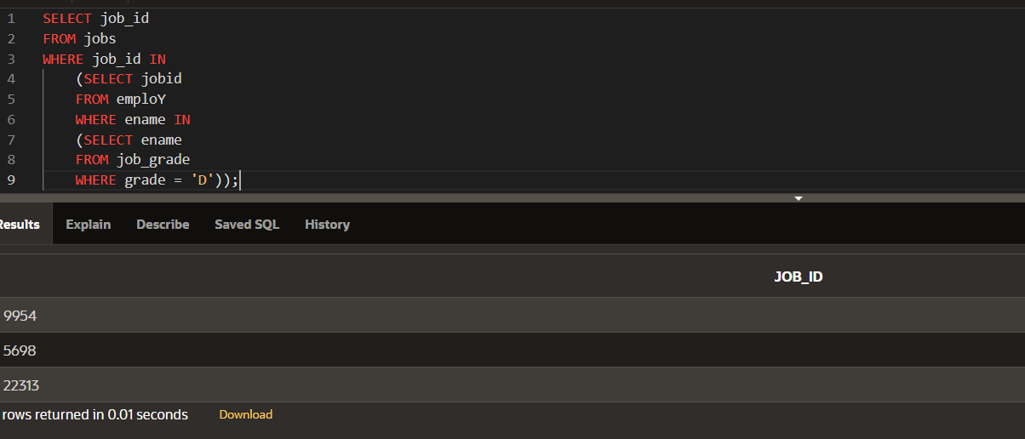

SUBQUERY AND NULL:

SELECT ename

FROM employ

WHERE depno =

(SELECT depno

FROM employ

WHERE ename = 'teju');

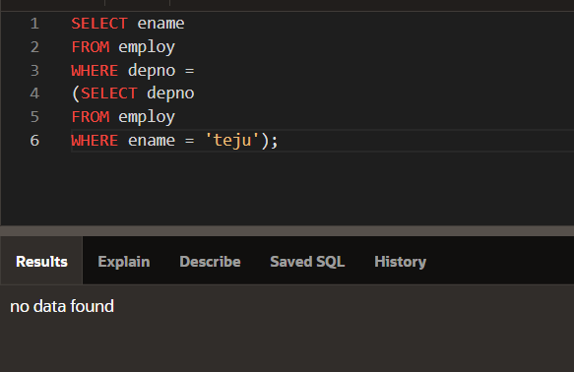

DP_10.2:

SUBQUERIES FROM DIFFERENT TABLES:

SELECT ename, jobid, salary, depno

FROM employ

WHERE jobid =

(SELECT jobid

FROM employ

WHERE eno = 4)

AND depname =

(SELECT job_title

FROM jobs

WHERE max_salary = 300000);

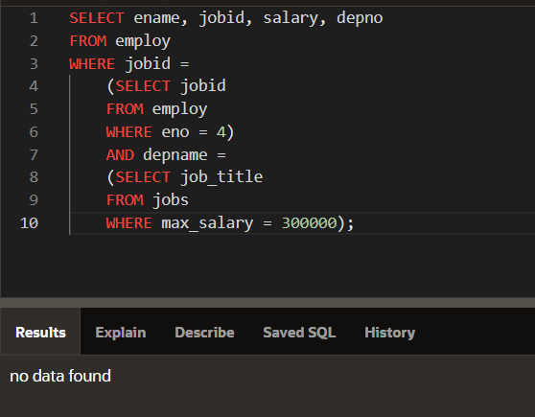

GROUP FUNCTIONS IN SUBQUERIES:

SELECT ename, salary

FROM employ

WHERE salary <

(SELECT AVG(salary)

FROM employ);

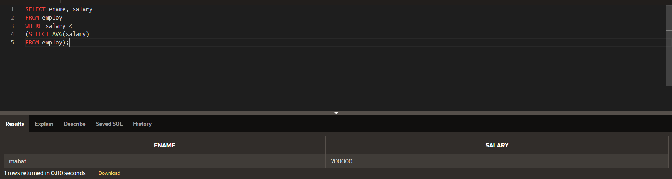

DP_10.3:

QUERY COMPARISON:

SELECT ename

FROM employ

WHERE salary =

(SELECT salary

FROM employ

WHERE depno = 3456433);

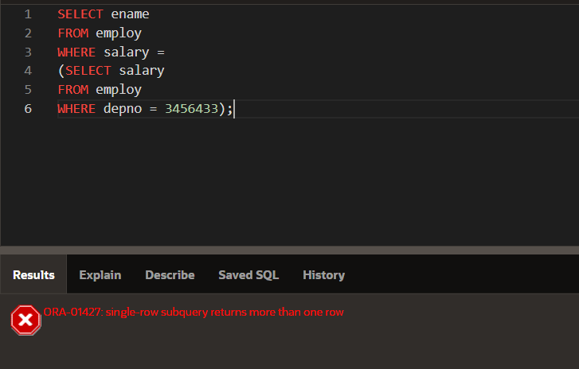

IN:

SELECT ename, create_date

FROM employ

WHERE EXTRACT(YEAR FROM create_date) IN

(SELECT EXTRACT(YEAR FROM create_date)

FROM employ

WHERE depno=3456433);

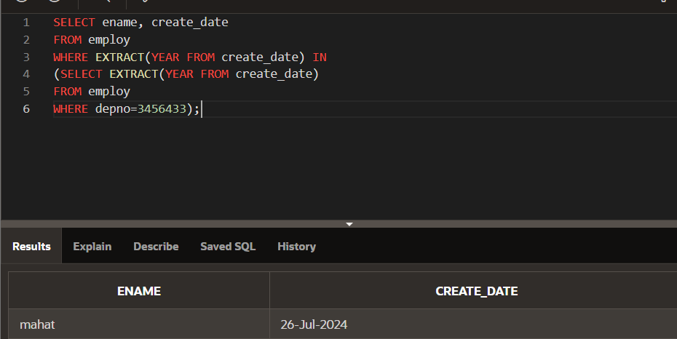

ANY:

SELECT ename, create_date

FROM employ

WHERE EXTRACT(YEAR FROM create_date) <= ANY

(SELECT EXTRACT(YEAR FROM create_date)

FROM employ

WHERE depno=3456433);

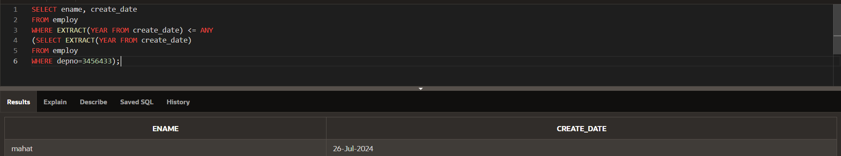

ALL:

SELECT ename, create_date

FROM employ

WHERE EXTRACT(YEAR FROM create_date) <= ALL

(SELECT EXTRACT(YEAR FROM create_date)

FROM employ

WHERE depno=3456433);

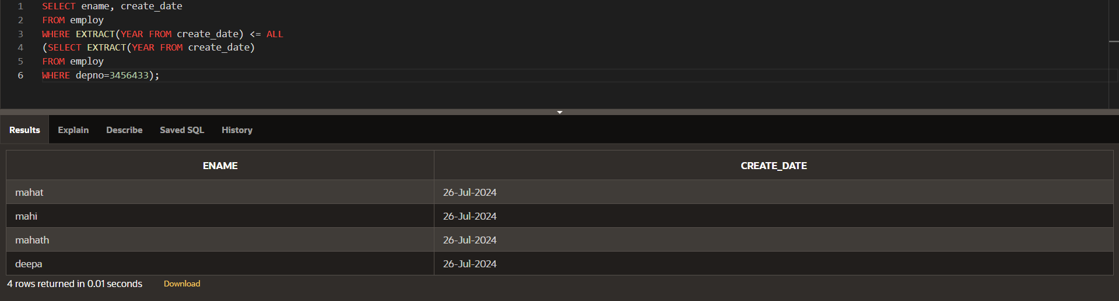

NULL Values:

SELECT ename, eno

FROM employ

WHERE eno IN

(SELECT jobid

FROM employ);

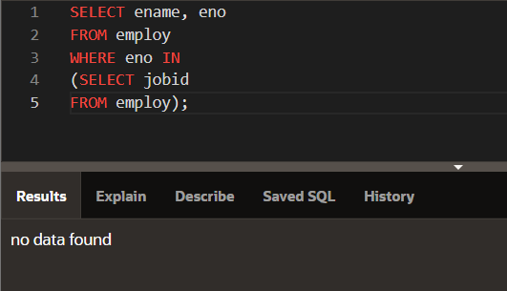

GROUP BY and HAVING:

SELECT jobid, MIN(salary)

FROM employ

GROUP BY jobid

HAVING MIN(salary) < ANY

(SELECT salary

FROM employ

WHERE jobid IN (5698,22313))

ORDER BY jobid;

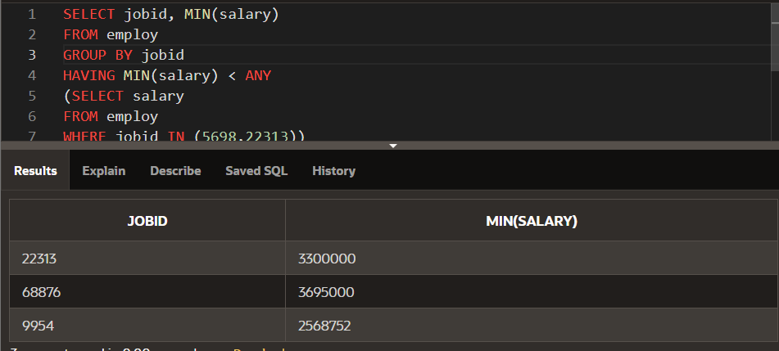

MULTIPLE-COLUMN SUBQUERIES:

SELECT epno, jobid, depno

FROM employ

WHERE(jobid,depno) IN

(SELECT jobid,depno

FROM employ

WHERE epno IN (684,3256))

AND epno NOT IN (684,3256)

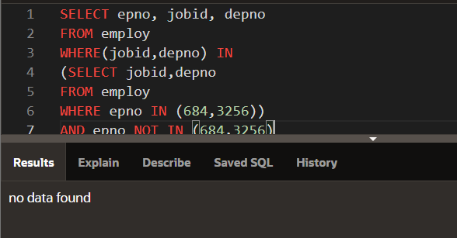

DP_10.4:

CORRELATED SUBQUERY:

SELECT o.ename,o.salary

FROM employ o

WHERE o.salary >

(SELECT AVG(i.salary)

FROM employ i

WHERE i.depno =

o.depno);

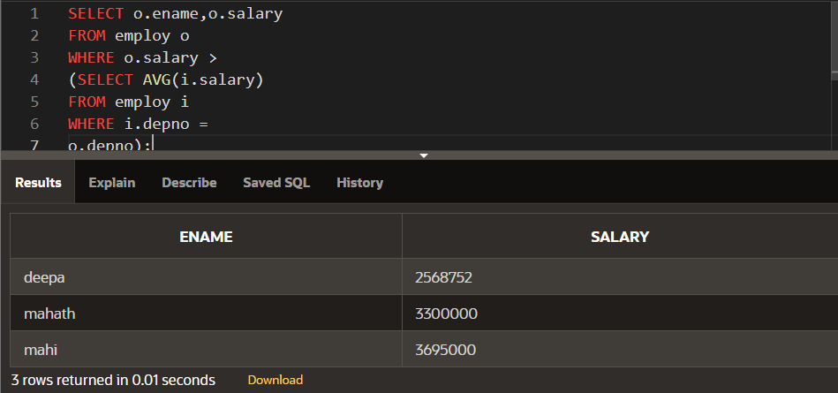

EXISTS & NOT EXISTS in Subqueries:

SELECT ename AS "Not a Manager"

FROM employ emp

WHERE NOT EXISTS

(SELECT *

FROM employ j

WHERE j.jobid = emp.jobid);

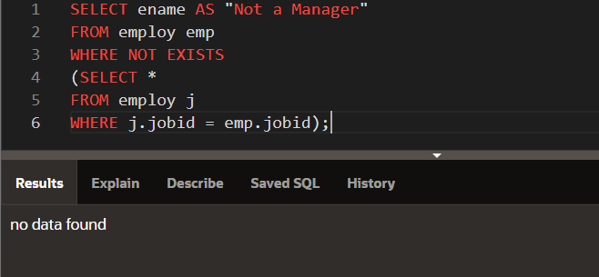

WITH Clause:

WITH managers AS

(SELECT DISTINCT manager_id

FROM employees

WHERE manager_id IS NOT NULL)

SELECT last_name AS "Not a manager"

FROM employees

WHERE employee_id NOT IN

(SELECT *

FROM managers);

