**Section13**

**DP 13.1:**

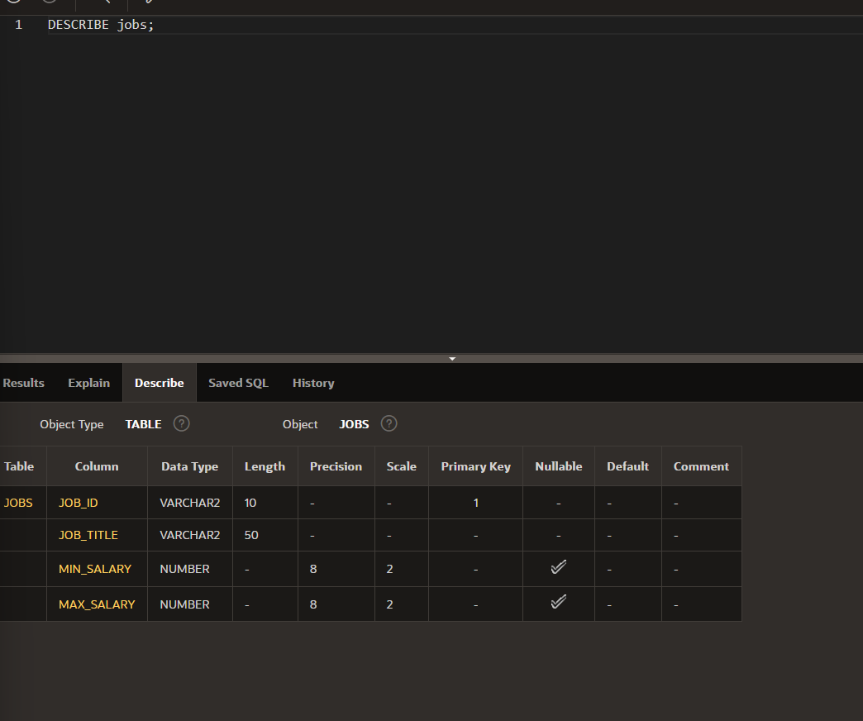

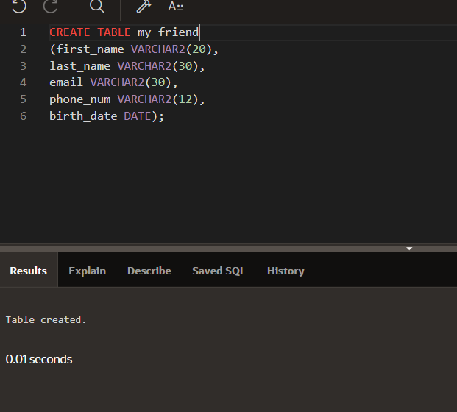

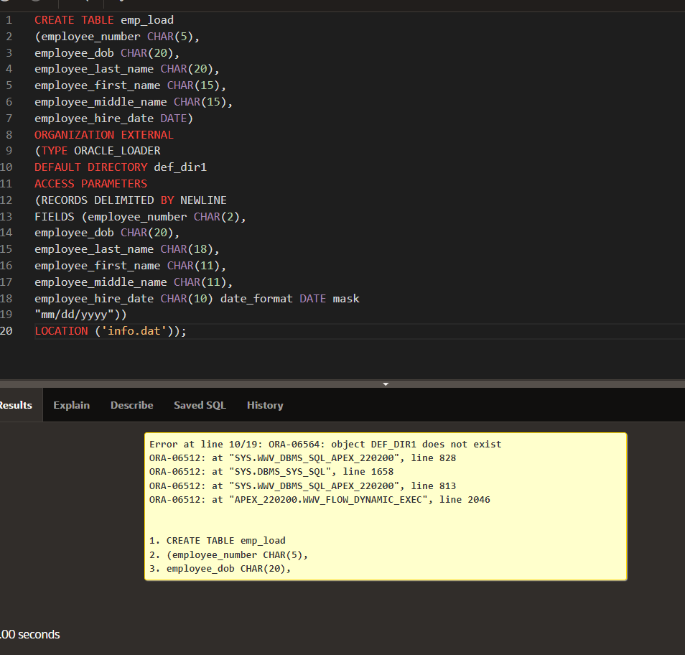

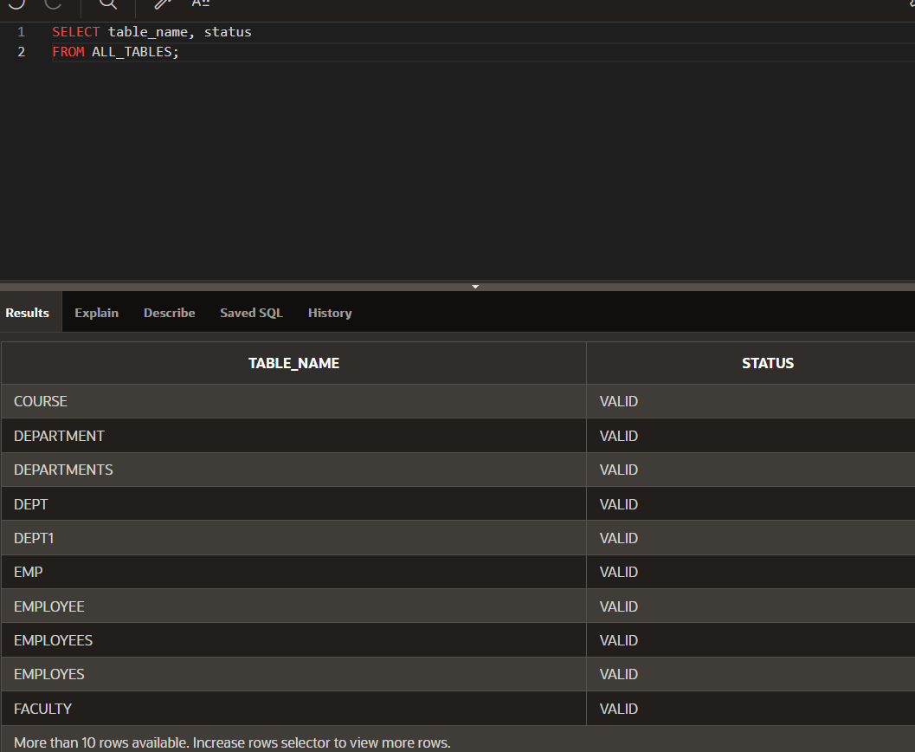

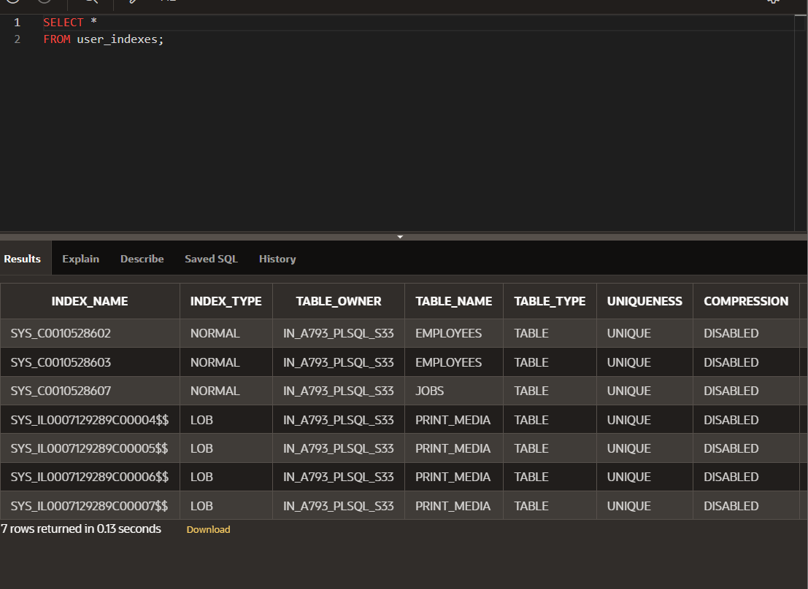

**DP 13.2:**

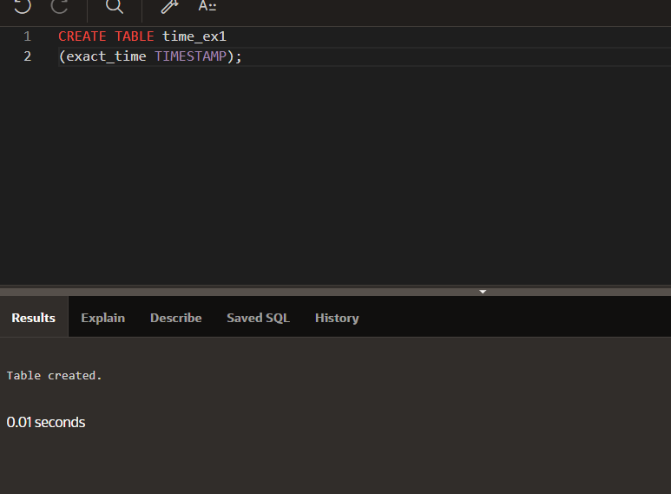

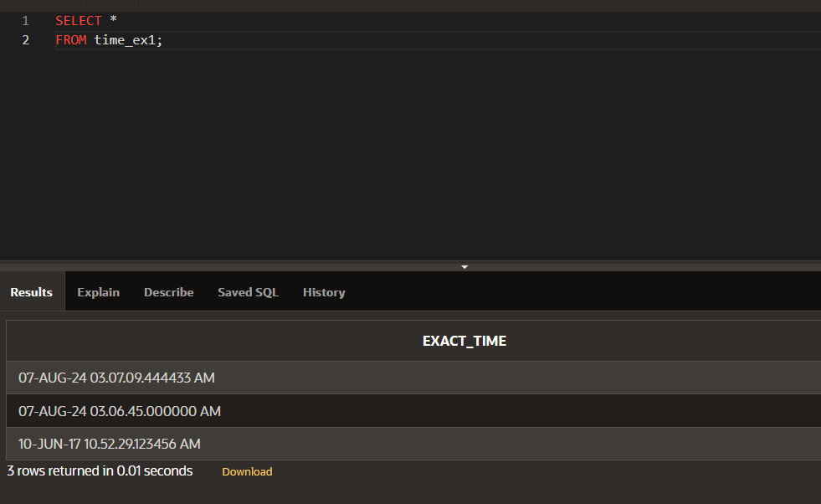

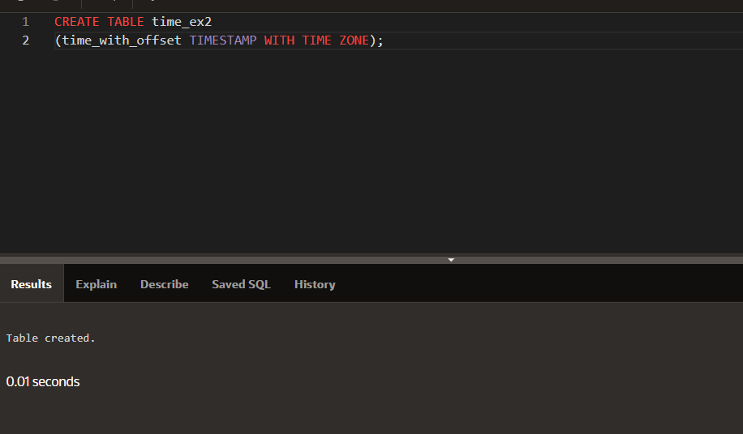

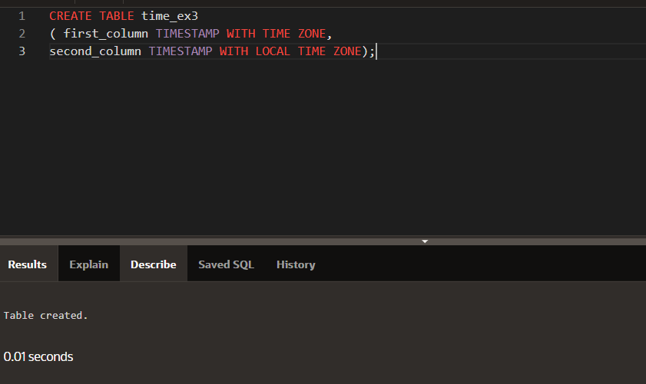

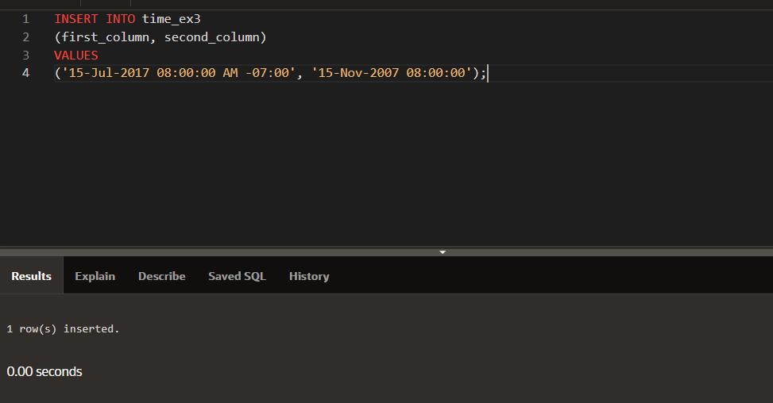

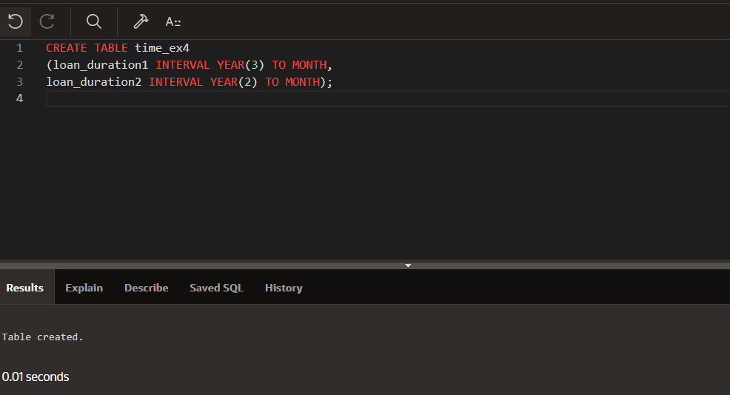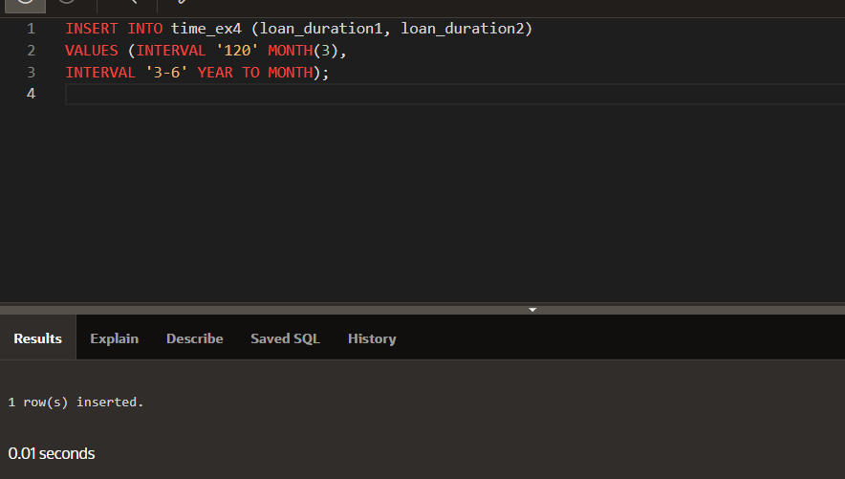

**DP 13.3:**