**Section15**

**DP 15.1:**

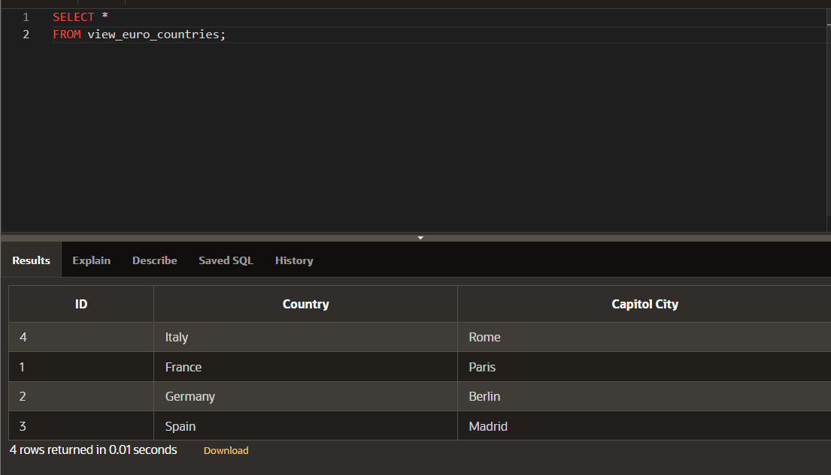

**DP 15.2:**

**DP 15.3:**



