**Section 9**

DP 9.1:

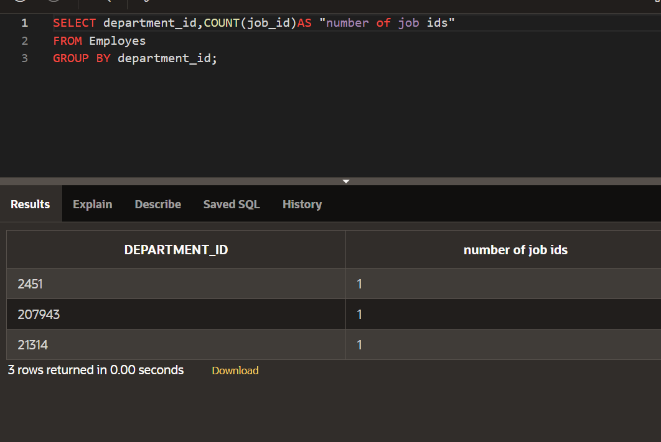

DP 9.2:

DP 9.3:



