**Assignment-1**

**1.CODE:**

<!DOCTYPE html>

<html lang="en">

<head>

<meta charset="UTF-8">

<meta name="viewport" content="width=device-width, initial-scale=1.0">

<title>E-Commerce</title>

<style>

body {

background-color: yellow;

color: blue;

}

.red {

color: red;

}

</style>

</head>

<body>

<h1>E-Commerce</h1>

<p>We are in the Age of Knowledge.</p>

<p>The phrases "knowledge is power" and "content is king" are often used in reference to business conducted on the Internet.</p>

<p>In the rather short history of e-business and e-commerce, events have demonstrated that successful e-businesses are those that recognize the needs of their target audiences and match them with relevant content.</p>

<p>However, the ability to construct such an e-business is not limited to seasoned professionals—many successful online ventures have been started by students on college campuses. The terms e-business and e-commerce, often used interchangeably,</p>

<p class="red">in fact have different meanings. According to Andrew Bartels, vice president and research leader of ecommerce trends at Giga Information Group, Inc.,</p>

<p>e-commerce refers to aspects of online business involving exchanges among customers,</p>

<p>business partners and vendors.</p>

</body>

</html>

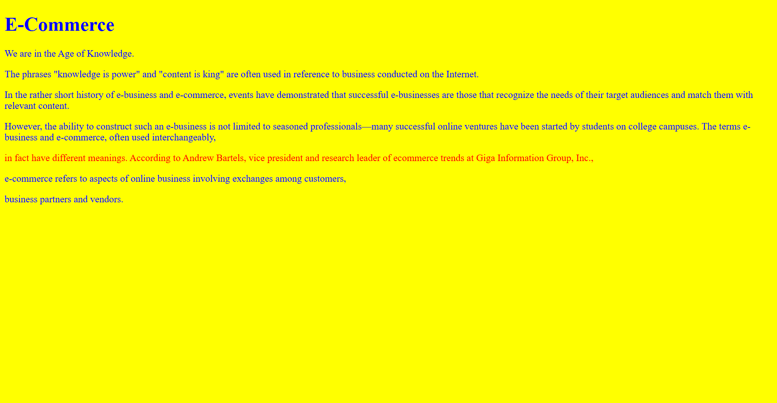

**2.CODE:**

<!DOCTYPE html>

<html lang="en">

<head>

<meta charset="UTF-8">

<meta name="viewport" content="width=device-width, initial-scale=1.0">

<title>Photography Gallery</title>

<style>

.gallery {

display: flex;

flex-wrap: wrap;

justify-content: space-around;

}

.gallery img {

max-width: 100%;

height: auto;

margin: 10px;

border: 2px solid #ccc;

}

.caption {

text-align: center;

font-size: 1.2em;

margin-top: 5px;

}

</style>

</head>

<body>

<h1>Photography Gallery</h1>

<div class="gallery">

<figure>

<img src="https://tse4.mm.bing.net/th?id=OIP.17c_elvoxC9WhOsZWbd7FwHaEo&pid=Api&P=0&h=220" alt="A beautiful sunrise over the mountains" loading="lazy">

<figcaption class="caption">A beautiful sunrise over the mountains</figcaption>

</figure>

<figure>

<img src="https://tse2.mm.bing.net/th?id=OIP.ey84F-CqVB1mWZaqaA9GpgHaEJ&pid=Api&P=0&h=220" alt="A serene beach with crystal clear water" loading="lazy">

<figcaption class="caption">A serene beach with crystal clear water</figcaption>

</figure>

<figure>

<img src="https://tse4.mm.bing.net/th?id=OIP.rPo1W6ho5XNSgcaZkjui0QHaEJ&pid=Api&P=0&h=220" alt="A bustling cityscape at night" loading="lazy">

<figcaption class="caption">A bustling cityscape at night</figcaption>

</figure>

<figure>

<img src="https://tse1.mm.bing.net/th?id=OIP.xxPT2HYBOb5ToW51suwOgAHaDt&pid=Api&P=0&h=220" alt="A tranquil forest path" loading="lazy">

<figcaption class="caption">A tranquil forest path</figcaption>

</figure>

</div>

</body>

</html>

