**Home Work – 3**

1. **CODE :-**

<!DOCTYPE html>

<html lang="en">

<head>

<meta charset="UTF-8">

<meta name="viewport" content="width=device-width, initial-scale=1.0">

<title>Frameset Example</title>

</head>

<frameset rows="20%,80%" frameborder="1">

<frame src="top.html" name="topFrame">

<frameset cols="50%,50%" frameborder="1">

<frame src="left.html" name="leftFrame">

<frame src="right.html" name="rightFrame">

</frameset>

</frameset>

</html>

**Left.html**

<!DOCTYPE html>

<html>

<head>

  <style>

    body {

        font-family: sans-serif;

      background-color: lightgreen;

      margin: 0;

    }

  </style>

</head>

<body>

  <h2>Left Frame</h2>

</body>

</html>

**Right.html**

<!DOCTYPE html>

<html>

<head>

  <style>

    body {

        font-family: sans-serif;

      background-color: lightcoral;

      margin: 0;

    }

  </style>

</head>

<body>

  <h2>Right Frame</h2>

</body>

</html>

**Top.html**

<!DOCTYPE html>

<html>

<head>

  <style>

    body {

        font-family: sans-serif;

      background-color: lightblue;

      margin: 0;

    }

  </style>

</head>

<body>

  <h2>Top Frame</h2>

</body>

</html>

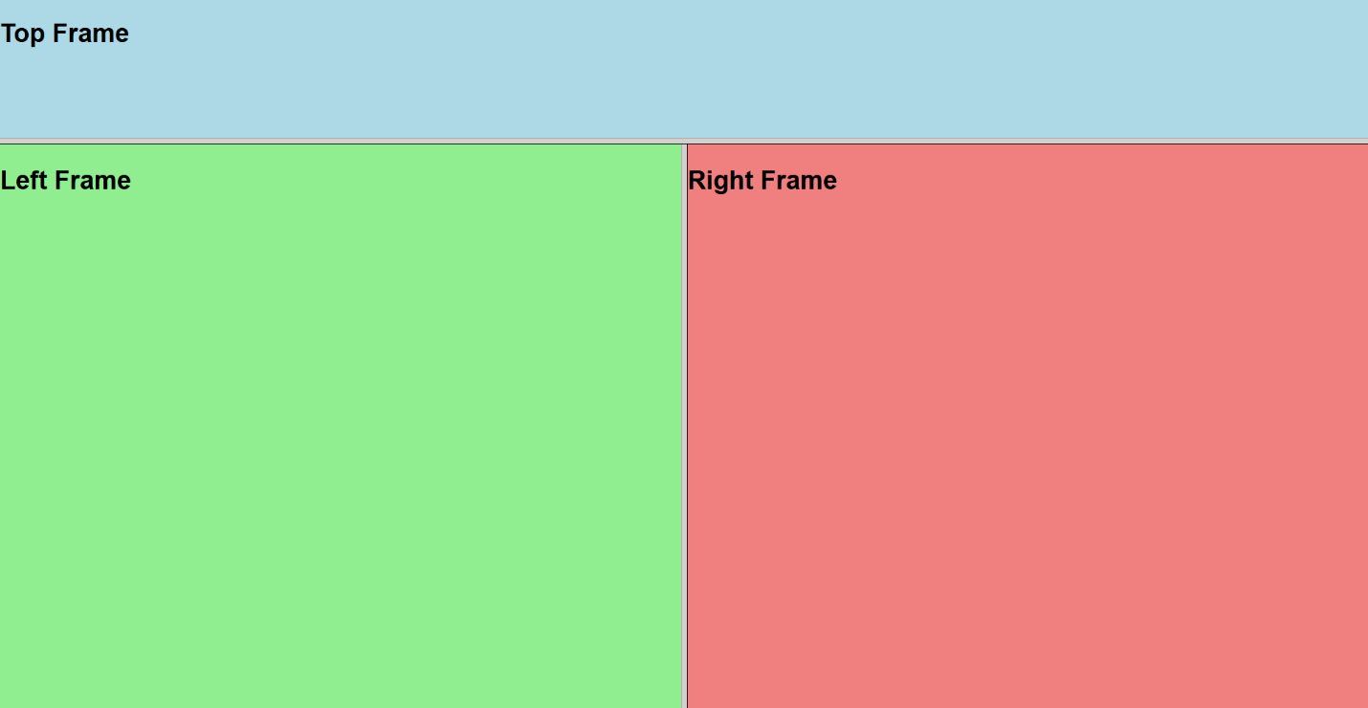

1. **CODE :-**

<!DOCTYPE html>

<html lang="en">

<head>

<meta charset="UTF-8" />

<meta name="viewport" content="width=device-width, initial-scale=1.0"/>

<title>Document</title>

<style>

.container {

width: 100%;

border: 1.5px solid gray;

padding: 20px;

display: flex;

justify-content: space-evenly;

}

video {

width: 500px;

}

</style>

</head>

<body>

<div class="container">

<video controls src="Videos/Saveetha School of Engineering _ SIMATS _ Campus Walk Through.mp4"></video>

<video controls src="Videos/SIMATS Saveetha School of Engineering Cover Song 2022 ArabicKuthu JalabulaJangu Halamithi Habibo.mp4"></video>

</div>

<script>

const videos = document.querySelectorAll("video");

videos.forEach((video) => {

video.addEventListener("play", () => {

videos.forEach((otherVideo) => {

if (otherVideo !== video) {

otherVideo.pause();

}

});

});

});

</script>

</body>

</html>

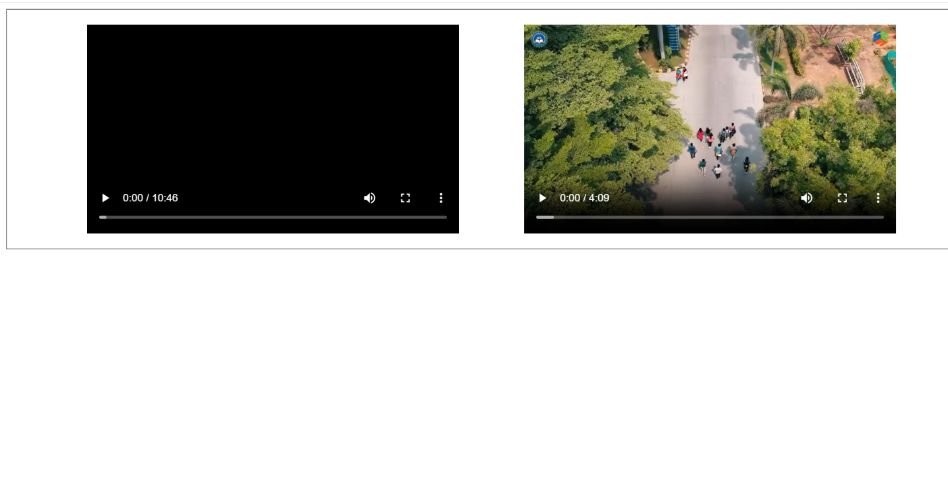

1. **CODE :-**

<!DOCTYPE html>

<html lang="en">

<head>

<meta charset="UTF-8">

<title>Online Ticket Booking</title>

<style>

body {

font-family: Arial, sans-serif;

background-color: #f2f2f2;

padding: 20px;

}

h2 {

color: #333;

}

form {

background-color: #fff;

padding: 20px;

border-radius: 8px;

max-width: 500px;

margin: auto;

}

label {

display: block;

margin-top: 10px;

margin-bottom: 5px;

}

input[type="text"],

textarea {

width: 100%;

padding: 8px;

box-sizing: border-box;

border: 1px solid #ccc;

border-radius: 4px;

}

textarea {

resize: vertical;

}

.radio-group,

.checkbox-group {

margin-bottom: 10px;

}

button {

background-color: #4CAF50;

color: white;

border: none;

padding: 10px 15px;

margin-top: 15px;

border-radius: 4px;

cursor: pointer;

}

button:hover {

background-color: #45a049;

}

</style>

</head>

<body>

<h2>Online Ticket Booking Form</h2>

<form action="#" method="post">

<label for="name">Full Name:</label>

<input type="text" id="name" name="fullname" required>

<label for="email">Email Address:</label>

<input type="text" id="email" name="email" required>

<label for="destination">Destination:</label>

<input type="text" id="destination" name="destination" required>

<label for="comments">Special Requests / Comments:</label>

<textarea id="comments" name="comments" rows="4"></textarea>

<label>Ticket Type:</label>

<div class="radio-group">

<input type="radio" id="oneway" name="ticket_type" value="One Way" checked>

<label for="oneway">One Way</label><br>

<input type="radio" id="roundtrip" name="ticket_type" value="Round Trip">

<label for="roundtrip">Round Trip</label>

</div>

<label>Additional Options:</label>

<div class="checkbox-group">

<input type="checkbox" id="meal" name="options" value="Meal">

<label for="meal">Include Meal</label><br>

<input type="checkbox" id="insurance" name="options" value="Travel Insurance">

<label for="insurance">Add Travel Insurance</label><br>

<input type="checkbox" id="priority" name="options" value="Priority Boarding">

<label for="priority">Priority Boarding</label>

</div>

<button type="submit">Book Ticket</button>

<button type="reset">Reset</button>

</form>

</body>

</html>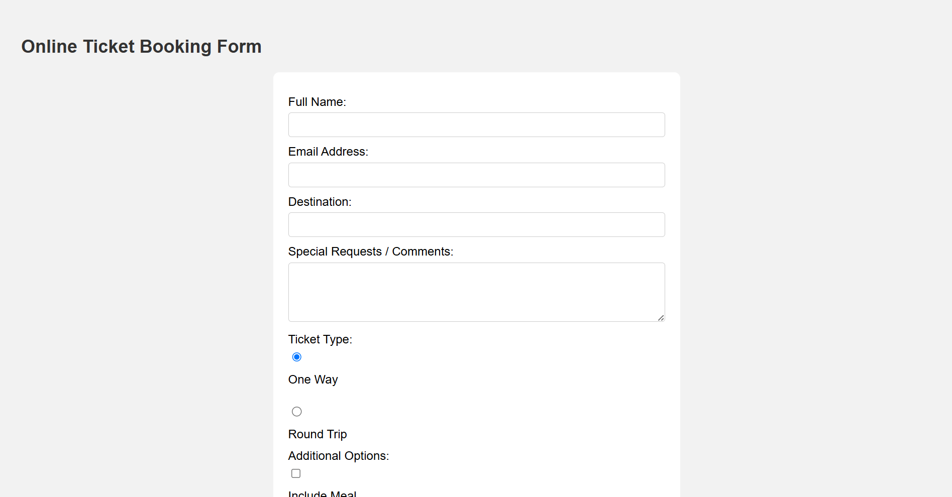

1. **CODE :-**

<!DOCTYPE html>

<html lang="en">

<head>

<meta charset="UTF-8">

<title>User Registration Form</title>

<style>

body {

font-family: Arial, sans-serif;

background-color: #eef2f3;

padding: 20px;

}

h2 {

text-align: center;

color: #333;

}

form {

background-color: #fff;

max-width: 600px;

margin: auto;

padding: 30px;

border-radius: 8px;

box-shadow: 0px 0px 10px rgba(0,0,0,0.1);

}

label {

display: block;

margin-top: 15px;

font-weight: bold;

}

input[type="text"],

input[type="email"],

textarea {

width: 100%;

padding: 8px;

margin-top: 5px;

box-sizing: border-box;

border: 1px solid #ccc;

border-radius: 4px;

}

.gender-group {

margin-top: 10px;

}

.gender-group label {

font-weight: normal;

margin-right: 15px;

}

.checkbox-group {

margin-top: 10px;

}

button {

margin-top: 20px;

padding: 10px 15px;

border: none;

border-radius: 4px;

cursor: pointer;

}

.submit-btn {

background-color: #28a745;

color: white;

}

.submit-btn:hover {

background-color: #218838;

}

.reset-btn {

background-color: #dc3545;

color: white;

margin-left: 10px;

}

.reset-btn:hover {

background-color: #c82333;

}

</style>

</head>

<body>

<h2>User Registration Form</h2>

<form action="#" method="post">

<label for="name">Full Name:</label>

<input type="text" id="name" name="fullname" required>

<label for="address">Address:</label>

<textarea id="address" name="address" rows="3" required></textarea>

<label for="email">Email Address:</label>

<input type="email" id="email" name="email" required>

<label>Gender:</label>

<div class="gender-group">

<input type="radio" id="male" name="gender" value="Male" required>

<label for="male">Male</label>

<input type="radio" id="female" name="gender" value="Female">

<label for="female">Female</label>

<input type="radio" id="other" name="gender" value="Other">

<label for="other">Other</label>

</div>

<label for="state">State:</label>

<input type="text" id="state" name="state" required>

<label for="country">Country:</label>

<input type="text" id="country" name="country" required>

<div class="checkbox-group">

<input type="checkbox" id="terms" name="terms" required>

<label for="terms">I agree to the terms and conditions</label>

</div>

<button type="submit" class="submit-btn">Register</button>

<button type="reset" class="reset-btn">Reset</button>

</form>

</body>

</html>

