**Case Study: Online Shopping Cart System(manoj reddy)**

**Scenario:**

You are tasked with developing an online shopping cart system for an e-commerce website. The system should handle products, customers, and orders, allowing customers to add products to their cart, view the cart contents, and proceed to checkout.

**Requirements:**

1. **Product Class**:
   * Attributes: productId (String), name (String), price (double), and stockQuantity (int).
   * Methods: updateStockQuantity(int quantity) to adjust stock levels when a product is purchased.

## Program:

public class Main {

public static void main(String[] args) {

// Create Product instances

Product product1 = new Product("P001", "Laptop", 999.99, 10);

Product product2 = new Product("P002", "Smartphone", 699.99, 20);

Product product3 = new Product("P003", "Tablet", 299.99, 15);

// Display product details

System.out.println("Product details:");

System.out.println(product1);

System.out.println(product2);

System.out.println(product3);

// Update stock quantity

System.out.println("\nUpdating stock quantity...");

product1.updateStockQuantity(2); // Sold 2 Laptops

product2.updateStockQuantity(5); // Sold 5 Smartphones

// Display updated product details

System.out.println("\nUpdated product details:");

System.out.println(product1);

System.out.println(product2);

System.out.println(product3);

}

}

class Product {

private String productId;

private String name;

private double price;

private int stockQuantity;

public Product(String productId, String name, double price, int stockQuantity) {

this.productId = productId;

this.name = name;

this.price = price;

this.stockQuantity = stockQuantity;

}

public String getProductId() {

return productId;

}

public String getName() {

return name;

}

public double getPrice() {

return price;

}

public int getStockQuantity() {

return stockQuantity;

}

public void updateStockQuantity(int quantity) {

if (quantity <= this.stockQuantity) {

this.stockQuantity -= quantity;

} else {

System.out.println("Error: Insufficient stock to update quantity.");

}

}

@Override

public String toString() {

return name + " (ID: " + productId + ", Price: $" + price + ", Stock: " + stockQuantity + ")";

}

}

Ouput:

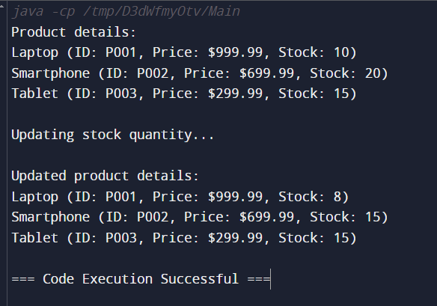

1. **Customer Class**:
   * Attributes: customerId (String), name (String), email (String), and cart (List<Product>).
   * Methods: addToCart(Product product), removeFromCart(Product product), viewCart(), and checkout().

## Program:

import java.util.ArrayList;

import java.util.List;

class Product {

private String productId;

private String name;

private double price;

private int stockQuantity;

public Product(String productId, String name, double price, int stockQuantity) {

this.productId = productId;

this.name = name;

this.price = price;

this.stockQuantity = stockQuantity;

}

public String getProductId() {

return productId;

}

public String getName() {

return name;

}

public double getPrice() {

return price;

}

public int getStockQuantity() {

return stockQuantity;

}

public void updateStockQuantity(int quantity) {

if (quantity <= this.stockQuantity) {

this.stockQuantity -= quantity;

} else {

System.out.println("Error: Insufficient stock to update quantity.");

}

}

@Override

public String toString() {

return name + " (ID: " + productId + ", Price: $" + price + ", Stock: " + stockQuantity + ")";

}

}

class Customer {

private String customerId;

private String name;

private String email;

private List<Product> cart;

public Customer(String customerId, String name, String email) {

this.customerId = customerId;

this.name = name;

this.email = email;

this.cart = new ArrayList<>();

}

public void addToCart(Product product) {

cart.add(product);

}

public void removeFromCart(Product product) {

cart.remove(product);

}

public void viewCart() {

if (cart.isEmpty()) {

System.out.println("Your cart is empty.");

} else {

System.out.println("Cart contents:");

for (Product product : cart) {

System.out.println(product);

}

}

}

public void checkout() {

if (cart.isEmpty()) {

System.out.println("Your cart is empty. Add items to the cart before checking out.");

} else {

Order order = new Order(customerId, cart);

order.calculateTotalAmount();

System.out.println("Order placed successfully. Total amount: $" + order.getTotalAmount());

cart.clear();

}

}

}

class Order {

private String customerId;

private List<Product> products;

private double totalAmount;

public Order(String customerId, List<Product> products) {

this.customerId = customerId;

this.products = new ArrayList<>(products);

this.totalAmount = 0.0;

}

public void calculateTotalAmount() {

for (Product product : products) {

totalAmount += product.getPrice();

}

}

public double getTotalAmount() {

return totalAmount;

}

}

public class Main {

public static void main(String[] args) {

// Create Product instances

Product product1 = new Product("P001", "Laptop", 999.99, 10);

Product product2 = new Product("P002", "Smartphone", 699.99, 20);

Product product3 = new Product("P003", "Tablet", 299.99, 15);

// Create Customer instance

Customer customer = new Customer("C001", "John Doe", "john.doe@example.com");

// Add products to the customer's cart

customer.addToCart(product1);

customer.addToCart(product2);

// View cart contents

System.out.println("Viewing cart:");

customer.viewCart();

// Remove a product from the cart

customer.removeFromCart(product2);

// View cart contents again

System.out.println("\nViewing cart after removing an item:");

customer.viewCart();

// Checkout

System.out.println("\nChecking out:");

customer.checkout();

// View cart contents after checkout

System.out.println("\nViewing cart after checkout:");

customer.viewCart();

}

}

Output:

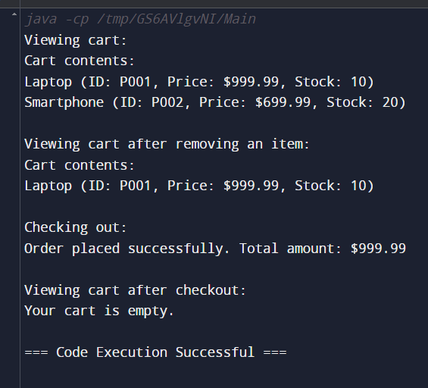

1. **Order Class**:
   * Attributes: orderId (String), customer (Customer), products (List<Product>), totalAmount (double), and orderDate (LocalDateTime).
   * Methods: calculateTotalAmount() to compute the total cost of the order.

## program:

import java.time.LocalDateTime;

import java.util.ArrayList;

import java.util.List;

class Product {

private String productId;

private String name;

private double price;

private int stockQuantity;

public Product(String productId, String name, double price, int stockQuantity) {

this.productId = productId;

this.name = name;

this.price = price;

this.stockQuantity = stockQuantity;

}

public String getProductId() {

return productId;

}

public String getName() {

return name;

}

public double getPrice() {

return price;

}

public int getStockQuantity() {

return stockQuantity;

}

public void updateStockQuantity(int quantity) {

if (quantity <= this.stockQuantity) {

this.stockQuantity -= quantity;

} else {

System.out.println("Error: Insufficient stock to update quantity.");

}

}

@Override

public String toString() {

return name + " (ID: " + productId + ", Price: $" + price + ", Stock: " + stockQuantity + ")";

}

}

class Customer {

private String customerId;

private String name;

private String email;

private List<Product> cart;

public Customer(String customerId, String name, String email) {

this.customerId = customerId;

this.name = name;

this.email = email;

this.cart = new ArrayList<>();

}

public void addToCart(Product product) {

cart.add(product);

}

public void removeFromCart(Product product) {

cart.remove(product);

}

public void viewCart() {

if (cart.isEmpty()) {

System.out.println("Your cart is empty.");

} else {

System.out.println("Cart contents:");

for (Product product : cart) {

System.out.println(product);

}

}

}

public void checkout() {

if (cart.isEmpty()) {

System.out.println("Your cart is empty. Add items to the cart before checking out.");

} else {

Order order = new Order(customerId, cart);

order.calculateTotalAmount();

System.out.println("Order placed successfully. Total amount: $" + order.getTotalAmount());

cart.clear();

}

}

}

class Order {

private String orderId;

private String customerId;

private List<Product> products;

private double totalAmount;

private LocalDateTime orderDate;

public Order(String customerId, List<Product> products) {

this.orderId = "ORD" + System.currentTimeMillis();

this.customerId = customerId;

this.products = new ArrayList<>(products);

this.orderDate = LocalDateTime.now();

}

public void calculateTotalAmount() {

totalAmount = 0;

for (Product product : products) {

totalAmount += product.getPrice();

}

}

public double getTotalAmount() {

return totalAmount;

}

@Override

public String toString() {

return "Order ID: " + orderId + "\nCustomer ID: " + customerId + "\nOrder Date: " + orderDate + "\nTotal Amount: $" + totalAmount;

}

}

public class Main {

public static void main(String[] args) {

// Create Product instances

Product product1 = new Product("P001", "Laptop", 999.99, 10);

Product product2 = new Product("P002", "Smartphone", 699.99, 20);

Product product3 = new Product("P003", "Tablet", 299.99, 15);

// Create Customer instance

Customer customer = new Customer("C001", "John Doe", "john.doe@example.com");

// Add products to the customer's cart

customer.addToCart(product1);

customer.addToCart(product2);

// View cart contents

System.out.println("Viewing cart:");

customer.viewCart();

// Remove a product from the cart

customer.removeFromCart(product2);

// View cart contents again

System.out.println("\nViewing cart after removing an item:");

customer.viewCart();

// Checkout

System.out.println("\nChecking out:");

customer.checkout();

// View cart contents after checkout

System.out.println("\nViewing cart after checkout:");

customer.viewCart();

}

}

Output:

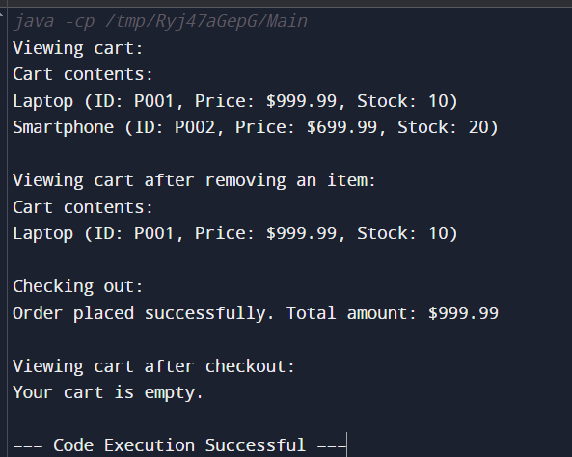

1. **Inventory Class**:
   * Attributes: products (List<Product>).
   * Methods: addProduct(Product product), getProductById(String productId), and updateProductStock(String productId, int quantity).

##### Program:

import java.time.LocalDateTime;

import java.util.ArrayList;

import java.util.List;

class Product {

private String productId;

private String name;

private double price;

private int stockQuantity;

public Product(String productId, String name, double price, int stockQuantity) {

this.productId = productId;

this.name = name;

this.price = price;

this.stockQuantity = stockQuantity;

}

public String getProductId() {

return productId;

}

public String getName() {

return name;

}

public double getPrice() {

return price;

}

public int getStockQuantity() {

return stockQuantity;

}

public void updateStockQuantity(int quantity) {

if (quantity <= this.stockQuantity) {

this.stockQuantity -= quantity;

} else {

System.out.println("Error: Insufficient stock to update quantity.");

}

}

@Override

public String toString() {

return name + " (ID: " + productId + ", Price: $" + price + ", Stock: " + stockQuantity + ")";

}

}

class Inventory {

private List<Product> products;

public Inventory() {

this.products = new ArrayList<>();

}

public void addProduct(Product product) {

products.add(product);

}

public Product getProductById(String productId) {

for (Product product : products) {

if (product.getProductId().equals(productId)) {

return product;

}

}

return null;

}

public void updateProductStock(String productId, int quantity) {

Product product = getProductById(productId);

if (product != null) {

product.updateStockQuantity(quantity);

}

}

}

class Customer {

private String customerId;

private String name;

private String email;

private List<Product> cart;

public Customer(String customerId, String name, String email) {

this.customerId = customerId;

this.name = name;

this.email = email;

this.cart = new ArrayList<>();

}

public void addToCart(Product product) {

cart.add(product);

}

public void removeFromCart(Product product) {

cart.remove(product);

}

public void viewCart() {

if (cart.isEmpty()) {

System.out.println("Your cart is empty.");

} else {

System.out.println("Cart contents:");

for (Product product : cart) {

System.out.println(product);

}

}

}

public void checkout(Inventory inventory) {

if (cart.isEmpty()) {

System.out.println("Your cart is empty. Add items to the cart before checking out.");

} else {

Order order = new Order(customerId, cart);

order.calculateTotalAmount();

System.out.println("Order placed successfully. Total amount: $" + order.getTotalAmount());

for (Product product : cart) {

inventory.updateProductStock(product.getProductId(), 1);

}

cart.clear();

}

}

}

class Order {

private String orderId;

private String customerId;

private List<Product> products;

private double totalAmount;

private LocalDateTime orderDate;

public Order(String customerId, List<Product> products) {

this.orderId = "ORD" + System.currentTimeMillis();

this.customerId = customerId;

this.products = new ArrayList<>(products);

this.orderDate = LocalDateTime.now();

}

public void calculateTotalAmount() {

totalAmount = 0;

for (Product product : products) {

totalAmount += product.getPrice();

}

}

public double getTotalAmount() {

return totalAmount;

}

@Override

public String toString() {

return "Order ID: " + orderId + "\nCustomer ID: " + customerId + "\nOrder Date: " + orderDate + "\nTotal Amount: $" + totalAmount;

}

}

public class Main {

public static void main(String[] args) {

// Create Inventory instance

Inventory inventory = new Inventory();

// Create Product instances and add them to the inventory

Product product1 = new Product("P001", "Laptop", 999.99, 10);

Product product2 = new Product("P002", "Smartphone", 699.99, 20);

Product product3 = new Product("P003", "Tablet", 299.99, 15);

inventory.addProduct(product1);

inventory.addProduct(product2);

inventory.addProduct(product3);

// Create Customer instance

Customer customer = new Customer("C001", "John Doe", "john.doe@example.com");

// Add products to the customer's cart

customer.addToCart(product1);

customer.addToCart(product2);

// View cart contents

System.out.println("Viewing cart:");

customer.viewCart();

// Remove a product from the cart

customer.removeFromCart(product2);

// View cart contents again

System.out.println("\nViewing cart after removing an item:");

customer.viewCart();

// Checkout

System.out.println("\nChecking out:");

customer.checkout(inventory);

// View cart contents after checkout

System.out.println("\nViewing cart after checkout:");

customer.viewCart();

// View updated stock in inventory

System.out.println("\nUpdated inventory stock:");

System.out.println(inventory.getProductById("P001"));

System.out.println(inventory.getProductById("P002"));

System.out.println(inventory.getProductById("P003"));

}

}

Output:

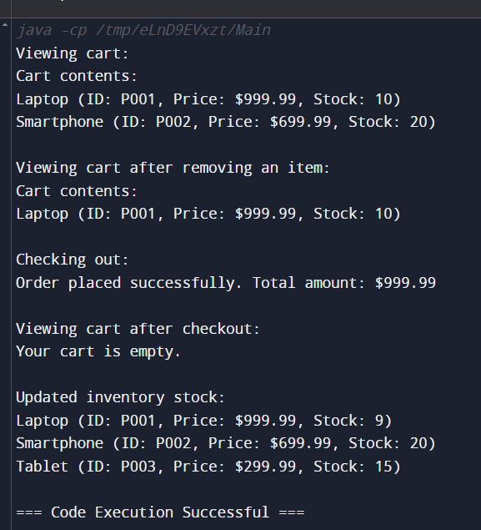

**Tasks:**

1. **Implement the Product Class**:
   * Define the class with appropriate attributes and methods.
   * Implement logic to update the stock quantity when products are purchased.
2. **Implement the Customer Class**:
   * Define the class with attributes and methods to manage the shopping cart.
   * Implement methods to add products to the cart, remove products from the cart, view the cart contents, and proceed to checkout.
3. **Implement the Order Class**:
   * Define the class with attributes and methods to handle order details.
   * Implement the calculateTotalAmount() method to compute the total cost of the order.
4. **Implement the Inventory Class**:
   * Define the class to manage the product inventory.
   * Implement methods to add products, retrieve a product by its ID, and update stock levels.
5. **Develop a Main Class to Test the System**:
   * Create instances of Product, Customer, and Inventory.
   * Add products to the inventory.
   * Simulate adding products to the customer's cart, viewing the cart, and checking out.

## Main program:

import java.time.LocalDateTime;

import java.util.ArrayList;

import java.util.List;

class Product {

private String productId;

private String name;

private double price;

private int stockQuantity;

public Product(String productId, String name, double price, int stockQuantity) {

this.productId = productId;

this.name = name;

this.price = price;

this.stockQuantity = stockQuantity;

}

public String getProductId() {

return productId;

}

public String getName() {

return name;

}

public double getPrice() {

return price;

}

public int getStockQuantity() {

return stockQuantity;

}

public void updateStockQuantity(int quantity) {

if (quantity <= this.stockQuantity) {

this.stockQuantity -= quantity;

} else {

System.out.println("Error: Insufficient stock to update quantity.");

}

}

@Override

public String toString() {

return name + " (ID: " + productId + ", Price: $" + price + ", Stock: " + stockQuantity + ")";

}

}

class Inventory {

private List<Product> products;

public Inventory() {

this.products = new ArrayList<>();

}

public void addProduct(Product product) {

products.add(product);

}

public Product getProductById(String productId) {

for (Product product : products) {

if (product.getProductId().equals(productId)) {

return product;

}

}

return null;

}

public void updateProductStock(String productId, int quantity) {

Product product = getProductById(productId);

if (product != null) {

product.updateStockQuantity(quantity);

}

}

}

class Customer {

private String customerId;

private String name;

private String email;

private List<Product> cart;

public Customer(String customerId, String name, String email) {

this.customerId = customerId;

this.name = name;

this.email = email;

this.cart = new ArrayList<>();

}

public void addToCart(Product product) {

cart.add(product);

}

public void removeFromCart(Product product) {

cart.remove(product);

}

public void viewCart() {

if (cart.isEmpty()) {

System.out.println("Your cart is empty.");

} else {

System.out.println("Cart contents:");

for (Product product : cart) {

System.out.println(product);

}

}

}

public void checkout() {

if (cart.isEmpty()) {

System.out.println("Your cart is empty. Add items to the cart before checking out.");

} else {

Order order = new Order(customerId, cart);

order.calculateTotalAmount();

System.out.println("Order placed successfully. Total amount: $" + order.getTotalAmount());

cart.clear();

}

}

}

class Order {

private String orderId;

private String customerId;

private List<Product> products;

private double totalAmount;

private LocalDateTime orderDate;

public Order(String customerId, List<Product> products) {

this.orderId = "ORD" + System.currentTimeMillis();

this.customerId = customerId;

this.products = new ArrayList<>(products);

this.orderDate = LocalDateTime.now();

}

public void calculateTotalAmount() {

totalAmount = 0;

for (Product product : products) {

totalAmount += product.getPrice();

}

}

public double getTotalAmount() {

return totalAmount;

}

@Override

public String toString() {

return "Order ID: " + orderId + "\nCustomer ID: " + customerId + "\nOrder Date: " + orderDate + "\nTotal Amount: $" + totalAmount;

}

}

public class Main {

public static void main(String[] args) {

Inventory inventory = new Inventory();

Product product1 = new Product("P001", "Laptop", 1000.0, 10);

Product product2 = new Product("P002", "Smartphone", 500.0, 20);

inventory.addProduct(product1);

inventory.addProduct(product2);

Customer customer = new Customer("C001", "John Doe", "john@example.com");

customer.addToCart(product1);

customer.addToCart(product2);

customer.viewCart();

customer.checkout();

inventory.updateProductStock("P001", 1);

inventory.updateProductStock("P002", 1);

System.out.println("Updated inventory:");

System.out.println(inventory.getProductById("P001"));

System.out.println(inventory.getProductById("P002"));

}

}

Output:

