**Experiment-1**

**Configuration of Network Devices using Packet Tracer tools (Hub, Switch, Ethernet, Broadcast).**

**Step 1:** 1 router,2 switch and 4 PCs

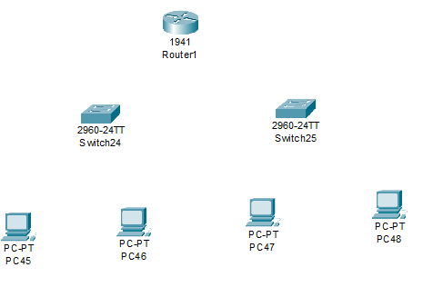

**Step2:** connect switch to router giga ethernet and switches to PCs fast Ethernet

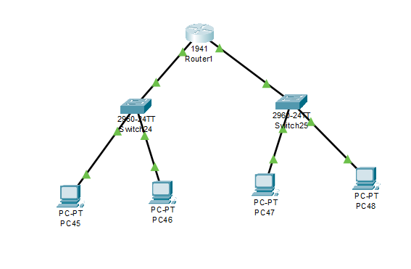

**Step3:**  Ip address for router

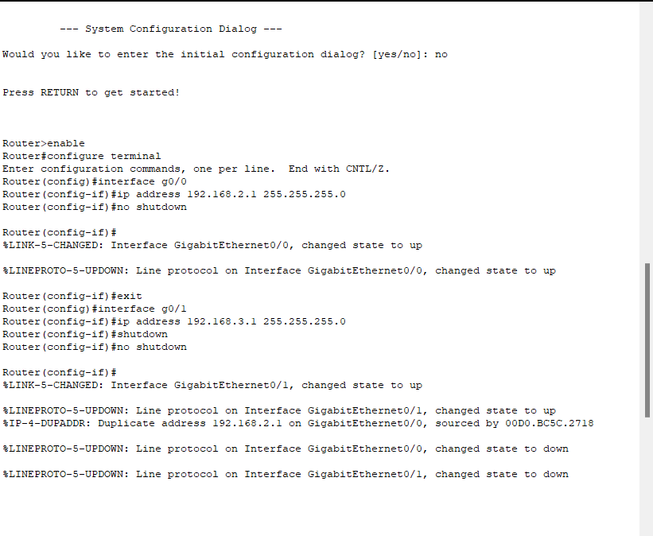

**Step3:** give Ip address for each pc and default gate way

IP address for pc0:192.168.2.10 gateway:192.168.2.1

IP address for pc1: 192.168.2.11 gateway:192.168.2.1

IP address for pc2: 192.168.3.10 gateway:192.168.3.1

IP address for pc3: 192.168.3.11 gateway:192.168.3.1

**Step4:** allocate the messages

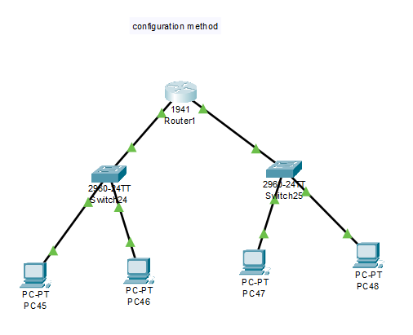

Result: The message sent successfully from one pc to another pc