EXERCISE-4

1. Counting Elements Given an integer array arr, count how many elements x there are, such that x + 1 is also in arr. If there are duplicates in arr, count them separately. Example Input: arr = [1,2,3] Output: 2 Explanation: 1 and 2 are counted cause 2 and 3 are in arr. Example 2: Input: arr = [1,1,3,3,5,5,7,7] Output: 0 Explanation: No numbers are counted, cause there is no 2, 4, 6, or 8 in arr. Constraints: ● 1 <= arr.length <= 1000 ● 0 <= arr[i] <= 1000

**Program:-**

def count_elements(arr):

return sum(1 for x in arr if x + 1 in arr)

# Test the function with examples

print(count_elements([1, 2, 3])) # Output: 2

print(count_elements([1, 1, 3, 3, 5, 5, 7, 7]))

**output:-**

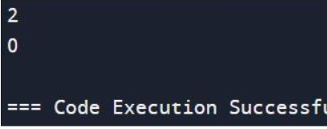

**Time complexity:-**O(n)

1. Perform String Shifts You are given a string s containing lowercase English letters, and a matrix shift, where shift[i] = [directioni, amounti]: ● directioni can be 0 (for left shift) or 1 (for right shift). ● amounti is the amount by which string s is to be shifted. ● A left shift by 1 means remove the first character of s and append it to the end. ● Similarly, a right shift by 1 means remove the last character of s and add it to the beginning. Return the final string after all operations. Example 1: Input: s = "abc", shift = [[0,1],[1,2]] Output: "cab" Explanation: [0,1] means shift to left by 1. "abc" -> "bca" [1,2] means shift to right by 2. "bca" -> "cab" Example 2: Input: s = "abcdefg", shift = [[1,1],[1,1],[0,2],[1,3]] Output: "efgabcd" Explanation: [1,1] means shift to right by 1. "abcdefg" -> "gabcdef" [1,1] means shift to right by 1. "gabcdef" -> "fgabcde" [0,2] means shift to left by 2. "fgabcde" -> "abcdefg" [1,3] means shift to right by 3. "abcdefg" -> "efgabcd" Constraints: ● 1 <= s.length <= 100 ● s only contains lower case English letters. ● 1 <= shift.length <= 100 ● shift[i].length == 2 ● directioni is either 0 or 1. ● 0 <= amounti <= 100

**PROGRAM:-**

def stringShift(s, shift):

total_shift = 0

for sh in shift:

if sh[0] == 0:

total_shift -= sh[1]

else:

total_shift += sh[1]

total_shift %= len(s)

return s[-total_shift:] + s[:-total_shift]

# Example 1

s1 = "abc"

shift1 = [[0,1],[1,2]]

print(stringShift(s1, shift1)) # Output: "cab"

# Example 2

s2 = "abcdefg"

shift2 = [[1,1],[1,1],[0,2],[1,3]]

print(stringShift(s2, shift2)) # Output: "efgabcd"

**OUTPUT:-**

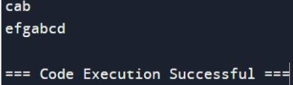

**TIME COMPLEXITY**:-O(n)

1. Leftmost Column with at Least a One A row-sorted binary matrix means that all elements are 0 or 1 and each row of the matrix is sorted in non-decreasing order. Given a row-sorted binary matrix binaryMatrix, return the index (0-indexed) of the leftmost column with a 1 in it. If such an index does not exist, return -1. You can't access the Binary Matrix directly. You may only access the matrix using a BinaryMatrix interface: ● BinaryMatrix.get(row, col) returns the element of the matrix at index (row, col) (0-indexed). ● BinaryMatrix.dimensions() returns the dimensions of the matrix as a list of 2 elements [rows, cols], which means the matrix is rows x cols. Submissions making more than 1000 calls to BinaryMatrix.get will be judged Wrong Answer. Also, any solutions that attempt to circumvent the judge will result in disqualification. For custom testing purposes, the input will be the entire binary matrix mat. You will not have access to the binary matrix directly. Example 1: Input: mat = [[0,0],[1,1]] Output: 0

**PROGRAM:-**

class BinaryMatrix:

def get(self, row: int, col: int) -> int:

# This method will be provided by the testing environment.

pass

def dimensions(self) -> list:

# This method will be provided by the testing environment.

pass

def leftMostColumnWithOne(binaryMatrix: BinaryMatrix) -> int:

rows, cols = binaryMatrix.dimensions()

current_row = 0

current_col = cols - 1

leftmost_col = -1

while current_row < rows and current_col >= 0:

if binaryMatrix.get(current_row, current_col) == 1:

leftmost_col = current_col

current_col -= 1 # Move left

else:

current_row += 1 # Move down

return leftmost_col

# Example for custom testing

class BinaryMatrixExample(BinaryMatrix):

def _init_(self, mat):

self.mat = mat

def get(self, row: int, col: int) -> int:

return self.mat[row][col]

def dimensions(self) -> list:

return [len(self.mat), len(self.mat[0])]

# Example usage

mat = [[0, 0], [1, 1]]

binaryMatrix = BinaryMatrixExample(mat)

print(leftMostColumnWithOne(binaryMatrix)) # Output: 0

**OUTPUT:-**

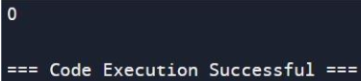

**TIME COMPLEXITY**:-O(num)

4.the object with the numbers in the queue. ● int showFirstUnique() returns the value of the first unique integer of the queue, and returns -1 if there is no such integer. ● void add(int value) insert value to the queue. Example 1: Input: ["FirstUnique","showFirstUnique","add","showFirstUnique","add","showFirstUnique","a dd","showFirstUnique"] [[[2,3,5]],[],[5],[],[2],[],[3],[]] Output: [null,2,null,2,null,3,null,-1] Explanation: FirstUnique firstUnique = new FirstUnique([2,3,5]); firstUnique.showFirstUnique(); // return 2 firstUnique.add(5); // the queue is now [2,3,5,5] firstUnique.showFirstUnique(); // return 2 firstUnique.add(2); // the queue is now [2,3,5,5,2] firstUnique.showFirstUnique(); // return 3 firstUnique.add(3); // the queue is now [2,3,5,5,2,3] firstUnique.showFirstUnique(); // return -1

**PROGRAM:-**

from collections import deque, defaultdict

class FirstUnique:

def _init_(self, nums):

self.queue = deque(nums) # Queue to maintain order of elements

self.count = defaultdict(int) # Dictionary to count occurrences

for num in nums:

self.count[num] += 1

def showFirstUnique(self):

# Remove elements from the front of the queue until we find a unique one

while self.queue and self.count[self.queue[0]] > 1:

self.queue.popleft()

return self.queue[0] if self.queue else -1

def add(self, value):

self.queue.append(value)

self.count[value] += 1

# Example usage

firstUnique = FirstUnique([2, 3, 5])

print(firstUnique.showFirstUnique()) # return 2

firstUnique.add(5) # the queue is now [2, 3, 5, 5]

print(firstUnique.showFirstUnique()) # return 2

firstUnique.add(2) # the queue is now [2, 3, 5, 5, 2]

print(firstUnique.showFirstUnique()) # return 3

firstUnique.add(3) # the queue is now [2, 3, 5, 5, 2, 3]

print(firstUnique.showFirstUnique()) # return -1

**OUTPUT:-**

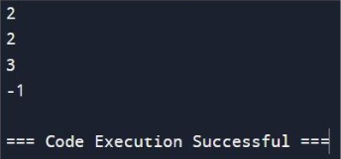

**TIME COMPLEXITY**:-O(n)

5.Check If a String Is a Valid Sequence from Root to Leaves Path in a Binary Tree Given a binary tree where each path going from the root to any leaf form a valid sequence, check if a given string is a valid sequence in such binary tree. We get the given string from the concatenation of an array of integers arr and the concatenation of all values of the nodes along a path results in a sequence in the given binary tree. Example 1: Input: root = [0,1,0,0,1,0,null,null,1,0,0], arr = [0,1,0,1] Output: true Explanation: The path 0 -> 1 -> 0 -> 1 is a valid sequence (green color in the figure). Other valid sequences are: 0 -> 1 -> 1 -> 0 0 -> 0 -> 0

**PROGRAM:**

# Definition for a binary tree node.

class TreeNode:

def _init_(self, val=0, left=None, right=None):

self.val = val

self.left = left

self.right = right

class Solution:

def isValidSequence(self, root: TreeNode, arr: List[int]) -> bool:

def dfs(node, arr, index):

if not node:

return False

if index >= len(arr) or node.val != arr[index]:

return False

if index == len(arr) - 1:

return not node.left and not node.right

return dfs(node.left, arr, index + 1) or dfs(node.right, arr, index + 1)

if not root:

return len(arr) == 0

return dfs(root, arr, 0)

# Example usage

root = TreeNode(0)

root.left = TreeNode(1)

root.right = TreeNode(0)

root.left.left = TreeNode(0)

root.left.right = TreeNode(1)

root.right.left = TreeNode(0)

root.left.left.right = TreeNode(1)

root.left.right.left = TreeNode(0)

root.left.right.right = TreeNode(0)

arr = [0, 1, 0, 1]

sol = Solution()

print(sol.isValidSequence(root, arr)) # Output: True

**OUTPUT:**-

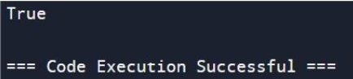

**TIME COMPLEXITY:-**O(n)

6.Kids With the Greatest Number of Candies There are n kids with candies. You are given an integer array candies, where each candies[i] represents the number of candies the ith kid has, and an integer extraCandies, denoting the number of extra candies that you have. Return a boolean array result of length n, where result[i] is true if, after giving the ith kid all the extraCandies, they will have the greatest number of candies among all the kids, or false otherwise. Note that multiple kids can have the greatest number of candies. Example 1: Input: candies = [2,3,5,1,3], extraCandies = 3 Output: [true,true,true,false,true] Explanation: If you give all extraCandies to: - Kid 1, they will have 2 + 3 = 5 candies, which is the greatest among the kids. - Kid 2, they will have 3 + 3 = 6 candies, which is the greatest among the kids. - Kid 3, they will have 5 + 3 = 8 candies, which is the greatest among the kids. - Kid 4, they will have 1 + 3 = 4 candies, which is not the greatest among the kids. - Kid 5, they will have 3 + 3 = 6 candies, which is the greatest among the kids

**PROGRAM**:-

def kidsWithCandies(candies, extraCandies):

max_candies = max(candies) # Find the current maximum number of candies

result = []

for candy in candies:

if candy + extraCandies >= max_candies:

result.append(True)

else:

result.append(False)

return result

# Example usage

candies = [2, 3, 5, 1, 3]

extraCandies = 3

print(kidsWithCandies(candies, extraCandies)) # Output: [true, true, true, false, true]

OUTPUT:-

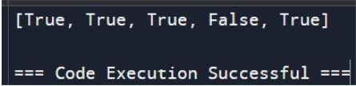

**TIME COMPLEXITY**:-O(n)

7.Max Difference You Can Get From Changing an Integer You are given an integer num. You will apply the following steps exactly two times: ● Pick a digit x (0 <= x <= 9). ● Pick another digit y (0 <= y <= 9). The digit y can be equal to x. ● Replace all the occurrences of x in the decimal representation of num by y. ● The new integer cannot have any leading zeros, also the new integer cannot be 0. Let a and b be the results of applying the operations to num the first and second times, respectively. Return the max difference between a and b. Example 1: Input: num = 555 Output: 888 Explanation: The first time pick x = 5 and y = 9 and store the new integer in a. The second time pick x = 5 and y = 1 and store the new integer in b. We have now a = 999 and b = 111 and max difference = 888

**PROGRAM**:-

def maxDiff(num):

num_str = str(num)

# To get the maximum possible value, replace the first non-9 digit with 9

max_num_str = num_str

for digit in num_str:

if digit != '9':

max_num_str = num_str.replace(digit, '9')

break

max_num = int(max_num_str)

# To get the minimum possible value, replace the first non-1 digit with 1

min_num_str = num_str

if num_str[0] != '1':

min_num_str = num_str.replace(num_str[0], '1')

else:

for digit in num_str[1:]:

if digit != '0' and digit != '1':

min_num_str = num_str.replace(digit, '0')

break

min_num = int(min_num_str)

reuurn max_num - min_num# Example usage

num = 555

print(maxDiff(num)) # Output: 888

**OUTPUT:**-

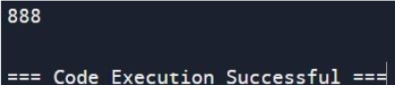

**TIME COMPLEXITY:**-O(n)

8.Check If a String Can Break Another String Given two strings: s1 and s2 with the same size, check if some permutation of string s1 can break some permutation of string s2 or vice-versa. In other words s2 can break s1 or vice-versa. A string x can break string y (both of size n) if x[i] >= y[i] (in alphabetical order) for all i between 0 and n-1. Example 1: Input: s1 = "abc", s2 = "xya" Output: true Explanation: "ayx" is a permutation of s2="xya" which can break to string "abc" which is a permutation of s1="abc"

**PROGARM:-**

def destCity(paths):

start_cities = set()

end_cities = set()

for path in paths:

start_cities.add(path[0])

end_cities.add(path[1])

return (end_cities - start_cities).pop()

# Example

paths = [["London", "New York"], ["New York", "Lima"], ["Lima", "Sao Paulo"]]

print(destCity(paths)) # Output: "Sao Paulo"

**OUTPUT:**-

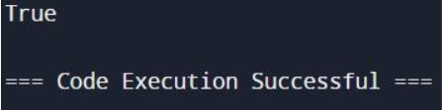

**TIME COMPLEXITY**:-O(nlog n)

9.Number of Ways to Wear Different Hats to Each Other There are n people and 40 types of hats labeled from 1 to 40. Given a 2D integer array hats, where hats[i] is a list of all hats preferred by the ith person. Return the number of ways that the n people wear different hats to each other. Since the answer may be too large, return it modulo 109 + 7. Example 1: Input: hats = [[3,4],[4,5],[5]] Output: 1

**PROGRAM**:-

def numberWaysToWearHatsMemoization(hats):

MOD = 10**9 + 7

n = len(hats)

all_hats = 1 << 40

memo = {}

def dfs(person, hat_mask):

if person == n:

return 1

if (person, hat_mask) in memo:

return memo[(person, hat_mask)]

ways = 0

for hat in hats[person]:

if not (hat_mask >> hat) & 1:

ways = (ways + dfs(person + 1, hat_mask | (1 << hat))) % MOD

memo[(person, hat_mask)] = ways

return ways

return dfs(0, 0)

# Example

hats = [[3, 4], [4, 5], [5]]

print(numberWaysToWearHatsMemoization(hats)) # Output: 1

**OUTPUT**:-

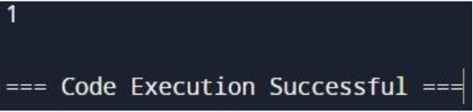

**TIME COMPLEXITY:-**O(2n+log n)

10.Destination City You are given the array paths, where paths[i] = [cityAi, cityBi] means there exists a direct path going from cityAi to cityBi. Return the destination city, that is, the city without any path outgoing to another city. It is guaranteed that the graph of paths forms a line without any loop, therefore, there will be exactly one destination city. Example 1: Input: paths = [["London","New York"],["New York","Lima"],["Lima","Sao Paulo"]] Output: "Sao Paulo" Explanation: Starting at "London" city you will reach "Sao Paulo" city which is thedestination city. Your trip consist of: "London" -> "New York" -> "Lima" -> "Sao Paulo". Example 2: Input: paths = [["B","C"],["D","B"],["C","A"]] Output: "A" Explanation: All possible trips are: "D" -> "B" -> "C" -> "A". "B" -> "C" -> "A". "C" -> "A". "A". Clearly the destination city is "A". Example 3: Input: paths = [["A","Z"]] Output: "Z" Constraints: 1 <= paths.length <= 100 paths[i].length == 2 1 <= cityAi.length, cityBi.length <= 10 cityAi != cityBi All strings consist of lowercase and uppercase English letters and the space character

**PROGRAM**:-

def destCity(paths):

start_cities = set()

end_cities = set()

for path in paths:

start_cities.add(path[0])

end_cities.add(path[1])

return (end_cities - start_cities).pop()

# Example

paths = [["London", "New York"], ["New York", "Lima"], ["Lima", "Sao Paulo"]]

print(destCity(paths)) # Output: "Sao Paulo"

**OUTPUT**:-

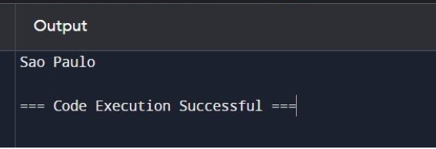

**TIME COMPLEXITY**:-O(n)