**79.Finding the maximum and minimum**

**PROGRAM:**

import time

def find_max_min(lst):

start_time = time.time() # Start time measurement

maximum = max(lst)

minimum = min(lst)

end_time = time.time() # End time measurement elapsed_time = end_time - start_time

return maximum, minimum, elapsed_time

# Example usage

example_list = [3, 1, 4, 1, 5, 9, 2, 6, 5, 3, 5]

max_value, min_value, execution_time = find_max_min(example_list)

print(f"Maximum value: {max_value}") print(f"Minimum value: {min_value}")

print(f"Execution time: {execution_time:.10f} seconds")

OUTPUT:-

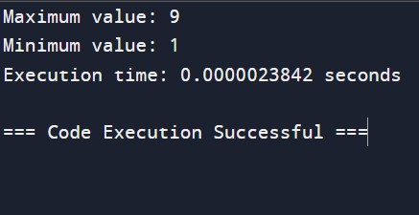

TIME COMPLEXITY:-O(n)

**80. Merge sort**

**PROGRAM:**

:- import time

def merge_sort(arr): if len(arr) > 1:

mid = len(arr) // 2 # Finding the mid of the array left_half = arr[:mid] # Dividing the array elements into 2 halves right_half = arr[mid:]

merge_sort(left_half) # Sorting the first half

merge_sort(right_half) # Sorting the second half

1. = j = k = 0

# Copy data to temp arrays L[] and R[] while i < len(left_half) and j < len(right_half): if left_half[i] < right_half[j]:

arr[k] = left_half[i]

* 1. += 1 else: arr[k] = right_half[j]
  2. += 1 k += 1

# Checking if any element was left while i < len(left_half): arr[k] = left_half[i]

i += 1

k += 1

while j < len(right_half): arr[k] = right_half[j]

1. += 1
2. += 1

def find_merge_sort_time(arr):

start_time = time.time() # Start time measurement

merge_sort(arr) # Perform merge sort

end_time = time.time() # End time measurement

elapsed_time = end_time - start_time

return elapsed_time

# Example usage example_list = [12, 11, 13, 5, 6, 7]

execution_time = find_merge_sort_time(example_list) print(f"Sorted list: {example_list}")

print(f"Execution time: {execution_time:.10f} seconds")

**OUTPUT**:-

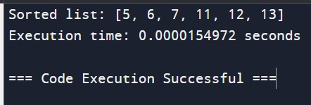

**TIME COMPLEXITY**:-O(n log n)

**81. Quick sort**

**PROGRAM:**

import time

def quick_sort(arr): if len(arr) <= 1: return arr else:

pivot = arr[len(arr) // 2] left = [x for x in arr if x < pivot] middle = [x for x in arr if x == pivot] right = [x for x in arr if x > pivot]

return quick_sort(left) + middle + quick_sort(right)

def find_quick_sort_time(arr):

start_time = time.time() # Start time measurement

sorted_arr = quick_sort(arr) # Perform quick sort

end_time = time.time() # End time measurement elapsed_time = end_time - start_time

return sorted_arr, elapsed_time

# Example usage example_list = [12, 11, 13, 5, 6, 7]

sorted_list, execution_time = find_quick_sort_time(example_list)

print(f"Sorted list: {sorted_list}")

print(f"Execution time: {execution_time:.10f} seconds")

**OUTPUT**:-

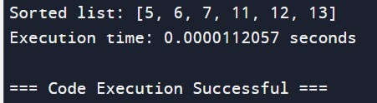

**TIME COMPLEXITY**:-O(n log n)

**82. Binary search**

**PROGRAM:**

:- import time

def binary_search(arr, x): left, right = 0, len(arr) - 1 while left <= right:

mid = left + (right - left) // 2 if arr[mid] == x: return mid elif arr[mid] < x: left = mid + 1 else: right = mid - 1 return -1

def find_binary_search_time(arr, x):

start_time = time.time() # Start time measurement

index = binary_search(arr, x) # Perform binary search

end_time = time.time() # End time measurement elapsed_time = end_time - start_time

return index, elapsed_time

# Example usage

example_list = [1, 2, 3, 4, 5, 6, 7, 8, 9, 10]

search_element = 7

index, execution_time = find_binary_search_time(example_list, search_element)

if index != -1:

print(f"Element found at index: {index}") else:

print("Element not found")

print(f"Execution time: {execution_time:.10f} seconds")

**OUTPUT**:-

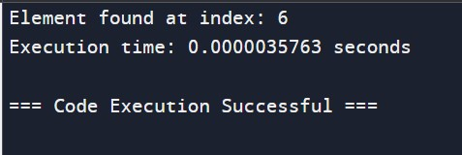

**TIME COMPLEXITY**:-O( log n)

**83. Strassens matrix multiplication**

**PROGRAM:**

import numpy as np import time

def strassen_matrix_multiplication(A, B):

n = len(A)

if n == 1:

return A * B

# Splitting matrices into quadrants

mid = n // 2 A11 = A[:mid, :mid]

A12 = A[:mid, mid:]

A21 = A[mid:, :mid]

A22 = A[mid:, mid:]

B11 = B[:mid, :mid]

B12 = B[:mid, mid:]

B21 = B[mid:, :mid]

B22 = B[mid:, mid:]

# Computing the 7 products using Strassen's formulas

M1 = strassen_matrix_multiplication(A11 + A22, B11 + B22)

M2 = strassen_matrix_multiplication(A21 + A22, B11)

M3 = strassen_matrix_multiplication(A11, B12 - B22)

M4 = strassen_matrix_multiplication(A22, B21 - B11)

M5 = strassen_matrix_multiplication(A11 + A12, B22)

M6 = strassen_matrix_multiplication(A21 - A11, B11 + B12)

M7 = strassen_matrix_multiplication(A12 - A22, B21 + B22)

# Combining the results to get the final quadrants

C11 = M1 + M4 - M5 + M7

C12 = M3 + M5

C21 = M2 + M4

C22 = M1 - M2 + M3 + M6

# Combining the quadrants into a single matrix

C = np.vstack((np.hstack((C11, C12)), np.hstack((C21, C22))))

return C

def find_strassen_time(A, B):

start_time = time.time() # Start time measurement

C = strassen_matrix_multiplication(A, B) # Perform Strassen's matrix multiplication

end_time = time.time() # End time measurement elapsed_time = end_time - start_time

return C, elapsed_time

# Example usage

n = 4 # Size of the matrix (must be a power of 2)

1. = np.random.randint(0, 10, (n, n))
2. = np.random.randint(0, 10, (n, n))

result, execution_time = find_strassen_time(A, B)

print("Matrix A:") print(A) print("Matrix B:") print(B)

print("Result of Strassen's Matrix Multiplication:") print(result)

print(f"Execution time: {execution_time:.10f} seconds")

**OUTPUT:**-

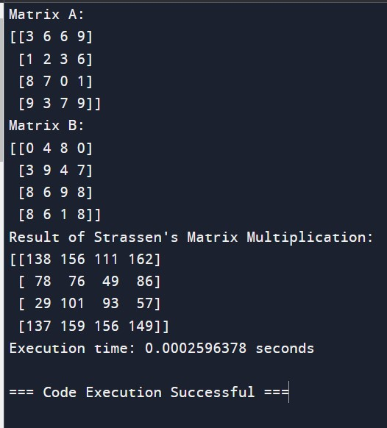

TIME COMPLEXITY:-O(n3)

**84. Karatsuba algorithm for multiplication**

**PROGRAM:**

:- import time

def karatsuba(x, y): # Base case for recursion if x < 10 or y < 10: return x * y

# Calculate the size of the numbers n = max(len(str(x)), len(str(y))) m = n // 2

# Split the digit sequences about the middle high1, low1 = divmod(x, 10**m)

high2, low2 = divmod(y, 10**m)

# Perform 3 multiplications z0 = karatsuba(low1, low2) z1 = karatsuba((low1 + high1), (low2 + high2)) z2 = karatsuba(high1, high2)

# Combine the results

return (z2 * 10**(2*m)) + ((z1 - z2 - z0) * 10**m) + z0

def find_karatsuba_time(x, y):

start_time = time.time() # Start time measurement

result = karatsuba(x, y) # Perform Karatsuba multiplication

end_time = time.time() # End time measurement

elapsed_time = end_time - start_time

return result, elapsed_time

# Example usage x = 12345678901234567890 y = 98765432109876543210

result, execution_time = find_karatsuba_time(x, y)

print(f"Multiplication result: {result}")

print(f"Execution time: {execution_time:.10f} seconds")

**OUTPUT**:-

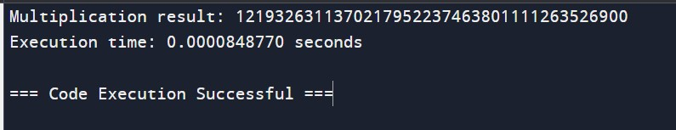

TIME COMPLEXITY:- O(n^log_2{3}) ≈ O(n^1.585)

**85. Closest pair of points using divide and conquer**

**PROGRAM:**

:- import math import time

def distance(point1, point2):

return math.sqrt((point1[0] - point2[0])**2 + (point1[1] - point2[1])**2)

def closest_pair_dc(points): def closest_pair_rec(points_sorted_x, points_sorted_y):

n = len(points_sorted_x) if n <= 3:

return brute_force_closest_pair(points_sorted_x)

mid = n // 2

mid_point = points_sorted_x[mid]

left_x = points_sorted_x[:mid]

right_x = points_sorted_x[mid:]

midpoint = points_sorted_x[mid][0] left_y = list(filter(lambda x: x[0] <= midpoint, points_sorted_y)) right_y = list(filter(lambda x: x[0] > midpoint, points_sorted_y))

(p1_left, p2_left, dist_left) = closest_pair_rec(left_x, left_y)

(p1_right, p2_right, dist_right) = closest_pair_rec(right_x, right_y)

if dist_left < dist_right: min_dist = dist_left min_pair = (p1_left, p2_left) else:

min_dist = dist_right

min_pair = (p1_right, p2_right)

(p3, p4, dist_split) = closest_split_pair(points_sorted_x, points_sorted_y, min_dist, min_pair)

if min_dist <= dist_split:

return min_pair[0], min_pair[1], min_dist else:

return p3, p4, dist_split

def brute_force_closest_pair(points):

min_dist = float('inf') p1, p2 = None, None n = len(points) for i in range(n): for j in range(i + 1, n): d = distance(points[i], points[j]) if d < min_dist: min_dist = d

p1, p2 = points[i], points[j] return p1, p2, min_dist

def closest_split_pair(points_sorted_x, points_sorted_y, delta, best_pair): n = len(points_sorted_x)

mid_x = points_sorted_x[n // 2][0]

sy = [p for p in points_sorted_y if mid_x - delta <= p[0] <= mid_x + delta]

best = delta ln_sy = len(sy) for i in range(ln_sy - 1): for j in range(i + 1, min(i + 7, ln_sy)):

p, q = sy[i], sy[j] dst = distance(p, q) if dst < best: best_pair = (p, q)

best = dst

return best_pair[0], best_pair[1], best

points_sorted_x = sorted(points, key=lambda x: x[0]) points_sorted_y = sorted(points, key=lambda x: x[1])

return closest_pair_rec(points_sorted_x, points_sorted_y)

def find_closest_pair_time(points):

start_time = time.time() # Start time measurement

result = closest_pair_dc(points) # Perform closest pair of points

end_time = time.time() # End time measurement elapsed_time = end_time - start_time

return result, elapsed_time

# Example usage

points = [(2, 3), (12, 30), (40, 50), (5, 1), (12, 10), (3, 4)]

result, execution_time = find_closest_pair_time(points)

print(f"Closest pair of points: {result[0]} and {result[1]}") print(f"Distance: {result[2]}")

print(f"Execution time: {execution_time:.10f} seconds")

**OUTPUT**:-

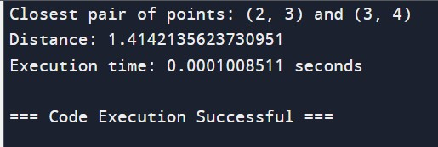

TIME COMPLEXITY:- *O*(*n*log*n*)

**86. Median of medians**

**PROGRAM:**

import time

def partition(arr, low, high, pivot_index):

pivot_value = arr[pivot_index]

arr[pivot_index], arr[high] = arr[high], arr[pivot_index] store_index = low for i in range(low, high): if arr[i] < pivot_value: arr[store_index], arr[i] = arr[i], arr[store_index] store_index += 1

arr[store_index], arr[high] = arr[high], arr[store_index] return store_index

def select(arr, low, high, k): if low == high: return arr[low]

pivot_index = median_of_medians(arr, low, high)

pivot_index = partition(arr, low, high, pivot_index)

if k == pivot_index: return arr[k] elif k < pivot_index: return select(arr, low, pivot_index - 1, k) else:

return select(arr, pivot_index + 1, high, k)

def median_of_medians(arr, low, high):

n = high - low + 1 if n < 10:

return partition5(arr, low, high)

medians = [] for i in range(low, high + 1, 5):

sub_right = i + 4 if sub_right > high: sub_right = high median5 = partition5(arr, i, sub_right)

medians.append(arr[median5])

return select(medians, 0, len(medians) - 1, len(medians) // 2)

def partition5(arr, low, high): sublist = arr[low:high + 1] sublist.sort() mid = (len(sublist) - 1) // 2 median = sublist[mid]

median_index = arr.index(median, low, high + 1) return median_index

def find_kth_smallest(arr, k):

return select(arr, 0, len(arr) - 1, k - 1)

def find_median_of_medians_time(arr):

start_time = time.time() # Start time measurement

n = len(arr) if n % 2 == 1:

median = find_kth_smallest(arr, n // 2 + 1) else:

left = find_kth_smallest(arr, n // 2) right = find_kth_smallest(arr, n // 2 + 1) median = (left + right) / 2

end_time = time.time() # End time measurement elapsed_time = end_time - start_time

return median, elapsed_time

# Example usage

arr = [3, 2, 9, 1, 7, 6, 8, 5, 4]

median, execution_time = find_median_of_medians_time(arr)

print(f"Median: {median}")

print(f"Execution time: {execution_time:.10f} seconds")

**OUTPUT**:-

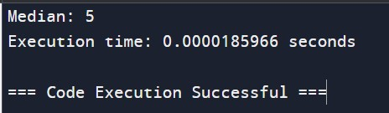

**TIME COMPLEXITY**:-o(n)

**87. Meet in middle technique**

**PROGRAM:**

import itertools import time

def meet_in_the_middle(numbers, target): # Divide the list into two halves mid = len(numbers) // 2 left_half = numbers[:mid]

right_half = numbers[mid:]

# Generate all subset sums for each half

left_sums = set(sum(subset) for i in range(len(left_half) + 1) for subset in itertools.combinations(left_half, i))

right_sums = set(sum(subset) for i in range(len(right_half) + 1) for subset in itertools.combinations(right_half, i))

# Check if there is a combination of sums from left and right halves that equals the target for l_sum in left_sums: if (target - l_sum) in right_sums:

return True

return False

def find_meet_in_the_middle_time(numbers, target): start_time = time.time() # Start time measurement

result = meet_in_the_middle(numbers, target) # Perform the meet-in-the-middle technique

end_time = time.time() # End time measurement elapsed_time = end_time - start_time

return result, elapsed_time

# Example usage numbers = [3, 34, 4, 12, 5, 2] target = 9

result, execution_time = find_meet_in_the_middle_time(numbers, target)

print(f"Subset sum to {target}: {result}")

print(f"Execution time: {execution_time:.10f} seconds")

**OUTPUT:**-

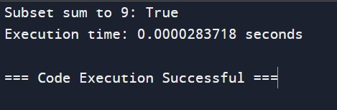

**TIME COMPLEXITY**:- O(2^(n/2) * n)