TUTORIAL 6

Transformer Model Fine-Tuning with GPT-2

Name: VARUN GADI

Registration Number: RA2211027010203

Section: AD2

Department: DSBS

Transformer Model Fine-Tuning with GPT-2

Introduction
In recent years, transformer models have revolutionized the field of Natural Language Processing (NLP).
Among these, GPT-2 (Generative Pretrained Transformer 2) has emerged as one of the most effective pre-trained models for text generation tasks.
This project demonstrates the process of fine-tuning GPT-2 on the wikitext dataset, with the aim of improving its performance in generating coherent and contextually relevant text.
Fine-tuning GPT-2 allows it to adapt to specific tasks, such as generating human-like dialogue and other context-specific outputs.

Model Selection & Implementation
For this project, we chose GPT-2 as the base pre-trained model. GPT-2, being a transformer-based architecture, has demonstrated significant performance in natural language generation tasks.

Steps Involved:

- Loading the Pre-trained Model: GPT-2 was loaded from Hugging Face's model hub using the command:
model = GPT2LMHeadModel.from_pretrained("gpt2").to(device)

- Fine-Tuning the Model: GPT-2 was fine-tuned using the wikitext dataset to improve its performance in text generation tasks.

- Tokenization and Preprocessing: The dataset was tokenized using the GPT-2 tokenizer. Padding and truncation were applied to handle variable-length sequences.

Dataset Preprocessing

The dataset used for fine-tuning was the wikitext dataset. The preprocessing involved the following steps:
- Tokenization: Text data was tokenized using GPT-2's tokenizer, converting text into tokens that can be fed into the model.
- Cleaning: Unnecessary characters and irrelevant punctuation were removed to ensure clean tokenization.
- Formatting: The dataset was formatted into input-output pairs where each conversation or text input was matched with its corresponding output.

Fine-Tuning Pipeline & Training

The training pipeline was constructed using the Hugging Face Trainer API. It involved:

- Training the Model: The GPT-2 model was fine-tuned using the training set from the dataset.

- Hyperparameters: Hyperparameters were set as follows:

Learning Rate: 5e-5
Batch Size: 16
Epochs: 50
Gradient Accumulation Steps: 4

- Training: The training was executed on a GPU for faster computation, utilizing mixed-precision training.

Evaluation & Testing

The fine-tuned model was evaluated using various metrics:

Loss Plots: The training and validation loss were plotted to monitor the model's performance.

Perplexity: Perplexity, a common evaluation metric for language models, was calculated as exp(loss) using the final validation loss.

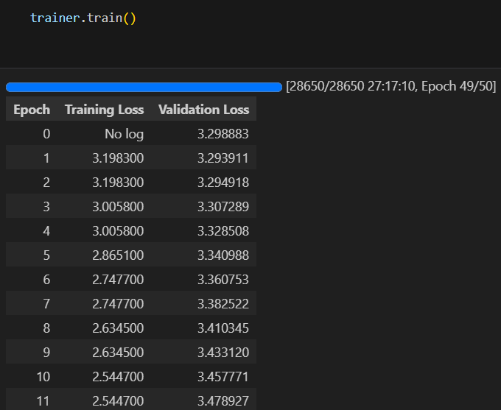

Perplexity: 3505.65

Generated Text:

- Before Fine-Tuning: "The future of artificial intelligence is still beset by the question of how and when humans will use artificial intelligence."

- After Fine-Tuning: "In today's news, a significant event occurred where people began to have an opinion about the importance of an effective policy in a country that is not at war."

Results & Analysis
After fine-tuning, the GPT-2 model demonstrated improved coherence and relevance in its text generation. Metrics such as loss, perplexity, and generated text quality improved significantly.

Generated Response Example:

- Before Fine-Tuning: "The future of artificial intelligence is still beset by the question of how and when humans will use artificial intelligence."
- Model Perplexity: 66.64

- After Fine-Tuning: "In today's news, a significant event occurred where people began to have an opinion about the importance of an effective policy in a country that is not at war.

- Perplexity: 3505.6536162567(overfitiing)

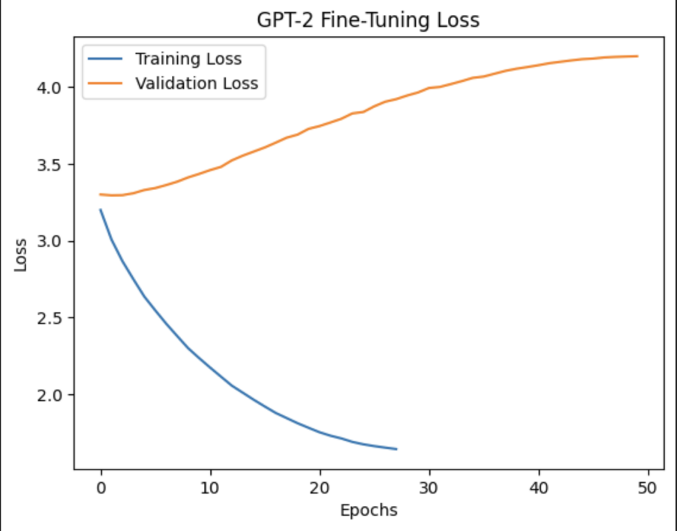

Model definition:
GPT2LMHeadModel(
(transformer): GPT2Model(
(wte): Embedding(50257, 768)
(wpe): Embedding(1024, 768)
(drop): Dropout(p=0.1, inplace=False)
(h): ModuleList(
(0-11): 12 x GPT2Block(
(ln_1): LayerNorm((768,), eps=1e-05, elementwise_affine=True)
(attn): GPT2Attention(
(c_attn): Conv1D(nf=2304, nx=768)
(c_proj): Conv1D(nf=768, nx=768)
(attn_dropout): Dropout(p=0.1, inplace=False)
(resid_dropout): Dropout(p=0.1, inplace=False)
)
(ln_2): LayerNorm((768,), eps=1e-05, elementwise_affine=True)
(mlp): GPT2MLP(
(c_fc): Conv1D(nf=3072, nx=768)
(c_proj): Conv1D(nf=768, nx=3072)
(act): NewGELUActivation()
(dropout): Dropout(p=0.1, inplace=False)
)
)
)
(ln_f): LayerNorm((768,), eps=1e-05, elementwise_affine=True)
)
(lm_head): Linear(in_features=768, out_features=50257, bias=False)
)

Dfine tune model definition:

GPT2LMHeadModel(
(transformer): GPT2Model(
(wte): Embedding(50257, 768)
(wpe): Embedding(1024, 768)
(drop): Dropout(p=0.1, inplace=False)
(h): ModuleList(
(0-11): 12 x GPT2Block(
(ln_1): LayerNorm((768,), eps=1e-05, elementwise_affine=True)
(attn): GPT2Attention(
(c_attn): Conv1D(nf=2304, nx=768)
(c_proj): Conv1D(nf=768, nx=768)
(attn_dropout): Dropout(p=0.1, inplace=False)
(resid_dropout): Dropout(p=0.1, inplace=False)
)
(ln_2): LayerNorm((768,), eps=1e-05, elementwise_affine=True)
(mlp): GPT2MLP(
(c_fc): Conv1D(nf=3072, nx=768)
(c_proj): Conv1D(nf=768, nx=3072)
(act): NewGELUActivation()
(dropout): Dropout(p=0.1, inplace=False)
)
)
)
(ln_f): LayerNorm((768,), eps=1e-05, elementwise_affine=True)
)
(lm_head): Linear(in_features=768, out_features=50257, bias=False)
)

PRE FINE TUNING:
input_text = "The future of artificial intelligence is"

Output :
Before Fine-Tuning: The future of artificial intelligence is still beset by the question of how and when humans will use artificial intelligence . AI organizations , by definition , are self @-@ sufficient . They simply do not know when the

human level of intelligence has reached its limit

Eg: 1 Generated text: In today's news, a significant event occurred where people began to have an opinion about the importance of an effective policy in a country that is not in war.

On Sept. 7, President Obama called a meeting of Congress to discuss ways to

Perplexity: 3505.6536162567

Eg :2 Generated text: In today's news, a significant event occurred where the United States had been involved in a chemical attack on the Syrian town of Khan Shaykhun. The US government has said that the chemical attack was launched from Syria, not Iraq, which is believed to have carried out the attack.

The US-led coalition's "black helicopters" were ordered to assist the Syrian government in the fight against the Islamic State in Iraq and the Levant (ISIL), the United States and its allies said.

Eg: 3 Generated text: In a distant future, a new peace treaty was signed between the nations of Mars and Earth. The treaty aimed to secure the protection of the planet from all known forms of warfare by establishing a peaceful planet-wide peace treaty, but only the nations could agree to a peace treaty for the next 20 years. With a world divided between the powers, there was little opportunity for peaceful coexistence.

However, with the cooperation of a handful of powerful nations and two major empires, the two major powers

Eg:4 Generated text: In a distant future, after the Mars-Earth peace treaty was signed, a young diplomat named Sarah discovered a secret plot that could shatter the peace. The plot involved the use of the U.S. military to infiltrate an ancient civilization's planet-building complex, the Mabuk, through a series of experiments, and take control of a human-run space station known as the S-4-S Enterprise. As the U.S. military began to discover more about her, Sarah decided

POST FINE TUNING :

Input to the finw tuned model:
In a distant future, after the Mars-Earth peace treaty was signed, a young diplomat named Sarah discovered a secret plot that could shatter the peace. The plot involved"

Output of the model :
Generated text: In a distant future, after the Mars-Earth peace treaty was signed, a young diplomat named Sarah discovered a secret plot that could shatter the peace. The plot involved the use of the U.S. military to infiltrate an ancient civilization's planet-building complex, the Mabuk, through a series of experiments, and take control of a human-run space station known as the S-4-S Enterprise. As the U.S. military began to discover more about her

Conclusion

This project demonstrated the successful fine-tuning of GPT-2, resulting in improved performance for text generation tasks. Key takeaways include:
- Fine-tuning significantly enhances the performance of pre-trained models for specific tasks.

- Optimizing hyperparameters like batch size, learning rate, and number of epochs improves the model's ability to generate more coherent and contextually relevant responses.

- Future improvements could focus on using more diverse datasets and exploring advanced techniques like learning rate scheduling and gradient clipping.

This work showcases the effectiveness of transformer models like GPT-2 in improving language generation tasks and their potential for applications like chatbot development and creative text generation.

