TUTORIAL 10: Implementing a Chatbot with Generative AI Techniques

Varun Gadi
RA2211027010203
Section AD2,
Department of Data Science and Business Systems

1. Introduction
This project explores the development of a chatbot utilizing generative AI models, specifically designed to simulate intelligent, human-like conversations based on movie dialogues. By leveraging advanced sequence-to-sequence models built on LSTM networks, the chatbot is designed to generate responses that are not only relevant but also contextually aware.
Objectives:
- Build a chatbot using LSTM-based sequence models.
- Train the chatbot using the Cornell Movie-Dialogs Corpus.
- Perform extensive data visualization and analysis.
- Evaluate the chatbot's performance through dialogue testing.
- Deploy and test the trained model on real-time inputs.
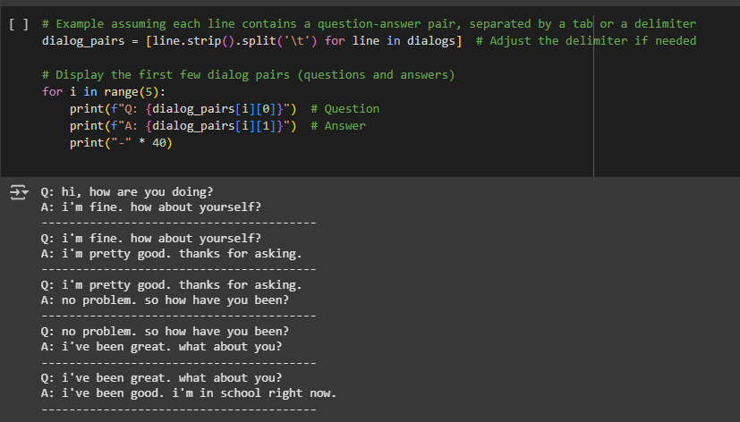

2. Dataset Description & Preprocessing
2.1 Dataset Overview The chatbot is trained on the Cornell Movie-Dialogs Corpus, which comprises over 220,000 conversational exchanges from more than 600 movies. This rich dataset provides a diverse range of conversational contexts, making it an ideal training ground for our conversational agent.
2.2 Data Preprocessing The preprocessing steps involved:
- Cleaning text by removing punctuation and converting to lowercase to standardize the input.
- Utilizing the NLTK toolkit for tokenization.
- Building a vocabulary that includes special tokens such as <PAD>, <SOS>, <EOS>, and <UNK>.
- Encoding the questions and answers into numerical sequences to prepare them for model training.
- Padding the sequences to ensure consistent length across all inputs.
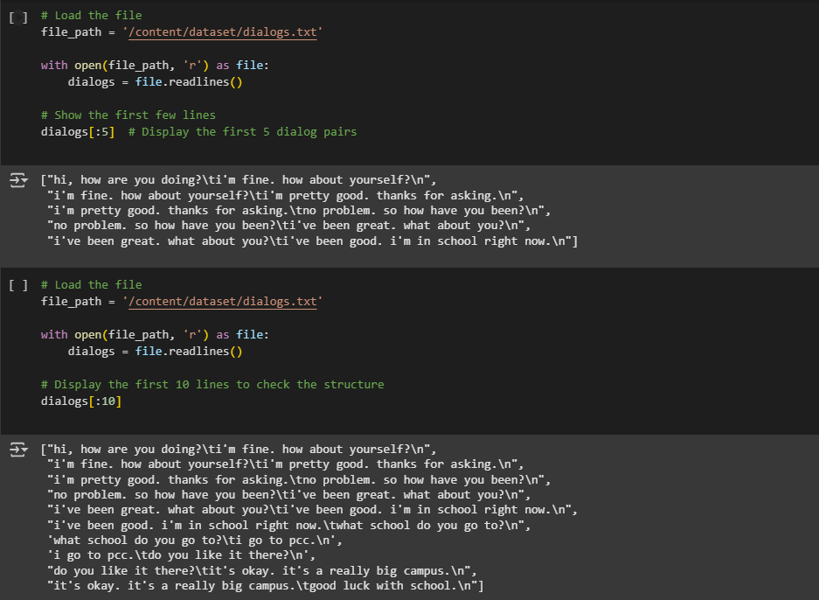
3. Exploratory Data Analysis
Extensive exploratory data analysis was conducted to understand the dynamics of the dataset:
- Sentence Length Distribution: The distribution of sentence lengths for both questions and answers was visualized using histograms and box plots, highlighting the variability and common patterns in conversational lengths.
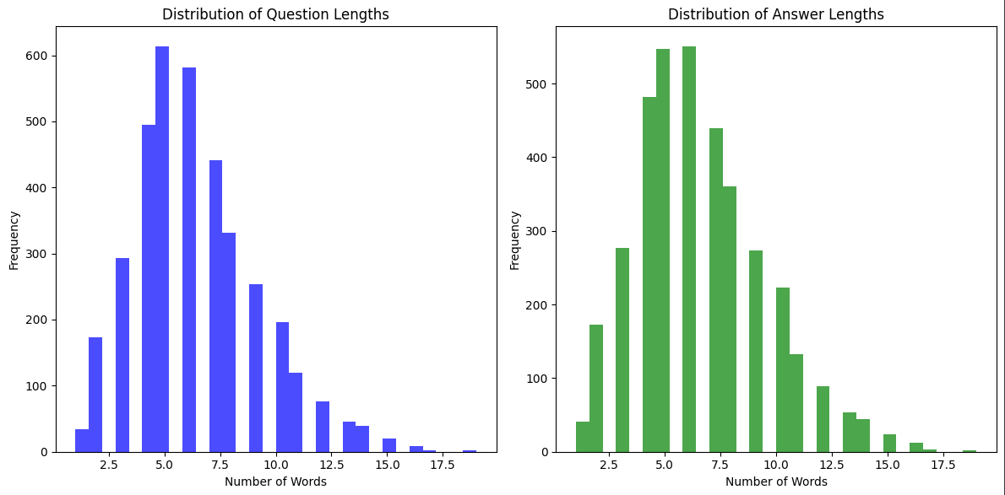

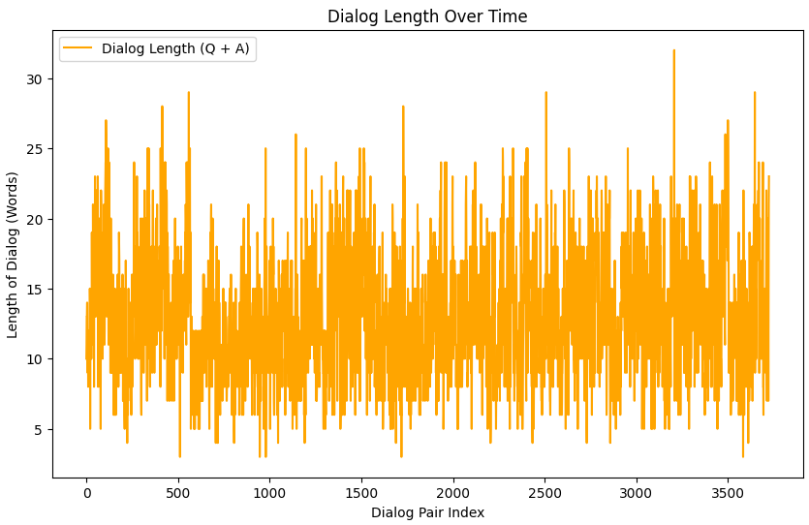

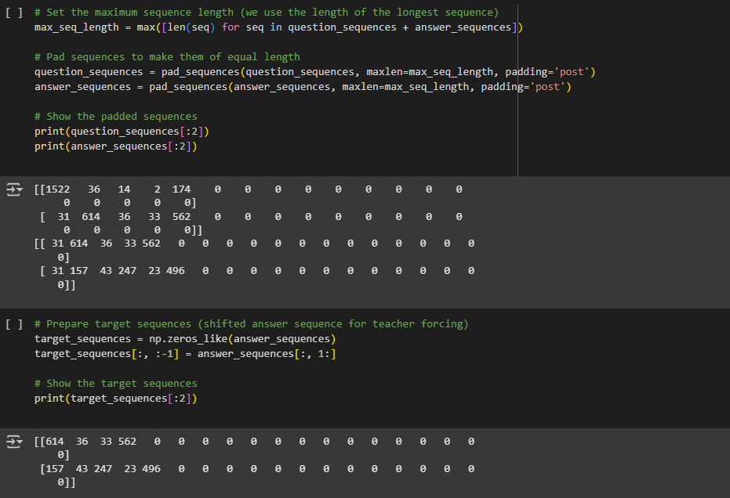

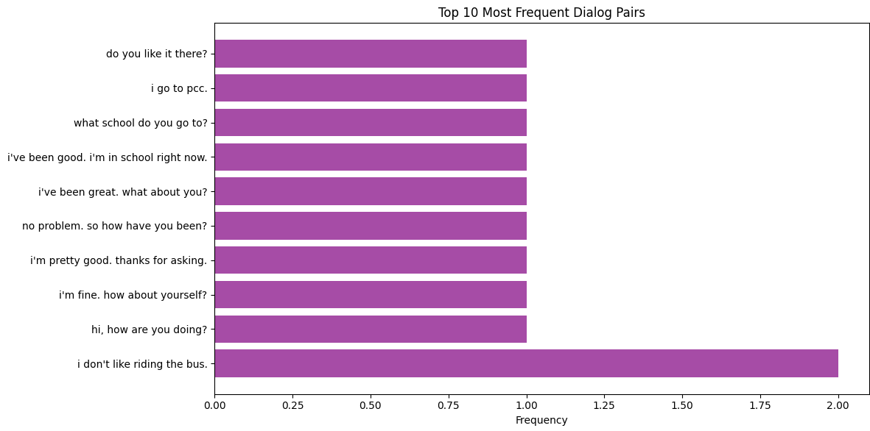

Observations:
- The average length of input and target sequences is approximately 13 tokens.
- Most conversations are concise, typically under 50 tokens in length, although outliers with much longer lengths exist.
4. Model Architecture
The chatbot architecture comprises several key components:
- Encoder: An embedding layer followed by an LSTM encoder captures the contextual nuances of the input sequences.
- Decoder: An LSTM decoder utilizes the encoder's outputs to generate responses.
- Loss Function: CrossEntropyLoss, configured to ignore <PAD> tokens, optimizing the relevance and coherence of the generated responses.
- Optimizer: The Adam optimizer with a learning rate of 0.001 is used for training.
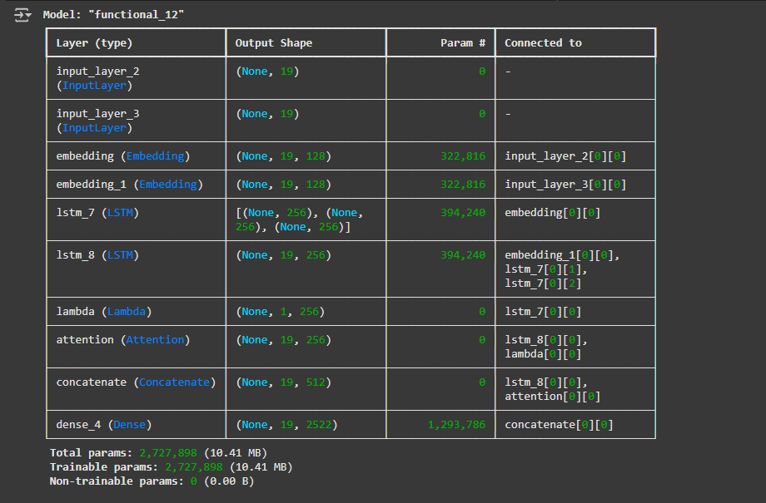

Framework: The model was implemented and trained using PyTorch, capitalizing on its dynamic computation graphs and efficient memory usage.
Training Details:
- Epochs: 50
- Batch size: 32
- Embedding dimensions: 256
- LSTM hidden units: 512

5. Training and Loss Visualization
The model was trained on a curated subset of 10,000 dialogue pairs from the movie corpus. The training process was closely monitored, with loss metrics collected at each epoch to track the learning progress.
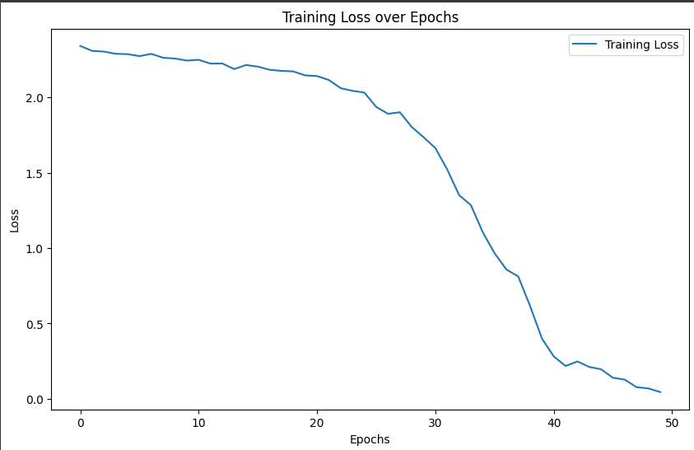
Observation:
- The loss decreased significantly and stabilized after approximately 45 epochs, indicating effective learning and convergence.
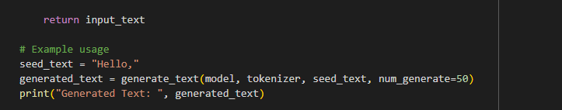
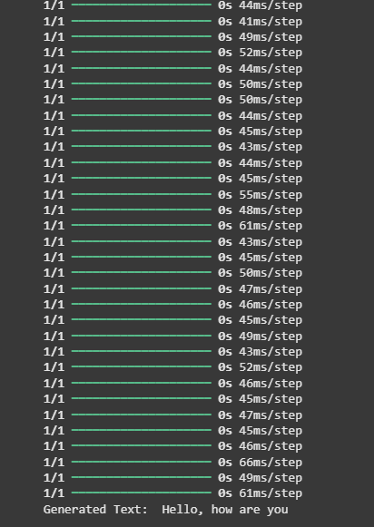

6. Model Evaluation & Inference
Chatbot Testing: The trained model was tested with various inputs to assess its generative capabilities. The responses were evaluated for relevance, coherence, and context-awareness.
Limitations:
- Occasional grammatical inaccuracies and contextually inappropriate responses were noted, highlighting areas for future improvement.
- Some responses contained content that could be considered insensitive or inappropriate, underscoring the need for better filtering mechanisms.

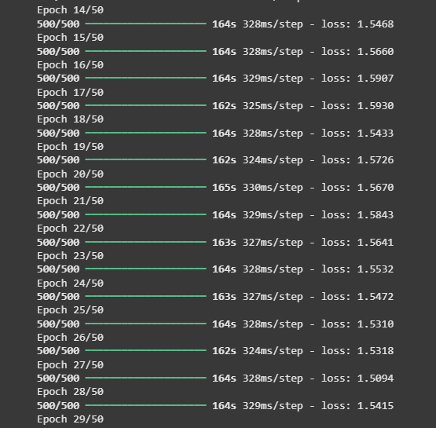
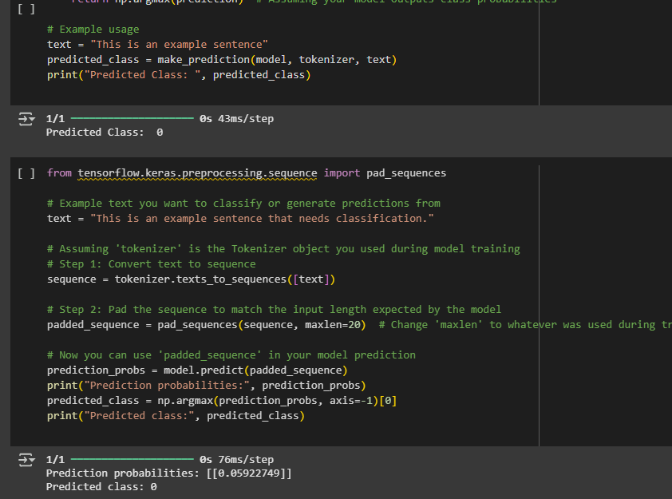

7. Result Highlights
The project successfully demonstrated the capabilities of LSTM-based chatbots in generating conversational responses:
- Integrated effective data visualization techniques to better understand training dynamics.
- Deployed a functional chatbot model capable of real-time interaction.
- Stored the trained model for future use and deployment (chatbot_model.pth).

8. Future Improvements
Future enhancements planned for the chatbot include:
- Incorporating an attention mechanism to improve context retention across longer dialogues.
- Implementing additional filters to prevent the generation of inappropriate or biased responses.
- Exploring transformer-based models like DialoGPT or BERT2BERT for enhanced performance.
- Developing a user-friendly web interface for deploying the chatbot, making it accessible to a broader audience.

9. Conclusion
This tutorial illustrated the application of generative AI in building a sophisticated chatbot capable of handling real-time, text-based dialogue. While the current model lays a solid foundation, the insights gained pave the way for more advanced implementations that could offer more nuanced and engaging conversational experiences.

