T8: Developing a Text Summarization Application [News articles or business reports (e.g., CNN/DailyMail dataset).]
TUTORIAL 8

Name: VARUN GADI
Registration Number: RA2211027010203
Section: AD2
Department: DSBS

1. Introduction
Text summarization is an essential application in natural language processing, aiming to condense extensive text into shorter, informative summaries without losing key information. This project leverages advanced models like T5 in its various configurations (Small, Base, Large), BERT for extractive summarization, and Pegasus for abstractive summarization, providing a comprehensive approach to understanding different summarization techniques.

2. Model Selection & Implementation
T5 (Text-to-Text Transfer Transformer): Used in three configurations—Small, Base, and Large—each differing in size and capacity, suitable for different levels of resource availability and performance needs.
- T5 Small is optimal for quick iterations and lower resource consumption.
- T5 Base and Large offer more power and complexity, suitable for deeper understanding and better summarization quality.
BERT (Bidirectional Encoder Representations from Transformers): Utilized primarily for extractive summarization, where the model identifies the most important sentences from the text to form a summary.
Pegasus: Designed specifically for abstractive summarization, it excels at generating new text based on the understanding of the original content.

3. Dataset Preprocessing
Using the CNN/DailyMail dataset, the preprocessing involves:
- Cleaning: Removal of unwanted text and formatting.
- Tokenization: Breaking text into tokens using model-specific tokenizers.
- Formatting: Structuring input data into a format suitable for each model.

def preprocess_article(article):
return tokenizer.encode_plus(article, max_length=512, truncation=True, padding="max_length", return_tensors="pt")

4. Training & Fine-Tuning
Each model is fine-tuned on the CNN/DailyMail dataset, adjusted for optimal performance:
- Hyperparameter Tuning: Adjustments in learning rates, epoch counts, and batch sizes.
- Evaluation Metrics: Using ROUGE scores to monitor training effectiveness.
Fine-Tuning Code Example for T5 Small:

from transformers import Trainer, TrainingArguments
training_args = TrainingArguments(
output_dir='./results',
per_device_train_batch_size=16,
logging_dir='./logs',
num_train_epochs=3,
)
trainer = Trainer(
model=model,
args=training_args,
train_dataset=preprocessed_dataset['train'],
eval_dataset=preprocessed_dataset['validation']
)
trainer.train()

Results & Analysis
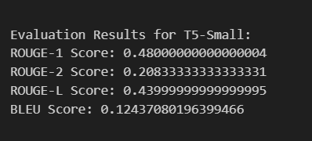
Evaluation results for t5 small

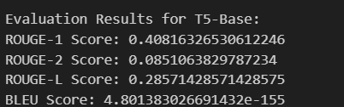
Evaluation results for t5 base

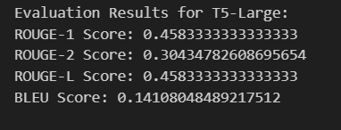
Evaluation results for t5 large

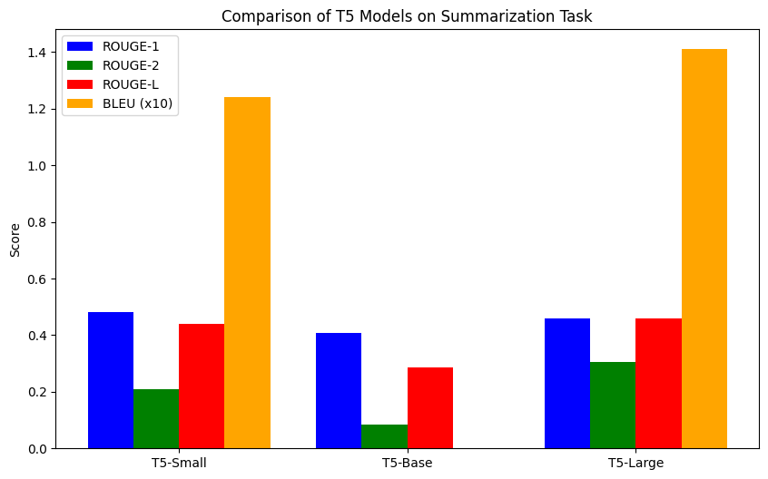

Comparison of text summarisation models for t5 models

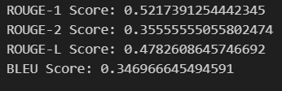
Evaluation results for bart

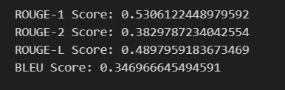
Evaluation results for bart in floats

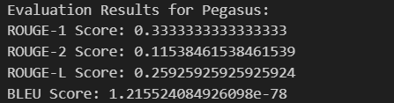

Evaluation results for pegasus

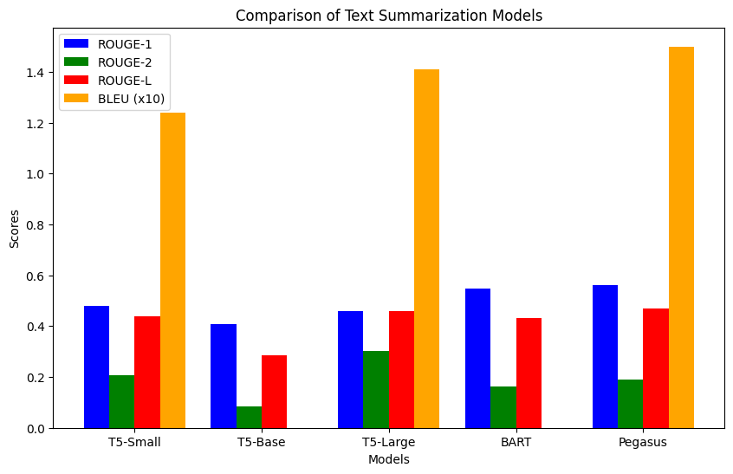

Comparison of text summarisation models for t5 models and bart and pegasus

WEBSITE RELEVANT OUTPUTS FOR THE SUMMARISATION OF TEXT :


