EduGenie
Project Documentation
AI-Powered Educational Learning Assistant

1. Project Overview
EduGenie is a web-based educational assistant built with FastAPI and a Gemini-powered backend. The application is designed to help learners explain concepts, answer questions, generate quizzes, summarize educational material, and create personalized learning paths.
This documentation is based on the project code and configuration shared during development, including the FastAPI application, Gemini client interface, Q&A module, explanation module, quiz module, summary module, learning-path module, templates, static JavaScript/CSS, and environment configuration visible in the project.

2. Main Features
Feature | Purpose
Concept Explanation | Explains an educational concept in clear language.
Ask Question | Accepts a learner's question and returns a focused educational answer.
Quiz Generation | Creates a structured multiple-choice quiz from supplied educational material.
Summarization | Summarizes supplied text.
Learning Path | Creates a personalized, staged learning roadmap based on topic and learner level.

3. Technology Stack
Technology | Role
Python | Application programming language
FastAPI | Backend web framework and REST API
Pydantic | Request validation and structured response validation
pydantic-settings | Environment/configuration management
Google Gemini | AI text generation
Uvicorn | ASGI development server
Jinja2 | HTML template rendering
HTML/CSS/JavaScript | Frontend interface

4. Project Structure
The project structure shown during development contains the following important files and directories:
edugenieai/
├── .venv/
├── static/
│ ├── css/
│ │ └── style.css
│ └── js/
│ └── app.js
├── templates/
│ └── index.html
├── tests/
│ ├── __init__.py
│ └── test_api.py
├── .env
├── .env.example
├── .gitignore
├── config.py
├── gemini_client.py
├── main.py
├── qna.py
├── explanation_module.py
├── quiz_module.py
├── summary_module.py
├── learning_path.py
├── requirements.txt
└── requirements-local.txt
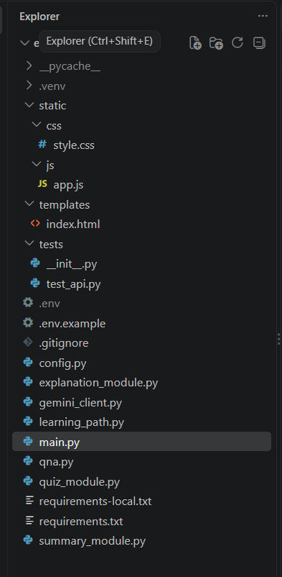

5. Backend Architecture
The backend uses a modular design. main.py exposes HTTP endpoints, while feature-specific modules contain the logic for each educational task. The Gemini client is kept separate so AI communication can be reused by multiple modules.
File/Area | Responsibility
main.py | Creates the FastAPI application, request models, routes, static files, and templates.
config.py | Loads application and Gemini-related settings from environment variables.
gemini_client.py | Creates the Gemini client and exposes text/structured-generation functions used by feature modules.
qna.py | Builds the system instruction and prompt for learner questions.
explanation_module.py | Handles concept explanation requests.
quiz_module.py | Defines Pydantic quiz models, generates quiz content, cleans JSON, and validates the result.
summary_module.py | Handles summarization requests.
learning_path.py | Defines learning-path models and generates a structured roadmap.
main.py routes | Connect frontend requests to the appropriate feature module.

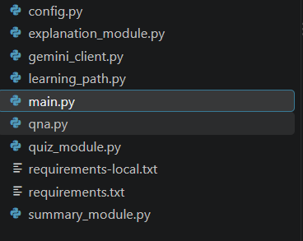

6. Configuration
The configuration class uses pydantic-settings and reads values from a .env file. The settings shown in the project include the application name, Gemini API key, explanation backend, local explanation model, maximum output tokens, and temperature.
from pydantic_settings import BaseSettings, SettingsConfigDict
class Settings(BaseSettings):
app_name: str = "EduGenie"
gemini_api_key: str = ""
explanation_backend: str = "gemini"
model_config = SettingsConfigDict(
env_file=".env",
env_file_encoding="utf-8",
extra="ignore",
)
Keep the real Gemini API key only in .env and do not commit that secret to source control. The .gitignore file should exclude .env.
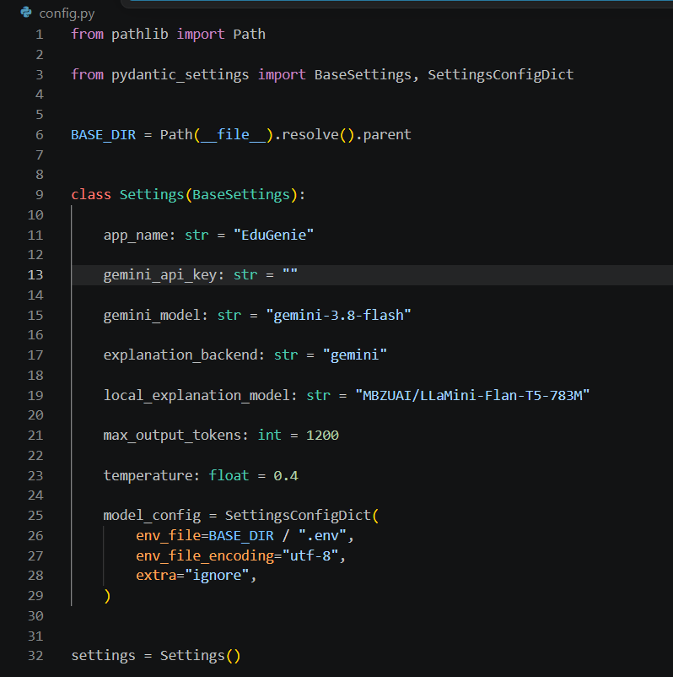

7. Gemini Client
The Gemini client is the common AI layer used by the feature modules. The project uses the Google GenAI Python package and reads GEMINI_API_KEY from the environment. During development, the client also exposed generate_structured(prompt), which feature modules use when they need machine-readable JSON.
An important compatibility detail discovered during development: the current generate_structured() interface accepts one positional prompt argument. Therefore, calls such as generate_structured(prompt, LearningPath) are incompatible with the current client interface; the learning-path module was corrected to call generate_structured(prompt) and validate the returned object with Pydantic.
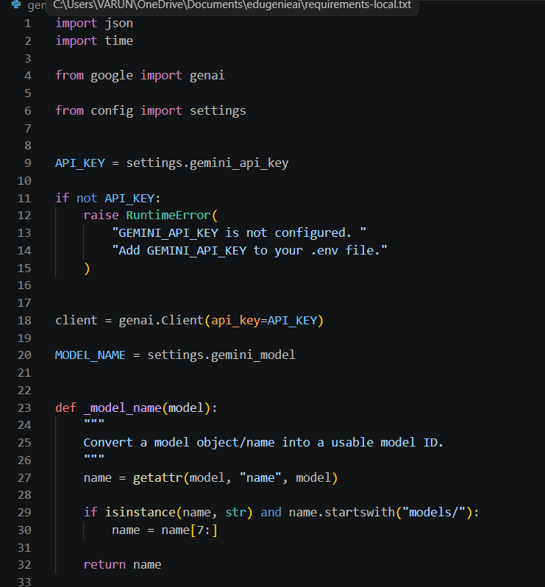

8. FastAPI Request Models
Model | Field | Validation | Used By
TextRequest | text | 1–20,000 characters | Explanation / summary
QARequest | question | 1–10,000 characters | Question answering
QuizRequest | text | 1–20,000 characters | Quiz generation
LearningPathRequest | topic | 1–5,000 characters | Learning path topic
LearningPathRequest | level | Maximum 50 characters | Learner level; defaults to beginner

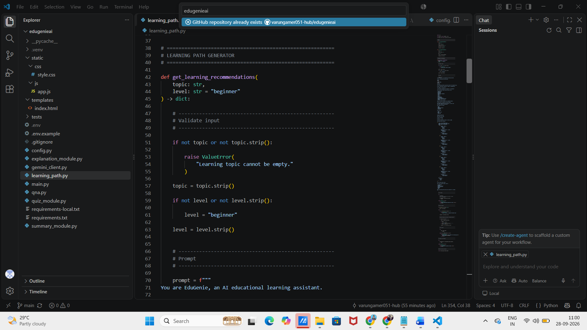

9. API Endpoints
Method | Endpoint | Purpose | Input
GET | / | Loads the EduGenie web interface. | HTML
GET | /health | Checks application status and whether the configured settings contain a Gemini key. | JSON
POST | /qa | Answers a learner's question. | {"question": "..."}
POST | /explain | Explains a concept. | {"text": "..."}
POST | /quiz | Generates a quiz from educational material. | {"text": "..."}
POST | /summarize | Summarizes educational text. | {"text": "..."}
POST | /learn/recommendations | Generates a personalized learning path. | {"topic": "...", "level": "beginner"}

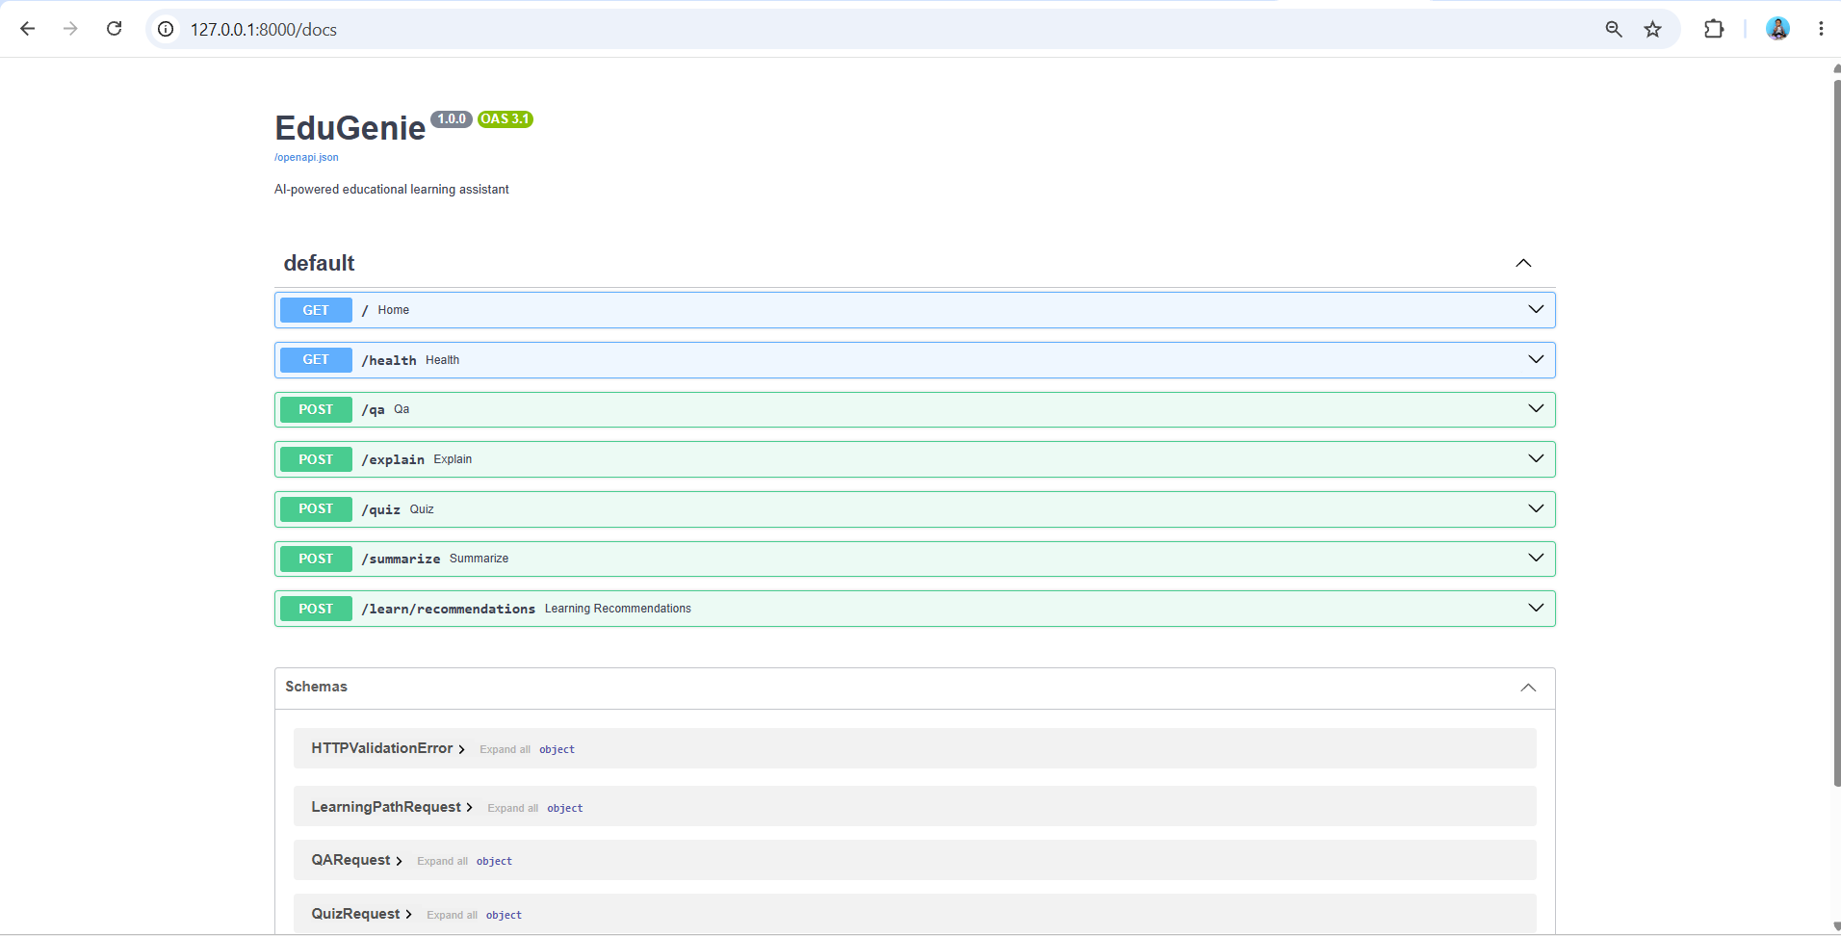

10. Question Answering Flow
The Q&A module defines an EduGenie system instruction and then creates a focused prompt containing the learner's question.
SYSTEM_INSTRUCTION = '''
You are EduGenie, an educational AI assistant.
Your job is to help students understand academic
and general educational questions.
Rules:
1. Answer accurately.
2. Give the direct answer first.
3. Explain difficult ideas using simple language.
4. Avoid unnecessary complexity.
5. If something is uncertain, clearly say so.
6. Do not invent sources.
7. Use examples when they improve understanding.
'''
The answer_question() function sends the prompt and system instruction through generate_text(). The API then returns the generated answer under the 'answer' field.
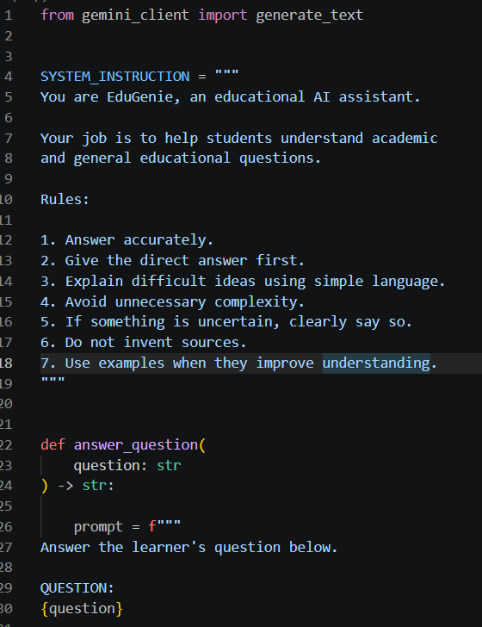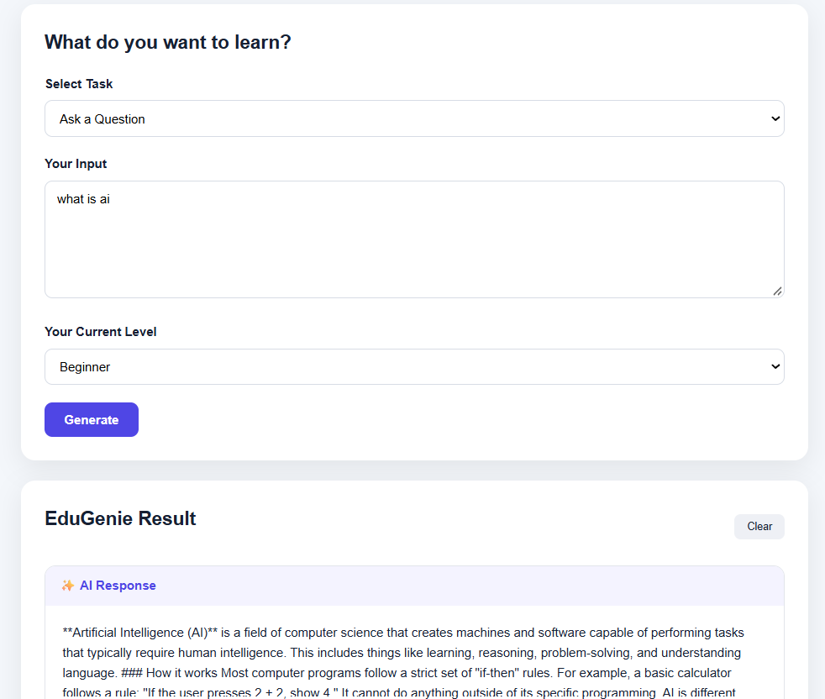

11. Quiz Generation
The quiz module uses two Pydantic models: QuizQuestion and QuizResponse. QuizQuestion contains a question, exactly four options, a correct answer, and an optional explanation. A validator checks that correct_answer matches one of the supplied options. QuizResponse requires exactly three questions.
class QuizQuestion(BaseModel):
question: str
options: list[str] = Field(min_length=4, max_length=4)
correct_answer: str
explanation: str = ""
class QuizResponse(BaseModel):
questions: list[QuizQuestion] = Field(
min_length=3,
max_length=3
)
The generator is instructed to base questions only on the supplied material, avoid invented information, provide four options, and include a short explanation. The JSON-cleaning step removes Markdown code fences if the model returns a fenced JSON block, after which json.loads() and Pydantic validation are used.
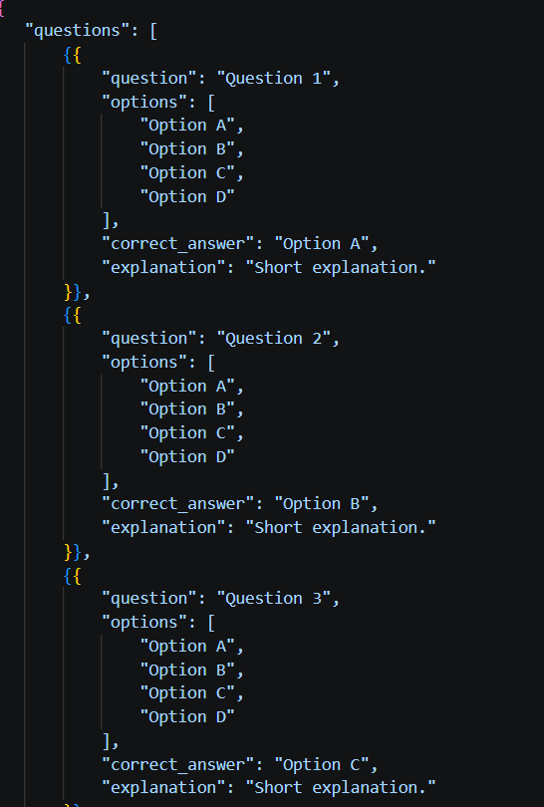
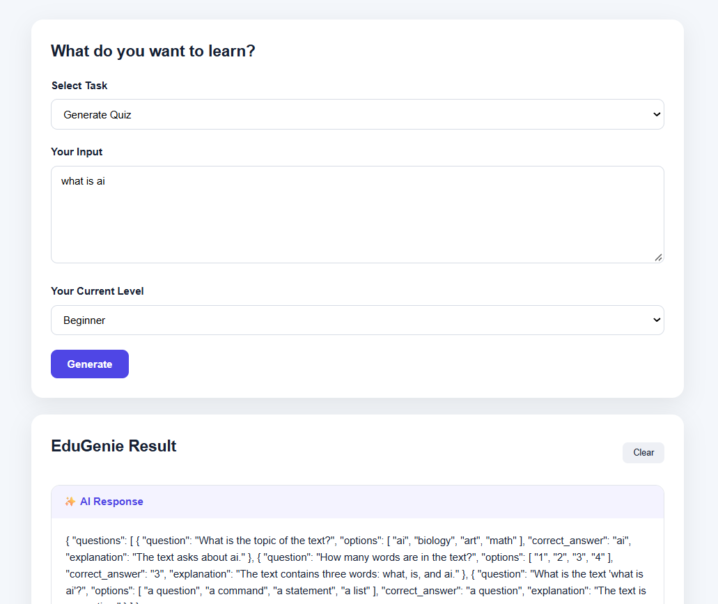

12. Learning Path Generation
The learning-path module models a LearningPath containing the topic, learner level, goal, learning steps, and study tips. Each LearningStep contains a stage, topics, suggested duration, activities, and resources.
class LearningStep(BaseModel):
stage: str
topics: list[str]
suggested_duration: str
activities: list[str]
resources: list[str]
class LearningPath(BaseModel):
topic: str
learner_level: str
goal: str
steps: list[LearningStep]
study_tips: list[str]
The learning-path prompt is designed to produce a progressive roadmap and adapt it to the learner's current level. It also instructs the model not to invent specific URLs and to use resource types such as documentation, textbooks, practice exercises, projects, videos, or notes.

13. Learning Path Input Examples
Good inputs are specific learning goals rather than single words. Examples:
- Learn Python programming from beginner to intermediate
- Learn mathematics for Class 10 from basics to exam preparation
- Learn HTML and CSS from beginner to intermediate
- Learn Java programming for beginners
- Learn machine learning fundamentals
- Learn SQL from beginner to intermediate
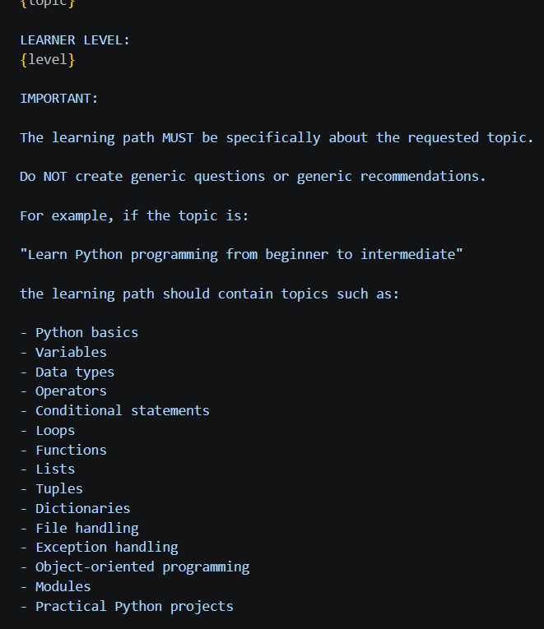

14. Example API Requests
Question answering:
POST /qa
{
"question": "What is photosynthesis?"
}
Quiz generation:
POST /quiz
{
"text": "Photosynthesis is the process by which green plants use sunlight, water, and carbon dioxide to produce glucose and oxygen."
}
Learning path:
POST /learn/recommendations
{
"topic": "Learn Python programming from beginner to intermediate",
"level": "beginner"
}

15. Frontend Flow
The frontend is served from templates/index.html and uses static/js/app.js and static/css/style.css. The interface allows the learner to select a task, enter educational input, and display the generated result. The Learning Path screen includes a topic input and learner-level selection.
During debugging, the browser Network panel showed requests such as /qa and /recommendations. The Q&A request successfully returned HTTP 200, while the learning recommendations request returned HTTP 500 until the generate_structured() argument mismatch was corrected.

16. Running the Project
From the project directory, activate the virtual environment and start Uvicorn.
# Windows PowerShell
.\.venv\Scripts\Activate.ps1
# Start the FastAPI development server
uvicorn main:app --reload
The application is then available at:
http://127.0.0.1:8000
Interactive API documentation is available at:
http://127.0.0.1:8000/docs
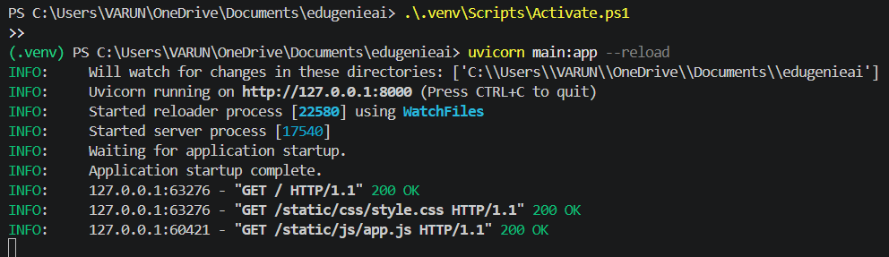

17. Recommended Testing Procedure
1. Start Uvicorn with --reload.
2. Open /health and confirm the application responds.
3. Open /docs and test /qa first.
4. Test /explain with a short educational concept.
5. Test /quiz with a paragraph of educational material rather than a single word.
6. Test /summarize with a paragraph or longer passage.
7. Test /learn/recommendations with a specific topic and learner level.
8. If the frontend reports an error, inspect the browser Network panel and the VS Code terminal.

18. Troubleshooting
Problem | Resolution
GEMINI_API_KEY is not configured | Confirm GEMINI_API_KEY exists in .env and that the application is started from the project directory. Restart Uvicorn after changing .env.
404 model not found | The configured Gemini model name may not be available for the API version or operation being used. Use a model supported by the installed Google GenAI client/API.
503 model temporarily unavailable | This indicates temporary model availability or demand issues. Retry later or use another supported model if appropriate.
generate_structured() takes 1 positional argument but 2 were given | Call generate_structured(prompt) with the current client interface. Validate the structured result separately with the Pydantic response model.
Backend returned invalid JSON: Internal Server Error | Open the browser Network request and check the FastAPI/VS Code terminal. Add exception logging around the affected route to expose the actual backend exception.
Quiz questions are too generic for a tiny input such as 'sun' | Provide enough educational material for the model to generate meaningful questions. The quiz prompt can also explicitly require conceptual questions rather than word-matching questions.

19. Security Notes
- Never publish the Gemini API key in screenshots, source code, Git repositories, or frontend JavaScript.
- Keep the API key in .env or another secure environment-variable mechanism.
- Do not send the Gemini API key to the browser.
- Keep .env excluded from version control.
- Validate incoming request sizes using the Pydantic limits already present in main.py.

20. Current Limitations
- The application currently focuses on the implemented educational features rather than user accounts and persistent progress tracking.
- The supplied implementation does not yet demonstrate voice input/output, multilingual interaction, mobile apps, offline storage, gamification, LMS integration, collaborative learning, OCR/document processing, cloud sync, or advanced analytics.
- Learning-path resources are intentionally described as resource types rather than invented URLs.
- AI-generated outputs depend on model availability and may fail temporarily when the upstream model service is unavailable.

21. Planned Future Enhancements
- Voice-based interaction using speech recognition and text-to-speech.
- Multilingual support.
- Android and iOS applications with offline functionality.
- Progress tracking dashboard with quiz scores, accuracy, completed topics, and improvement graphs.
- Gamification with badges, streaks, leaderboards, and daily challenges.
- Adaptive learning paths based on learner performance and pace.
- Integration with Moodle, Google Classroom, and Canvas.
- Collaborative study and group quiz mode.
- Image/PDF input with OCR and educational extraction.
- Smart study reminders and notifications.
- User profiles and cloud synchronization.
- Enhanced responsive UI/UX.
- Interactive AI Tutor mode.
- Learning analytics for teachers or parents.
- Integration with external knowledge sources such as educational/reference APIs.

22. End-to-End Request Flow
Learner
|
v
Frontend (HTML / CSS / JavaScript)
|
v
FastAPI endpoint in main.py
|
+---- /qa ----------------------> qna.py
|
+---- /explain -----------------> explanation_module.py
|
+---- /quiz --------------------> quiz_module.py
|
+---- /summarize ---------------> summary_module.py
|
+---- /learn/recommendations ---> learning_path.py
|
v
gemini_client.py
|
v
Gemini API
|
v
Structured result
|
v
Pydantic validation
|
v
JSON response
|
v
Frontend

23. Conclusion
EduGenie has a clear modular foundation for an AI learning assistant. FastAPI handles the web/API layer, Pydantic provides validation, feature modules keep educational logic separated, and gemini_client.py centralizes AI communication. The current implementation already supports question answering, concept explanation, quiz generation, summarization, and personalized learning-path generation. The architecture also leaves clear extension points for the planned voice, multilingual, mobile, analytics, adaptive-learning, and collaboration features.

