

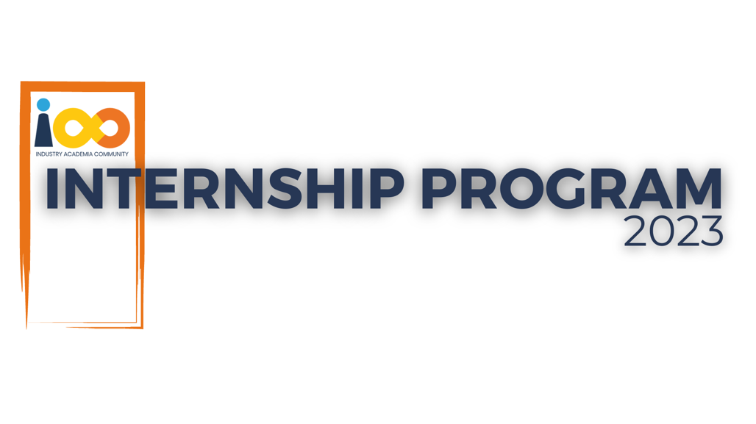

PROJECT REPORT

DATA ANALYTICS  
  
ABSENCE OF INSIGHTS FOR THE RELATIONSHIP BETWEEN STUDENT’S ECONOMIC BACKGROUND, ACADEMIC PERFORMANCE, COMPETENCE AND EXPECTED SALARY

|  |  |  |  |
| --- | --- | --- | --- |
| **Created By:** | VARUN PAI | **Approved By:** |  |
| **Created On:** | 25-08-2025 | **Approved On:** |  |

Page left blank intentionally

**INDEX**

**1** **PROJECT DETAILS** 2

**2** **SUMMARY** 2

**3** **INTRODUCTION** 2

3.1 Background 2

3.2 Stakeholders 2

3.3 Objectives 2

**4** **METHODOLOGY** 2

4.1 Considerations & Assumption 3

4.2 Approach 3

4.3 Activities 3

**5** **TARGETTED V/S ACHIEVED OUTPUT** 3

**6** **CONCLUSION** 3

**7** **APPENDICES** 4

7.1 Appendix A – Title 4

**General Instructions for using the Live Project Report Template**

* This template and the subsequent document created using this template is a confidential document and is the intellectual property of Cloud Counselage Pvt. Ltd. Circulating it outside of the organisation without the consent of Cloud Counselage Pvt. Ltd. is the breach of company policies and will lead to legal actions
* This template is a guideline document to communicate the implementation of design ideas and the results of the work to the stakeholders.
* The **text between inequality (< >) is to be replaced** by relevant text
* Please **remove the yellow highlight on the Text** between the inequality (< >). This is done to help you notice the text to be changed/replaced
* The text in *italics* highlighted in grey is just for reference and should be removed after adding the relevant text

# **PROJECT DETAILS**

|  |  |  |  |
| --- | --- | --- | --- |
| **Project Name** | ABSENCE OF INSIGHTS FOR THE RELATIONSHIP BETWEEN STUDENT’S ECONOMIC BACKGROUND, ACADEMIC PERFORMANCE, COMPETENCE AND EXPECTED SALARY | | |
| **Project Sponsor** |  | | |
| **Project Manager** |  | | |
| **Start Date** | 02-06-2025 | **Completion Date** | 20-08-2025 |

# **SUMMARY**

This project was carried out to understand students better—how their academics, background, and skills affect their career expectations and event participation. The dataset included details like CGPA, graduation year, family income, Python programming experience, and event engagement.

By analyzing this data, the project brought out patterns such as how salary expectations rise with CGPA and technical experience, which events students are more attracted to, and how colleges influence awareness of opportunities. These insights can be used to improve event planning, support student career growth, and guide institutions to make data-driven decisions.

# **INTRODUCTION**

## Background

In today’s world, data plays a key role in improving how students are supported and guided. By studying academic records, skills, and event participation, institutions can understand where students stand and how to engage them better. This project used Python-based data analysis to explore these aspects, helping uncover useful insights for both students and institutions.

## Stakeholders

Students: Gain from better opportunities and events tailored to their needs.

Colleges/Universities: Understand academic strengths and skill gaps in their student base.

Event Organizers: Identify which events draw the most attention and which promotion channels work best.

Recruiters: See the link between academics, technical skills, and career expectations.

## Objectives

The main objective of this project was to conduct a comprehensive analysis of student interns to understand the relationships between their academic performance, event participation, and career aspirations, along with the factors influencing their success.

More specifically, the project aimed to:

* Analyze academic performance (CGPA) across different colleges, cities, and income groups.
* Study patterns in event participation and identify which events attract students from specific fields of study.
* Examine the impact of family income and technical skills (e.g., Python programming experience) on student expectations, especially regarding career and salary.
* Understand how students come to know about events, with a focus on the role of colleges as information channels.
* Provide actionable insights that can support both students and institutions in improving outcomes and engagement

# **METHODOLOGY**

## Considerations & Assumption

While working on the dataset, some challenges came up—like missing entries and broad income categories. To make analysis possible, income ranges were converted to midpoint values (e.g., 2–5 lakh became 3.5 lakh). For event awareness, answers mentioning “college” were treated as genuine indicators that students heard about events from their institutes*.*

## Approach

The approach followed was straightforward:

1. Clean and prepare the data.
2. Use exploratory data analysis (EDA) to uncover trends.
3. Group and compare data points like CGPA, salary expectations, and event participation.
4. Use charts and visualizations to make the findings easier to understand.

## Activities

Some of the key activities carried out included:

1. Understanding the dataset and requirements.
2. Preprocessing and cleaning the data.
3. Running analysis for questions such as graduation year distribution, Python experience, and expected salary.
4. Creating visualizations to highlight key trends.
5. Summarizing insights in a structured form.

# **TARGETTED V/S ACHIEVED OUTPUT**

**Target**: The project aimed to identify insights about academics, career expectations, and event participation trends among students.

**Achieved**: The analysis successfully highlighted:

* Average CGPA levels and differences across colleges and cities.
* Distribution of Python programming experience.
* Relationship between family income and CGPA.
* How CGPA and Python experience influence salary expectations.
* The most engaging events and the top promotion channels.
* Students graduating by 2024 and their awareness sources.

Minor deviations happened due to incomplete data entries, but they did not stop the project from meeting its overall goals.

# **CONCLUSION**

The project gave a clearer picture of how different factors—academic performance, income background, and technical experience—impact students’ expectations and engagement. It showed, for instance, that students with higher CGPA and more Python experience expect better salaries, and that colleges play a huge role in spreading awareness about events.

Looking ahead, this kind of analysis can be scaled further. Larger datasets and machine learning models could be used to predict trends in student performance and career outcomes. Real-time dashboards could also be developed for colleges and event organizers to make quicker, data-driven decisions.

# **APPENDICES**

## Appendix A – Title

<Add component table as required>