Q6 — Transportation & Accessibility
Part A — Sampling
- Senior center/clinic bias: Classic availability sampling; captures mobile, service-engaged, healthier older adults; misses homebound, cognitively impaired, those without transportation to the center — worst bias possible for this research question
- Stratified better for policy comparison across transit environments; voter list better for individual-level inference but misses non-voters and recent movers
- 300 interviews allocation: Disproportionate allocation — outer suburbs get more than population share because transit problem is worst there and needs reliable estimates; principle = allocation serves analytical goal not just population proportion
Part B — Study Design
- Evaluation: Pre-post with comparison group (difference-in-differences); outcomes = trips made, appointments attended, self-reported accessibility, mobility independence scale
- Worst-access selection: Regression to mean + selection bias; comparison areas had better baseline access → simple comparison will exaggerate impact; treated areas may improve naturally
- Self-selection: Early adopters are more mobile and tech-comfortable — those who benefit most (most isolated) don't use it; apply intent-to-treat principle — measure all older adults in pilot area, not just users
Part C — Key Teaching Points
- 400m rule = binary object representation of continuous accessibility — ignores walkability, safety, slope, mobility, weather (field view more appropriate)
- 50 respondents in same outer suburb share same transit desert — NOT independent — inflated confidence (spatial autocorrelation)
- Micro-transit boundary is administratively arbitrary — human movement is continuous across it — classic MAUP/boundary problem

Q4 — Environmental Health & Pollution
Part A — Sampling
- Full population still has problems: spatial autocorrelation (nearby children share environment — not independent); MAUP (which unit to measure exposure?); school records miss homeschooled/dropped-out children
- Stratified by proximity: Ensures adequate sample of high-exposure children — most important group; requires proximity data first
- Information needed: Residential addresses, demographics, asthma status, school location
Part B — Study Design
- RCT: Not ethical — cannot assign children to live near polluting facilities; exposure is pre-existing environmental condition
- Cohort: Cohort = children born in metro area; Exposure = residential distance to facilities or modeled pollution concentration; Outcome = incident asthma; Follow-up = 5-10 years; Key confounders = income, housing quality, race/ethnicity, parental smoking, healthcare access
- Cross-sectional: Can identify associations and high-burden areas; cannot establish temporal order; cannot prove causation; ecological fallacy risk high
Part C — Key Teaching Points
- Zip code boundary for exposure = MAUP problem — arbitrary boundaries misclassify children; continuous field representation (pollution gradient) is more accurate
- Nearby children sharing environment → non-independence → inflated statistical confidence (spatial autocorrelation)
- Income and facility location co-vary geographically — environmental justice confounding — statistically impossible to fully separate; must be stated as limitation

Q1 — Climate & Heat Adaptation
Part A — Sampling
- Simple random: Unbiased but may severely under-sample rural fringe (small population); risk of too few rural respondents for reliable conclusions
- Stratified: Recommended — matches spatial structure of heat exposure; ensures all neighborhood types represented; allows group comparison; requires boundary decisions
- Cluster: Practical for field work; but people on same block share housing/shade/income — not independent; lower statistical efficiency
- 600 interviews: Workable with ∼200 per stratum; tight for subgroup analysis; formal power calculation ideal
Part B — Study Design
- Best design: Cohort using records of kit recipients vs. non-recipients
- RCT: Possible prospectively but kits already sent; contamination likely (neighbors share kits); blinding impossible
- Cohort limitation: Selection bias — those who requested kits likely already motivated to adapt
Part C — Key Teaching Points
- Zip code boundaries are arbitrary — different boundaries produce different strata compositions (MAUP preview)
- Neighbors on opposite sides of a boundary share identical environments — boundary classification is artificial
- Shared neighborhood environment = non-independent observations (spatial autocorrelation preview)

Q1 — Climate & Heat Adaptation

Part A — Sampling Method
1. Strengths and weaknesses of each approach:
Simple random sampling:
- Strengths: Unbiased if registry is complete; every resident has equal probability of selection; straightforward to implement
- Weaknesses: By chance, may heavily under-sample rural fringe areas (small population); won't guarantee representation of all neighborhood types; 600 interviews spread randomly may give very few rural respondents — too few to draw reliable conclusions about that group
Stratified sampling by neighborhood type:
- Strengths: Guarantees representation from all three neighborhood types; allows reliable comparison across groups; most appropriate given the known geographic variation in heat exposure and adaptation capacity; can use proportional or disproportional allocation
- Weaknesses: Requires pre-existing information to define strata boundaries; results depend on how strata are defined (which boundaries?); disproportional stratification requires weighting when estimating city-wide totals
Cluster sampling by city block:
- Strengths: Practical and cheaper for door-to-door interviewing; reduces travel time for interviewers
- Weaknesses: People on the same block share housing stock, shade, income level — they are not independent; statistical efficiency is lower than simple random for the same sample size; need many clusters to get reliable estimates
2. Recommended method: Stratified sampling by neighborhood type is most appropriate. The research question is explicitly about differences across neighborhood types, heat exposure varies systematically by urban/suburban/rural, and stratification ensures each group is represented. Proportional allocation (more interviews in urban core because it has more people) with a modest boost for the smaller rural fringe group would be ideal.
3. Is 600 enough? Key factors: How precise does the estimate need to be? Are comparisons across strata required (if so, each stratum needs sufficient n, perhaps 150-200 each)? How variable is the outcome? With 3 strata and 600 interviews, roughly 200 per stratum is workable but tight for subgroup analysis. A power calculation based on expected effect size and variability would be the formal approach.

Part B — Study Design
1. Best study design: A cohort study (prospective or retrospective) is most feasible. Define two groups: those who received the kit and those who did not. Compare self-reported behavior change between groups. If records of who received kits exist, this can be done retrospectively.
2. Could this be an RCT? In principle yes — randomly assign half the city to receive kits and half not, then follow up. Requirements: random assignment mechanism, ability to prevent contamination (kit recipients sharing with non-recipients), baseline measurement of behavior, follow-up survey. Challenges: The kits were already mailed — opportunity for prospective RCT has passed. If done prospectively: contamination is likely (neighbors share resources), blinding is impossible, and it may be politically difficult to withhold a potentially helpful intervention from some residents.
3. Next best option: A quasi-experimental cohort study comparing kit recipients vs. non-recipients. Limitations: Non-recipients may differ from recipients in unmeasured ways (those who requested kits may be more health-conscious); selection bias is likely; cannot establish causation. Strengthened by collecting baseline data on behavior and controlling for demographics.

Part C — Geographic Teaser: Key Teaching Points
- Boundary problem (MAUP preview): Zip codes are administrative units not designed to reflect heat exposure or social homogeneity. Census tracts, neighborhood boundaries, or heat island zones would be more meaningful strata. Different boundary choices will produce different strata compositions and potentially different results.
- Arbitrary boundaries: Neighbors on opposite sides of a zip code line share almost identical environments. Classifying them in different strata is conceptually problematic and introduces measurement error.
- Spatial autocorrelation preview: People in the same neighborhood share the same physical environment — same building materials, same tree cover, same distance to cooling centers. Their responses are therefore not independent. Statistical tests that assume independence will overestimate certainty. This is a preview of Tobler's First Law.

Question 4 — Environmental Health & Pollution: Answers

Part A — Sampling Method
1. Does having full population data eliminate sampling concerns? No — for several important reasons:
- Spatial autocorrelation: Children living near each other share the same air, schools, and social environments. They are not statistically independent. Standard tests treating 40,000 children as 40,000 independent observations will produce falsely confident (overnarrow) confidence intervals and spurious significance.
- MAUP: Having all the children doesn't tell you which geographic unit to use for measuring exposure. The choice of zip code vs. census tract vs. custom pollution buffer will change your results.
- Completeness: The 40,000 represents children in the school system — children who are home-schooled, have dropped out, or moved are excluded.
2. Simple random vs. stratified sampling:
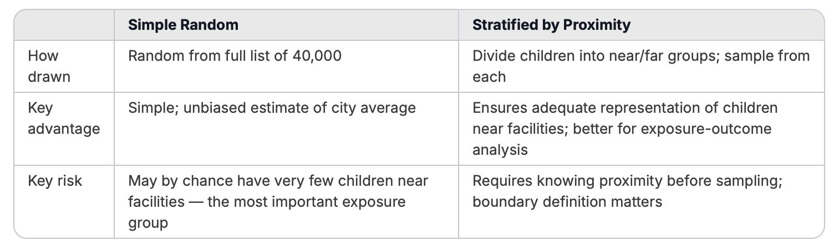
3. Information needed before sampling: Residential address (for proximity calculation); demographic information (age, race/ethnicity, insurance status — for stratification and confounding control); asthma diagnosis status (to check representativeness); which schools are in areas of concern.

Part B — Study Design
1. Is an RCT suited to this question? No — for fundamental ethical and practical reasons. You cannot randomly assign children to live near industrial facilities. Exposing children to pollution for research purposes is ethically impermissible. The exposure is a pre-existing environmental condition, not an assignable intervention. This is a classic case where observational designs are the only ethical option.
2. Cohort study design:
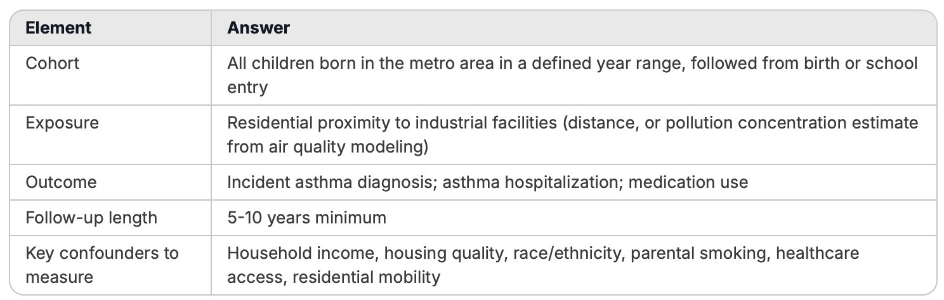
3. Cross-sectional design — what it can and cannot tell you: Can tell you: Whether zip codes with higher pollution loads currently have higher asthma prevalence; generate hypotheses; identify areas of concern for further study. Cannot tell you: Temporal ordering (did pollution exposure come before asthma?); causation; whether individuals in high-pollution zip codes are the same ones who have asthma (ecological fallacy); anything about who moved in or out of the area.

Part C — Geographic Teaser: Key Teaching Points
- MAUP and exposure misclassification: The zip code boundary problem is a concrete illustration of MAUP — the geographic unit used to define exposure creates arbitrary in/out classifications that do not reflect actual exposure gradients. More appropriate approaches use distance-based buffers or pollution dispersion models (field view rather than object view of pollution).
- Spatial autocorrelation inflates confidence: Nearby children sharing the same air quality, school environment, and neighborhood conditions are not independent. Standard regression treating them as such will underestimate standard errors and produce p-values that are too small — false positives.
- Confounding by place: This is the environmental justice confounding problem. Industrial facility location is not random — it is correlated with neighborhood income, race, housing quality, and healthcare access. These factors are themselves associated with asthma. Separating pollution effects from poverty effects requires careful design and is often impossible to do completely — a fundamental limitation that should be stated explicitly in any study.

Question 6 — Transportation & Accessibility: Answers

Part A — Sampling Method
1. Bias from recruiting at senior centers and clinics: Classic availability sampling bias. Those present at senior centers and clinics are: already mobile enough to get there independently or with help; already engaged with services; likely healthier and more socially connected. Missing: homebound older adults with the most severe accessibility problems; those without transportation to the senior center itself; those with cognitive decline; those who have given up trying to access services. This is the worst possible bias for this study — the people least able to access transportation are systematically excluded from a study about transportation access.
2. Stratified vs. simple random:
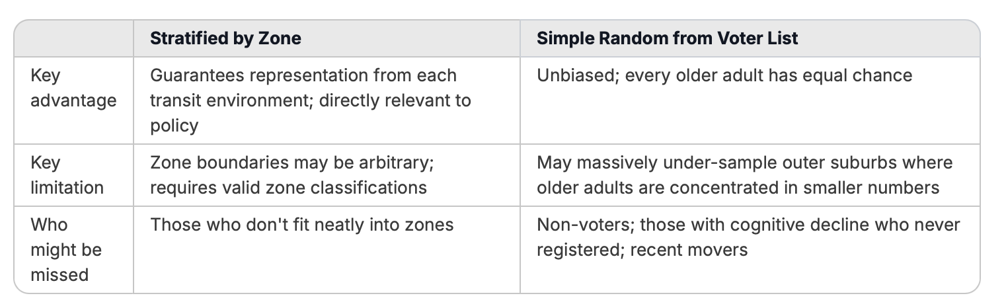
3. How to allocate 300 interviews across zones: Use disproportionate stratified allocation — allocate more interviews than population share to outer suburbs because: (a) that is where the transit problem is worst and policy interest is highest; (b) the population of older adults there is smaller so proportional allocation would give too few for reliable analysis. A reasonable allocation: urban core 80, inner suburb 110, outer suburb 110, even if outer suburbs have fewer older adults overall. The key principle is that allocation should serve the analytical goals of the study, not just mirror population distribution.

Part B — Study Design
1. Evaluation design: A pre-post comparison with control group (difference-in-differences design). Outcomes: number of medical appointments attended; self-reported trip frequency; self-reported ability to reach services; mobility independence scale. Comparison group: older adults in similar outer suburban areas that did not receive micro-transit, measured over the same period.
2. Problem with selecting worst-access areas: This creates regression to the mean and selection bias problems. Areas with the absolute worst access at baseline have nowhere to go but up — some improvement may occur even without the intervention (new residents move in, informal carpooling emerges). Comparing to areas that already had moderate access will exaggerate the apparent impact of micro-transit. Additionally, the three areas may differ from comparison areas in unmeasured ways beyond transit access (income, demographics, political will to engage with new services).
3. Self-selection into service use: Early adopters of the app-based service are likely: more technologically comfortable; more mobile; more socially connected; younger within the 65+ group. The most isolated and mobility-limited older adults — those who would benefit most — may not use the service at all. This means outcome measures (trips taken using micro-transit) will overstate the service's reach and impact. The intent-to-treat principle from RCTs is relevant here: you should measure outcomes for all older adults in the pilot area, not just those who used the service.

Part C — Geographic Teaser: Key Teaching Points
- The 400-meter rule as object vs. field thinking: The binary 400m rule treats transit access as an object (you either have it or you don't at a boundary). But real accessibility is a field — it varies continuously based on walkability, safety, slope, mobility, weather, and time of day. The same distance means very different things in different spatial contexts. This is a direct application of O'Sullivan & Unwin's point that the representation chosen shapes what you find.
- Spatial autocorrelation in survey responses: Older adults in the same outer suburb share the same transit desert, the same service geography, the same neighborhood characteristics. Their responses are correlated — they are experiencing the same spatial reality. Treating 50 respondents from one suburb as 50 independent observations inflates confidence in your estimates.
- Boundary arbitrariness: The micro-transit service boundary is administratively drawn but geographically arbitrary in terms of actual travel behavior. People just outside the zone may have family inside it; people just inside may rarely travel to destinations the service reaches. This is a preview of MAUP and the general problem that geographic boundaries imposed on continuous human movement patterns create artificial categories.

