Exercise 1: Course Logistics

Instructions: Please type in your responses to the questions, save the file as ‘yourusername_ex1.docx’ and submit to your respective ‘exercises’ folder (see Q1).

- OneDrive: You should all have access to your individual OneDrive submission folders. You will use these folders to submit all your materials such as in-class exercises, checkpoint assignments, and your final project deliverables. Please check that you have access to your folder (labelled as your USC username). Within the folder, create 3 folders labelled as: ‘exercises’, ‘checkpoint_assignments’, and ‘final_project’. Respond to this question by typing ‘completed’ once you create your folders.

- Course website and Syllabus: All course materials will be posted on the course website at https://gisph.netlify.app, including the updated class syllabus and schedule. Please read the class syllabus. Make sure to check the syllabus before asking any questions about course logistics via Piazza or email. To ensure that you have read the class syllabus and seen the updated class schedule on the website, please answer the following questions:

- How many points is the final project presentation worth?
- Which week is the lecture on Disease risk and diffusion?

- Software Installation: Please make sure to review the software document and reach out to me if you run into problems installing the required software on your computer. While we will use R, GeoDA, and SatScan at a later point in the semester, we will start using QGIS from Week 2! Please make sure that you have the correct version of QGIS (the long term version) fully installed on your computer. Once QGIS is installed, answer the following:

- Paste a screenshot showing that QGIS is installed on your computer. Here is an example of a screenshot from my mac:
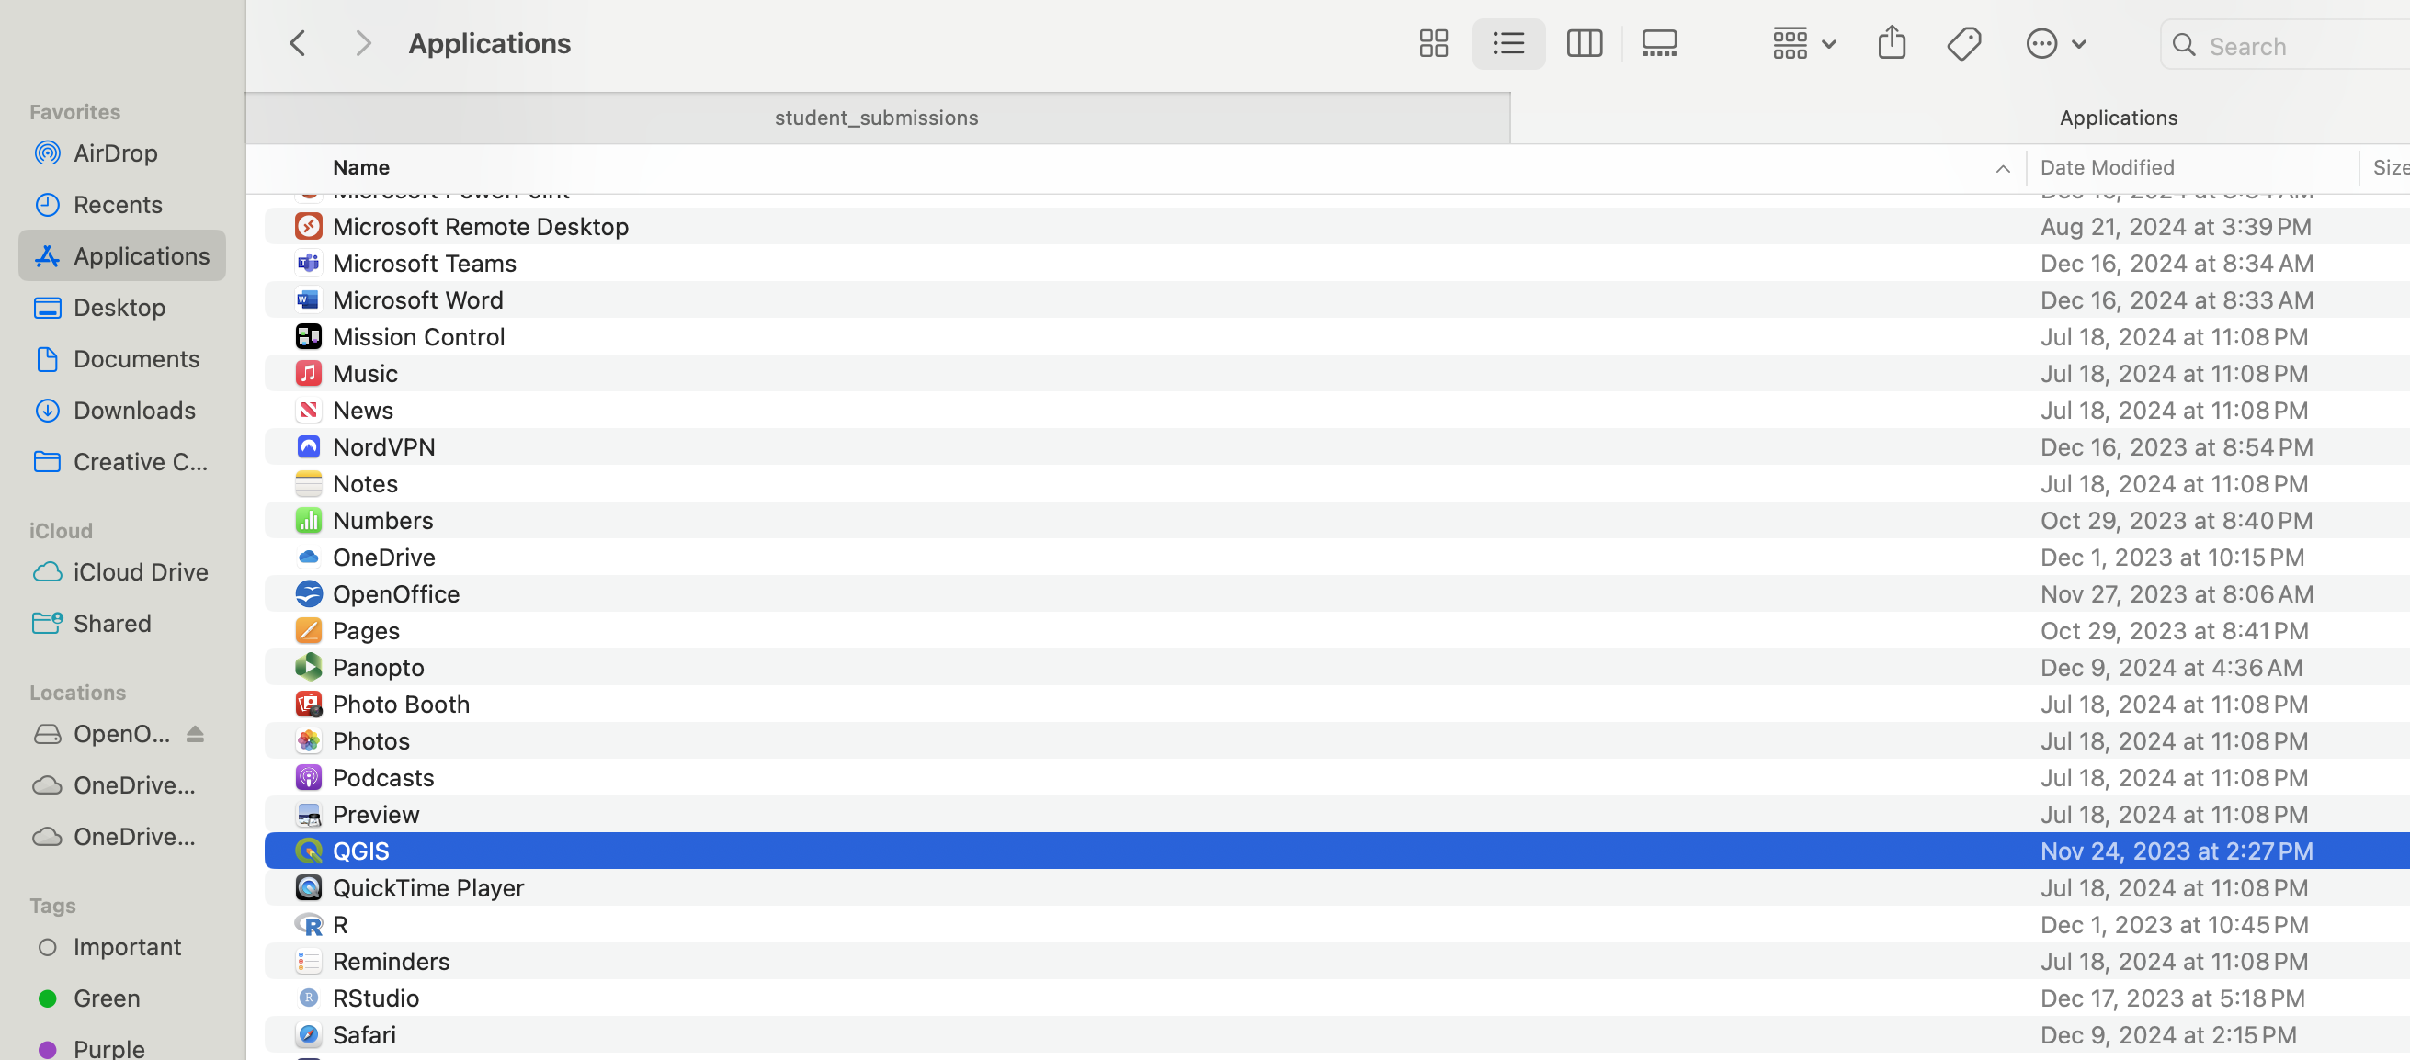

- What version of QGIS is installed on your computer? Note that each QGIS version is named after a city. What city is your version named after?

- Required Textbook: You should all have access to either a physical copy of the required textbook or an electronic copy that is freely available through the USC library. If you are still having issues with accessing the textbook, please let me know promptly. Please take a look at the introduction and Ch 1 of the book and answer the following questions:
  - Name 3 measures that can be used in epidemiological studies to compare health outcomes between different groups (page 6 & 7 in Introduction)
  - Name 2 spatial analysis functions each related to ‘Network and location analysis’, and ‘Topological analysis’ (page 30 in chapter 1)

