Stat & Data Analysis: 3.2 worksheet NAME: _______________________
Directions: Complete the following problem. Write probability notation for each question. Use your calculator. Don’t forget units when they are needed.

Cholesterol levels of adult American women are normally distributed with a mean of 188 mg/dL and a standard deviation of 24 mg/dL.
- Draw and label the normal model below N(188, 24)
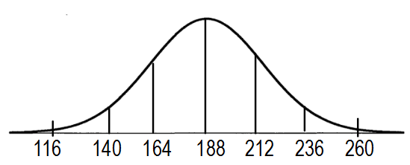
- What percent of American women have cholesterol levels above 200?
P(X > 200) = 0.3085 = 30.85%

- What percent of American women have cholesterol levels below 160?
P(x < 160) = 0.1217 = 12.17%

- What percent of American women have cholesterol levels between 170 and 210?
P(170 < X < 210) = 0.5937 = 59.37%

- An American woman has a cholesterol level of 180. What is her percentile?
P(X < 180) = 0.3694 = 36.94%

- An American woman has a cholesterol level that is at the 35th percentile. What is her actual cholesterol level?
P(X < A) = 35% A = 178.75 mg/dL

- Above what value are the highest 15% of women’s cholesterol levels?
P(X < A) = 15% A = 212.87 mg/dL

- Where do the middle 70% of cholesterol levels fall?
P(X < A) = 15% A = 163.13 mg/dL
P(X < B) = 85% A = 212.87 mg/dL

- What is the first quartile of cholesterol levels?
P(X < Q1) = 25% A = 171.81 mg/dL

- What is the third quartile of cholesterol levels?
P(X < Q3) = 75% A = 204.19 mg/dL

- What is the IQR of cholesterol levels? 204.19 – 171.81 = 32.38 mg/dL

- What is the median of cholesterol levels? Mean = median = 188 mg/dL

