AP Stats
Chap 5 Name ______________________________________________ Pd _______

Who Gets the Gold?

Consider the performances of three athletes shown below in a three-event competition and answer the following questions:
- Who gets the gold medal?
- Who turned in the most remarkable performance of the competition?
Note that each placed first, second, and third in one event.
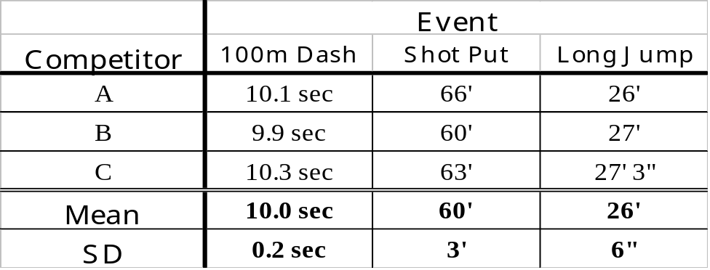

Being able to answer these questions boils down to knowing whether it is harder to run a second faster, thrown a foot farther, or jump an inch longer. Standard deviations to the rescue! ☺ Since we are given the mean and standard deviations of the events, we can compute the z-scores and therefore answer the questions.

Think
We want to compare athletic performances across several different events, so we need some way to compare without units. We will compare z-scores from each event! Also…don’t forget that the lower times are better in the 100m dash.

Show
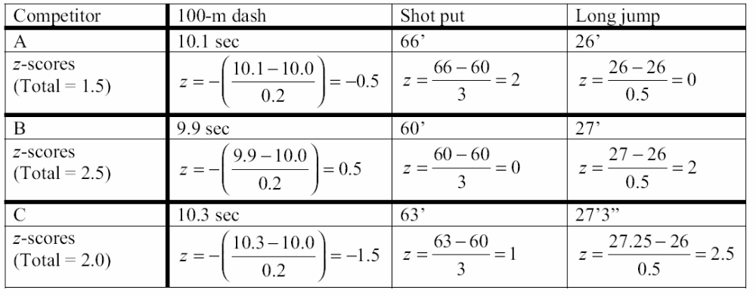

Tell
B was the winner, with a total of 2.5 standard deviations above the mean performance.

C won the silver and A the bronze, with 2.0 and 1.5 standard deviations above the mean, respectively.

C’s long jump was the most startling feat: 2.5 standard deviations longer than the average.

