AP Stats Classwork
Standardizing Scores

Let’s talk about scoring the decathlon. Silly example, but suppose two competitors tie in each of the first eight events. In the ninth event, the high jump, one clears the bar 1 in. higher. Then in the 1500-meter run the other one runs 5 seconds faster. Who wins? It boils down to knowing whether it is harder to jump an inch higher or run 5 seconds faster. We have to be able to compare two fundamentally different activities involving different units. Standard deviations to
the rescue! If we knew the mean performance (by world-class athletes) in each event, and the standard deviation, we could compute how far each performance was from the mean in SD units (called z-scores). So consider the three athletes’ performances shown below in a three event competition. Note that each placed first, second, and third in an event.

Who gets the gold medal? Who turned in the most remarkable performance of the competition?

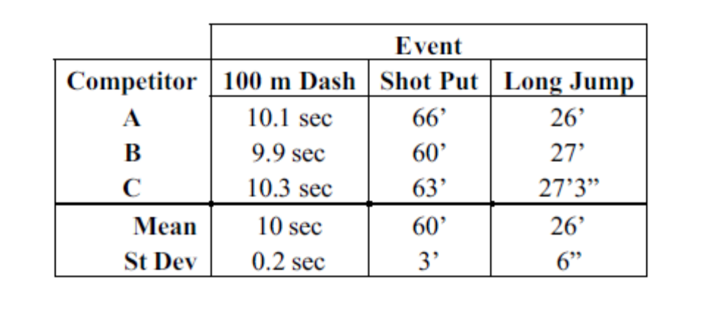

Competitor | 100 m Dash | Shot Put | Long Jump
A

B

C

