JavaScript var
- The var statement declares a variable.
- Variables are containers for storing information.
- Creating a variable in JavaScript is called "declaring" a variable:
var carName;
- After the declaration, the variable is empty (it has no value).
- To assign a value to the variable, use the equal sign:
carName = "Volvo";
- You can also assign a value to the variable when you declare it:
var carName = "Volvo";
- Note - A variable declared with var without a value has the value undefined.
- Variables defined with let cannot be redeclared.
var x = "John Doe";
var x = 0;
- Variables declared with the var keyword can NOT have block scope.
var x = 10;
// Here x is 10
{
var x = 2;
// Here x is 2
}
// Here x is 2

- Variables declared inside a { } block can be accessed from outside the block.
{
var x = 2;
}
// x CAN be used here

JavaScript let
- The let keyword was introduced in ES6 (2015).
- Variables defined with let cannot be Redeclared.
let x = "John Doe";
let x = 0;
// SyntaxError: 'x' has already been declared

- Variables defined with let must be Declared before use.
- Variables defined with let have Block Scope.
{
let x = 2;
}
// x can NOT be used here

var x = 2; // Allowed
let x = 3; // Not allowed
{
let x = 2; // Allowed
let x = 3; // Not allowed
}
{
let x = 2; // Allowed
var x = 3; // Not allowed
}

let x = 2; // Allowed
{
let x = 3; // Allowed
}
{
let x = 4; // Allowed
}
- Redeclaring a variable inside a block will not redeclare the variable outside the block: like var
let x = 10;
// Here x is 10
{
let x = 2;
// Here x is 2
}
// Here x is 10

JavaScript Const
- The const keyword was introduced in ES6 (2015).
- Variables defined with const cannot be Redeclared.
- Variables defined with const cannot be Reassigned.
- Variables defined with const have Block Scope.
- A const variable cannot be reassigned:
const PI = 3.141592653589793;
PI = 3.14; // This will give an error
PI = PI + 10; // This will also give an error
- JavaScript const variables must be assigned a value when they are declared:
// Correct
const PI = 3.14159265359;
// Incorrect
const PI;
PI = 3.14159265359;
- When to use JavaScript const?
  - Always declare a variable with const when you know that the value should not be changed.
  - Use const when you declare:
A new Array
A new Object
A new Function
A new RegExp
- The keyword const is a little misleading. It does not define a constant value. It defines a constant reference to a value.
- Because of this you can NOT:
  - Reassign a constant value
  - Reassign a constant array
  - Reassign a constant object
- But you CAN:
  - Change the elements of constant array
  - Change the properties of constant object
// You can create a constant array:
const cars = ["Saab", "Volvo", "BMW"];
// You can change an element:
cars[0] = "Toyota";
// You can add an element:
cars.push("Audi");

const cars = ["Saab", "Volvo", "BMW"];
cars = ["Toyota", "Volvo", "Audi"]; // ERROR

// You can create a const object:
const car = {type:"Fiat", model:"500", color:"white"};
// You can change a property:
car.color = "red";
// You can add a property:
car.owner = "Johnson";

const car = {type:"Fiat", model:"500", color:"white"};
car = {type:"Volvo", model:"EX60", color:"red"}; // ERROR
- Declaring a variable with const is similar to let when it comes to Block Scope.

Hoisting
- Hoisting in JavaScript is a behaviour in which a function or a variable can be used before declaration. For example,
// Using test before declaring
console.log(test); // undefined
var test;
- The above program works and the output will be undefined.

- The above program behaves as
// Using test before declaring
var test;
console.log(test); // undefined
- Since the variable test is only declared and has no value, undefined value is assigned to it.

- Note: In hoisting, though it seems that the declaration has moved up in the program, the actual thing that happens is that the function and variable declarations are added to memory during the compile phase.

Function Hoisting
- One of the advantages of hoisting is that it lets you use a function before you declare it in your code.

- Example 1

catName("Tiger");
function catName(name) {
console.log(`My cat's name is ${name}`);
}
/*
The result of the code above is: "My cat's name is Tiger"
*/

- Without hoisting you would have to write the same code like this:

function catName(name) {
console.log(`My cat's name is ${name}`);
}
catName("Tiger");
/*
The result of the code above is the same: "My cat's name is Tiger"
*/

- Example 2
// program to print the text
greet();
function greet() {
console.log('Hi, there.');
}
- In the above program, the function greet is called before declaring it and the program shows the output. This is due to hoisting

- Example 3
// program to print the text
greet();
let greet = function() {
console.log('Hi, there.');
}
- Output
Uncaught ReferenceError: greet is not defined
- When a function is used as an expression, an error occurs because only declarations are hoisted.

- Example 4
- If var was used in the above program, the error would be:
Uncaught TypeError: greet is not a function

Variable Hoisting

- Hoisting works with variables too, so you can use a variable in code before it is declared and/or initialised.
- However JavaScript only hoists declarations, not initializations!
- This means that initialization doesn't happen until the associated line of code is executed, even if the variable was originally initialised then declared, or declared and initialised in the same line.
- Note: Until that point in the execution is reached the variable has its default initialization (undefined for a variable declared using var, otherwise uninitialized).

var hoisting
- Here we declare and initialise the value of a var after using it. The default initialization of the var is undefined.

console.log(num); // Returns 'undefined' from hoisted var declaration (not 6)
var num; // Declaration
num = 6; // Initialization
console.log(num); // Returns 6 after the line with initialization is executed

- The same thing happens if we declare and initialise the variable in the same line.
console.log(num); // Returns 'undefined' from hoisted var declaration (not 6)
var num = 6; // Initialization and declaration.
console.log(num); // Returns 6 after the line with initialization is executed.

- If we forget the declaration altogether (and only initialise the value) the variable isn't hoisted.
- Trying to read the variable before it is initialised results in a ReferenceError exception.
console.log(num); // Throws ReferenceError exception - the interpreter doesn't know about `num`.
num = 6; // Initialization

- However, that initialization also causes declaration (if not already declared).
- The code snippet below will work, because even though it isn't hoisted, the variable is initialised and effectively declared before it is used.
a = 'Cran'; // Initialise a
b = 'berry'; // Initialise b
console.log(`${a}${b}`); // 'Cranberry'

let and const hoisting
- Variables declared with let and const are also hoisted but, unlike var, are not initialised with a default value (i.e., ‘var’ is initialised with default value ‘undefined’) .
- An exception will be thrown if a variable declared with let or const is read before it is initialised.

console.log(num); // Throws ReferenceError exception as the variable value is uninitialized
let num = 6; // Initialization

Temporal Dead Zone
- A temporal dead zone (TDZ) is the area of a block where a variable is inaccessible until the moment the computer completely initialises it with a value.
- Suppose you attempt to access a variable before its complete initialization. In such a case, JavaScript will throw a ReferenceError.
- So, to prevent JavaScript from throwing such an error, you’ve got to remember to access your variables from outside the temporal dead zone.
- But where exactly does the TDZ begin and end? Let’s find out below.
- A block’s temporal dead zone starts at the beginning of the block’s local scope. It ends when the computer fully initialises your variable with a value.

Example:
{
// bestFood's TDZ starts here (at the beginning of this block's local scope)
// bestFood's TDZ continues here
// bestFood's TDZ continues here
// bestFood's TDZ continues here
console.log(bestFood); // returns ReferenceError because bestFood's TDZ continues here
// bestFood's TDZ continues here
// bestFood's TDZ continues here
let bestFood = "Vegetable Fried Rice"; // bestFood's TDZ ends here
// bestFood's TDZ does not exist here
// bestFood's TDZ does not exist here
// bestFood's TDZ does not exist here
}

Function and Block Scope

- var refers to a variable in the function scope, while let, const refers to a variable in the block scope
- When we use the var keyword to declare a variable, it is available on every line of the function, hence Function scoped
- When we use the let, const keyword to declare a variable, it is only accessible within the block in which it was declared, hence block scope
- So, in this example iAmTwo can be accessed even outside the if block, but iAmFour cannot be accessed outside the if block because it is declared with let keyword

function iAmAFunction() {
var iAmTwo = 2;
if (iAmTwo == 2) {
var iAmThree = 3;
let iAmFour = 4;
}
console.log(iAmThree); // 3
console.log(iAmFour); // error
}
iAmAFunction();

Problem with var
- There's a weakness that comes with var. We use the example below to explain:

var greeter = "hey hi";
var times = 4;
if (times > 3) {
var greeter = "say Hello instead";
}
console.log(greeter) // "say Hello instead"

- So, since times > 3 returns true, greeter is redefined to "say Hello instead".
- While this is not a problem if you knowingly want greeter to be redefined, it becomes a problem when you do not realise that a variable greeter has already been defined before.
- If you have used greeter in other parts of your code, you might be surprised at the output you might get.
- This will likely cause a lot of bugs in your code. This is why let and const are necessary.

Q1.
Predict the output of the following code:
var a = 10;
{
var a = -10;
}
let b = a;
{
let b = -20;
}
console.log(b)

-20
-10
10
undefined

Q2.
for(var i=0;i<3;i++){
console.log(i)
}
console.log("i outside the loop: ", i);
for(let j=0;j<3;j++){
console.log(j);
}
console.log("j outside the loop :", j);

Q3.
console.log(y);
y = 1;

Q4
console.log(y);
var y = 2;

Q5
y = 3;
console.log(y);
var y;

Q6
var a = 1;
console.log(a);
var a = 2;
console.log(a);

Q7
var z = 1;
let z;
console.log(z);

Q8
console.log(z);
let z = 1;

Q9
function hoistExample() {
var a;
console.log("Before: ", a);
a = 10;
console.log("After: ", a);
}
hoistExample();

Q9
function hoistingExample() {
console.log("Value of a in local scope: ", a);
}
console.log("Value of a in global scope: ", a);
var a = 1;
hoistingExample();

Q10
function hoistingExample() {
a = 1;
}
hoistingExample();
console.log(a);

Q11
function hoistingExample() {
var a = 1;
}
hoistingExample();
console.log(a);

Q12
function a(){
console.log("1")
}
a();
function a(){
console.log("2")
}
a();

Q13
var test = 1;
function functionHoisting() {
test = 10;
return;
function test() {}
}
functionHoisting();
console.log(test);

Q14
alert(a());
function a() {
var b = function() {
return 3;
};
return b();
var b = function() {
return 8;
};
}

Q15
alert(a());
function a() {
function b() {
return 3;
}
return b();
function b() {
return 8;
}
}

Summary & Key Points
- var declarations are globally scoped or function scoped while let and const are block scoped.
- var variables can be updated and re-declared within its scope; let variables can be updated but not re-declared; const variables can neither be updated nor re-declared.
- They are all hoisted to the top of their scope. But while var variables are initialised with undefined, let and const variables are not initialised.
- While var and let can be declared without being initialised, const must be initialised during declaration.
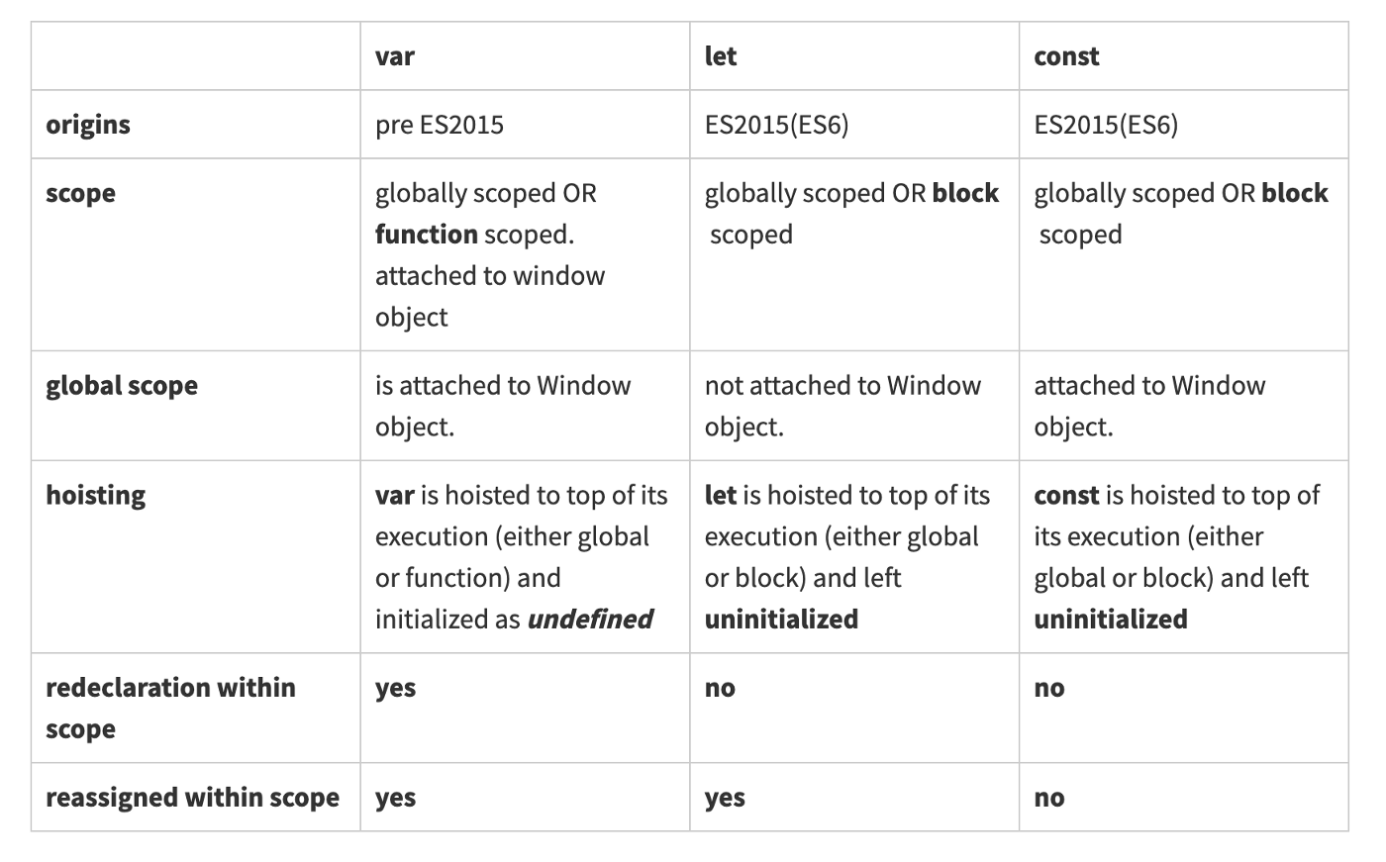

Find Output-
Q1.
//code will throw an error
function foo(n) {
if (n == 6) {
let num = 2;
}
console.log(num);
}

var n = 6;
console.log(n);
foo(6);

Q2.
function foo(){
var n=6;
console.log(n);
}

var n=5;
console.log(n);
foo();

Q3.
function parent() {
var hoisted = "I'm a variable";
function hoisted() {
return "I'm a function";
}
return hoisted();
}
console.log(parent());

Q4.
alert(foo());
function foo() {
var bar = function () {
return 3;
};
return bar();
var bar = function () {
return 8;
};
}
Q5.
var myVar = "foo";
(function () {
console.log("Original value was: " + myVar);
var myVar = "bar";
console.log("New value is: " + myVar);
})();

