# Sample Run & Results:

Application UI:

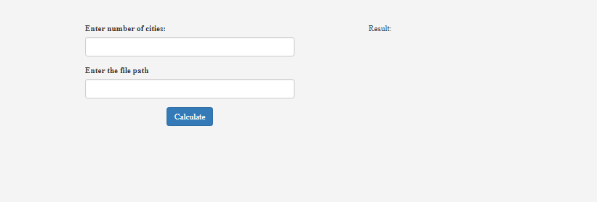

Enter number of cities:

Example: Cities =5

Enter the File Path:

Location of the text file having Distances between each cities

Example:

0 12 10 19 8

12 0 3 7 6

10 3 0 2 20

19 7 2 0 4

8 6 20 4 0

Click Calculate: it will print the result on the right side

