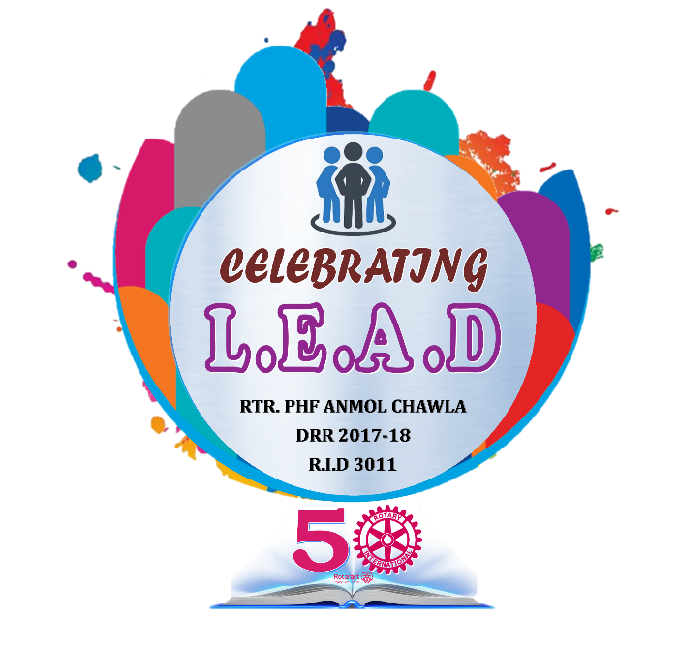

Club Logo

SPONSORED BY

**ROTARY CLUB OF BBBBBBBB-BBBBBBB**

**R. I. DISTRICT 3011 | ZONE: # R. I. YEAR 2017-18**

**ROTARACT CLUB OF AAAAAA-AAAAAAA**

RTR. YYYYYYY-YYYYYYY

SECRETARY

RTR. XXXXXXX-XXXXXXX

PRESIDENT