**Fading Channels &Mobile Communications**

**IIT Kharagpur**

**Date: 8/Oct/2018**

**Exp10: Frequency Selective Fading**

**Name: MOHIT KAPOOR**

**__________________________________________________________**

**Results**

|  |  |  |  |  |  |  |
| --- | --- | --- | --- | --- | --- | --- |
|  | **Environment** | **Mean Excess** | **RMS Delay(uS)** | **Bc(>0.5)MHz** | **Bc(>0.9)MHz** | **Max.Tow(uS)** |
|  |  | **Delay(uS)** |  |  |  |  |
|  | UMi(LoS) | Actual:0.1286 | Actual:0.1087 | Actual:1.8399 | Actual:0.184 | Actual:0.42 |
|  |  | Entered:1 | Entered:1 | Entered:1 | Entered:1 | Entered:1 |
|  |  |  |  |  |  |  |
|  | UMi(NLoS) |  |  |  |  |  |
|  |  |  |  |  |  |  |
|  | UMa(LoS) |  |  |  |  |  |
|  |  |  |  |  |  |  |
|  | UMa(NLoS) |  |  |  |  |  |
|  |  |  |  |  |  |  |
|  | Rural |  |  |  |  |  |
|  | Macro(LoS) |  |  |  |  |  |
|  |  |  |  |  |  |  |
|  | Rural |  |  |  |  |  |
|  | Macro(NLoS) |  |  |  |  |  |
|  |  |  |  |  |  |  |
|  | Suburban |  |  |  |  |  |
|  | Macro(LoS) |  |  |  |  |  |
|  |  |  |  |  |  |  |
|  | Suburban |  |  |  |  |  |
|  | Macro(NLoS) |  |  |  |  |  |
|  |  |  |  |  |  |  |
|  | Suburban |  |  |  |  |  |
|  | Macro(Outdoor- |  |  |  |  |  |
|  | Indoor) |  |  |  |  |  |
|  |  |  |  |  |  |  |

**Discussion:**

(Signature of MOHIT KAPOOR)

(Signature of Faculty)

**Power Delay Profile**

|  |
| --- |
| **P o w e r ( d B )** |



* + 5
* 10
* 15



* 20



* 25

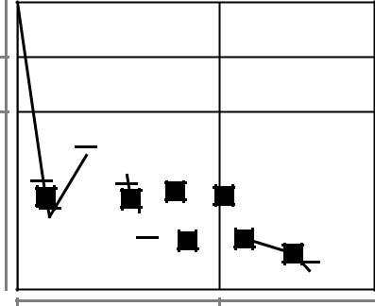

0.00 0.25

**t o w ( u S )**

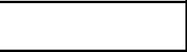

UMi(LoS)



(Signature of MOHIT KAPOOR)

(Signature of Faculty)